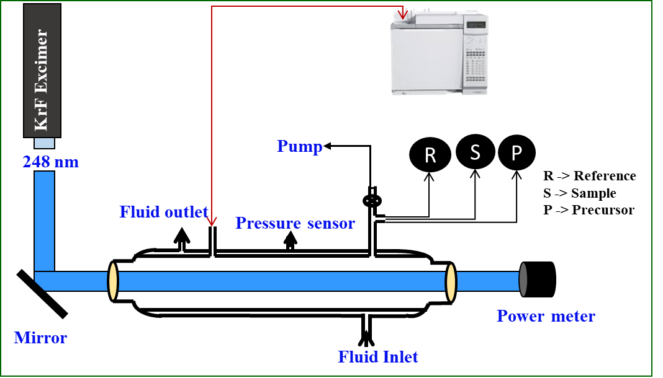

Schematic illustration of Relative Rate (RR) experimental setup.

