Supplementary data for
Synthesis and biological evaluation of 2-epi-jaspine B analogs as selective sphingosine kinase 1 inhibitors

Haoran Yang^{1,2,3#}, Ying Li^{1,2,3#}, Huining Chai^{1,2,3}, Takayuki Yakura⁴, Bo Liu^{1,2,3}*, Qingqiang Yao^{1,2,3}*
¹Institute of Materia Medica, Shandong Academy of Medical Sciences, Jinan 250062, P. R. China;
²Key Laboratory for Biotech-Drugs Ministry of Health, Jinan 250062, P. R. China;
³Key Laboratory for Rare & Uncommon Diseases of Shandong Province, Jinan 250062, P. R. China; ⁴Graduate School of Medicine and Pharmaceutical Sciences, University of Toyama, Toyama 930-0194, Japan.

Corresponding authors:
Bo Liu, E-mail: mls_liub@ujn.edu.cn;
Qingqiang Yao, E-mail: yao_imm@163.com.
#: These authors contributed equally.

Table of contents
Content page
¹H NMR spectra of compound YHR1 S1
¹³C NMR spectra of compound YHR1 S2
¹H NMR spectra of compound YHR2 S3
¹³C NMR spectra of compound YHR2 S4
¹H NMR spectra of compound YHR3 S5
¹³C NMR spectra of compound YHR3 S6
¹H NMR spectra of compound YHR4 S7
¹³C NMR spectra of compound YHR4 S8
¹H NMR spectra of compound YHR5 S9
¹³C NMR spectra of compound YHR5 S10
¹H NMR spectra of compound YHR6 S11
¹³C NMR spectra of compound YHR6 S12
¹H NMR spectra of compound YHR7 S13
¹³C NMR spectra of compound YHR7 S14
¹H NMR spectra of compound YHR8 S15
¹³C NMR spectra of compound YHR8 S16
¹H NMR spectra of compound YHR9 S17
¹³C NMR spectra of compound YHR9 S18
¹H NMR spectra of compound YHR10 S19
¹³C NMR spectra of compound YHR10 S20
¹H NMR spectra of compound YHR11 S21
¹³C NMR spectra of compound YHR11 S22

Content page
¹H NMR spectra of compound YHR12 S23
¹³C NMR spectra of compound YHR12 S24
¹H NMR spectra of compound YHR13 S25
¹³C NMR spectra of compound YHR13 S26
¹H NMR spectra of compound YHR14 S27
¹³C NMR spectra of compound YHR14 S28
¹H NMR spectra of compound YHR15 S29
¹³C NMR spectra of compound YHR15 S30
¹H NMR spectra of compound YHR16 S31
¹³C NMR spectra of compound YHR16 S32
¹H NMR spectra of compound YHR17 S33
¹³C NMR spectra of compound YHR17 S34

¹H NMR spectra of compound YHR1 measured in CDCl₃ at 400 MHz
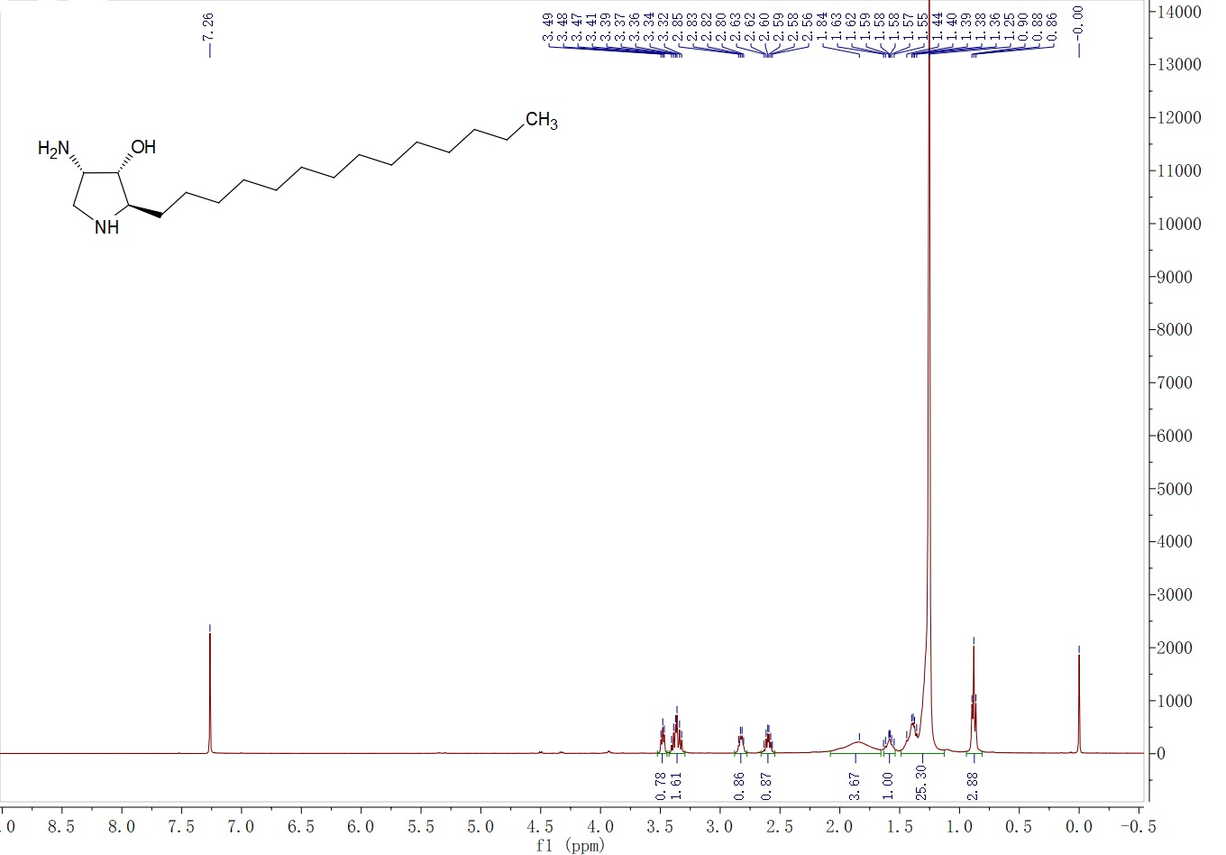

¹³C NMR spectra of compound YHR1 measured in CDCl₃ at 100 MHz
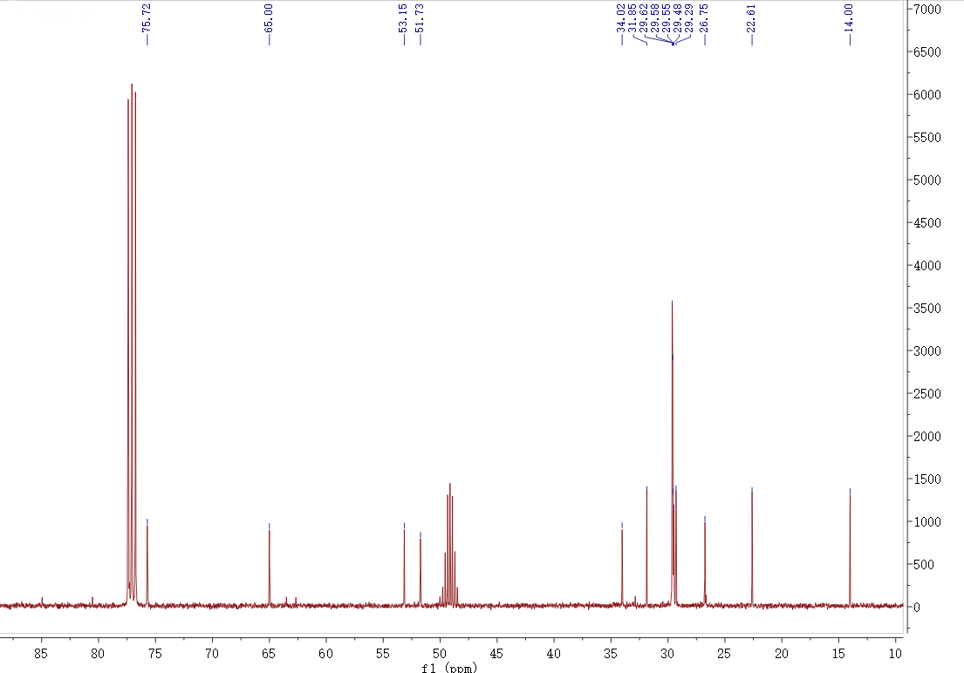

¹H NMR spectra of compound YHR2 measured in CD₃OD at 600 MHz
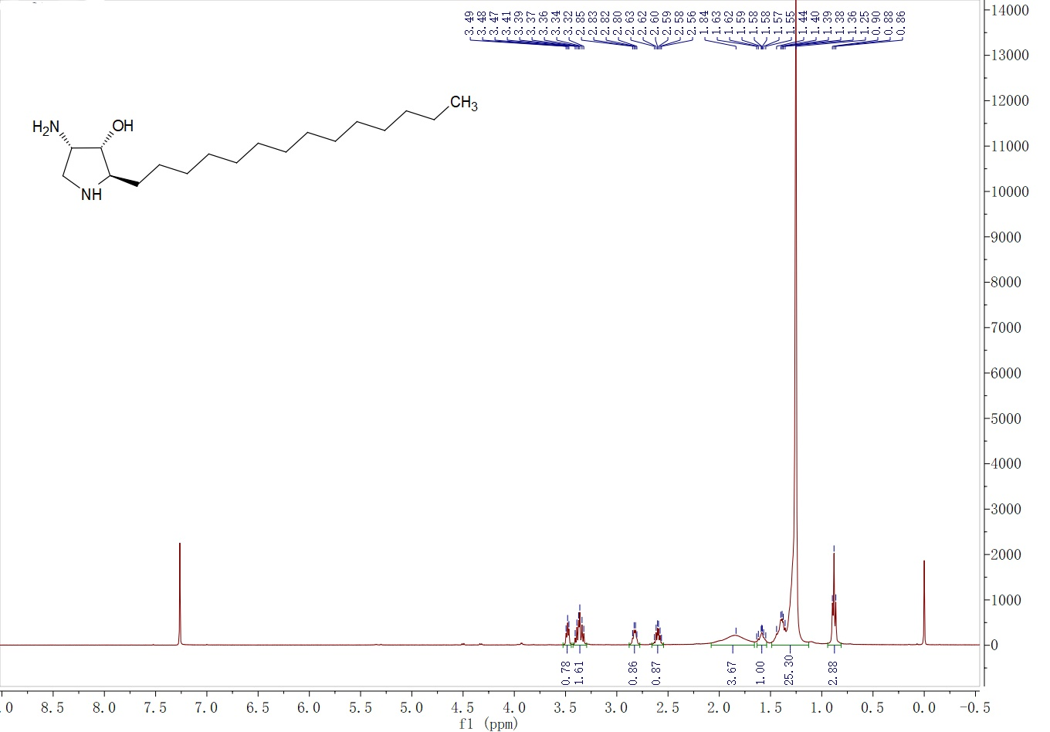

¹³C NMR spectra of compound YHR2 measured in CD₃OD at 150 MHz
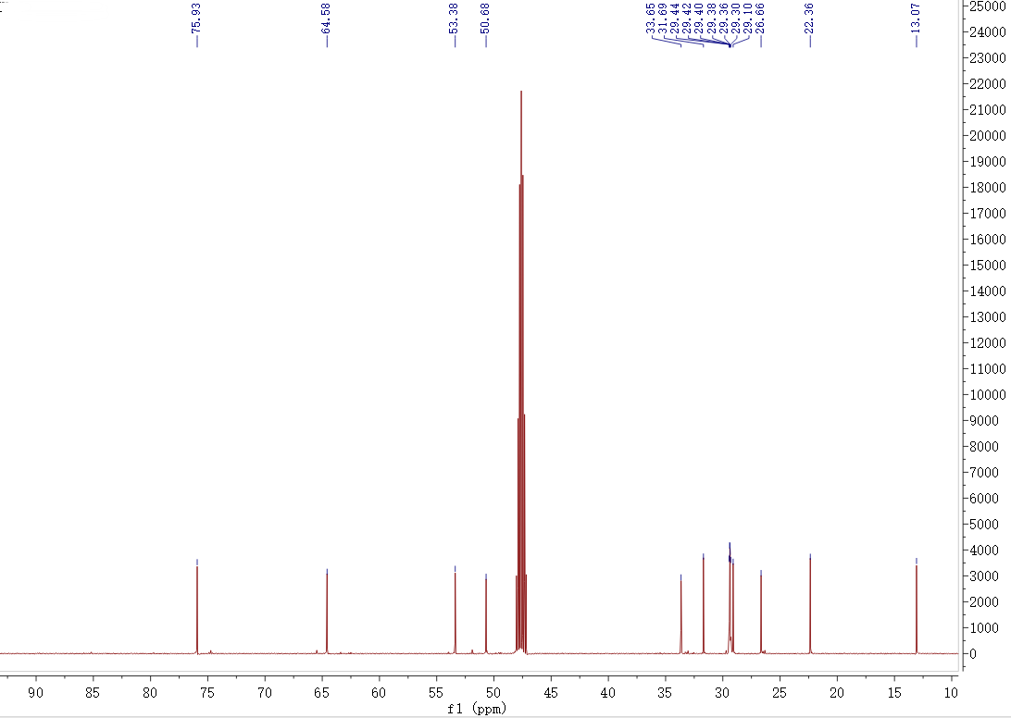

¹H NMR spectra of compound YHR3 measured in CD₃OD at 600 MHz
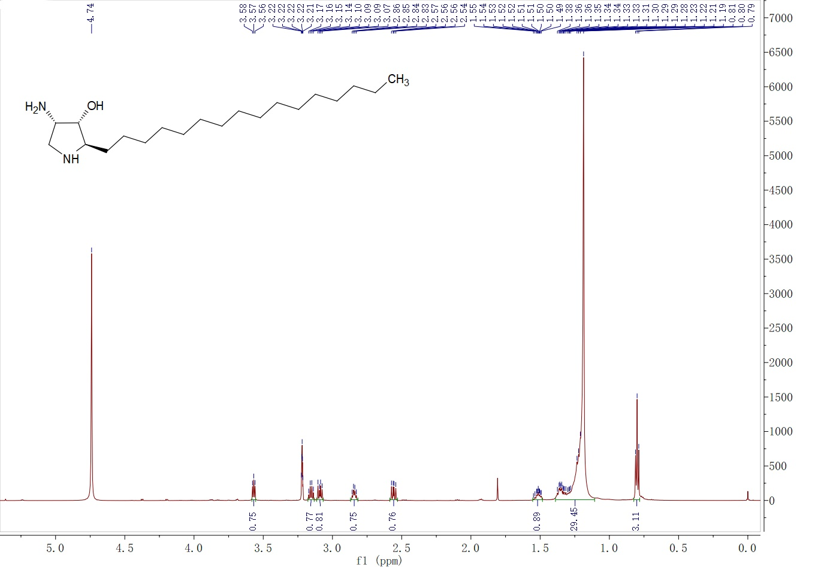

¹³C NMR spectra of compound YHR3 measured in CDCl₃ at 150 MHz
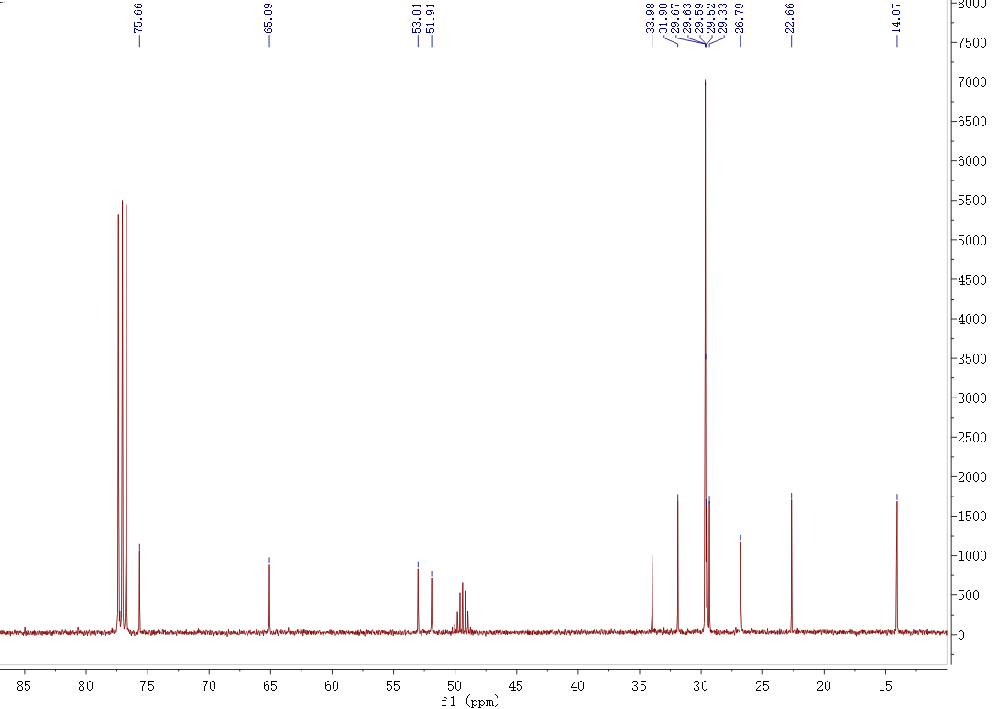

¹H NMR spectra of compound YHR4 measured in CDCl₃ at 400 MHz
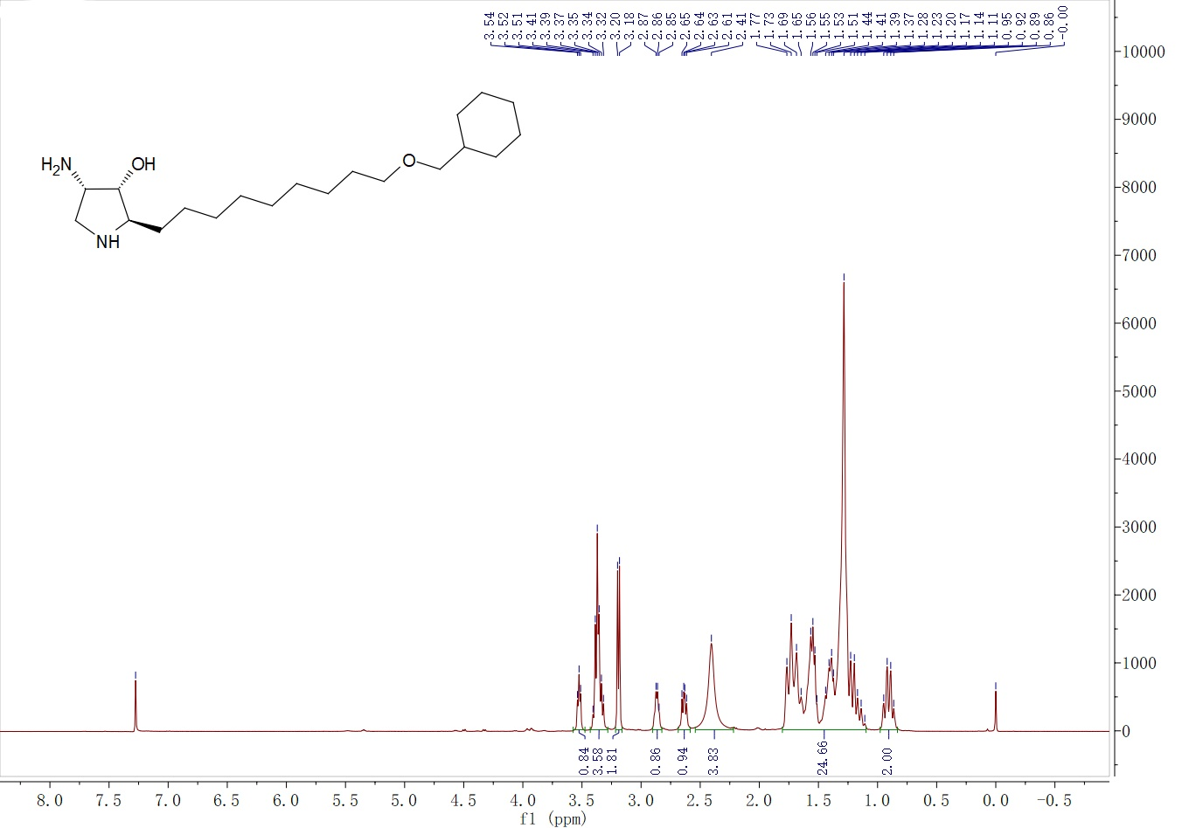

¹³C NMR spectra of compound YHR4 measured in CDCl₃ at 100 MHz
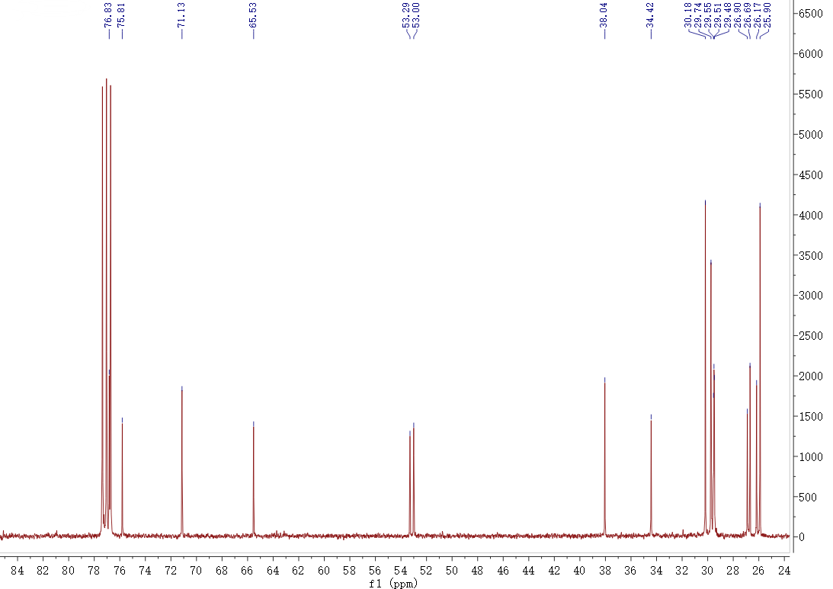

¹H NMR spectra of compound YHR5 measured in CD₃OD at 400 MHz
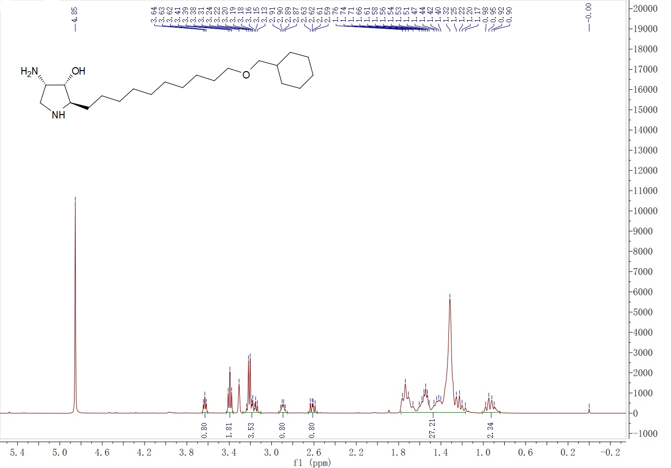

¹³C NMR spectra of compound YHR5 measured in CD₃OD at 100 MHz
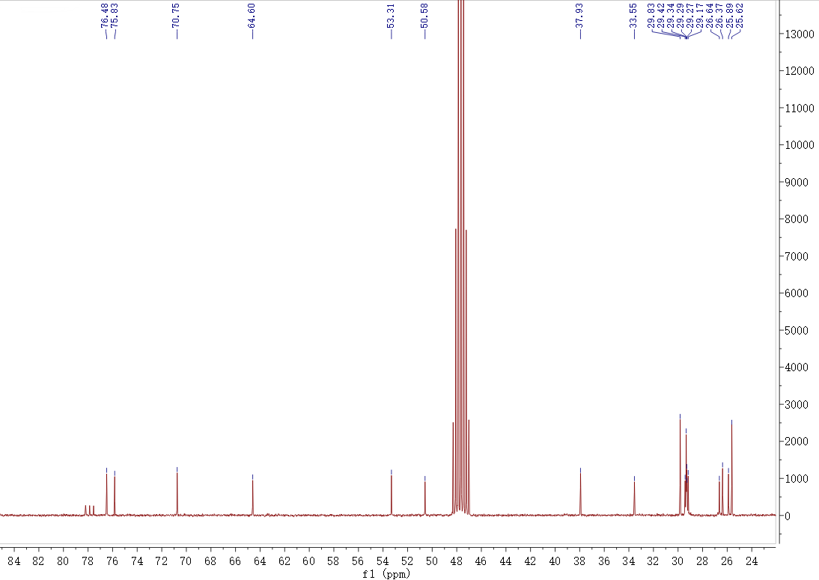

¹H NMR spectra of compound YHR6 measured in CDCl₃ at 400 MHz
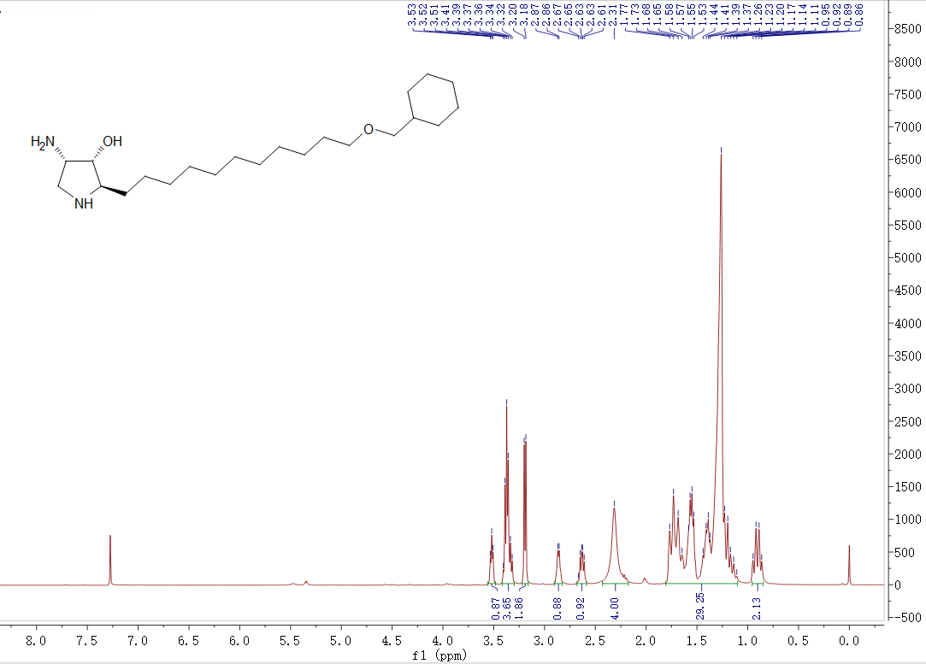

¹³C NMR spectra of compound YHR6 measured in CDCl₃ at 100 MHz
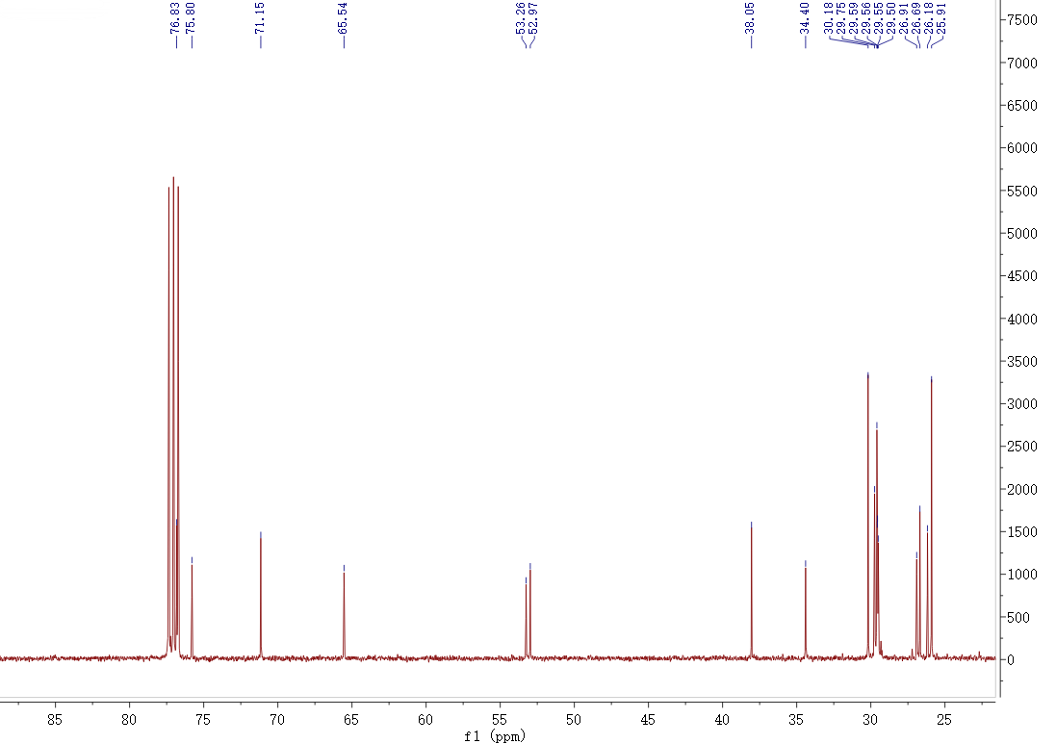

¹H NMR spectra of compound YHR7 measured in CD₃OD at 600 MHz
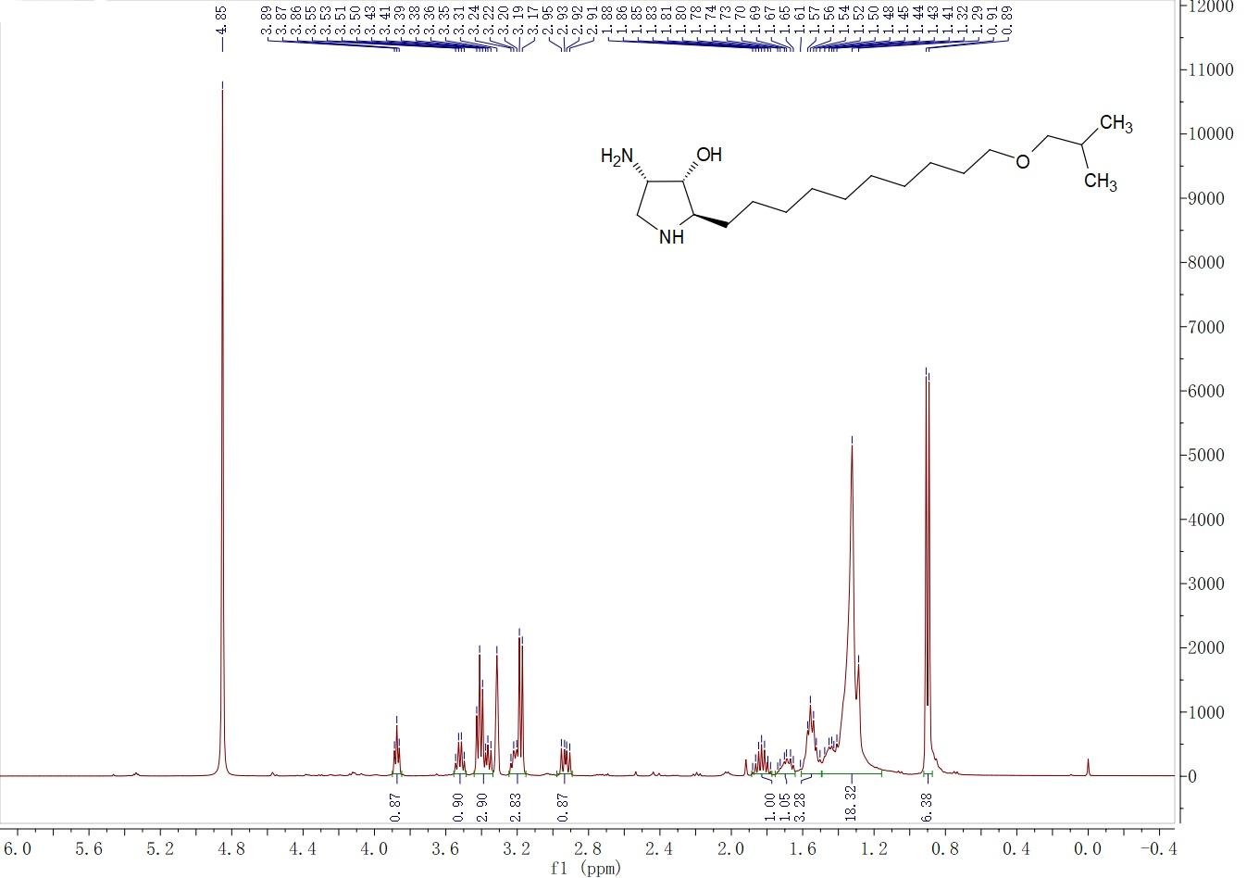

¹³C NMR spectra of compound YHR7 measured in CD₃OD at 150 MHz
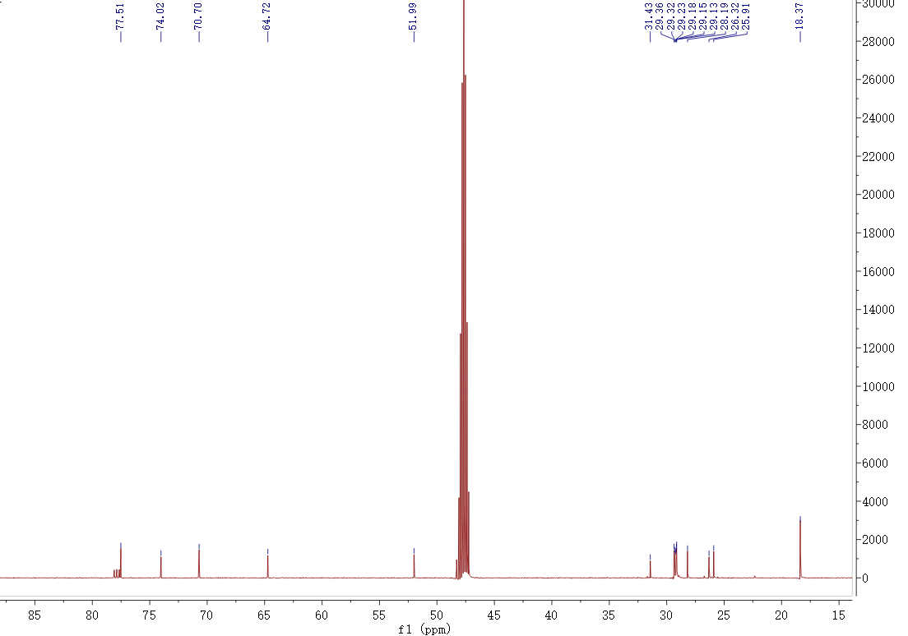

¹H NMR spectra of compound YHR8 measured in CDCl₃ at 400 MHz
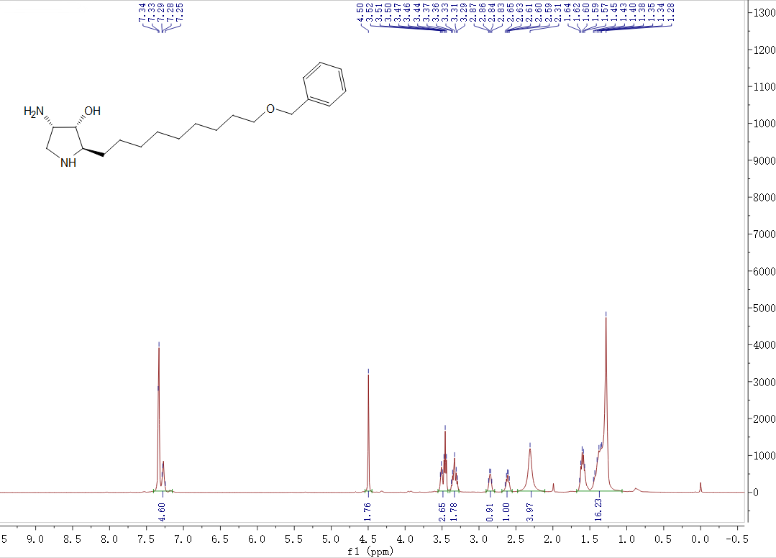

¹³C NMR spectra of compound YHR8 measured in CDCl₃ at 100 MHz
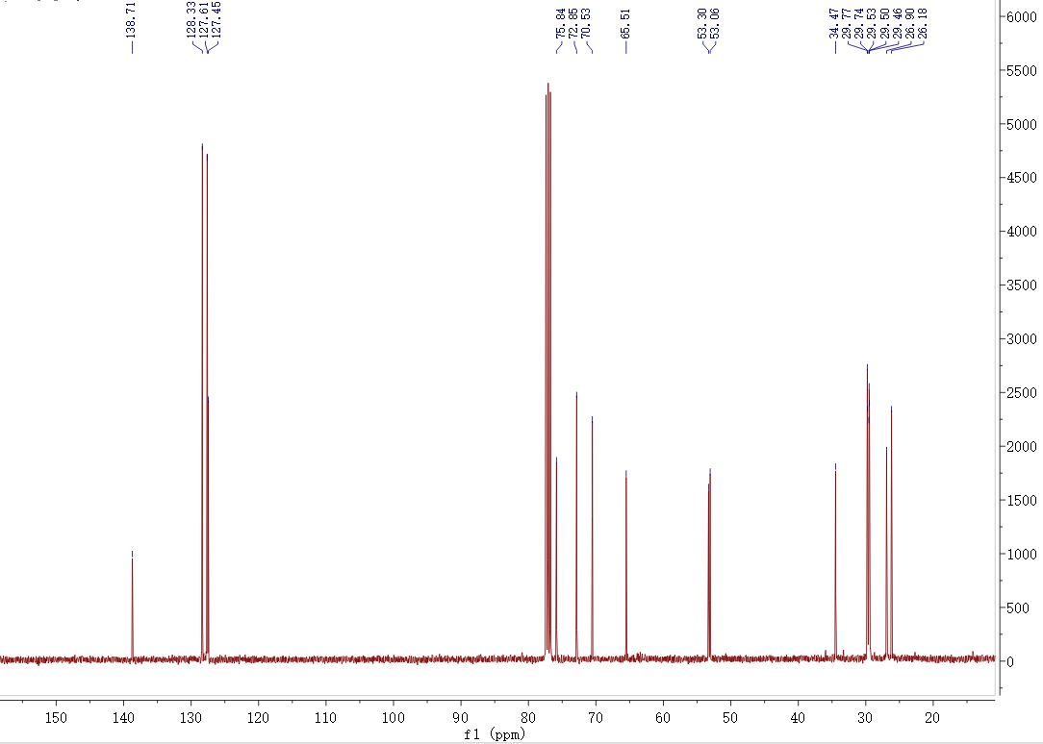

¹H NMR spectra of compound YHR9 measured in CD₃OD at 400 MHz
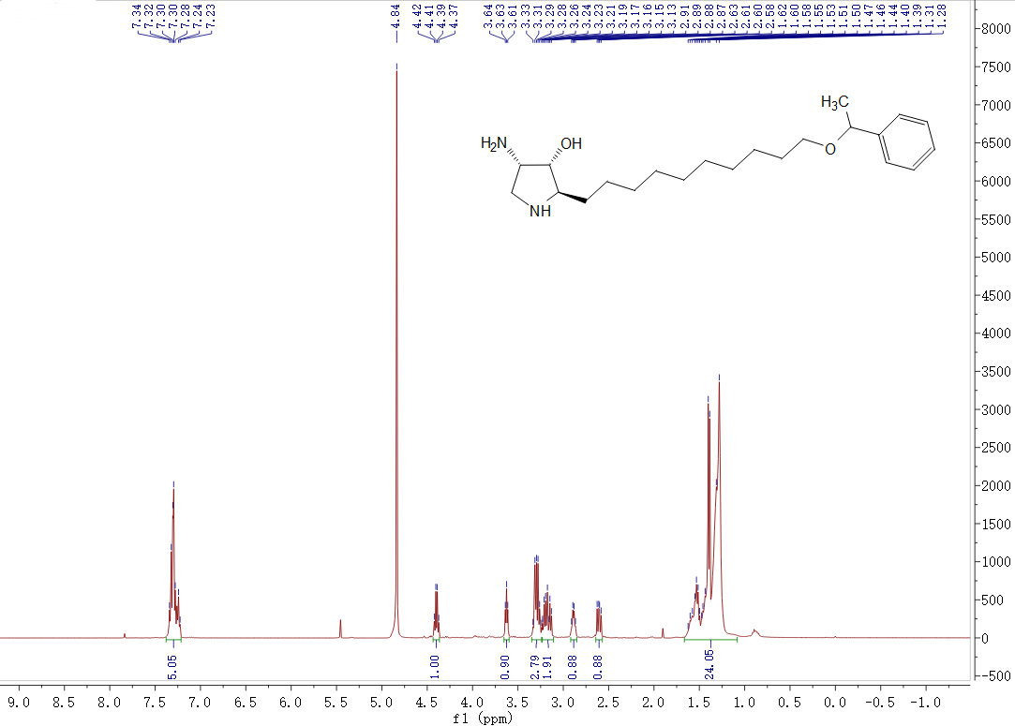

¹³C NMR spectra of compound YHR9 measured in CD₃OD at 100 MHz
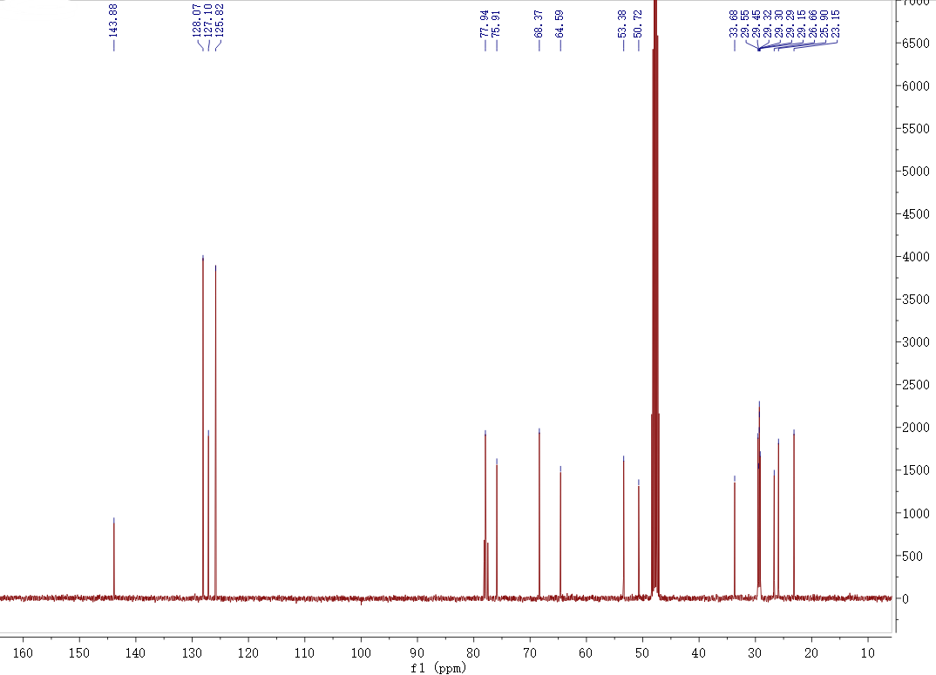

¹H NMR spectra of compound YHR10 measured in CDCl₃ at 400 MHz
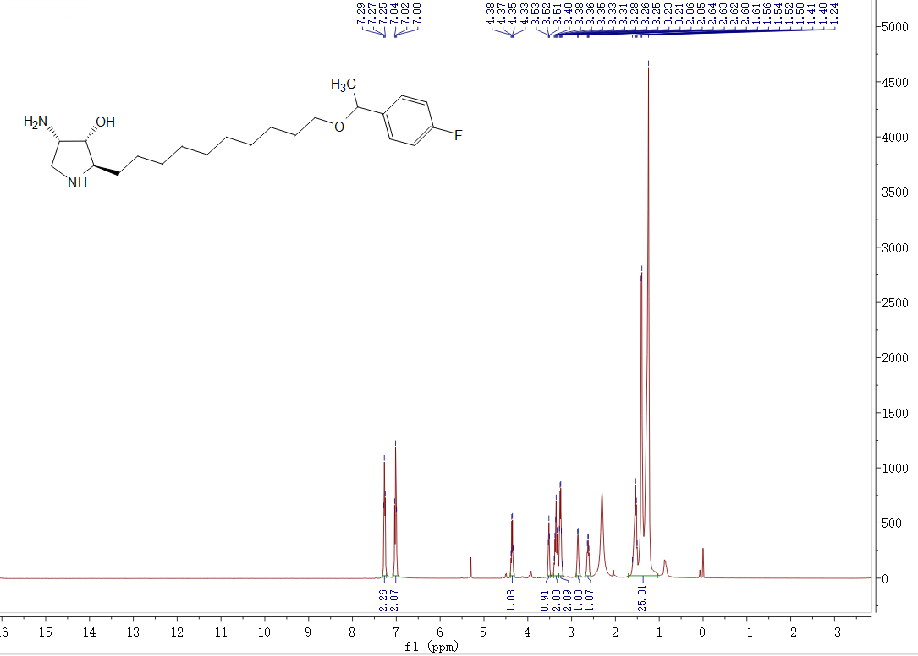

¹³C NMR spectra of compound YHR10 measured in CDCl₃ at 100 MHz
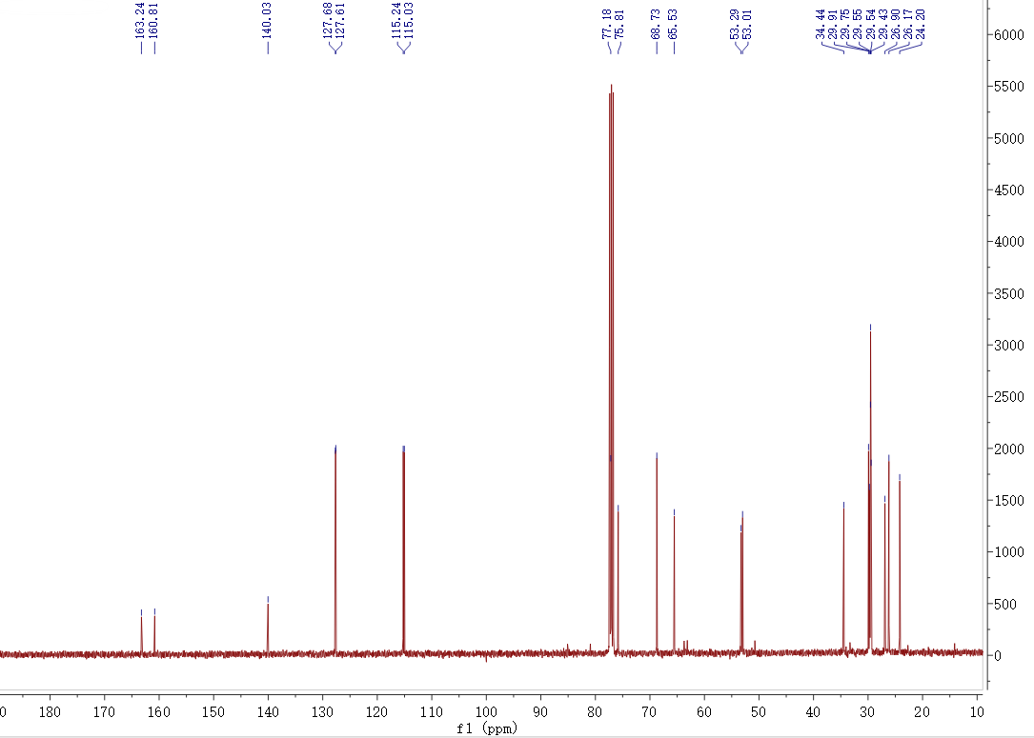

¹H NMR spectra of compound YHR11 measured in CD₃OD at 400 MHz
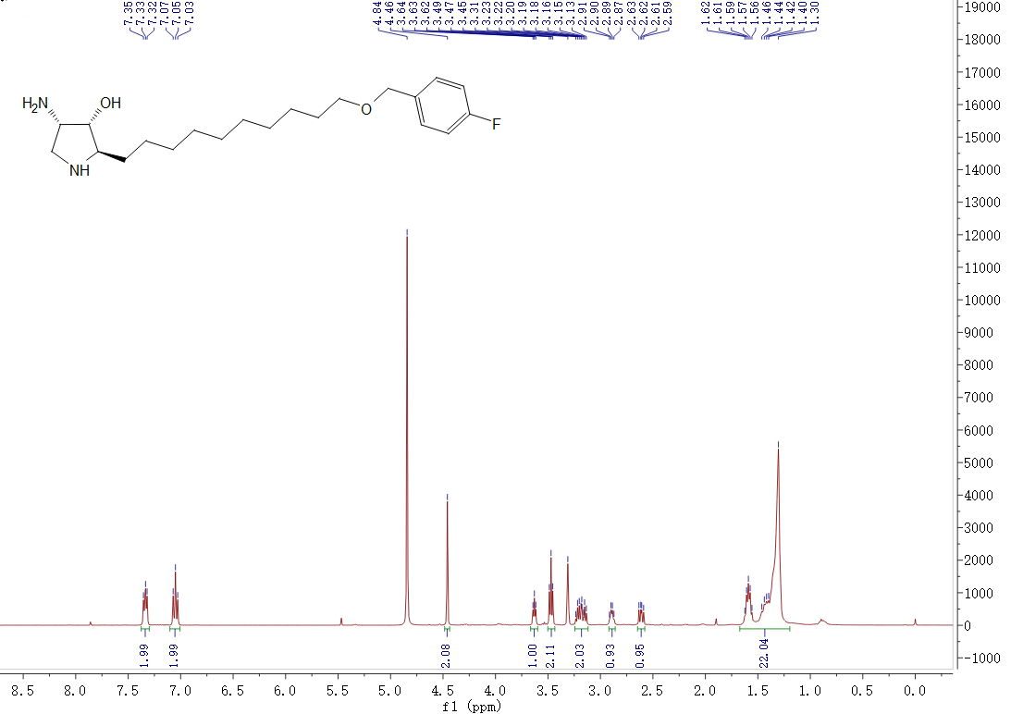

¹³C NMR spectra of compound YHR11 measured in CD₃OD at 100 MHz
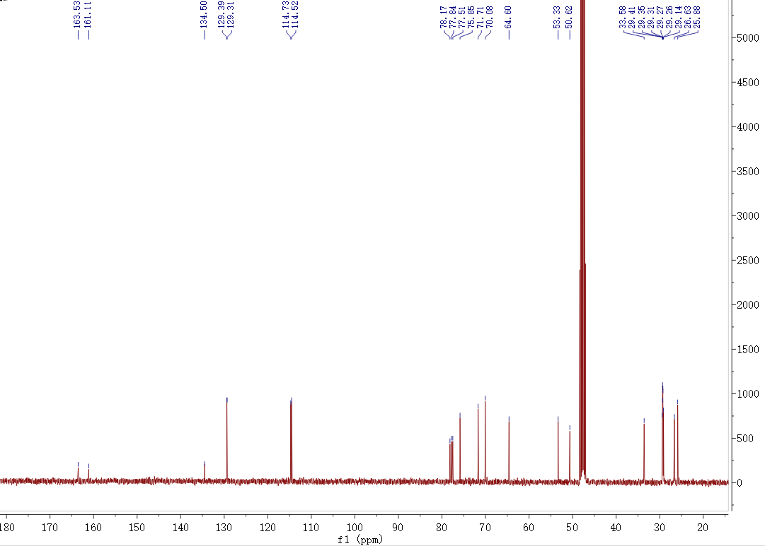

¹H NMR spectra of compound YHR12 measured in CD₃OD at 600 MHz
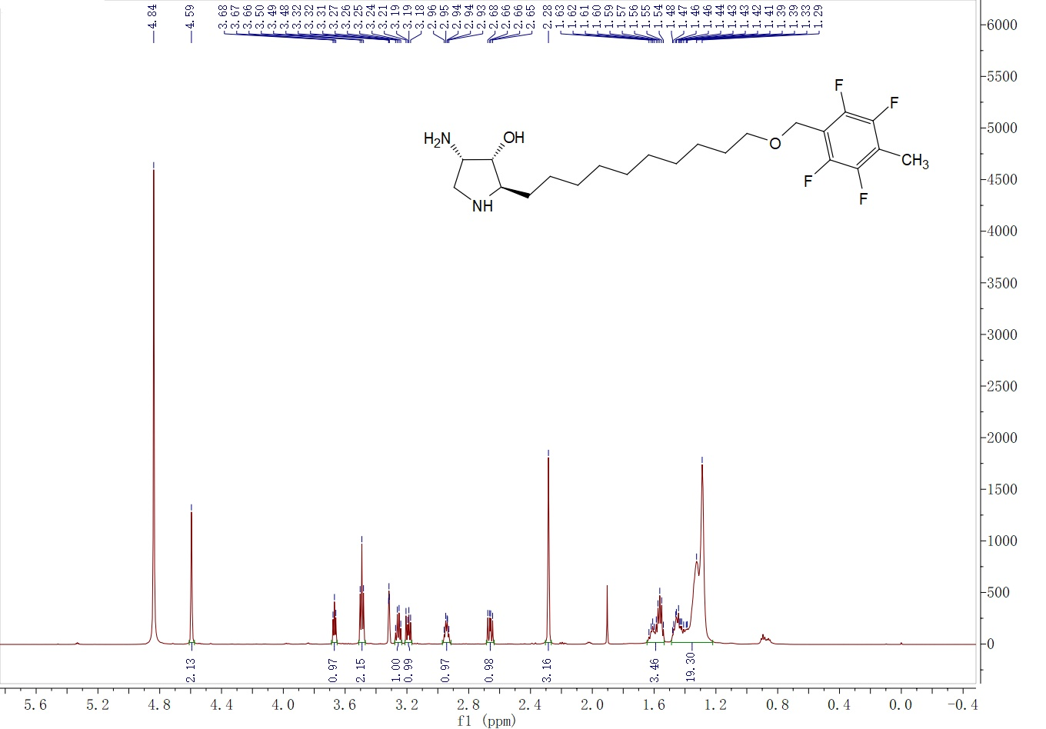

¹³C NMR spectra of compound YHR12 measured in CDCl₃ at 100 MHz
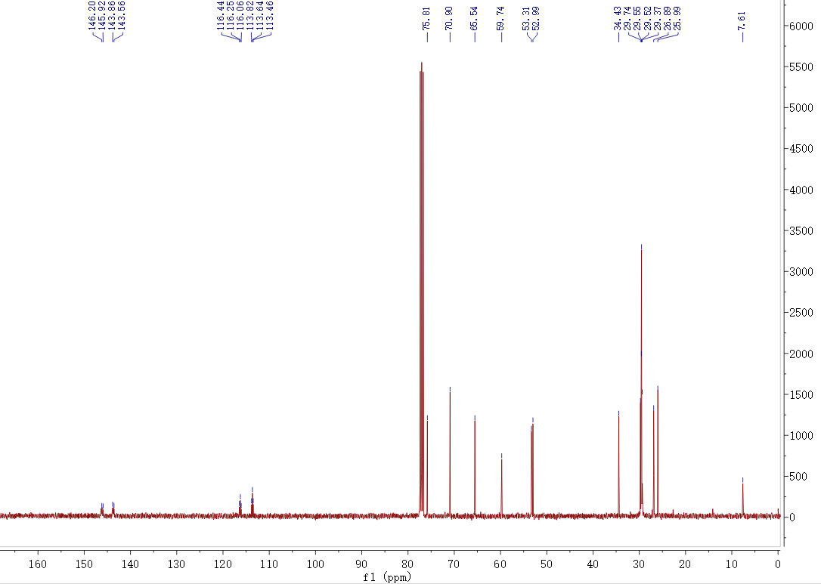

¹H NMR spectra of compound YHR13 measured in CDCl₃ at 400 MHz
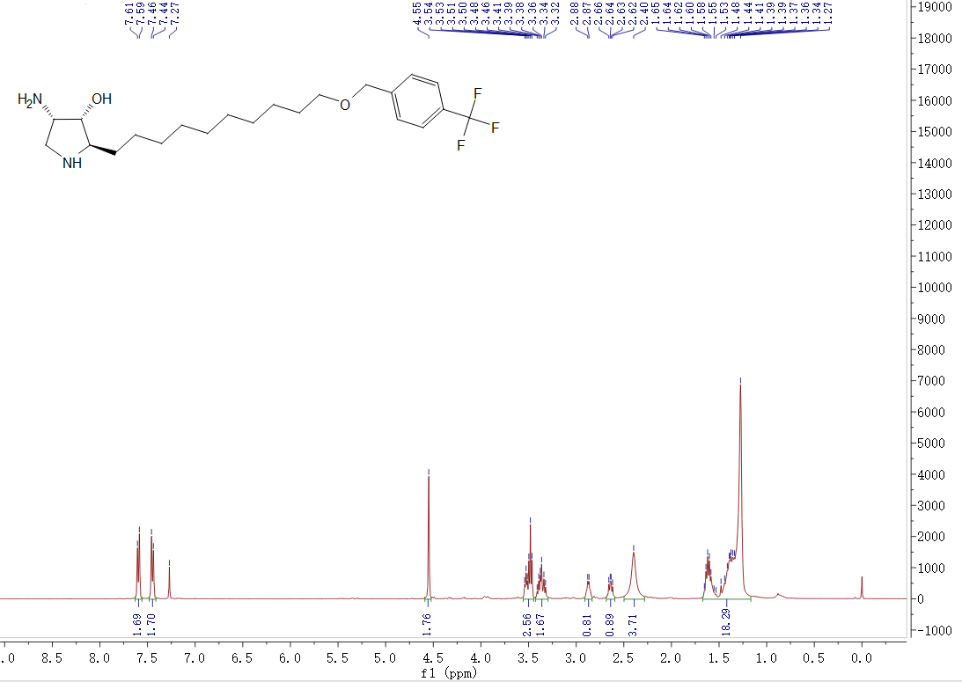

¹³C NMR spectra of compound YHR13 measured in CDCl₃ at 100 MHz
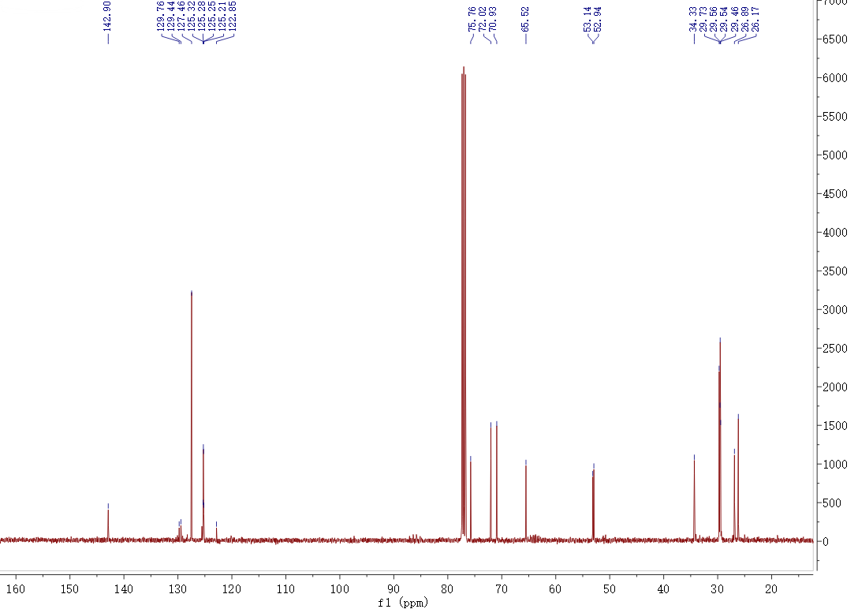

¹H NMR spectra of compound YHR14 measured in CD₃OD at 600 MHz
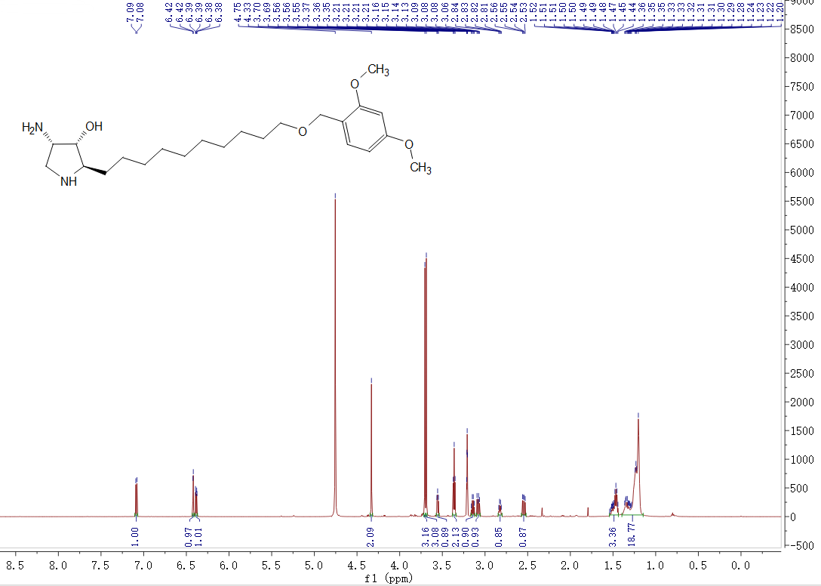

¹³C NMR spectra of compound YHR14 measured in CD₃OD at 150 MHz
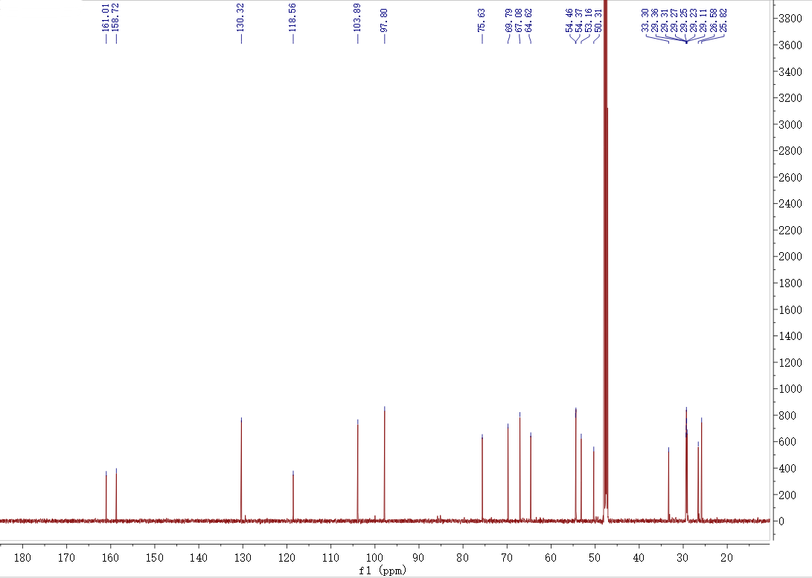

¹H NMR spectra of compound YHR15 measured in CD₃OD at 600 MHz
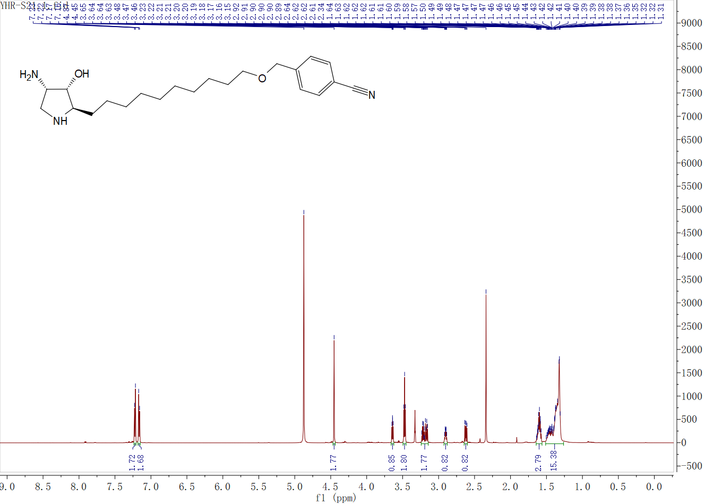

¹³C NMR spectra of compound YHR15 measured in CD₃OD at 150 MHz
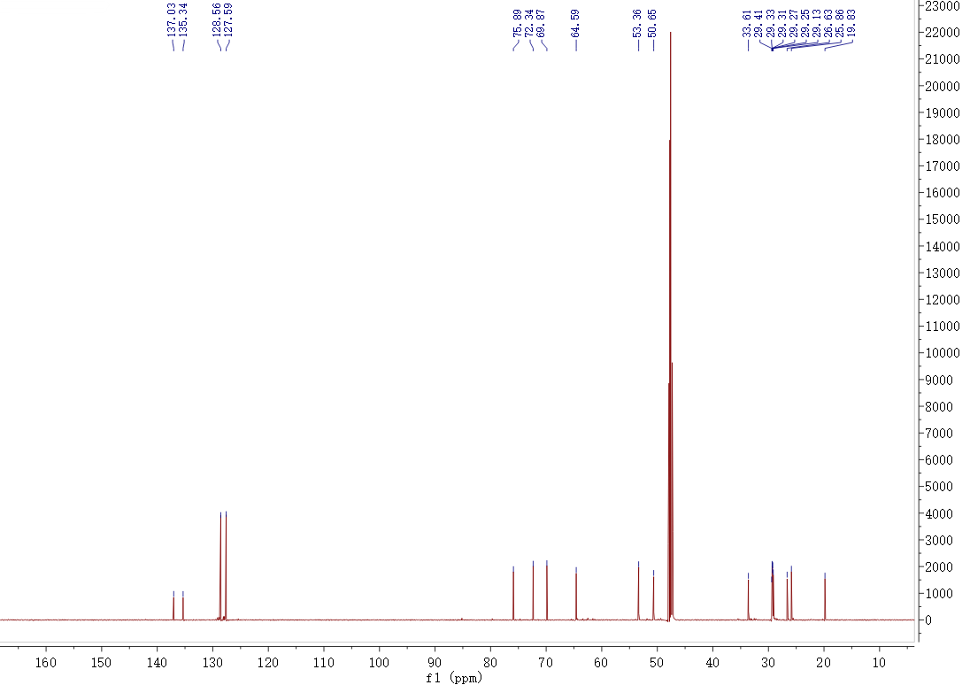

¹H NMR spectra of compound YHR16 measured in CDCl₃ at 400 MHz
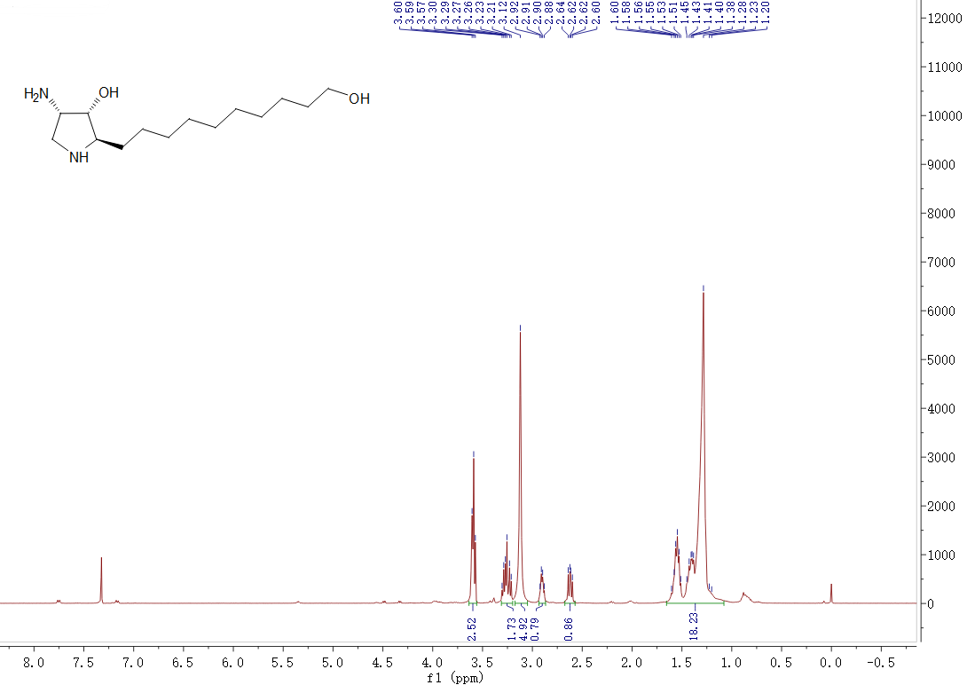

¹³C NMR spectra of compound YHR16 measured in CDCl₃ at 100 MHz
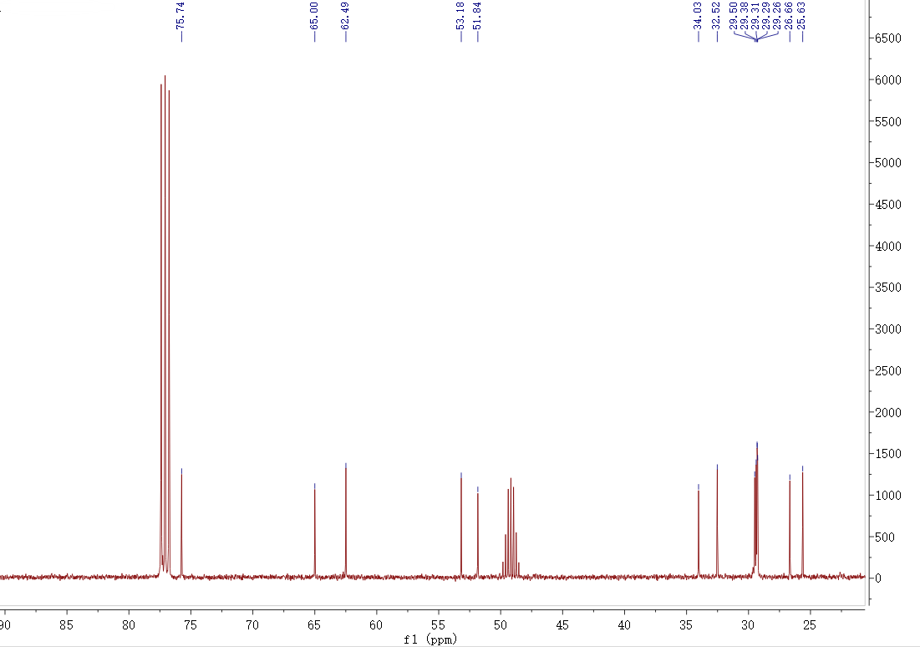

¹H NMR spectra of compound YHR17 measured in CD₃OD at 600 MHz
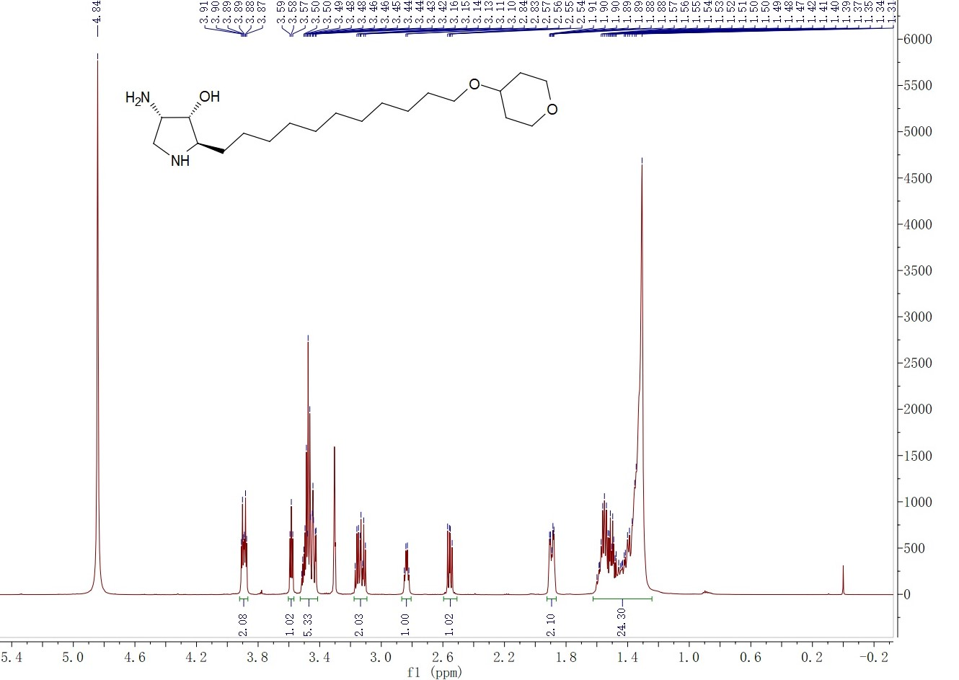

¹³C NMR spectra of compound YHR17 measured in CD₃OD at 150 MHz

