Microchemical Journal
A rapid LC-MS/MS method for lutein quantification in spinach (Spinacia oleracea)
Masashi Miura; Miho Sakai; Mamiko Nogami; Miwa Sato; Takeshi Yatsushiro

Appendix A. Supplementary data
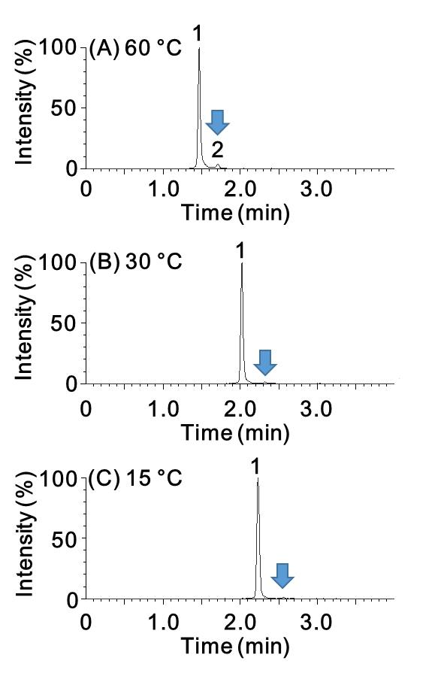
Fig. A.1. MS/MS chromatograms of standard lutein (0.4 mg/L) at different column temperature settings: (A) 60 °C, (B) 30°C, and (C) 15°C. All-trans lutein (1) and an unknown compound (putative geometrical isomer of lutein) (2) are shown. Arrows indicate the position of the column temperature-dependent unknown peak.

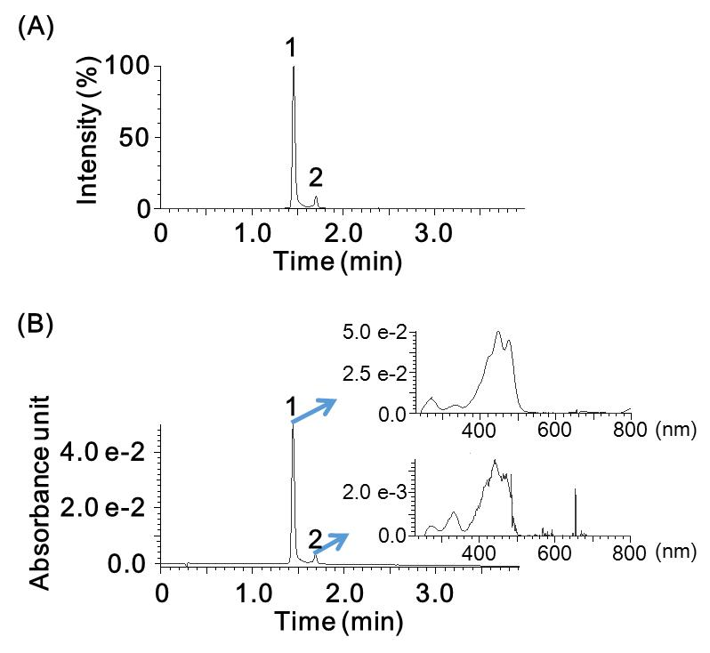
Fig. A.2. Chromatograms of standard lutein (5 mg/L) at a column temperature at 60 °C. The MS/MS chromatogram (A) and UV chromatogram (B) of all-trans lutein (1) and an unknown compound (putative geometrical isomer of lutein) (2) are shown, respectively. Arrows indicate each absorbance spectrum of the corresponding peaks in the range from 250 to 800 nm, respectively.

Table A.1. Precursor and product ion m/z-values for MS/MS analysis used in the study
Analyte | Precursor ion (m/z) | Product ion (m/z) | Description
Lutein | 551.468 | 105.023 | [M-H₂O+H]⁺, quantitative ion
Lutein | 568.468 | 105.023 | [M+], confirmation ion

Table A.2. Comparison of quantitative data obtained from MS/MS detection and in-line UV detection (n = 5)
Analyte | Detection technique | Mean (mg 100 g⁻¹) | RSD (%) | p valueª
Lutein (sample #1) | MS/MS | 8.98 | 5.07 | 0.52
 | UV | 8.75 | 8.68
ªStudent’s t-test between MS/MS detection and UV detection

able A.3. Instruments and gradients used for the inter-laboratory study
Lab no. | LC | MS/MS | Column | ªGradient conditions
1 | UltiMate3000 (Thermo Fisher Scientific) | Triple Quad™5500 (SCIEX) | ACQUITY UPLC RBEH C8 (Waters) | 2 solvents
2 | Acquity UPLC H-Class (Waters) | Xevo TQ-S micro (Waters) | ACQUITY UPLC RBEH C8 (Waters) | 3 solvents
3 | Acquity UPLC H-Class (Waters) | Xevo TQ-S micro (Waters) | ACQUITY UPLC RBEH C8 (Waters) | 3 solvents
4 | Acquity UPLC H-Class (Waters) | Xevo TQ-S micro (Waters) | ACQUITY UPLC RBEH C8 (Waters) | 3 solvents
5 | Acquity UPLC H-Class (Waters) | Xevo TQ-S micro (Waters) | ACQUITY UPLC RBEH C8 (Waters) | 3 solvents
ªFor 2 solvents, mobile phase A consisted of 0.1% formic acid in water, and mobile phase B consisted of acetonitrile/2-propanol (6:1); for 3 solvents, mobile phase A consisted of 0.1% formic acid in water, mobile phase B consisted of acetonitrile, and mobile phase C consisted of 2-propanol.
Separation and elution conditions were described in Materials and Methods.

Table A.4. Calibration curves and regression coefficients used for the inter-laboratory study
Lab no. | ªRetention time | ^{b}Range (mg L⁻¹) | Calibration curve | Regression coefficient (r²)
1 | 2.72 | 0.0125–0.4 | y = 1322101.1x² + 532281.15x – 5072.3667 | 0.9999
2 | 2.02 | 0.0125–0.4 | y = 17162x – 252.19 | 0.9994
3 | 2.09 | 0.0125–0.4 | y = 22559x – 51.06 | 0.9996
4 | 1.97 | 0.0125–0.4 | y = 32306x – 218.81 | 0.9994
5 | 1.98 | 0.0125–0.4 | y = 28288x –199.69 | 0.9988
ªmeans of 6 points in the calibration curve. ^{b}6 points in the calibration curve: 0.0125, 0.025, 0.05, 0.1, 0.2, and 0.4 (mg L⁻¹).

Table A.5. Precursor and product ion m/z values of lutein used in the inter-laboratory study
Lab no. | Precursor ion (m/z) | Product ion (m/z) | Descriptions
1 | 551.425 | 105.070 | [M-H₂O+H]⁺, quantitative ion
 | 551.425 | 91.055 | [M-H₂O+H]⁺, confirmation ion
 | 551.425 | 119.086 | [M-H₂O+H]⁺, confirmation ion
2 | 551.4 | 105.0 | [M-H₂O+H]⁺, quantitative ion
 | 568.4 | 105.0 | [M+], confirmation ion
3 | 551.400 | 104.800 | [M-H₂O+H]⁺, quantitative ion
4 | 551.468 | 105.023 | [M-H₂O+H]⁺, quantitative ion
 | 568.468 | 105.023 | [M+], confirmation ion
5 | 551.468 | 105.023 | [M-H₂O+H]⁺, quantitative ion
 | 568.468 | 105.023 | [M+], confirmation ion

