Folic Acid and Rhodamine Labelled pH Responsive Hyperbranched Polymers: synthesis, characterization and cell uptake studies
Chester Blackburn¹, Hongyun Tai^{1*}, Martina Salerno², Xi Wang³, Edgar Hartsuiker² and Wenxin Wang*³
¹ Chemistry Division, School of Natural Sciences, Bangor University, Deiniol Road, Bangor, Gwynedd LL57 2UW, UK
² NWCR Institute, School of Medical Sciences, Bangor University, Deiniol Road, Bangor, Gwynedd LL57 2UW, UK
³ Charles Institute of Dermatology, School of Medicine, University College Dublin, Dublin 4, Ireland.

* Correspondence: h.tai@bangor.ac.uk; wenxin.wang@ucd.ie

Supplementary TOC

Figure S1: ¹H NMR of synthesized HBP5050………………………………………………………………2

Figure S2: ¹H NMR of synthesized HBP4060………………………………………………………………3

Figure S3: ¹H NMR of synthesized HBP3070………………………………………………………………3

Figure S4: PCS peak output as a function of intensity for HBP4060 in differing pH media …………..4

Figure S5: PCS output for HBP4060_{pegf} as a function of intensity …………………………………….…...5

Figure S6: SEC Traces for HBPs HBP3070 (Green) HBP4060 (Blue) HBP5050 (Red) ……….....6

Figure S7: UV-VIS Spectra for HBP and HBP folate conjugates with RAFT agent peak identification..6

Figure S8: ¹H NMR of synthesized HBP4060_{pegf} …………...……………………………………………….7

Table S1: Summarization of Figure S4 …………………………………………………………………........4

Table S2: Summarization of figure S5 ………………………………………………………………….........5

E1: Experimental procedures ………………….. …………………………………………………………… 8

Scheme 1: Synthesis of 2-propyl acrylic acid .............................................................................…...8

Scheme 2: Synthesis of DSDA……………………………………………………………………………9

Scheme 3: Synthesis of PEGPHT …..…………………………………………………………………..9

Scheme 4: Synthesis of PEG diamine …………………………………………………………………10

Scheme 5: Mono BOC protection of diamines .……………………………………………………....10

Scheme 6: Synthesis of BOC-PEG-Folate …………………………………………………………… 11

Scheme 7: BOC deprotection to isolate NH₂-PEG-Folate ….……………………………………… 11

Scheme 8: Synthesis of Rhodamine B ethylene diamine ..………………………………………… 12

Figure S1: ¹H NMR of synthesised HBP5050

Figure S2: ¹HNMR of synthesized HBP4060
Figure S3: ¹HNMR of synthesized HBP3070

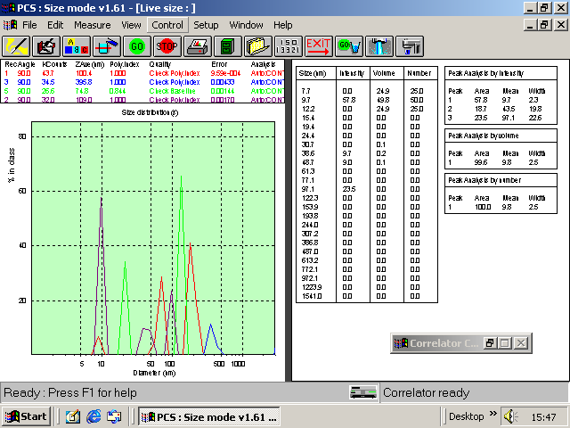
Figure S4: PCS peak output as a function of intensity for HBP4060 in differing pH media

Peak | pH | Particle size (mean)
Purple | Dulbecco PBS | 109.0nm
Red | 7.4 | 100.4nm
Green | 6.8 | 74.8nm
Blue | 5.4 | 396.5nm
Table S1: Summarization of Figure S4

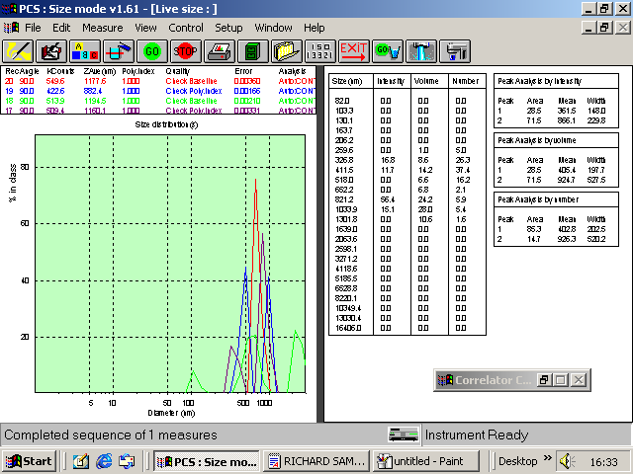
Figure S5: PCS output for HBP4060_{pegf} as a function of intensity

Peak | pH | Particle size (mean)
Red | Dulbecco PBS | 1177.6nm
Blue | 7.4 | 882.4nm
Green | 6.8 | 1194.5nm
Purple | 5.4 | 1160.1nm
Table S2: Summarization of figure S5

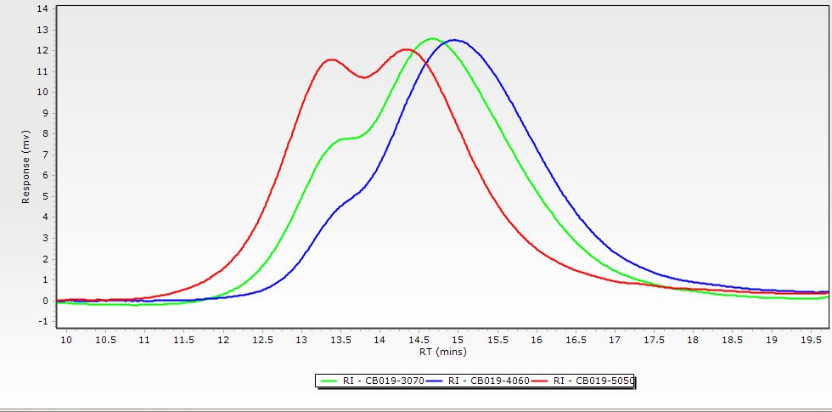
Figure S6: SEC Traces for HBPs HBP3070 (Green) HBP4060 (Blue) HBP5050 (Red)

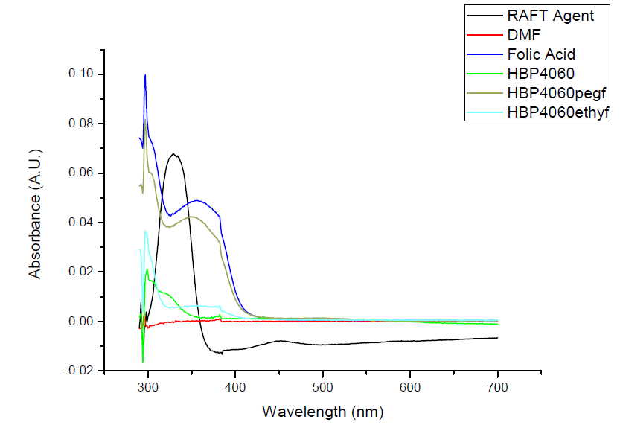
Figure S7: UV-VIS Spectra for HBP and HBP folate conjugates with RAFT agent peak identification

Figure S8: ¹H NMR of synthesized HBP4060_{pegf}

E1 Experimental procedures

E1.1: Synthesis of monomer 2-Propyl acrylic acid (PAA)
Diethylpropylmalonate (1) (50 g 0.24 mol) was added to round bottom flask alongside 300 ml 1 M KOH solution (IMS) and left to stir at room temperature overnight. The solid precipitate was filtered and placed into a 1 L conical flask. The solution was then concentrated in vaccuo and the resultant oil was added to the solid. The contents of the conical flask was then dissolved in minimal volume of de-ionized water and acidified to pH 2 with dilute HCl, at this point an oil was separated from the aqueous solution. The oil was taken up into ether and the aqueous layer was extracted thrice with 200 ml diethyl ether. The organic phase was then dried with magnesium sulfate, filtered and concentrated to quantitatively yield 2-(ethoxycarbonyl)pentanoic acid (2) ( 42 g 0.24 mol) FTIR (neat cm⁻¹) 3500-3000, 1710. The synthesized 2-(ethoxycarbonyl) pentanoic acid (42 g 0.24 mol) was placed into a round bottom flask equipped with a reflux condenser and cooled in an ice bath before addition of diethyl amine (12.5 ml 0.24 mol). An addition funnel is equipped to the reflux condenser and charged with formalin solution (37% formaldehyde in water) (0.24 mol 19.3 g) the contents of the addition funnel were then added dropwise to the cooled reaction vessel and then allowed to warm to room temperature and allowed to stir for 24hrs. The reaction mixture was then heated to 60°C and allowed to stir for a further 8hrs. The reaction now consisted of two distinct layers. The mixture was again cooled with an ice bath and concentrated sulfuric acid was added until the evolution of gas was no longer present and the mixture was extracted thrice with 200 ml of diethyl ether. The organic extracts were combined and dried with magnesium sulfate, filtered and concentrated in vaccuo to yield crude ethyl 2-methylenepentanoate (3) (91% yield). Finally, crude ethyl 2-methylenepenatanoate (0.22 mol) was added to a round bottom flask equipped with a reflux condenser alongside 400 ml of 1 M KOH (aq) and was heated to reflux for 20hrs. The solution was then allowed to cool to room temperature and was acidified to pH 2 with dilute HCl. An oil then separated from the solution. Extraction was performed 4 times with 200 ml of diethyl ether and the organics were dried with magnesium sulfate filtered and concentrated to obtain as an oil 2-propyl acrylic acid (4) (0.178mol 20g 81% yield 74% overall). ¹H NMR (400 MHz CDCl₃ δ) 11.67 (s, 1H COOH) 6.23 (s, 1H vinyl H) 5.58 (s, 1H vinyl H) 2.21 (t, 2H, CH₂-CH₂) 1.51-1.39 (m, 2H CH₃-CH₂) 0.87 (t, 3H, CH₂-CH₃)
Scheme 1 Synthesis of 2-Propyl Acrylic Acid

E1.2: Synthesis of Disulfanediylbis(ethane-2,1-diyl) diacrylate (DSDA)
2-2’-disulfanediylbis(ethan-1-ol) (5) (9.8 ml 0.08 mol) was dissolved in 200ml chloroform and placed into a 2-neck round bottom flask submerged into an ice bath whilst also being bubbled with nitrogen. Trimethylamine (44.5 ml 0.32 mol) was added to the reaction flask and the mixture was left to stir for 20 mins. Whilst still cool and bubbling acryloyl chloride (25.8 ml 0.32 mol) was added dropwise for 30 mins. The flask was then sealed with a nitrogen balloon and the nitrogen pipe was removed. The mixture was then left to stir for 36 hrs at room temperature. The solution was then filtered to remove solid precipitate and washed twice with 150 ml of de-ionized water and 150 ml of 0.1 M Na₂CO₃ (aq) solution six times before two final washes with NaCl brine. The organics were then dried with magnesium sulfate, filtered and concentrated to yield a brown oil of crude DSDA (6). Purification was afforded via column chromatography. The crude oil was passed through an aluminum oxide column washed with dichloromethane and the product fractions were concentrated to yield a dark brown oil of DSDA (Yield 45%). ¹H NMR (400 MHz CDCl₃) 6.54-6.27 (m, 2H 2x vinyl H) 6.18-5.95 (m, 2H 2x vinyl H) 5.79 (m, 2H 2x vinyl H) 4.45-4.28 (t, 4H 2x CH₂-O) 2.29 (t, 4H 2x S-CH₂)

Scheme 2 Synthesis of DSDA

E1.3: Synthesis of PEG₈ Diamine Linker
10 g of PEG (7) (M_{w} 400) (25 mmol PEG 50 mmol OH groups) was dissolved in 150 ml of 1, 4- Dioxane (anhydrous) and purged with argon for 20 minutes. Separately, a solution of Diisopropyl azodicarboxylate (DIAD) (17.7 g 87.5 mmol 1.75 eq) in 10 ml 1,4-dioxane (anhydrous) was added dropwise under argon to an ice cooled solution of PPh₃ (22.95 g 87.5 mmol 1.75 eq) under a continuous stirring of the solution for a further 30 mins. PEG solution was then transferred under argon by use of a double-ended needle and the solution was allowed to stir for a further 30 mins at ambient temperature. As a powder, phthalimide was added (12.9 g 87.5 mmol 1.75 eq) and the resultant mixture was allowed to stir at ambient temperature for a further 1 hr. afterwards, the mixture was heated to 50°C and allowed to react overnight. Extraction of the desired compound was afforded by firstly removing 1, 4-dioxane in vaccuo and suspending the orange oil in 200 ml of water, washed with 50 ml ethyl acetate (x2) diethyl ether (x1) and IMS was used to break down emulsions that had formed (ca.2 ml). Extraction of the desired compound was then performed upon the aqueous layer via 75 ml DCM (x3). DCM was then dried over magnesium sulfate for 1 hr, filtered and volatiles were removed in vaccuo. Precipitation of the product was then performed in ice cold diethyl ether to produce a slightly yellow oil of PEGdiPHT(8) (12.34 g, 18 mmol, 75% yield). ¹H NMR (400 MHz CDCl₃ δ), 7.8-7.52 (m, 4H aromatic H on phthalimide), 3.91 (t, 4H CH₂-CH₂-Phthalimide), 3.75 (t, 4H –CH₂-CH₂-Phthalimide), 3.7-3.51 (m, -[CH₂]₂-O).

Scheme 3 Synthesis of PEGPHT
PEGdiPHT (8) (12.34 g 18 mmol of PEG 36 mmol of PHT) was dissolved in 125 ml of absolute ethanol in a round bottom flask. To the flask 10 equivalents of hydrazine hydrate (35%) was added and the mixture was left to reflux for 6 hrs, the mixture was then allowed to cool and filtered to remove the white precipitate that had formed. The solution was then concentrated in vaccuo and dissolved in 150 ml of DCM, filtered again and extracted with 2 ml 1 M NaOH (aq). The aqueous layer was then back extracted with 25 ml DCM and the combined organics were dried over magnesium sulfate and concentrated in vacuo. The resultant brown oil yielded PEG diamine (9), this was stored in the fridge and any free phthalamide was allowed to crystallize before being filtered, and a further precipitation into ice cold diethyl ether. (33% yield). ¹H NMR (400 MHz CDCl₃ δ) 3.63-3.57 (m, - [CH₂]₂-O), 3.48 (t, 4H –CH₂-CH₂-NH₂), 2.82 (t, 4H –CH₂-CH₂-NH₂).

Scheme 4 Synthesis of PEG diamine

E1.4: Mono Boc protection of Diamine derivatives
For the Boc protection of ethylene diamine (10) 0.5 eq. of BOC anhydride was dissolved in 100 ml chloroform and added dropwise to an ice-cold solution of ethylene diamine over a period of 3 hrs. The mixture was stirred overnight and washed 8 times with 150 ml of distilled water. The organic phase was then dried with magnesium sulfate, filtered and dried via rotary evaporator, and a clear slightly yellow oil was obtained.(11) ¹H NMR (400 MHz CDCl₃ δ), 5.21 (s, 1H CH₂-NH), 3.1 (s, 2H CH₂-NH), 2.74 (s, 2H H₂N-CH₂), 1.36 (m, 9H BOC methyl groups), 1.12 (s, H₂N-CH₂For the Boc protection of PEG₈ Diamine , BOC anhydride (110 mg, 0.5 mmol) was dissolved in 10 ml chloroform and the mixture was added dropwise to an ice-cold solution of PEG diamine (500 mg, 1.25 mmol) over a period of 2 hrs. The mixture was stirred overnight and washed 5 times with 100 ml distilled water. The organic phase was dried under magnesium sulfate, filtered and concentrated before ppt in cold diethyl ether to yield a brown oil 250 mg (12) (80% yield). ¹H NMR (400 MHz CDCl₃ δ), 3.58 (s, -[CH₂]₂-O), 3.46 (t, 4H –CH₂-CH₂-NH₂), 2.80 (t, 4H –CH₂-CH₂-NH₂), 1.37 (s, 9H BOC methyl groups).

Scheme 5 Mono Boc protection of diamines

E1.5: Synthesis of BOC-PEG-Folate
Folic acid (13) (264 mg, 0.6 mmol) was dissolved in 10 ml DMF alongside N-hydroxysuccinimide (115 mg, 1 mmol) and dicyclohexylurea (206 mg, 1 mmol) and left to stir at ambient temperature in the dark for 2 hrs. After this time, BOC-PEG₈-NH2 (200 mg 0.3 mmol) was dissolved in 1 ml of DMF and added into the reaction mixture and left to stir overnight in the dark. The mixture was then filtered, water (2 ml) was added and the product was freeze dried to remove DMF to yield 250 mg (yield 87%) crude material (14) as a brown/orange powder that was used without further purification for the next step.
Scheme 6 Synthesis of BOC-PEG-FOLATE

E1.6: BOC deprotection of BOC-PEG-FOLATE
BOC-PEG-Folate (14) (250 mg, 0.26 mmol) was suspended in 2 ml of chloroform before the addition of tri-flouroacetic acid (20 µl, 0.32 mmol) into a 10 ml reaction vial and submerged in a sand bath protected from light and left to stir at 30°C for 3 hrs. Upon this time the suspension had formed a dark orange solution. Volatiles were removed via rotary evaporation to yield an orange powder of NH2-PEG-Folate (15) (217 mg, 0.25 mmol, 96% yield). ¹H NMR (400 MHz DMF-d7 δ ) 10.76 (s, 1H, α-COOH) 10.50 (s, 1H, NH; guanidine on folate) 8.82 (s, 1H, N=CH) 8.71 ( d, 1H, O=C-NH ; folate) 8.39 (s, ) 8.33 (d,) 7.85 (m, 2H, arH-C-C=O) 6.80 (dd, 2H, (NH-arH) 4.71-4.66 (t, 1H NH-CH) 4.66 (s, 2H, N=C-CH₂) 3.58 (s,-[CH₂]₂-O ), 3.48 (t, 4H –CH₂-CH₂-NH₂).

Scheme 7 BOC deprotection to isolate NH₂-PEG-Folate

E1.7: Synthesis of Rhodamine B ethylene diamine
Mono-boc protected ethylene diamine was synthesized using the same method described in E1.4 Rhodamine B (16) (887 mg, 2 mmol) was dissolved in 10 ml DMF alongside NHS (287 mg, 2.5 mmol) DCC (516 mg, 2.5 mmol) and mono-BOC protected ethylene diamine (11) (400 mg, 2.5 mmol) and left to react overnight at ambient temperature in the dark. Solids were filtered and the resultant solution was concentrated via rotary evaporation. The resultant oil was then dissolved in 3 ml of water and then freeze dried to yield a dark red solid which was used crude.(17) (700 mg,1.2 mmol 60% yield).
The resultant compound was taken and dissolved in 4 ml CH₂Cl₂ in a 10 ml reaction vial alongside TFA (400 µl) and submerged in a sand bath protected from light and heated to 30°C and stirred for 2 hrs. The solution was then concentrated via rotary evaporation to yield a dark red solid (18) (291 mg, 0.6 mmol yield 50%).

Scheme 8 Synthesis of Rhoadmine B ethylene diamine

E 1.8: Ninhydrin test for free amines
Polymer samples (HBP4060, HBP4060ethyf and HBP4060pegf) were dissolved in deionized water at a concentration of 4 mg/ml, whilst 2% Ninhydrin solution was dissolved in absolute ethanol. The polymer solution and Ninhydrin solutions were then taken 1ml of each and added into a vial to make a final polymer concentration of 2 mg/ml (2 ml final volume). Separately, the procedure was repeated with Glycine to produce a final concentration of 400 nmol/ml (2ml). The vials were then placed into a sand bath for 25 minutes at 100°C to allow for the reaction to commence. The vials were then taken from the bath and allowed to cool to room temperature. Purple staining is indicative of free primary amines present (i.e. incomplete conjugation). All HBPs did not stain (negative) whilst the glycine control for primary amine stained purple (positive). Further characterization was performed on a Perkin Elmer Lambda 35 UV/Vis Spectrophometer in 1 mm polystyrene cuvettes at 570 nm, however no absorbance was found from the HBP samples.

