Table 2: Information of molecular docking
No. | Proteins | PDB ID | Protein structure | Test compounds | Docking Score (pKd/pKi)
1 | EGFR | 3W2S | 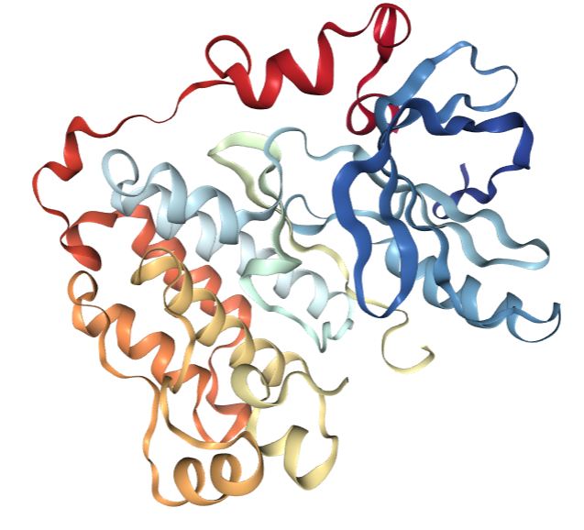 | quercetin | 6.829
 |  |  |  | luteolin | 6.013
2 | IL1B | 2NVH | 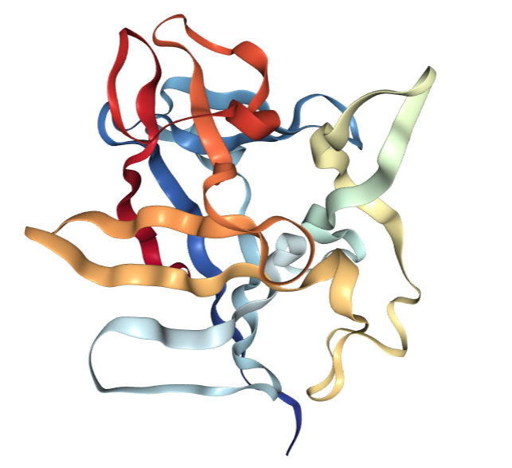 | quercetin | 6.097
3 | IL2 | 1M48 | 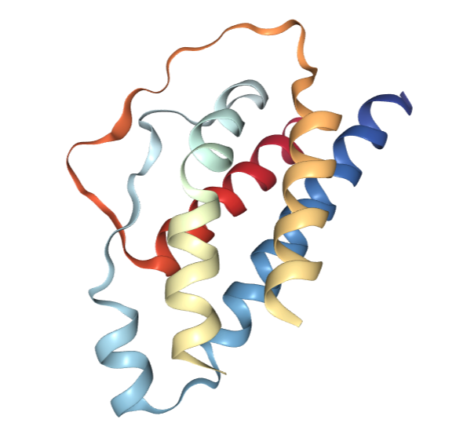 | quercetin | 6.595
4 | IL6 | 1ALU | 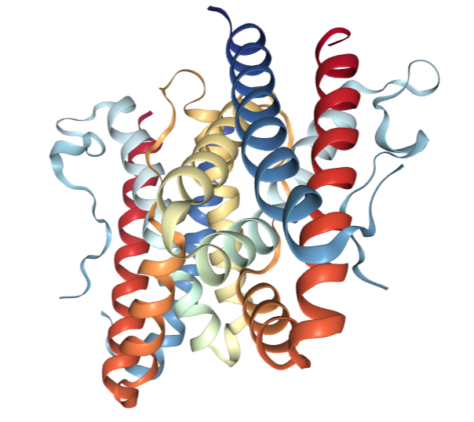 | quercetin | 6.692
 |  |  |  | luteolin | 6.625
5 | MAPK1 | 3O71 | 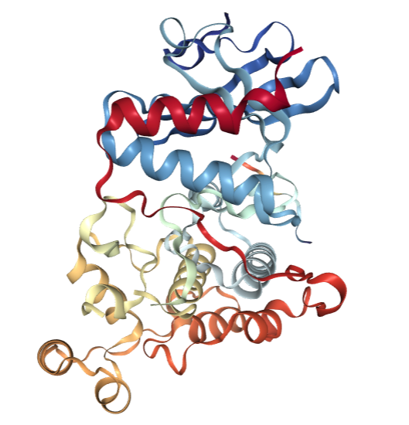 | licochalcone a | 7.955
 |  |  |  | quercetin | 6.708
 |  |  |  | luteolin | 6.686
 |  |  |  | naringenin | 6.625
6 | MAPK8 | 3PZE | 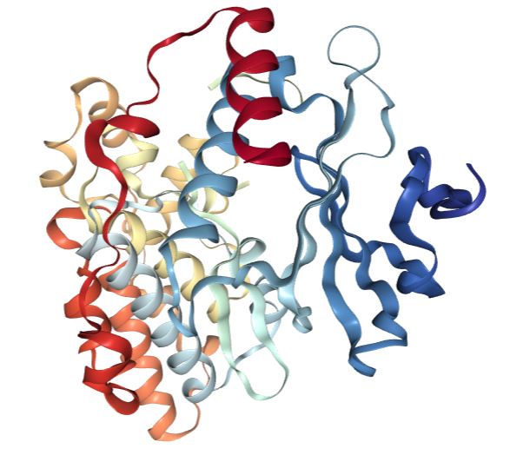 | kaempferol | 2.376
7 | TNF | 2AZ5 | 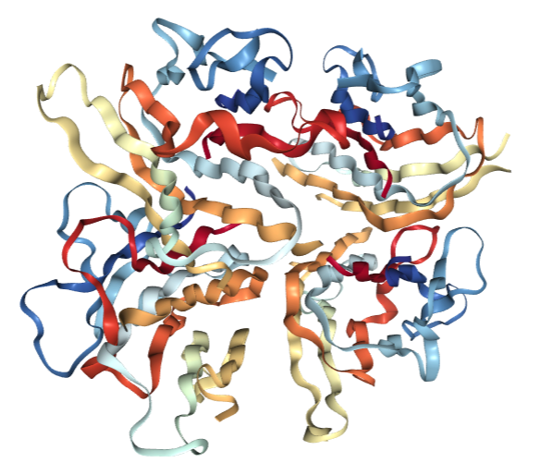 | luteolin | 6.629
 |  |  |  | kaempferol | 6.588
 |  |  |  | quercetin | 6.358
 |  |  |  | isovitexin | 6.614

