Supporting information

Amphiphilic Ligands for Cu-catalyzed Aerobic Oxidation of sp3 C-H to Synthesize 9-Fluorenones in Water

Longjia Li, Zibo Liu, Shanyu Tang, Jiao Li, Xuanhe Ren, Guanyu Yang, Bingxin Yuan*, and Heng Li*

**Contents**

**Supporting information S1**

**General Information S3**

**Synthesis of Ligands S3**

Typical Procedure for the Products S3

Uv characterization of ligands S3

**Characterization Data of all products S5**

References S11

The NMR Spectra of all products S12

# General Information

All materials and catalysts were purchased from general merchant. 1H NMR and 13C NMR spectra were recorded at a Bruker AvanceⅢ HD spectrometer (Bremen, Germany) at 400 MHz for 1H NMR and 100 MHz for 13C NMR with CDCl3 as the solvent and TMS as the internal standard. High resolution mass spectra (HRMS) were measured with an Agilent 1290-6540 (Santa Clara, USA). Low resolution mass spectra (LRMS) were recorded at an electron ionization (EI) conditions by using a Shimadzu GCMS-QP2010 Plus mass spectrometer (Kyoto, Japan). The melting points of the products were determined by an X-4 micro-melting point apparatus (Beijing, China). UV is measured by Agilent 8453 UV-visible Spectroscopy System.

# Synthesis of Ligands

General Procedure: Synthesis of Ligands (**L1-L10**). Triethylene glycol monomethyl ether (0.96 mL, 6 mmol), NaH (0.173 g, 7.2 mmol) and DMF (2 mL) were added to a 25 mL Schlenk tube armedwith a magnetic stirbar. The reaction mixture was stirred at room temperature until no gas was released from the reaction system, then added 4,7-dichloro-1,10-phenanthroline (0.15 g, 0.6 mmol). The tube was filled with air and placed in an oil bath at 100 °C with stirring for 6 h. After reaction, the tube was cooled to room temperature, and the mixture was diluted with DCM, washed with brine, dried with Na2SO4, and concentrated on a rotovap. The residue was purified using column chromatography to give the product. Everything else was synthesized in the same way (**L1-L10**).

## Typical Procedure for the Products

A 25 mL Schlenk flask was charged with 9H-fluorene (33.2 mg, 0.2 mmol), CuCl2**.**2 H2O (0.17 mg, 0.001 mmol), **L1** (0.5 mg, 0.001 mmol), NaOH (56 mg, 1.4 mmol), H2O (3 mL), O2 balloon, and then the resulting mixture was stirred at 50 oC. After 16 h, the reaction mixture was extracted with ethyl acetate (3 × 10 mL), and then dried over Na2SO4 and filtered. After evaporation of the solvent under vacuum, the residue was subjected to flash column chromatography on silica gel to afford products **2a**-**2l**.

## Uv characterization of ligands

**Ln** was formulated into a 0.015 mol/L aqueous solution. CuCl2·2H2O was added in keeping CuCl2:**L** = 1:1. The mixed solution was stirred at room temperature for 12 h and then diluted to 4×10-5 mol/L. The measurement was carried out using water as a background solution.



 

Figure S1. Absorption spectra of **L2-10** in water.

# Characterization Data of all products

**4,7-bis(2-(2-(2-methoxyethoxy)ethoxy)ethoxy)-1,10-phenanthroline (L1).** Orange oil (284.9 mg, 94% yield) (methyl alcohol as eluent). 1H NMR (400 MHz, CDCl3) δ = 8.99 (d, J = 5.2 Hz, 2H), 8.20 (s, 2H), 6.99 (d, J = 5.3 Hz, 2H), 4.44-4.37 (m, 4H), 4.07-4.01 (m, 4H), 3.85-3.80 (m, 4H), 3.74-3.65 (m, 8H), 3.57-3.52 (m, 4H), 3.37 (s, 6H). 13C NMR (100 MHz, CDCl3) δ = 161.42, 151.12, 146.93, 120.94, 119.08, 103.48, 71.90, 71.06, 70.72, 70.62, 69.40, 68.12, 59.07. HRMS(ESI): m/z calcd for C26H36N2O8[M+H]+, 505.2544; found, 505.2548.

**3,8-bis(2-(2-(2-methoxyethoxy)ethoxy)ethoxy)-1,10-phenanthroline(L2).** Yellow oil (248.5 mg, 82% yield)(ethyl acetate/methyl alcohol = 10:1 as eluent).1H NMR (400 MHz, CDCl3) δ = 8.90 (d, *J* = 2.9 Hz, 2H), 7.68 (s, 2H), 7.51 (d, *J* = 2.9 Hz, 2H), 4.33-4.28 (m, 4H), 3.99-3.93 (m, 4H), 3.81-3.75 (m, 4H), 3.73-3.64 (m, 8H), 3.57-3.50 (m, 4H), 3.37 (s, 6H). 13C NMR (100 MHz, CDCl3) δ = 153.55, 142.85, 140.52, 127.93, 126.74, 115.18, 71.87, 70.91, 70.62, 70.55, 69.55, 67.91, 59.01. HRMS(ESI): m/z calcd for C26H36N2O8[M+H]+, 505.2544; found, 505.2548.

**2,9-bis(2-(2-(2-methoxyethoxy)ethoxy)ethoxy)-1,10-phenanthroline (L3).** Colorless oil (272.7 mg, 90% yield) (ethyl acetate as eluent). 1H NMR (400 MHz, CDCl3) δ = 8.04 (d, *J* = 8.7 Hz, 2H), 7.56 (s, 2H), 7.09 (d, *J* = 8.7 Hz, 2H), 4.89-4.82 (m,4H), 4.03-3.97 (m, 4H), 3.81-3.74 (m,4H), 3.71-3.60 (m, 8H), 3.54-3.48 (m, 4H), 3.34 (s, 6H). 13C NMR (100 MHz, CDCl3) δ = 162.06, 142.90, 138.96, 125.18, 123.37, 113.63, 71.90, 70.64, 70.60, 70.54, 69.88, 65.10, 59.02. HRMS(ESI): m/z calcd for C26H36N2O8[M+H]+, 505.2544; found, 505.2543.



**4,7-bis((2,5,8,11-tetraoxatridecan-13-yl)oxy)-1,10-phenanthroline (L4).** Orange oil (337.6 mg, 95% yield) (methyl alcohol as eluent). 1H NMR (400 MHz, CDCl3) δ = 8.97 (d, *J* = 5.3 Hz, 2H), 8.14 (s, 2H), 6.99 (d, *J* = 5.4 Hz, 2H), 4.42-4.35 (m, 4H), 4.04-3.98 (m, 4H), 3.81-3.73 (m, 4H), 3.70-3.57 (m, 16H), 3.52-3.46 (m, 4H), 3.32 (s, 6H). 13C NMR (100 MHz, CDCl3) δ = 161.67, 150.94, 146.10, 120.93, 119.12, 103.66, 71.86, 70.99, 70.64, 70.60, 70.55, 70.45, 69.33, 68.28, 58.98. HRMS(ESI): m/z calcd for C30H44N2O10[M+H]+, 593.3069; found, 593.3071.

**2-(2-(2-(2-methoxyethoxy)ethoxy)ethoxy)-1,10-phenanthroline (L5).** Colorless oil (197.1 mg, 96% yield) (ethyl acetate as eluent). 1H NMR (400 MHz, CDCl3) δ = 9.20-9.12 (m, 1H), 8.26-8.16 (m, 1H), 8.11 (d, *J* = 8.7 Hz, 1H), 7.77-7.62 (m, 2H), 7.61-7.54 (m, 1H), 7.18 (d, *J* = 8.7 Hz, 1H), 4.99-4.91 (m, 2H), 4.03-3.96 (m, 2H), 3.83-3.77 (m, 2H), 3.74-3.63 (m, 4H), 3.58-3.51(m, 2H), 3.37 (s, 3H). 13C NMR (100 MHz, CDCl3) δ = 162.80, 150.00, 145.32, 144.26, 138.98, 136.14, 129.12, 126.30, 124.85, 123.73, 122.42, 114.19, 71.95, 70.68, 70.63, 70.59, 69.85, 65.54, 59.06. HRMS(ESI): m/z calcd for C19H22N2O4[M+H]+, 343.1652; found, 343.1657.



**4,4'-bis(2-(2-(2-methoxyethoxy)ethoxy)ethoxy)-2,2'-bipyridine (L6).** Yellow oil (284.9 mg, 89% yield) (ethyl acetate as eluent). 1H NMR (400 MHz, CDCl3) δ = 8.45 (d, *J* = 5.7 Hz, 2H), 7.98 (d, *J* = 2.4 Hz, 1H), 6.90-6.82 (m, 2H), 4.31-4.25 (m, 4H), 3.92-3.86 (m, 4H), 3.76-3.62 (m, 12H), 3.56-3.49 (m, 4H), 3.36 (s, 6H). 13C NMR (100 MHz, CDCl3) δ = 165.85, 157.79, 150.13, 111.51, 106.63, 71.93, 70.92, 70.67, 70.60, 69.38, 67.46, 59.05. HRMS(ESI): m/z calcd for C24H36N2O8[M+H]+, 481.2544; found, 481.2549.



**6,6'-bis(2-(2-(2-methoxyethoxy)ethoxy)ethoxy)-2,2'-bipyridine (L7).** Yellow oil (284.9 mg, 89% yield) (ethyl acetate as eluent). 1H NMR (400 MHz, CDCl3) δ 7.98-7.92 (m, 2H), 7.71-7.61 (m, 2H), 6.82-6.74 (m, 2H), 4.61 (t, *J* = 3.8 Hz, 4H), 3.96-3.88 (m, 4H), 3.79-3.63 (m, 12H), 3.57-3.52 (m, 4H), 3.37 (s, 6H). 13C NMR (100 MHz, CDCl3) δ = 162.84, 153.19, 139.28, 113.72, 111.34, 71.94, 70.70, 70.68, 70.59, 69.77, 64.86, 59.07. HRMS(ESI): m/z calcd for C24H36N2O8[M+H]+, 481.2544; found, 481.2549.



**2,6-bis(2-(2-(2-methoxyethoxy)ethoxy)ethoxy)pyridine (L8).** Yellow oil (220.1 mg, 91% yield) ( ethyl acetate as eluent). 1H NMR (400 MHz, CDCl3) δ = 7.46 (t, *J* = 7.9 Hz, 1H), 6.32 (d, *J* = 7.9 Hz, 2H), 4.45-4.39 (m, 4H), 3.86-3.80 (m, 4H), 3.74-3.64 (m, 12H), 3.57-3.51 (m, 4H), 3.37 (s, 6H). 13C NMR (100 MHz, CDCl3) δ = 162.14, 140.86, 101.62, 71.80, 70.56, 70.51, 70.42, 69.55, 64.90, 58.86. HRMS(ESI): m/z calcd for C19H33NO8[M+H]+, 404.2279; found, 404.2284.



**2,4-bis(2-(2-(2-methoxyethoxy)ethoxy)ethoxy)pyridine (L9).** Yellow oil (224.9 mg, 93% yield) ( ethyl acetate as eluent). 1H NMR (400 MHz, CDCl3) δ = 7.92 (d, *J* = 5.9 Hz, 1H), 6.54-6.42 (m, 1H), 6.25 (d, *J* = 2.1 Hz, 1H), 4.49-4.41 (m, 2H), 4.16-4.10 (m, 2H), 3.89-3,80 (m, 4H), 3.74-3.62 (m, 12H), 3.58-3,51 (m, 4H), 3.37 (s, 6H). 13C NMR (100 MHz, CDCl3) δ = 166.88, 165.32, 147.15, 106.62, 94.72, 71.83, 71.82, 70.76, 70.53, 70.48, 70.45, 69.68, 69.17, 67.21, 65.10, 58.92. HRMS(ESI): m/z calcd for C19H33NO8[M+H]+, 404.2279; found, 404.2283.



**2-(2-(2-(2-methoxyethoxy)ethoxy)ethoxy)pyridine (L10).** Yellow oil (131.8 mg, 90% yield) (ethyl acetate as eluent). 1H NMR (400 MHz, CDCl3) δ = 8.16-8.09 (m, 1H), 7.60-7.50 (m 1H), 6.89-6.80 (m, 1H), 6.77 (d, *J* = 8.4 Hz, 1H), 4.52-4.43 (m, 2H), 3.89-3.82 (m, 2H), 3.76-3.70 (m, 2H), 3.70-3.62 (m, 4H), 3.57-3.51 (m, 2H), 3.37 (s, 1H). 13C NMR (100 MHz, CDCl3) δ = 163.49, 146.62, 138.48, 116.71, 111.24, 71.83, 70.55, 70.53, 70.44, 69.64, 64.89, 58.90. HRMS(ESI): m/z calcd for C12H19NO4[M+H]+, 242.1387; found, 242.1396.



**9H-fluoren-9-one(2a)**[1]**.** Yellow solid (34.9 mg, 97% yield) (PE/DCM = 10:1 as eluent). mp 79-81 oC. 1H NMR (400 MHz, CDCl3) δ = 7.64 (d, *J* = 7.3 Hz, 2H), 7.51-7.43 (m, 4H), 7.30-7.24 (m, 2H). 13C NMR (100 MHz, CDCl3) δ = 193.93, 144.43, 134.69, 134.15, 129.08, 124.30, 120.32. LRMS(EI): m/z calcd for C13H8O[M]+, 180; found, 180.



**2-bromo-9H-fluoren-9-one(2b)**[1]**.** Yellow solid (46.4 mg, 90% yield) (PE/DCM = 10:1 as eluent). mp 143-146 oC. 1H NMR (400 MHz, CDCl3) δ = 7.76 (d, *J* = 1.7 Hz, 1H), 7.66 (d, *J* = 7.4 Hz, 1H), 7.63-7.59 (m, 1H), 7.52-7.48 (m, 2H), 7.39 (d, *J* = 7.9 Hz, 1H), 7.36-7.29 (m, 1H). 13C NMR (100 MHz, CDCl3) δ = 192.40, 143.65, 142.99, 137.10, 135.74, 135.06, 133.67, 129.44, 127.54, 124.60, 122.93, 121.74, 120.46. LRMS(EI): m/z calcd for C13H7BrO[M]+, 258; found, 258.



**2-iodo-9H-fluoren-9-one(2c)**[3]**.** Yellow solid (45.9 mg, 75% yield) (PE/DCM = 10:1 as eluent). mp 146-149 oC. 1H NMR (400 MHz, CDCl3) δ = 7.84 (d, *J* = 1.5 Hz, 1H), 7.73-7.68 (m, 1H), 7.54 (d, *J* = 7.4 Hz, 1H), 7.41-7.36 (m, 2H), 7.27-7.20 (m, 1H), 7.16 (d, *J* = 7.8 Hz, 1H). 13C NMR (100 MHz, CDCl3) δ = 192.40, 143.72, 143.60, 143.09, 135.69, 135.01, 133.29, 129.60, 124.53, 122.02, 120.49, 93.97. LRMS (EI): m/z calcd fo rC13H7IO[M]+, 306; found, 306.



**2,7-dichloro-9H-fluoren-9-one(2d)**[2]**.** Yellow solid (45.6 mg, 92% yield) (PE/DCM = 10:1 as eluent). mp 192-194 oC. 1H NMR (400 MHz, CDCl3) δ = 7.50 (d, *J* = 1.6 Hz, 2H), 7.39-7.31 (m, 4H). 13C NMR (100 MHz, CDCl3) δ = 191.06, 141.77, 135.39, 135.37, 134.54, 124.95, 121.50. LRMS(EI): m/z calcd for C13H6Cl2O[M]+, 248; found, 248.



**2,7-dibromo-9H-fluoren-9-one(2e)**[1]**.** Yellow solid (58.5 mg, 87% yield) (PE/DCM= 10:1 as eluent). mp 203-205 oC. 1H NMR (400 MHz, CDCl3) δ = 7.68 (d, *J* = 1.8 Hz, 2H), 7.57-7.52 (m, 2H), 7.30 (d, *J* = 7.9 Hz, 2H). 13C NMR (100 MHz, CDCl3) δ = 189.93, 141.23, 136.45, 134.23, 126.82, 122.30, 120.83. LRMS (EI): m/z calcd for C13H6Br2O[M]+, 336; found, 336.



**2-bromo-7-iodo-9H-fluoren-9-one(2f)**[2]**.** Yellow solid (71.4 mg, 93% yield) (PE/DCM= 10:1 as eluent). mp 195-198 oC. 1H NMR (400 MHz, CDCl3) δ = 7.87 (d, *J* = 1.4 Hz, 1H), 7.77-7.73 (m, 1H), 7.66 (d, *J* = 1.7 Hz, 1H), 7.56-7.51 (m, 1H), 7.29 (d, *J* = 7.9 Hz, 1H), 7.20-7.15 (m, 1H). 13C NMR (100 MHz, CDCl3) δ = 190.97, 143.48, 142.87, 142.33, 137.46, 135.19, 134.89, 133.60, 127.78, 123.47, 122.12, 121.90, 94.35. LRMS(EI): m/z calcd for C13H6BrIO[M]+, 384; found, 384.



**2-nitro-9H-fluoren-9-one(2g)**[1]**.** Yellow solid (27 mg, 59% yield) (PE/DCM = 1:1 as eluent). mp 144-148 oC. 1H NMR (400 MHz, CDCl3) δ = 8.48 (d, *J* = 2.0 Hz, 1H), 8.45-8.39 (m 1H), 7.77 (d, *J* = 7.4 Hz, 1H), 7.73-7.63 (m, 2H), 7.65-7.56 (m,1H), 7.49-7.40(m, 1H). 13C NMR (100 MHz, CDCl3) δ = 190.93, 149.73, 148.78, 142.32, 135.45, 135.06, 135.02, 131.02, 129.94, 125.11, 121.79, 120.71, 119.56. LRMS(EI): m/z calcd for C13H7NO3[M]+, 225; found, 225.



**2-acetyl-9H-fluoren-9-one(2h)**[2]**.** Yellow solid. (40.4 mg, 91% yield) (PE/DCM = 2:1 as eluent). mp 153-156 °C. 1H NMR (400 MHz, CDCl3) δ = 8.11 (d, *J* = 1.0 Hz, 1H), 8.09-8.05 (m, 1H), 7.64 (d, *J* = 7.4 Hz, 1H), 7.57-7.51 (m, 2H), 7.50-7.44 (m, 1H), 7.34-7.27 (m, 1H), 2.56 (s, 3H). 13C NMR (100 MHz, CDCl3) δ = 196.62, 192.75, 148.48, 143.26, 137.80, 135.06, 134.92, 134.87, 134.31, 130.25, 124.67, 124.16, 121.30, 120.46, 26.77. LRMS(EI): m/z calcd for C15H10O2[M]+, 222; found, 222.



**2-amino-9H-fluoren-9-one(2i)**[4]**.** Yellow solid (31.2 mg, 80% yield) (PE/DCM = 1:1 as eluent). mp 148-152 oC. 1H NMR (400 MHz, CDCl3) δ = 7.48 (d, *J* = 7.3 Hz, 1H), 7.35-7.28 (m 1H), 7.25 (d, *J* = 7.4 Hz, 1H), 7.21-7.16 (m, 1H), 7.10-7.03 (m, 1H), 6.88 (d, *J* = 2.2 Hz, 1H), 6.67-6.59 (m, 1H), 3.82 (br, 2H). 13C NMR (100 MHz, CDCl3) δ = 194.45, 147.65, 145.57, 135.93, 134.82, 134.58, 134.03, 127.28, 124.19, 121.38, 119.61, 119.09, 111.05. LRMS(EI): m/z calcd for C13H9NO[M]+, 195; found, 195.



**2,7-di-tert-butyl-9H-fluoren-9-one(2j)**[3]**.** Yellow solid. (57.6 mg, 99% yield) (PE/DCM = 10:1 as eluent). mp 98 -101 °C. 1H NMR (400 MHz, CDCl3) δ = 7.60 (d, *J* = 1.7 Hz, 2H), 7.41-7.35 (m, *2*H), 7.29 (d, *J* = 7.8 Hz, 2H), 1.25 (s, 9H). 13C NMR (100 MHz, CDCl3) δ = 194.94, 152.28, 141.90, 134.61, 131.48, 121.54, 119.79, 35.02, 31.21. LRMS(EI): m/z calcd for C21H24O[M]+, 292; found, 292.



**4-bromo-2,7-di-tert-butyl-9H-fluoren-9-one(2k).** Yellow solid. (70.3 mg, 95% yield) (PE/DCM = 10:1 as eluent). mp 156-158 °C. 1H NMR (400 MHz, CDCl3) δ = 8.17 (d, *J* = 8.0 Hz, 1H), 7.73 (d, *J* = 1.7 Hz, 1H), 7.65 (d, *J* = 1.7 Hz, 1H), 7.58-7.52 (m, 1H), 1.34 (d, *J* = 6.3 Hz, 1H). 13C NMR (100 MHz, CDCl3) δ = 193.38, 153.97, 152.86, 141.19, 139.96, 137.08, 135.98, 134.59, 131.59, 122.86, 121.68, 120.70, 116.99, 35.07, 35.03, 31.12, 31.02. LRMS(EI): m/z calcd for C21H23BrO[M]+, 370; found, 370.



**2-phenyl-9H-fluoren-9-one(2l)**[3]**.** Yellow solid. (49.7 mg, 97% yield) (PE/DCM = 10:1 as eluent). mp 115-119 °C. 1H NMR (400 MHz, CDCl3) δ = 7.90 (d, *J* = 1.4 Hz, 1H), 7.74-7.69 (m, 1H), 7.67 (d, *J* = 7.3 Hz, 1H), 7.64-7.59 (m, 2H), 7.59-7.43 (m, 5H), 7.41-7.35 (m, 1H), 7.32-7.26 (m, 1H). 13C NMR (400 MHz, CDCl3) δ = 193.84, 144.31, 143.24, 142.32, 139.87, 134.92, 134.82, 134.51, 133.21, 129.04, 128.96, 127.93, 126.81, 124.42, 123.00, 120.70, 120.40. LRMS(EI): m/z calcd for C19H19O[M]+, 256; found, 256.

## References

1. Zhang, X.;Ji, X.;Jiang, S.;Liu,L.; Zhang,Z. ; *Green Chem.,* **2011**, 13, 1891-1896.
2. Wu, J.;Liu, Y.;Ma, X.;Liu,P.;Dai,B. ; *Chin. J. Chem.* **2017**, 35, 1391-1395.
3. Kojima, M.;Oisaki, K.;Kanai, M.; Xu,*Tetrahedron Letters.***2014**, 55, 4736-4738.
4. Yang, F.;Zhou, B.;Chen, P.;Ren,W.;Li,L. ;*Molecules.***2018,** 23, 1922.

## **The NMR Spectra of all products**

**4,7-bis(2-(2-(2-methoxyethoxy)ethoxy)ethoxy)-1,10-phenanthroline**

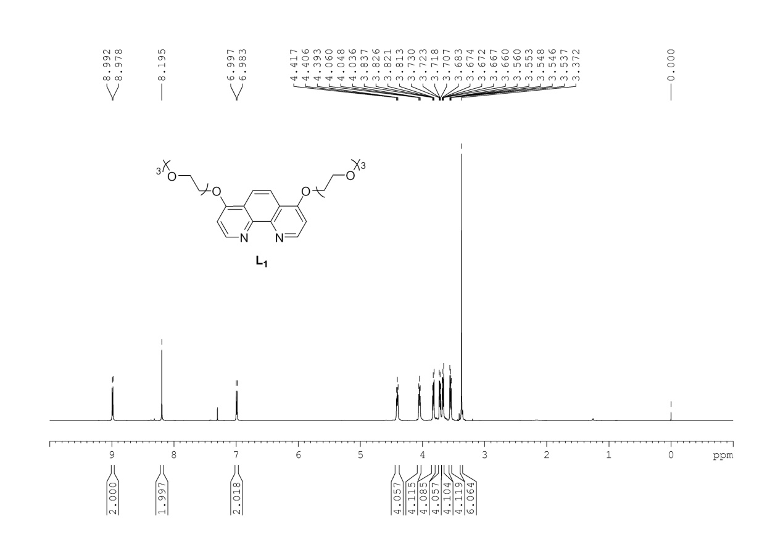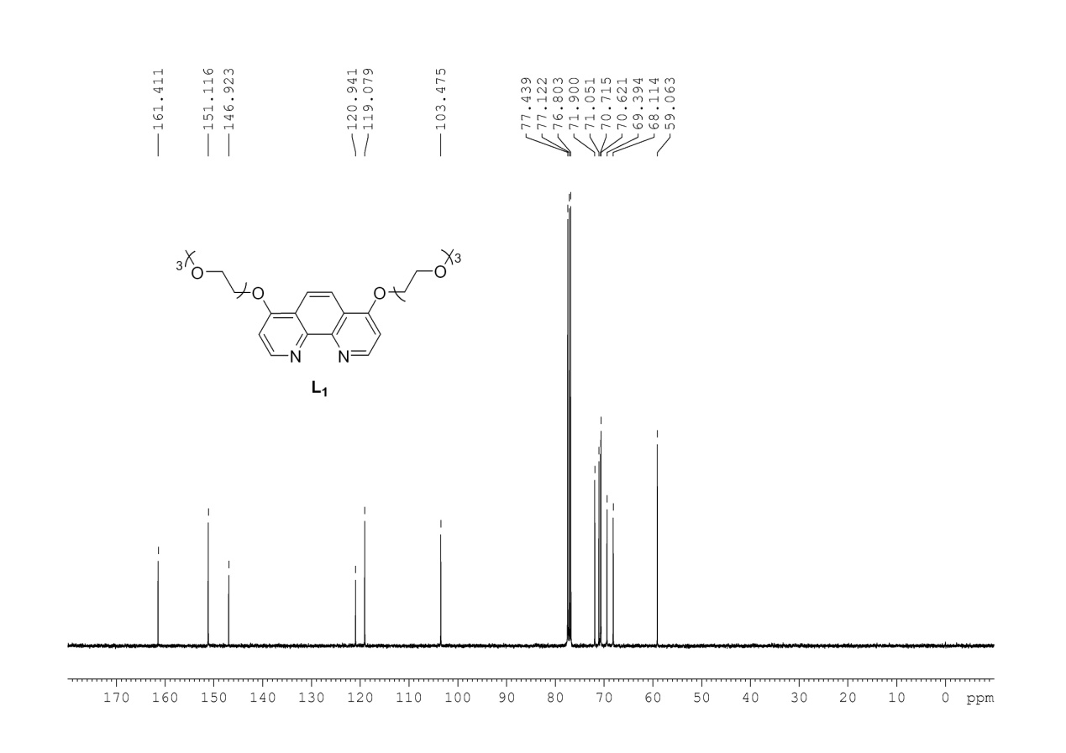

**3,8-bis(2-(2-(2-methoxyethoxy)ethoxy)ethoxy)-1,10-phenanthroline**

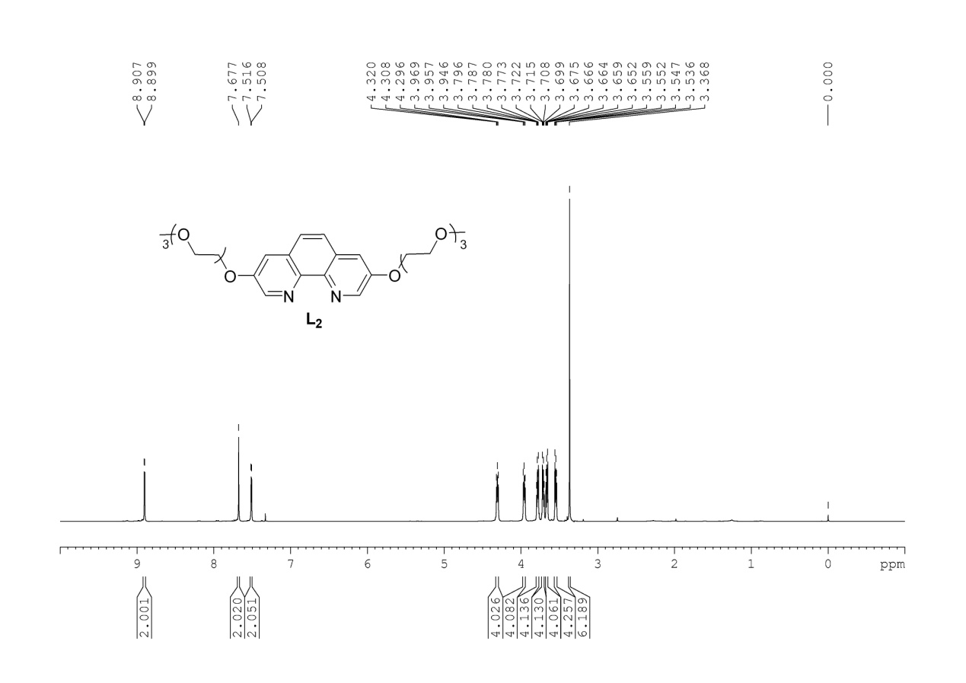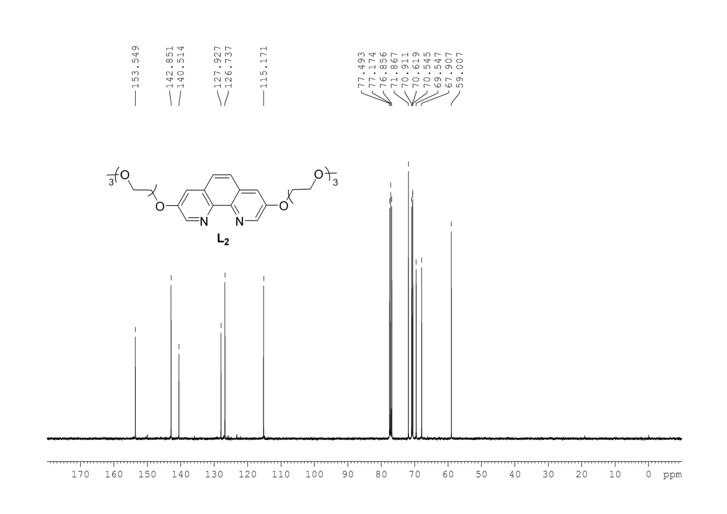

**2,9-bis(2-(2-(2-methoxyethoxy)ethoxy)ethoxy)-1,10-phenanthroline**

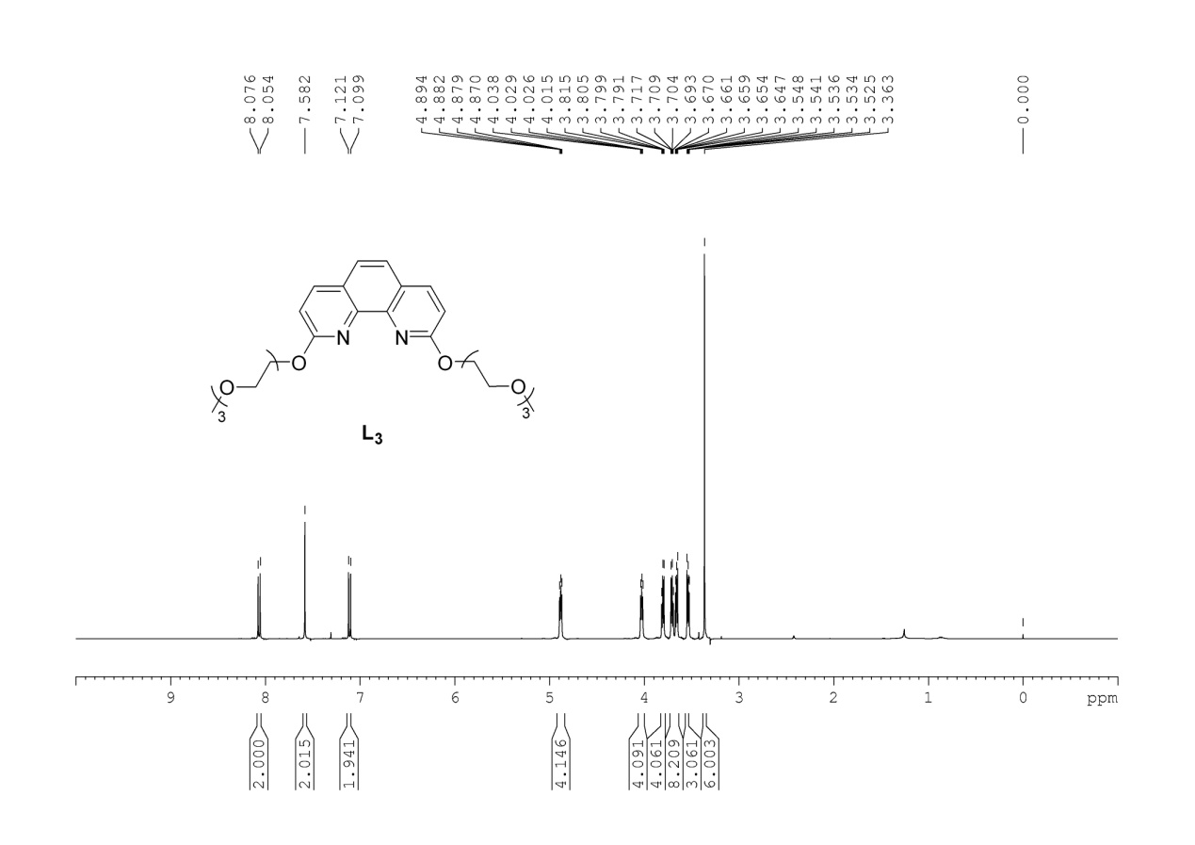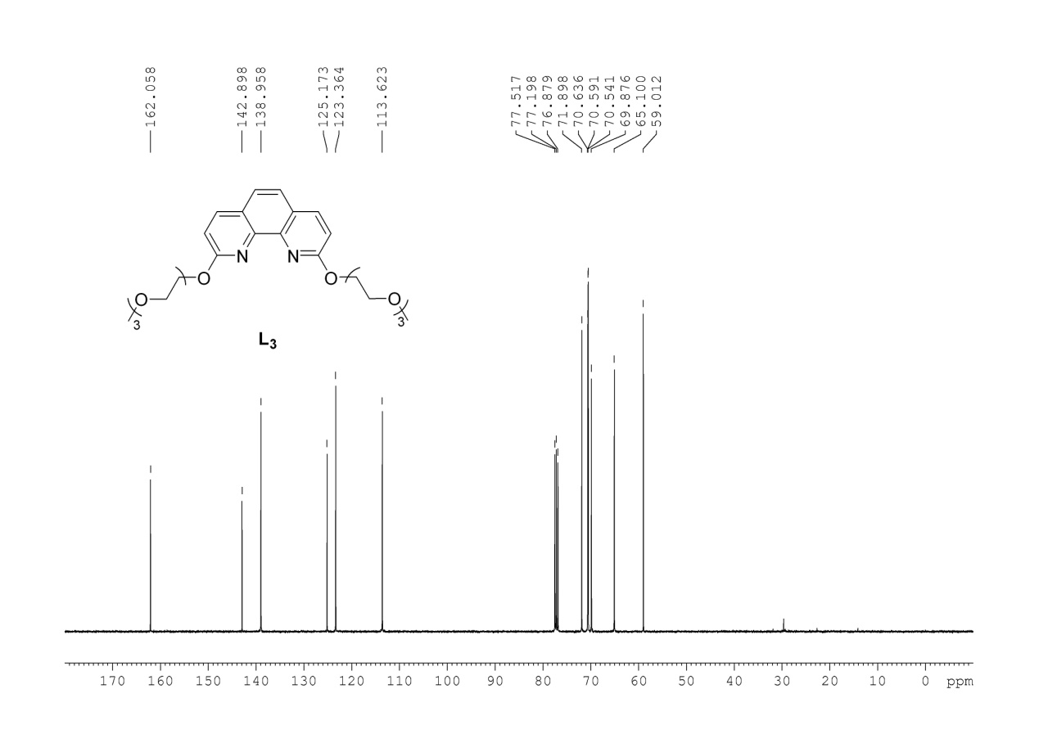

**4,7-bis((2,5,8,11-tetraoxatridecan-13-yl)oxy)-1,10-phenanthroline**

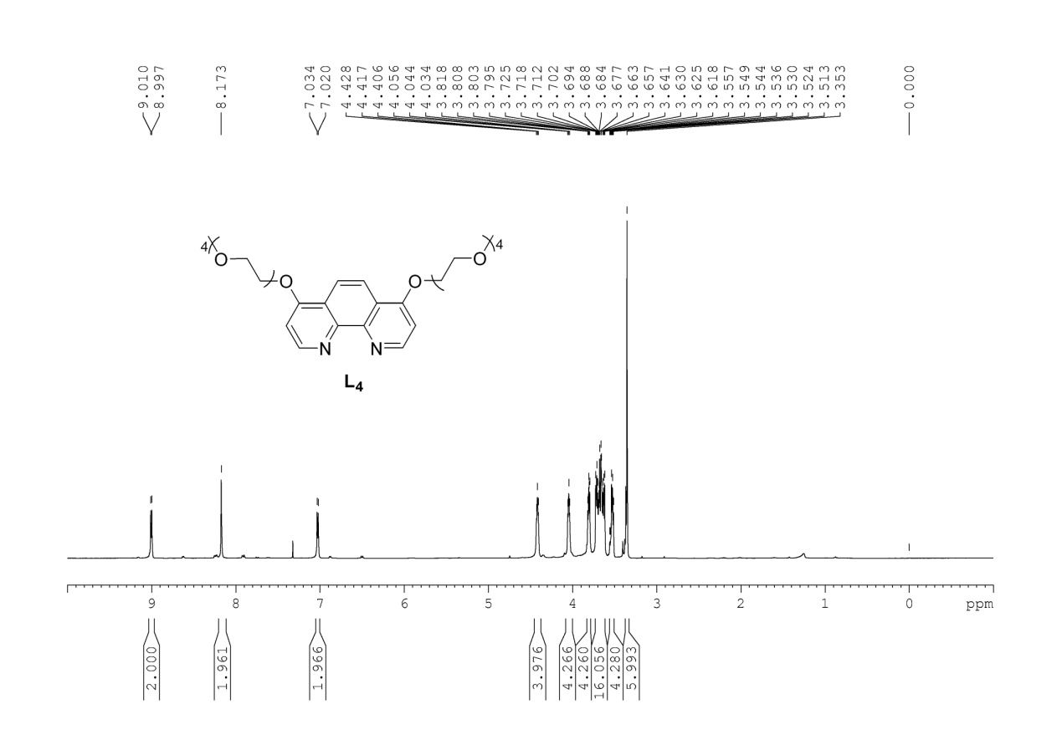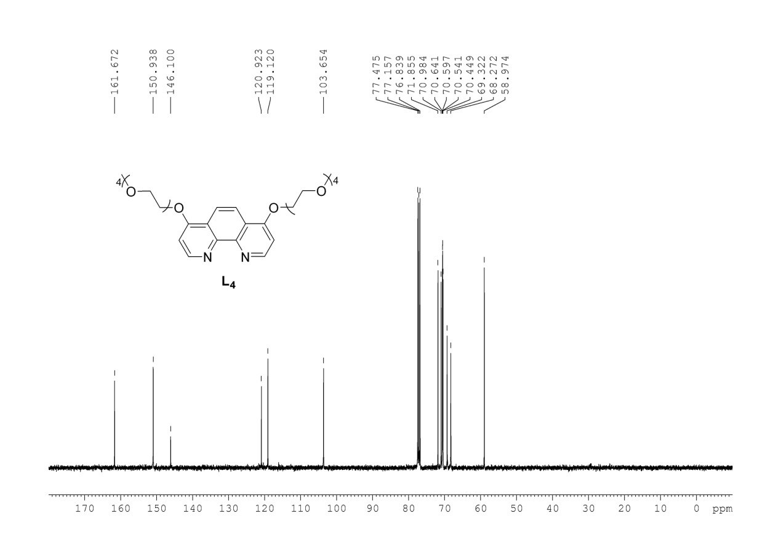

**2-(2-(2-(2-methoxyethoxy)ethoxy)ethoxy)-1,10-phenanthroline**

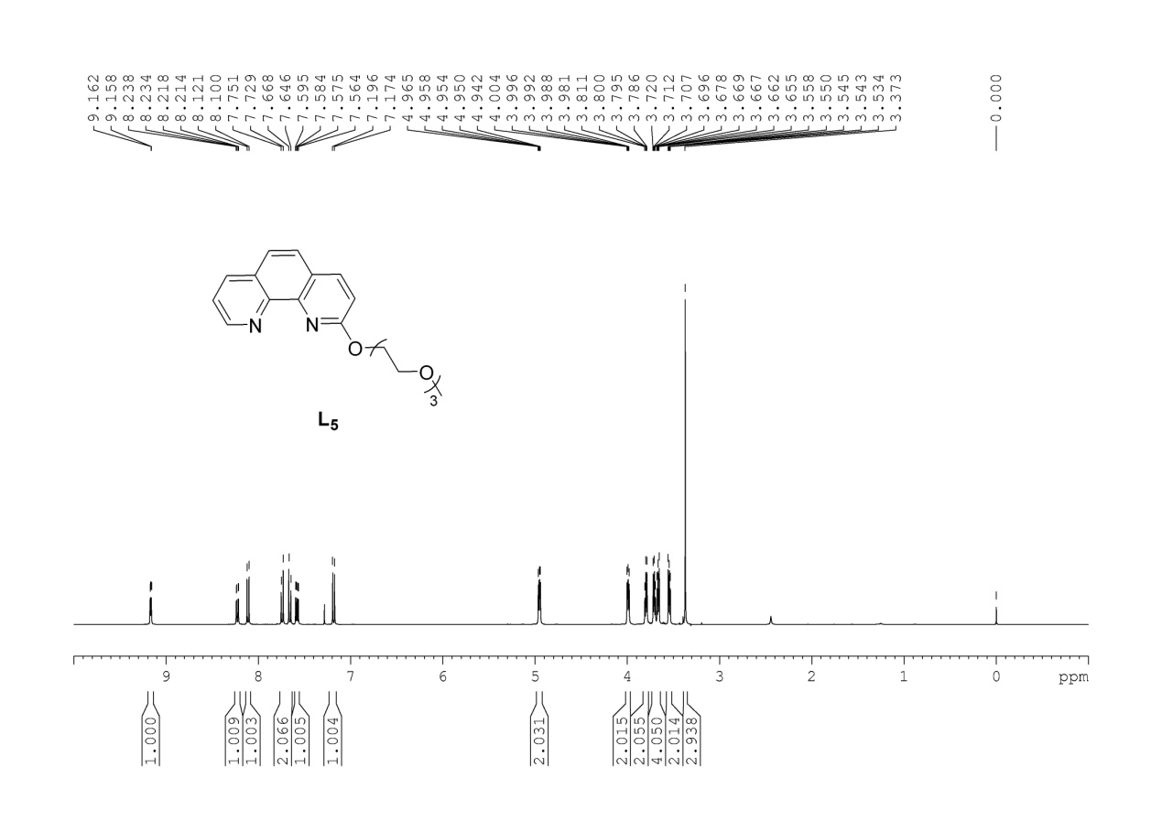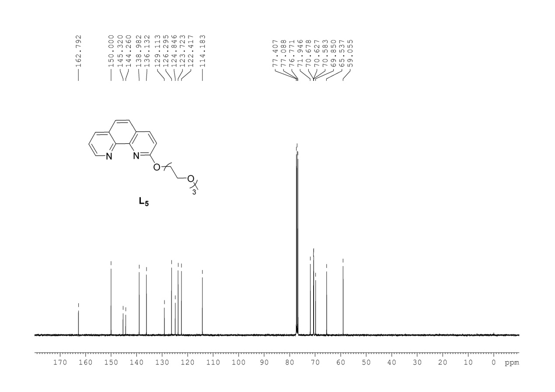

**4,4'-bis(2-(2-(2-methoxyethoxy)ethoxy)ethoxy)-2,2'-bipyridine**

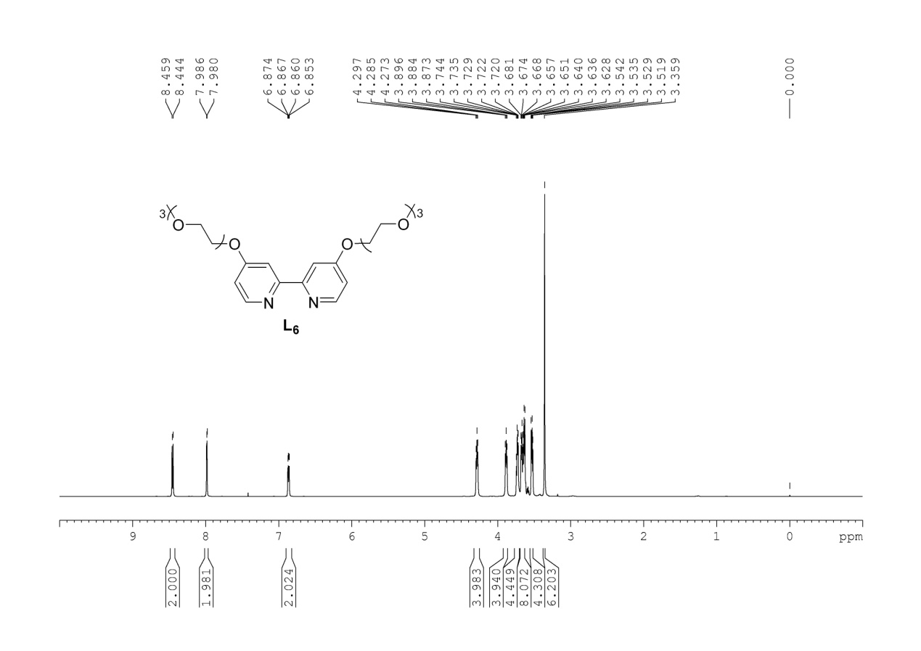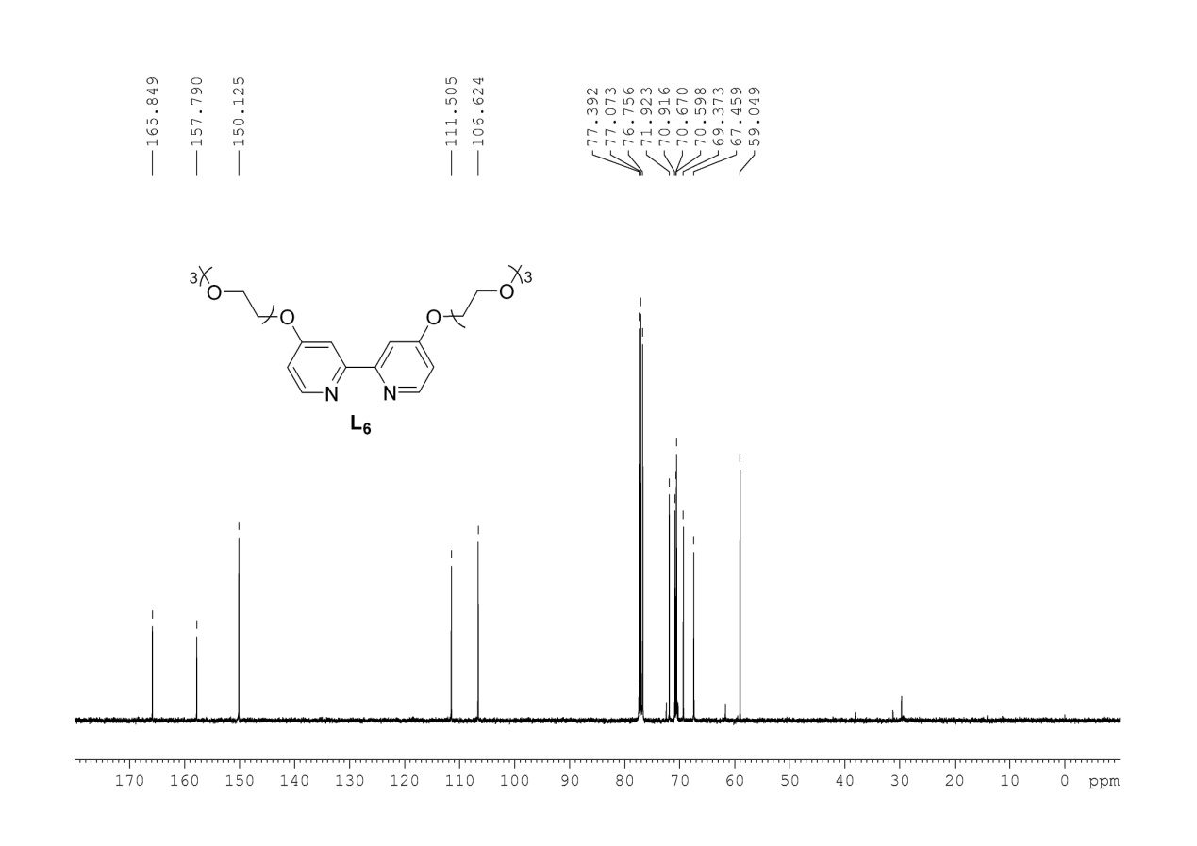

**6,6'-bis(2-(2-(2-methoxyethoxy)ethoxy)ethoxy)-2,2'-bipyridine**

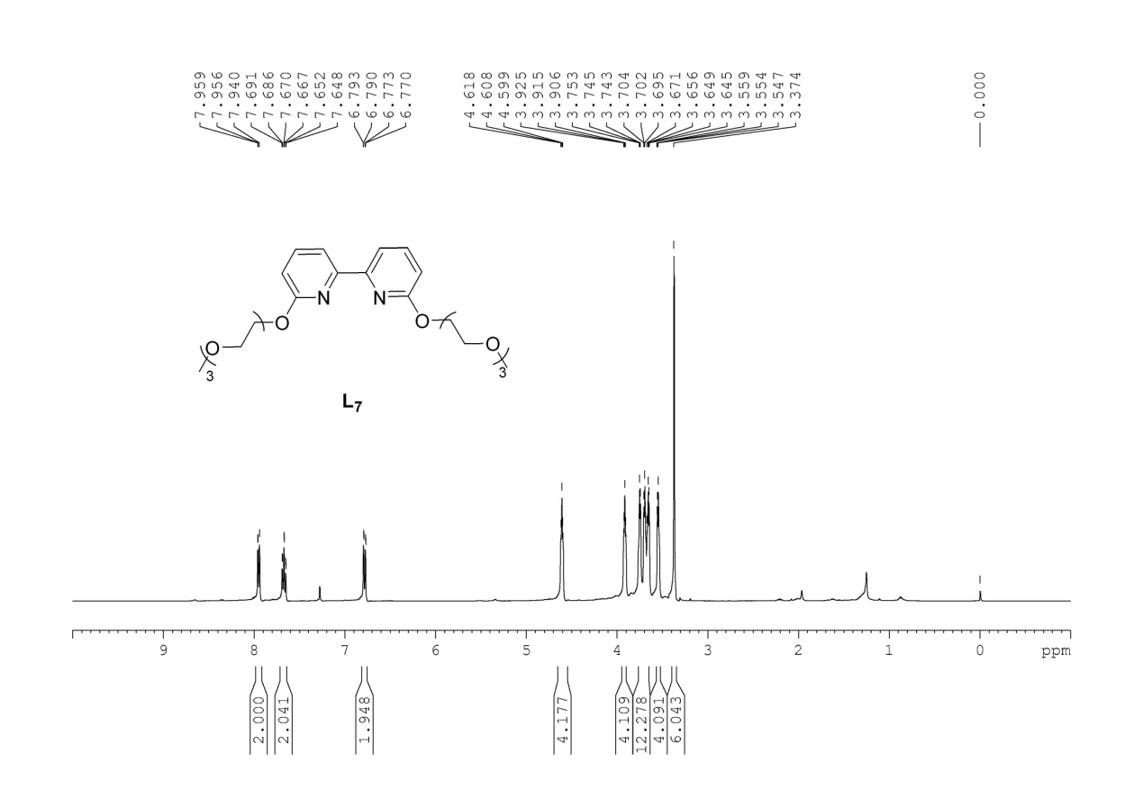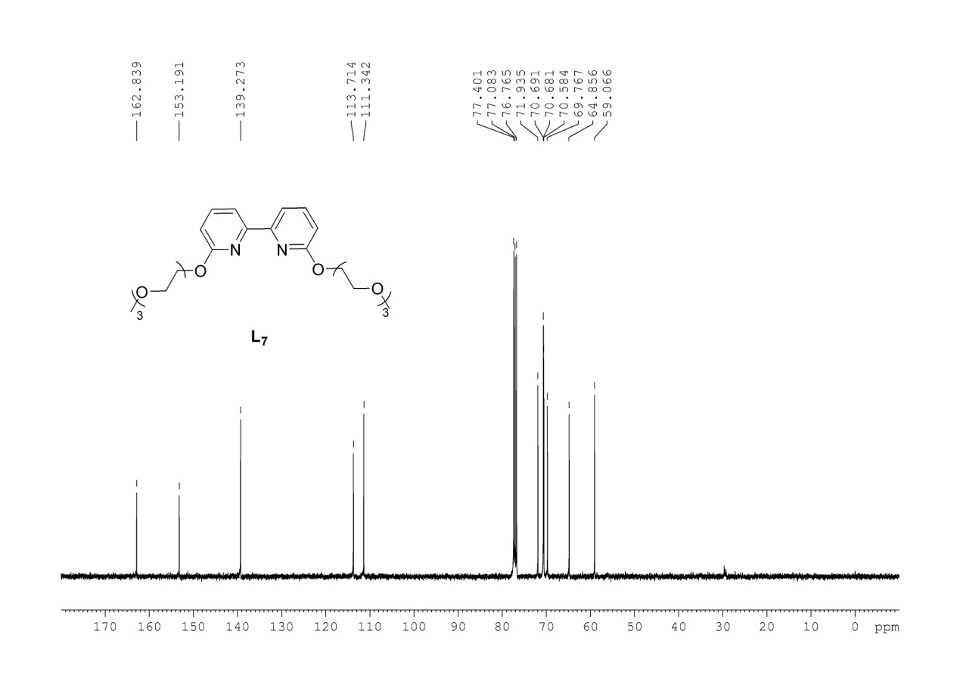

**2,6-bis(2-(2-(2-methoxyethoxy)ethoxy)ethoxy)pyridine**

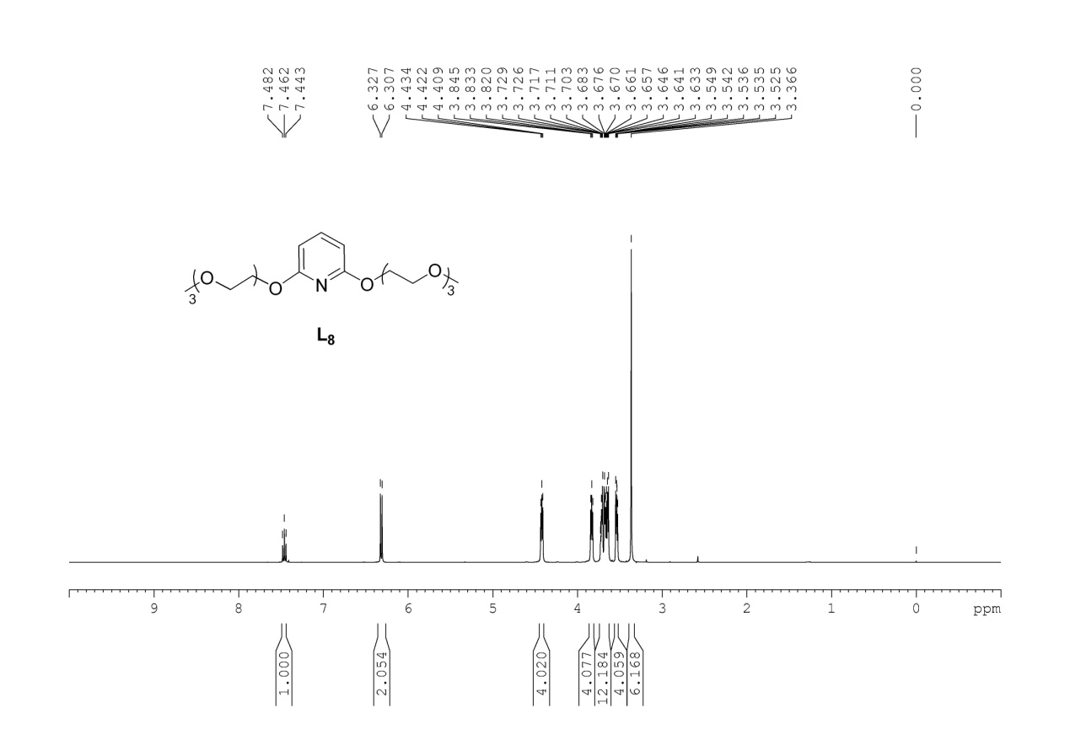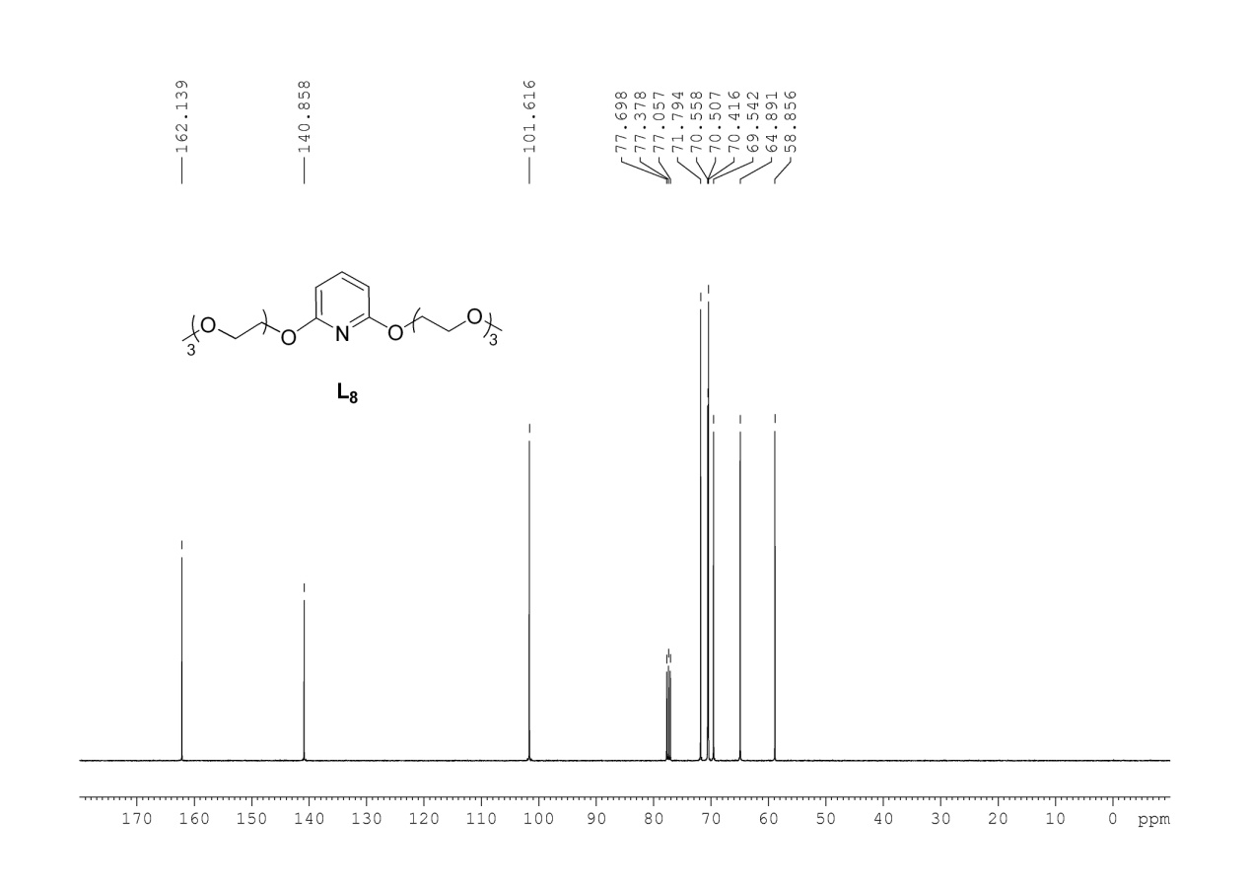

**2,4-bis(2-(2-(2-methoxyethoxy)ethoxy)ethoxy)pyridine**

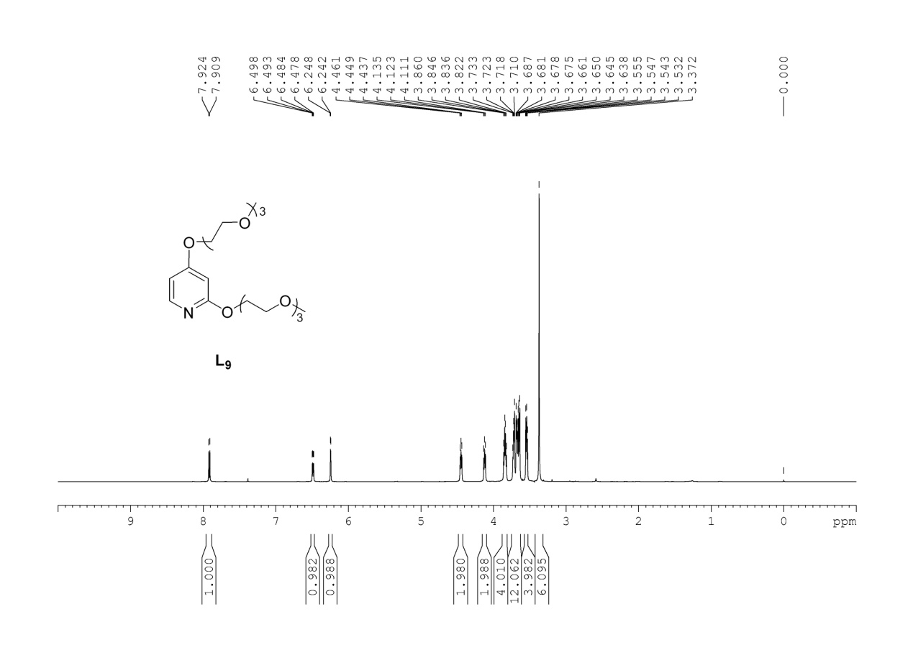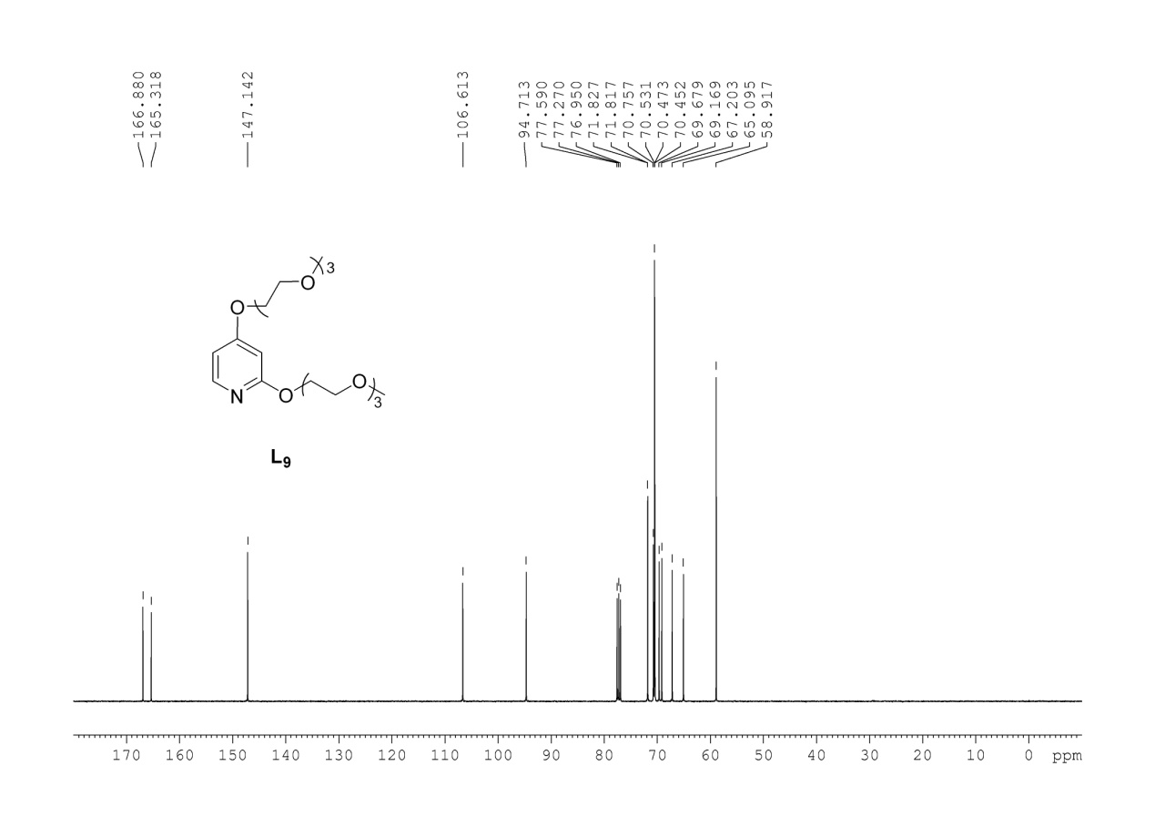

**2-(2-(2-(2-methoxyethoxy)ethoxy)ethoxy)pyridine**

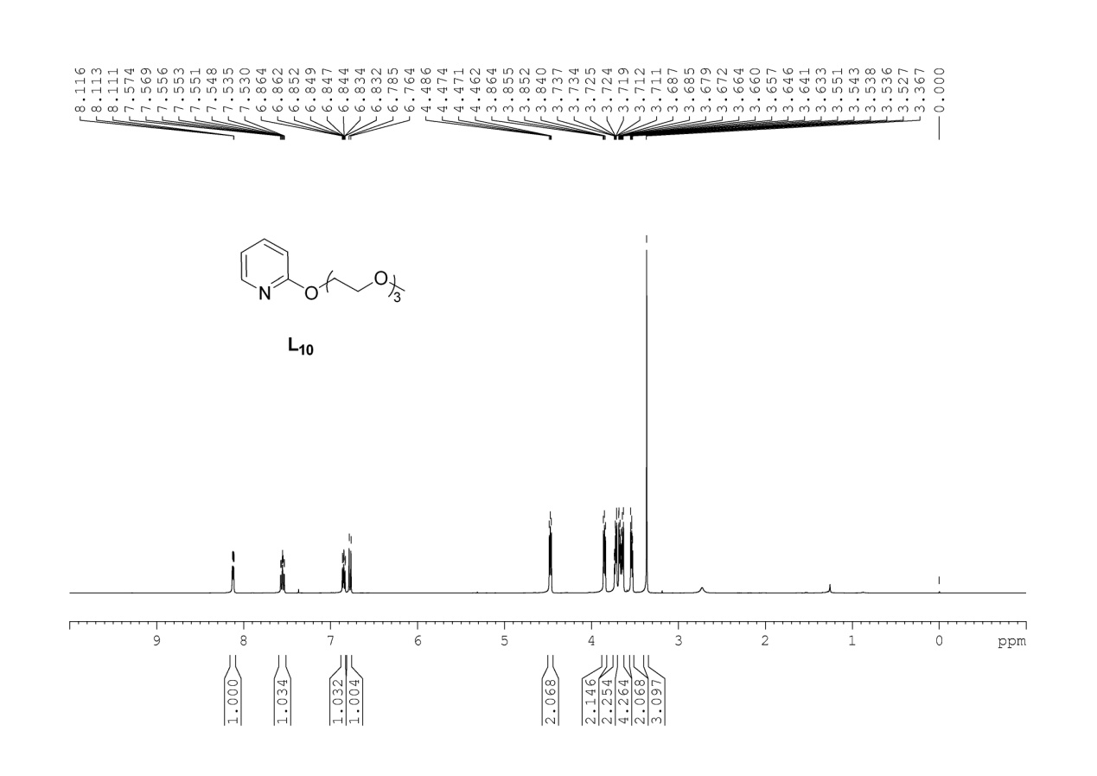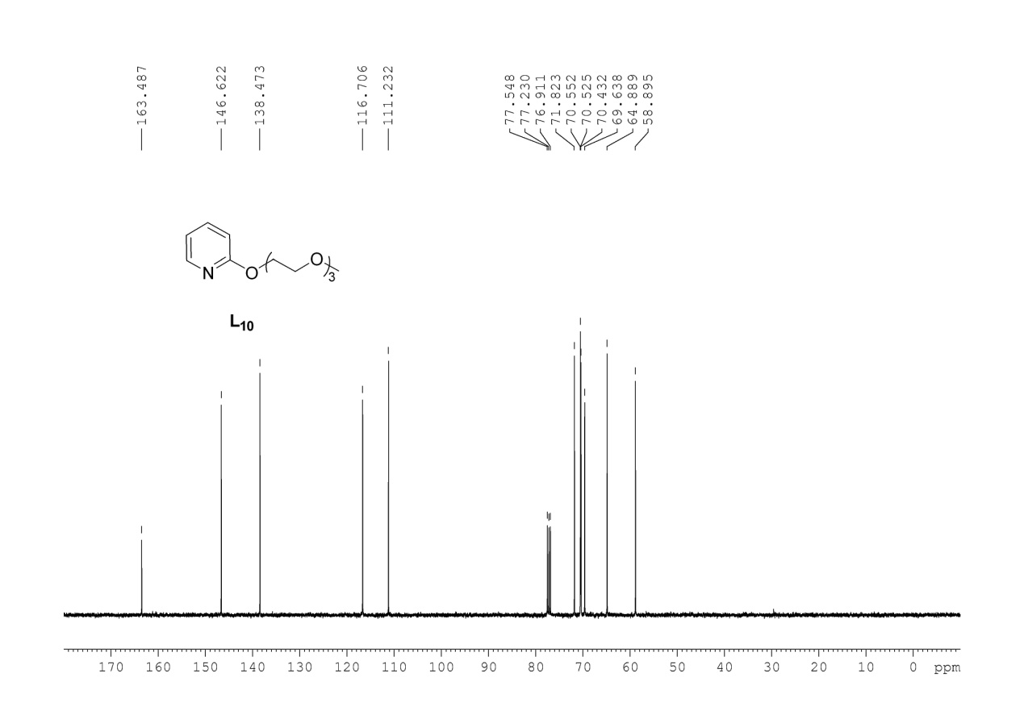

**9H-fluoren-9-one**

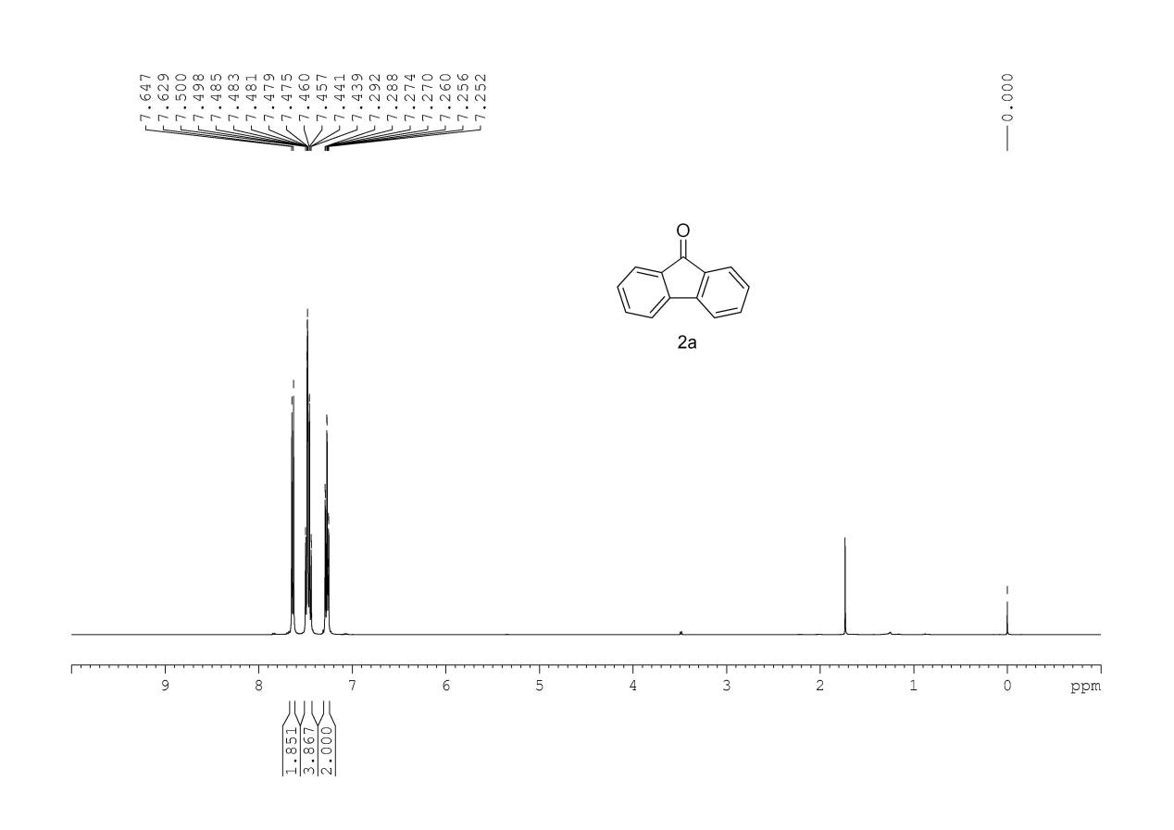

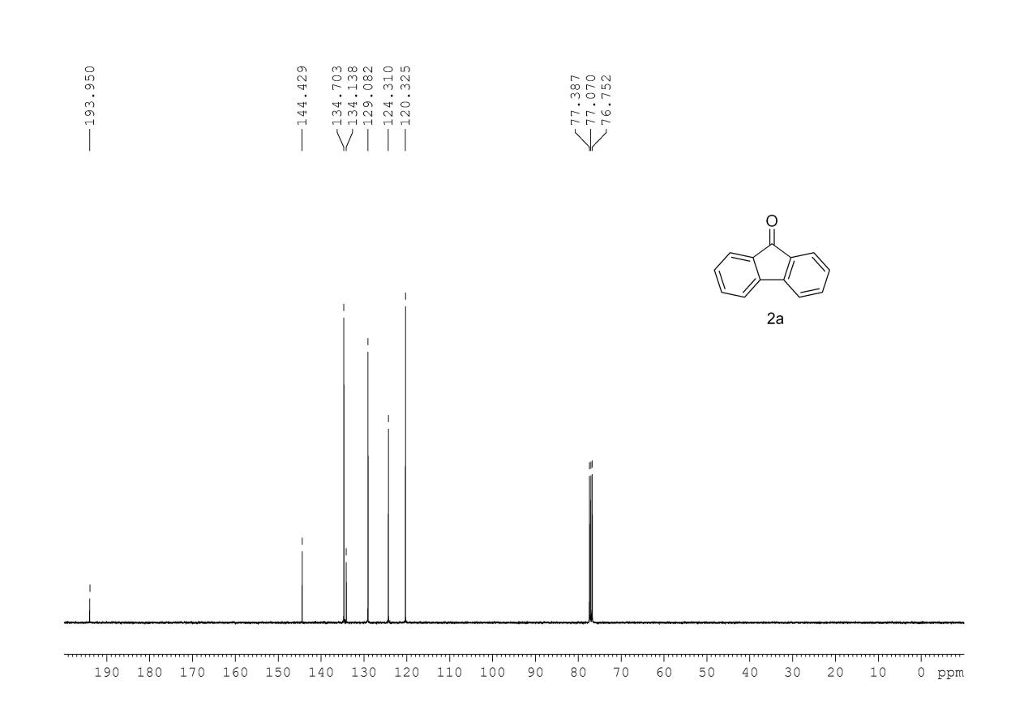

**2-bromo-9H-fluoren-9-one**

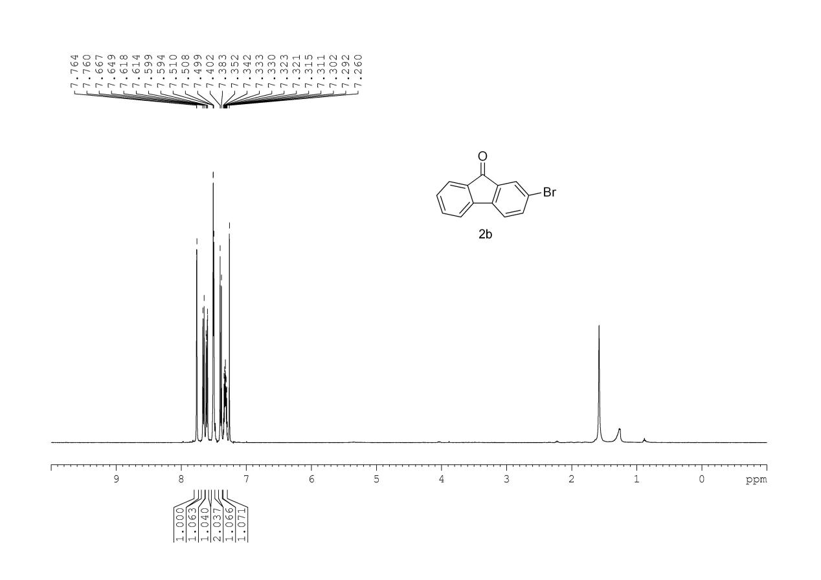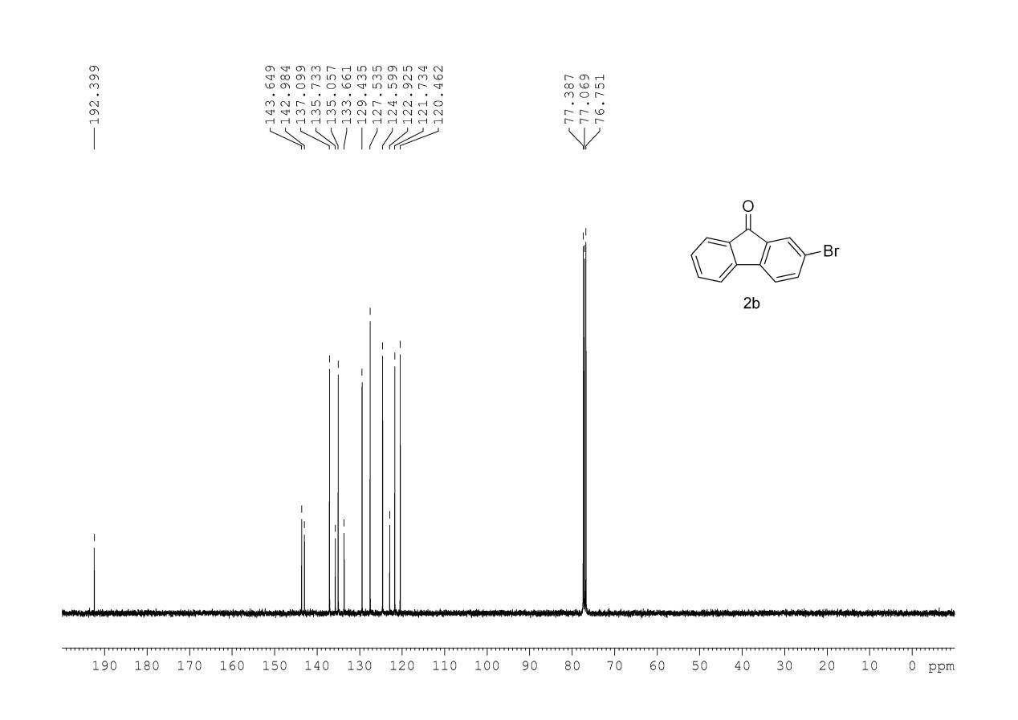

**2-iodo-9H-fluoren-9-one**

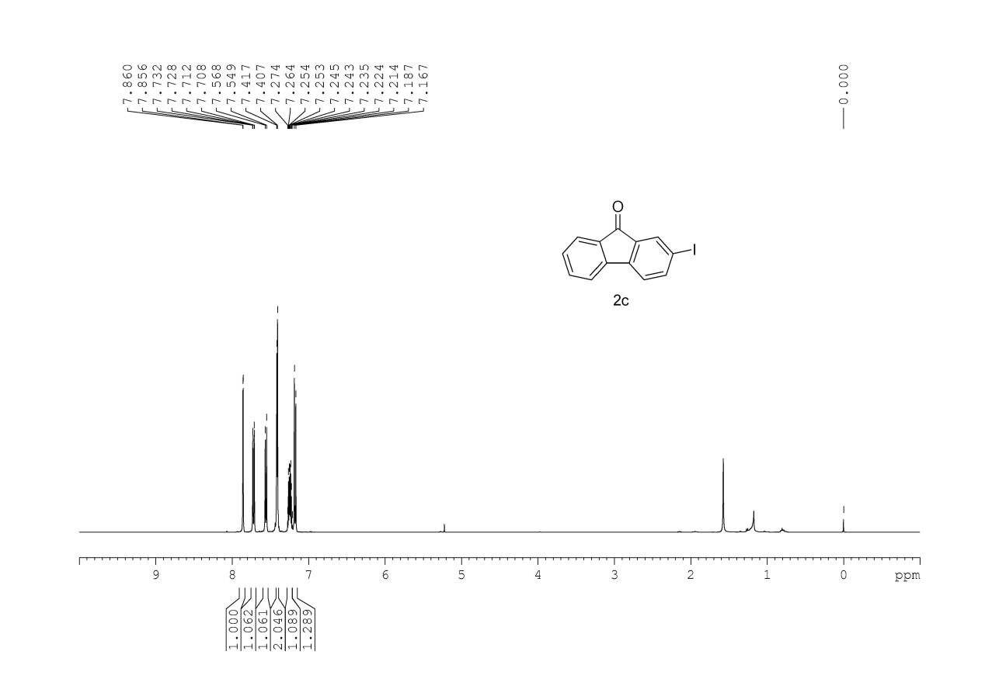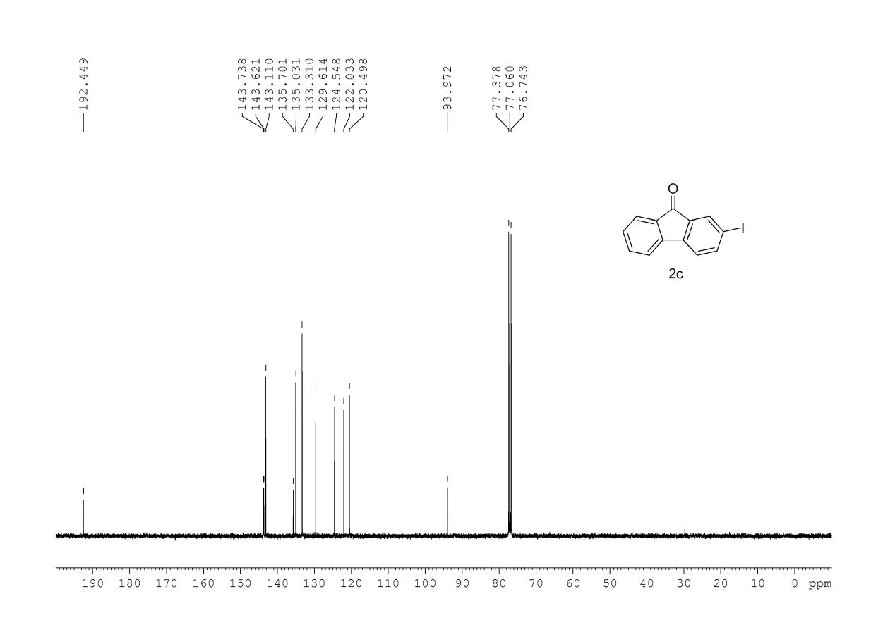

**2,7-dichloro-9H-fluoren-9-one**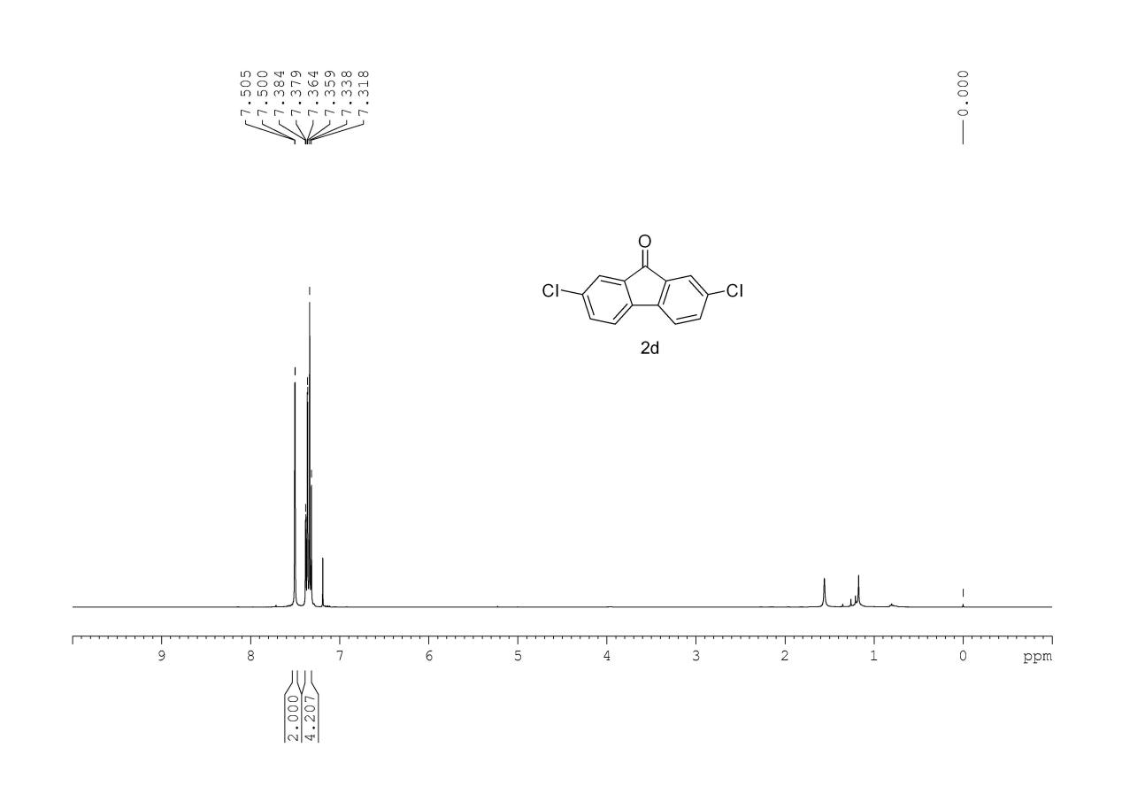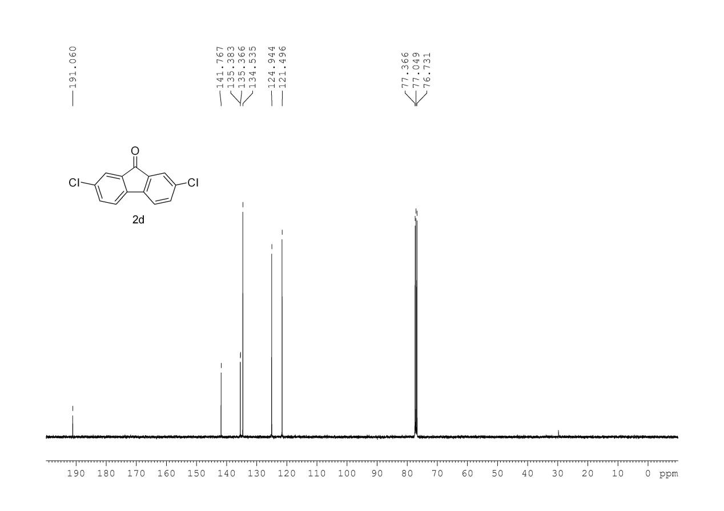

**2,7-dibromo-9H-fluoren-9-one**

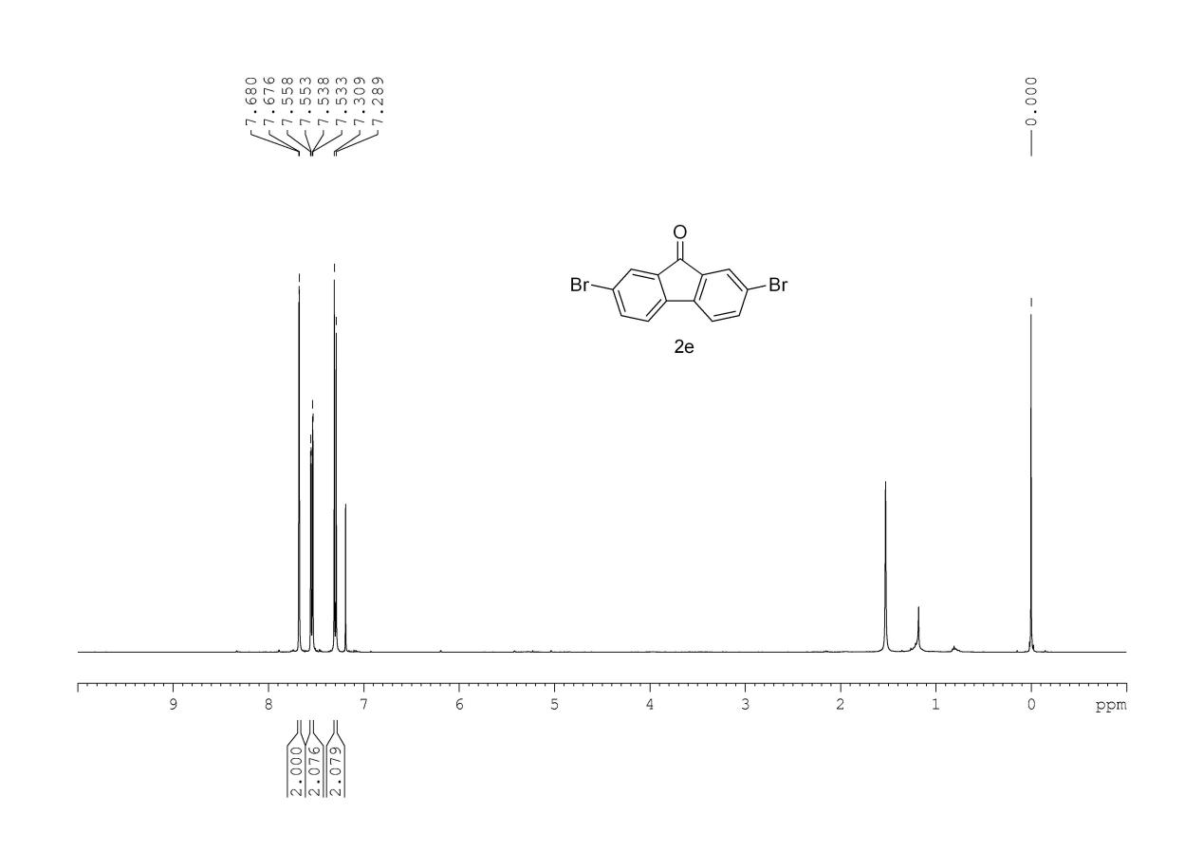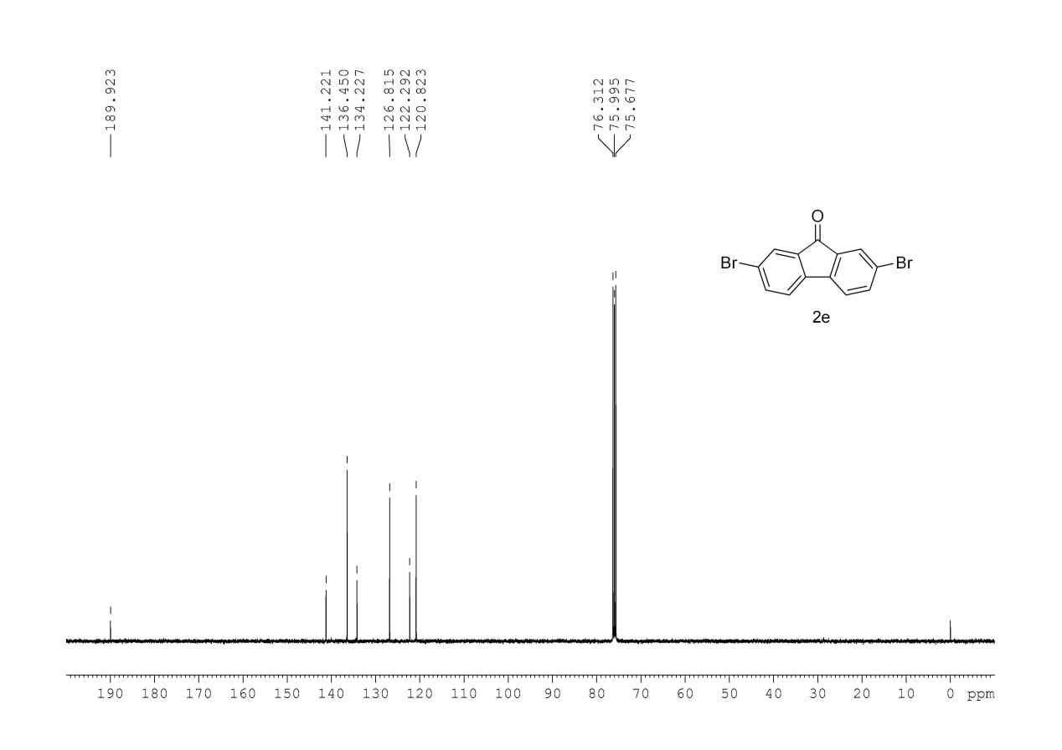

**2-bromo-7-iodo-9H-fluoren-9-one**

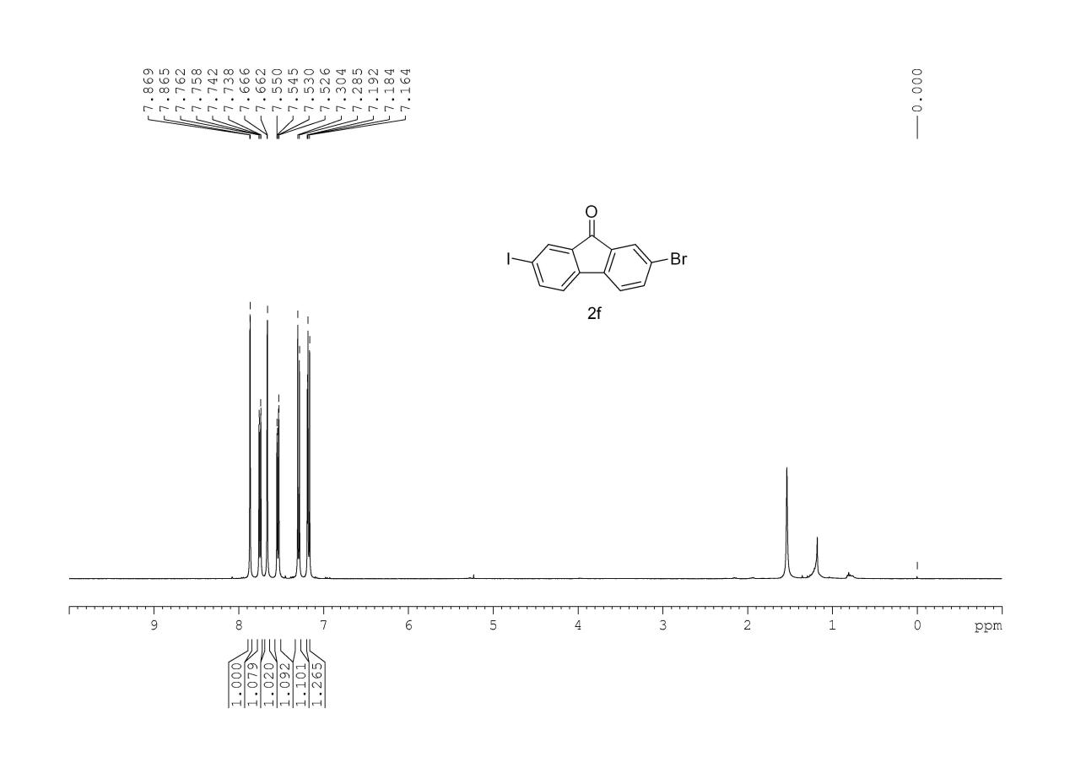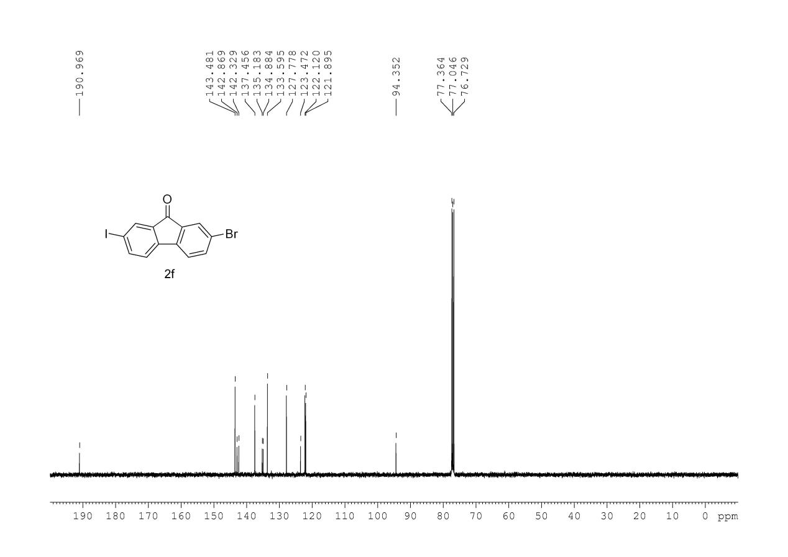

**2-nitro-9H-fluoren-9-one**

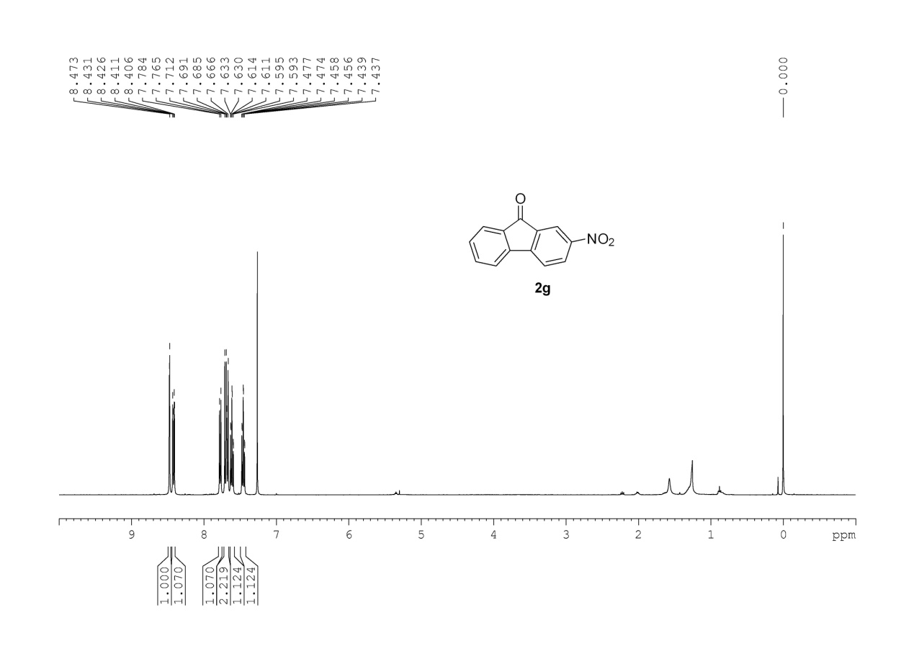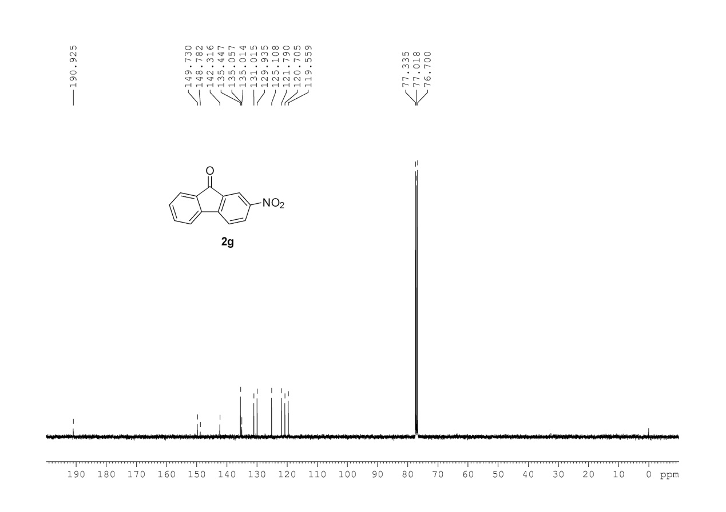

**2-acetyl-9H-fluoren-9-one**

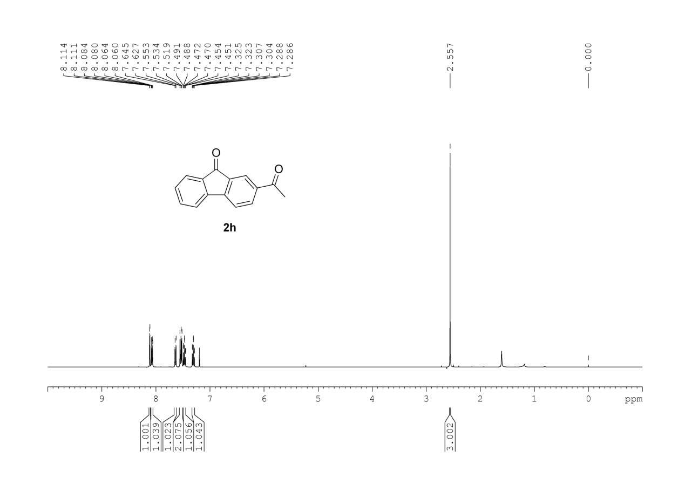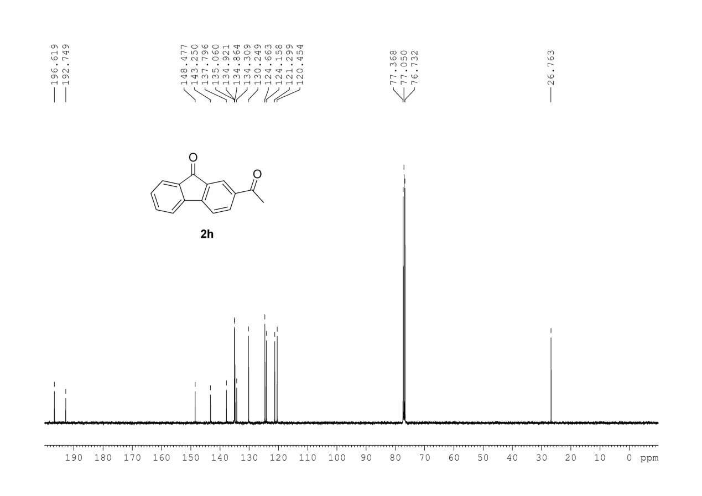

**2-amino-9H-fluoren-9-one**

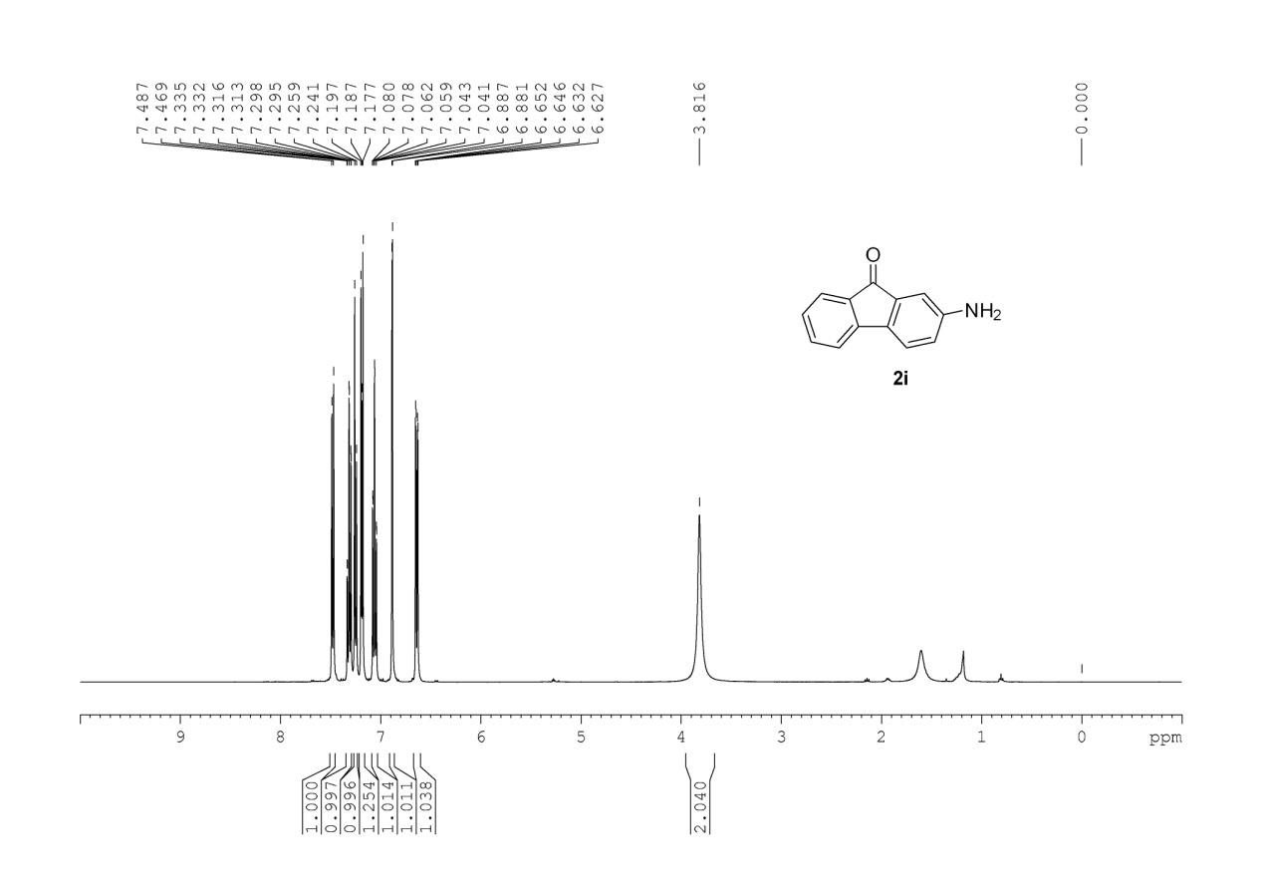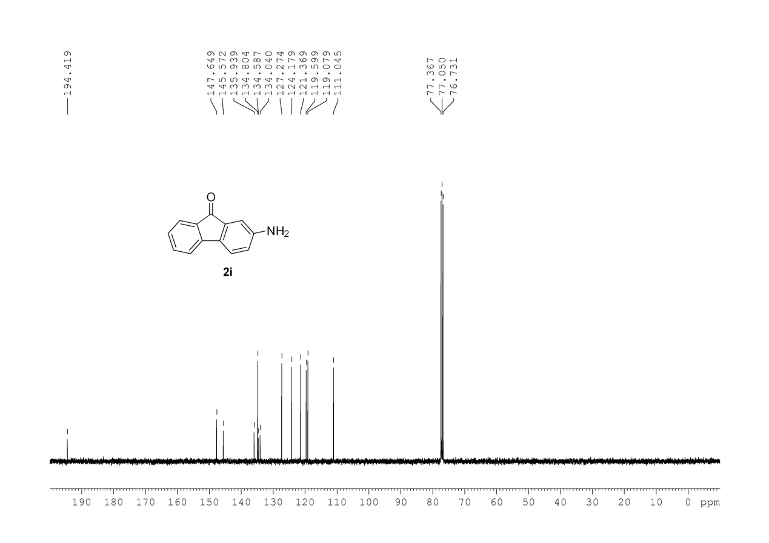

**2,7-di-tert-butyl-9H-fluoren-9-one**

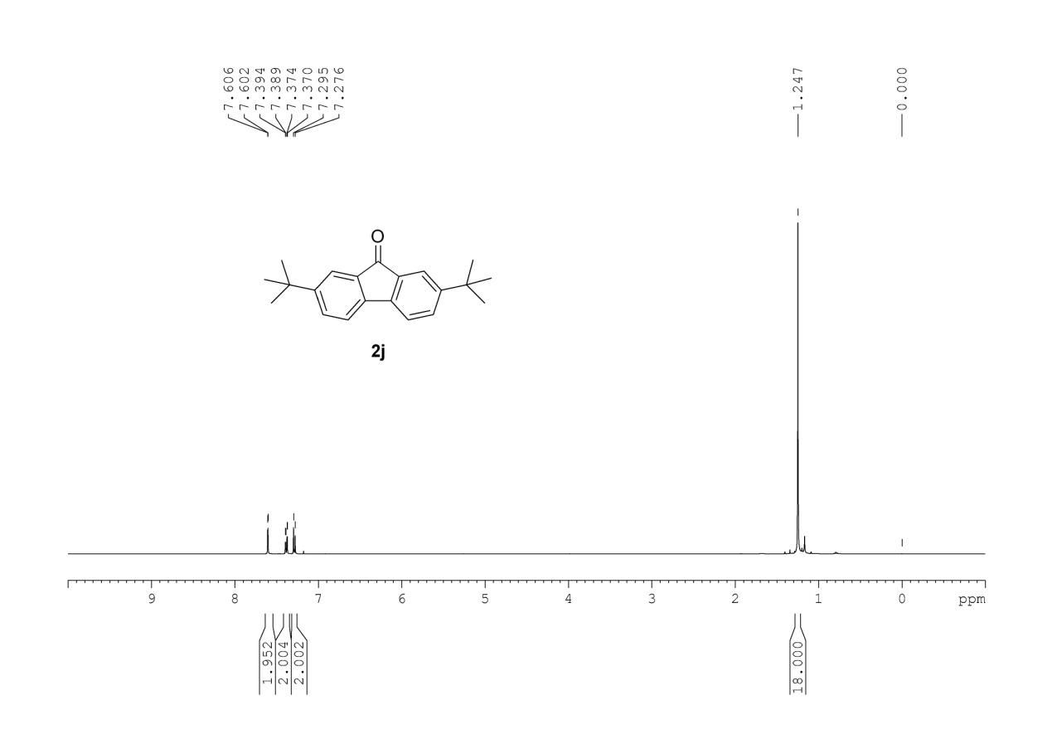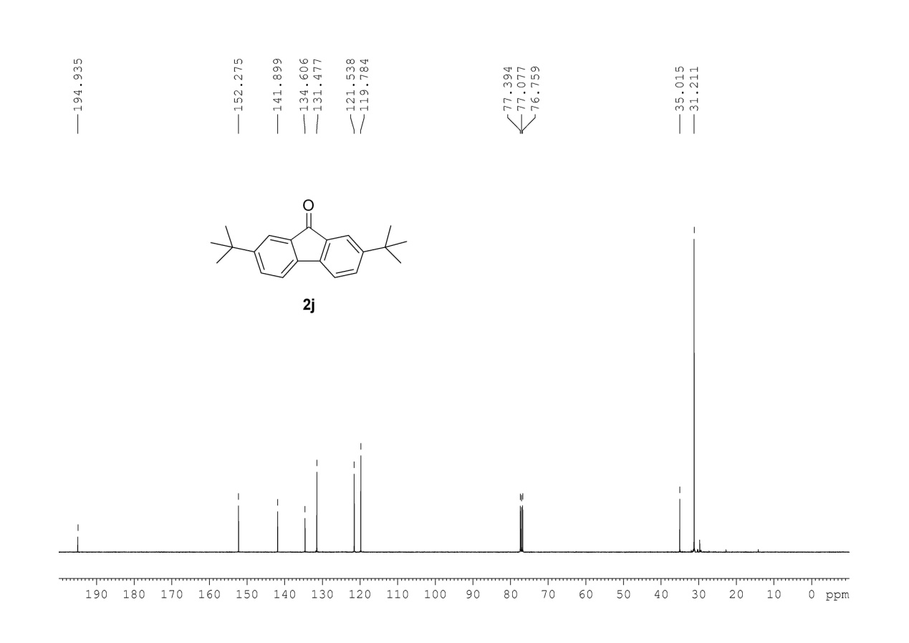

**4-bromo-2,7-di-tert-butyl-9H-fluoren-9-one**

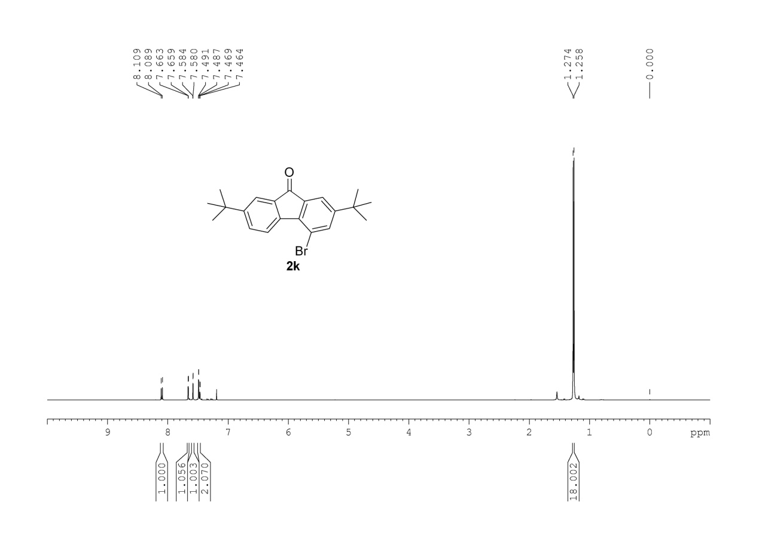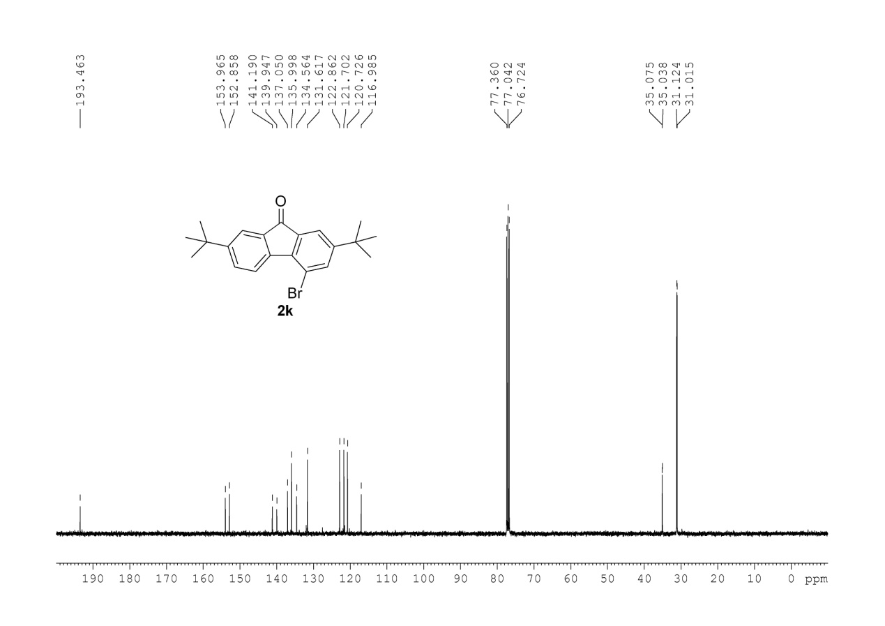

**2-phenyl-9H-fluoren-9-one**

1. 