Sequence stratigraphic approaches and sedimentary facies modeling of Campanian/Maastrichtian hydrocarbon-bearing sandstones, Arshad area, Central Sirt Basin, Libya
Burki, M.¹and Abu-Khadra, A.²
¹Geology Department, Cairo University, Cairo-Egypt & Sirte Oil Co., Libya (miladburki@yahoo.com)
²Geology Department, Faculty of Science, Cairo University, Giza-Egypt (abukhadra@sci.cu.edu.eg)
ABSTRACT
Sequence stratigraphic analysis has been used to support the reservoir geological modeling of the Upper Cretaceous succession of the Arshad area, Central Sirt Basin, Libya. Four major sedimentary cycles (1 to 4) can be distinguished in the succession of the Arshad area which can be related to the standard Mesozoic cycle charts. These cycles are bounded by five sequence boundaries (SB types 1 and 2). Sedimentary cycle number 1 is represented by retrogradational patterns (shale and minor carbonates) at the base of the Arshad Formation, which pinch out to the south. Sedimentary cycle number 2 comprises a prograding pattern in the lower part (Arshad Formation) passing upward into retrograding patterns of the Sirte Formation in the upper part. This cycle includes reworked clastics of the underlying (Cambro-Ordovician) Gargaf Formation. These sandstone-dominated shallow-marine facies include the principal hydrocarbon-bearing reservoirs in the study area. The sedimentary cycles nos. 3 and 4 are composed mainly of shales and limestones (Sirte and Kalash formations), representing the main hydrocarbon source rocks and cap rocks for the underlying sandstone reservoirs in the Central Sirt Basin. These sediments trace the sea level changes, and increasing water depth above the major Hercynian sequence boundary. These sedimentary cycles are affected by syn-depositional tectonics which control the distribution of the hydrocarbon-bearing sands plus post-depositional changes (diagenesis) which affect the reservoir quality and performance (porosity-permeability relationship).
Key words: Sequence stratigraphy; Upper Cretaceous; Arshad; hydrocarbon reservoir; Sirt Basin, Libya.
1- Introduction
The study area covers an area of approximately 900 km² and it is located in the Central Sirt Basin (Fig. 1). It lies between latitudes 29°00’and 30°00’ N and longitudes 19°40’and 20°00’ E, between two major fields, the Attahaddy gas field to the north and the Lehib oil field to the south (Fig. 1b).
The term Arshad Formation is restricted to the Arshad area and was first used informally by Sirte Oil Company for a part of Upper Cretaceous sequence (e. g., Keskin and Abugares, 1987: Burki, 2003). It consists mainly of fine to medium-grained detrital quartz sandstone with occasional coarse to very coarse grains. The sandstones are quartz-arenites with porosity ranges from poor to good (Burki, 2014). The sandstones range in thickness between 398’ the in Cy-2 well to 23’ in Cy-7 well. The sandstone occasionally contains shale and carbonate.
The main objective of the present work is to re-interpret the syn-rift Cretaceous succession in terms of cyclo-sequence stratigraphic concepts, in order to establish vertical stacking patterns for the hydrocarbon-bearing clastic sediments. This will assist the identification of potential reservoirs in the Central Sirt Basin.
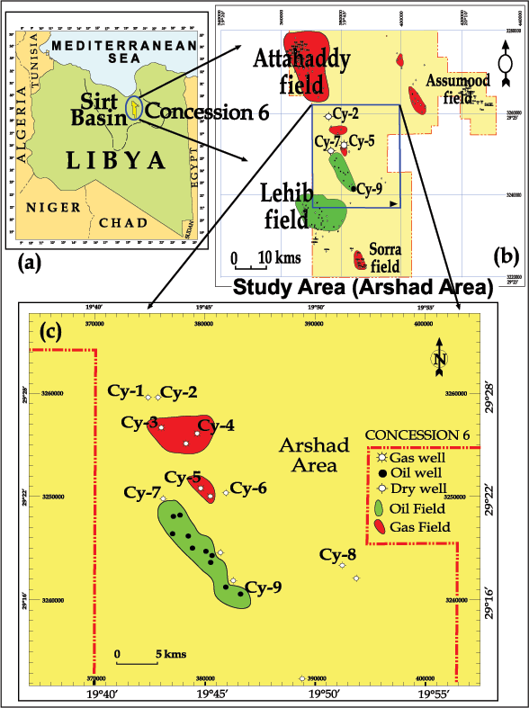
Fig.1. Location map of the study area in; (a) Sirt Basin in Central Libya,
(b) Central Concession 6 in the Sirt Basin including the fields, and
(c) Location of the selected wells in the Arshad area.
The study focuses on the Upper Cretaceous sequence and the bounding unconformities within the Arshad area. The available data set has been integrated and then subjected to sedimentary facies analysis using wireline logs and conventional cores from the sandstone reservoir in the Arshad area.
The succession has a unique depositional history that reflects the response to depositional processes and other factors, including tectonics, climate, sediment supply and global eustatic sea level fluctuations (Nio et al., 2005). These factors resulted in cyclic patterns within the depositional sequences. The integration of the data sets, including seismic reflection profiles and wireline log data permit the construction of a hydrocarbon reservoir geological model for the Arshad area.
A 3D seismic programme was acquired by Sirte Oil Company (SOC) in 2002 which led to a better understanding of the complexity of the structures and hydrocarbon traps. Internal company reports on the subsurface of the Arshad area have been produced by Keskin and Abugares (1987) and Burki (2003). Regional studies of the petroleum geology and geochemistry of the Mesozoic source rocks and hydrocarbons have been conducted in the Sirt Basin by Sikander et al. (2013) and Khaled et al. (2014). The present work adds the concept of cyclo-sequence stratigraphy to the earlier work in an attempt to better define the reservoir potential of the Central Sirt Basin, specifically in the Arshad area.
2- Methodology and data source
The present study is based on Cyclolog® software, a proprietary method of log correlation and interpretation developed by ENRES in the Netherlands which can be used to identify sequence boundaries, lithology changes and changes in sedimentation rate. Its use of Integrated Prediction Error Filter Analysis (INPEFA) allows for a faster and more accurate interpretation of facies sensitive well logs. INPEFA permits the definition of major truncation and inflection events that can be correlated over the study area based on the progradation and retrogradation patterns from the Gamma Ray and INPEFA log patterns.
Biostratigraphic data in the studied wells is poor and does not provide sufficient constraints to enable meaningful well correlation. Here, for the first time, the application of cyclo-sequence stratigraphy has been used to determine the distribution of hydrocarbon reservoirs in the Arshad area. The sequence studied consists of clastic-dominated reservoirs, overlain by marine Upper Cretaceous shales and carbonates. The stratigraphic interpretation is based on the Gamma Ray, Sonic, Density and Neutron logs, for which the CycloLog® computes a Prediction Error Filter Analysis (PEFA) value. By numerically integrating and normalizing the PEFA curve a new curve can be generated called an Integrated Prediction Error Filter (INPEFA) log which shows trends not apparent on standard log traces, and which provides an excellent means of correlation between wells (Nio et al., 2005). The available log data are integrated with core data and the prediction error filter analysis (PEFA) curve can be interpreted geologically as an indicator of the continuity or otherwise of the stratigraphic succession - larger errors imply more significant breaks in the succession. The interpretation of INPEFA curves, therefore, focuses on identifying breaks in the succession and trends rather than on finding identical patterns (Nio et al.,op.cit). A total of 9 wells (Cy-1, 2, 3, 4, 5, 6, 7, 8 and Cy-9) were selected (Fig. 1c) for the Cyclolog® study, both PEFA- and INPEFA patterns where major truncations and inflection events could be correlated across the study area. This greatly assists the recognition of both siliciclastic and carbonate depositional patterns.
3- Geological setting
The stratigraphic and lithologic sequence is differentiated into Cambro-Ordovician quartizites unconformably overlain by Upper Cretaceous and Tertiary deposits across the Arshad area (Fig. 2). The Upper Cretaceous sandstones, carbonates and shales are the most important part of the succession in the study area, since the sandstones form the main hydrocarbon bearing reservoirs, and the shales form the principal source rocks.
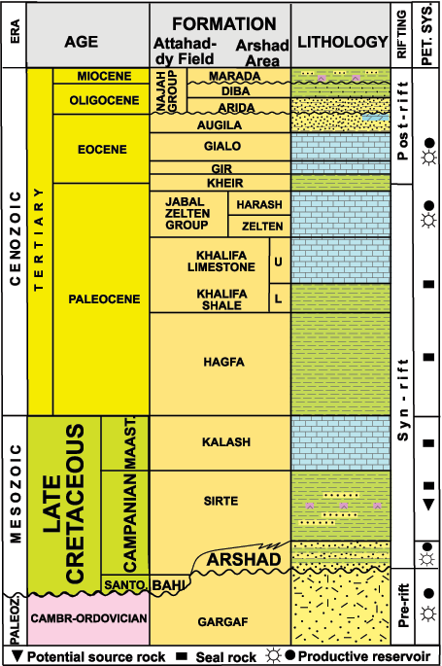
Fig. 2. Stratigraphic section of the study area
(After Sirte Oil Co., with modification).
The Arshad area is bounded by series of NW-SE fault systems superimposed on a Paleozoic high (Klitzsch, 1971; Goudarzi, 1980). The Arshad area is a significant horst block trending approximately northwest-southeast Kalash Formation level (late Maastrichtian) with additional minor faulting present below that level as shown on the 3D seismic data and on the structure contour maps of top Arshad Formation (Campanian) from existing 2D data and from well data (Fig. 3).
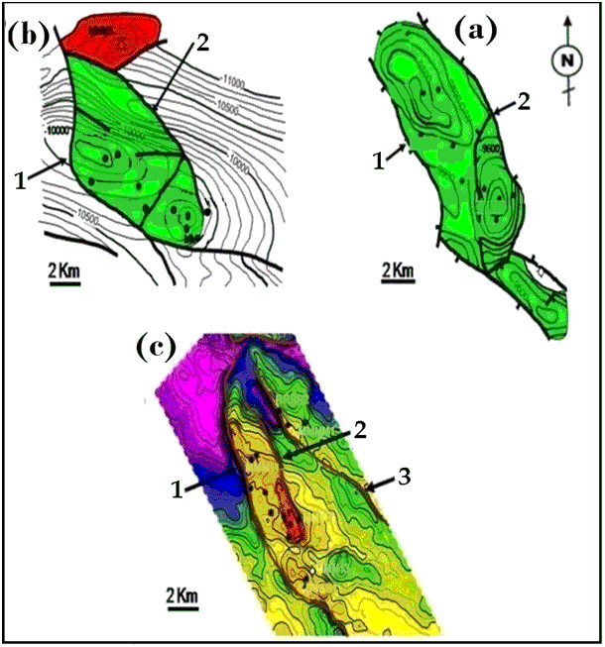
Fig. 3 Structure contour maps of the top Arshad Formation (a, b and c) showing the NW-SE trend based on; (a, b) 2D seismic interpretation and wells data (SOC-Exploration, 1986 & 1992) and (c) 3D seismic interpretation (SOC-Exploration, 2005). Bar scale 2 km each.
4- Interpretation from Cyclolog® patterns
4. 1. Sequence stratigraphic surfaces
The principal sequence boundary in the Arshad area, as shown by core data is the Hercynian unconformity, recorded at depth 10,304’ in core # 2 in the Cy-7 well (Fig. 4). It is characterized by the presence of conglomerates with gravel-size sandstone clasts and are commonly structureless and fractured with a lack of burrows. They rest directly on the Paleozoic Gargaf Formation. The composition of the pebbles and cobbles is similar to that of the Gargaf Formation, indicating reworking as the source of these sediments.
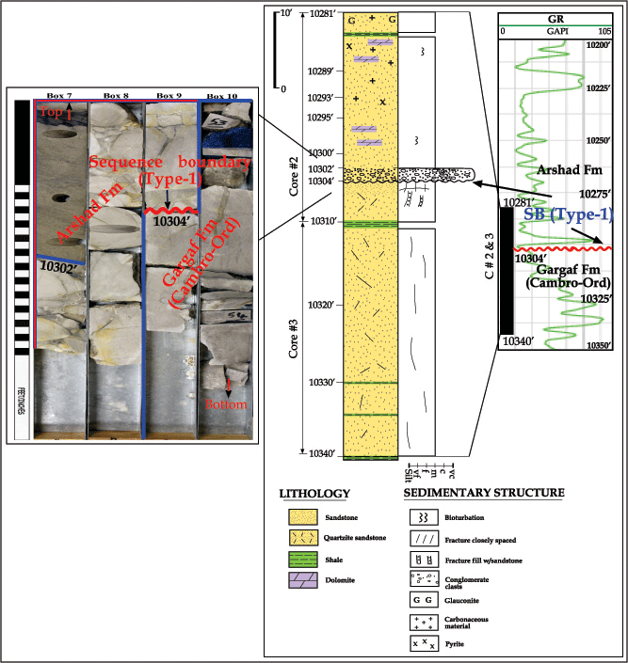
Fig 4. Sedimentological log of cored interval (10,281’-10,340’); cores # 2 and 3 from Cy-7 well showing lithology, sedimentary structures of Arshad Formation above SB Type-1 (Hercynian boundary) at depth 10,304’ (After Burki, 2014).
The character of the conglomerate with a general lack of structure, absence of marine sediments and trace fossils and shales are indicative of deposition as an alluvial fan (Burki, 2014; Burki and Derwish, 2017). This surface forms the boundary between the Cambro-Ordovician Gargaf quartzitic sandstones and the Upper Cretaceous calcareous, dolomitic sandstones and represents a major sequence boundary (SB-1, Type 1, Vail et al., 1977; Van Wagoner et al., 1988). It is possible to correlate this sequence boundary in wells where the Gargaf Formation was penetrated over large area in the Central Sirt Basin.
The Cambro-Ordovician Gargaf quartzitic sandstones subcrop the Hercynian unconformity over much of the Central Sirt Basin (Selley, 1998), marking an extended period of erosion during the Late Paleozoic (Roberts, 1970). It reflects a major marine regression when sea-level fell below the depositional shoreline break (Vail, et al., 1991) and is reflected in an abrupt shallowing of the lithofacies across the boundary (Van Wagoner et al., 1990). In fact, the sequence boundary may be difficult to recognize from the wireline logs alone (Emery and Myers, 1996) as there is no set of diagnostic responses, but evidence of a sequence boundary is clear from conventional cores (Rider, 1996).
Key sequence boundaries can be recognized on PEFA patterns. Each pattern has a series of truncation surfaces represented by positive and negative trends on the PEFA, where the negative breaks indicate inflection (truncation or erosional surfaces), while flooding is shown by the positive PEFA peaks as illustrated in Figure 5. These patterns reflect an interaction between accommodation space and sediment supply (Fig. 5).
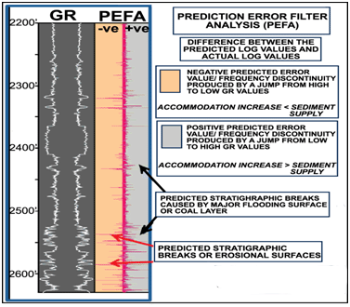
Fig. 5. Negative and positive breaks as being recognized on PEFA (Prediction
Error Filter Analysis) patterns vs the Gamma ray mirror image (Nio et al., 2005).
The INPEFA curve of the selected wells shows progradational and retrogradational depositional patterns with a near-absence of aggradational patterns in the area, as shown in Figure 7. The Upper Cretaceous succession is frequently bounded by surfaces of different hierarchical levels. The term maximum flooding surface (MFS) was introduced as by Galloway (1989) and Embry (2001) which marks the change from a transgressive trend below to a regressive one above. It is important to note that the maximum flooding surface (maximum extent of sea-level rise) often coincides with the maximum diversity and abundance of bio-taxa.
Sirte Oil Company (SOC) established a local stratigraphy for the Arshad area for sequences that unconformably overlie the Cambro-Ordovician Gargaf Formation (Roberts, 1970; Selley, 1998). The Campanian-Maastrichtian sequences (Fig. 2) comprise the Arshad, Sirte and Kalash formations. The Mesozoic-Cenozoic cycle charts of Vail, 1978; Haq, 1991 and Waite, 2002, show that these sequences can be correlated with the Upper Zuni, 2nd order super cycles (UZ A-3 and UZ A-4) of North America. The Campanian cycles (84-74 Ma) include five 3rd order cycles 3.4-3.5 and 4.1-4.3, while the Maastrichtian cycles (74-66.5 Ma) include two 3rd order cycles 4.4 and 4.5 (Fig. 6). Using the biostratigraphic results (Barr and Weegar, 1972; Sikander et al., 2013; Hallett and Clark Lowes, 2016) integrated with CycloLog® (PEFA and INPEFA curves, Figs. 5&7), these 3rd order cycles can be distinguished based on the major inflection trends and truncation events. Reviewing the study sequences, five major sequence boundaries (Types 1 and 2) can be recognized and identified (Fig. 6 & 7).
1- SB-1 (Type-1) at the base of the Arshad Formation (Hercynian unconformity).
2- SB-2 (Type-2) at the top of the 3rd order cycle 3.4 (85 Ma) in well Cy-1 in the north which changes to Type-1 on the Paleozoic platform in the south.
3- SB-3 (Type-1) at the top of the 3rd order cycle 3.5 (80 Ma).
4- SB-4 (Type-2) at the top of the 3rd order cycle 4.3 (74 Ma), at the top of the Sirte Formation.
5- SB-5 (Type 1) at the top of the 3rd order cycle 4.5 (about 66.5 Ma) at the top of the Kalash Formation.
The sedimentary cycles can be distinguished into four 3rd order cycles which correlate with the UZA-3 (3.4 and 3.5) and UZA-4 (4.1-4.5) cycles and which are commonly bounded by stratigraphic inflection patterns on PEFA and INPEFA. The depositional patterns reflect the distribution of the sediments in each cycle, and are shown to be variable in their thickness, and absent in some wells (e. g. Cy-1 well), probably due to tectonic uplift and subsequent erosion and/or faulting. Based on the stratigraphic inflection patterns (INPEFA curves), four 3rd order cycles can be distinguished and correlated in the study wells within the Mesozoic cycle (Fig. 6). The top of the Kalash Formation is considered by Barr and Weeger (1972) as conformable with the Paleocene Hagfa Formation while Hallett and Clark Lowes (2016) maintain that this boundary is unconformable.
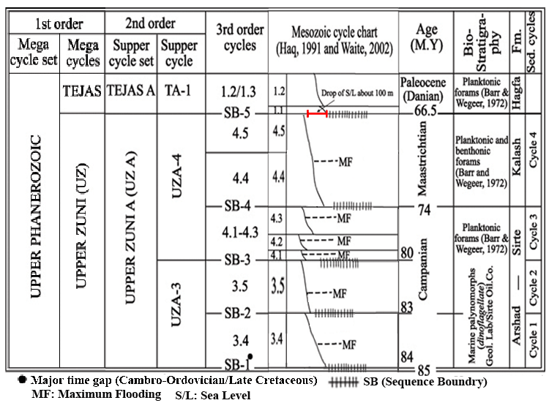
Fig. 6. Sedimentary cycle and sequences boundary of Arshad area (Late Cretaceous/
Paleocene) based on Mesozoic cycle chart (After Vail, 1978; Haq, 1991; Waite, 2002).
Based on the Tethyan cycle chart (Vail, 1978; Haq, 1991; Waite, 2002), the Cretaceous/Tertiary boundary represents a rapid drop of sea level of about (100 m) and is marked by an unconformity between the Maastrichtian and the Paleocene (Fig. 6). The facies/distribution of the Danian Hagfa Formation is controlled by the paleogeography of the early Paleocene, which is significantly different from that of the Late Cretaceous Tawadros (2001, 2011) and (Hallett and Clark Lowes, 2016).
4. 2. Major sedimentary cycles
Based on INPEFA trends (progradation and retrogradation patterns), four major Cretaceous sedimentary cycles (1 to 4) are recognized. Each sedimentary cycle is bounded by sequence boundary. They can be correlated between selected wells in the Arshad area (Fig. 7). Table 1 illustrates the depth intervals and thicknesses of these cycles in the selected wells.
4. 2.1. Sedimentary cycle no. 1
Cycle No 1 is recognized in the Cy-1 well with a recorded thickness of 395 feet (Table 1) in the northern sedimentary depression near to the Attahaddy field. It is a shale-dominated succession with thin beds of sandstone. It represents a shallow marine transgressive systems tract above the irregular Paleozoic unconformity.
Cycle no. 1 is bounded by SB-1 (Type 1, Hercynian unconformity) at the base and SB-2 (Type 2) at the top (Fig. 7).
Lateral correlation between wells reveals that cycle no. 1 pinches out southwards (Fig. 7). On the INPEFA curve it shows a slightly serrated aggrading to retrograding pattern, denoting an almost balanced system between sediment accumulation and accommodation with a slight decrease in sediment influx upwards. Close to the top a noticeable negative inflection in a prograding sand body (Fig. 7), denotes a pronounced shift in the depositional system. It is correlated with the 3rd order cycle UZA-3 (3.4). The northwest-southeast correlation profile shows the absence of this cycle on the Paleozoic platform, probably due to the presence of a structural high in this area.
Table 1. Depth intervals and thicknesses of the four major sedimentary
cycles in the study Arshad wells.
Sedi. Cycle  Well | Cycle no. 1 | Cycle no. 2 | Cycle no. 3 | Cycle no. 4
Cy-1 | 11950'-12345' (395') | 11368'-11950' *(582') | 11030'-11368' (608') | 11030'-10570' (460')
Cy-2 | NR | 10796'-11708' (912') | 10796'-10563' (233') | 10271'-10796' (525')
Cy-4 | Missing | 10527'-11452' * (925') | 10297'-10527' (230') | 10087'-10297' (208')
Cy-5 | NR | 11009’-10376' (633') | 10179'-10376' (197') | 10179'-9946' (233')
Cy-6 | Missing | 10442'-11315' * (873') | 10240'-10442' (202') | 10085'-10240' (155’)
Cy-7 | Missing | 10140'-10304' * (164') | 9921'-10140' (219') | 9760'-9921' (161')
Cy-8 | NR | 10504'-10085' (424') | 9813'-10085' (272') | 9813'-10085' (175’)
Cy-9 | NR | 10675'-10865' (190') | 10267'-10675' (408') | 10276'-9940' (327')
* Complete measured section of sedimentary cycle no. 2.
NR: Not reached the base of sedimentary cycle no. 2.
4. 2.2. Sedimentary cycle no. 2
The sedimentary cycle no. 2 consists mainly of a sandstone-dominated succession of the Arshad Formation in the lower part, followed by a shale-dominated Sirte Formation with minor carbonate interbeds in the upper part. The maximum thickness of cycle no. 2 is 925' recorded in Cy-4 well (Fig. 7 and Table 1). The minimum thickness is 164' penetrated in the Cy-7 well on the paleo-high structure (Fig. 7 and Table 1). It is bounded at the base by SB-2 (Type 2) in well Cy-1, and Type 1 in wells Cy-3, Cy-4, Cy-7 and Cy-6 on the Paleozoic platform, and SB-3 (Type 1) at the top (Figs. 7 and 8).
The isopach maps of this cycle (Figs. 9a, b and c) show a northwest-southeast depocentre thinning to both east and west, in both the Arshad and Sirte formations which corresponds to the structural trend shown on Fig. 3.
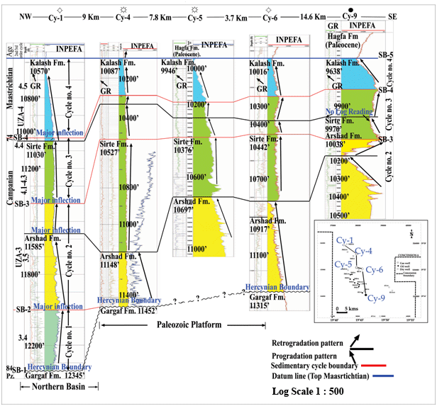
Fig.7. NW-SE correlation profile showing lateral distribution of the major sedimentary cycles (1-4) in Arshad area (Late Cretaceous/Paleocene), based on INPEFA progradation and retrogradation patterns. Datum line is the top of the Maastrichtian (Kalash Fm.).
Cycle No 2 includes reworked clastics from the underlying Paleozoic Gargaf Formation, as shown by core samples (Fig. 4) formed as a result of rapid sea level raise.
This sedimentary cycle is considered the most significant part of the studied succession as it includes the hydrocarbon-bearing sandstones, and the main top seal of the Arshad-Sirte petroleum system (Burki, 2014; Khaled et al., 2014). The shale was deposited as a major flooding event during Campanian time.
It is a prograding systems tract in which the rate of sediment supply was much greater than basin accommodation (Fig. 8). On the other hand, the uppermost sequence (Sirte Formation) shows a change retrograding patterns of under-filled basin type as the rate of sediment fill decreased relative to the accommodation space available (Figs. 3 and 9).
Cycle No 2 is represented by two INPEFA curve patterns, a lower prograding system that grades up to a retrograding trend (Fig. 8).
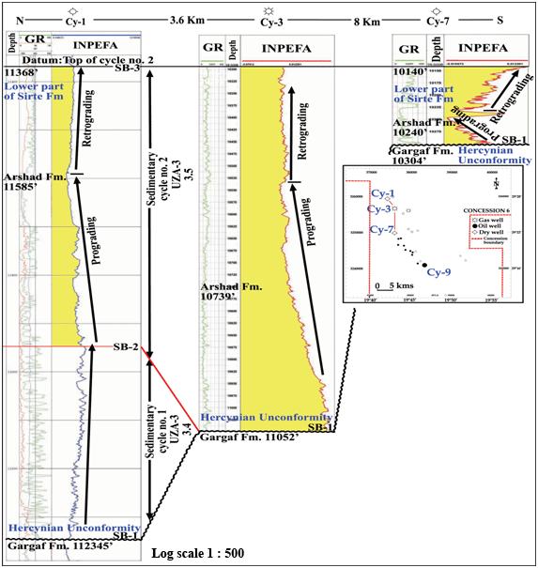
Fig. 8. A North to South cross-section profile showing the complete measured section of the sedimentary cycle no. 2 that bounded at the base by BS-1/2 and at the top by SB-3, based on INPEFA progradation and retrogradation patterns.
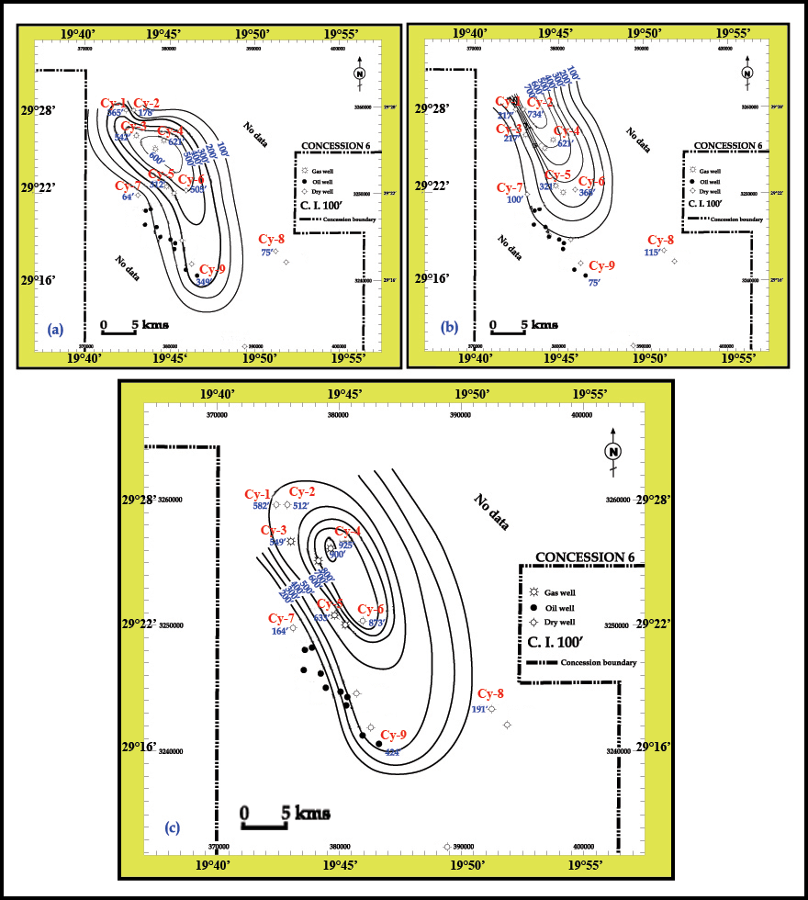
Fig. 9. Isopach maps for (a) total prograding pattern (Arshad Fm) (b) total retrograding pattern (Sirte Fm) and (c) total sedimentary cycle no. 2, Arshad area, Sirt Basin.
4. 2. 3. Sedimentary cycle no. 3
Sedimentary cycle No 3 consists of sediments of both the upper part of the Sirte Formation and the lower part of Kalash Formation. It is dominated characterized by shales with minor carbonates in both parts of the sequence (Campanian to Maastrichtian in age).
The maximum penetrated thickness is 608' in the Cy-1 well towards the northern sub-basin and a minimum thickness of 197' is recorded in the Cy-5 well in the central area (Table 1). The isopach map shows the sediment distribution (Fig. 10). Cycle no. 3 is thick in the eastern depocentre, but thins to the west. It is bounded by SB-3 at its base and SB-4 at top (Figs. 7), and forms the hydrocarbon source rock and cap rock for many underlying producing reservoirs in the Central Sirt Basin.
Cycle no. 3 is represented by a prograding INPEFA pattern followed by a retrograding INPEFA system in the lower part of Kalash Formation (Figs. 7). The prograding and retrograding patterns in this cycle consist mainly of Sirte Formation in the north, in the Cy-1 well, to limestone-dominated lower Kalash Formation in the area between Cy-4 to Cy-6 wells (Fig. 7). The Cy-9 well (Fig. 7), in the south shows a similar prograding pattern in the upper Sirte Formation and a retrograding trend of the lower Kalash sediments.
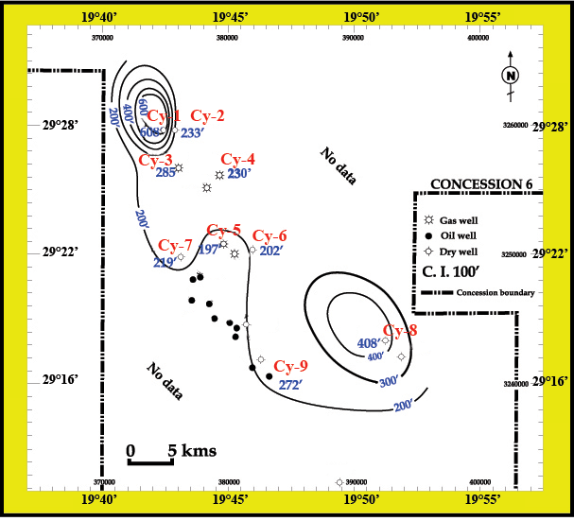
Fig. 10. Isopach map of sedimentary cycle no. 3
4. 2. 4. Sedimentary cycle no. 4
Cycle No 4 represents the upper part of the Maastrichtian Kalash Formation (Fig. 7). It is marked at the top by SB-5 (Type-1), a surface which is widespread in the Central Sirt Basin where the Kalash Formation is found over most of the basin.
The isopach map shows the sediment distribution (Fig. 11), where the maximum penetrated thickness of 525’ is in the Cy-2 well and the minimum of 161’ is recorded in the Cy-7 well (Table 1). As in cycles 1 to 3 it thins from the eastern depocentre towards the west. It is believed that this cycle was affected by structural activity which created the north-south trends. The Kalash Formation is a widely mappable deep seismic reflector in the Arshad area. The widespread distribution of Kalash Formation over much of the platform and basins suggests that tectonics were relatively interactive during Maastrichtian time (Gumati et al., 1985).
Cycle no. 4 forms an effective cap rock for many underlying producing reservoirs in the Central Sirt Basin, where the Sirte Formation is absent.
The cycle is characterized by a prominent INPEFA log pattern of a prograding system (Fig. 7). There is no retrograding system in the study area, most probably due to erosion as a result of a rapid drop of sea level (Fig. 7). Wennekers et al. (1996) pointed out that the Danian Hagfa Formation unconformably overlies Kalash Formation, and this eroded surface has locally removed part of the Maastrichtian rocks in this part of the basin.
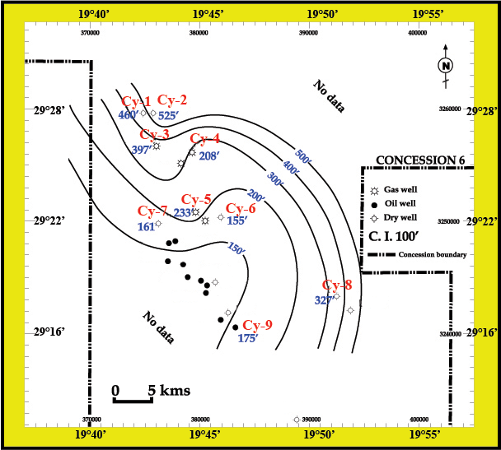
Fig. 11. Isopach map of sedimentary cycle no. 4.
5. Hydrocarbon-bearing sandstone reservoirs: cyclicity distribution
The sedimentary cycles (1-4) consist of variable lithologies (sandstones, shales and carbonates). Each cycle includes shallowing-upward packages, passing in to deepening-upward trends (coarsening-upward overlain by fining-upward sequences). On the wireline logs, the common feature of a complete cycle is a gradual decrease followed by an increase in gamma ray values which reflects a change in the energy of the depositional environment. It also reflects a landward retreat of shorelines, (progradation) in the lower part of each cycle, followed by a retrograding trend in the upper part as a function of a gradual sea-level rise. The advantage of the Cyclolog and cyclicity interpretation is the ability to identify the lateral and vertical distribution of hydrocarbon reservoirs in the Arshad area based on a reliable depositional model.
The isopach maps of the major sedimentary cycles; 2, 3, 4 (Figs. 9-11) confirm the role of syn-depositional tectonic events combined with the sea-level changes and the shifting of the depocentres in the sub-basin. These maps show the depositional trends in the Arshad area during the Campanian-Maastrichtian events. The Cyclolog interpretation of the Upper Cretaceous sequence suggests that syn-depositional tectonics controlled the distribution of the hydrocarbon-bearing sands in time and space. However, post-depositional deformation also occurred forming the anticlinal features, and enhancing the potential for trapping hydrocarbons in the Arshad reservoirs.
The Upper Cretaceous sequence is the most important succession in the study area, since the sandstone of cycle number 2 forms the main hydrocarbon bearing reservoir, from which oil and gas accumulations are commercially produced. Furthermore, the Upper Cretaceous carbonates and shales representing cycles numbers 3 & 4 in the Arshad area are hydrocarbon source rocks and cap rocks.
6. Depositional model of the Arshad area, Central Sirt Basin.
The Upper Cretaceous succession in the Arshad area can be interpreted from the view point of its relation with the depositional model.
The stratigraphic and lithologic sequence is differentiated into Cambro-Ordovician quartizites followed by Upper Cretaceous deposits across the Arshad area. These are made up of sandstones, carbonates and shales of a syn-rift system represented by four sedimentary cycles. The interpretation shows that some units pinch out due to regional tectonic events that led to the absence of parts of the sequence in the study area.
Lateral correlation in the Lehib-Arshad-Attahaddy area, (SW-N trend) indicate that the Arshad Formation is absent toward the north on the Attahaddy structure toward the regional depocentre, due to erosion or non-deposition (Fig. 12). The formation is thought to be of limited extent.
The Sirte Formation of cycle number 3 in the Arshad area thickens significantly into the troughs and represents well-established hydrocarbon source rocks, and seals in the underlying reservoirs. The Maastrichtian Kalash Formation of cycle number 4 is widely present in the study area, and marks the top of the Mesozoic sequence. In the Lehib area, the Sirte Formation is absent due to the presence of a paleohigh. The Kalash unconformably rests on Paleozoic sandstones. The figure 12 block diagram and cross-section illustrate the geological evolution of the study area and neighbouring areas (Attahaddy and Lehib fields).
The Upper Cretaceous succession is characterized by repetitive episodes of progradation punctuated by periods of transgression and flooding over during periods of regional paleotectonic instability.
The tectonic events and global sea level changes are responsible for the distribution of the sedimentary cycles in the Arshad area. The Tethyan Sea repeatedly invaded the Arshad area from north to south during late Cretaceous time depositing shallow marine sequences (Spring and Hansen, 1998). The area was affected by relative sea level changes that alternately increased and decreased water depth, and by a change of sediment types (Van Wagner et al., 1988; Emery and Myer, 1996) above the Hercynian sequence boundary (Roberts, 1970; Selley, 1998).
Furthermore, during the initial rise of sea level (transgressive phase), the basal sandstones of the Arshad Formation (Cy-7 well, Fig. 4) of cycle number 2, which contain the main hydrocarbon reservoir were deposited unconformably on the Gargaf Formation (quartzitic sandstones) in the Arshad area. Cycle number 3 (Campanian Sirte Formation and early Maastrichtian Kalash Formation) shows both aggradation and progradation in the north, but a more complex retrograding-prograding-retrograding sequence in the south. Cycle number 4 (Kalash Formation) was deposited in open marine neritic conditions during Maastrichtian time (Barr and Weegar, 1972).
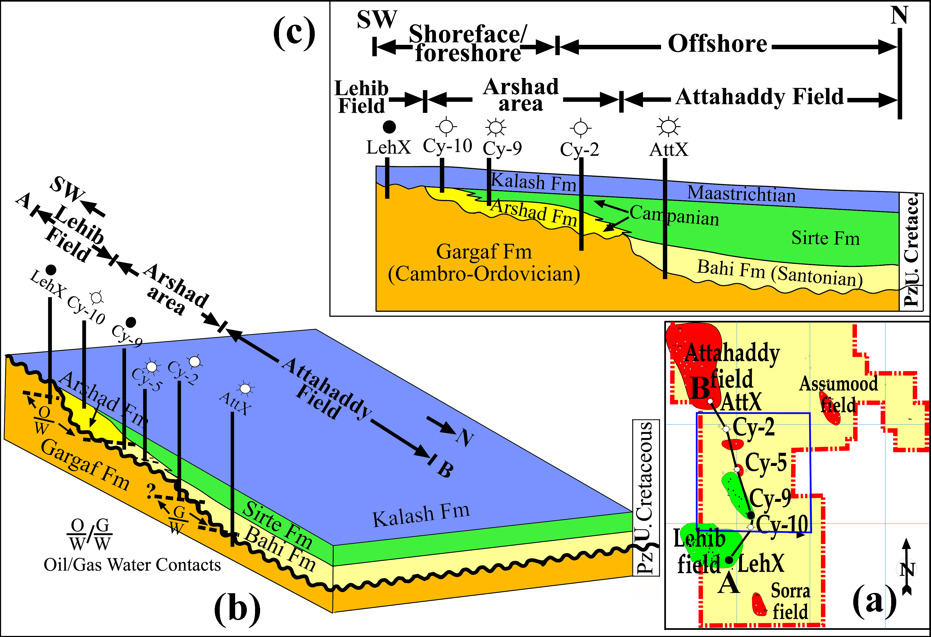
Fig. 12. Block diagram and cross-section illustrating the depositional model for Arshad and surrounding areas in Central Sirt Basin. Reference wells are not to scale. A-B schematic cross-section showing lateral and vertical distribution of the Upper Cretaceous chronostratigraphic sequence and the depositional settings in the area of study.
7. Conclusions
The Arshad area is located in the Central Sirt Basin, Libya and is bounded by a major NW-SE fault system and hosts several gas accumulations in the north and oil accumulations in the south. Cyclo-sequence stratigraphic analysis and interpretation has been used to model the stratigraphy and map individual sequences. Cyclolog® software techniques were applied to interpret and highlight the role of syn-depositional tectonics on the sediment distribution and to identify distinct depositional cycles. Based on the Cyclolog® interpretation including PEFA peaks and INPEFA (progradational and retrogradational) patterns, the Upper Cretaceous sequences are subdivided into four major sedimentary cycles bounded by five sequence boundaries (SB Types 1 and 2). Each cycle can be subdivided into progradational and retrogradational INPEFA patterns.
The sedimentary cycles were subdivided into seven 3rd order cycles of UZ A-3 (3.4-3.5) and UZ A-4 (4.1-4.5) which are commonly bounded by stratigraphic inflection PEFA peaks.
The major sedimentary cycle number 2 includes reworked material of the underlying Paleozoic Gargaf Formation. The lower part of sedimentary cycle number 2 consists of a sandstone-dominated sequence of the Arshad Formation, followed by the shale-dominated Sirte Formation with minor carbonate interbeds. It is considered as the main cycle in the succession as it includes hydrocarbon-bearing sandstones, and the main top seal. Sedimentary cycles 3 and 4 consist of shales and carbonates which provide the best hydrocarbon source rocks and seals the underlying reservoirs. The proposed depositional model (Fig. 12) of the Arshad area and its surroundings based no well correlations indicates that the Arshad Formation does not extend further to the north, but probably extends further to the south. The Upper Cretaceous was subjected to relative sea-level changes, fluctuation of water depth, and change of sediment type above the Hercynian sequence boundary. The Tethyan Sea repeatedly invaded the Central Sirt Basin from the north to south during the late Cretaceous depositing shallow marine sequences. The Upper Cretaceous succession was affected by marine transgressive and regressive phases which resulted in the deposition of the four cycles discussed in this paper.
Acknowledgement
The authors wish to thank National Oil Corporation (NOC) and Sirte Oil Company (SOC), Libya for providing the essential data for this study. Our special thanks go to Dr. Ed. Tawadros, Geological Consultant, Canada, Dr. Don Hallett, Consultant, UK, Prof. Dr. M. Darwish and Prof. Dr. S. Abdel-Wahab in Geology Department, Faculty of Science, Cairo University and Dr. Mustafa J. Salem, Professor of Geology at University of Tripoli-Libya for their comments and review of this paper.
References
Barr, F. T. and Weegar, A. A., 1972. Stratigraphic nomenclature of the Sirt Basin, Libya. Petr. Expl. Soci., Libya (PESL), 179pp.
Burki, M. M., 2003. Sedimentology, sequence stratigraphy and petrographic study of the Pre-Kalash sandstones (North Arshad-South Attahaddy), Concession 6, Sirt Basin. Sirte Oil Co. Geol. Repo. No. 290 (Unpublished). 25pp.
Burki, M. M., 2014. Petroleum system and hydrocarbon potential of Arshad area, Sirt Basin, Libya, Unpublished PhD Thesis, Cairo University, Egypt, 257pp.
Burki, M. and Darwish M., 2017. Electrofacies vs. lithofacies sandstone reservoir characterization Campanian sequence, Arshad gas/oil field, Central Sirt Basin, Libya, J. African Earth Sciences, v 130, 619-636.
Embry, A., 2001. The six surfaces of sequence stratigraphy. AAPG Bull., Hedberg Conference on sequence stratigraphic and allostratigraphic principles and concepts, Dallas. Abstract volume, 26-27.
Emery, D. and Myers, K. J., 1996. Sequence stratigraphy. Blackwell Science, Oxford, 297pp.
Galloway, W., 1989. Genetic stratigraphic sequences in basin analysis I: architecture and genesis of flooding surface bounded depositional units. AAPG Bull.,73, 125-142.
Goudarzi, G. H., 1980. Structure-Libya. In: M. J. Salem and Busrewil, M. T. (eds.): The Geology of Libya Academic Press, London, III, 879-892.
Gumati, Y. D., and Kanes W. H., 1985. Early Tertiary subsidence and Sedimentary facies, northern Sirt Basin, Libya. AAPG Bull., 69, 39-52.
Hallett, D., and Clark Lowes, D. 2016. Petroleum Geology of Libya. 2nded., Elsevier Science B. V, Amsterdam, 392pp.
Haq, B. U., 1991. Sequence stratigraphy, sea-level change, and significance for the deep sea. In: Macdonald, D. I. M (ed.): Sedimentation, tectonics and eustasy sea-level changes at active margins. IAS, 12, 3-39.
Khaled, A. K. A., Darwish, M., Abu-Khadra, A. and Burki, M. M., 2014. Geochemical evaluation of Campanian Sirte shale source rock, Arshad area, Sirt Basin, Libya. Journal of Applied Geology and Geophysics (IOSR-JAGG), v. 2, 84-101.
Keskin, C. and Abugares, Y. I., 1987. Arshad study. Geol. Report No. 220 (Unpublished), 68pp.
Klitzsch, E., 1971. The structural development of parts of North Africa since Campanian time. In: C. Gray (ed.): Symposium Geology of Libya. Faculty of Science, University of Libya, Tripoli: 253-262.
Nio, S. D., Brouwers, J., Smith, D. de Jong, M., Bohm, A. 2005. Spectral trend attribute analysis: applications in the stratighraphic analysis of wireline logs. EAGA, First break , 23, 71-75.
Rider, M. H., 1996. The geological interpretation of well logs. 2nded., Whittles Publishing, 280pp.
Roberts, J. M., 1970. Amal field, Libya. In: M. T. Halbouty (ed.): Geology of giant petroleum fields. AAPG, Memoir 14, 438-448.
Selley, R. C., 1998. Elements of petroleum geology. 2nd ed., Academic Press, USA, 471p.
Sikander A. H.; Basu, S., Wafa, F and Ertug, K 2013. Atlas of the petroleum geology and geochemistry of source rocks and hydrocarbons in Sirt Basin, Libya. Exploration Department Sirte Oil Co. Benghazi University Research Centre, Special Publication 6, 340pp.
Sirte Oil Company (SOC-Exploration), 1986 & 1992. Structure contour map of the top Arshad Formation (2D seismic interpretation).
Sirte Oil Company (SOC-Exploration), 2002 & 2005. Structure contour map of the top Arshad Formation (3D seismic interpretation).
Spring, D. and Hansen, O. P., 1998. The influence of platform morphology and sea level on the development of a carbonate sequence: Harash Formation, eastern Sirt Basin, Libya. In: Macgregor, D. S., Moody, R. T. J. and Clark-Lowes, D. D. (eds.): Petroleum Geology of N. Africa. Geol. of Soc., Spec. Pub., 123, 335-353.
Tawadros, E. E., 2001. Geology of Egypt and Libya. Balkema, Rotterdam, 468pp.
Tawadros, E. E., 2011.Geology of North Africa. Leiden, CRC/Balkema, 952pp.
Vail, P. R., Mitchum, R. M., Jr, Tood, G. R., Widmir, J. M., Thopson, S. III, Sangree, J. B., Bubb, J. N. and Htleid, W. C., 1977. Seismic stratigraphy and global changes in sea level. In: Pyton, C. (ed.): Seismic stratigraphy-applications to hydrocarbon exploration. AAPG, Memoir 26, 49-62.
Vail, P. R., 1978. Seismic stratigraphy interpretation using sequence stratigraphy Part 1. In: A. W. Bally (ed.): Seismic stratigraphy interpretation procedure, Atlas of seismic stratigraphy, 1. AAPG. Studies in Geology, 27, 1-10.
Vail, P. R., Audemard, F., Bowman, S. A., Eisner, P. N. and Perezcruz, C., 1991. The stratigraphic signatures of tectonics, eustasy and sedimentology-an overview. In: Einsele, G., Ricken, W. and Seilacher, A. (eds.): Cycles and events in stratigraphy Berlin. Springer-Verlag, 617-659.
Van Wagoner, J. C., Posamentier, H. W., Mitchum, R. M., Vail, P R., Sarg, J. F., Loutit, T. S. and Hardenbol, J., 1988. An overview of the fundamentals of sequence stratigraphy and key definitions. In: Wigus, C. K., Hastings, B. S., Kendall, C. G. St C, Posamentier, H. W., Ross C. A. and Van Wagoner, J. C., (eds.): Sea-Level Changes-An integrated approach. SEPM Spec. Pub., 42, 39-45.
Van Wagoner, J. C., Mitchum, R. M., Campion, K. M. and Rahmanian, V. D., 1990. Siliciclastic sequence stratigraphy in well logs, cores, and outcrops. AAPG, Methods in Exploration Series No. 7, 55pp.
Waite, L., 2002. Phanerozoic cycles and events. Global Stratigraphic Chart. Pioneer Natural Resources.
Wennekers, J. H. N., Wallace, F. K. and Abugares, Y. I., 1996. The geology and hydrocarbons of the Sirt Basin: a synopsis. In: Salem, M. J., Mouzughi, A. J. and Hammuda, O. S., (eds.): First Symposium on the Sedimentary Basins of Libya, Geology of the Sirt Basin, Elsevier, Amsterdam, 1, 3-56.

