Supplementary Information

Processes leading to reduced and oxidized carbon compounds during corrosion of zero-valent iron powder in alkaline anoxic conditions
Typhaine Guillemot, Benjamin Z. Cvetković, Dominik Kunz, Erich Wieland
Laboratory for Waste Management, Paul Scherrer Institute, Villigen PSI, Switzerland
Figures
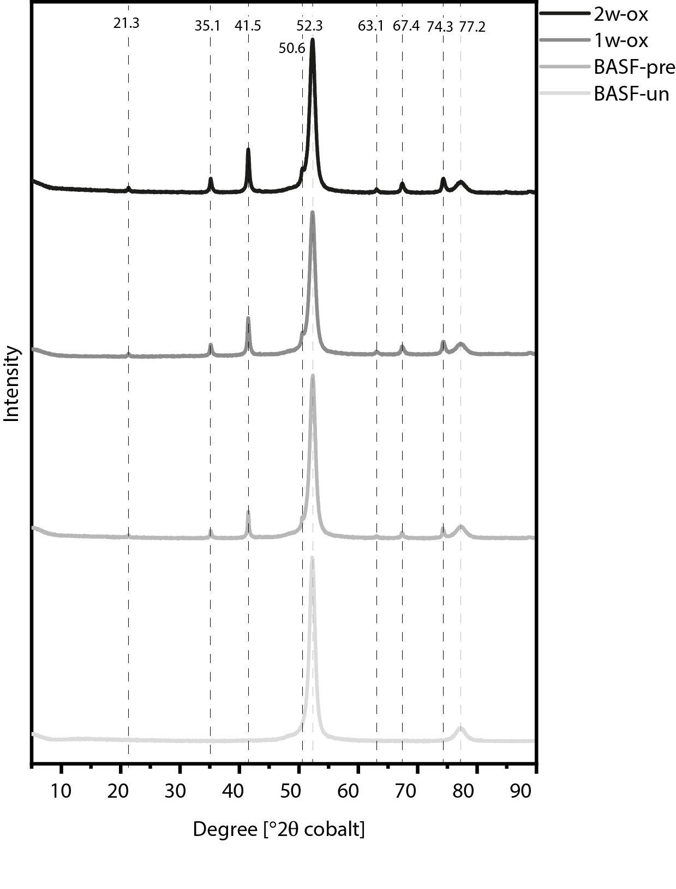
Figure S1: Phase identification of BASF-un, BASF-pre, BASF-1w-ox and BASF-2w-ox ZVI powders by XRD. The BASF-un has two pronounced peaks at ~52 and 77 °2θ, which are features of Fe⁰. In the diffractograms of BASF-pre and the oxidized BASF powders (BASF-1w-ox, BASF-2w-ox), new peaks emerged at ~21, 35, 41, 51, 63, 67 and 74 °2θ, indicating presence of Fe₃O₄.
Figure S2: Chromatogram of a gas sample with overlapping peaks obtained by injections of standard gases (butane and a mixture of hydrocarbons: pentane, 1-hexene, hexane and heptane).

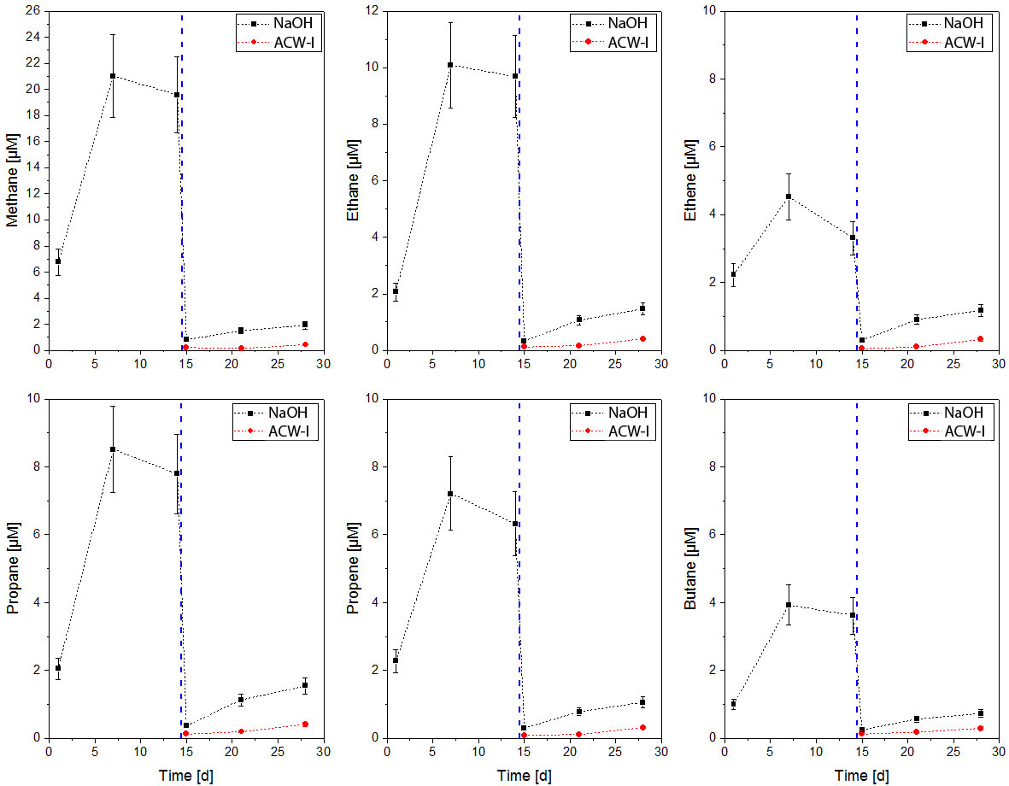
Figure S3: Concentration of hydrocarbons (HCs) upon replacement of NaOH by ACW-I solution. a) methane; b) ethane; c) ethene; d) propane; e) propene; f) butane.

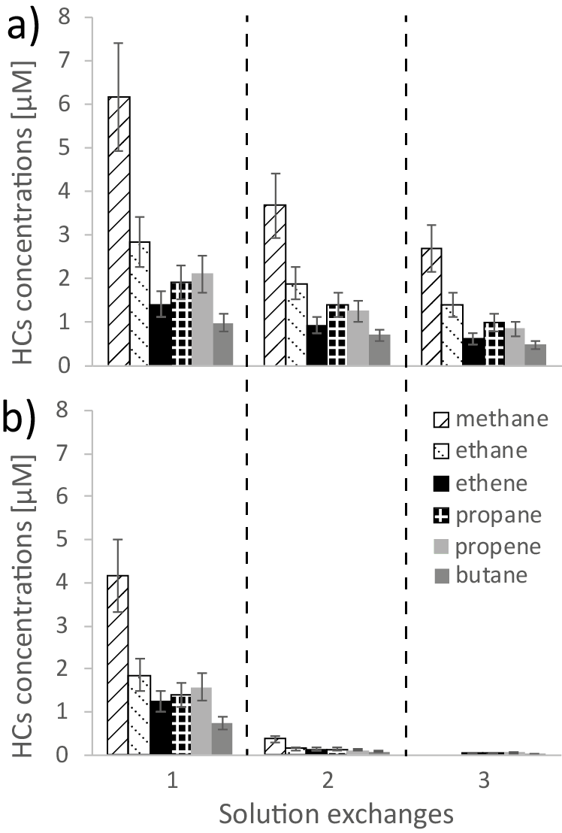
Figure S4: HC concentrations (μM) during solution exchange experiment with BASF-pre powder in a) NaOH at pH 11 and b) NaOH at pH 12.5.

Tables
Table S1: Time-dependent HC concentrations (μM) determined in the corrosion experiments with BASF-un, BASF-pre, BASF-1w-ox and BASF-2w-ox immersed in NaOH at pH 11 and 12.5.
pH initial | time | BASF-un |  |  |  |  |  |  | BASF-pre
 | [d] | methane | ethane | ethene | propane | propene | butane | total carbon | methane | ethane | ethene | propane | propene | butane | total carbon
 |  | Concentrations [μM] |  |  |  |  |  |  | Concentrations [μM]
11 | 1 | 5.72 | 2.02 | 1.34 | 1.44 | 1.66 | 0.74 | 24.7 | 15.24 | 5.94 | 2.91 | 3.48 | 2.89 | 1.76 | 59.09
 | 2 | 7.57 | 2.98 | 1.64 | 2.1 | 2.3 | 1.1 | 34.41 | 21.5 | 9.11 | 4.02 | 5.21 | 4.42 | 2.59 | 87.01
 | 7 | 10.93 | 5.17 | 2.02 | 3.2 | 2.93 | 1.81 | 50.94 | 29.45 | 14.31 | 3.79 | 7.56 | 6.01 | 3.11 | 118.8
 | 14 | 11.16 | 5.62 | 2.24 | 3.59 | 3.38 | 1.98 | 55.71 | 34.06 | 18.19 | 4.45 | 9.64 | 7.78 | 3.95 | 147.4
 | 21 | 10.06 | 5.56 | 2.19 | 3.66 | 3.57 | 1.99 | 55.21 | 53.17 | 40.98 | 6.37 | 22.69 | 18.56 | 8.76 | 306.66
 | 28 | 8.12 | 4.94 | 2.3 | 3.24 | 3.76 | 1.76 | 50.64 | 52.69 | 47.73 | 7.85 | 28.85 | 24.32 | 10.78 | 366.48
12.5 | 1 | 4.97 | 1.81 | 1.28 | 1.37 | 1.66 | 0.73 | 23.16 | 9.66 | 3.59 | 2.33 | 2.47 | 2.29 | 1.44 | 41.54
 | 2 | 5.54 | 2.06 | 1.42 | 1.56 | 1.87 | 0.84 | 26.15 | 10.42 | 4.31 | 2.71 | 3.01 | 2.84 | 1.74 | 48.97
 | 7 | 5.41 | 2.12 | 1.5 | 1.66 | 2.02 | 0.88 | 27.21 | 8.92 | 4.1 | 2.82 | 3.08 | 3.03 | 1.74 | 48.05
 | 14 | 3.21 | 1.72 | 1.52 | 1.64 | 2.04 | 0.85 | 24.13 | 8.78 | 3.78 | 2.53 | 2.72 | 2.65 | 1.58 | 43.83
 | 21 | 4.26 | 1.76 | 1.23 | 1.42 | 1.68 | 0.75 | 22.54 | 7.93 | 3.76 | 2.43 | 2.75 | 2.76 | 1.51 | 42.88
 | 28 | 4.02 | 1.92 | 1.42 | 1.62 | 1.99 | 0.86 | 24.97 | 9.41 | 3.88 | 2.59 | 2.81 | 2.86 | 1.39 | 44.92
pH initial | time | 1w-ox |  |  |  |  |  |  | 2w-ox
 | [d] | methane | ethane | ethene | propane | propene | butane | total carbon | methane | ethane | ethene | propane | propene | butane | total carbon
 |  | Concentrations [μM] |  |  |  |  |  |  | Concentrations [μM]
11 | 1 | 0 | 0 | 0.02 | 0.03 | 0.09 | 0.05 | 0.6 | 0 | 0 | 0 | 0 | 0.07 | 0.02 | 0.29
 | 2 | 0.2 | 0.09 | 0.05 | 0.06 | 0.11 | 0.06 | 1.23 | 0.32 | 0.11 | 0.09 | 0.07 | 0.12 | 0.04 | 1.45
 | 7 | 0.21 | 0.1 | 0.05 | 0.06 | 0.11 | 0.06 | 1.26 | 0.98 | 0.48 | 0.29 | 0.31 | 0.31 | 0.13 | 4.9
 | 14 | 0.81 | 0.55 | 0.15 | 0.31 | 0.26 | 0.15 | 4.52 | 1.43 | 0.69 | 0.67 | 0.52 | 0.66 | 0.24 | 8.65
 | 21 | 2.61 | 1.43 | 0.63 | 0.88 | 0.84 | 0.4 | 13.49 | 0.66 | 0.3 | 0.19 | 0.19 | 0.22 | 0.08 | 3.19
 | 28 | 2.24 | 1.2 | 0.54 | 0.71 | 0.67 | 0.32 | 11.14 | 1.42 | 0.82 | 0.49 | 0.55 | 0.55 | 0.23 | 8.26
12.5 | 1 | 0 | 0 | 0 | 0 | 0.07 | 0.04 | 0.37 | 0.29 | 0.1 | 0.11 | 0.07 | 0.13 | 0.04 | 1.47
 | 2 | 0 | 0 | 0 | 0 | 0.07 | 0.04 | 0.37 | 0.24 | 0 | 0 | 0 | 0.07 | 0.01 | 0.49
 | 7 | 0.22 | 0.13 | 0.04 | 0.06 | 0.11 | 0.05 | 1.27 | 0.47 | 0.22 | 0.21 | 0.16 | 0.22 | 0.07 | 2.75
 | 14 | 1.43 | 0.96 | 0.13 | 0.44 | 0.38 | 0.14 | 6.63 | 0.34 | 0.18 | 0.13 | 0.11 | 0.17 | 0.06 | 2.04
 | 21 | 0.22 | 0.16 | 0.04 | 0.07 | 0.12 | 0.05 | 1.39 | 0.81 | 0.41 | 0.37 | 0.29 | 0.4 | 0.13 | 4.96
 | 28 | 0.44 | 0.38 | 0.07 | 0.22 | 0.2 | 0.1 | 3 | 1.21 | 0.71 | 0.55 | 0.49 | 0.62 | 0.21 | 7.9

Table S2: Time-dependent carboxylic acid concentrations (μM) determined in the corrosion experiments with BASF-un, BASF-pre, BASF-1w-ox and BASF-2w-ox immersed in NaOH at pH 11 and 12.5 (FA = formic acid; AA = acetic acid; MA = malonic acid; OA = oxalic acid; BA = butyric acid; GA = glycolic acid; PA = propionic acid; LA = lactic acid).
pH initial | time | BASF-un |  |  |  |  |  |  |  |  | BASF-pre
 | [d] | FA | AA | MA | OA | BA | GA | PA | LA | total carbon | FA | AA | MA | OA | BA | GA | PA | LA | total carbon
 |  | Concentrations [μM] |  |  |  |  |  |  |  |  | Concentrations [μM]
11 | 1 | 46 | 5 | 0.5 | 1.9 | 0 | 0.4 | 0 | 0 | 62.1 | 13 | 35 | 0 | 0 | 0 | 0.8 | 0 | 0 | 84.6
 | 2 | 44 | 6 | 0.5 | 3.9 | 0 | 0.5 | 0 | 0 | 66.3 | 12 | 36 | 0 | 0 | 0 | 0.7 | 0 | 0 | 85.4
 | 7 | 45 | 5 | 0.6 | 4.8 | 0 | 0.5 | 0 | 0 | 67.4 | 14 | 39 | 0 | 0 | 0.1 | 1.7 | 0.6 | 0 | 97.6
 | 14 | 47 | 12 | 0.7 | 1.6 | 0.2 | 0.5 | 0.7 | 0 | 80.2 | 15 | 38 | 0.4 | 1.2 | 0.1 | 2.1 | 0.8 | 0 | 101.6
 | 21 | 45 | 10 | 0.9 | 3.4 | 0 | 0.6 | 0.5 | 0 | 77.2 | 18 | 40 | 0.3 | 0.7 | 0.2 | 1.5 | 0.7 | 0 | 106.2
 | 28 | 52 | 8 | 1.0 | 1.6 | 0.2 | 0.6 | 0.7 | 0.6 | 80.1 | 16 | 38 | 0.6 | 0.6 | 0.1 | 1.4 | 0.7 | 0 | 100.3
12.5 | 1 | 12 | 0 | 0.4 | 2.4 | 0 | 0 | 0 | 0 | 18 | 17 | 41 | 1.4 | 5.1 | 0 | 2.9 | 0.8 | 0 | 121.6
 | 2 | 20 | 0 | 0.4 | 2.7 | 0 | 0 | 0 | 0 | 26.6 | 18 | 41 | 1.6 | 9.0 | 0 | 2.8 | 0.6 | 0 | 130.2
 | 7 | 35 | 4 | 0.5 | 3.4 | 0 | 0 | 0 | 0 | 51.3 | 19 | 48 | 1.8 | 14.5 | 0.1 | 3.2 | 0.9 | 0 | 158.9
 | 14 | 33 | 0 | 0.5 | 3.7 | 0 | 0 | 0 | 0 | 41.9 | 21 | 42 | 1.7 | 4.5 | 0.2 | 3.3 | 1.0 | 0 | 129.5
 | 21 | 40 | 0 | 0.5 | 4.0 | 0.1 | 0.3 | 0 | 0 | 50.5 | 13 | 36 | 2.4 | 11.6 | 0 | 3.1 | 0.6 | 0 | 123.4
 | 28 | 40 | 0 | 0.5 | 4.0 | 0 | 0.3 | 0 | 0 | 50.1 | 18 | 40 | 2.0 | 3.1 | 0 | 2.2 | 0.8 | 0 | 117
pH initial | time | 1w-ox |  |  |  |  |  |  |  |  | 2w-ox
 | [d] | FA | AA | MA | OA | BA | GA | PA | LA | total carbon | FA | AA | MA | OA | BA | GA | PA | LA | total carbon
 |  | Concentrations [μM] |  |  |  |  |  |  |  |  | Concentrations [μM]
11 | 1 | 17 | 15 | 0.4 | 4.2 | 0.2 | 0 | 0.6 | 0 | 59.2 | 11 | 11 | 0.5 | 3.9 | 0 | 0 | 0 | 0 | 42.3
 | 2 | 20 | 18 | 0.6 | 5.5 | 0.2 | 0 | 0.8 | 0 | 72 | 12 | 12 | 0.5 | 3.9 | 0 | 0 | 0 | 0 | 45.3
 | 7 | 19 | 17 | 0.6 | 5.9 | 0.2 | 0 | 0.8 | 0 | 69.8 | 11 | 13 | 0.6 | 4.2 | 0 | 0 | 0 | 0 | 47.2
 | 14 | 18 | 15 | 0.6 | 5.6 | 0.2 | 0 | 0.6 | 0.6 | 65.4 | 21 | 20 | 1.6 | 4.9 | 0 | 0.6 | 0 | 0 | 76.8
 | 21 | 23 | 22 | 0.8 | 5.9 | 0.2 | 0.4 | 0.8 | 0.5 | 86.7 | 14 | 13 | 0.8 | 5.7 | 0 | 0 | 0 | 0 | 53.8
 | 28 | 26 | 21 | 1.3 | 7.8 | 0.2 | 0.6 | 1.0 | 1.3 | 96.4 | 18 | 17 | 1.4 | 8.5 | 0 | 0 | 0 | 0 | 73.2
12.5 | 1 | 18 | 18 | 0.5 | 1.1 | 0.2 | 0 | 0.8 | 0 | 60.9 | 18 | 14 | 0.7 | 1.3 | 0 | 0 | 0 | 0 | 50.7
 | 2 | 22 | 18 | 0.7 | 3.9 | 0.1 | 0 | 0.7 | 0.6 | 72.2 | 17 | 19 | 1.1 | 5.2 | 0 | 0 | 0 | 0 | 68.7
 | 7 | 21 | 18 | 0.9 | 6.0 | 0.1 | 0 | 0.6 | 0.5 | 75.4 | 20 | 20 | 1.6 | 7.6 | 0 | 0.2 | 0 | 0 | 80.4
 | 14 | 22 | 20 | 0.6 | 1.7 | 0.2 | 0 | 0.7 | 0 | 70.1 | 19 | 15 | 0.8 | 1.7 | 0 | 0 | 0 | 0 | 54.8
 | 21 | 20 | 20 | 1.1 | 5.7 | 0 | 0.2 | 0 | 0 | 75.1 | 19 | 17 | 1.8 | 5.3 | 0 | 0.3 | 0 | 0 | 69.6
 | 28 | 20 | 18 | 1.1 | 6.7 | 0 | 0.2 | 0 | 0 | 73.1 | 26 | 19 | 2.9 | 8.2 | 0 | 0.3 | 0 | 0 | 89.7

Table S3: Time-dependent concentrations of H₂ and HCs in corrosion experiment with BASF-pre iron powder in NaOH at pH 11.
Time | methane | ethane | ethene | propane | propene | butane | hydrogen
[d] | Concentrations [μM]
1 | 3.78 | 1.15 | 1.06 | 0.93 | 0.99 | 0.66 | 0.96
 | 3.33 | 1.05 | 0.99 | 0.83 | 0.96 | 0.40 | 1.08
2 | 4.28 | 1.52 | 1.33 | 1.27 | 1.34 | 0.67 | 1.69
 | 4.83 | 1.64 | 1.43 | 1.35 | 1.46 | 0.83 | 1.62
4 | 5.30 | 1.86 | 1.55 | 1.53 | 1.48 | 0.91 | 1.78
 | 5.25 | 1.80 | 1.54 | 1.48 | 1.56 | 0.83 | 1.88
7 | 7.49 | 2.92 | 2.30 | 2.47 | 2.26 | 1.42 | 2.30
 | 9.21 | 3.79 | 2.89 | 3.18 | 2.86 | 1.78 | 3.49
14 | 7.69 | 3.07 | 2.44 | 2.77 | 2.47 | 1.68 | 1.45
 | 10.57 | 4.59 | 3.47 | 4.09 | 3.50 | 2.36 | 2.44

Table S4: Time-dependent concentrations of H₂ and carboxylic acids in corrosion experiment with BASF-pre iron powder in NaOH at pH 11.
Time | formic acid | acetic acid | malonic acid | oxalic acid | butyric acid | glycolic acid | lactate
[d] | Concentrations [μM]
1 | 15.25 | 47.77 | 1.38 | 9.34 | 0.10 | 2.62 | 2.24
 | 13.76 | 46.58 | 1.38 | 8.98 | 0.10 | 2.43 | 2.44
2 | 15.72 | 44.33 | 2.11 | 9.56 | 0.16 | 1.57 | 1.79
 | 15.41 | 46.62 | 1.95 | 8.34 | 0.17 | 1.61 | 1.81
4 | 15.98 | 44.61 | 2.01 | 12.42 | 0.16 | 1.64 | 1.87
 | 15.29 | 42.90 | 2.07 | 12.44 | 0.14 | 1.57 | 1.68
7 | 16.62 | 45.32 | 2.43 | 14.40 | 0.16 | 1.84 | 2.00
 | 16.50 | 49.46 | 2.39 | 12.13 | 0.19 | 1.84 | 2.11
14 | 12.73 | 42.76 | 2.60 | 17.24 | 0.11 | 2.12 | 1.90
 | 15.18 | 45.17 | 2.88 | 16.53 | 0.16 | 2.02 | 2.03

Table S5: HC concentrations released during solution exchange experiments in NaOH.
ZVI | pH | Exchange | methane | ethane | ethene | propane | propene | butane
 |  |  | Concentrations [μM]
BASF-pre | 11 | 1 | 6.18 | 2.84 | 1.42 | 1.93 | 2.12 | 1.00
 |  | 2 | 3.69 | 1.90 | 0.93 | 1.39 | 1.26 | 0.71
 |  | 3 | 2.70 | 1.40 | 0.63 | 1.00 | 0.85 | 0.48
 | 12.5 | 1 | 4.16 | 1.86 | 1.25 | 1.39 | 1.58 | 0.73
 |  | 2 | 0.38 | 0.14 | 0.13 | 0.14 | 0.12 | 0.08
 |  | 3 | 0 | 0 | 0.04 | 0.04 | 0.06 | 0.03
BASF-1w-ox | 11 | 1 | 0.39 | 0.17 | 0.04 | 0.07 | 0.10 | 0.03
 |  | 2 | 0.30 | 0.14 | 0.03 | 0.08 | 0.08 | 0.03
 |  | 3 | 0.37 | 0.19 | 0.07 | 0.12 | 0.13 | 0.08
 | 12.5 | 1 | 0 | 0 | 0 | 0 | 0.01 | 0
 |  | 2 | 0 | 0 | 0 | 0 | 0.03 | 0
 |  | 3 | 0 | 0.07 | 0 | 0.04 | 0.09 | 0.04
BASF-2w-ox | 11 | 1 | 0.34 | 0.12 | 0.10 | 0.07 | 0.11 | 0.03
 |  | 2 | 0.23 | 0.10 | 0.06 | 0.06 | 0.09 | 0.03
 |  | 3 | 0.22 | 0.10 | 0.07 | 0.07 | 0.11 | 0.06
 | 12.5 | 1 | 0.21 | 0.09 | 0.03 | 0.04 | 0.07 | 0.02
 |  | 2 | 0.16 | 0.09 | 0.04 | 0.05 | 0.08 | 0.02
 |  | 3 | 0.23 | 0.10 | 0.08 | 0.08 | 0.13 | 0.07

Table S6: Carboxylic acid concentrations released during solution exchange experiments in NaOH. (FA = formic acid; AA = acetic acid; MA = malonic acid; OA = oxalic acid; BA = butyric acid; GA = glycolic acid; PA = propionic acid; LA = lactic acid).
ZVI | pH | Exchange | FA | AA | MA | OA | BA | GA | PA | LA
 |  |  | Concentration [μM]
BASF-pre | 11 | 1 | 10 | 46 | 0.5 | 2.4 | 0 | 1.6 | 0 | 1.8
 |  | 2 | 0 | 0 | 0.4 | 2.6 | 0 | 0 | 0 | 0
 |  | 3 | 0 | 0 | 0.2 | 1.4 | 0 | 0 | 0 | 0
 | 12.5 | 1 | 13 | 49 | 1.2 | 7.0 | 0 | 2.2 | 0 | 2.2
 |  | 2 | 0 | 0 | 0 | 0.5 | 0 | 0 | 0 | 0
 |  | 3 | 0 | 0 | 0 | 0 | 0 | 0 | 0 | 0
1w-ox | 11 | 1 | 16 | 11 | 0.4 | 3.8 | 0.1 | 0 | 0.6 | 0.5
 |  | 2 | 0 | 0 | 0 | 0.7 | 0 | 0 | 0 | 0
 |  | 3 | 0 | 0 | 0 | 0 | 0 | 0 | 0 | 0
 | 12.5 | 1 | 17 | 12 | 0.7 | 4.6 | 0.1 | 0.2 | 0.6 | 0.8
 |  | 2 | 0 | 0 | 0 | 0.5 | 0 | 0 | 0 | 0
 |  | 3 | 0 | 0 | 0 | 0 | 0 | 0 | 0 | 0
2w-ox | 11 | 1 | 12 | 11 | 0.6 | 4.1 | 0 | 0 | 0 | 0
 |  | 2 | 0 | 0 | 0 | 0.9 | 0 | 0 | 0 | 0
 |  | 3 | 0 | 0 | 0 | 0 | 0 | 0 | 0 | 0
 | 12.5 | 1 | 15 | 13 | 1 | 4.2 | 0 | 0.3 | 0 | 0.9
 |  | 2 | 0 | 0 | 0 | 0 | 0 | 0 | 0 | 0
 |  | 3 | 0 | 0 | 0 | 0 | 0 | 0 | 0 | 0

Table S7: Carboxylic acid concentrations (μM) determined in the iron change experiments with BASF-pre, BASF-1w-ox and BASF-2w-ox immersed in NaOH at pH 11 and 12.5 (FA = formic acid; AA = acetic acid; MA = malonic acid; OA = oxalic acid; BA = butyric acid; GA = glycolic acid; PA = propionic acid; LA = lactic acid).
ZVI | pH | Exchange | FA | AA | MA | OA | BA | GA | PA | LA
 |  |  | Concentrations [μM]
BASF-pre | 11 | 1 | 11 | 46 | 0.6 | 2.7 | 0 | 1.7 | 0 | 1.9
 |  | 2 | 20 | 90 | 0.2 | 0.8 | 0 | 1.9 | 0 | 2.3
 |  | 3 | 30 | 142 | 0 | 0 | 0 | 2.2 | 0 | 4.1
 | 12.5 | 1 | 13 | 46 | 1.2 | 7.2 | 0 | 2.4 | 0 | 2.1
 |  | 2 | 28 | 88 | 2.8 | 19.1 | 0 | 3.5 | 0 | 3.6
 |  | 3 | 42 | 133 | 4.6 | 37.6 | 0 | 6.4 | 0.7 | 6.0
BASF-1w-ox | 11 | 1 | 17 | 14 | 0.4 | 4.3 | 0.1 | 0 | 0.6 | 0
 |  | 2 | 36 | 32 | 1.0 | 9.1 | 0.4 | 0.2 | 1.3 | 0.5
 |  | 3 | 46 | 45 | 1.1 | 10 | 0.4 | 0.3 | 1.5 | 0.8
 | 12.5 | 1 | 20 | 15 | 0.8 | 4.9 | 0.2 | 0 | 0.8 | 0
 |  | 2 | 39 | 31 | 1.4 | 8.7 | 0.2 | 0.3 | 1.0 | 0.8
 |  | 3 | 57 | 54 | 2.2 | 11.4 | 0.3 | 0.6 | 1.5 | 1.6
BAF-2w-ox | 11 | 1 | 13 | 13 | 0.5 | 3.5 | 0 | 0 | 0 | 0
 |  | 2 | 23 | 25 | 1.0 | 7.7 | 0 | 0 | 0.6 | 0
 |  | 3 | 36 | 43 | 1.5 | 10.7 | 0.1 | 0.3 | 0.9 | 0
 | 12.5 | 1 | 18 | 16 | 1.1 | 4.6 | 0 | 0 | 0 | 0
 |  | 2 | 34 | 31 | 2.1 | 8.4 | 0 | 0.4 | 0.7 | 0.6
 |  | 3 | 45 | 46 | 2.6 | 9.7 | 0 | 0.6 | 0.9 | 1.0

Table S8: Concentrations of long HCs (C5-C7) released after 28 days of BASF-pre corrosion.
 | Concentrations [μM]
Solutions | Pentane | Hexene | Hexane | Heptane
ACW / pH 11 | 0.34 | 0.69 | 0.10 | 0.03
ACW / pH 12.5 | 0.31 | 0.35 | 0.10 | 0.04
NaOH / pH 11 | 2.67 | 2.14 | 0.83 | 0.28
NaOH / pH 12.5 | 1.62 | 1.46 | 0.48 | 0.15

Table S9: Molar fractions calculated from HC concentrations determined during corrosion of the BASF-pre powder immersed in NaOH and ACW at pH 11 and 12.5.
 | Concentrations [µM] |  |  | mass fraction (%)
Solutions | C1 | C2-C4 | C5-C7 | C1 | C2-C4 | C5-C7
ACW / pH 11 | 3.8 | 4.7 | 1.2 | 20.75 | 52.6 | 26.66
ACW / pH 12.5 | 2.1 | 2.9 | 0.8 | 14.53 | 58.81 | 26.66
NaOH / pH 11 | 34.1 | 40.9 | 5.9 | 22.58 | 57.81 | 19.61
NaOH / pH 12.5 | 8.8 | 13.1 | 3.7 | 17.71 | 44.65 | 37.64

