Supplementary Material S1

Abbreviations used
LCA Life cycle assessment
GHG Greenhouse gas (emissions)
ASF Animal-source food
LOCL Low-opportunity-cost livestock
FIA Fixed impact assessment
SCA Systemic consequences analysis

Review approach
The aim of this study is to identify causes for differences in conclusions of studies assessing environmental impacts of diets. The literature review conducted to address this aim followed four stages, cf. (Moher et al., 2009): first, identification of records, second, screening of records, where duplicates were removed and decision for exclusion was based on the title and abstract of the identified records. In the third stage, eligibility of records was assessed based on the full-text article. Finally, in stage four, the final set of articles was defined for inclusion in the subsequent analysis.
Stage 1: Identification. The literature review was performed in the databases Web of Science (ISI) by keyword search and Boolean operators on 25-02-2019. Keywords and Boolean operators were combined to queries as follows:
(diet OR diet* NEAR/2 choice* OR diet* NEAR/2 change* OR diet* scenario* OR diet* NEAR/2 pattern* OR diet* NEAR/2 type*) AND (climate OR greenhouse gas OR land) AND (sustain* OR impact*)
(diet* NEAR/2 human* OR diet* NEAR/2 choice* OR diet* NEAR/2 change* OR diet* NEAR/2 scenario* OR diet* NEAR/2 pattern* OR diet* NEAR/2 type* OR food NEAR/2 demand OR feed* NEAR/3 world) AND (climate OR greenhouse gas OR GHG OR land) AND (sustaina* OR env* NEAR/2 impact*)
Following the database search, references of previous review articles on related topics (Aleksandrowicz et al., 2016; Jones et al., 2016; Ridoutt et al., 2017; Van Zanten et al., 2018) were screened to identify additional records that were potentially missed. This led to a total of 605 identified studies.
Stage 2: Screening. In this phase, all articles identified in the first stage were screened, based on the information given in the title and abstract. Studies were included if they met all five inclusion criteria:
- peer-reviewed English-language publication;
- published between January 2014 and date of search (25-02-2019)
- assessment of environmental impacts - with a minimum requirement of either land use (LU) or greenhouse gas emissions (GHG) of potentially more sustainable diets being covered;
- comparison of environmental impacts of an alternative diet with the current situation or between alternative diets; and
- environmental impact assessment for diets on a regional or global scale, focusing on studies within Europe or the US and global assessments. Thus, on the one hand, assessments of diets at the level of individual persons are excluded. And on the other, studies from other parts of the world - such as Africa or Asia - were excluded, to minimise the potential for sources other than methodological choices that influence the recommendations.
In stage 2, a total of 539 studies was excluded.
Stage 3: Eligibility. Remaining articles were downloaded and their full text assessed, whether it matches all inclusion criteria defined above. Of these, another ten were excluded; 5 due to a geographical scope that was not compliant with our inclusion criteria (Hendrie et al., 2014; Li et al., 2016; Milner et al., 2017; Song et al., 2019), 2 due to the assessment of individual diets (Scarborough et al., 2014; Walker et al., 2018), 1 due to direct assessment of current diets (Hyland et al., 2017), 1 because not complete diets were assessed (Rohmer et al., 2019), and 1 study was not accessible (Sabate & Soret, 2014).
Stage 4: Inclusion. After this procedure, a total of 56 studies remained and was included in the subsequent analysis, cf. Supplementary Material S2.

Studies not matching the typical methodological approaches
Not all studies identified in the literature review correspond to one of the identified typical methodological approaches. For scenario specification, 4 studies did not apply the proposed combination of values. The studies (Erb et al., 2016; Springmann et al., 2018; Willett et al., 2019) follow products in the allocation, but consider restrictions on resource use and sink capacities, thus do correspond to consumption- or resource-oriented scenario specification exactly. One study (Hedenus et al., 2014) on the contrary, follows nutrients after the allocation, but does not account for restrictions on resource use and sink capacities. Further, for environmental impact assessment, three studies follow products after the allocation and consider restrictions on resource use and sink capacities (Springmann et al., 2018; Willett et al., 2019), and additionally, consequences (Erb et al., 2016). (Saxe, 2014) and (Goldstein et al., 2016) also follow products in the allocation and consider consequences (by using CLCA). One study (Hedenus et al., 2014) follows nutrients in the allocation and considers consequences, but does not consider restrictions on resource use and sink capacities. Lastly, one study (Röös et al., 2016) follows nutrients in the allocation, performs the inventory analysis on product level, and considers consequences and restrictions on resource use and sink capacities. These combinations are not covered by either FIA or SCA, and therefore, these studies do not match the identified typical methodological approaches.
It has to be noted that this lack of congruence is not an issue of quality. The typical methodological approaches in the studies reviewed are highly diverse, which makes it difficult to build categories where all studies fit into.
In Figure S1, the recommendations of the studies not falling into one of the typical methodological approaches are presented. We see that also these studies agree on a reduction of most animal-source foods (ASF) categories. With regard to optimal range and rationale for change, the studies not fitting to the typical methodological approaches for scenario specification resemble those from the consumption-oriented scenario specification. For the typical methodological approaches on environmental impact assessment, recommendations of studies are mixed, thus, could be part of both FIA and SCA.
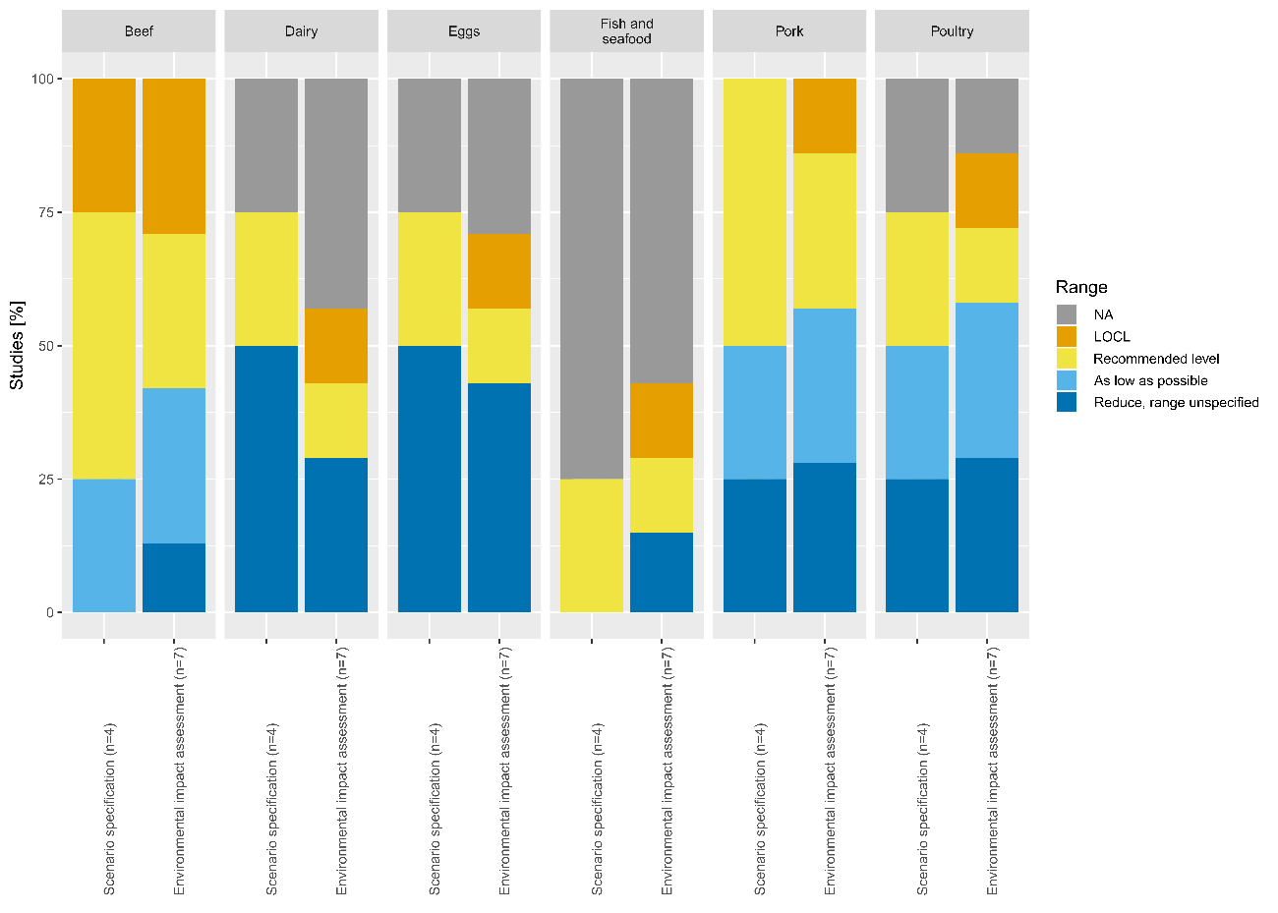
Figure S1: Inventory of optimal ranges for animal-source food reduction solutions to achieve reduced environmental impacts of the food system (% of the studies excluded from scenario specification and environmental impact assessment, respectively). Colors indicate the proposed range; low-opportunity-cost livestock (LOCL), recommended level, as low as possible, reduce with unspecified range, and not assessed (NA).

Comparing environmental performance between scenarios
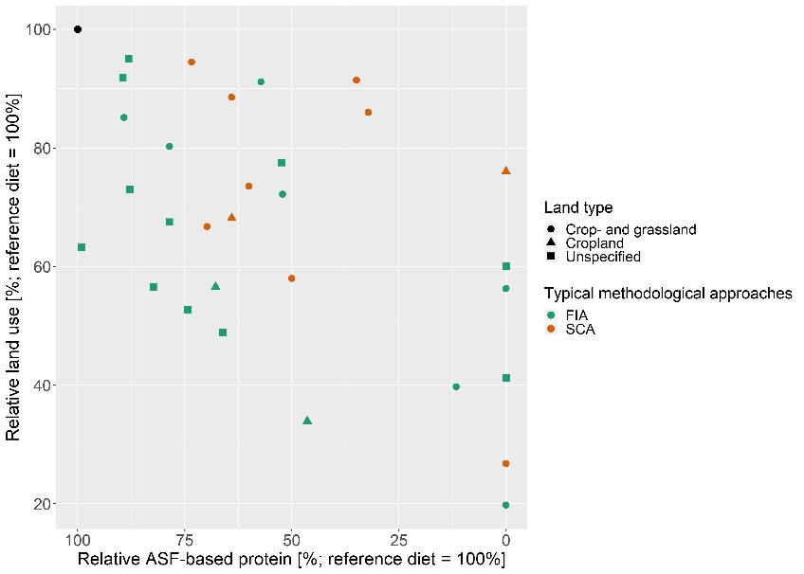
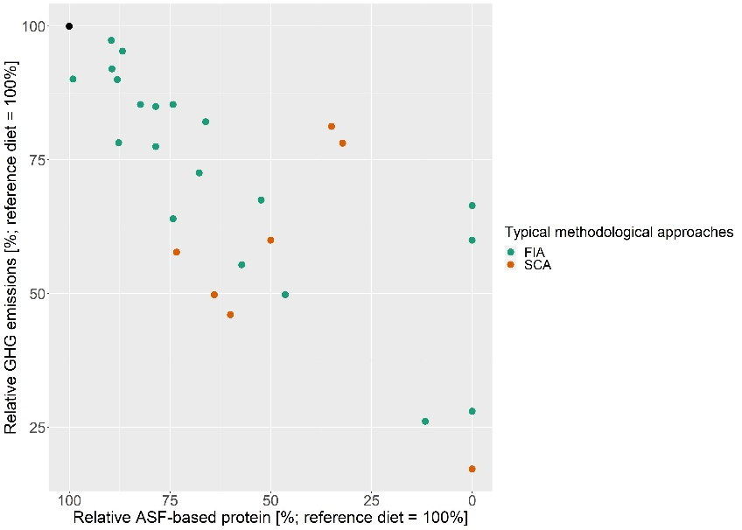
Environmental performance between studies and scenarios can be compared relative to a vegan scenario or relative to a reference scenario. Results relative to the vegan scenario, as presented in Figure 3 in the main paper, are an update of Figure 1 in Van Zanten et al. (2018). Only studies that calculated a vegan scenario were included in this Figure, to be able to demonstrate the range for LU and GHG emission results for the whole range of shares of ASF in human diets. When comparing results relative to the reference scenarios (see Figure S2), more studies can be included, because most studies include reference scenarios while only some studies include vegan scenarios. Figure S2 reveals similar results as can be obtained from comparing impacts relative to vegan scenarios; for GHG emissions, results indicate a clear negative correlation between g of ASF-based protein in the human diet, while for LU, results are more dependent on the methodological approach chosen and land type included.
Figure S2: Left: relative greenhouse gas (GHG) emissions per relative animal-source food (ASF)-based protein. Right: relative land use per relative ASF-based protein (land type is indicated by shape). Each dot represents one dietary scenario. Colors indicate typical methodological approaches; fixed impact assessment (FIA) and systemic consequences analysis (SCA). ASF, land use, and GHG emissions of dietary scenarios are presented relative to reference scenarios of the same studies (black dot) in percentage. Caloric consumption across scenarios is normalised to 2000 kcal to facilitate comparison.

References
Aleksandrowicz, L., Green, R., Joy, E. J., Smith, P., & Haines, A. (2016). The impacts of dietary change on greenhouse gas emissions, land use, water use, and health: a systematic review. PLoS One, 11(11), e0165797. doi:10.1371/journal.pone.0165797
Erb, K.-H., Lauk, C., Kastner, T., Mayer, A., Theurl, M. C., & Haberl, H. (2016). Exploring the biophysical option space for feeding the world without deforestation. Nature communications, 7, 11382. doi:10.1038/ncomms11382
Goldstein, B., Hansen, S. F., Gjerris, M., Laurent, A., & Birkved, M. (2016). Ethical aspects of life cycle assessments of diets. Food Policy, 59, 139-151. doi:10.1016/j.foodpol.2016.01.006
Hedenus, F., Wirsenius, S., & Johansson, D. J. (2014). The importance of reduced meat and dairy consumption for meeting stringent climate change targets. Climatic change, 124(1-2), 79-91. doi:10.1007/s10584-014-1104-5
Hendrie, G., Ridoutt, B., Wiedmann, T., & Noakes, M. (2014). Greenhouse gas emissions and the Australian diet—comparing dietary recommendations with average intakes. Nutrients, 6(1), 289-303. doi:10.3390/nu6010289
Hyland, J. J., McCarthy, M. B., Henchion, M., & McCarthy, S. N. (2017). Dietary emissions patterns and their effect on the overall climatic impact of food consumption. International journal of food science & technology, 52(12), 2505-2512. doi:10.1111/ijfs.13419
Jones, A. D., Hoey, L., Blesh, J., Miller, L., Green, A., & Shapiro, L. F. (2016). A systematic review of the measurement of sustainable diets. Advances in Nutrition, 7(4), 641-664. doi:10.3945/an.115.011015
Li, H., Wu, T., Wang, X., & Qi, Y. (2016). The greenhouse gas footprint of China's food system: an analysis of recent trends and future scenarios. Journal of Industrial Ecology, 20(4), 803-817. doi:10.1111/jiec.12323
Milner, J., Joy, E. J., Green, R., Harris, F., Aleksandrowicz, L., Agrawal, S., . . . Dangour, A. D. (2017). Projected health effects of realistic dietary changes to address freshwater constraints in India: a modelling study. The Lancet Planetary Health, 1(1), e26-e32. doi:10.1016/S2542-5196(17)30001-3
Moher, D., Liberati, A., Tetzlaff, J., & Altman, D. G. (2009). Preferred reporting items for systematic reviews and meta-analyses: the PRISMA statement. Annals of internal medicine, 151(4), 264-269.
Ridoutt, B. G., Hendrie, G. A., & Noakes, M. (2017). Dietary strategies to reduce environmental impact: a critical review of the evidence base. Advances in Nutrition, 8(6), 933-946. doi:10.3945/an.117.016691
Rohmer, S., Gerdessen, J. C., & Claassen, G. (2019). Sustainable supply chain design in the food system with dietary considerations: A multi-objective analysis. European Journal of Operational Research, 273(3), 1149-1164. doi:10.1016/j.ejor.2018.09.006
Röös, E., Patel, M., Spångberg, J., Carlsson, G., & Rydhmer, L. (2016). Limiting livestock production to pasture and by-products in a search for sustainable diets. Food Policy, 58, 1-13. doi:10.1016/j.foodpol.2015.10.008
Sabate, J., & Soret, S. (2014). Sustainability of plant-based diets: back to the future. The American journal of clinical nutrition, 100(suppl_1), 476S-482S. doi:10.3945/ajcn.113.071522
Saxe, H. (2014). The New Nordic Diet is an effective tool in environmental protection: it reduces the associated socioeconomic cost of diets. The American journal of clinical nutrition, 99(5), 1117-1125. doi:10.3945/ajcn.113.066746
Scarborough, P., Appleby, P. N., Mizdrak, A., Briggs, A. D., Travis, R. C., Bradbury, K. E., & Key, T. J. (2014). Dietary greenhouse gas emissions of meat-eaters, fish-eaters, vegetarians and vegans in the UK. Climatic change, 125(2), 179-192. doi:10.3945/ajcn.113.077958
Song, G., Gao, X., Fullana-i-Palmer, P., Lv, D., Zhu, Z., Wang, Y., & Bayer, L. B. (2019). Shift from feeding to sustainably nourishing urban China: A crossing-disciplinary methodology for global environment-food-health nexus. Science of the Total Environment, 647, 716-724. doi:10.1016/j.scitotenv.2018.08.040
Springmann, M., Clark, M., Mason-D’Croz, D., Wiebe, K., Bodirsky, B. L., Lassaletta, L., . . . Carlson, K. M. (2018). Options for keeping the food system within environmental limits. nature, 562(7728), 519. doi:10.1038/s41586-018-0594-0
Van Zanten, H. H., Herrero, M., Hal, O. V., Röös, E., Muller, A., Garnett, T., . . . De Boer, I. J. M. (2018). Defining a land boundary for sustainable livestock consumption. Global change biology. doi:10.1111/gcb.14321
Walker, C., Gibney, E. R., & Hellweg, S. (2018). Comparison of environmental impact and nutritional quality among a European sample population–findings from the Food4Me study. Scientific reports, 8(1), 2330. doi:10.1038/s41598-018-20391-4
Willett, W., Rockström, J., Loken, B., Springmann, M., Lang, T., Vermeulen, S., . . . Wood, A. (2019). Food in the Anthropocene: the EAT–Lancet Commission on healthy diets from sustainable food systems. The Lancet, 393(10170), 447-492. doi:10.1016/S0140-6736(18)31788-4

