Supporting information

Branched polyethylenes using thermally enhanced bis(imino)acenaphthene- nickel catalysts: exploring the effects of temperature and pressure

Qiuyue Zhang,^{a,b} Randi Zhang,^{a,b} Yanping Ma,^{a,b} Gregory A. Solan,*^{a,c} Tongling Liangª and Wen-Hua Sun^{a,b,d}*

ª Key Laboratory of Engineering Plastics and Beijing National Laboratory for Molecular Sciences, Institute of Chemistry, Chinese Academy of Sciences, Beijing 100190, China.
^{b} CAS Research/Education Center for Excellence in Molecular Sciences, University of Chinese Academy of Sciences, Beijing 100049, China.
^{c} Department of Chemistry, University of Leicester, University Road, Leicester LE1 7RH, UK.
^{d} State Key Laboratory for Oxo Synthesis and Selective Oxidation, Lanzhou Institute of Chemical Physics, Chinese Academy of Sciences, Lanzhou 730000, China.
Contents
- ¹³C NMR spectra of the polyethylenes and their interpretation
- Figure S1 ¹³C NMR spectrum of the polyethylene obtained using Ni5/EASC at 30 °C under 10 atm ethylene (entry 2, Table 6).
- Figure S2 ¹³C NMR spectrum of the polyethylene obtained using Ni5/EASC at 70 °C under 10 atm ethylene (entry 9, Table 6).
- Figure S3 ¹³C NMR spectrum of the polyethylene obtained using Ni5/EASC at 90 °C under 10 atm ethylene (entry 10, Table 6).
- Figure S4 ¹³C NMR spectrum of the polyethylene obtained using Ni5/MAO at 90 °C under 10 atm ethylene (entry 10, Table 4).
- Figure S5 ¹³C NMR spectrum of the polyethylene obtained using Ni5/EASC at 30 °C under 1 atm ethylene (entry 3, Table 5).
- Figure S6 Elastic recovery curves for PE-70_{E/10atm} at -10 and 30 °C (10 cycles).
- Figure S7 ¹H NMR spectra of Ni1 – Ni5 (recorded in CDCl₃ at ambient temperature)
- Table S1 Branching analysis of PE-30_{M/10atm} obtained using Ni5/MAO at 30 °C under 10 atm ethylene
- Table S2 Branching analysis of PE-70_{M/10atm} obtained using Ni5/MAO at 70 °C under 10 atm ethylene
- Table S3 Branching analysis of PE-90_{M10atm} obtained using Ni5/MAO at 90 °C under 10 atm ethylene
- Table S4 Branching analysis of PE-30_{M/1atm} obtained using Ni5/MAO at 30 °C under 1 atm ethylene
- Table S5 Branching analysis of PE-30_{E/10atm} obtained using Ni5/EASC at 30 °C under 10 atm ethylene
- Table S6 Branching analysis of PE-70_{E/10 atm} obtained using Ni5/EASC at 70 °C under 10 atm ethylene
- Table S7 Branching analysis of PE-90_{E/10atm} obtained using Ni5/EASC at 90 °C under 10 atm ethylene
- Table S8 Branching analysis of PE-30_{E/1atm} obtained using Ni5/EASC at 30 °C under 1 atm ethylene
- Table S9 Crystal data and structure refinements for Ni3 and Ni7.

¹³C NMR spectra of the polyethylenes and their interpretation
For the ¹³C NMR spectra of the polyethylenes, a weighed amount of polyethylene (80 - 100 mg) was dissolved in 1,1,2,2-tetrachloroethane-d₂ (2 mL) with TMS as an internal standard and inverse gated ¹³C spectra recorded on a Bruker DMX 300 spectrometer at 75.47 MHz in 5 mm standard glass tubes at 100 °C with the number of scans between 2000 and 3000. Operating conditions used: spectral width 17.9856 kHz; acquisition time 1.8219 s; relaxation delay 2.0 s.

An estimation of the branching content was made by integration of the corresponding peaks in the ¹³C NMR spectra using approaches described in the literature [G. B. Galland, R. Quijada, R. Rojas, G. Bazan, Z. J. A. Komon, NMR Study of Branched Polyethylenes Obtained with Combined Fe and Zr Catalysts, Macromolecules 35 (2002) 339-345].

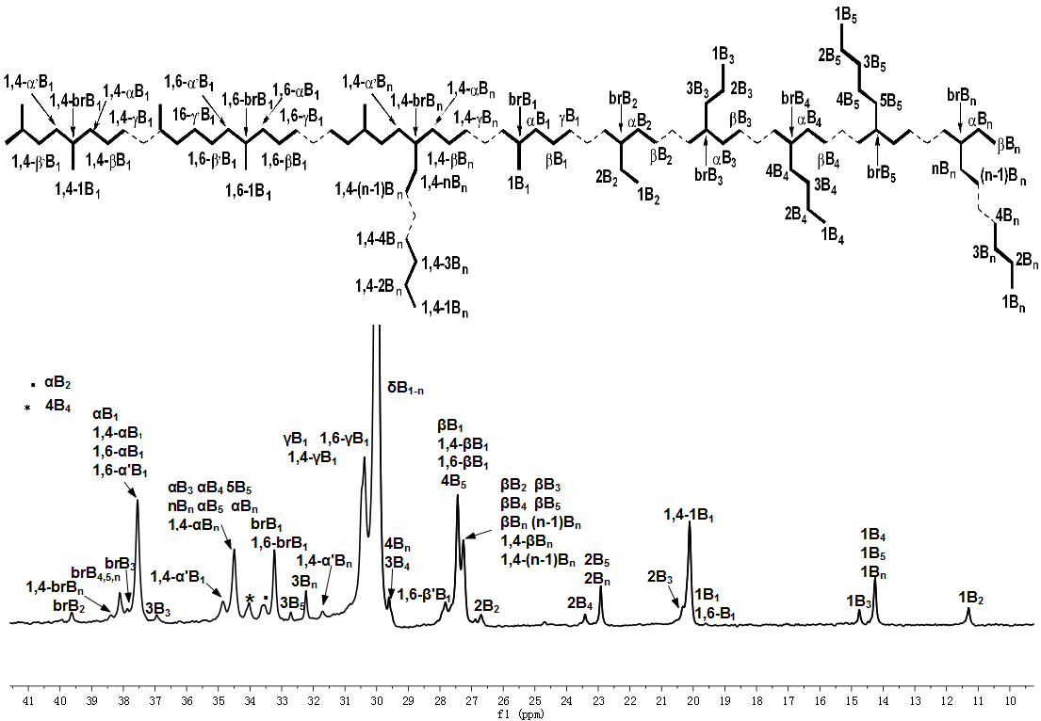
Figure S1 ¹³C NMR spectrum of the polyethylene obtained using Ni5/EASC at 30 °C under 10 atm ethylene (entry 2, Table 6).
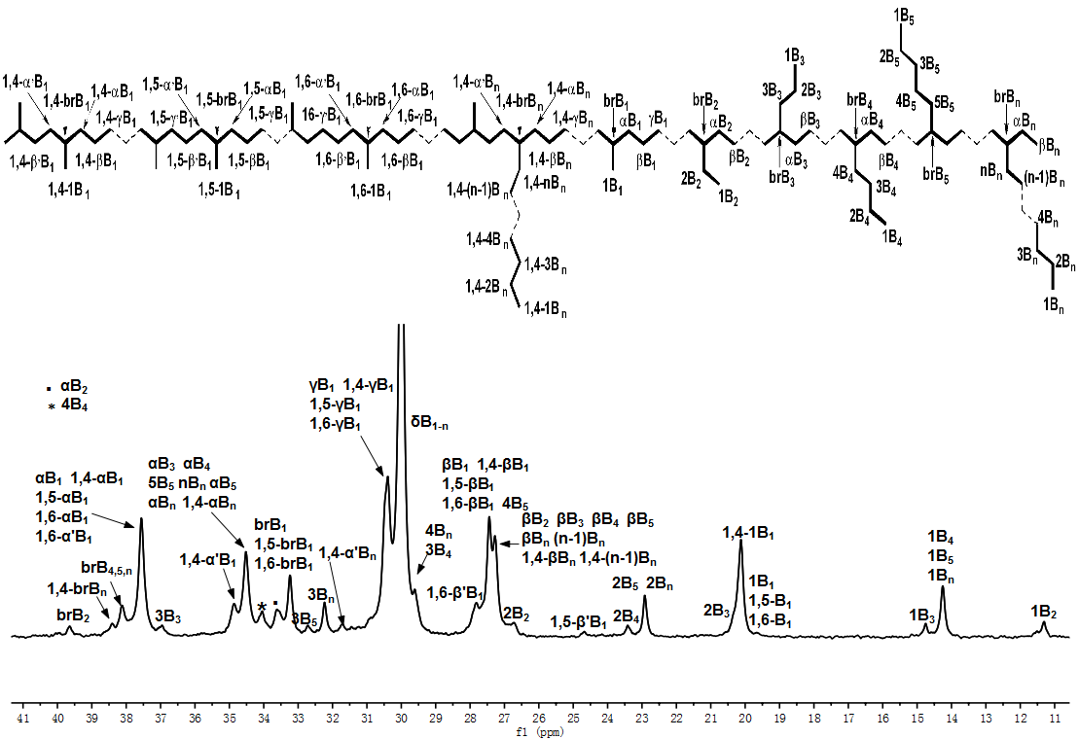
Figure S2 ¹³C NMR spectrum of the polyethylene obtained using Ni5/EASC at 70 °C under 10 atm ethylene (entry 9, Table 6).

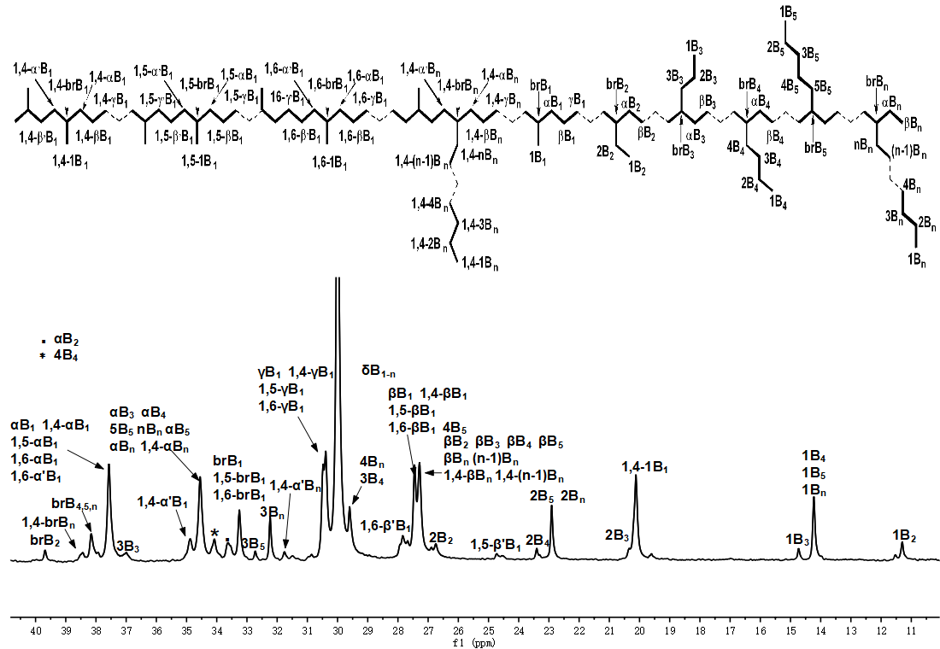
Figure S3 ¹³C NMR spectrum of the polyethylene obtained using Ni5/EASC at 90 °C under 10 atm ethylene (entry 10, Table 6).
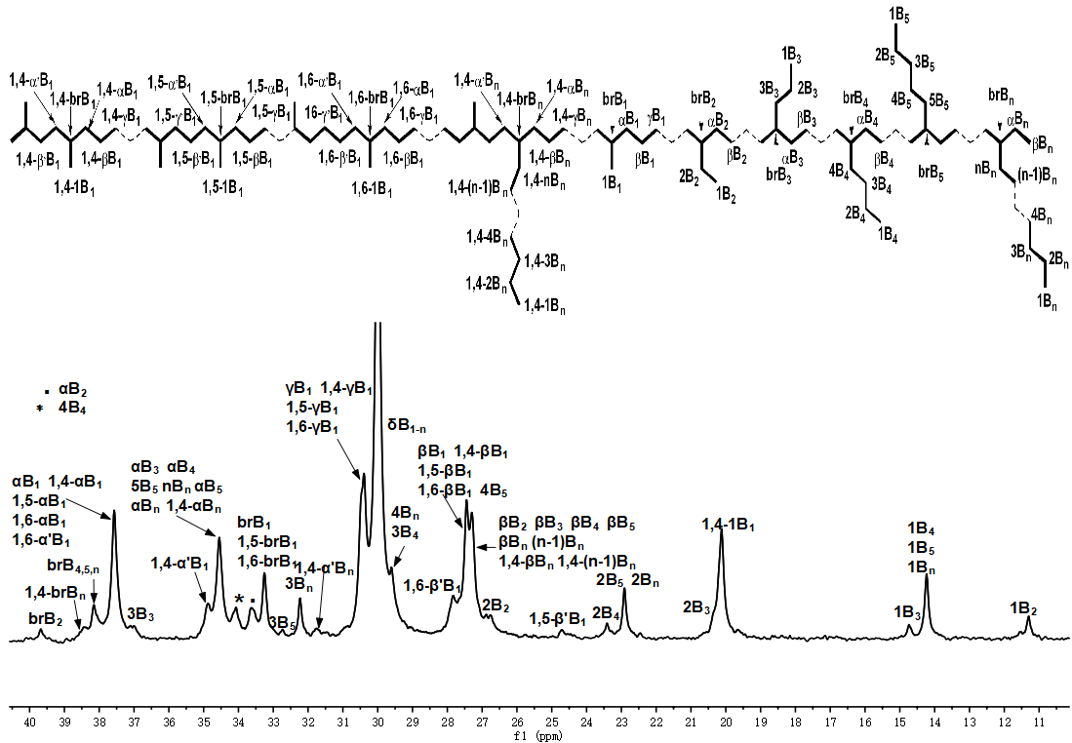
Figure S4 ¹³C NMR spectrum of the polyethylene obtained using Ni5/MAO at 90 °C under 10 atm ethylene (entry 10, Table 4).

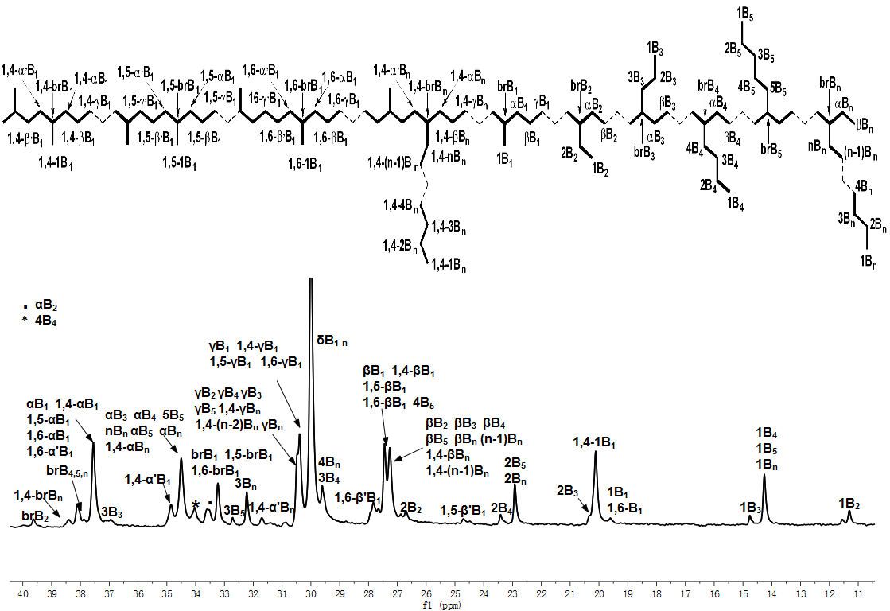
Figure S5 ¹³C NMR spectrum of the polyethylene obtained using Ni5/EASC at 30 °C under 1 atm ethylene (entry 3, Table 5).

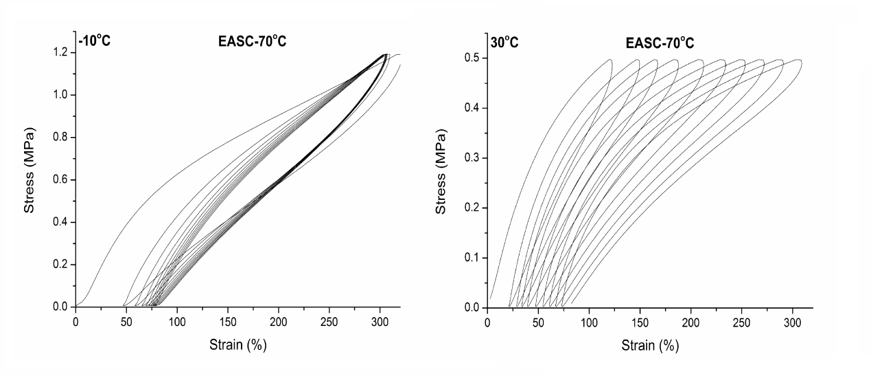
Figure S6 Elastic recovery curves for PE-70_{E/10atm} at -10 and 30 °C (10 cycles).

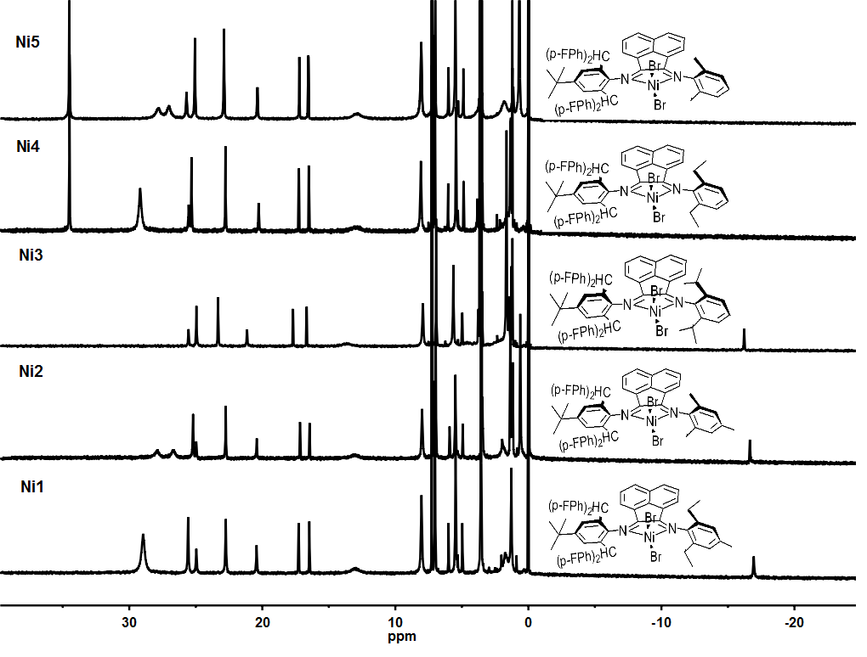
Figure S7 ¹H NMR spectra of Ni1 – Ni5 (recorded in CDCl₃ at ambient temperature)

Table S1 Branching analysis of PE-30_{M/10atm} obtained using Ni5/MAO at 30 °C under 10 atm ethyleneª
Peak no. | δ (ppm) | Relative integral | Type of branch |  | Relative percentage of branch
1 | 11.31 | 0.22 | N_{M} | 4.6 | 56.78%
2 | 14.27 | 1 | N_{E} | 0.16 | 2.00%
3 | 14.77 | 0.18 | N_{P} | 0.27 | 3.36%
4 | 19.86 | 0.17 | N_{B} | 0.53 | 6.48%
5 | 20.12 | 2.39 | N_{A} | 0.38 | 4.69%
6 | 20.33 | 1.13 | N_{M(1,4)} | 0.81 | 9.94%
7 | 22.93 | 0.57 | N_{M(1,5)} | 0 | 0
8 | 23.42 | 0.1 | N_{M(1,6)} | 0.53 | 6.54%
9 | 24.67 | 0 | N_{L} | 0.49 | 5.99%
10 | 26.69 | 0.12 | N_{L(1,4)} | 0.35 | 4.26%
11 | 27.25 | 2.2
12 | 27.44 | 5.86 | [E] | 17.65
13 | 27.83 | 1.06 | [R] | 8.10
14 | 29.53 | 0.22
15 | 29.61 | 0.62 | Total | 157.30
16 | 30 | 36.31 | branching | Branches/1000C
17 | 30.38 | 9.42
18 | 30.48 | 1.57 | Methyl branches |  | 73.22%
19 | 31.68 | 0.72 | Ethyl branches |  | 2.00%
20 | 32.23 | 1.01 | Propyl branches |  | 3.36%
21 | 32.72 | 0.38 | Butyl branches |  | 6.48%
22 | 33.22 | 2.3 | Amyl branches |  | 4.69%
23 | 33.57 | 1.1 | Longer branches |  | 10.25%
24 | 33.83 | 0.11
25 | 34.01 | 0.95
26 | 34.49 | 3.1
27 | 34.86 | 1.06
28 | 36.94 | 0.27
29 | 37.55 | 5.03
30 | 37.86 | 0.51
31 | 38.1 | 1.21
32 | 38.37 | 0.33
33 | 39.62 | 0.31
ª Data determined from the ¹³C NMR spectrum using approaches described by G. B. Galland, R. F. de Souza, R. S. Mauler and F. F. Nunes, Macromolecules, 1999, 32, 1620-1625.

Table S2 Branching analysis of PE-70_{M/10atm} obtained using Ni5/MAO at 70 °C under 10 atm ethyleneª
Peak no. | δ (ppm) | Relative integral | Type of branch |  | Relative percentage of branch
1 | 11.31 | 0.4 | N_{M} | 1.69 | 31.43%
2 | 14.27 | 1 | N_{E} | 0.35 | 6.51%
3 | 14.77 | 0.29 | N_{P} | 0.44 | 8.18%
4 | 19.86 | 0.11 | N_{B} | 0.450 | 9.21%
5 | 20.12 | 2.57 | N_{A} | 0.35 | 6.51%
6 | 20.33 | 0.2 | N_{M(1,4)} | 0.69 | 12.88%
7 | 22.93 | 0.76 | N_{M(1,5)} | 0.15 | 2.79%
8 | 23.42 | 0.3 | N_{M(1,6)} | 0.55 | 10.13%
9 | 24.67 | 0.15 | N_{L} | 0.28 | 5.11%
10 | 26.69 | 0.43 | N_{L(1,4)} | 0.39 | 7.25%
11 | 27.25 | 1.3
12 | 27.44 | 3.01 | [E] | 5.49
13 | 27.83 | 1.09 | [R] | 5.38
14 | 29.53 | 0.1
15 | 29.61 | 1.38 | Total | 247.53
16 | 30 | 11.75 | branching | Branches/1000 Cs
17 | 30.38 | 6.66
18 | 30.48 | 0.65 | Methyl branches |  | 57.23%
19 | 31.68 | 0.46 | Ethyl branches |  | 6.51%
20 | 32.23 | 0.78 | Propyl branches |  | 8.18%
21 | 32.72 | 0.35 | Butyl branches |  | 9.21%
22 | 33.22 | 1.16 | Amyl branches |  | 6.51%
23 | 33.57 | 0.83 | Longer branches |  | 12.36%
24 | 33.83 | 0.52
25 | 34.01 | 0.69
26 | 34.49 | 2.13
27 | 34.86 | 0.97
28 | 36.94 | 0.44
29 | 37.55 | 2.93
30 | 37.86 | 0.56
31 | 38.1 | 0.73
32 | 38.37 | 0.55
33 | 39.62 | 0.36
ª Data determined from the ¹³C NMR spectrum using approaches described by G. B. Galland, R. F. de Souza, R. S. Mauler and F. F. Nunes, Macromolecules, 1999, 32, 1620-1625.

Table S3 Branching analysis of PE-90_{M10atm} obtained using Ni5/MAO at 90 °C under 10 atm ethyleneª
Peak no. | δ (ppm) | Relative integral | Type of branch |  | Relative percentage of branch
1 | 11.31 | 0.44 | N_{M} | 0.97 | 22.83%
2 | 14.27 | 1 | N_{E} | 0.34 | 8.00%
3 | 14.77 | 0.17 | N_{P} | 0.33 | 7.76%
4 | 19.86 | 0.18 | N_{B} | 0.51 | 11.88%
5 | 20.12 | 1.84 | N_{A} | 0.18 | 4.24%
6 | 20.33 | 0.45 | N_{M(1,4)} | 0.55 | 12.94%
7 | 22.93 | 0.83 | N_{M(1,5)} | 0.25 | 5.88%
8 | 23.42 | 0.35 | N_{M(1,6)} | 0.59 | 13.88%
9 | 24.67 | 0.25 | N_{L} | 0.36 | 8.35%
10 | 26.69 | 0.88 | N_{L(1,4)} | 0.18 | 4.24%
11 | 27.25 | 2.16
12 | 27.44 | 2.27 | [E] | 3.92
13 | 27.83 | 1.18 | [R] | 4.25
14 | 29.53 | 0
15 | 29.61 | 1.5 | Total | 260.10
16 | 30 | 8.43 | branching | Branches/1000C
17 | 30.38 | 1.93
18 | 30.48 | 1.86 | Methyl branches |  | 55.53%
19 | 31.68 | 0.22 | Ethyl branches |  | 8.00%
20 | 32.23 | 0.59 | Propyl branches |  | 7.76%
21 | 32.72 | 0.18 | Butyl branches |  | 11.88%
22 | 33.22 | 1.01 | Amyl branches |  | 4.24%
23 | 33.57 | 0.76 | Longer branches |  | 12.59%
24 | 33.83 | 0
25 | 34.01 | 0.66
26 | 34.49 | 1.89
27 | 34.86 | 0.72
28 | 36.94 | 0.33
29 | 37.55 | 2.45
30 | 37.86 | 0.16
31 | 38.1 | 0.94
32 | 38.37 | 0.25
33 | 39.62 | 0.14
ª Data determined from the ¹³C NMR spectrum using approaches described by G. B. Galland, R. F. de Souza, R. S. Mauler and F. F. Nunes, Macromolecules, 1999, 32, 1620-1625.

Table S4 Branching analysis of PE-30_{M/1atm} obtained using Ni5/MAO at 30 °C under 1 atm ethylene ª
Peak no. | δ (ppm) | Relative integral | Type of branch |  | Relative percentage of branch
1 | 11.31 | 0.26 | N_{M} | 0.94 | 31.00%
2 | 14.27 | 1 | N_{E} | 0.17 | 5.60%
3 | 14.77 | 0.14 | N_{P} | 0.18 | 5.93%
4 | 19.86 | 0.18 | N_{B} | 0.36 | 11.71%
5 | 20.12 | 1.66 | N_{A} | 0.06 | 1.98%
6 | 20.33 | 0.31 | N_{M(1,4)} | 0.39 | 12.78%
7 | 22.93 | 0.77 | N_{M(1,5)} | 0.14 | 4.62%
8 | 23.42 | 0.21 | N_{M(1,6)} | 0.34 | 11.05%
9 | 24.67 | 0.14 | N_{L} | 0.4 | 13.19%
10 | 26.69 | 0.41 | N_{L(1,4)} | 0.07 | 2.14%
11 | 27.25 | 2.07
12 | 27.44 | 1.71 | [E] | 3.55
13 | 27.83 | 0.67 | [R] | 3.03
14 | 29.53 | 0.28
15 | 29.61 | 1.11 | Total | 230.52
16 | 30 | 7.58 | branching | Branches/1000C
17 | 30.38 | 1.37
18 | 30.48 | 1.47 | Methyl branches |  | 57.45%
19 | 31.68 | 0.1 | Ethyl branches |  | 5.60%
20 | 32.23 | 0.49 | Propyl branches |  | 5.93%
21 | 32.72 | 0.06 | Butyl branches |  | 11.71%
22 | 33.22 | 0.88 | Amyl branches |  | 1.98%
23 | 33.57 | 0.57 | Longer branches |  | 15.33%
24 | 33.83 | 0.12
25 | 34.01 | 0.5
26 | 34.49 | 1.92
27 | 34.86 | 0.49
28 | 36.94 | 0.18
29 | 37.55 | 2.1
30 | 37.86 | 0.08
31 | 38.1 | 0.48
32 | 38.37 | 0.08
33 | 39.62 | 0.04
ª Data determined from the ¹³C NMR spectrum using approaches described by G. B. Galland, R. F. de Souza, R. S. Mauler and F. F. Nunes, Macromolecules, 1999, 32, 1620-1625.

Table S5 Branching analysis of PE-30_{E/10atm} obtained using Ni5/EASC at 30 °C under 10 atm ethylene ª
Peak no. | δ (ppm) | Relative integral | Type of branch |  | Relative percentage of branch
1 | 11.31 | 0.13 | N_{M} | 3.12 | 42.77%
2 | 14.27 | 1 | N_{E} | 0.21 | 2.86%
3 | 14.77 | 0.12 | N_{P} | 0.43 | 5.90%
4 | 19.86 | 0.11 | N_{B} | 0.54 | 7.41%
5 | 20.12 | 3.03 | N_{A} | 0.53 | 7.28%
6 | 20.33 | 0.38 | N_{M(1,4)} | 0.915 | 12.56%
7 | 22.93 | 0.75 | N_{M(1,5)} | 0 | 0%
8 | 23.42 | 0.02 | N_{M(1,6)} | 0.495 | 6.80%
9 | 24.67 | 0 | N_{L} | 0.535 | 7.35%
10 | 26.69 | 0.15 | N_{L(1,4)} | 0.515 | 7.07%
11 | 27.25 | 2.63
12 | 27.44 | 4.47 | [E] | 17.58
13 | 27.83 | 0.99 | [R] | 7.28
14 | 29.53 | 0.22
15 | 29.61 | 1.03 | Total | 146.48
16 | 30 | 36.38 | branching | Branches/1000C
17 | 30.38 | 13.69
18 | 30.48 | 0.85 | Methyl branches |  | 62.13%
19 | 31.68 | 0.68 | Ethyl branches |  | 2.86%
20 | 32.23 | 1.22 | Propyl branches |  | 5.90%
21 | 32.72 | 0.53 | Butyl branches |  | 7.41%
22 | 33.22 | 2.29 | Amyl branches |  | 7.28%
23 | 33.57 | 1.1 | Longer branches |  | 14.42%
24 | 33.83 | 0.11
25 | 34.01 | 1.06
26 | 34.49 | 3.33
27 | 34.86 | 1.28
28 | 36.94 | 0.43
29 | 37.55 | 5.15
30 | 37.86 | 0.94
31 | 38.1 | 1.28
32 | 38.37 | 0.69
33 | 39.62 | 0.42
ª Data determined from the ¹³C NMR spectrum using approaches described by G. B. Galland, R. F. de Souza, R. S. Mauler and F. F. Nunes, Macromolecules, 1999, 32, 1620-1625.

Table S6 Branching analysis of PE-70_{E/10 atm} obtained using Ni5/EASC at 70 °C under 10 atm ethylene ª
Peak no. | δ (ppm) | Relative integral | Type of branch |  | Relative percentage of branch
1 | 11.31 | 0.15 | N_{M} | 1.23 | 28.11%
2 | 14.27 | 1 | N_{E} | 0.11 | 2.51%
3 | 14.77 | 0.19 | N_{P} | 0.21 | 4.79%
4 | 19.86 | 0.05 | N_{B} | 0.44 | 9.92%
5 | 20.12 | 1.86 | N_{A} | 0.31 | 7.07%
6 | 20.33 | 0.26 | N_{M(1,4)} | 0.76 | 17.33%
7 | 22.93 | 0.71 | N_{M(1,5)} | 0.1 | 2.28%
8 | 23.42 | 0.15 | N_{M(1,6)} | 0.46 | 10.38%
9 | 24.67 | 0.1 | N_{L} | 0.36 | 8.10%
10 | 26.69 | 0.05 | N_{L(1,4)} | 0.42 | 9.51%
11 | 27.25 | 1.65
12 | 27.44 | 2.43 | [E] | 5.48
13 | 27.83 | 0.91 | [R] | 4.39
14 | 29.53 | 0.12
15 | 29.61 | 0.44 | Total | 222.36
16 | 30 | 11.87 | branching | Branches/1000C
17 | 30.38 | 6.22
18 | 30.48 | 0.96 | Methyl branches |  | 58.1%
19 | 31.68 | 0.59 | Ethyl branches |  | 2.51%
20 | 32.23 | 0.92 | Propyl branches |  | 4.79%
21 | 32.72 | 0.31 | Butyl branches |  | 9.92%
22 | 33.22 | 1.11 | Amyl branches |  | 7.07%
23 | 33.57 | 0.86 | Longer branches |  | 17.61%
24 | 33.83 | 0
25 | 34.01 | 0.72
26 | 34.49 | 2.7
27 | 34.86 | 1.09
28 | 36.94 | 0.21
29 | 37.55 | 2.68
30 | 37.86 | 0.11
31 | 38.1 | 1.11
32 | 38.37 | 0.54
33 | 39.62 | 0.28
ª Data determined from the ¹³C NMR spectrum using approaches described by G. B. Galland, R. F. de Souza, R. S. Mauler and F. F. Nunes, Macromolecules, 1999, 32, 1620-1625.

Table S7 Branching analysis of PE-90_{E/10atm} obtained using Ni5/EASC at 90 °C under 10 atm ethylene ª
Peak no. | δ (ppm) | Relative integral | Type of branch |  | Relative percentage of branch
1 | 11.31 | 0.31 | N_{M} | 0.50 | 15.51
2 | 14.27 | 1 | N_{E} | 0.25 | 7.94
3 | 14.77 | 0.17 | N_{P} | 0.21 | 6.58
4 | 19.86 | 0.18 | N_{B} | 0.42 | 13.16
5 | 20.12 | 1.68 | N_{A} | 0.12 | 3.76
6 | 20.33 | 0.2 | N_{M(1,4)} | 0.44 | 13.71
7 | 22.93 | 0.85 | N_{M(1,5)} | 0.20 | 6.27
8 | 23.42 | 0.22 | N_{M(1,6)} | 0.50 | 15.67
9 | 24.67 | 0.2 | N_{L} | 0.44 | 13.79
10 | 26.69 | 0.66 | N_{L(1,4)} | 0.12 | 3.61
11 | 27.25 | 2.12
12 | 27.44 | 1.54 | [E] | 3.78
13 | 27.83 | 1 | [R] | 3.19
14 | 29.53 | 0
15 | 29.61 | 1.07 | Total | 229.03
16 | 30 | 8.14 | branching | Branches/1000C
17 | 30.38 | 1.54
18 | 30.48 | 1.7 | Methyl branches |  | 51.16%
19 | 31.68 | 0.14 | Ethyl branches |  | 7.94%
20 | 32.23 | 0.59 | Propyl branches |  | 6.58%
21 | 32.72 | 0.12 | Butyl branches |  | 13.16%
22 | 33.22 | 0.9 | Amyl branches |  | 3.76%
23 | 33.57 | 0.53 | Longer branches |  | 17.40%
24 | 33.83 | 0
25 | 34.01 | 0.62
26 | 34.49 | 2.02
27 | 34.86 | 0.61
28 | 36.94 | 0.21
29 | 37.55 | 2.13
30 | 37.86 | 0.16
31 | 38.1 | 0.58
32 | 38.37 | 0.16
33 | 39.62 | 0.1
ª Data determined from the ¹³C NMR spectrum using approaches described by G. B. Galland, R. F. de Souza, R. S. Mauler and F. F. Nunes, Macromolecules, 1999, 32, 1620-1625.

Table S8 Branching analysis of PE-30_{E/1atm} obtained using Ni5/EASC at 30 °C under 1 atm ethylene ª
Peak no. | δ (ppm) | Relative integral | Type of branch |  | Relative percentage of branch
1 | 11.31 | 0.2 | N_{M} | 0.74 | 27.90%
2 | 14.27 | 1 | N_{E} | 0.19 | 7.28%
3 | 14.77 | 0.11 | N_{P} | 0.11 | 4.18%
4 | 19.86 | 0.13 | N_{B} | 0.29 | 11.01%
5 | 20.12 | 1.69 | N_{A} | 0.04 | 1.52%
6 | 20.33 | 0.2 | N_{M(1,4)} | 0.24 | 9.02%
7 | 22.93 | 0.84 | N_{M(1,5)} | 0.2 | 7.59%
8 | 23.42 | 0.2 | N_{M(1,6)} | 0.34 | 12.91%
9 | 24.67 | 0.2 | N_{L} | 0.46 | 17.27%
10 | 26.69 | 0.24 | N_{L(1,4)} | 0.04 | 1.32%
11 | 27.25 | 1.72
12 | 27.44 | 1.46 | [E] | 4.16
13 | 27.83 | 0.68 | [R] | 2.63
14 | 29.53 | 0.51
15 | 29.61 | 1.47 | Total | 194.00
16 | 30 | 8.81 | branching | Branches/1000C
17 | 30.38 | 1.75
18 | 30.48 | 1 | Methyl branches |  | 57.42%
19 | 31.68 | 0.04 | Ethyl branches |  | 7.28%
20 | 32.23 | 0.5 | Propyl branches |  | 4.18%
21 | 32.72 | 0.04 | Butyl branches |  | 11.01%
22 | 33.22 | 0.71 | Amyl branches |  | 1.52%
23 | 33.57 | 0.37 | Longer branches |  | 18.59%
24 | 33.83 | 0.53
25 | 34.01 | 0.38
26 | 34.49 | 1.9
27 | 34.86 | 0.29
28 | 36.94 | 0.11
29 | 37.55 | 1.81
30 | 37.86 | 0.11
31 | 38.1 | 0.52
32 | 38.37 | 0.05
33 | 39.62 | 0.07
ª Data determined from the ¹³C NMR spectrum using approaches described by G. B. Galland, R. F. de Souza, R. S. Mauler and F. F. Nunes, Macromolecules, 1999, 32, 1620-1625.

Table S9 Crystal data and structure refinements for Ni3 and Ni7
 | Ni3 | Ni7
CCDC No.  Empirical formula | 1854203  C₆₀H₅₂Br₂F₄N₂Ni·2CH₂Cl₂ | 1854204  C₅₈H₄₈Cl₂F₄N₂Ni·(C₂H₅)₂O
Formula weight | 1265.45 | 1052.71
Temperature/K | 173.15 | 173.1500
Crystal system | triclinic | monoclinic
Space group | P1 | P21
a/Å | 10.598(2) | 10.479(2)
b/Å | 11.685(2) | 19.556(4)
c/Å | 13.282(3) | 13.067(3)
α/° | 75.04(3) | 90
β/° | 84.64(3) | 93.20(3)
γ/° | 64.83(3) | 90
Volume/Å³ | 1437.9(6) | 2673.6(9)
Z | 1 | 2
ρ_{calc}g/cm³ | 1.4612 | 1.308
μ/mm⁻¹ | 1.966 | 0.520
F(000) | 644.6 | 1100.0
Crystal size/mm³ | 0.453 × 0.147 × 0.041 | 0.229 × 0.176 × 0.048
2Θ range for data collection/° | 4.24 to 50 | 3.122 to 55.044
Index ranges | -13 ≤ h ≤ 13, -15 ≤ k ≤ 15, -17 ≤ l ≤ 17 | -13 ≤ h ≤ 13, -25 ≤ k ≤ 24, -16 ≤ l ≤ 16
Reflections collected | 15146 | 21234
Independent reflections | 8963 [R_{int} = 0.0420, R_{sigma} = 0.0554] | 11869 [R_{int} = 0.0432, R_{sigma} = 0.0647]
Data/restraints/parameters | 8963/49/703 | 11869/143/714
Goodness-of-fit on F² | 1.046 | 1.044
Final R indexes [I>=2σ (I)] | R₁ = 0.0662, wR₂ = 0.1807 | R₁ = 0.0614, wR₂ = 0.1449
Final R indexes [all data] | R₁ = 0.0674, wR₂ = 0.1827 | R₁ = 0.0662, wR₂ = 0.1505
Largest diff. peak/hole / e Å⁻³ | 0.92/-0.60 | 1.00/-0.43
Flack parameter | 0.139(13) | 0.036(19)

