Appendix A. Supplementary materials
1. A5-sized half-fold leaflet
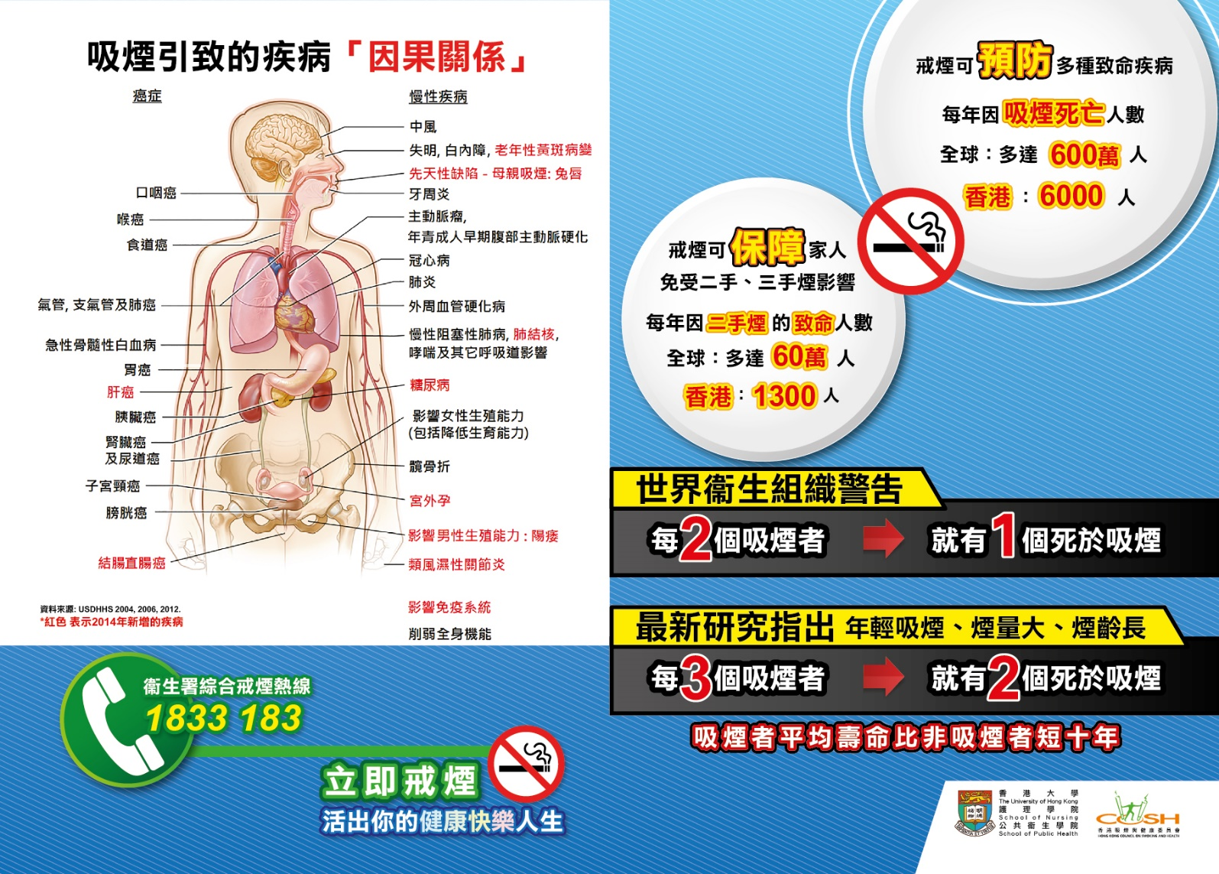
(Front)

Descriptions:
The figure on the left page shows the diseases caused by cigarette smoking based on the findings from the US Surgeon General’s Report in 2004 “The Health Consequences of Smoking”; in 2006 “The Health Consequences of Involuntary Exposure to Tobacco Smoke; and in 2014 “The Health Consequences of Smoking—50 Years of Progress”. The bottom of left page shows the contact number of Integrated Smoking Cessation Hotline under the Department of Health in Hong Kong: 1833 183
The top of right page contains information about the burden of smoking, including the annual number of deaths attributable to active smoking and passive smoking globally and in Hong Kong. The bottom of right page includes 3 statements of (1) “The World Health Organization warns that 1 in 2 smokers will die prematurely due to smoking”; (2) Emerging evidence suggests that 2 in 3 smokers who began smoking at younger ages, smoke more or have greater number of years of smoking will die prematurely because of smoking; and (3) The life expectancy of smokers is on average 10 years shorter than non-smokers.

1. A5-sized half-fold leaflet (continue)
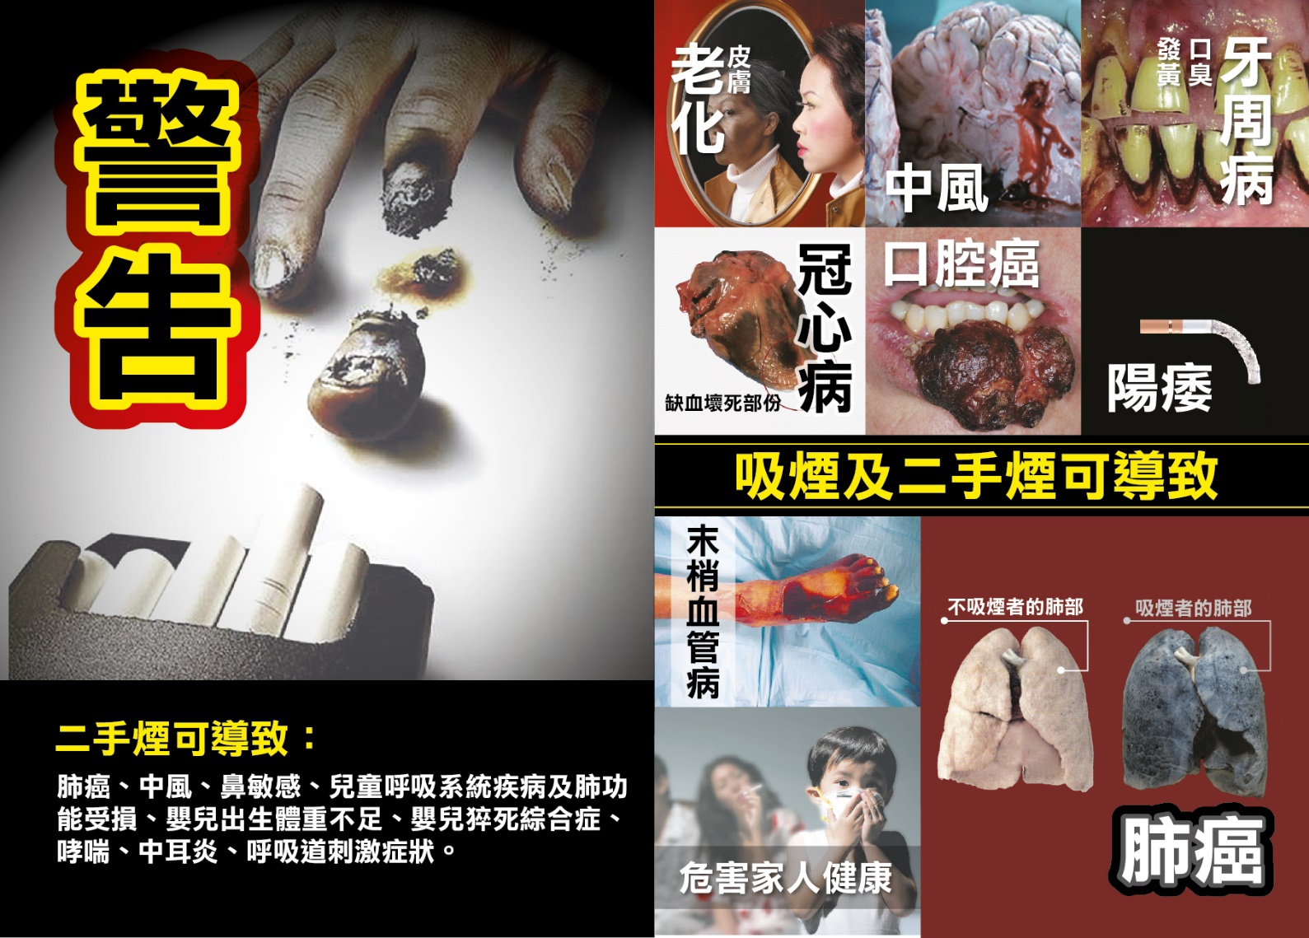
(Back)

Descriptions:
The text in bottom left lists the diseases attributable to secondhand smoke exposure including lung cancer, stroke, allergic rhinitis, child respiratory diseases and impaired lung function, low birth weight, sudden infant death syndrome, asthma, otitis media and respiratory symptoms.
The figures on the right show the harms of smoking including premature skin aging, stroke, periodontitis/ poor oral breath/ stained teeth, coronary heart disease, oral cancer, erectile dysfunction, peripheral vascular disease, lung cancer and harm to family health.
2. Information card on smoking cessation services in Hong Kong
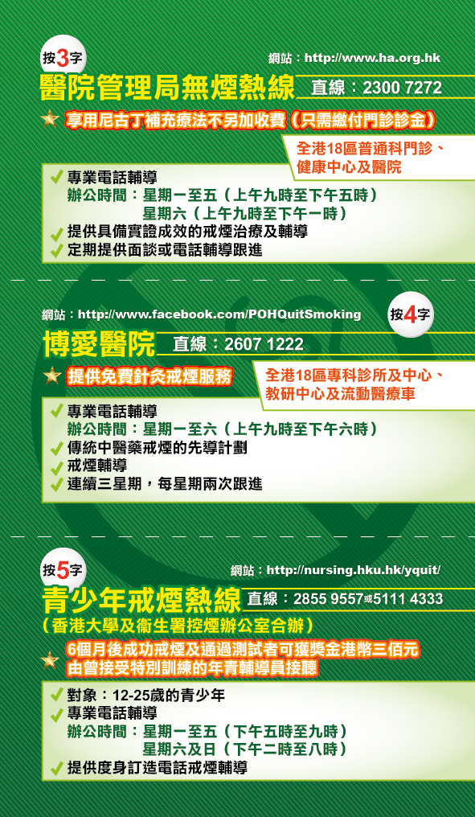
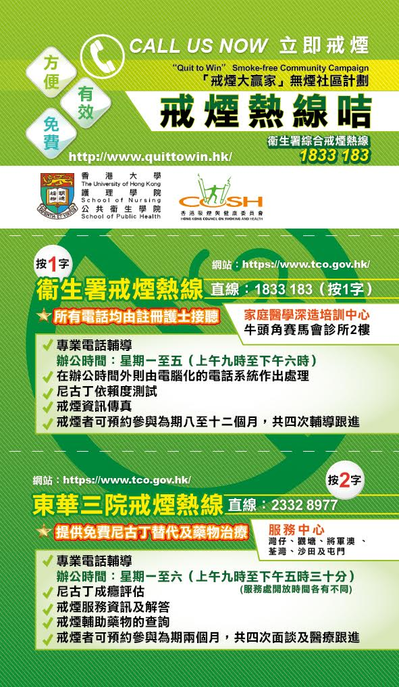
(Front) (Back)

Descriptions:
The information card shows the contact numbers of 5 major smoking cessation services in Hong Kong including (1) Department of Health Integrated Smoking Cessation, (2) Tung Wah Group of Hospitals Integrated Centre on Smoking Cessation, (3) Hospital Authority Smoking Counselling and Cessation Programme, (4) Pok Oi Hospital Smoking Cessation Service and (5) Youth Quitline of the University of Hong Kong.
Brief information about the treatment modalities (e.g., counselling, smoking cessation aids, traditional Chinese medicine) and target group (e.g. youths aged 12 to 25 years) of each smoking cessation service providers were provided.

3. Self-help smoking cessation booklet
The booklet (in Chinese, PDF file) can be directly accessed from the web site of Hong Kong Council on Smoking and Health via the following link: http://www.smokefree.hk/UserFiles/resources/about_us/books/Smoking_Cessation_Booklet_v2016.pdf [Archived at WebCite: http://www.webcitation.org/723UTSPf9]
The 12-page self-help entitled: “Be Smart, Quit Smoking!” covers information about the harms of smoking and benefits of quitting (page 1-2); self-assessment tools including the Fagerström Test for Nicotine Dependence (page 3-4); tips on dealing with craving (page 5), a calendar table for progress recording (page 6-7); introduction of smoking cessation aids (page 8-9); information on and methods to overcome nicotine withdrawal symptoms (page 10); common questions and answers related to quitting (page 11-12); and information about smoking cessation services in Hong Kong (last page).

