Measured data of the materials at the imports and exports in 17000 Nm³/h ASU
 | Stage | Phase | Temperature  /K | Pressure  /kPa | $$x_{N_{2}}$$ | $$x_{O_{2}}$$ | Flow rate  /mol·s⁻¹
N₂ product | 1 | V | 79.305 | 126.71 | 0.999922 | 0.00005 | 210.807
LN₂ return | 1 | L | 79.305 | 126.72 | 0.999838 | 0.000005 | 275.107
Waste N₂ withdrawn | 3 | V | 81 | 130.08 | 0.934 | 0.054 | 583.496
Waste LN₂ in | 15 | L | 80.68 | 126.69 | 0.813122 | 0.175 | 215.302
Rich O₂ liquid air in | 27 | L | 82.633 | 129.57 | 0.612502 | 0.3732 | 72.156
Expanded air in | 36 | V | 83.886 | 129.5 | 0.78175 | 0.209 | 112.396
Liquid air return | 37 | L | 86.228 | 127.99 | 0.614712 | 0.37098 | 276.791
Ar withdrawn | 55 | V | 92.4 | 129.94 | 0.000159 | 0.936841 | 233.056
Ar return | 77 | L | 92.281 | 129.8 | 0.000046 | 0.937288 | 224.345
LO₂ product | 111 | L | 92.796 | 132.18 | 0 | 0.99765 | 148.738
Notes: The data is measured by Hangzhou Hangyang Co. Ltd, China. ($x_{O_{2}}+x_{N_{2}}+x_{Ar}=1$)

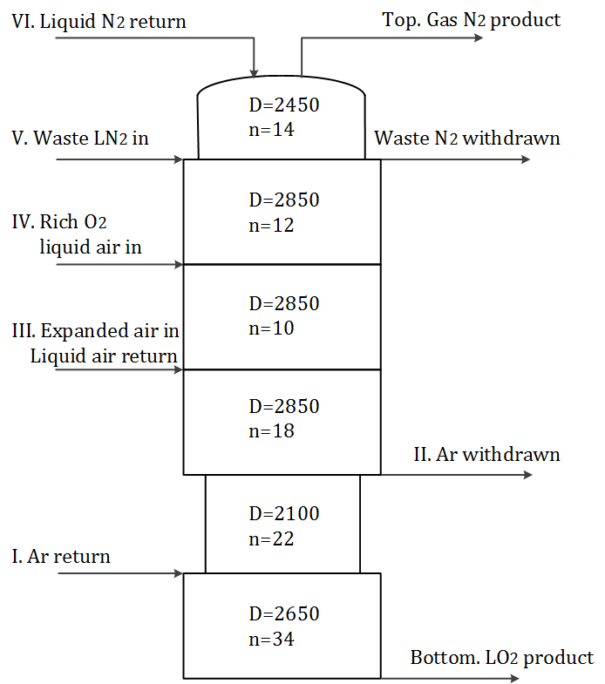
Parameters of the structured packing upper column

