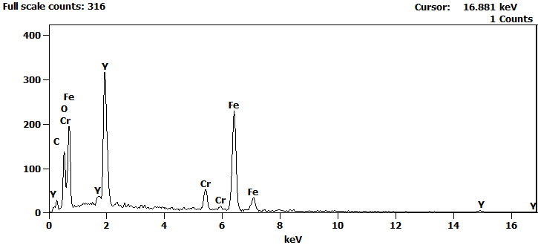
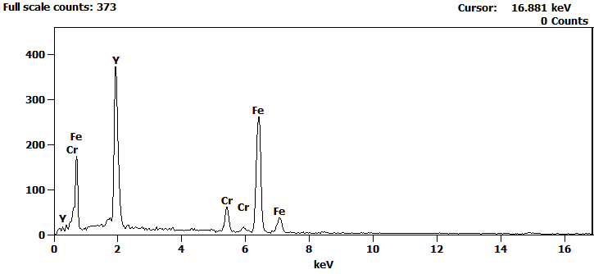
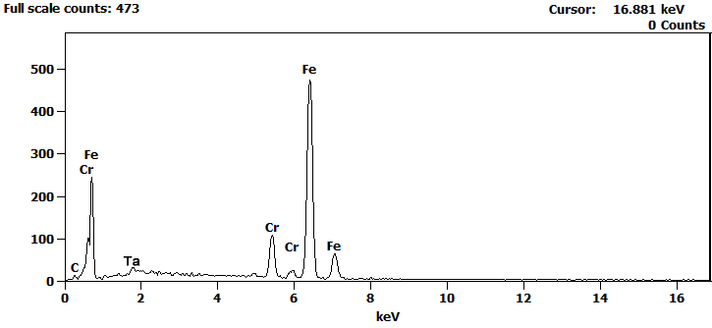
Atom %
 | C | O | Cr | Ta | Fe | Y
pt1 | 8.14 | 44.86 | 4.64 |  | 29.75 | 12.61
pt2 |  |  | 7.98 |  | 62.11 | 29.91
pt3 | 14.35 |  | 21.78 | 2.25 | 61.62

