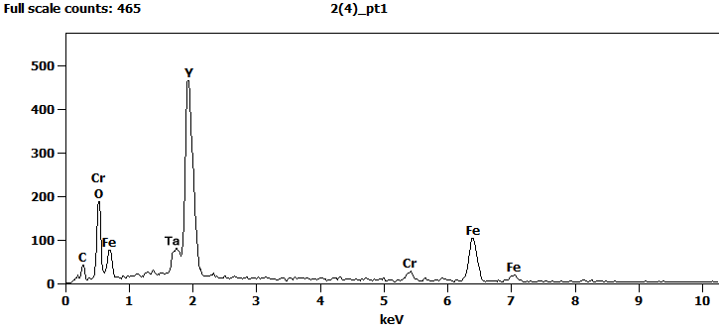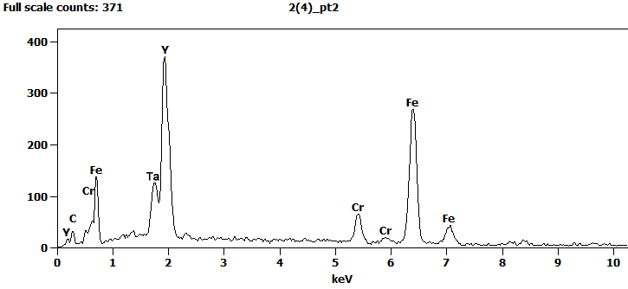
Atom %
 | C | O | Cr | Ta | Fe | Y
pt1 | 5.71 | 30.55 | 2.55 |  | 23.20 | 37.99
pt2 | 4.53 |  | 6.03 | 6.10 | 45.28 | 38.06

