Graphical Abstract
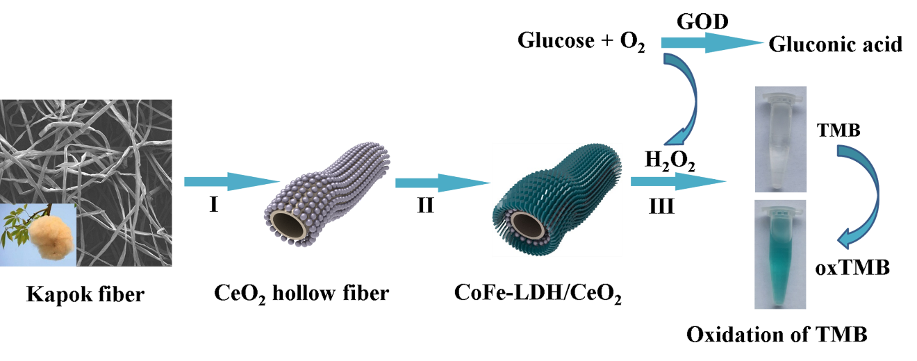

Abstract
Biomass-derived hierarchically porous CoFe-LDH (layered double hydroxides)/CeO₂ hybrid possessing an inherent peroxidase-like activity was first fabricated employing kapok as bio-template. The CeO₂ fibers not only exhibited peroxidase-like activity, but also served as a support and guided the deposition of CoFe-LDH nanosheets on their surface to form a hierarchically porous network. The resultant CoFe-LDH/CeO₂ hybrid acted as a peroxidase mimic to catalyze 3,3′,5,5′- tetramethylbenzidine (TMB) with H₂O₂ to generate a typical blue colored product. Furthermore, CoFe-LDH/CeO₂ hybrid displayed superior peroxidase-like catalytic property compared to the pristine CeO₂ and CoFe-LDH, which was attributed to the unique hierarchical-porous morphology and the synergistic effect between CoFe-LDH and CeO₂. A facile and highly sensitive colorimetric system for H₂O₂ and glucose determination was successfully proposed, which exhibited a sensitive response to glucose ranging from 0.05 ~ 2 mM with a detection limit of 0.015 mM based on the accelerated electron transfer between TMB and H₂O₂ with the assistance of CoFe-LDH/CeO₂. This paper offered a feasible way for the fabrication of materials with hierarchical structure and provided a new insight into seeking novel peroxidase mimics with boosted catalytic activities.

