Dear Researcher,

Thank you for using this code and datasets. I explain how CFTS code related to my paper "A clustering based forecasting algorithm for multivariable fuzzy time series using linear combinations of independent variables" published in Applied Soft Computing works. All datasets mentioned in the paper accompanied with CFTS code are included.
If there is any question feel free to contact me at:
bas_salaraskari@yahoo.com
s_askari@aut.ac.ir

Regards,

S. Askari

Guidelines for CFTS algorithm:
- Open the file CFTS Code using MATLAB.
- Enter or paste name of the dataset you wish to simulate in line 5 after "load". It loads the dataset in the workplace.
- Lines 6 and 7: "r" is number of independent variables and "N" is number of data vectors used for training.
- Line 9: "C" is number of clusters. You can use the optimal number of clusters given in Table 6 of paper or your own preferred value.
- If line 28 is "comment", covariance norm (Mahalanobis distance) is use and if it is "uncomment", identity norm (Euclidean distance) is used.
- For your own dataset, please arrange the data as the datasets given here.

I explain this with an example. Consider the following dataset with 4 variables and 10 observations.
The entire input data are "XIorig" and their corresponding outputs are "ydorig".
"XIorig" is (orig=original):
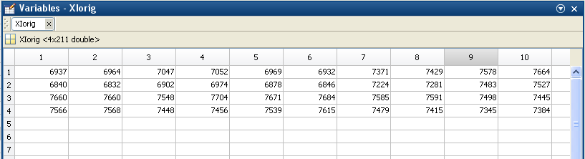

"ydorig" is:
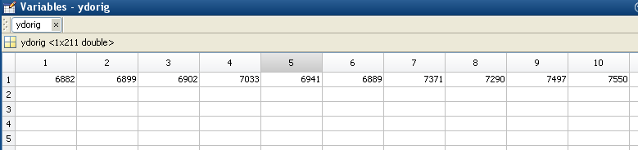

Assume we want to reserve the last three observations for testing the CFTS algorithm. We remove them from "XIorig" and "ydorig" which yields "XI" and "yd", respectively, as follows:

"XI" is:
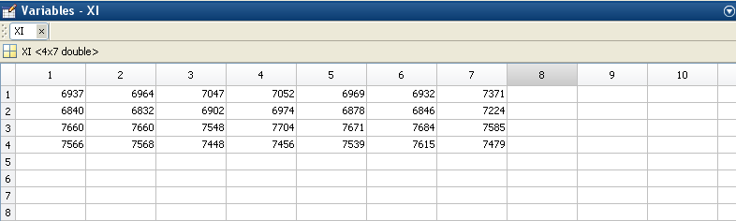

"yd" is:
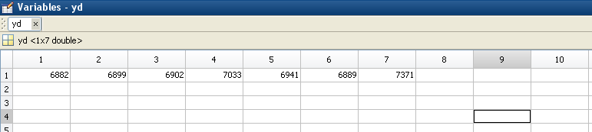

Please note that "XI" and "yd" are used to train CFTS and testing data are extracted from "XIorig" and "ydorig" by the algorithm itself.

