Electronic Annex to: Test Validation of Extension-Twisting coupled Laminates with Matched Orthotropic Stiffness.

Table A1: Geometry for each of the four samples, corresponding to the three laminate designs of Table 2 of the above article.

- – Laminate 1
 |  | Specimen thickness |  |  |  |  | Specimen width
Position: | Top | 2.43 | 2.62 | 2.59 | 2.58 |  | 24.05 | 24.09 | 24.08 | 24.05
 | Middle | 2.56 | 2.62 | 2.63 | 2.63 |  | 24.07 | 24.06 | 24.15 | 24.16
 | Bottom | 2.60 | 2.66 | 2.70 | 2.64 |  | 24.02 | 24.09 | 24.12 | 24.10
Laminate: | Average H | 2.53 | 2.63 | 2.64 | 2.62 |  | 24.05 | 24.08 | 24.11667 | 24.10
Ply: | Average t | 0.158 | 0.165 | 0.165 | 0.164
- – Laminate 2
 |  | Specimen thickness |  |  |  |  | Specimen thickness
Position: | Top | 2.53 | 2.57 | 2.62 | 2.66 |  | 24.05 | 24.09 | 24.08 | 24.05
 | Middle | 2.61 | 2.65 | 2.69 | 2.66 |  | 24.07 | 24.06 | 24.15 | 24.16
 | Bottom | 2.61 | 2.67 | 2.70 | 2.70 |  | 24.02 | 24.09 | 24.12 | 24.10
Laminate: | Average H | 2.58 | 2.63 | 2.67 | 2.67 |  | 24.05 | 24.08 | 24.12 | 24.10
Ply: | Average t | 0.161 | 0.164 | 0.167 | 0.167
- – Laminate 3
 |  | Specimen thickness |  |  |  |  | Specimen thickness
Position: | Top | 2.61 | 2.69 | 2.64 | 2.7 |  | 23.64 | 23.8 | 23.86 | 23.57
 | Middle | 2.64 | 2.66 | 2.63 | 2.67 |  | 23.57 | 23.83 | 23.59 | 23.49
 | Bottom | 2.66 | 2.66 | 2.62 | 2.68 |  | 23.67 | 23.82 | 23.74 | 23.64
Laminate: | Average H | 2.64 | 2.67 | 2.63 | 2.68 |  | 23.63 | 23.82 | 23.73 | 23.57
Ply: | Average t | 0.165 | 0.167 | 0.164 | 0.168

Figure A1 – Gauge length measurement confirmed from indentations on test specimens from bevel edged serrated grips.
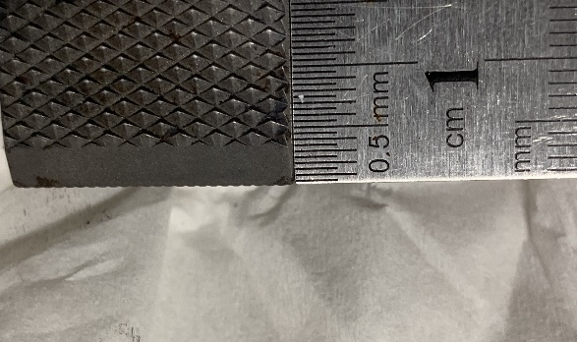 | 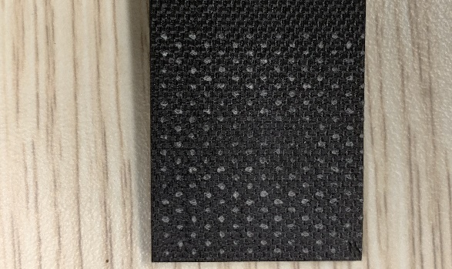

ABAQUS Input Files:
LAMINATE 1
*HEADING
EXTENSION-TWISTING TEST SPECIMEN
*NODE
1001,0,0,0
1025,24.07,0,0
201001,0,189,0
201025,24.07,189,0
300000,12,199,0
*NSET,NSET=RNODE
300000
*NGEN,NSET=TOP
201001,201025
*NGEN,NSET=BOTTOM
1001,1025
*NFILL,NSET=ALL
BOTTOM,TOP,200,1000
*ELEMENT,TYPE=S4R
1001,1001,1002,2002,2001
*ELGEN,ELSET=PLATE
1001,24,1,1,200,1000,1000
*RIGID BODY, REF=RNODE,TIENSET=TOP
*MATERIAL,NAME=CFRP
*ELASTIC,TYPE=LAMINA
131E3,8.2E3,0.38,4.3E3,4.3E3,2.2E3
*SHELL SECTION,ELSET=PLATE,COMPOSITE
**Laminate 1
0.152,3,CFRP,-22.5,PLY_1
0.152,3,CFRP,-22.5,PLY_2
0.152,3,CFRP,67.5,PLY_3
0.152,3,CFRP,67.5,PLY_4
0.152,3,CFRP,22.5,PLY_5
0.152,3,CFRP,67.5,PLY_6
0.152,3,CFRP,-22.5,PLY_7
0.152,3,CFRP,-67.5,PLY_8
0.152,3,CFRP,67.5,PLY_9
0.152,3,CFRP,22.5,PLY_10
0.152,3,CFRP,-67.5,PLY_11
0.152,3,CFRP,-22.5,PLY_12
0.152,3,CFRP,-67.5,PLY_13
0.152,3,CFRP,-67.5,PLY_14
0.152,3,CFRP,22.5,PLY_15
0.152,3,CFRP,22.5,PLY_16
*BOUNDARY
BOTTOM,ENCASTRE
RNODE,1
RNODE,3,4
RNODE,6
*STEP, INC=7500, NLGEOM
*STATIC,RIKS
0.01, 1., 1.E-5, 0.01, 1
*CLOAD
RNODE,2,5000
*RESTART,WRITE,FREQUENCY=0
*OUTPUT,FIELD,VARIABLE=PRESELECT
*OUTPUT,HISTORY
*NODE OUTPUT,NSET=RNODE
CF2,UR2
*END STEP

LAMINATE 2

Change only the nodal data and laminate description from the above input file, as follows:

*NODE
1001,0,0,0
1025,24.11,0,0
201001,0,189,0
201025,24,189,0
300000,12,199,0

**Laminate 2
0.159,3,CFRP,-22.5,PLY_1
0.159,3,CFRP,22.5,PLY_2
0.159,3,CFRP,67.5,PLY_3
0.159,3,CFRP,67.5,PLY_4
0.159,3,CFRP,67.5,PLY_5
0.159,3,CFRP,-22.5,PLY_6
0.159,3,CFRP,-22.5,PLY_7
0.159,3,CFRP,-22.5,PLY_8
0.159,3,CFRP,-67.5,PLY_9
0.159,3,CFRP,67.5,PLY_10
0.159,3,CFRP,-67.5,PLY_11
0.159,3,CFRP,-67.5,PLY_12
0.159,3,CFRP,22.5,PLY_13
0.159,3,CFRP,-67.5,PLY_14
0.159,3,CFRP,22.5,PLY_15
0.159,3,CFRP,22.5,PLY_16

LAMINATE 3:

Change only the nodal data and laminate description from the above input file, as follows:

*NODE
1001,0,0,0
1025,23.72,0,0
201001,0,189,0
201025,23.69,189,0
300000,12,189,0

**Laminate 3
0.163,3,CFRP,-22.5,PLY_1
0.163,3,CFRP,67.5,PLY_2
0.163,3,CFRP,67.5,PLY_3
0.163,3,CFRP,-22.5,PLY_4
0.163,3,CFRP,22.5,PLY_5
0.163,3,CFRP,22.5,PLY_6
0.163,3,CFRP,22.5,PLY_7
0.163,3,CFRP,-67.5,PLY_8
0.163,3,CFRP,-67.5,PLY_9
0.163,3,CFRP,-67.5,PLY_10
0.163,3,CFRP,-67.5,PLY_11
0.163,3,CFRP,-67.5,PLY_12
0.163,3,CFRP,-67.5,PLY_13
0.163,3,CFRP,22.5,PLY_14
0.163,3,CFRP,22.5,PLY_15
0.163,3,CFRP,22.5,PLY_16

