**Supplemental Data**

**Effects of** **compositions, chemical structures, and nanoporosity of sedimentary organic matter on degradation of benzo(a)pyrene by hydrogen peroxide**

Chenya Zhuo*a,b*, Dainan Zhang*a*, Yu Yang*a*, Xiangyun Zhang*a*, Yong Ran*a*\*, Jingdong Mao*c*

*a State Key Laboratory of Organic Geochemistry, Guangzhou Institute of Geochemistry, Chinese Academy of Sciences, Guangzhou 510640, China*

*b University of Chinese Academy of Sciences, Beijing 100049, China*

*c Department of Chemistry and Biochemistry, Old Dominion University, Norfolk, Virginia, 23529, USA*

* Corresponding authors: 86-20-85290263 (phone), 86-20-85290706 (fax), e-mail: yran@gig.ac.cn (Yong Ran)

**Contents:**

**1.** Sediment collection

**2.** Sediment spiking with BaP and aging.

**3.** Determination of radioactivity in degradation experiments.

**3. Figure S1.** The sampling locations for the sediments.

**4. Figure S2**. Flow diagram of degradation experiment

**5. Figure S3**. Flow diagram for the separation of organic matter with different stability

**6. Figure S4.** Correlations of aliphatic C and aromatic C from CP spectra with aliphatic C and aromatic C from DP spectra. The data were cited from Huang et al.1

**7.Figure S5.** Carbon dioxide adsorption isotherms fitted to the Dubinin-Radushkevitch equation on the OS and ROC of different sediments.

**8. Figure S6.** Porosity distributions calculated by the CO2-DFT Model on the OS and ROC of different sediments.

**9. Figure S7.** The histogram of the contents of ferrous ions in sediments (a), XRD diffraction diagram in different sediments (b).

**10. Figure S8.** Correlations among the contents of the chemically resistant OC (ROC) and the Vo-bulk and SSA-bulk values (a-b), where Vo-bulk or SSA-bulk means nanopore volumes or specific surface areas from the ROC fractions in the bulk samples; Correlations between the Faliph-C and alky-C with the Vo-bulk and SSA-bulk values (c-f).

**11.Figure S9.** Residual amounts of parent compounds (BaP) in extractable residues **(a)** before oxidizing, andwater-soluble residues **(b)**, extractable residues **(c)** after oxidizing were determined by HPLC, respectively. Red: A1 sample; black: A4 sample; blue: E2 sample; gray: E3 sample; green: E4 sample; yellow: E5 sample.

**12. Figure S10.** Correlations of the Faliph-bulk (%), alkyl C-bulk (%), (CH2)n-bulk (%), Farom-bulk (%), arom(C-C)–bulk (%) and Arom(C-O)–bulk (%) with the degradation efficiency of 14C-BaP (%)

**12. Figure S11.** The relationship of the degradation kinetics parameters (Frap, Fslow) with Vo-bulk (μL/g) and SSA-bulk (m2/g).

**13. Table S1.** OCcontents of USOC, STOC, MOC, and ROC, and their percentages.

**14. Table S2.** Specific surface areas (SSA), nanopores (Vo), and pore size distributions of the sediments before and after oxidation

**15. Table S3.** The compositions and contents of the mineralsin different sediments

16. **Table S4.** Residual radioactivity (%) in each residue after treatment

17. **Table S5**. Residual amount of parent compound (BaP) in water-soluble residues and extractable residues after treatment

**16. Table S6.** Correlations among the SOC fractions (SOC, MOC, and ROC), functional groups of the ROC fractions, nanoporosity and degradation kinetics parameters in the bulk sediments.

**1. Sediment collection.** The sampling sites are presented in Figure S1. One sediment sample (X1: 23.77°N, 114.57°E) was collected in January 2012 in the Xinfengjiang reservoir. Two sediment samples (A1: 13o52.909"E, 22o 25.220"N, A4: 113o49.53" E, 22o 00.408"N) were collected in January 2012 in the Pearl River Estuary. Four sediment samplers (E2: 113°59.946"E, 21°0.035"N, E3: 114°13.563"E, 20°38.333"N, E4: 114°35.915"E, 20°0.021"N, E5: 114°53.798"E, 19°30.000"N) were collected in May in 2012 in the northern South China Sea. The water depth was 28.7 m for X1, 21 m for A1, 11m for A4, 79 m for E2, 83 m for E3, 208 m for E4, and 1468 m for E5.

**2.Sediment spiking with BaP and aging.** The spiked process is briefly described as follows: 20 g (dw, dry weight) of a given sediment was weighted to a 250 ml conical flask, spiked by 50 ng/g of 14C-BaP and 450 ng/g of non-radioactive labeled BaP stock solution in acetone, and artificially stirred for 1 h until it was fully mixed. This mixture was placed in a fume hood overnight so that acetone solvent was allowed to be evaporated. A given amount of deionized water was added, aged for one month. Afterwards, the samples were freeze-dried and ground through an 80-mesh sieve for the degradation experiment. In order to examine the homogeneity of BaP in the sediments, we randomly selected 0.05 g of each sample, and burned at 900 °C on a Model A307 Sample Oxidizer (Perkin Elmer, USA) for 5 min. The generated 14CO2 was absorbed with 15 mL of alkaline cocktail (Perkin Elmer, USA), and the radioactivity was counted on a liquid scintillation counter (LSC) (Perkin Elmer, USA). The relative standard deviation of radioactivity for sediment replicates ranges from 1.40% to 3.65%, indicating that BaP was homogeneously distributed in the spiked samples.

**3.** **Determination of radioactivity in degradation experiments.** Each of the extracts was shaken and concentrated to 2-3 mL by evaporation, then mixed with 10 ml of scintillation cocktail (Perkin Elmer, USA) and counted on liquid scintillation counter (LSC) (Perkin Elmer, USA). For radioactivity in aqueous samples, 5 mL of water samples and 1 mL of alkaline solution (14CO2) were mixed with 10mL and 3mL cocktail, respectively. For radioactivity in bound residues, 0.5 g of extracted sediment was combusted using a Model A307 Sample Oxidizer (Perkin Elmer, USA) for 5 min and the generated 14CO2 was absorbed with 15 mL of alkaline cocktail (Perkin Elmer, USA), and counted on LSC.

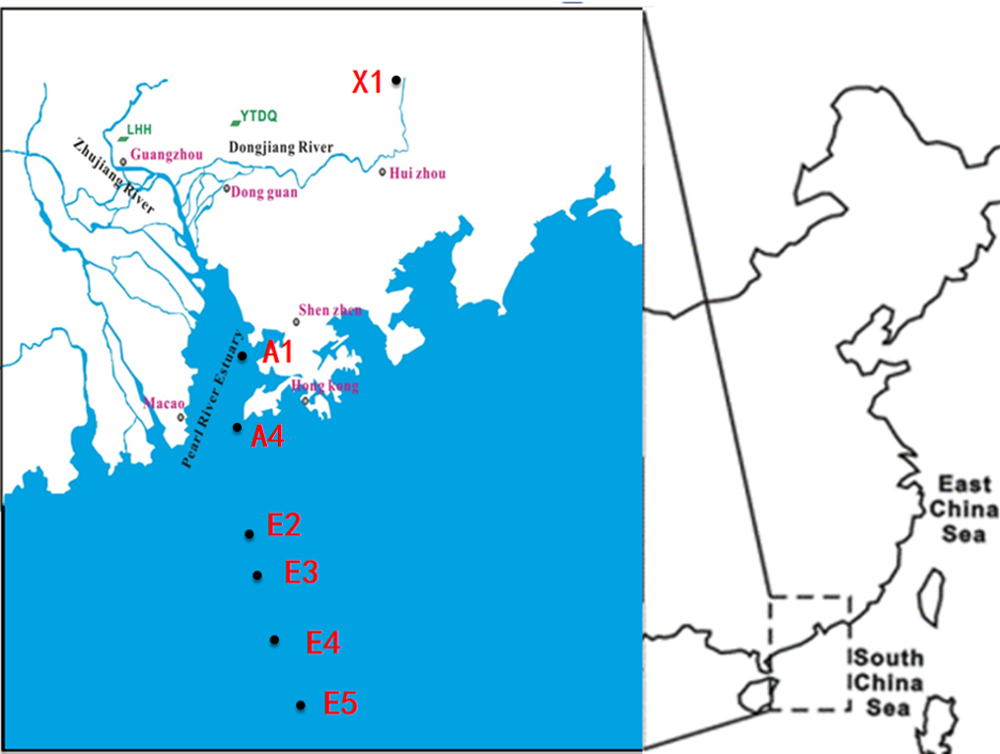

**Figure S1.** The sampling locations for the sediments

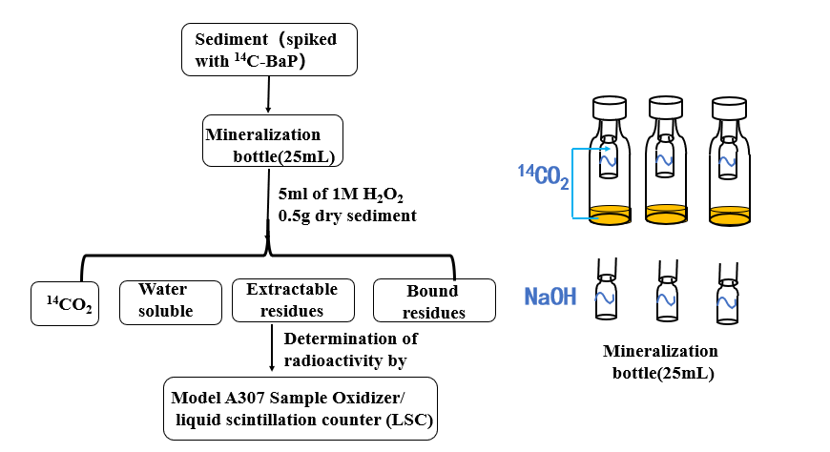

**Figure S2**. Flow diagram of degradation experiment

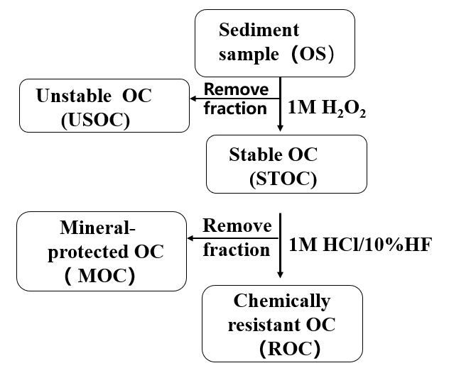

**Figure S3**. Flow diagram for the separation of organic matter fractions.



**Figure S4.** Correlations of aliphatic C and aromatic C from CP spectra with aliphatic C and aromatic C from DP spectra. The data were cited from Huang et al.1



**Figure S5.** Carbon dioxide adsorption isotherms fitted to the Dubinin-Radushkevitch equation on the OS and ROC of different sediments.



**Figure S6.** Porosity distribution calculated by CO2-DFT Model on the OS and ROC of different sediments.



**Figure S7**. Correlations among the contents of the ROC and the Vo-bulk and SSA-bulk values (a-b), where Vo-bulk or SSA-bulk means nanopore volumes or specific surface areas from the ROC fractions in the bulk samples; Correlations between the Faliph-C and alky-C with the Vo-bulk and SSA-bulk values (c-f).



**Figure S8.** The histogram of the contents of ferrous ions in sediments (a), XRD diffraction diagram in different sediments (b).



**Figure S9.** Residual amounts of parent compounds (BaP) in extractable residues **(a)** before oxidation, andwater-soluble residues **(b)**, extractable residues **(c)** after oxidation, which were determined by HPLC, respectively. Red: A1 sample; black: A4 sample; blue: E2 sample; gray: E3 sample; green: E4 sample; yellow: E5 sample.



**Figure S10.** Correlations of the Faliph-bulk (%), alkyl C-bulk (%), (CH2)n-bulk (%), Farom-bulk (%), arom(C-C)–bulk (%) and arom(C-O)–bulk (%) with the degradation efficiency of 14C-BaP (%).



**Figure S11.** The relationships of the degradation kinetics parameters (Frap, Fslow) with Vo-bulk (μL/g) and SSA-bulk (m2/g).

|  |  |  |  |  |  |  |  |  |  |
| --- | --- | --- | --- | --- | --- | --- | --- | --- | --- |
| **Table S1 OC contents of USOC, STOC, MOC, and ROC) in the bulk, and the percentages accounting for the bulk OC in the six sediment samples** | | | | | | | | | |
|  | OC(Bulk) | **a** USOC | USOC/OC | STOC | STOC/OC | **b**MOC | MOC/OC | ROC | ROC/OC |
| **c**g.kg-1 | g.kg-1 | % | g.kg-1 | % | g.kg-1 | % | g.kg-1 | % |
| A01 | 8.91 | 6.75 | 75.80 | 2.16 | 24.20 | 1.37 | 15.38 | 0.78 | 8.80 |
| A04 | 8.58 | 4.59 | 53.50 | 3.99 | 46.50 | 2.99 | 34.80 | 1.09 | 12.70 |
| E2 | 2.55 | 1.24 | 48.60 | 1.31 | 51.40 | 0.11 | 4.30 | 1.20 | 47.10 |
| E3 | 3.14 | 1.08 | 34.40 | 2.06 | 65.6 | 0.42 | 13.40 | 1.64 | 52.20 |
| E4 | 1.71 | 0.62 | 36.30 | 1.09 | 63.70 | 0.11 | 6.43 | 0.98 | 57.30 |
| E5 | 6.89 | 0.38 | 5.52 | 6.51 | 94.50 | 1.52 | 22.10 | 4.99 | 72.40 |
| a: USOC = Bulk – SOC、 b: MOC = SOC –ROC、c:g-OC/kg-bulk-sediment | | | | | | | | | |

|  |  |  |  |  |  |  |  |  |  |
| --- | --- | --- | --- | --- | --- | --- | --- | --- | --- |
| Table S2. specific surface area (SSA), nanopore (Vo), pore size distribution, and calibration volume (Vo (CO2-N2)) | | | | | | | | | |
| for the OS and the ROC fractions | | | | | | | | | |
| sample | Dubinin-radushkevitch (DR) | | | |  | cumulative volume (CV) | | | |
| Vo | SSA | CSA | Vo (CO2-N2) |  | 0-1.1nm | 0-0.7nm | 0.7-1.1nm | |
| μL/g | m2/g | m2/g | μL/g |  | μL/g | μL/g (%of 0-1.1nm) | μL/g (% of 0-1.1nm) | |
|  |  |  |  |  | OS |  |  | |  |  |  |
| A1 | 6.24 | 15.6 | 5.44 | 5.18 |  | 1.61 | 1.23 (76.5) | 0.38 (23.4) | |
| A4 | 7.28 | 18.2 | 4.89 | 6.22 |  | 1.47 | 1.13 (76.9) | 0.34 (23.1) | |
| E2 | 2.71 | 6.76 | 1.91 | 2.29 |  | 0.56 | 0.46 (82.1) | 0.10 (17.9) | |
| E3 | 3.32 | 8.29 | 0.97 | 3.14 |  | 0.28 | 0.24 (86.0) | 0.04 (14.0) | |
| E4 | 5.25 | 13.1 | 3.46 | 3.62 |  | 0.99 | 0.80 (80.8) | 0.19 (19.2) | |
| E5 | 10.77 | 26.9 | 12.42 | 8.81 |  | 3.51 | 2.76 (78.7) | 0.75 (21.3) | |
|  |  |  |  |  | ROC |  |  | |  |  |  |
| A1 | 7.13 | 19.3 | 10.40 | 5.30 |  | 3.07 | 2.36 (76.9) | 0.71 (23.1) | |
| A4 | 8.01 | 20.0 | 9.31 | 6.51 |  | 2.76 | 2.14 (77.5) | 0.62 (22.5) | |
| E2 | 11.1 | 27.6 | 5.98 | 10.3 |  | 1.80 | 1.42 (78.6) | 0.39 (21.4) | |
| E3 | 10.7 | 26.6 | 8.09 | 10.4 |  | 2.45 | 1.86 (75.8) | 0.59 (24.2) | |
| E4 | 10.7 | 26.7 | 6.05 | 7.85 |  | 1.82 | 1.39 (76.6) | 0.43 (23.4) | |
| E5 | 15.0 | 37.5 | 15.90 | 13.0 |  | 4.42 | 3.73 (84.3) | 0.69 (15.7) | |

|  |  |  |  |  |  |  |
| --- | --- | --- | --- | --- | --- | --- |
| Table S3. The compositions and contents of the mineral in different sediments | | | | | | |
| NO. | Quartz (%) | Illite (%) | Albite (%) | Calcite (%) | pyrite | siderite |
| A1 | 89.8 | 10.2 | N.D. | N.D. | N.D. | N.D. |
| A4 | 76.3 | 10.9 | 8.3 | 4.5 | N.D. | N.D. |
| E2 | 69.4 | 10.2 | 14.7 | 5.7 | N.D. | N.D. |
| E3 | 26.5 | 13.4 | 26.6 | 9.8 | N.D. | 23.8 |
| E4 | 36.9 | 14.7 | 17.4 | 13.8 | 0.5 | 11.9 |
| E5 | 35.3 | 16.7 | 22.5 | 25.5 | N.D. | N.D. |

|  |  |  |  |  |  |  |  |
| --- | --- | --- | --- | --- | --- | --- | --- |
| **Table S4.** Residual radioactivity (%) in each residue after the treatment | | | | | | | |
| % Recovery | X1 | A1 | A4 | E2 | E3 | E4 | E5 |
| Degradation to 14CO2 | 81.00 | 60.80 | 23.80 | 15.80 | 19.90 | 11.30 | 1.42 |
| Extractable residues | 5.40 | 13.81 | 30.66 | 41.78 | 37.57 | 40.99 | 60.56 |
| Water-soluble residues | 5.30 | 6.02 | 20.32 | 16.16 | 21.60 | 19.90 | 4.19 |
| Bound residues | 4.30 | 17.81 | 19.37 | 23.74 | 17.93 | 25.23 | 30.58 |
| Total recovery | 96.00 | 98.44 | 94.15 | 97.48 | 97.00 | 97.43 | 96.75 |
| The radioactivity in extractable residues, water-soluble residues and bound residues may include intermediates and parent compounds. | | | | | | | |

|  |  |  |  |  |  |  |  |
| --- | --- | --- | --- | --- | --- | --- | --- |
| **Table S5.** Residual amount of parent compound (BaP) in water-soluble residues and | | | | | | | |
| extractable residues after treatment | | | | | | | |
| % Recovery | X1 | A1 | A4 | E2 | E3 | E4 | E5 |
| Extractable residues | 4.10 | 11.51 | 12.17 | 26.50 | 22.34 | 36.17 | 57.56 |
| Water-soluble residues | nd | nd | nd | 1.11 | nd | nd | 0.12 |

|  |  |  |  |  |  |  |  |  |  |  |  |  |  |  |
| --- | --- | --- | --- | --- | --- | --- | --- | --- | --- | --- | --- | --- | --- | --- |
| **Table S6.** Correlations among the SOM fractions (SOC, MOC, and ROC), functional groups of the ROC fractions, nanoporosity, and degradation kinetics parameters in the bulk sediments. | | | | | | | | | | | | | | |
|  | **STOCa** | **MOCa** | **ROCa** | **Farom-bulkb** | **Faliph-bulkb** | **alkyl C-bulkb** | **arom(C-C)-bulkb** | **Vo-bulka** | **SSA-bulka** | ***Frap*a** | ***krap*a** | ***Fslow*a** | ***kslow*a** |
| **STOCa** | **1** | **0.435** | **0.926\*\*** | **-0.791\*** | **0.894\*\*** | **0.958\*\*** | **-0.859\*** | **0.882\*\*** | **0.912\*\*** | **-0.762\*** | **-0.627** | **0.765\*** | **-0.678** |
| **MOCa** |  | **1** | **0.200** | **-0.399** | **0.398** | **0.583** | **-0.339** | **0.617** | **0.629** | **-0.547** | **-0.235** | **0.559** | **-0.371** |
| **ROCa** |  |  | **1** | **-0.848\*** | **0.840\*** | **0.825\*** | **-0.831\*** | **0.714\*** | **0.746\*** | **-0.651** | **-0.580** | **0.651** | **-0.599** |
| **Farom-bulkb** |  |  |  | **1** | **-0.975\*\*** | **-0.841\*** | **0.959\*\*** | **-0.801\*** | **-0.859\*** | **0.943\*\*** | **0.836\*** | **-0.937\*\*** | **0.499** |
| **Faliph-bulkb** |  |  |  |  | **1** | **0.917\*\*** | **-0.969\*\*** | **0.915\*\*** | **0.879\*\*** | **-0.884\*\*** | **-0.713** | **0.884\*\*** | **-0.467** |
| **alkyl C-bulkb** |  |  |  |  |  | **1** | **-0.835\*** | **0.991\*\*** | **0.995\*\*** | **-0.797\*** | **-0.513** | **0.807\*** | **-0.398** |
| **arom(C-C)-bulkb** |  |  |  |  |  |  | **1** | **-0.819\*** | **-0.780\*** | **0.880\*\*** | **0.694** | **-0.882\*\*** | **0.608** |
| **Vo-bulka** |  |  |  |  |  |  |  | **1** | **0.991\*\*** | **-0.783\*** | **-0.572** | **0.784\*** | **-0.373** |
| **SSA-bulka** |  |  |  |  |  |  |  |  | **1** | **-0.714\*** | **-0.414** | **0.718\*** | **-0.358** |
| ***Frap*a** |  |  |  |  |  |  |  |  |  | **1** | **0.511** | **-0.999\*\*** | **0.509** |
| ***Krap*a** |  |  |  |  |  |  |  |  |  |  | **1** | **-0.483** | **0.271** |
| ***Fslow*a** |  |  |  |  |  |  |  |  |  |  |  | **1** | **0.582** |
| ***kslow*a** |  |  |  |  |  |  |  |  |  |  |  |  | **1** |
| **Correlation is significant at the 0.01 level. * Correlation is significant at the 0.05 level. a: n = 6, b: n = 5. | | | | | | | | | | | | | | |
| Farom-bulk, Faliph-bulk, alkyl C-bulk and Arom(C-C)-bulk refer to the the contents of aliphatic C, aromatic C, alky C and arom(C-C) from the NHC fractions in the bulk respectively. | | | | | | | | | | | | | | |

**Reference**

1. Huang, Y.; Zhang, D.; Duan, D.; Yu, Y.; Xiong, Y.; Yong, R., Importance of the structure and nanoporosity of organic matter on the desorption kinetics of benzo[ a ]pyrene in sediments Environ. Pollut. **2017,** 225, 628.