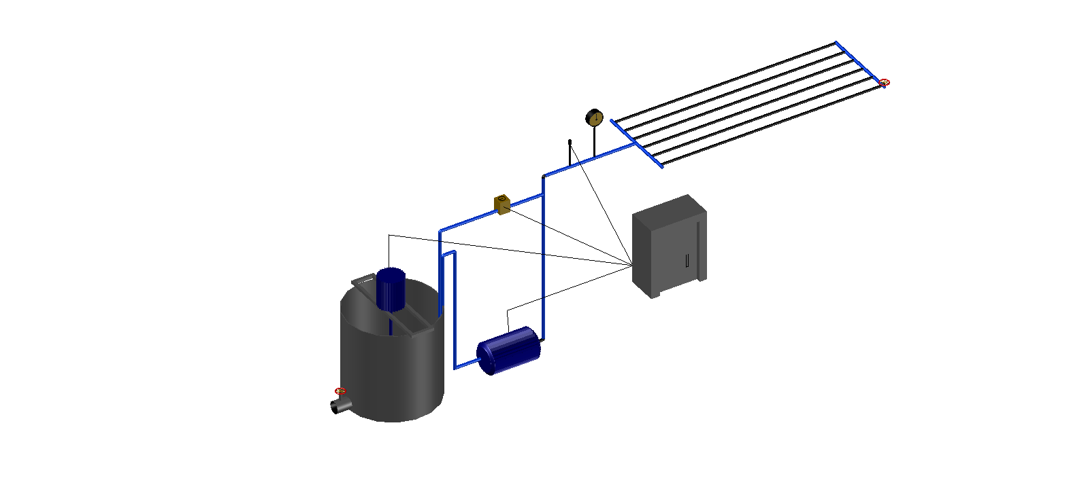
1
2
3
4
5
6
9
7
8
10
Fig. 1 Drip irrigation test platform
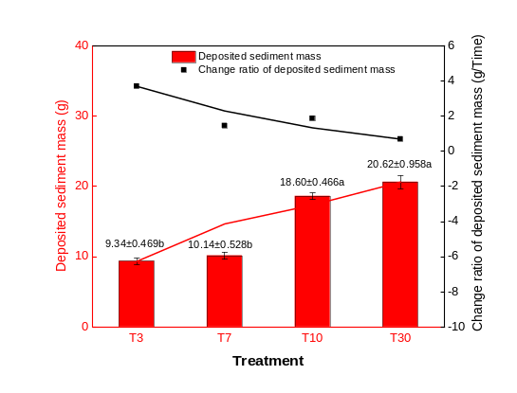 | 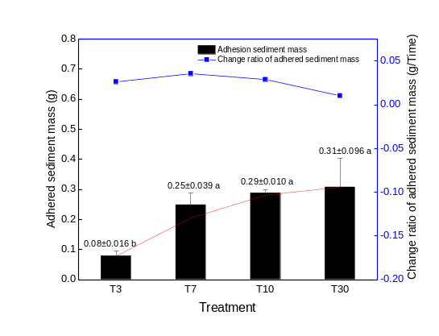
Fig. 2. Changes in deposited sediment mass in the laterals for the different irrigation times | Fig. 3. Changes in adhered sediment mass in laterals for the different irrigation times

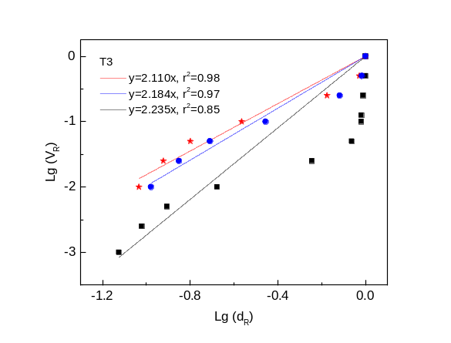 | 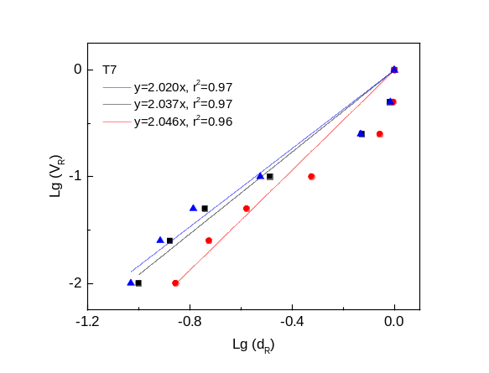
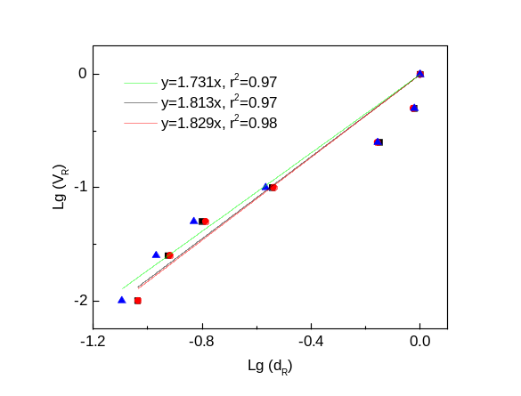 | 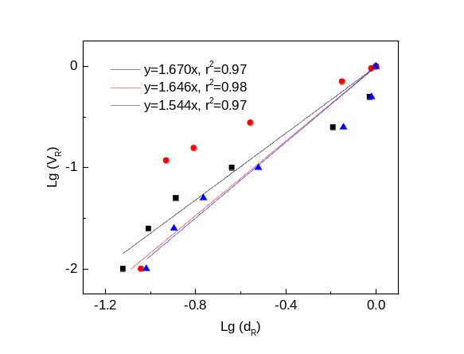
Fig. 4 Linear fit of lg(d_{R})-lg(V_{R}) for the deposited sediment
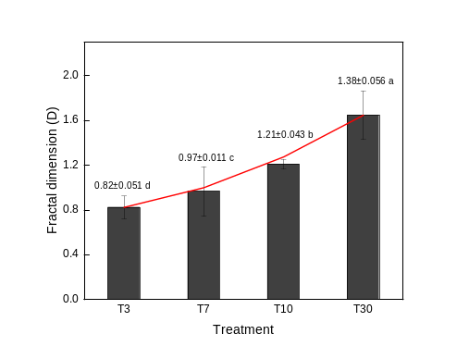
Fig. 5 Variation in the fractal dimension of the sediment
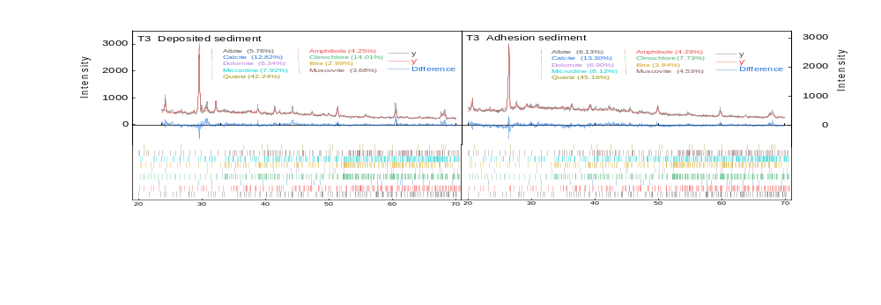
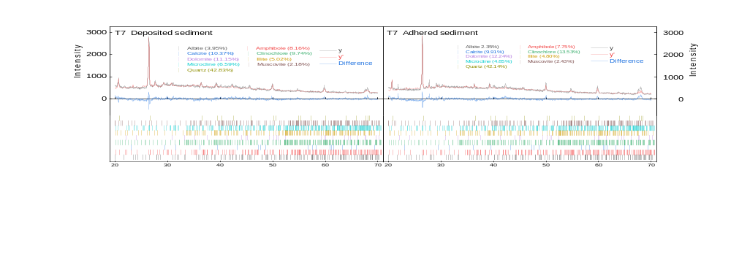
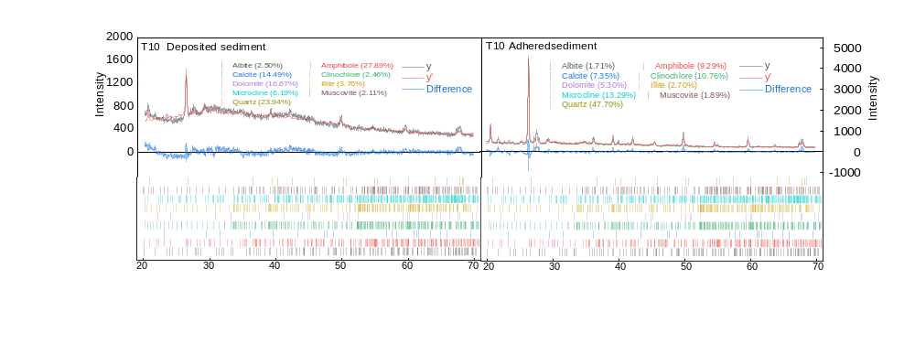
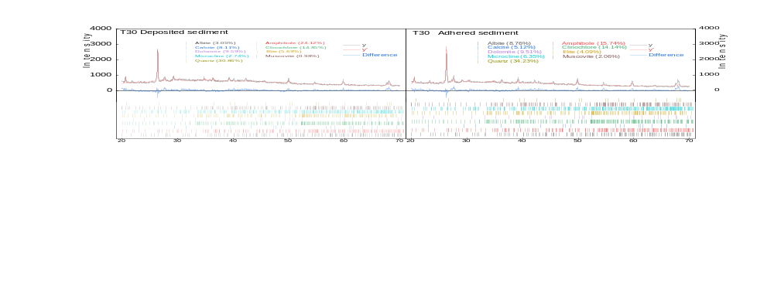
Fig. 6 X-ray diffraction Topas refinement maps of the sediment
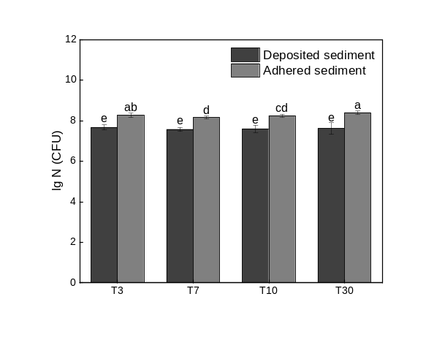
Fig. 7 Changes in the bacterial quantity in the sediment for the different irrigation times
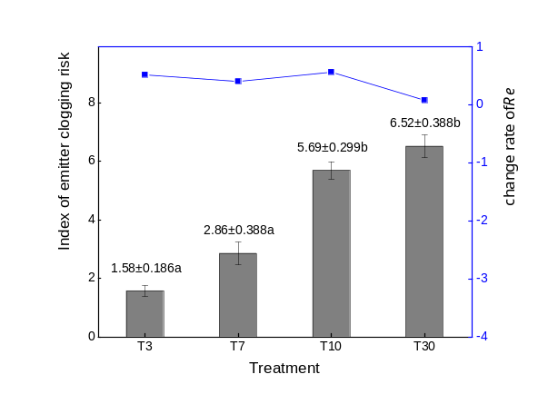
Fig. 8 Index of the emitter clogging risk for the different irrigation times

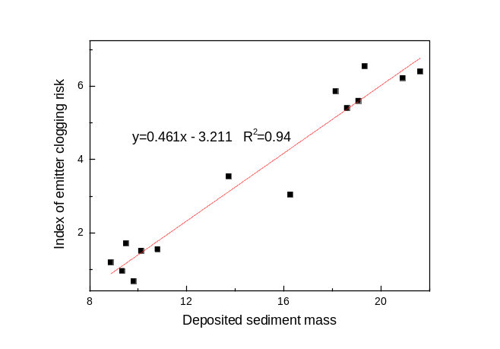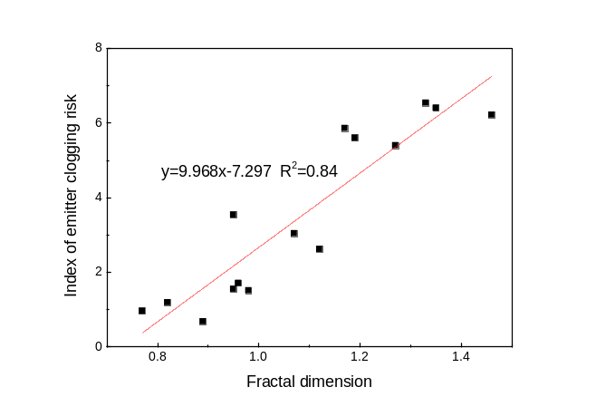
Fig. 9 Linear regression of the emitter clogging risk index and the DS mass
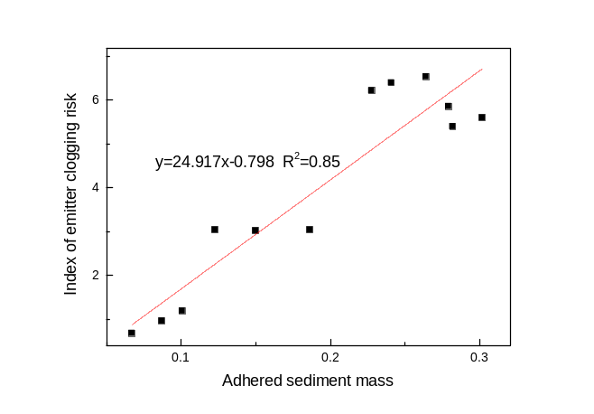
Fig. 10. Linear regression of the emitter clogging risk index and the AS mass
Table 1 Mineral composition of the test sediment
Mineral composition | Quartz | Albite | Microcline | Calcite | Dolomite | Muscovite | Clinochlore | Amphibole
Content | 43% | 15% | 7% | 8% | 3% | 11% | 9% | 4%
Table 5 Mineral content of the sediment in the laterals
Treatment | T3 |  | T7 |  | T10 |  | T30
Treatment | DS | AS | DS | AS | DS | AS | DS | AS
Viscous minerals | 7.719 | 11.455 | 14.761 | 18.33 | 6.22 | 13.467 | 13.831 | 18.235
Non-viscous minerals | 92.28 | 88.816 | 85.24 | 81.669 | 93.78 | 86.533 | 86.17 | 81.763
Table 6 Topas refined R factor table
Treatment | T3 |  | T7 |  | T10 |  | T30
Treatment | DS | AS | DS | AS | DS | AS | DS | AS
Fitted value(R_{wp}) | 9.21 | 9.08 | 8.16 | 9.71 | 7.75 | 12.56 | 8.37 | 9.92
Fitting expectation(R_{exp}) | 4.93 | 4.56 | 4.55 | 4.80 | 4.29 | 5.14 | 4.32 | 4.75
Goodness of fit(gof) | 1.87 | 1.99 | 1.79 | 2.03 | 1.81 | 2.44 | 1.94 | 2.09

Table 7 Pearson correlation analysis of the factors related to emitter clogging
 | Index of emitter clogging risk | Change rate of R_{ec} | Change of DS mass | Change of AS mass | Fractal dimension | Bacterial content in DS | Bacterial content in AS | DS mass | AS mass
Index of emitter clogging risk | 1 | -- | -- | -- | -- | -- | -- | -- | --
Change rate of R_{ec} | 0.163 | 1 | -- | -- | -- | -- | -- | -- | --
Change of DS mass | 0.248 | -0.490 | 1 | -- | -- | -- | -- | -- | --
Change of AS mass | -0.694** | -0.136 | 0.277 | 1 | -- | -- | -- | -- | --
Fractal dimension | 0.917** | -0.050 | 0.424 | -0.502 | 1 | -- | -- | -- | --
Bacterial content in DS | 0.028 | -0.256 | 0.160 | -0.269 | -0.087 | 1 | -- | -- | --
Bacterial content in AS | -0.040 | 0.017 | -0.414 | -0.519* | -0.153 | -0.121 | 1 | -- | --
DS mass | 0.917** | 0.227 | 0.340 | -0.524* | 0.928** | -0.071 | -0.056 | 1 | --
AS mass | -0.747** | 0.431 | -0.465 | 0.487 | -0.746** | -0.211 | -0.613* | -0.527* | 1
** indicates a significant correlation at the α= 0.01 level (two-tailed);
* indicates a significant correlation at the α= 0.05 level (two-tailed).

