Supplementary Materials Information

Synthesis, characterization and cytotoxic properties of bismuth(III) chloride complexes with heterocyclic thioamides.

S. Yararª, I.I. Ozturk^{a,}*, C.N. Banti^{b,}*, N. Panagiotou^{c}, C. Papatriantafyllopoulou^{c}, M. Manoli^{c}, M.J. Manos^{b}, A.J. Tasiopoulos^{c,}*, S.K. Hadjikakou^{b,}*

ª Department of Chemistry, Namık Kemal University, 59030, Tekirdag, Turkey
^{b} Section of Inorganic and Analytical Chemistry, Department of Chemistry, University of Ioannina, 45110 Ioannina, Greece
^{c} Department of Chemistry, University of Cyprus,1678 Nicosia, Cyprus

*All correspondence should be addressed to:
Dr. I.I. Ozturk (Assistant Professor) e-mail: iiozturk@nku.edu.tr
Dr. C.N. Banti (Post Doctoral Fellow); email: cbanti@cc.uoi.gr
Dr. A.J. Tasiopoulos (Associate Professor); email: atasio@ucy.ac.cy
Dr. S.K. Hadjikakou (Professor) e-mail: shadjika@uoi.gr , tel.:xx30-26510-08374,

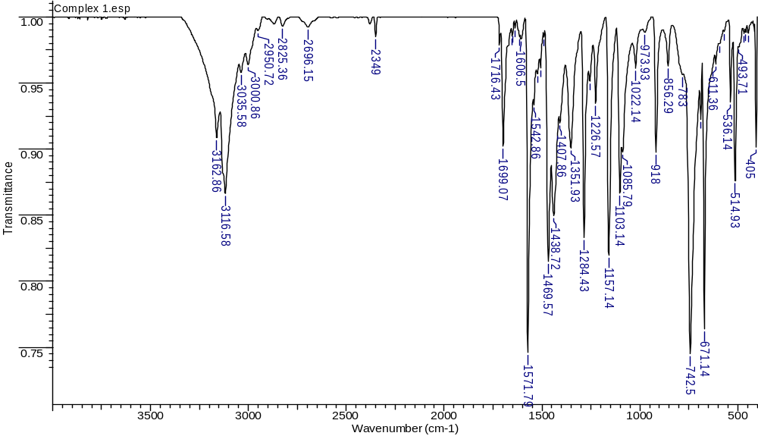
Figure S1 MID-IR spectrum of{[BiCl₂(µ₂-Cl)(MMI)₂]_{2.}(CH₃)₂CO} (1)
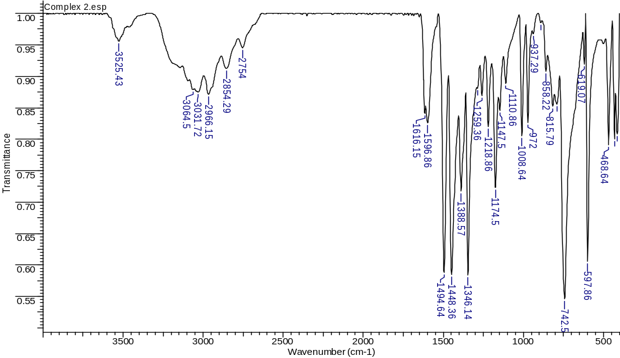
Figure S2 MID-IR spectrum of{[BiCl₂(MBZIM)₄].Cl. H₂O} (2)
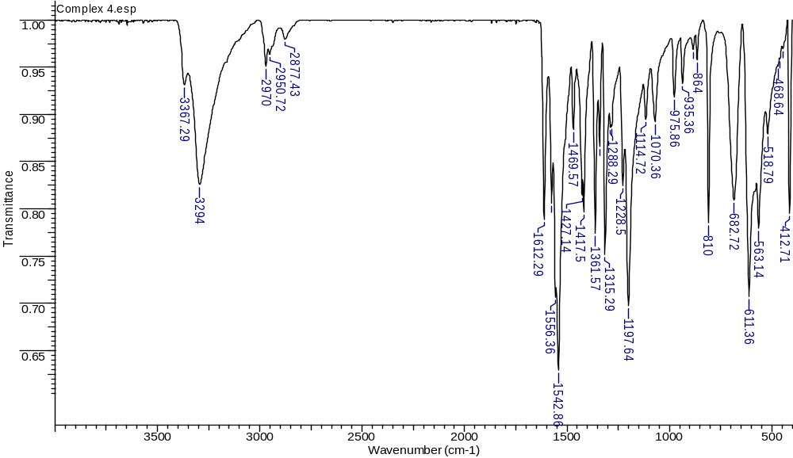
Figure S3 MID-IR spectrum of[BiCl₃(tHPMT)₃] (3)
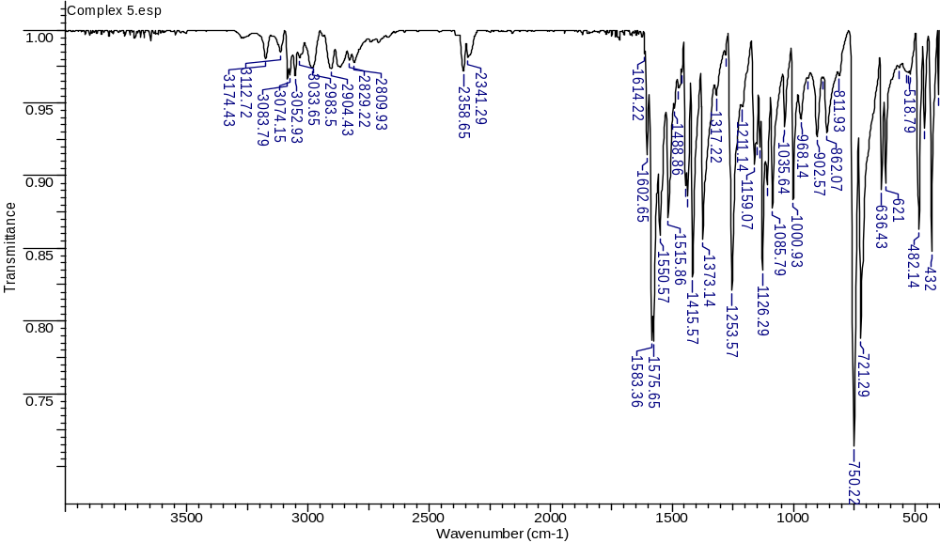
Figure S4 MID-IR spectrum of{[BiCl₃(µ₂-S-PYT)(PYT)]₂} (4)
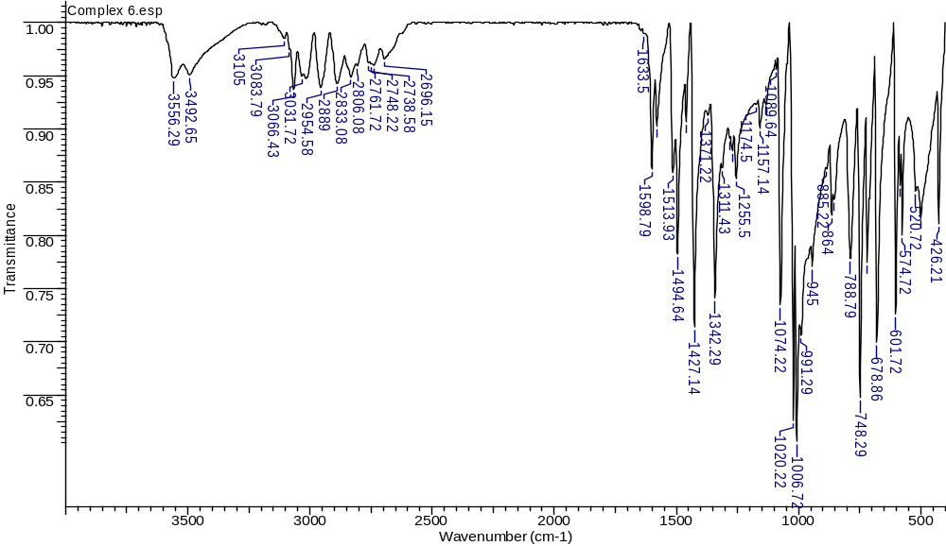
Figure S5 MID-IR spectrum of{[BiCl₂(µ₂-Cl)(MBZT)₂]₂} (5)
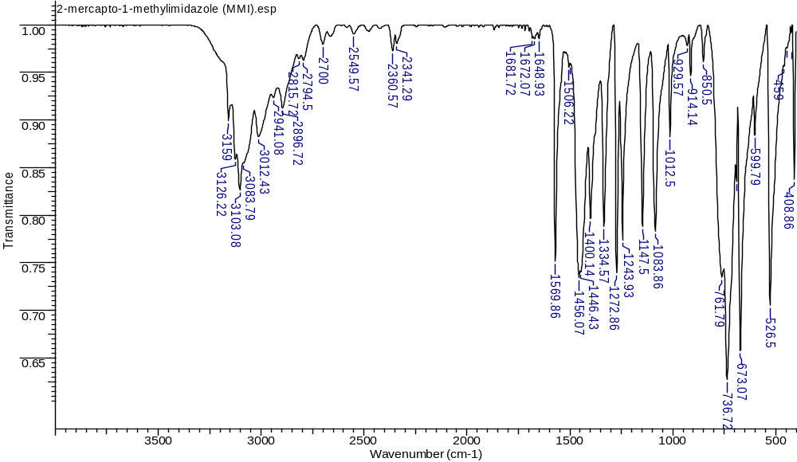Figure S6 MID-IR spectrum of2-mercapto-1-methylimidazole (MMI)

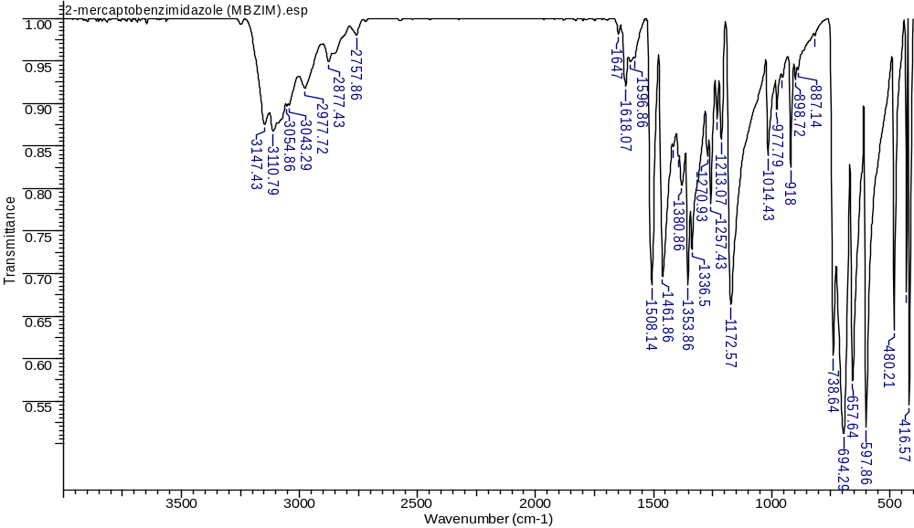
Figure S7 MID-IR spectrum of2-mercaptobenzimidazole (MBZIM)
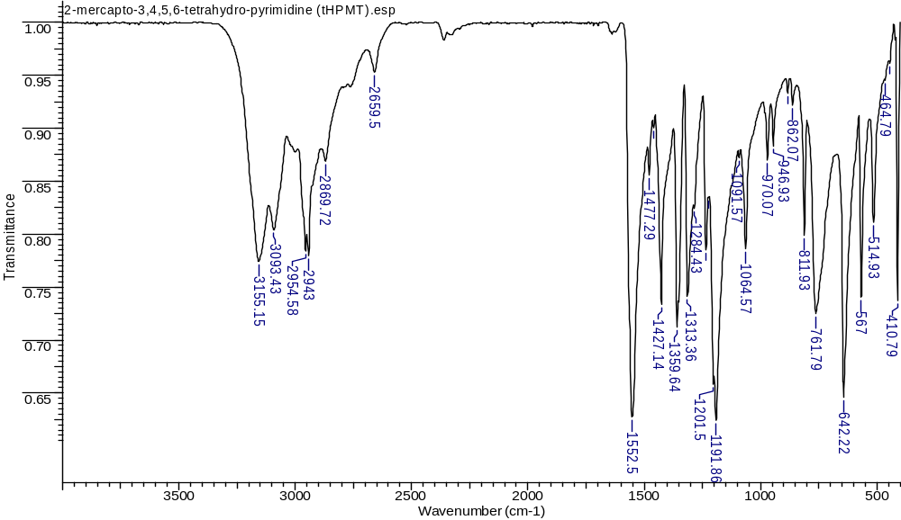
Figure S8 MID-IR spectrum of2-mercapto-3,4,5,6-tetrahydro-pyrimidine (tHPMT)
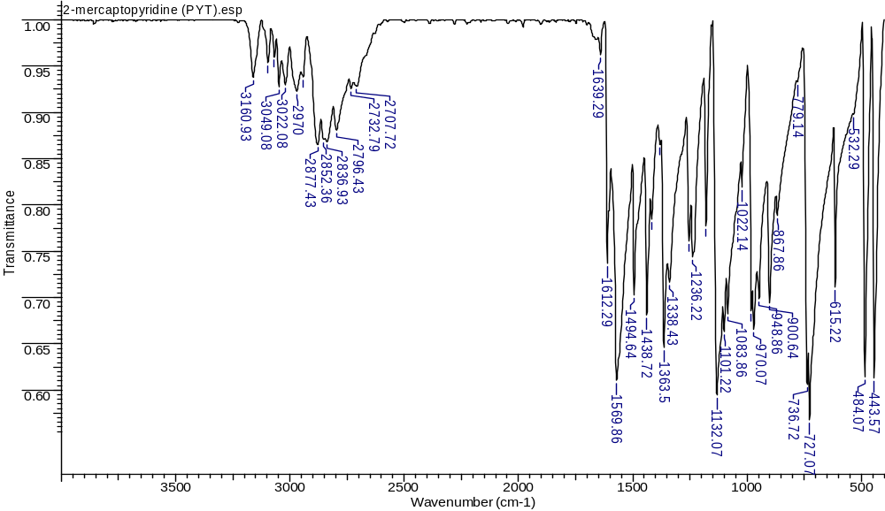
Figure S9 MID-IR spectrum of2-mercaptopyridine (PYT)
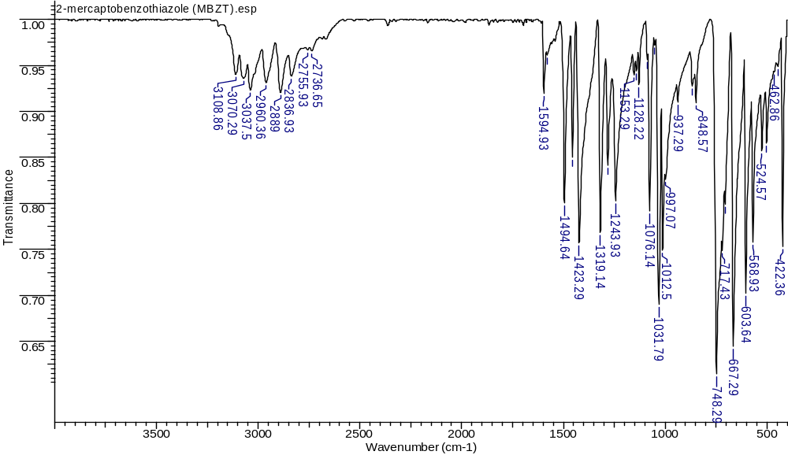
Figure S10 MID-IR spectrum of2-mercaptobenzothiazole (MBZT)
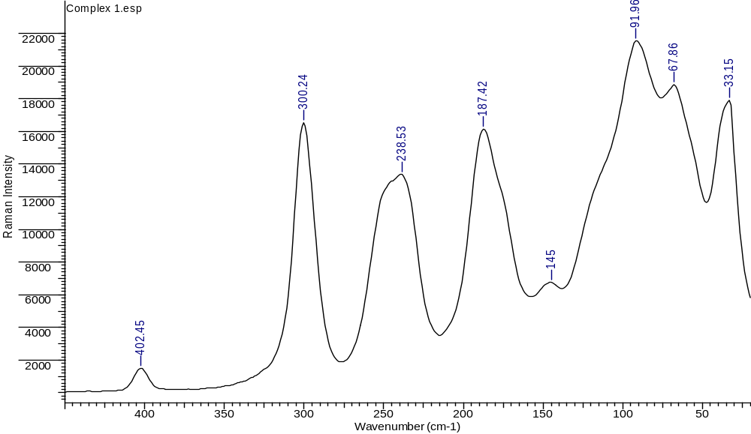
Figure S11 Ramanspectrum of{[BiCl₂(µ₂-Cl)(MMI)₂]_{2.}(CH₃)₂CO} (1)
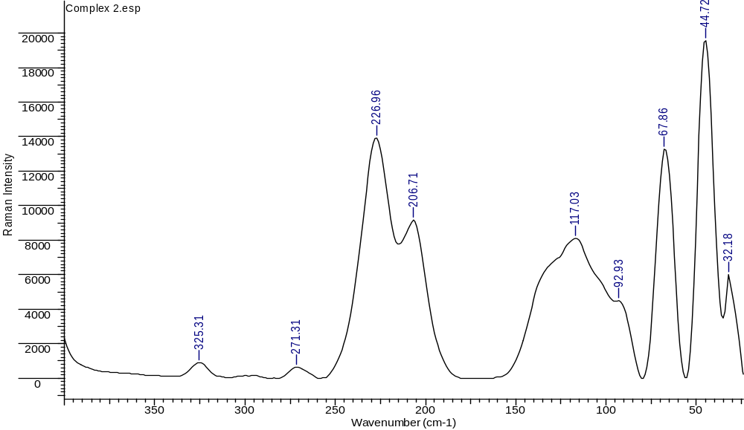
Figure S12 Ramanspectrum of {[BiCl₂(MBZIM)₄].Cl. H₂O} (2)
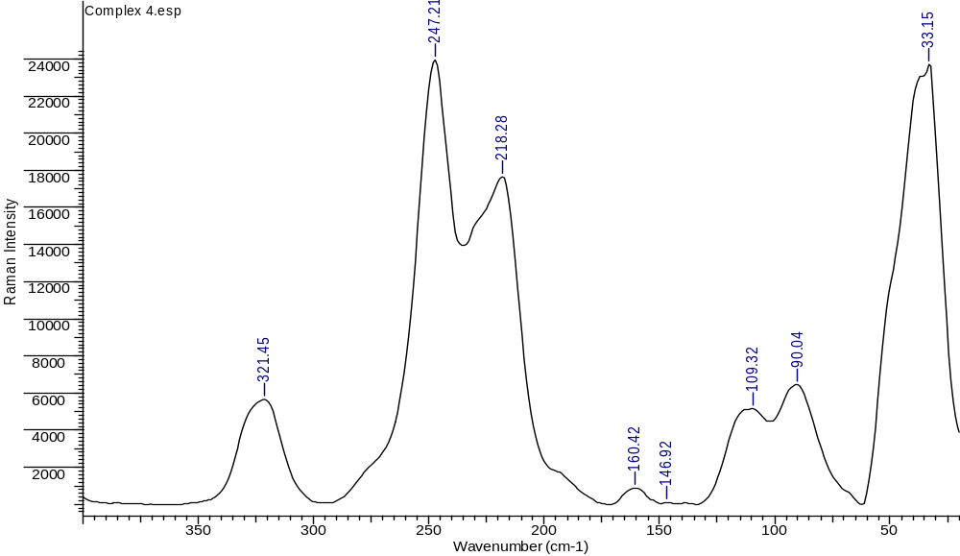
Figure S13 MID-IR spectrum of[BiCl₃(tHPMT)₃] (3)
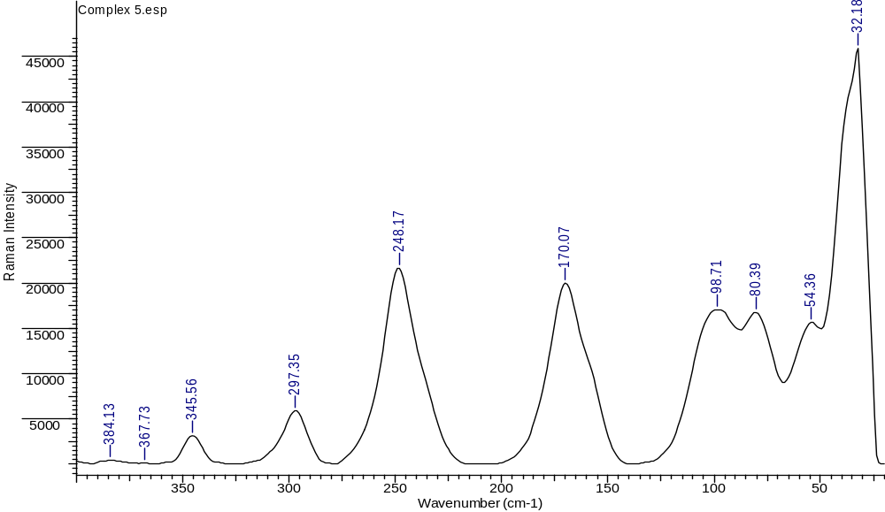
Figure S14 MID-IR spectrum of{[BiCl₃(µ₂-S-PYT)(PYT)]₂} (4)
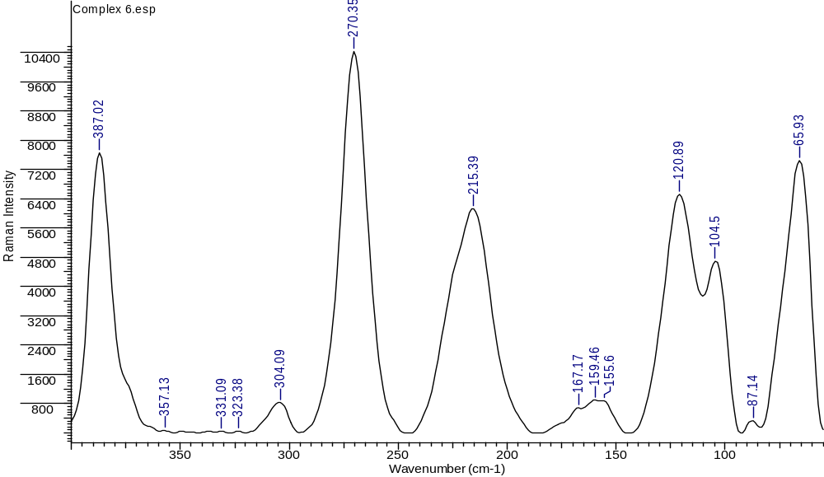
Figure S15 MID-IR spectrum of{[BiCl₂(µ₂-Cl)(MBZT)₂]₂} (5)

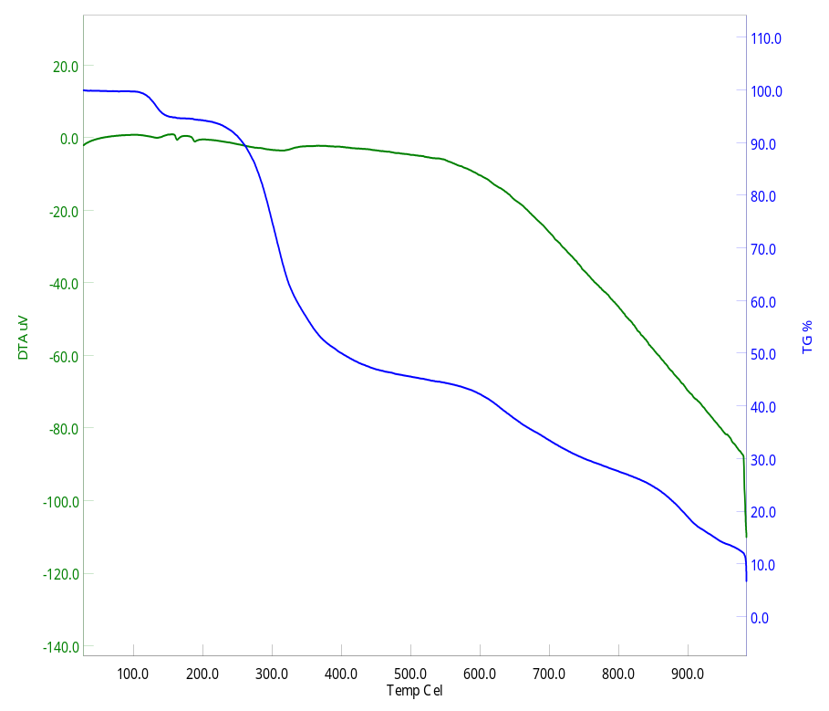
Figure S16 TG-DTA Analysis of Complex 1 {[BiCl₂(µ₂-Cl)(MMI)₂]_{2.}(CH₃)₂CO}
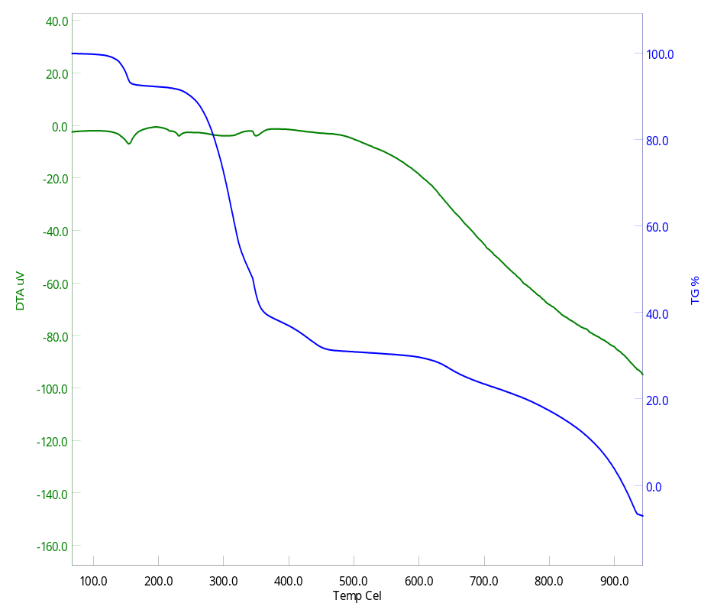
Figure S17 TG-DTA Analysis of Complex 2 {[BiCl₂(MBZIM)₄].Cl. H₂O}

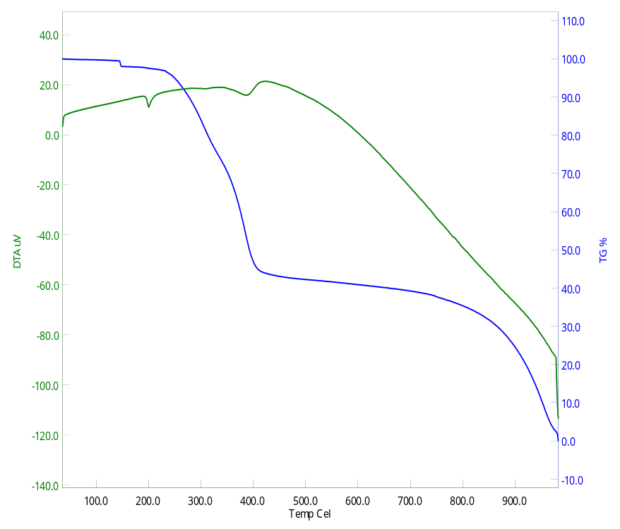
Figure S18 TG-DTA Analysis of Complex 3 [BiCl₃(tHPMT)₃]
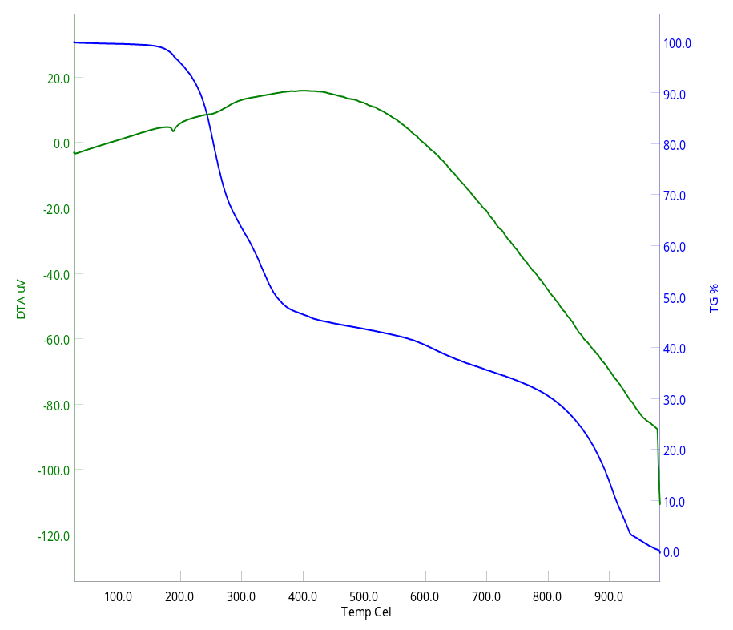
Figure S19 TG-DTA Analysis of Complex 4 {[BiCl₃(µ₂-S-PYT)(PYT)]₂}

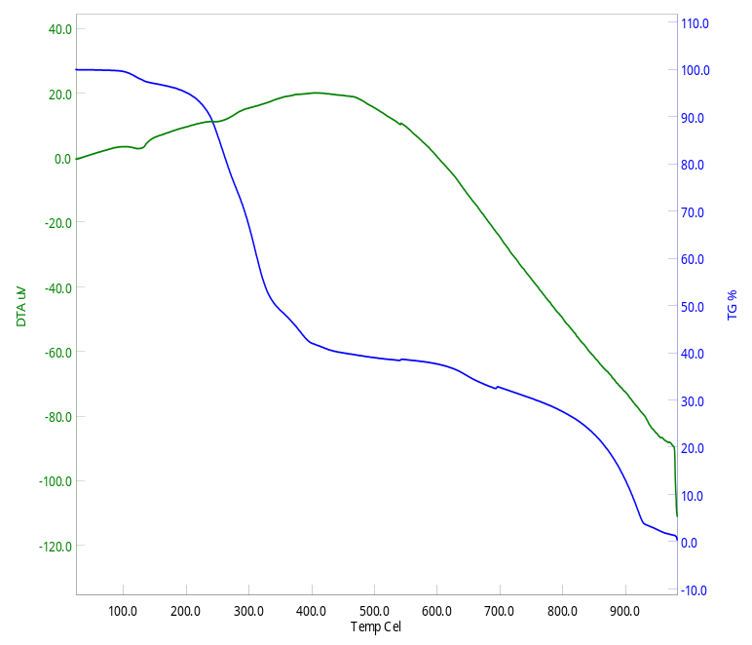
Figure 20 TG-DTA Analysis of Complex 5 {[BiCl₂(µ₂-Cl)(MBZT)₂]₂}

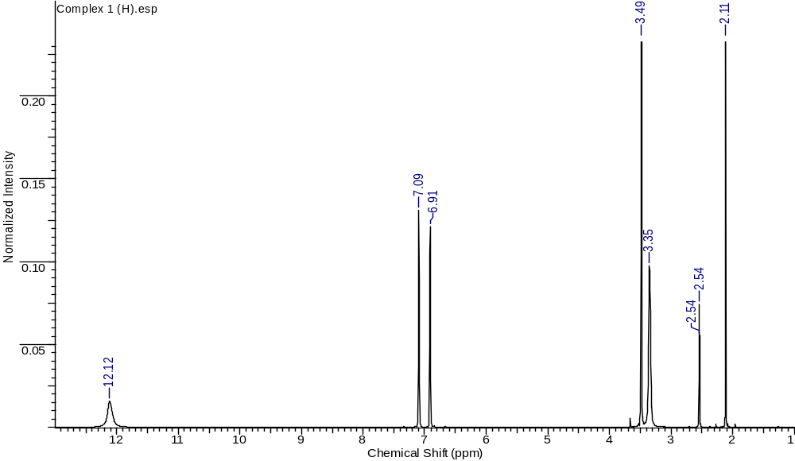
Figure S21 ¹H-NMRspectrum of{[BiCl₂(µ₂-Cl)(MMI)₂]_{2.}(CH₃)₂CO} (1)
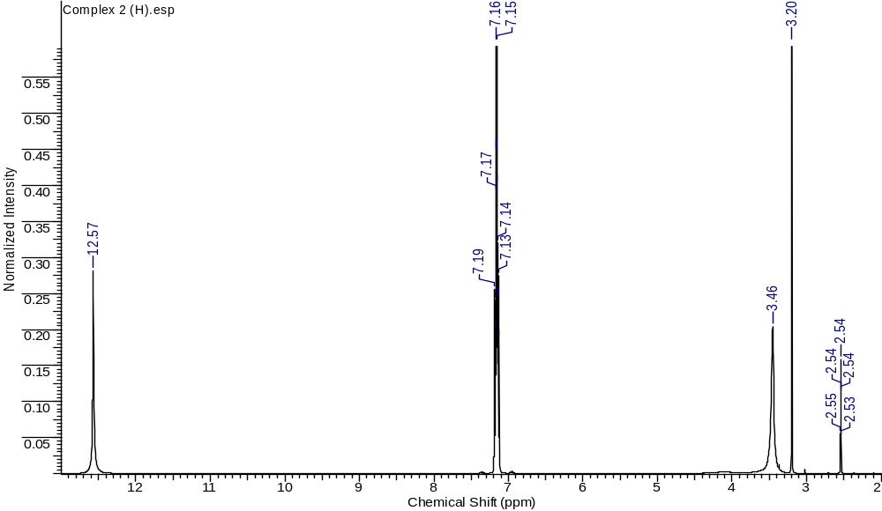
Figure S22 ¹H-NMR spectrum of{[BiCl₂(MBZIM)₄].Cl.H₂O} (2)
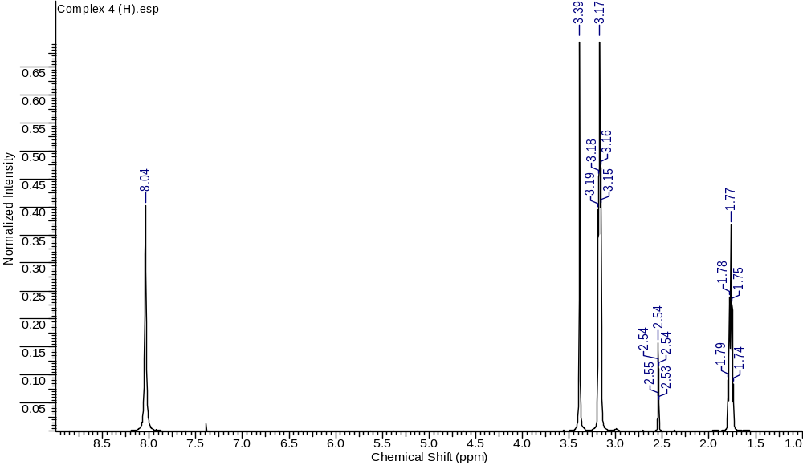
Figure S23 ¹H-NMR spectrum of[BiCl₃(tHPMT)₃] (3)
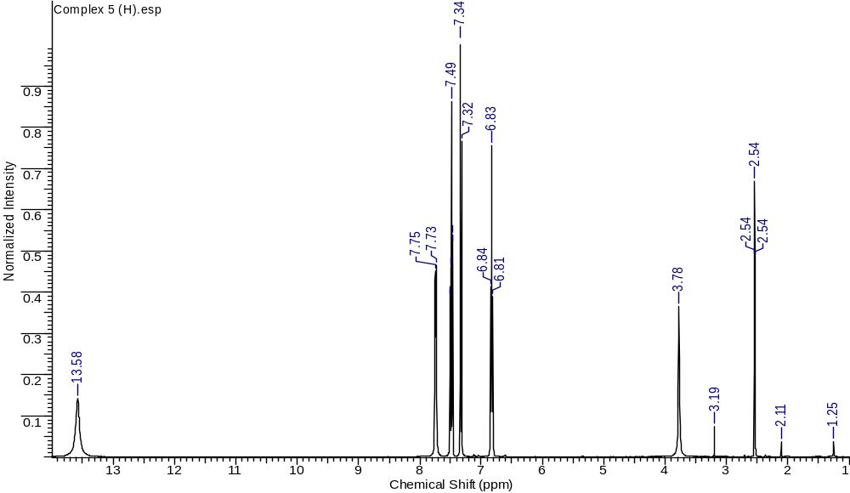
Figure S24 ¹H-NMR spectrum of{[BiCl₃(µ₂-S-PYT)(PYT)]₂} (4)
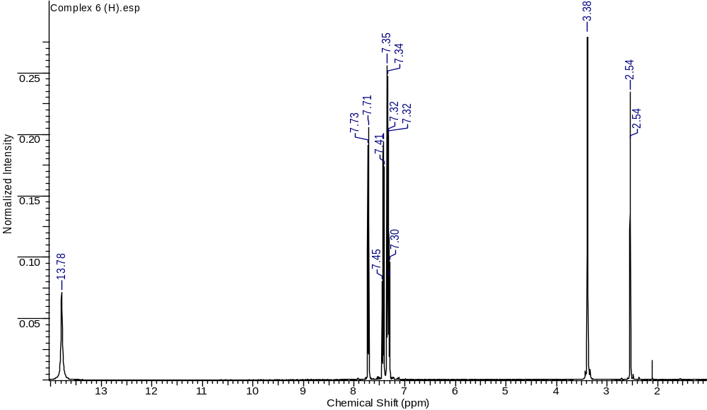
Figure S25 ¹H-NMR spectrum of{[BiCl₂(µ₂-Cl)(MBZT)₂]₂} (6)

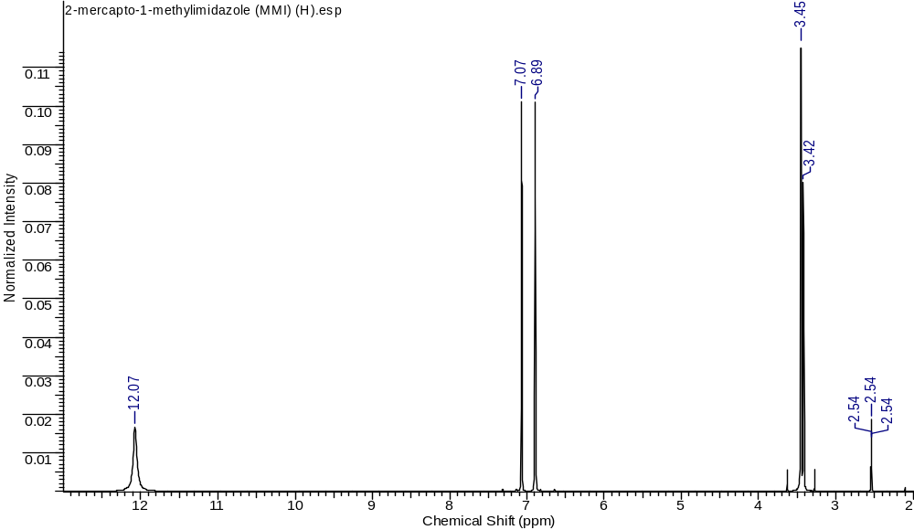Figure S26 ¹H-NMR spectrum of2-mercapto-1-methylimidazole (MMI)
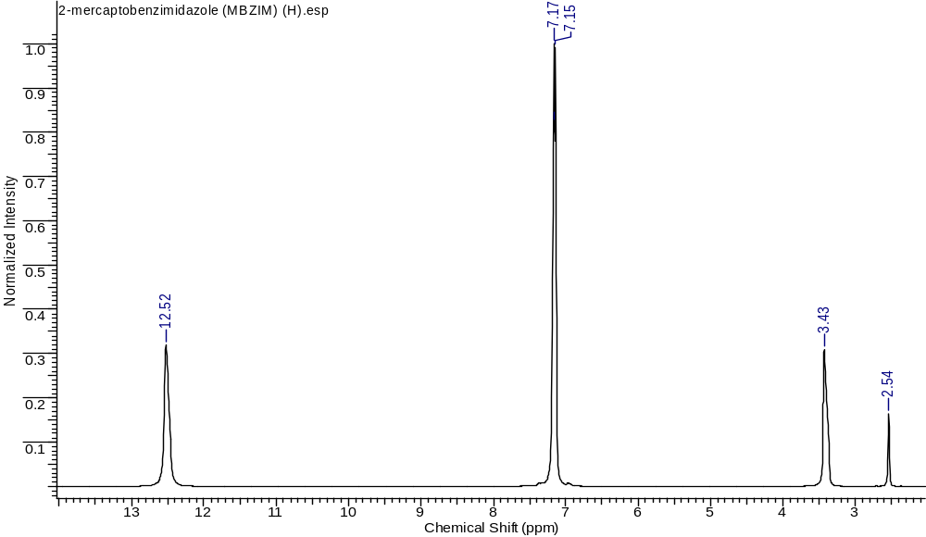
Figure S27 ¹H-NMR spectrum of2-mercaptobenzimidazole (MBZIM)
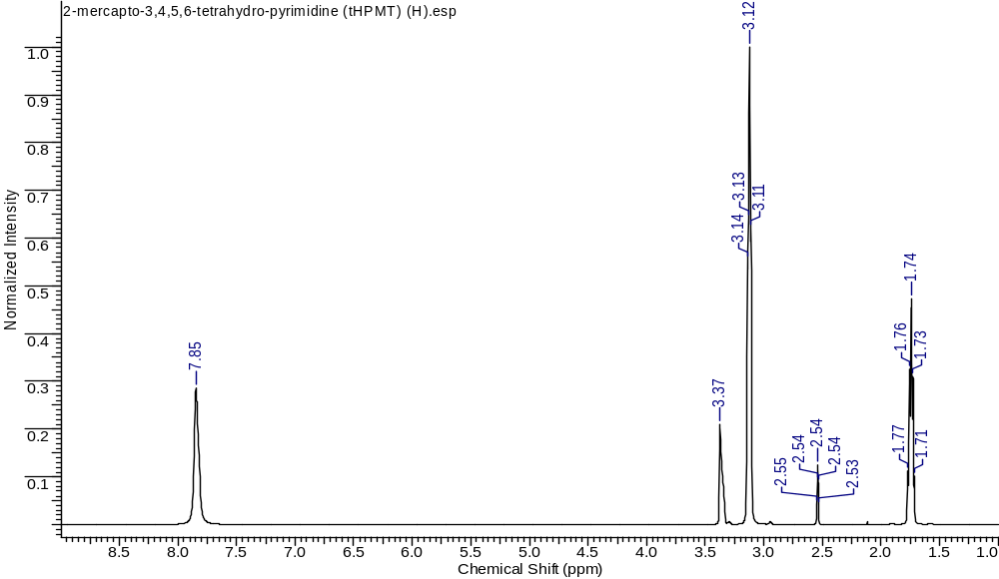
Figure S28 ¹H-NMR spectrum of2-mercapto-3,4,5,6-tetrahydro-pyrimidine (tHPMT)
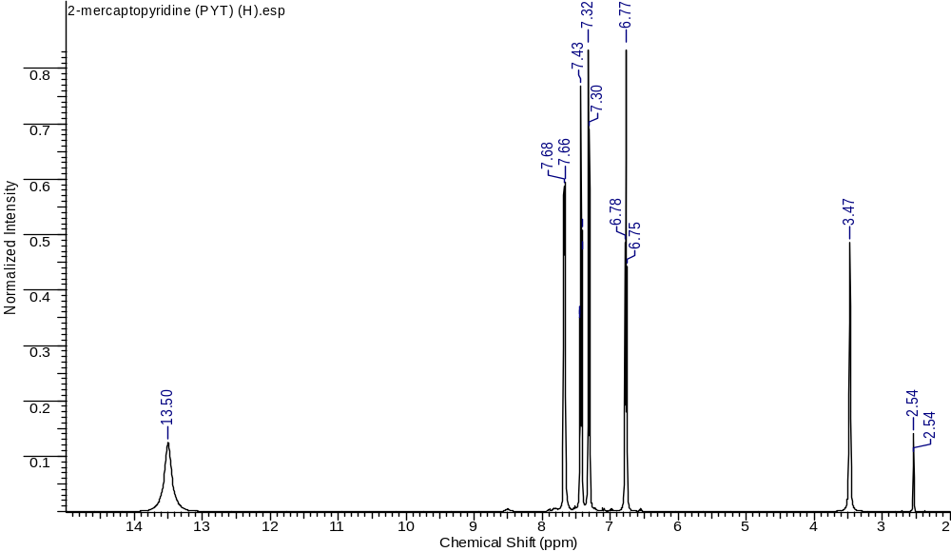
Figure S29 ¹H-NMR spectrum of2-mercaptopyridine (PYT)

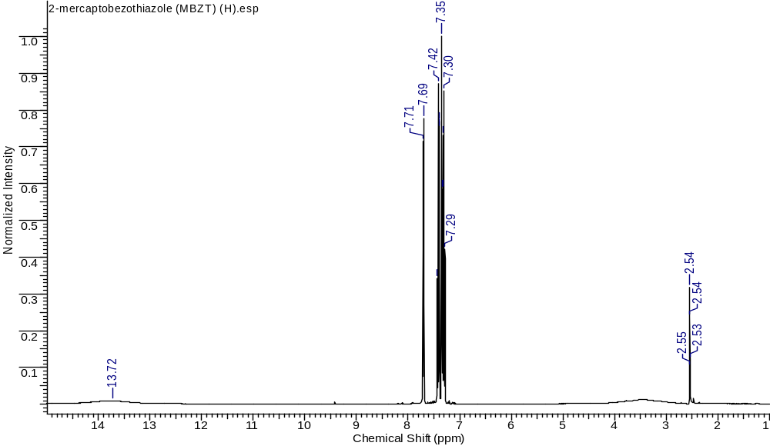 Figure S30 ¹H-NMR spectrum of2-mercaptobenzothiazole (MBZT)
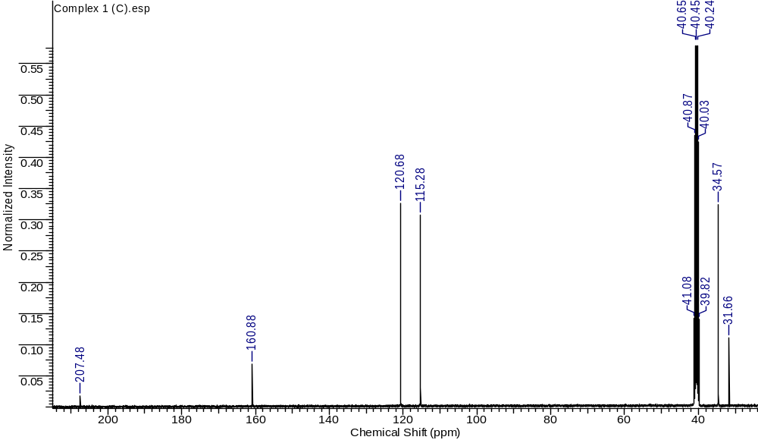
Figure S31 ¹³C-NMR spectrum of{[BiCl₂(µ₂-Cl)(MMI)₂]_{2.}(CH₃)₂CO} (1)
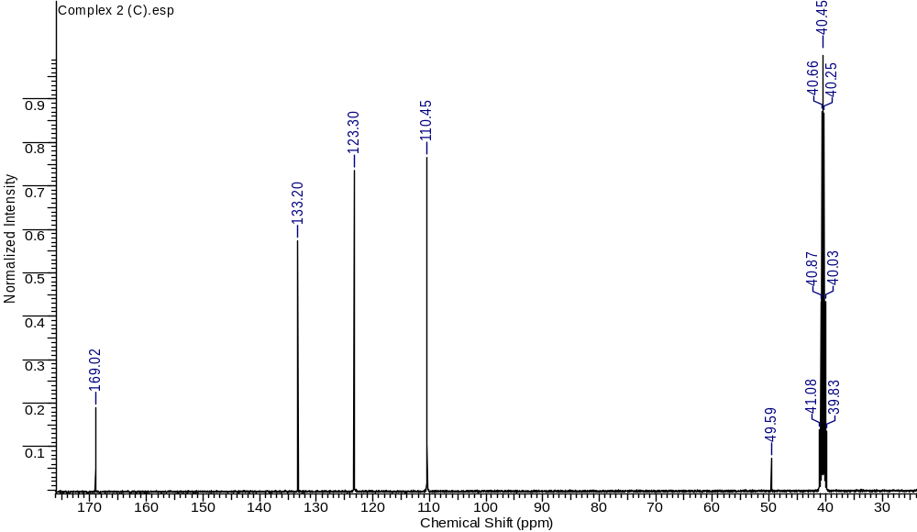
Figure S32 ¹³C-NMR spectrum of{[BiCl₂(MBZIM)₄].Cl.CH₃OH} (2)
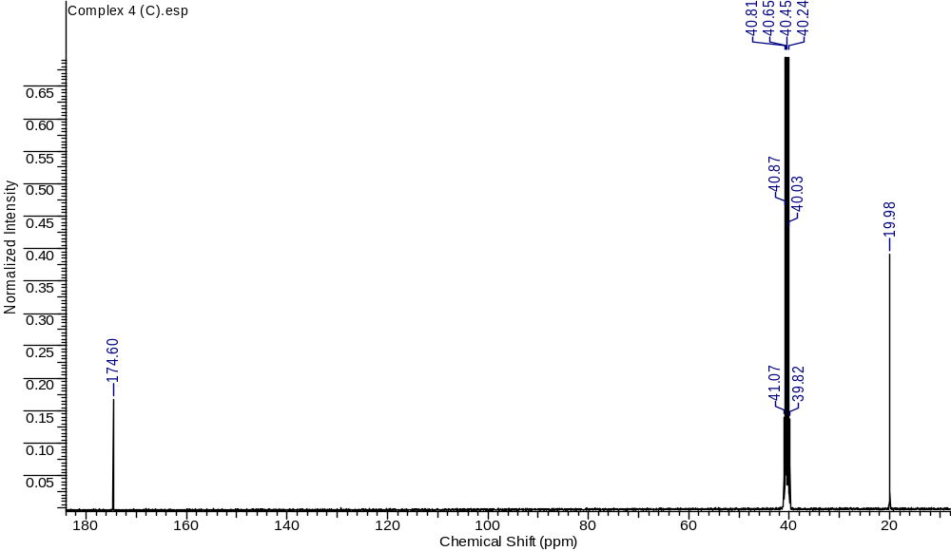
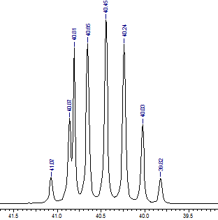
Figure S33 ¹³C-NMR spectrum of[BiCl₃(tHPMT)₃] (3)
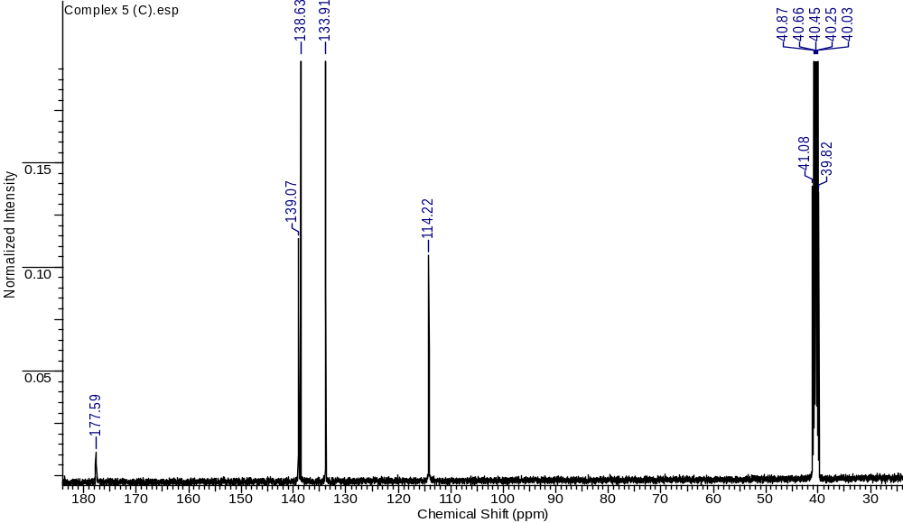
Figure S34 ¹³C-NMR spectrum of{[BiCl₃(µ₂-S-PYT)(PYT)]₂} (4)
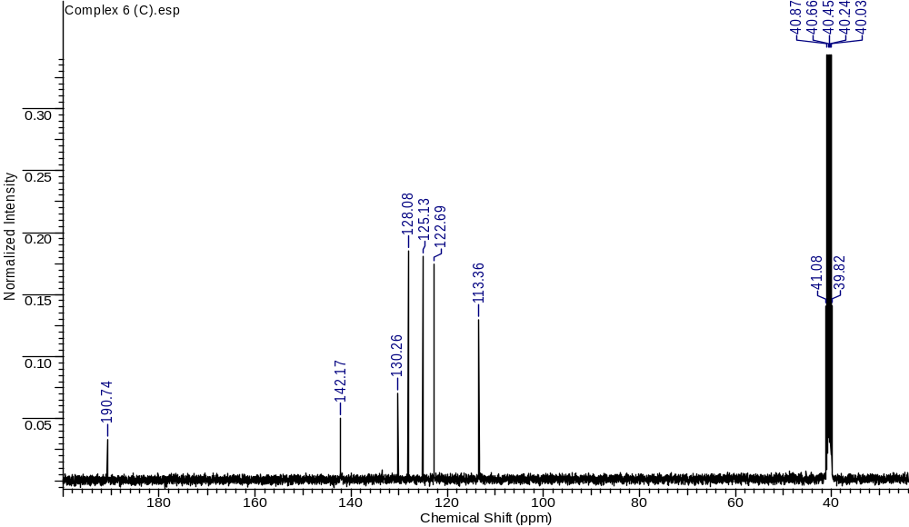
Figure S35 ¹³C-NMR spectrum of{[BiCl₂(µ₂-Cl)(MBZT)₂]₂} (6)
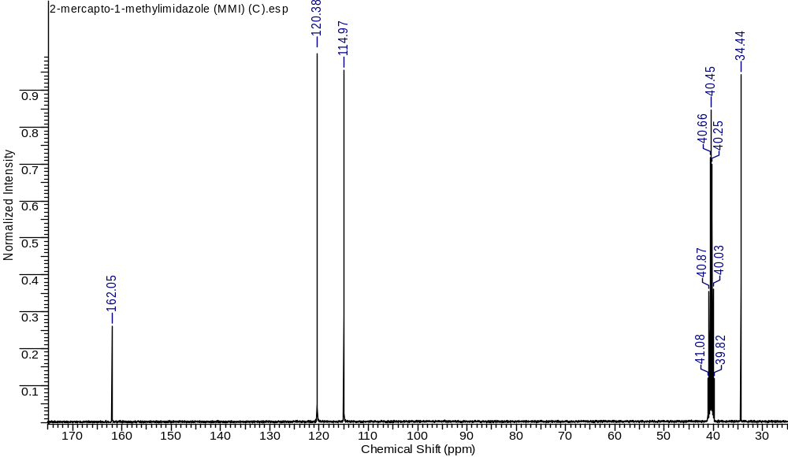
Figure S36 ¹³C-NMR spectrum of2-mercapto-1-methylimidazole (MMI)
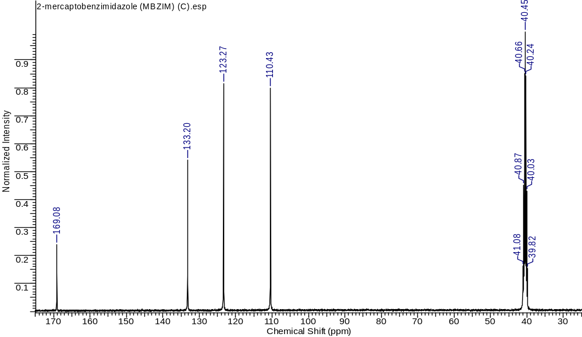
Figure S37 ¹³C-NMR spectrum of2-mercaptobenzimidazole (MBZIM)
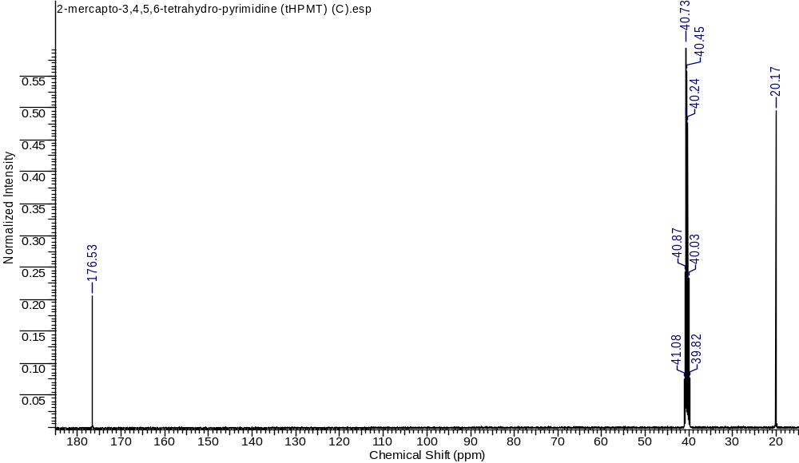
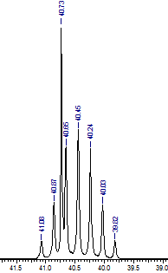
Figure S38 ¹³C-NMR spectrum of2-mercapto-3,4,5,6-tetrahydro-pyrimidine (tHPMT)
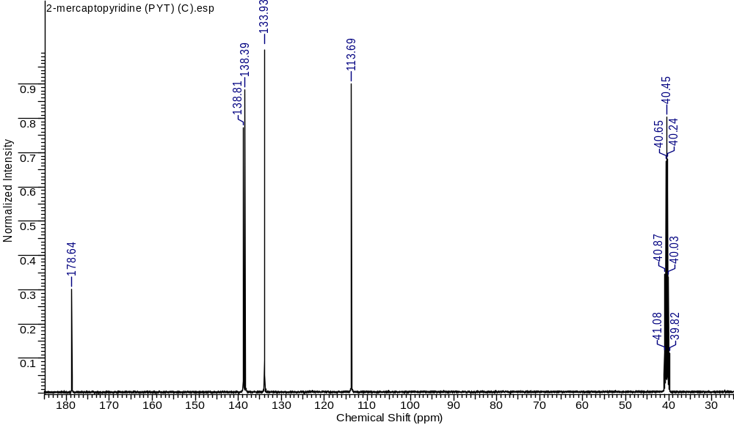
Figure S39 ¹³C-NMR spectrum of2-mercaptopyridine (PYT)
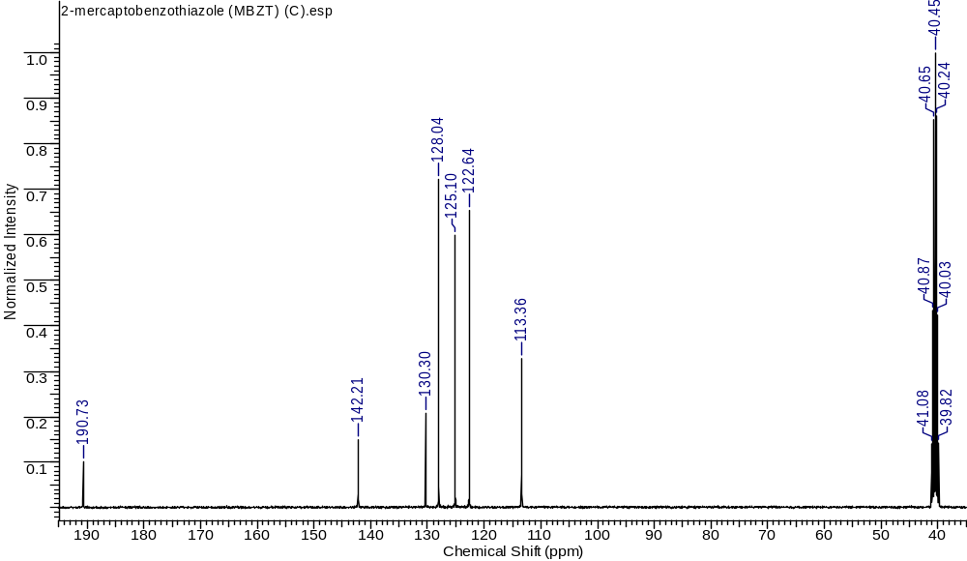
Figure S40 ¹³C-NMR spectrum of2-mercaptobenzothiazole (MBZT)

