**Supplementary data**



**Fig. S1** The effect of different KGM concentrations on the particle size distribution of WPI-stabilized curcumin emulsions.

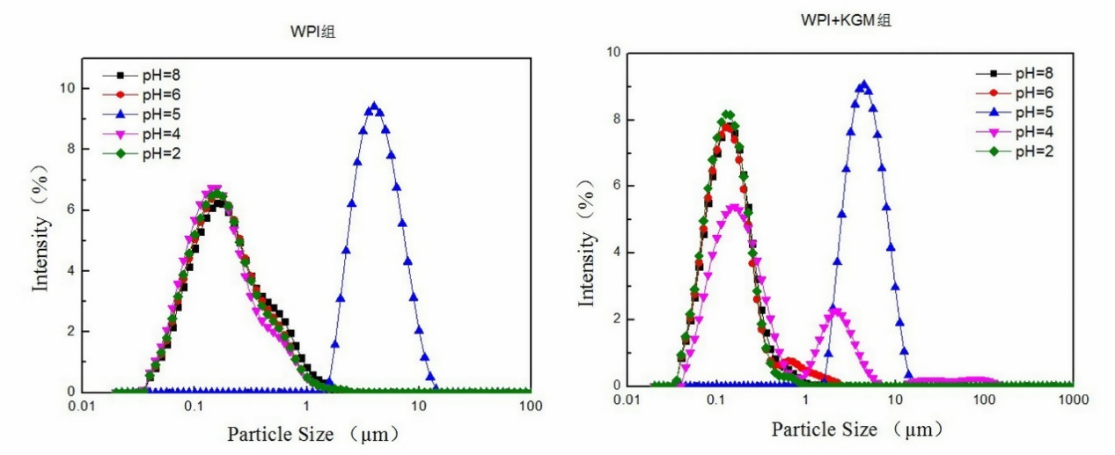

1. **(B)**



**(C) （D）**



**(E) (F)**

**Fig. S2** The effect pH on the particle size of the WPI-stabilized curcumin emulsions with KGM (A) and without KGM (B); The effect of NaCl concentrations on the particle size of the WPI-stabilized curcumin emulsions with KGM (C) and without KGM (D); The effect of heat treatment on the particle size distribution of WPI-stabilized curcumin emulsions without KGM (E) and with KGM (F)



**（A）**



**（B）**

**Fig. S3** The zeta-potential of the WPI-stabilized curcumin emulsions without KGM (A) and with KGM (B) after exposure to simulated stomach condition at different digestion time.



**（A）**



**(B)**

**Fig. S4** The zeta-potential of the WPI-stabilized curcumin emulsions without KGM (A) and with KGM (B) after exposure to simulated intestinal condition at different digestion time.