DATA
1. Materials and methods
1.1. Animals
All animals used in this experiment were approved by the Committee of Animal Welfare. Animal studies and experiments were approved and carried out according to Institutional Animal Care and Use Committee guidelines at the College of Animal Science and Technology at Jiangxi Agricultural University.
1.2. Toxic model construction and sample acquisition
In order to better select the infusion dose, we divided 60 white feather broiler chickens into 6 groups equally for different dose gradient infusion of DDVP and recorded the death number of each group. The data obtained are calculated by modified KARBER method for LD50. Modified KARBER method's main formula is
LD 50 =lg ­²[ Xn -i($\frac{2∑m+h}{2^{n}}$-0.75)]
[ Xn is the logarithm of dose in the highest response group; i is the difference of logarithmic doses between the two adjacent groups (i.e., group spacing); M is the reaction number of each group. Sigma m is the sum of the dynamic reactions of each group. N is the number of animals in each group; H is the mean of the number of reactions in the first and last two groups ]. At the same time, SPSS Software (Version 17.0) was used to assist the verification. In this study, LD0, the maximum dose without death, was selected as the perfusion dose in the low-dose group, and LD100 was selected as the perfusion dose in the high-dose group.
In this experiment, sixty healthy and disease-free broiler chickens with a weight of 1-2 kg were purchased from a chicken farm in the city of Nanchang, Jiangxi, China. Sixty chickens were randomly divided into three groups with each group has 20 chickens. The three groups are the control group, low-dose group and high-dose group. The control group was given proper amount of distilled water. The low-dose group was given 77.5% dichlorvos at 1.13 mg/kg dose. The high-dose group was given 77.5% dichlorvos at 10.2 mg/kg dose. Both the low-dose group and the high-dose group are “poisoned” groups, and are used to compared with the control group. After the administration of dichlorvos, the clinical symptoms of each chicken in each group were observed and the time of each symptom was recorded. The chickens showing ataxia and other neurological symptoms were immediately slaughtered by jugular vein bloodletting.
Five chickens in each group was randomly selected and their whole brains were immersed into 0.4% paraformaldehyde for histopathological examination. Five samples were put in electron liquid for observation using the electron microscope. The remaining 10 samples were quickly put into the liquid nitrogen at -80℃ in a refrigerator, stored, tested and analyzed using PCR arrays.
1.3. Observation of clinical symptoms
The clinical symptoms of feathers, eyelid, pupil, respiration, excretion and mental state were observed by naked eyes. The chicken meningeal showed the presence of hyperemia edema phenomenon in macroscopic observation.
2.4. Pathological anatomy
The brain which was immersed into 0.4 % paraformaldehyde was taken for pathological analysis to determine any change in the pathology using HE staining and immunofluorescence. HE staining includes the dewaxing of paraffin to water, wood staining, eosin staining, and dehydration of sealing film. Immunofluorescence technique uses the specificity of antibodies to their antigen to attach fluorescent dyes to specific biomolecule targets to allow visualization under microscopes. Immunofluorescence includes paraffin dewaxing to water, antigen repair, quenching of spontaneous fluorescence, and serum closed. GFAP and CY3 goat anti rabbit (Google Biological Technology Company, Wuhan, Hubei, China) were used to make a slice in optical microscope (Nikon Eclipse C1 Microscope System, Nikon Company, Japan) by using the scanner (Pannoramic MIDI, Nikon Company, Japan). Imaging was performed using the Case Viewer software and then observed and analyzed with the major pathological changes of pathological sections stained with HE in brain tissue. Moreover, objective lens of MIDI selects 10 different regions for statistical comparison of counts in each group. The main protein expression positions, changes in protein expression and apoptosis in immune histochemical results were observed and analyzed. The morphological changes of organelles in brain cells were observed by electron microscopy at a magnification of 1200x and 5000x.

Figures
Fig. 1 Clinical symptoms and cerebrotomy of chickens
A: The control group. B: The low-dose group. C: The high-dose group. D: The whole brain of the control group. E: The whole brain of the low-dose group. F: the whole brain of the high-dose group. In the two poisoned groups, i.e. low-dose group and high-dose group, obvious salivation dyspnea and other clinical symptoms were observed, together with cerebral hyperemia and redness.
Fig. 2 Pathological changes in the brain (HE staining)
1: The vascular sheath. 2: The nucleus disintegrating neuron. 3: The glial cell. A, B, C: HE staining sections of brain tissue. D: Histograms were made in 10 randomly selected brain regions in each group. Compared with the control group, the number of blood vessels and nuclear fission neurons in brain tissue increased significantly in the high-dose group and the low-dose group.

Fig.3 Fluorescent immunofluorescence detection of the brain
A, B, C: The whole-brain immunofluorescence for each of the three groups. D, E, F: The local magnification diagram for each of the three groups. G: Changes of expressions in the whole brain. Compared with the control group, brain tissue expression was significantly increased in the two poisoned groups, especially in the low-dose group.

Fig.4 Apoptosis detection of TUNEL cells in chicken brain tissues
A, B, C: The whole-brain immunofluorescence for each of the three groups at the magnification of 60x. D, E, F: The local magnification for each of the three groups with the magnification of 400x. Compared with the control group, the number of apoptosis in brain tissue was significantly increased in the two poisoned groups and the apoptosis was the most serious in the high-dose group.

Fig. 5 Electron microscopy of chicken brains
A, B, C: Submicroscopic structure of chicken cerebral cortical cells under 1200x electron microscope. D, E, F: Submicroscopic structure of chicken cerebral cortical cells under 5000x electron microscope. Compared with the control group, the internal structure of the cells in the two poisoned groups, i.e. low-dose group and high-dose group, was irregular, the mitochondrial morphology was changed and even the outer membrane was dissolved.

Fig.6 Heatmap of differentially expressed genes (DEGs).
The X axis represents samples. 1-3: The control group. 4-5: The low-dose group. 6-9: The high-dose group. The Y axis represents DEGs. The color represents the log10-transformed gene expression levels (Red indicates a high expression level and green indicates a low expression level). The expression of multiple genes in the two poisoned groups, i.e. the low-dose group and the high-dose group, changed significantly compared with the control group.

Fig. 7 Volcanic detection of differentially expressed genes
The X axis represents the log2 fold change. The Y axis represents -Log10(p value) where the p value was obtained in the t test. Genes with no significant expression difference between groups are represented by gray dots below the dotted line. The colored dots above the dotted line indicate the genes with significant expression difference between groups. Red indicates an increase in expression whereas blue indicates a decrease in expression.

Fig.8 Part of AMPK signaling pathway genes via qRT-PCR
The X-axis represents different groups. The Y-axis represents mRNA expression levels.

Fig.9 The fitting curve of qRT-PCR and validation of PCR array
The X-axis represents different genes. The Y-axis represents different gene expression levels. The broken line diagram represents PCR array results. The histogram represents q-PCR detection results.
Fig.1
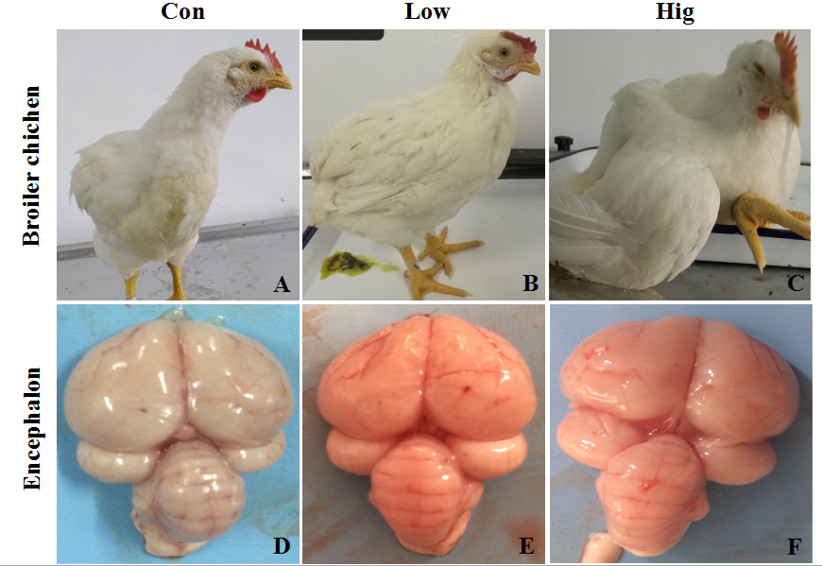
Fig.2
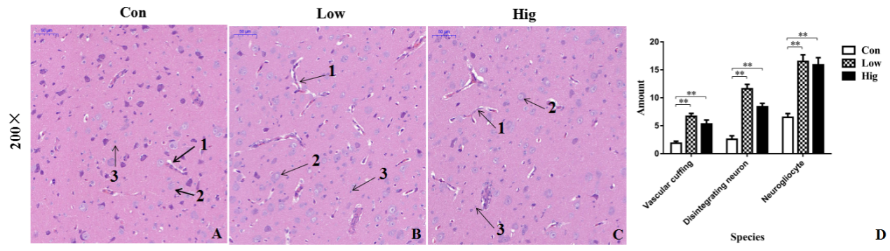
Fig.3
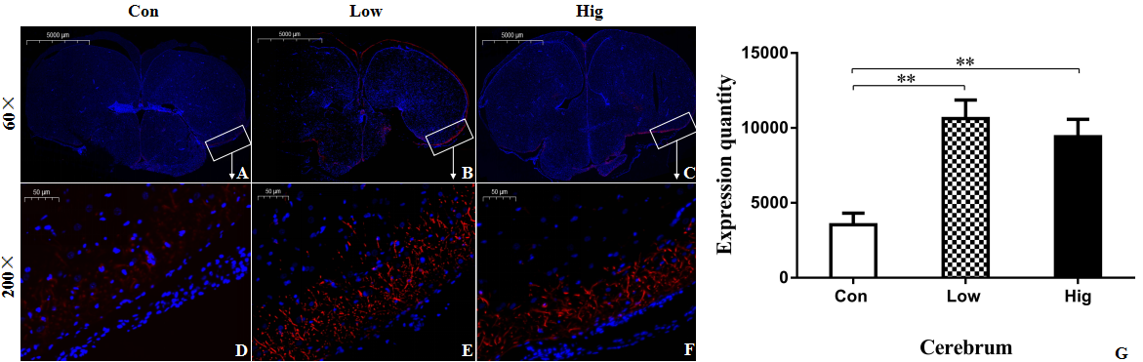

Fig.4
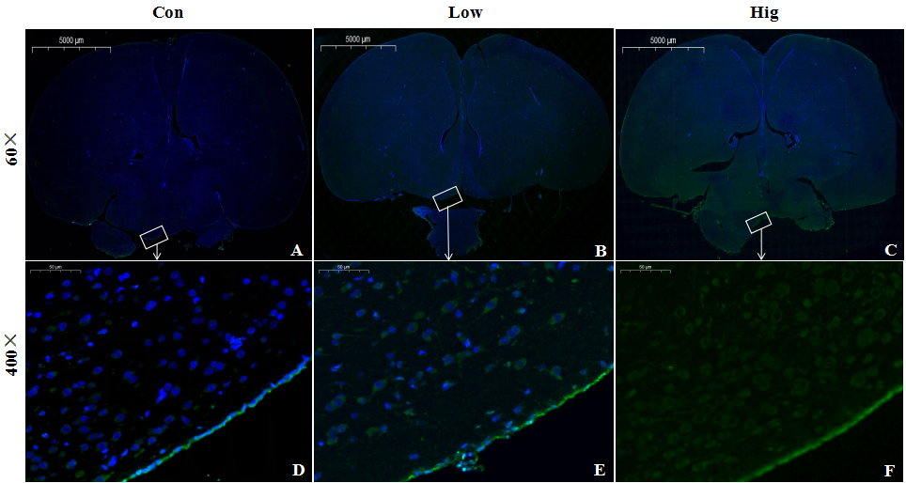

Fig.5
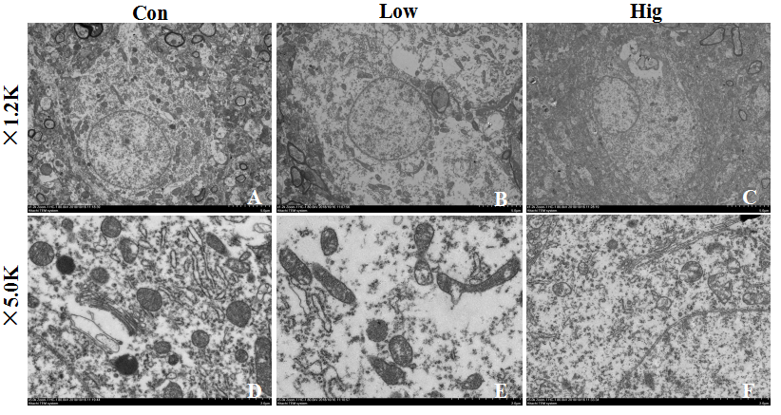

Fig.6
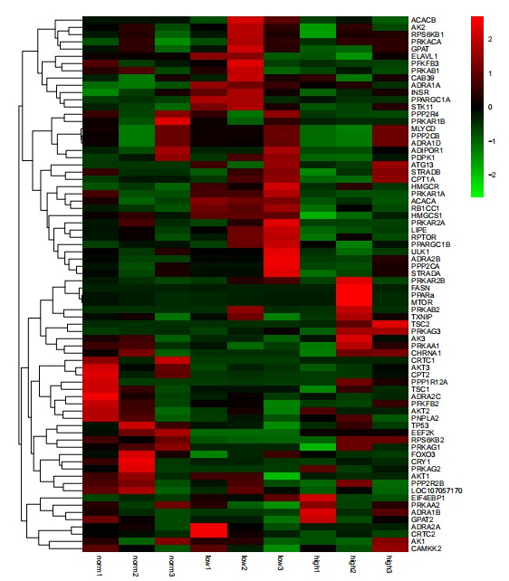

Fig.7
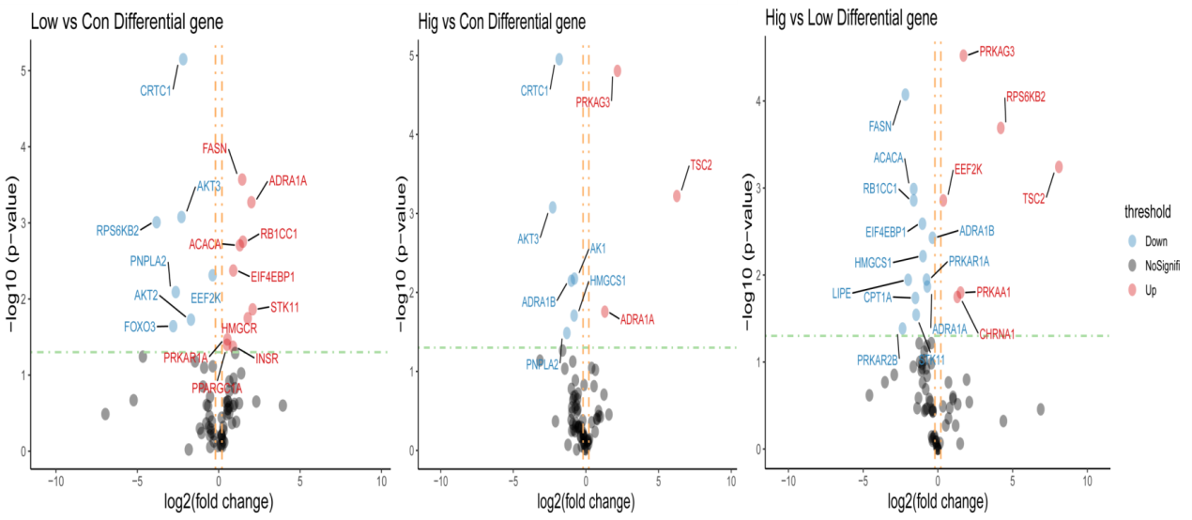

Fig.8
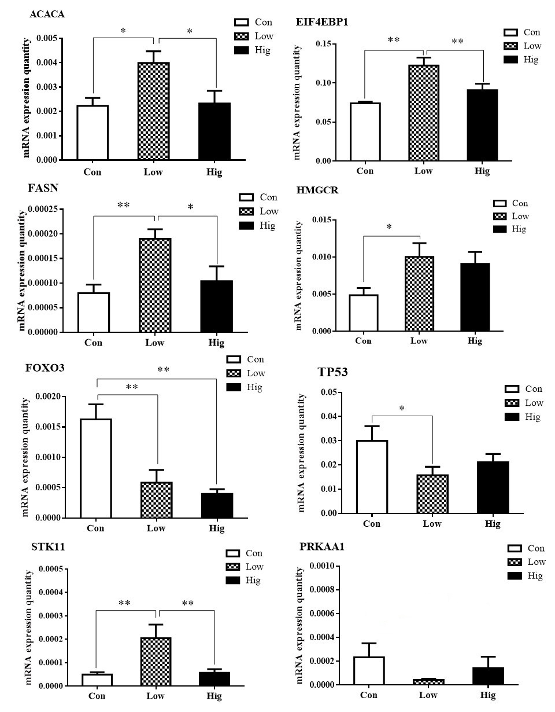

Fig.9
