Supplementary Materials
The following supplementary materials section contains details for each constructed cross section and the data available to construct the cross section. An interpreted seismic profile in the Frenchman Hills is also included.

Additionally, two .kmz (Google Earth) files with georeferenced images and a .csv file with orientation measurements are also provided as supplementary materials. Not all 300 georeferenced images are included in the dataset, as the authors entered an agreement with the Department of the Army to only provide digital photographs of outcrop within the Yakima Training Center. Thus, landscape photos of western Saddle Mountains have not been included in this dataset.

For each cross section, basic information including the label number used in the text (e.g. S3), the name used during research, the end points (given in UTM zone 10), length (m), and depth (m) are included. More detailed information including well, geologic, structural, and seismic data are also included. For each cross section we include a short justification of why and how faults and folds were interpreted as well as a photo of the cross section taken from our interpretation software.

S1) Cross Section Details
Name: Royal Section
XY max: 770136.7, 5193380.7
XY min: 766987.5, 5180898.6
Length: 12482.0
Depth: 3149.2

Well Data
Number of wells | 0
Names of wells
Depth of wells
Distance of wells

Geologic Data
Faults | 3 (2 at surface, 1 inferred)
Folds | 2 (1 syncline to north, 1 anticline to S)
Units | EM, As, PR, R, Palouse, Ringold
Trends | Fold axis dips to north (asymmetry is to south). In order to maintain bed thickness across the top of the ridge, this had to be the case. The tighter part of the fold is where the anticline is marked on the geologic map, but overall the fold vergence is to the south. The syncline to the north is constrained by dip measurements in the Elephant Mt member.

Structural Data
Number of SDs | 38
Max Distance | ~ 4 km
Units | FS, R, PR, Rattlesnake Ridge, Quincy, Asotin, EM, Palouse,

Seismic Data
Available | No
Length
Depth

Were any faults drawn? How and why?
Three faults were drawn. Two are indicated on the geologic map as thrust faults that meet the surface on the northern side of the mountain. One is inferred due to the asymmetry of the mountain in this location. This asymmetry can be generated by slight displacement on the south-dipping master followed by additional displacement along a north dipping conjugate thrust. The steep dips of the faults are influenced by steep dips in the nearest seismic section and the use of strike lines to calculate fault dip at close to 70 degrees at the surface.

Were any folds drawn? How and why?
An asymmetric anticline and a symmetric syncline were drawn. The anticline was marked on the geologic map and conformed to SD measurements, but the syncline was purely supported by strike and dip measurements.

Additional Notes
Image
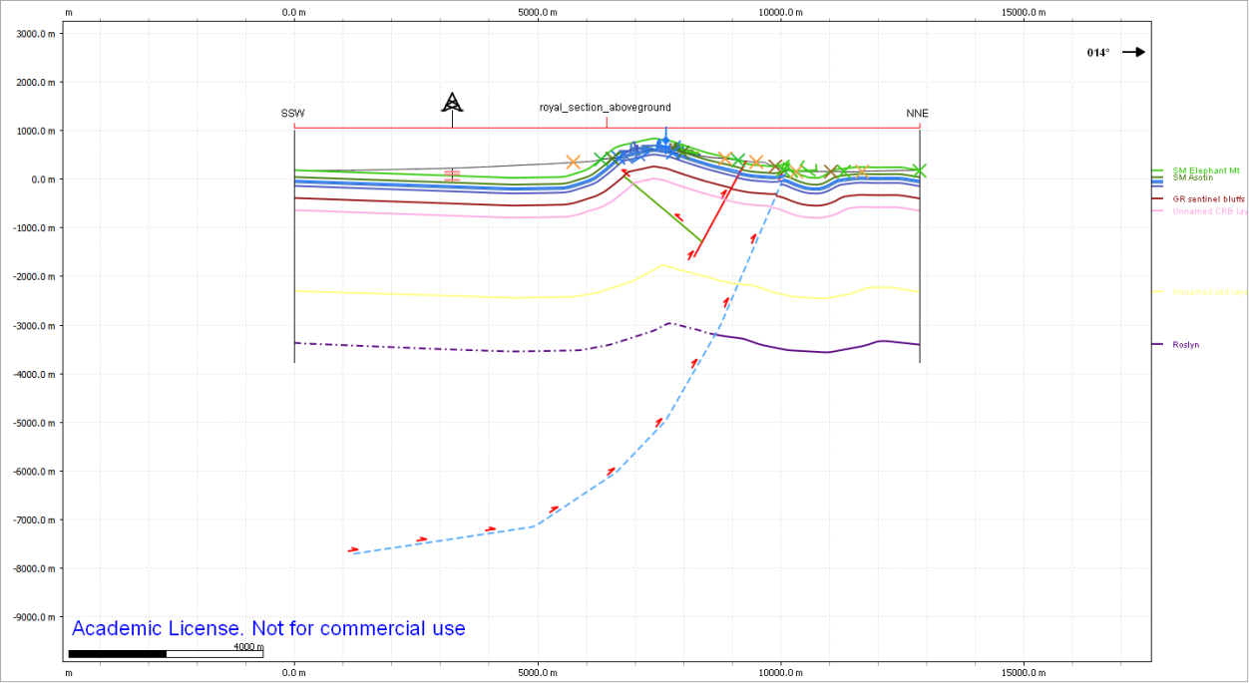

S2) Cross Section Details
Name: Section_dipdata2
XY max: 764512.8, 5195445.9
XY min: 761144.3, 5185880.5
Length: 10141.2

Well Data
Number of wells | 1
Names of wells | AWS
Depth of wells | ~450 m
Distance of wells | 3.30 km

Geologic Data
Faults | 3
Folds | 3 major anticlines, 2 minor anticlines, and 1 mono-syncline
Units | Palouse, Pomona, Asotin, PR, R, FS, EM
Trends | The faults are again steep here and all thrusts, with a conjugate thrust dipping north. The tighter anticline on the north side can be achieved with a less dramatic shallowing of the fault dip at the base of the fault. This tightness is indicated by dip measurements. This structure is more asymmetric than the structure in the cross section to the east, suggesting a more developed conjugate thrust.

Structural Data
Number of SDs | 38
Max Distance | 6 km
Units | EM, PR, R, Asotin, FS

Seismic Data
Available | No
Length
Depth

Were any faults drawn? How and why?
Yes, 3. These faults were tied so closely to folding that they are both described together in the section below.

Were any folds drawn? How and why?
Yes, 3. The intermediate surface breaking fault indicated on the geologic map, and has a steep dip using strike lines for estimation (also supported by the steep dips of faults in the seismic section next to this section). Asymmetry in lower folds, but not in the upper folds indicates that this fault extends to depth, but the conjugate does not, and the resulting structure at the surface is a double anticline with shallow dips between hinges. The upturned tight northern anticline is rotated by motion on the northern fault after displacement on the conjugate. Irregularities in the symmetric structure are attributed to stair-steps in the conjugate fault. The northernmost blind thrust produces a small anticline to the north.

Additional Notes

Image
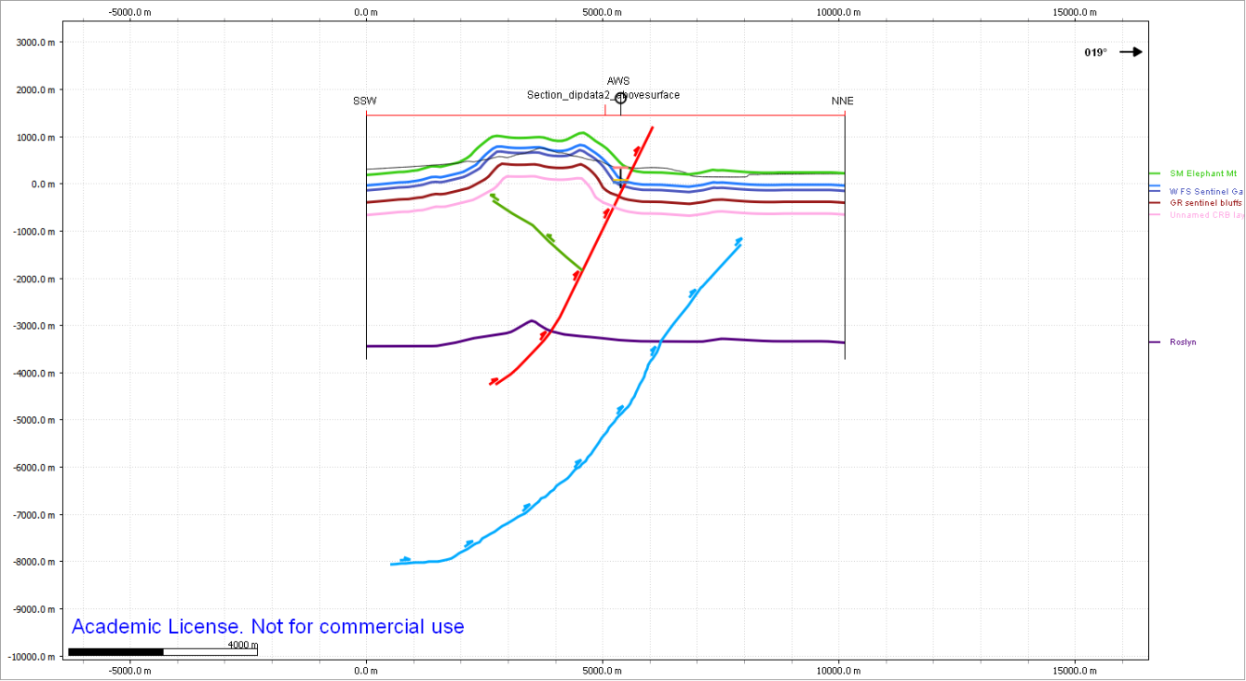

S3) Cross Section Details
Name: Section_H456
XY max: 751535.2, 5196568.4
XY min: 749974.6, 5180004
Length: 16637.7

Well Data
Number of wells | 3
Names of wells | Lemco, AF19, BN19
Depth of wells | 250 m, 4300 m, 5300 m
Distance of wells | 0 m, 1980 m, 1140 m

Geologic Data
Faults | 2 major shallowing thrusts, 2 more minor thrusts, 1 very minor thrust, 1 conjugate thrust, one normal fault
Folds | 1 south verging fold above the conjugate thrust, one anticline in the basement verging north above the deepest fault, one north verging anticline above the intermediate depth major thrust, a broad anticline corresponding to sequential folding above two thrusts, two synclines (one associated with the footwall of a minor thrust and one associated with the down-dropped block of the normal fault. There is also a very broad syncline trailing the south verging anticline.
Units | Pomona, PR, Mabton (not mapped), Palouse, Rosa, FS, GR, EM
Trends | The geometry broadens and the folds open as faults shallow and possible disconnect from deeper structure. Models show that more gently dipping faults produce more open folding. Some rotation may be present on the front minor thrust, linking it to the previous cross section (dipdata2) where roation occurred above the frontal thrust.

Structural Data
Number of SDs | 16
Max Distance | 5100 m
Units | EM, rattlesnake ridge, Rosa, FS, PR, Asotin

Seismic Data
Available | Yes
Length | 9500 m
Depth | 9700 m

Were any faults drawn? How and why?
Yes, three of the faults on the northern portion of the section (including the normal fault) were noted on the geologic map. These faults were noted by strike lines as having steep dips. The normal fault dipped to the north. One north verging fault was added where a small anticline needed to be accounted for and where the quality of reflection changed in the seismic data. Regions of seismic data with horizontal reflections were assumed to be in the footwall of faults or in the hanging-wall of faults where they were deposited as horizontal syntectonic or post-tectonic sediment. Dipping reflections were interpreted to be folded horizons in hanging walls. Contacts between continuous dark reflections and static (not near the edges of the seismic data) were interpreted to be faults as well where footwall rock produced dark reflections and deformed hanging wall rock produced chaotic reflections. These transitions also corresponded to predicted folds from strike and dip data, map data, and geologic data.

Were any folds drawn? How and why?
A broad north verging anticline trailed by a southern syncline is the main feature, with smaller anticlines produced by a conjugate thrust and by secondary thrusts with rotation.

Additional Notes

Image
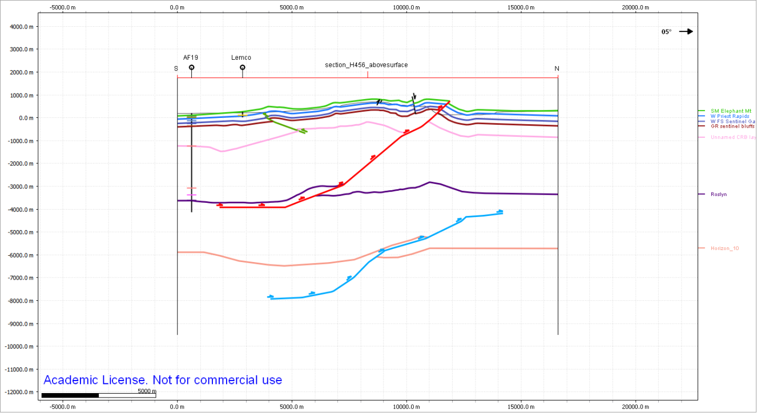

S4) Cross Section Details
Name: Section 4
XY max: 741132.5, 5198936.1
XY min: 739687.2, 5180274.8
Length: 18717.2

Well Data
Number of wells | 2
Names of wells | Royal, Ponderosa
Depth of wells | ~ 150 m each
Distance of wells | 3.5 and 3.7 km

Geologic Data
Faults | Only 1 fault was reported on the 100k geologic map, but I drew 5 north verging thrusts total.
Folds | There are three broad synclines, and five anticlines at the surface. These anticlines appear tighter at the surface than at depth, where some are very broad.
Units | Ringold, Rosa, FS, GR, Asotin, Pomona, EM, PR, Palouse
Trends | The faults all verge north, with between 40 and 60 degree dips to the south. The deepest fault roots to -7500 m, and shallows, but actually has relatively little displacement when compared with the upper thrusts. The upper thrusts all produce recognizable anticlines at the surface narrower than those at depth. There is almost certainly a conjugate fault, but I was not able to identify displacement in the seismic data. Thus, I have not drawn this fault.

Structural Data
Number of SDs | 20
Max Distance | ~3500 m
Units | GR, Ringold, Missoula, Asotin, PR, FS, Rosa,

Seismic Data
Available | Yes
Length | 18717 m
Depth | 9 km

Were any faults drawn? How and why?
Five thrust faults were drawn. Three were identified by clear offset of bold and characteristically identifiable reflections. The reflections were recognizable by their thickness and continuity. The deepest fault was easiest to identify as it corresponded to clearly identifiable offset in multiple bold reflections. The second deepest fault was identifiable in three bold offset layers, and the third deepest thrust fault could be identified in two bold offsets, and propagated below an anticline identified in the seismic profile. Reflections in the seismic profile clearly indicated folded layers. The northernmost thrust fault is relatively shallow and corresponds to two offset layers and one shallow anticline in the surface. The only thrust fault that mapped to the surface (and is the shallowest thrust fault) shows the greatest displacement close to the surface. Although it has a similar dip to the surrounding thrusts, the lack of deep offset reflections indicates that the fault does not continue downward.

Were any folds drawn? How and why?
Folds were drawn where curved reflections were present in the seismic section or where the strike and dips indicated an anticline. There are two notable anticlines that need addressing apart from what was written above concerning the faults. (1) An anticline that verges south indicates the presence of a southward verging fault; however none was identified. The southern vergence (indicated by strike and dip measurements) is attributed to geologic data only and in the subsurface, reflections appear mostly horizontal. If a fault is present, it is shallow. The other anticline worth mentioning is the north verging anticline associated with the fault mapped at the surface. This fault shows maximum displacement at 500m depth and offsets reflections down to 2000 m depth.

Additional Notes

Image
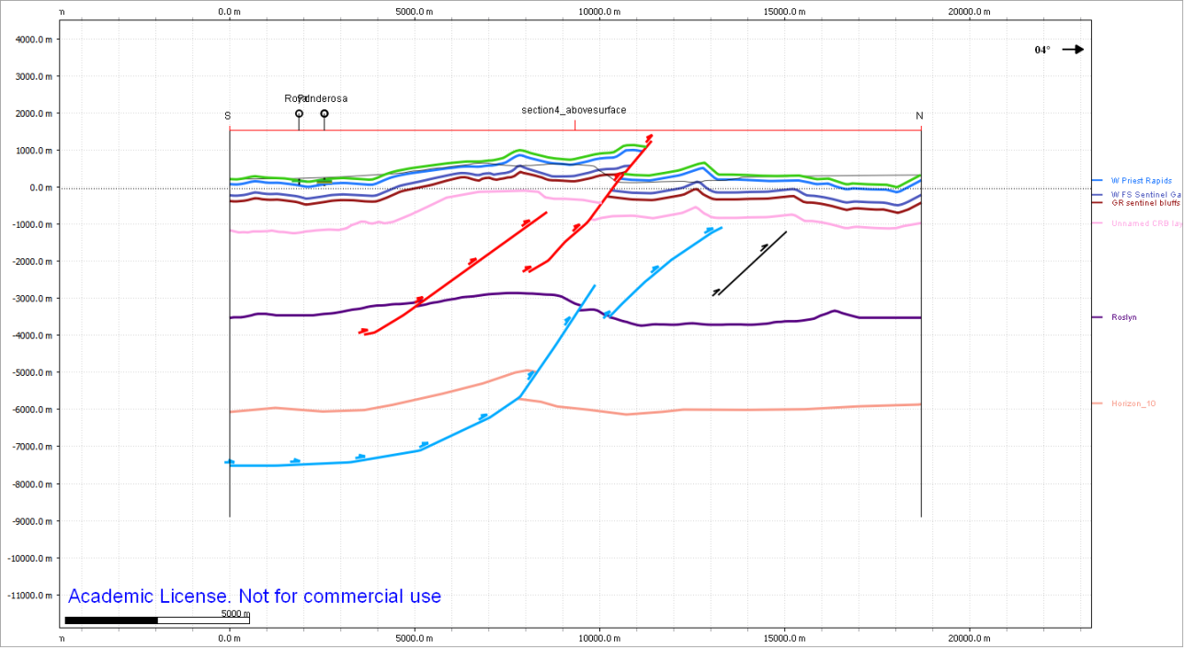

S5) Cross Section Details
Name: East Columbia
XY max: 736889.7, 5194612.6 m
XY min: 735735, 5181414.1 m
Length: 13248.9 m

Well Data
Number of wells | 0
Names of wells
Depth of wells
Distance of wells

Geologic Data
Faults | Two faults are marked at the surface, and one additional fault may need to be drawn below the southernmost anticline. A normal fault is at the top of the anticline. I do not show slip on the normal fault and this fault is not drawn deep because it is nearly perpendicular to the section and the fault trace at the surface is short.
Folds | The northernmost anticline is large and mostly eroded. The southernmost anticline is a mono-anticline and transitions from nearly horizontal behind the northern anticline to about a 10 degree dip to the south. This fold transitions into a mono-syncline in the Missoula deposits, which is present in all of the eastern cross sections.
Units | EM, Asotin, GR, PR, Rosa, FS
Trends | This is the easternmost cross section where the fold structure is more asymmetric than symmetric.

Structural Data
Number of SDs | 35
Max Distance
Units

Seismic Data
Available | No
Length
Depth

Were any faults drawn? How and why?
One main fault was drawn, and this fault was drawn to -2000 m depth with a stair-step geometry. Fault bend folds produce fold hinges near each change in dip of their fault plane, and the dip of the plane reflects the dip in the bedding. Thus I drew a shallow ramps below the nearly horizontal mono-anticline northern limb, and bent this ramp into a flat below the hinge of that fold. I steepened the plane dip below the northernmost anticline because steeper planes produce more exaggerated folding.

Were any folds drawn? How and why?
Two anticlines were drawn based on (1) being marked on the geologic map and (2) presence of strike and dips. Using these strike and dips to constrain the dips of the units produces two distinct folds, and supports the southernmost fold being interpreted as a mono-anticline.

Additional Notes

Image
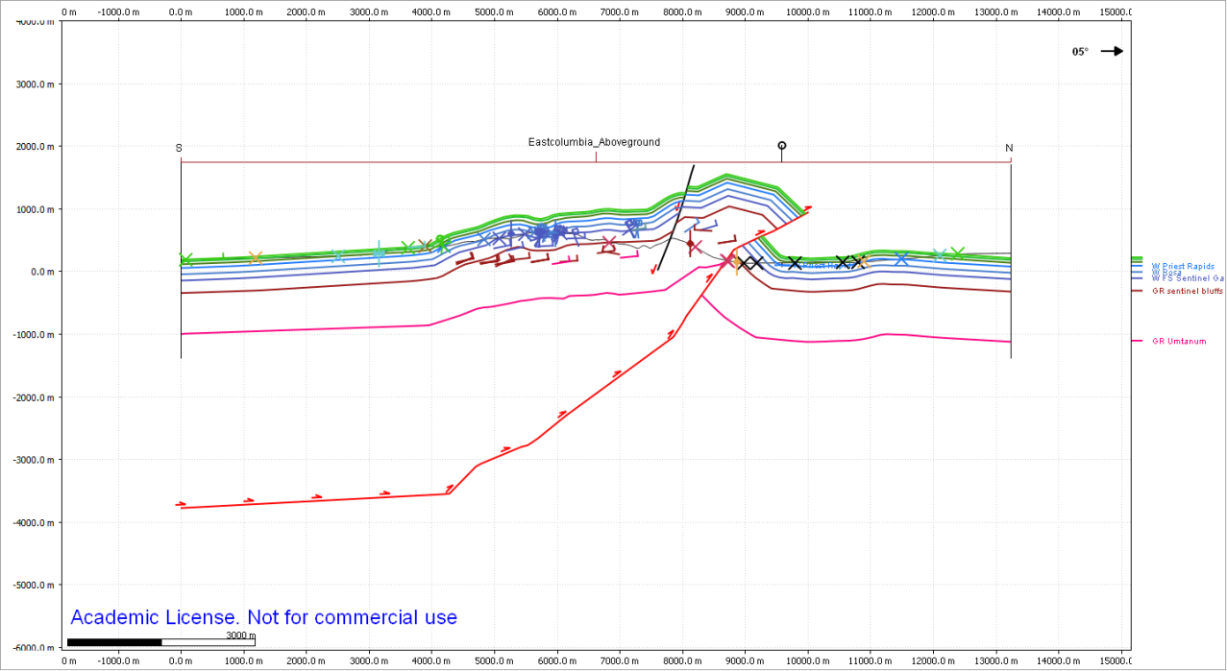

S6) Cross Section Details
Name: West Columbia
XY max: 731874, 5194739.7
XY min: 728908.5, 5175108.2
Length: 19854.2 m

Well Data
Number of wells | 0
Names of wells
Depth of wells
Distance of wells

Geologic Data
Faults | 4 thrust faults (one major, three minor)
Folds | A major mono-anticline is predicted north of the frontal thrust, and a minor anticline is predicted between two of the minor northern thrusts. Two mono-anticlines are mapped south of the frontal and minor thrusts, and these bends were observed in the field.
Units | Rosa, Priest Rapids, FS, GR
Trends

Structural Data
Number of SDs | 49
Max Distance | 4100 m
Units | FS, Asotin, GR, Rosa, PR

Seismic Data
Available | No
Length
Depth

Were any faults drawn? How and why?
Four faults were drawn. All four were northward verging thrusts. The frontal thrust was most northern. Its dip was determined by strike-line calculations and by the modelling tool. Bends in anticlines within the southern limb of the fold indicated that this fault had a stair step structure. Strike-line calculations show a minimum dip of 45 degrees. The two minor northern thrusts were not recognized in the field, and do not accommodate enough slip to juxtapose different flow units. Their dips were calculated from strike lines and ranged from 38 to 45 degrees. The southern thrust must have a noticeable amount of offset because the older Rosa units are next to younger Priest Rapids units, and both have nearly horizontal dips. The displacement may be between 100 and 200 m.

Were any folds drawn? How and why?
Folds were drawn based on strike and dip data collected in the field. There is one discrepancy in the fold as I have drawn it and how it is suggested on the 24k and 100k geologic maps. On these maps, bedding is indicated to be vertical or nearly vertical in front (to the north) of the main fold axis. I nearly mapped the units this way when I was in the field until I realized that the fins protruding from the talus slopes were fins of basalt created through differential weathering and that the layers of columnar basalt in those fins were still nearly horizontal or gently dipping to the north. I therefore, do not draw the main northern fold with steeply dipping front slope, but leave the fold with a more gentle northern slope, as suggested by what I saw in the field.

Additional Notes

Image
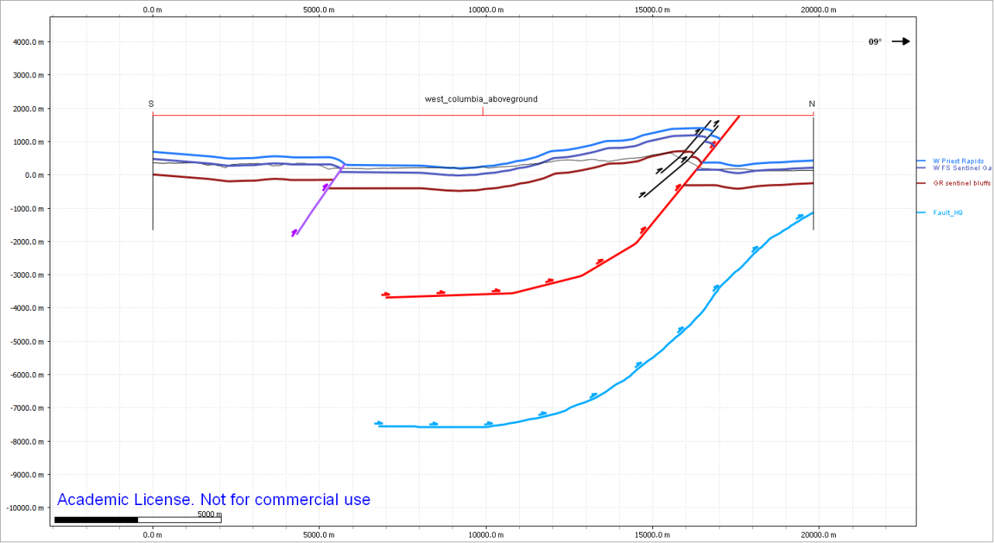

S7) Cross Section Details
Name: Saddle West
XY max:725270.9 m, 5195526.2 m
XY min:715838.8 m, 5180554.2 m
Length: 17695.4 m

Well Data
Number of wells | 0
Names of wells
Depth of wells
Distance of wells

Geologic Data
Faults | 2 thrust faults, 1 steeply dipping and 1 shallowly dipping
Folds | 4 synclines and three anticlines are present on the geologic map
Units | FS, GR, Rosa, PR
Trends | The southern thrust has a very strange map pattern, and a shallow dip (as shallow as 8 degrees in some places). The anticlines and tight syncline between them above the northern frontal thrusts predicts that the northern frontal thrust has a stair-stepped shape and steep dip near the surface.

Structural Data
Number of SDs | 41
Max Distance | 3700 m
Units | GR, Rosa, FS

Seismic Data
Available | No
Length
Depth

Were any faults drawn? How and why?
Two faults were drawn to account for two main anticlines. Both were mapped on the geologic map. The more southern thrust roots near 1000 m depth, while the northern thrust (which is part of the frontal thrust) reaches nearly 4000 m depth. The stair-step shape of the southern thrust accounts for the asymmetry of the anticline and the folds apparent vergence to the south. After reviewing the geologic map, this fault was calculated to dip between 8 and 35 degrees in places, and verged north. The northern frontal thrust has more complicated stair-step geometry. The near surface portion dips steeply to account for the upturned units and the calculated nearly 70-degree dip. A deep step near 1000 m depth is necessary for the model to produce the additional anticline-syncline pair behind the main anticline of the thrust. The gentle slope southward of the step suggests the fault gently flattens with depth.

Were any folds drawn? How and why?
Folds were drawn where suggested by strike and dip data. This produced a gentle anticline in the southern portion of the section and an unusual dual-anticline pair separated by a tight syncline in the northern half of the section south of the main thrust. The FS unit is shown at the highest elevation surrounded by GR, and the GR unit is shown to dip inward below this highest unit. The only way to produce the GR unit constrained by these dips and the surface geology is to have some form of double anticline-system at the top of the ridge. These anticlines are also noted on the geologic map.

Additional Notes

Image
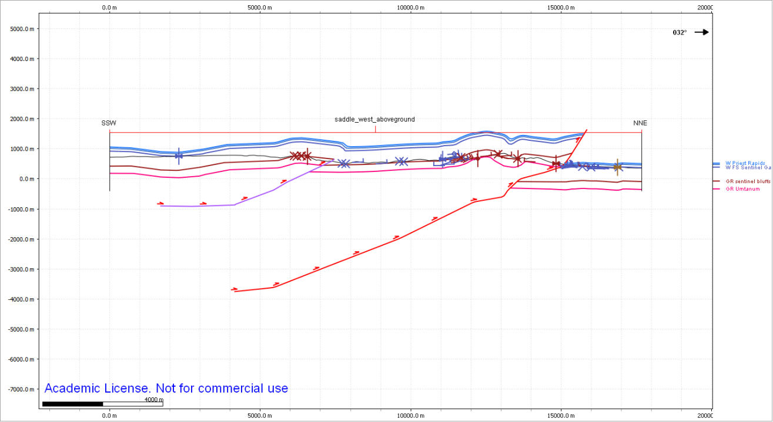

S8) Cross Section Details
Name: Saddle_West2
XY max:719642.2 m, 5195425.0 m
XY min:715269.0 m, 5177885.2 m
Length:18076.8 m

Well Data
Number of wells | 0
Names of wells
Depth of wells
Distance of wells

Geologic Data
Faults | 2 thrusts, one more southern and one more northern.
Folds | 3 anticlines, two of which are marked on the geologic map, and a third, just south of the frontal thrust, which is apparent in adjacent sections of the geologic map. This anticline may not be marked here because the evidence has eroded away, and only the syncline is obvious at the surface. There is a syncline just north of the southernmost anticline and another syncline north of the main northern anticline. A syncline-anticline pair is present in the southern part of the section and is extremely broad and almost not noticeable. The geometry of these folds is constrained by surface geometry and maintaining bed thickness.
Units | FS, Rosa, GR
Trends | North verging asymmetric anticlines following synclines.

Structural Data
Number of SDs | 34
Max Distance | 2300 m
Units | GR, Rosa, FS

Seismic Data
Available | No
Length
Depth

Were any faults drawn? How and why?
The southern thrust was drawn as shallowly dipping south due to strike line calculations on the geologic map. This thrust was not continued up into the upper units, because this would imply that the fault was active and surface breaking when these units were deposited. I think it is more likely that the upper units were folded, not faulted. The northern thrust was drawn with a steeper dip, as calculations from the geologic map indicated a 28 to 52 degree dip. Dip was calculated to be steeper in deeply eroded valleys and more shallow at the front of the ridge. Thus, I propose that the fault dip changes suddenly with depth. I also chose to continue the fault upward, cutting the younger units in the frontal thrust. This keeps continuity with its neighboring cross section. The offset seems drastic, but on the geologic map, the Rosa is not far from being adjacent to the GR, completely skipping over the very thick FS unit. This implies much displacement. I did try to propagate the fault below the surface, but in the context of the Rosa being so close by, the thickness of the FS unit made this impossible.

Were any folds drawn? How and why?
The southernmost anticline, associated with the southern thrust is drawn above the low angle thrust with a north verging sense of asymmetry. The syncline to the north, just south of the frontal thrust is the same (likely) as the one in Saddle West, and the anticline just south of this is related to the northernmost anticlines in the Saddle West section. It is as if these two anticlines merge into one anticline in Saddle West 2.

Additional Notes

Image
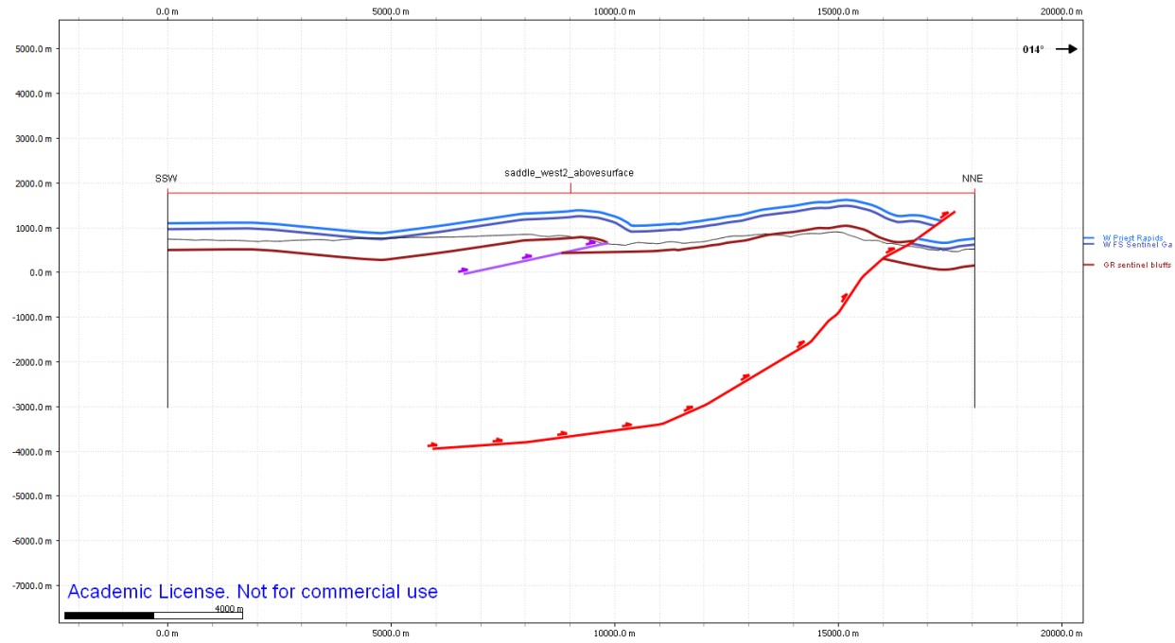

S9) Cross Section Details
Name: Badger Pocket
XY max:718857.5 m, 5199347.4 m
XY min:700420.0 m, 5179575.5 m
Length: 27034.5

Well Data
Number of wells | 0
Names of wells
Depth of wells
Distance of wells

Geologic Data
Faults | 3 north-verging, south dipping thrusts
Folds | 2 syncline-anticline pairs
Units | GR, FS, Rosa
Trends | Two north verging anticlines with synclines to their north. The northern anticline is broader, and further deformed by a second thrust.

Structural Data
Number of SDs | 41
Max Distance | 4500 m
Units | FS, Rosa, GR, Vantage

Seismic Data
Available | No
Length
Depth

Were any faults drawn? How and why?

Three faults were drawn, all of which were indicated on the geologic map. The dip of the southernmost fault is shallow, between 11 and 15 degrees as calculated by strike-line method. The geometry of the fault was constructed using the fault geometry tool, and is similar to the southernmost thrusts in saddle west 2 and saddle west. Although on the geologic map these faults do not connect, their tips are very near each other, suggesting that they connect at depth. Except for their tips, the strikes and dips of the faults are very similar. The intermediate fault is drawn shallower than the other two faults. Its dip was calculated to be between 35 and 44.9 degrees, and may not represent much displacement. Although significant erosion has taken place behind the fault exposing younger units, slivers of GR are left unmoved and indicate that the fault is not major. It may have contributed to the rotation and formation of a broad anticline-syncline pair. The main thrust was calculated to dip near 29 degrees, and using the horizons from fault modelling tool, was produced with a fault depth of 4000 m.

Were any folds drawn? How and why?
The left edge (southern edge) of the cross section is characterized by a very broad anticline, which is unrelated to the broad anticline is saddlewest2. The broad syncline directly north of this anticline is related to the syncline in saddlewest2, although in this section, it is not mapped. An anticline was drawn above the southern thrust, as indicated on the geologic map and by my strike and dip measurements. Though the thrust breaks the surface, I do not interpret that it faulted the upper part of the Frenchman springs, as this unit is mapped adjacent to the fault with a syncline, suggesting that the upper layers were folded, not faulted. An anticline syncline pair was drawn behind the main thrust.The syncline dips steeply just north of the fault. This is drawn in this way because the Rosa outcrops near by (so it was necessary to bring the Rosa close to the surface) and because the GR also outcrops nearby. The Rosa only outcrops just north of the fault, but not farther North, indicating that the GR can rise toward the surface farther away from the fault.

Additional Notes

Image
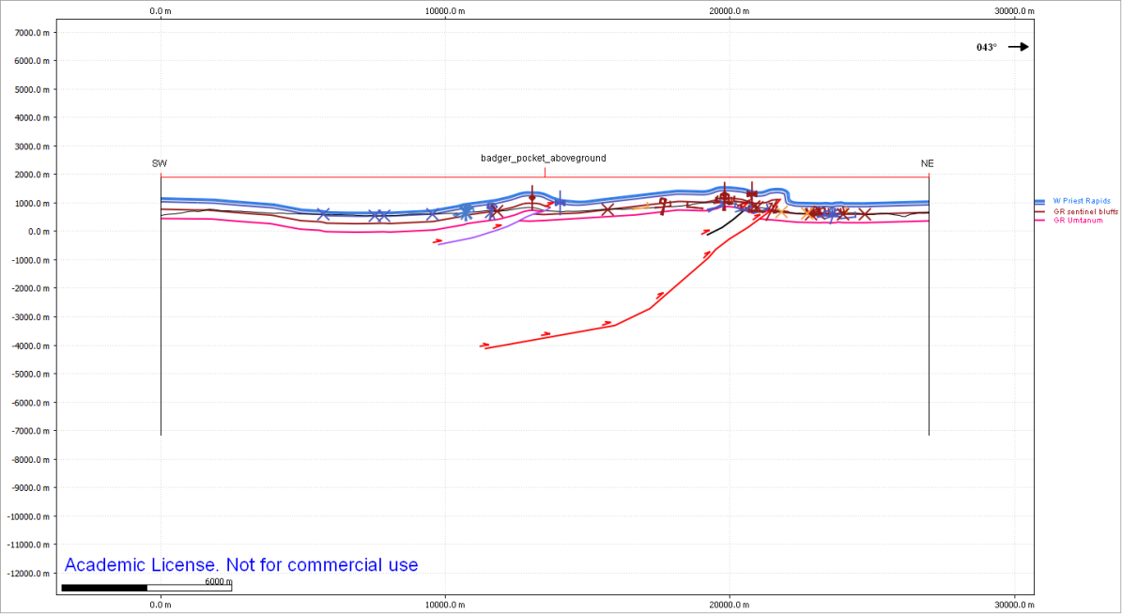

S10) Cross Section Details
Name: Section85266
XY max: 709217.4 m, 5202303.9 m
XY min: 692057.3 m, 5180418.2 m
Length: 27811.0 m

Well Data
Number of wells | 4
Names of wells | Yakima 1-33, Burbank, Eastwood, 2335BN
Depth of wells | -4000 m, 340 m, 480 m, -3050 m
Distance of wells | 1800 m, 1840 m, 3000 m, 1300 m

Geologic Data
Faults | 4 shown on the map, 2 additional, all thrusts
Folds | 3 anticlines, 3 syclines
Units | Rosa, FS, GR, Umtanum, PR
Trends | This cross section crosses the Kittitas Valley floor. The northern end of the cross section is near the frontal thrust surface break, except that in this particular location, the surface break of the thrust is mapped at a strange angle, dipping into a valley. I believe this may represent a separate thrust that links to main, frontal thrust, which is below the surface at the location of the cross section. This is also justified by the change in dip between the portion of the fault within the valley and the rest of the long, frontal thrust.  On the south side of the valley, there is an anticline syncline pair against a south verging thrust, followed to the south by exposures of FS and GR. Because the GR is exposed in the valleys and some of the peaks, we can calculate the thickness of the FS. Another anticline-syncline pair follows above a non-surface breaking thrust fault.

Structural Data
Number of SDs | 41
Max Distance | 6000 m
Units | GR, Vantage, FS, Rosa, GR Umt

Seismic Data
Available | Yes
Length | 11.5 km
Depth | 9 km

Were any faults drawn? How and why?
Six faults were drawn. The two southernmost thrust faults verge away from each other, and their surface breaks are only 700 m apart. While the northern of these two faults (dipping south) is only 5.8 km long, the southern fault connects as a back thrust behind the main thrust of Manastash Ridge. Thus, this fault was drawn to a deeper depth and showed more displacement. The displacement was also necessary, as constrained by surface geology and two wells (Burbank and Yakima 1-33). The next thrust fault to the north, the frontal thrust of Manastash Ridge, does not break the surface. This fault actually connects Umtanum Ridge and Manastash Ridge as being underlain by a connected fault system. The dip and shape of the fault were determined using the fault building tools. Offset along the fault was predicted by surface geology and constrained by well data. The geologic map showed an extreme thinning of the FS, which is a 400 m thick unit. A more likely explanation is that a fault is present at depth, and the upper portion of the syncline and FS is exposed. The three northern faults are inter-fingering. Oppositely verging thrusts may have contributed to the formation of the Kittitas Valley. Both thrusts were constrained by strike line method calculation and the fault-building model. The northernmost fault is the frontal thrust which does not break the surface but is evidenced by folds and offset reflections in the seismic section.

Were any folds drawn? How and why?
A broad anticline was drawn above the Yakima 1-33 well as indicated by geologic map data. The Umtanum Ridge anticline was also drawn, and with a syncline just to its north. Above the northern thrusts, I also interpreted anticlines. While all folds were constrained by well data, strike and dips, and surface geology, the northernmost anticlines were also visible in the seismic section.

Additional Notes

Image
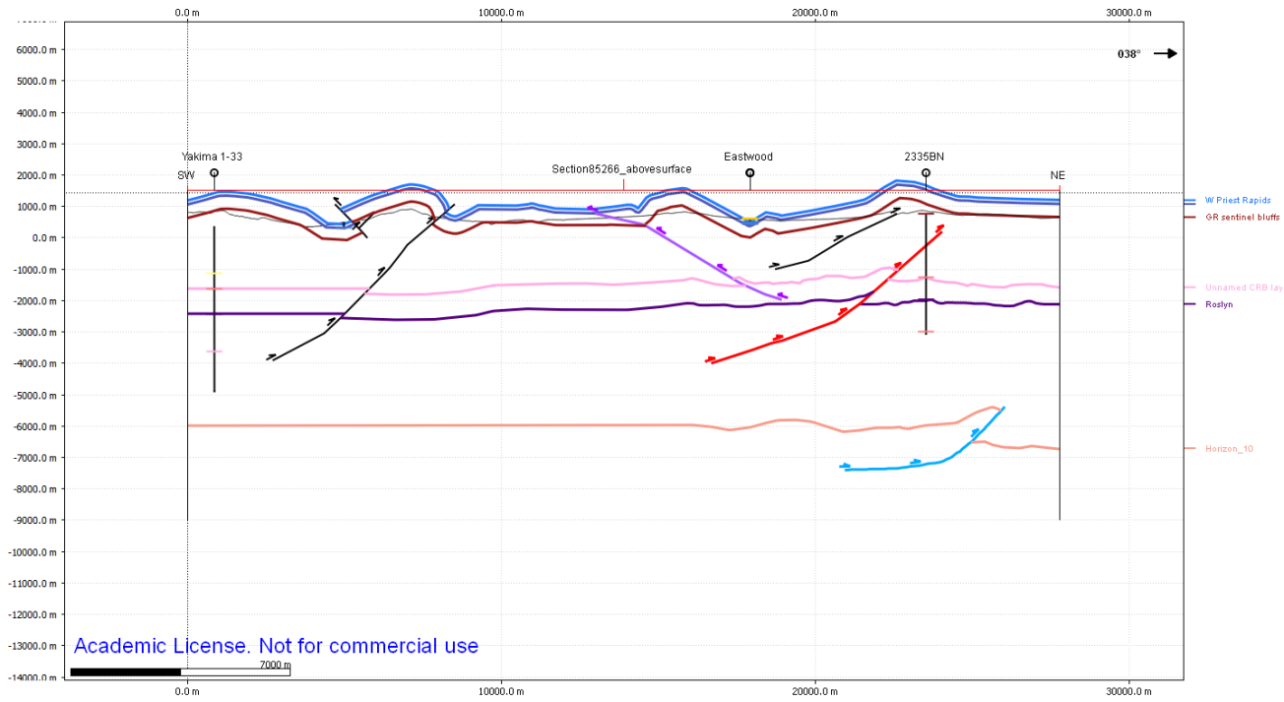

F1) Cross Section Details
Name: Frenchman Hills
XY max: 742284.9 m, 5209005 m
XY min: 742724.6 m, 5194454.2 m
Length: 15088 m (14000 km interpretable)
Depth: 9700 m
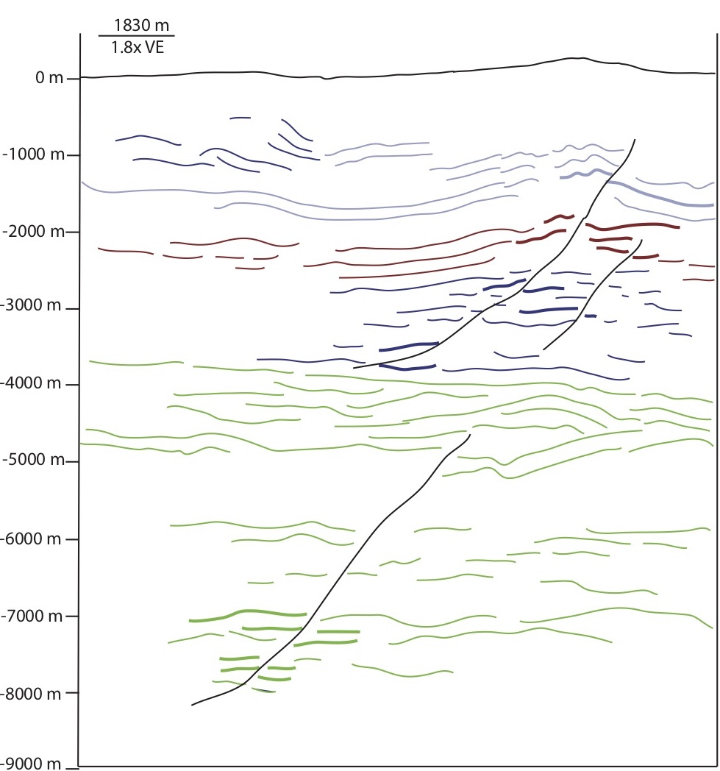
For this cross section, our goal was only to interpret the general structure (faults and folds) within the seismic data. Strong amplitude, continuous seismic reflections that played a key role in interpretation have been outlined in color and bolded where offset reflections were especially apparent. Black lines indicate interpreted thrust faults. Colors do not correlate with specific strata, but were solely used to help guide the author’s eye during interpretation.

