Supplementary Information for
Ultralow thermal conductivity and low charge carrier scattering potential in Zn_{1-x}Cd_{x}Sb solid solutions for thermoelectric application
R. Biswas, S. Mukherjee^{2,3}, R. C. Mallik², S. Vitta¹ and T. Dasgupta^{1,*}
¹Department of Metallurgical Engineering and Materials Science, Indian Institute of Technology Bombay, Mumbai 400 076, India
²Thermoelectric Materials and Device Laboratory, Department of Physics, Indian Institute of Science, Bangalore 560 012, India
³Interdisciplinary Centre for Energy Research, Indian Institute of Science, Bangalore 560 012, India

Rietveld Refinement
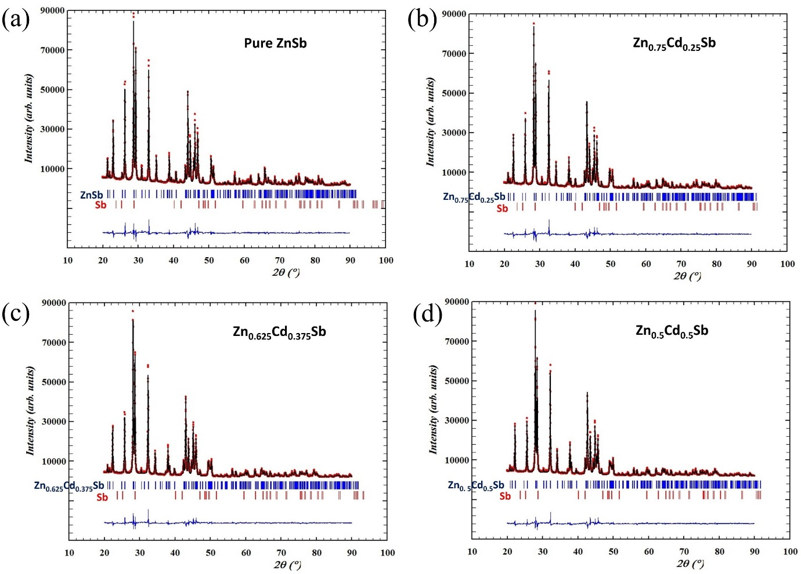
Rietveld refinement of slow-scanned powder XRD data was performed using the FullProf Suite software and reference crystal data were taken from standard JCPDS data for ZnSb (PDF no.- 01-089-2614 37-1008) [S1], CdSb (PDF no.- 01-073-6894) [S2] and Sb (PDF no.- 01-085-1322 35-732) [S3]. The quality of fitting is shown if Figure S1.
Figure S1 – Rietveld refinement plot for different compositions: (a) x=0, (b) x=0.25, (c) x=0.375 and (d) x=0.5. Red coloured dotted pattern and black coloured pattern at top and the blue coloured line at bottom represent experimental data, fitted data and their difference respectively. At the middle the Bragg’s diffraction positions are marked for Zn_{1-x}Cd_{x}Sb and Sb with blue and red coloured sticks respectively.

Cadmium distribution in the matrix
SEM micrographs of different compositions (in BSE mode) and elemental mapping of the Zn_{0.625}Cd_{0.375}Sb composition are given in Figure S2 and S3 respectively. From the elemental map, the secondary Sb regions can be identified. The matrix region show a uniform distribution of Cd, Zn and Sb with no observable variation in the color contrast. This is indicative of uniform Cd alloying in the matrix phase.

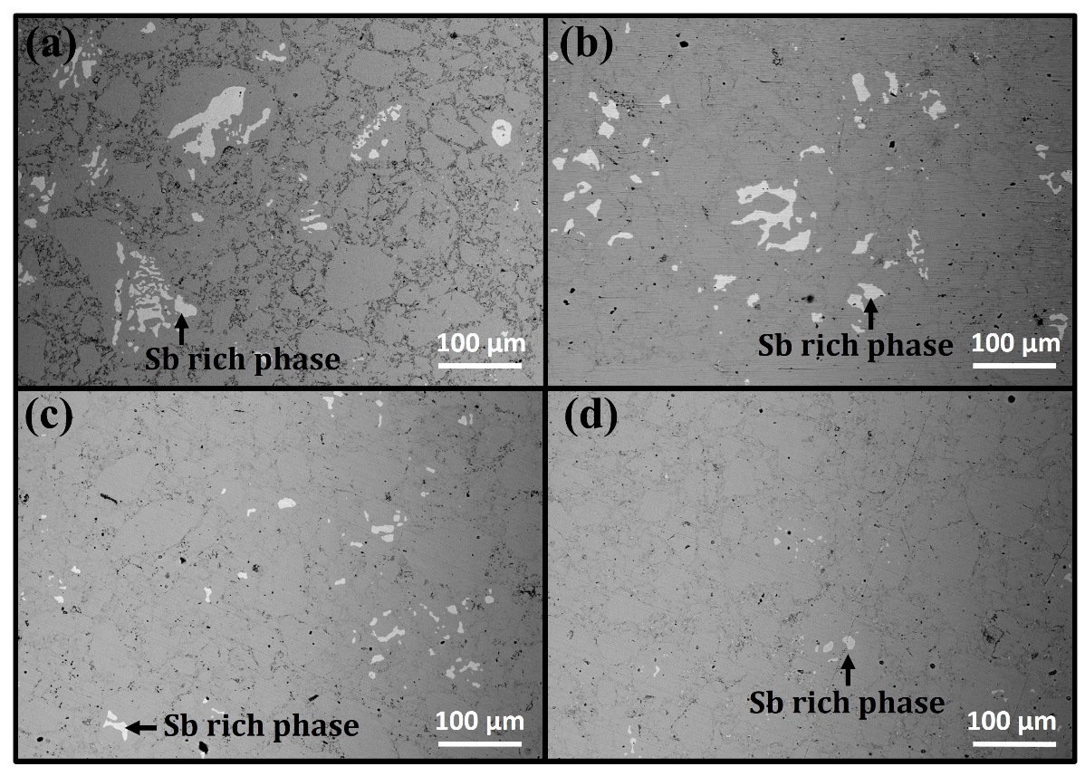
Figure S2 – SEM images for the different compositions taken in Back Scattered imaging mode: (a) x=0, (b) x=0.25, (c) x=0.375 and (d) x=0.5.

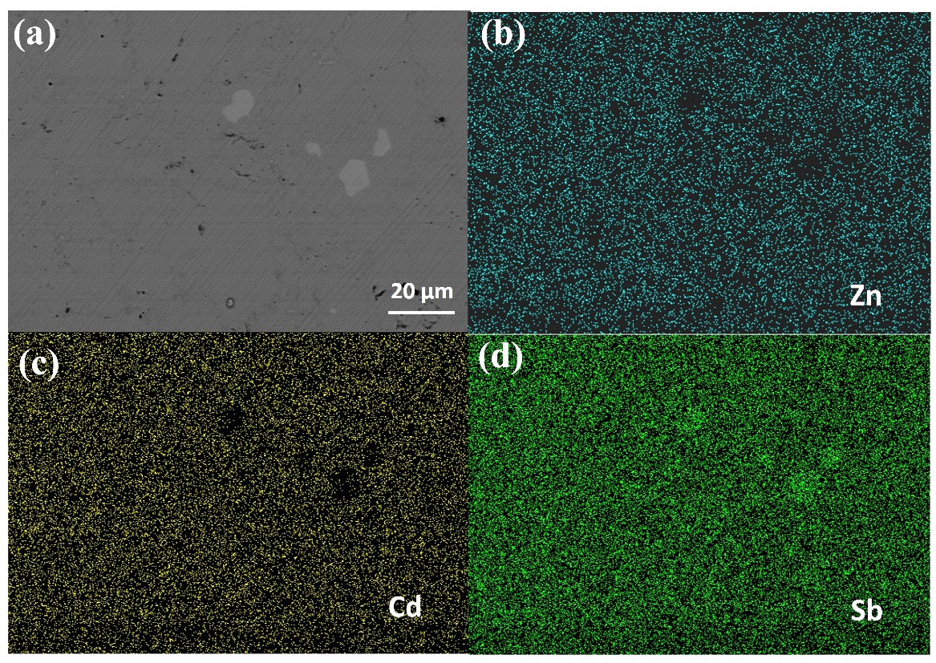
Figure S3 – Elemental mapping for the x=0.375 composition: (a) BSE image, (b)-(d) distribution of Zn, Cd and Sb respectively.

Specific Heat ($C_{P}$)
The specific heat capacity${ (C}_{P})$ with temperature (Figure S4) was measured from differential scanning calorimetry data measure by NETZSCH DSC 204 F1 Phoenix instrument following a 3 step route with sapphire used as the standard material. The experimentally measured values for all compositions are higher than their Dulong-Petit values. The maximum difference is observed for x=0.25 composition, which shows the highest ${ C}_{P}$ value. Polynomial of second order was fitted to the experimental data and the maxima was used as constant at high temperature. The fitted data shown by lines with symbols were used for calculation of thermal conductivity.
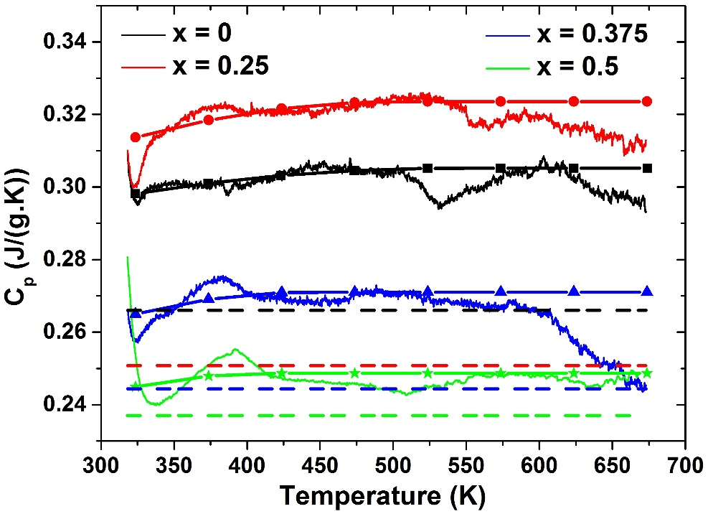
Figure S4 – Specific heat capacity, C_{p} vs. temperature plot obtained from the DSC data for different compositions. The curvy lines, the lines with symbols and the dashed lines represent experimental, fitted data used for $κ$ calculation and Dulong-Petit value respectively.

Diffusivity ($D$)
Thermal diffusivity ($D$) variation with temperature was measured in a laser flash apparatus (NETZSCH LFA 457 MicroFlash). The variation of thermal diffusivity with temperature plot of the samples is given in Figure S5. . It shows that x=0.5 composition has minimum thermal diffusivity. The heating and cooling curves do not show much hysteresis, which indicates that the samples are very much stable in the temperature range.

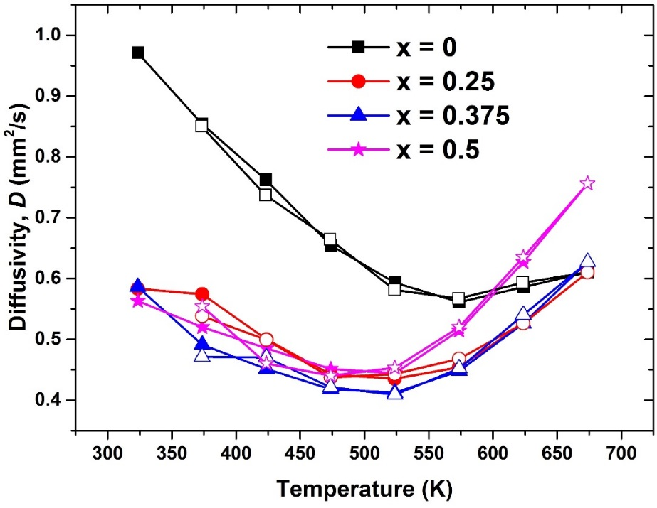
Figure S5 - Diffusivity (D) vs. temperature data for different compositions. (Filled symbols indicate heating, while empty symbols indicate cooling.)

Thermal Cycling Data
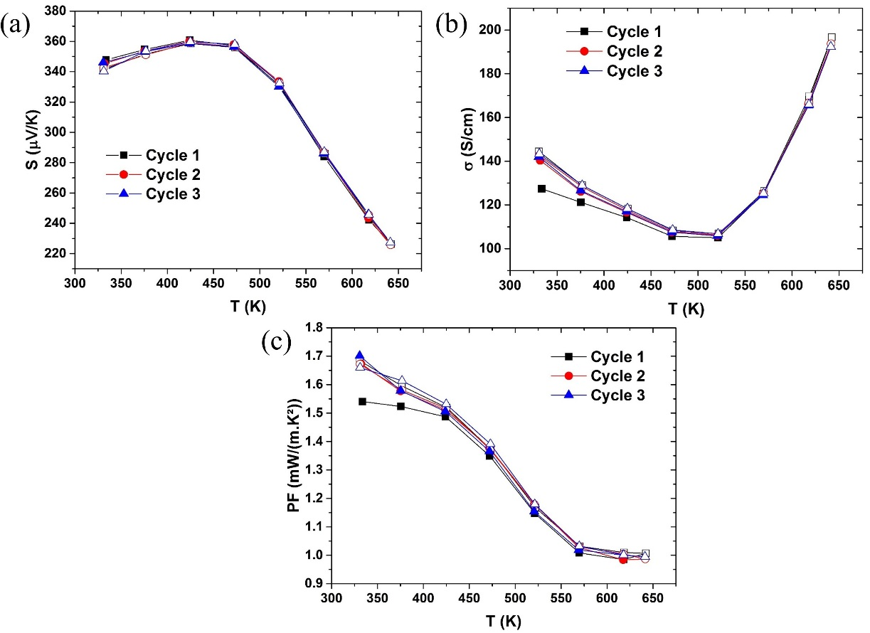
Thermal cycling of S and σ and the calculate power factor (PF) of x=0.375 composition is presented in Figure S6. Filled symbol in the data indicate heating cycle while unfilled symbols indicate the data collected during cooling. As observed from the plots, a deviation in the (also minor variation in S) data happens during the first heating and cooling cycle. Further thermal cycling do not result in a variation of the data. It can thus be concluded that this composition exhibits short term thermal stability
Figure S6 - Thermal cycling of S and σ and power factor (PF) of x=0.375 composition. (Filled symbols indicate heating, while empty symbols indicate cooling.)

($κ_{L}$) vs. 1/T plot
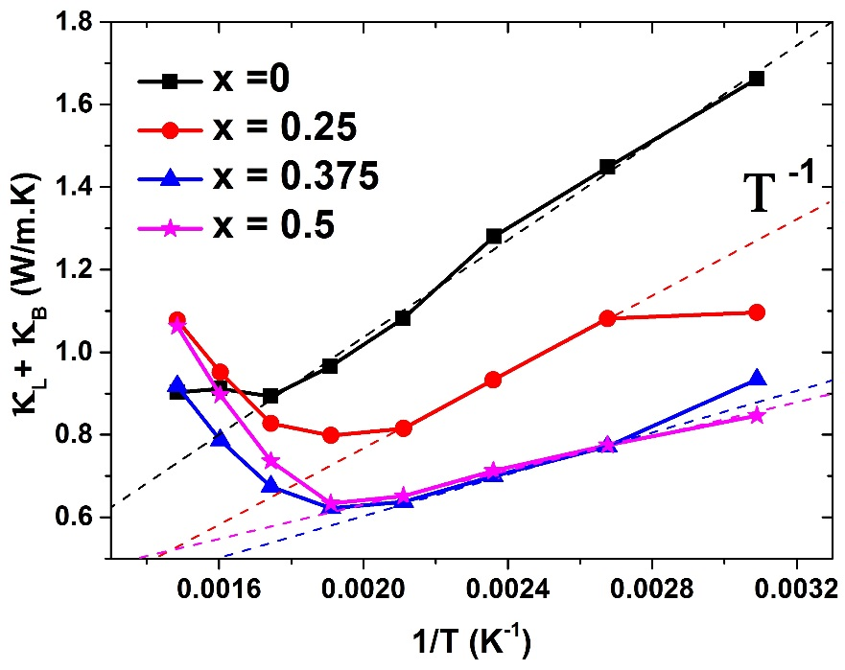
($κ_{L}+κ_{B}$) vs. 1/T plot is given in Figure S7. The dashed line shows T⁻¹ dependence for pure ZnSb composition at lower temperatures, indicative of Umklapp phonon scattering being the dominant scattering mechanism.
Figure S7 - ($κ_{L}+κ_{B}$) vs. 1/T plot. The dashed lines present T⁻¹ dependence for pure ZnSb composition.

Parameters used for calculation of $({}_{L}+{}_{B})$
The values of the parameters ($v$ - average group velocity of phonon/sound, $θ_{D}$ -Debye temperature, $V$ or $Ω$ - average atomic volume, $u$ – disorder scaling parameter, $Γ$ – total scattering parameter, $Γ_{m}$ - mass fluctuation scattering parameters, $Γ_{s}$ - strain field fluctuation scattering parameter and $ε$ - a parameter function of Grüneisen parameter) used for calculation of $({}_{L}+{}_{B})$ are given in Table S1. Debye temperature ($θ_{D}$) and the average group velocity of phonon/sound ($v$) for pure ZnSb and pure CdSb were taken from literature and for alloyed compositions (x=0.25, 0.375 and 0.5), these were calculated using their weighted average.

Table S1 – Values of important parameters used for calculation of $({}_{L}+{}_{B})$ for different compositions.
Sample Compositions  / Parameters | X = 0 | X = 0.25 | X = 0.375 | X = 0.5 | X = 1
$v$ (m/s) | 2538.17 [S4] | 2392.71 | 2319.98 | 2247.25 | 1956.33 [S5]
$θ_{D}$ (K) | 253 [S6] | 234.75 | 225.625 | 216.5 | 180 [S7]
$V$ or $Ω$ (m³/atom) | 2.43x10⁻²⁹ | 2.53 x10⁻²⁹ | 2.58 x10⁻²⁹ | 2.64 x10⁻²⁹ | 2.84 x10⁻²⁹
$$u$$ | - | 1.4810 | 1.9543 | 2.2704 | -
$$Γ$$ | - | 0.0854 | 0.1425 | 0.1843 | -
$$Γ_{m}$$ | - | 0.0697 | 0.0752 | 0.07 | -
$$Γ_{S}=Γ-Γ_{m}$$ | - | 0.0157 | 0.0673 | 0.1143 | -
$$ε$$ | - | 6.6 | 22.7 | 36.1 | -
Prefactor, A | - | 1.26 x10⁻⁴¹ | 2.10 x10⁻⁴¹ | 2.71 x10⁻⁴¹ | -
Prefactor, B | 2.17 x10⁻¹⁷ | 2.40 x10⁻¹⁷ | 2.52 x10⁻¹⁷ | 2.64 x10⁻¹⁷ | 3.11 x10⁻¹⁷
$({}_{L}+{}_{B})$Cal (W.m⁻¹K⁻¹) | - | 0.99 | 0.84 | 0.76 | -
$({}_{L}+{}_{B})$Exp (W.m⁻¹K⁻¹) | 1.67 | 1.1 | 0.93 | 0.85 | 1

References
[S1] F.L. Carter, R. Mazelsky, J. Phys. Chem. Solids 25 (1964) 571–581.
[S2] K.-J. Range, J. Pfauntsch, U. Klement, Acta Crystallogr. Sect. C 44 (1988) 2196–2197.
[S3] C.S. Barrett, P. Cucka, K. Haefner, Acta Crystallogr. 16 (1963) 451–453.
[S4] P. Jund, R. Viennois, X. Tao, K. Niedziolka, J.C. Tedenac, Phys. Rev. B - Condens. Matter Mater. Phys. 85 (2012) 1–13.
[S5] S. Wang, J. Yang, L. Wu, P. Wei, J. Yang, W. Zhang, Y. Grin, Chem. Mater. 27 (2015) 1071–1081.
[S6] A. Fischer, E.-W. Scheidt, W. Scherer, D. Benson, Y. Wu, D. Eklöf, U. Häussermann, Phys. Rev. B 91 (2015) 224309.
[S7] O. Madelung, Semiconductors:Data Handbook, Springer-Verlag Berlin Heidelberg, 2004.

