Development and characterization of BODIPY-derived tracers for fluorescent labeling of the endoplasmic reticulum

Flip de Jong,ª Jan Pokorny,^{b} Bella Manshian,^{c,d} Brent Daelemans,^{e} Johannes Vandaele,ª Justyna B. Startek,^{f} Stefaan Soenen,^{c,d} Mark Van der Auweraer,ª Wim Dehaen,^{e} Susana Rocha ^{*a} Gaston Silveira-Dorta^{*e}

ªMolecular Imaging and Photonics, Department of Chemistry, KU Leuven, Leuven Chem&Tech, Celestijnenlaan 200F, 3001 Leuven, Belgium
^{b}Department of Organic Chemistry, Faculty of Science, Palacky University in Olomouc, 17, Listopadu 1192/12, 771 46 Olomouc, Czech Republic
^{c}NanoHealth and Optical Imaging Group, Department of Imaging and Pathology, KU Leuven, B3000 Leuven, Belgium
^{d}MoSAIC, KU Leuven, B3000 Leuven, Belgium
^{e}Molecular Design and Synthesis, Department of Chemistry, KU Leuven, Celestijnenlaan 200F, B-3001 Leuven, Belgium
^{f}Department of Cellular and Molecular Medicine, Laboratory of Ion Channel Research, KU Leuven, VIB Center for Brain & Disease Research, Herestraat 49, Campus Gasthuisberg, O&N1 Box 801, 3000 Leuven, Belgium

E-mail: gaston.silveira@kuleuven.be susana.rocha@kuleuven.be

Table of Contents
 | General experimental methods | S4
Figure S1. | ¹H and ¹³C NMR spectra for compound 5 | S5
Figure S2. | ¹H and ¹³C NMR spectra for compound N,N-dibenzyl-2-methylquinolin-8-amine | S6
Figure S3. | ¹H and ¹³C NMR spectra for compound 6 | S7
Figure S4. | ¹H and ¹³C NMR spectra for compound 7 | S8
Figure S5. | ¹H and ¹³C NMR spectra for compound 9 | S9
Figure S6. | ¹H and ¹³C NMR spectra for compound 3 | S10
Figure S7. | ¹H and ¹³C NMR spectra for compound 10 | S11
Figure S8. | ¹H and ¹³C NMR spectra for compound 11 | S12
Figure S9. | ¹H and ¹³C NMR spectra for compound 12 | S13
Figure S10. | ¹H and ¹³C NMR spectra for compound 13 | S14
Figure S11. | ¹H and ¹³C NMR spectra for compound 14 | S15
Figure S12. | ¹H and ¹³C NMR spectra for compound 15 | S16
Figure S13. | ¹H and ¹³C NMR spectra for compound 16 | S17
Figure S14. | ¹H and ¹³C NMR spectra for compound 17 | S18
Figure S15. | ¹H and ¹³C NMR spectra for compound 18 | S19
Figure S16. | ¹H and ¹³C NMR spectra for compound 19 | S20
Figure S17. | High content images of co-localization of 3 | S21
Figure S18. | High content images of co-localization of 10 | S21
Figure S19. | High content images of co-localization of 11 | S22
Figure S20. | High content images of co-localization of 13 | S22
Figure S21. | High content images of co-localization of 14 | S23
Figure 22. | High content images of co-localization of 15 | S23
Figure 23. | High content images of co-localization of 16 | S24
Figure 24. | High content images of co-localization of 17 | S24
Figure 25. | High content images of co-localization of 18 | S25
Figure 26. | High content images of co-localization of 19 | S25
Figure 27. | Confocal images of co-localization of 17 | S26
Tables S1-S3 | Pearson colocalization | S27
Figure 28. | Cytotoxicity of 3 at 0, 5, 15, 30, 60, 120, 180, 240 min | S28
Figure 29. | Cytotoxicity of 10 at 0, 5, 15, 30, 60, 120, 180, 240 min | S28
Figure 30. | Cytotoxicity of 11 at 0, 5, 15, 30, 60, 120, 180, 240 min | S28
Figure 31. | Cytotoxicity of 12 at 0, 5, 15, 30, 60, 120, 180, 240 min | S29
Figure 32. | Cytotoxicity of 13 at 0, 5, 15, 30, 60, 120, 180, 240 min | S29
Figure 33. | Cytotoxicity of 14 at 0, 5, 15, 30, 60, 120, 180, 240 min | S29
Figure 34. | Cytotoxicity of 15 at 0, 5, 15, 30, 60, 120, 180, 240 min | S30
Figure 35. | Cytotoxicity of 16 at 0, 5, 15, 30, 60, 120, 180, 240 min | S30
Figure 36. | Cytotoxicity of 17 at 0, 5, 15, 30, 60, 120, 180, 240 min | S30
Figure 37. | Cytotoxicity of 18 at 0, 5, 15, 30, 60, 120, 180, 240 min | S31
Figure 38. | Cytotoxicity of 19 at 0, 5, 15, 30, 60, 120, 180, 240 min | S31
Figure 39 - 41 | Absorption and Emission Spectrum of the compounds 3, 10, 11, 12, 13 and 14 in different solvents | S32
Figure 42 - 44 | Absorption and Emission Spectrum of the compounds 15, 16, 17, 18 and 19 in different solvents | S33
Table S4 | Spectroscopic Data and quantum yields | S34

General experimental methods

NMR spectra were acquired on commercial instruments (Bruker Avance 300 MHz, Bruker AMX 400 MHz or Bruker Avance II+ 600 MHz) and chemical shifts (δ) are reported in parts per million (ppm) which are referenced to tetramethylsilane (¹H) or the internal (NMR) solvent signal (¹³C). Exact mass spectra were acquired on a quadrupole orthogonal acceleration time-of-flight mass spectrometer (Synapt G2 HDMS, Waters, Milford, MA). Samples were infused at 3 µL min⁻¹ and spectra were obtained in positive (or negative) ionization mode with a resolution of 15 000 FWHM using leucine enkephalin as lock mass. Melting points (not corrected) were determined using a Reichert Thermovar apparatus. For column chromatography, 70–230 mesh silica 60 (E. M. Merck) was used as the stationary phase. Chemicals received from commercial sources were used without further purification. Dry-reaction solvents were used as received from commercial sources. Reactions were monitored using thin-layer chromatography (TLC) on aluminum packed percolated Silica Gel 60 F254 plates. Flash column chromatography was carried out with silica gel 60 (particle size less than 0.020 mm) by using appropriate mixtures of ethyl acetate and hexanes as eluents. Compounds were visualized on the TLC plates by using UV light. Anhydrous magnesium sulfate was used for drying solutions. Chemical nomenclature was generated using Chem Bio Draw Ultra 13.0

NMR Spectra spectrum

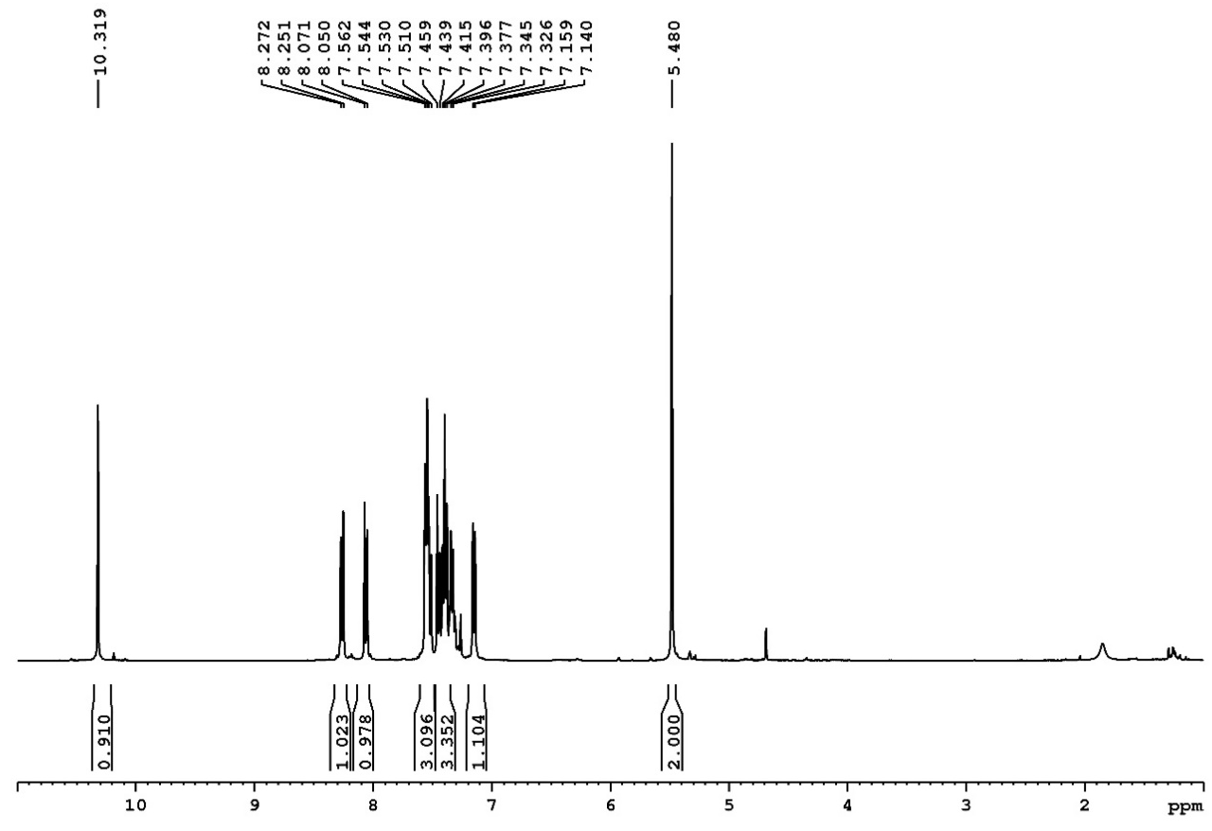

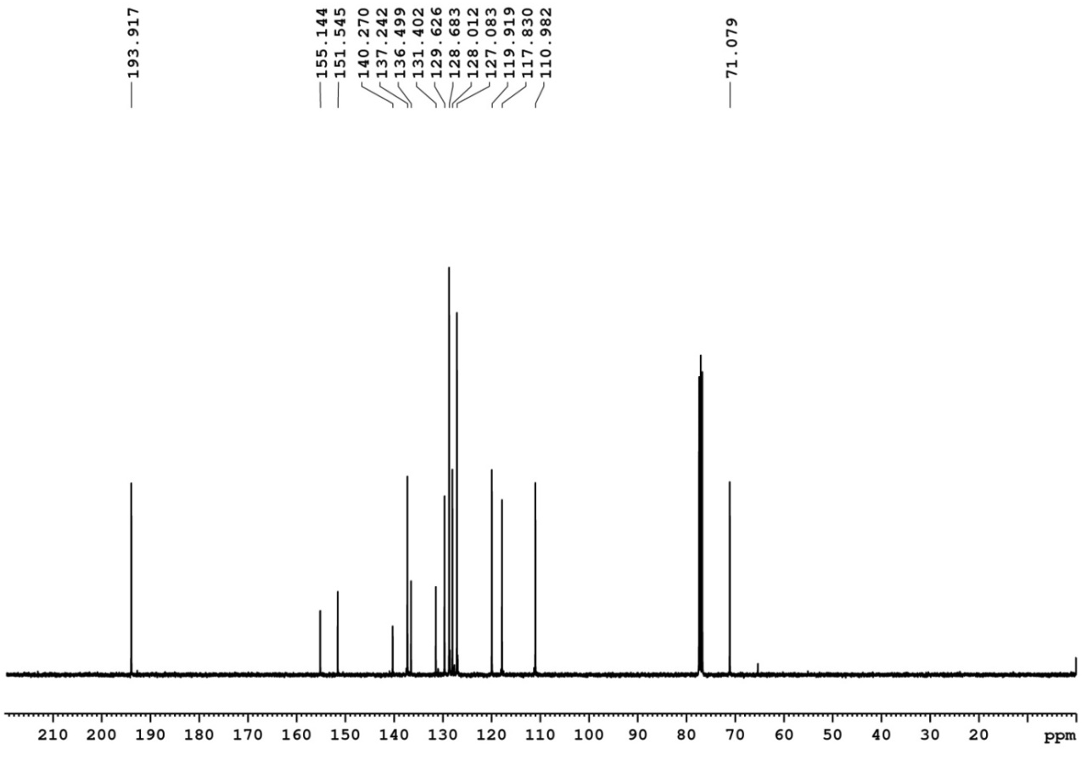

Figure S1. ¹H (400 MHz) and ¹³C (100 MHz) NMR spectra of 5 in CDCl₃.

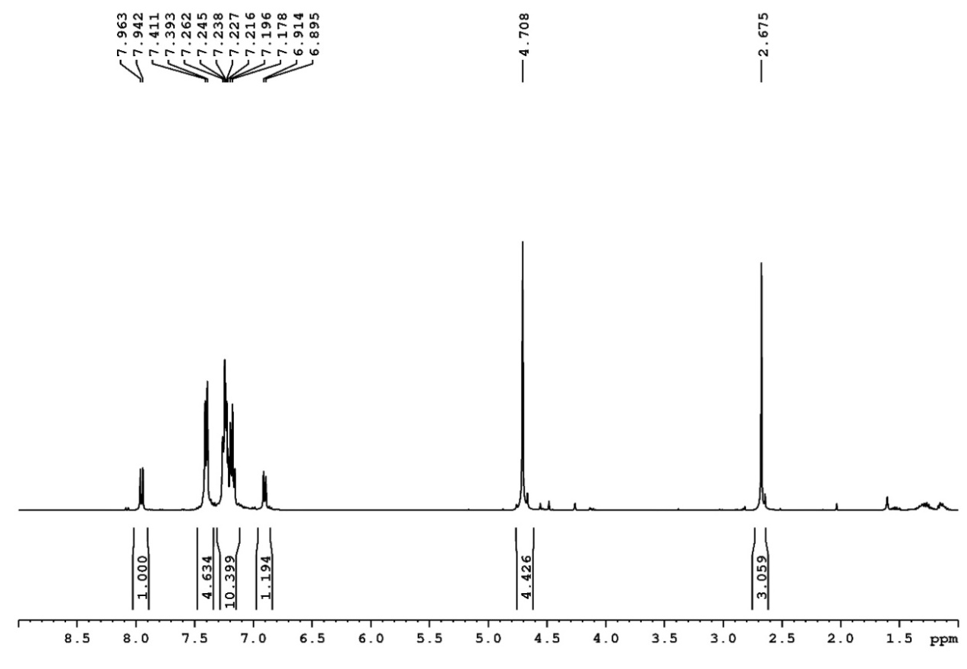

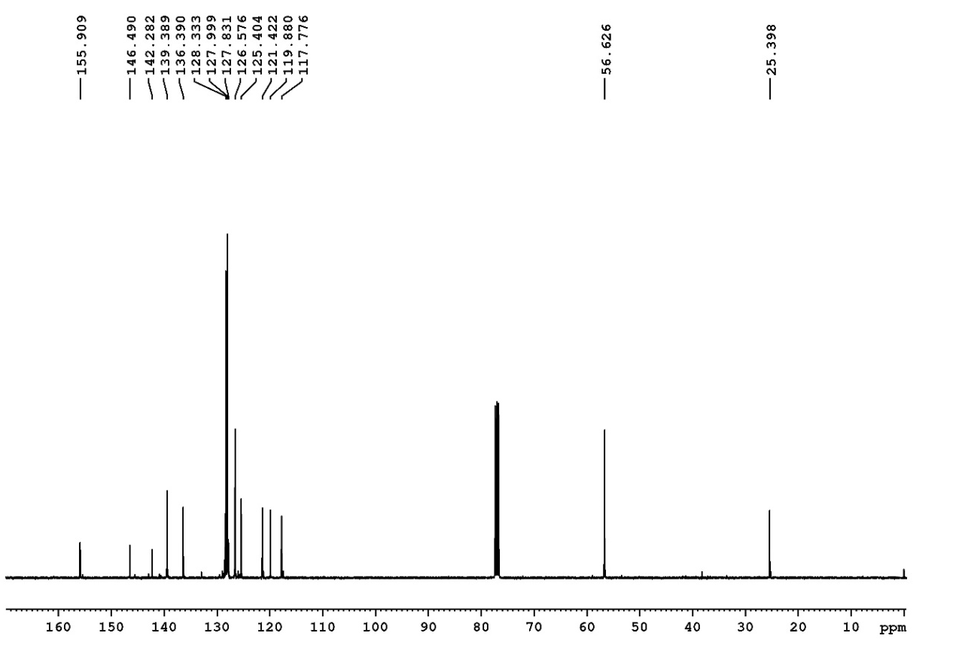

Figure S2. ¹H (400 MHz) and ¹³C (100 MHz) NMR spectra of Synthesis of N,N-dibenzyl-2-methylquinolin-8-amine in CDCl₃.
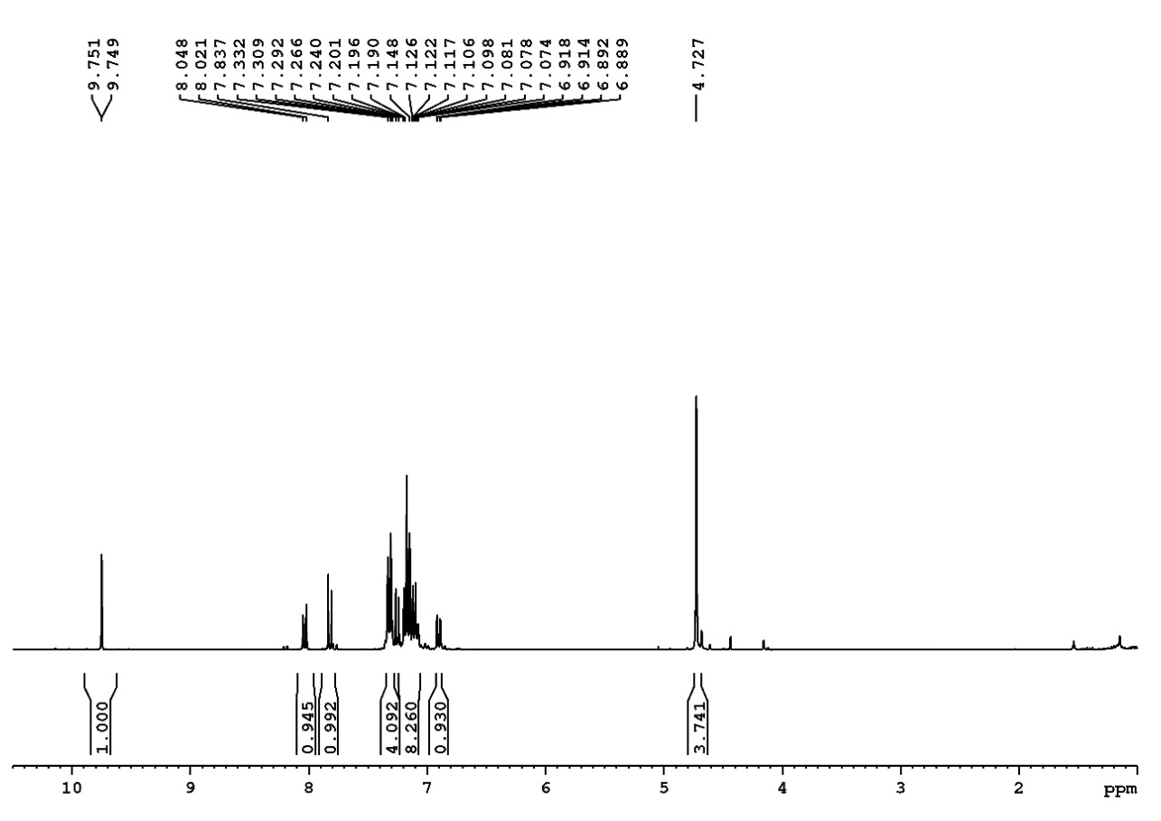

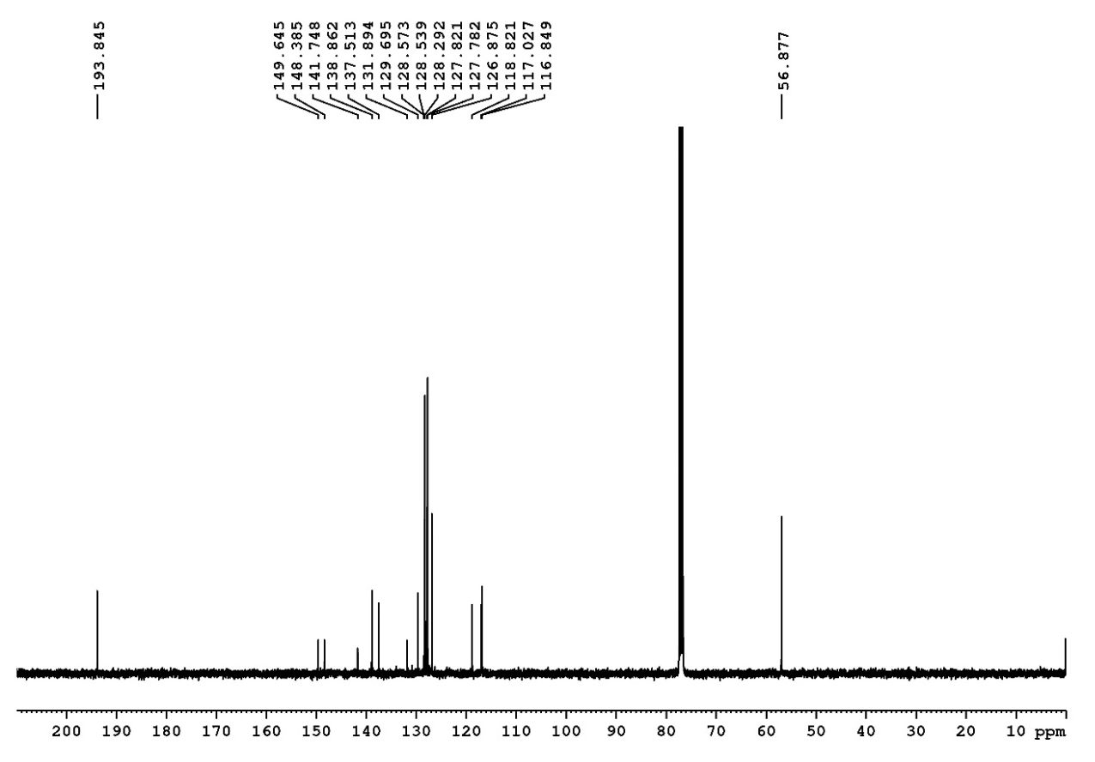

Figure S3. ¹H (400 MHz) and ¹³C (100 MHz) NMR spectra of 6 in CDCl₃.
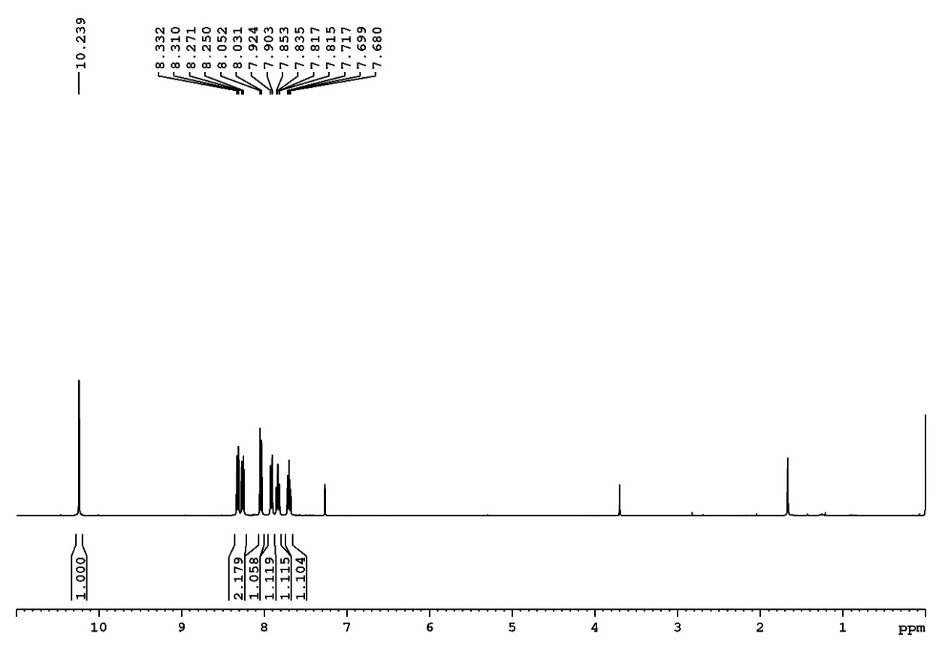

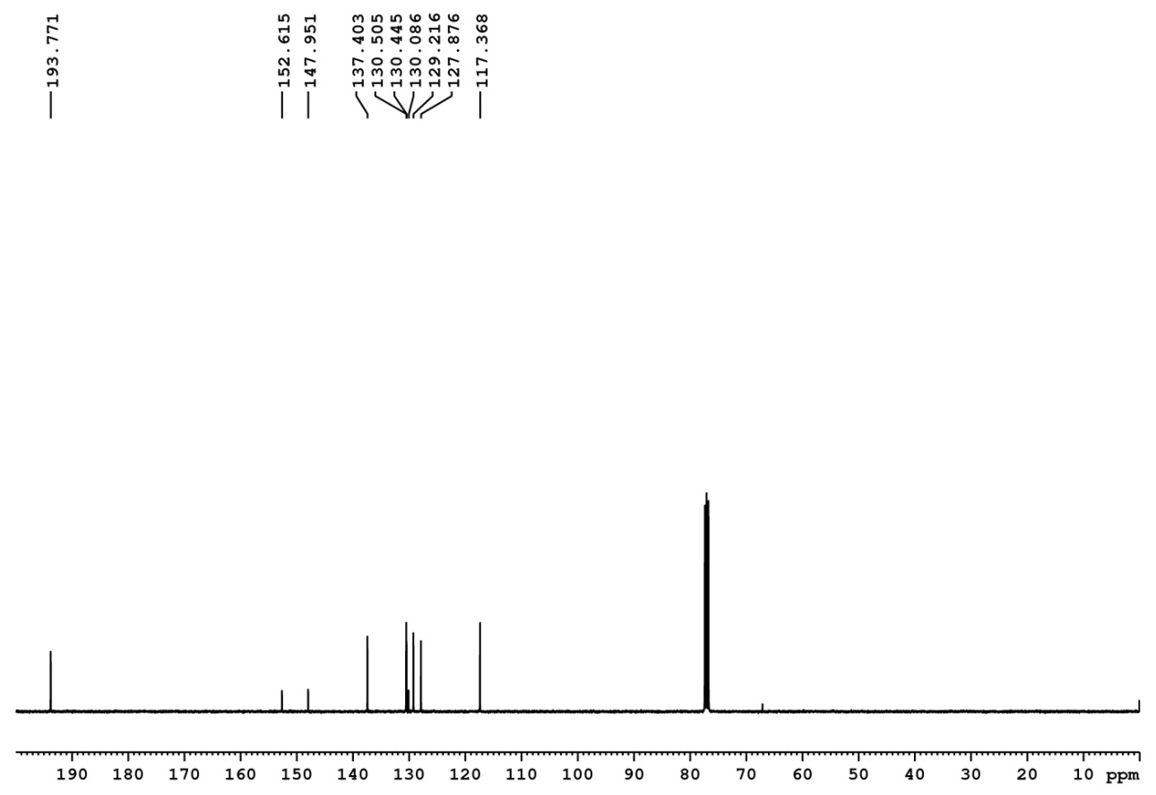

Figure S4. ¹H (400 MHz) and ¹³C (100 MHz) NMR spectra of 7 in CDCl₃.

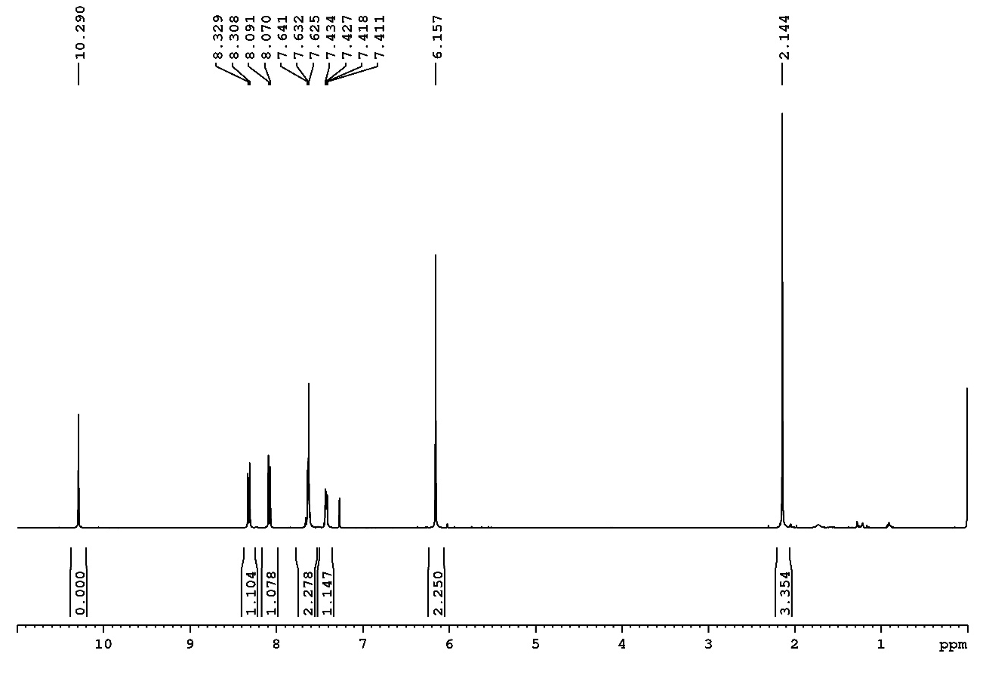

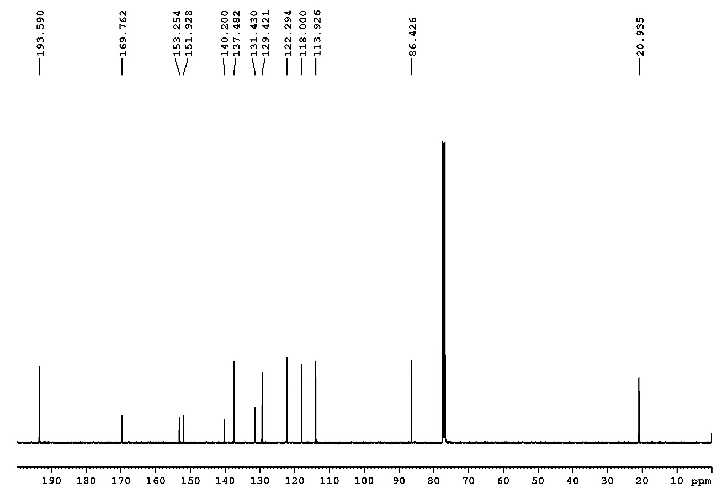

Figure S5. ¹H (400 MHz) and ¹³C (100 MHz) NMR spectra of 9 in CDCl₃.
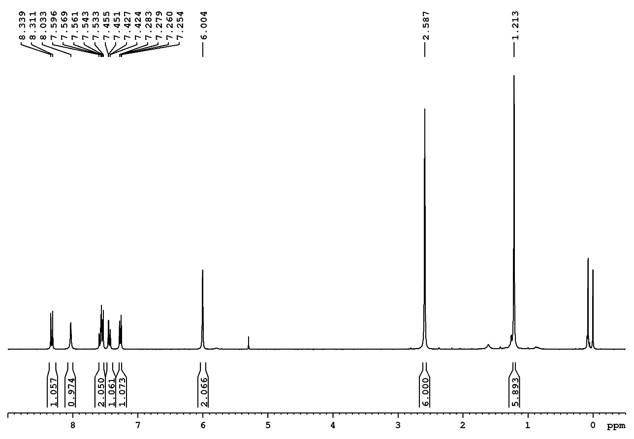

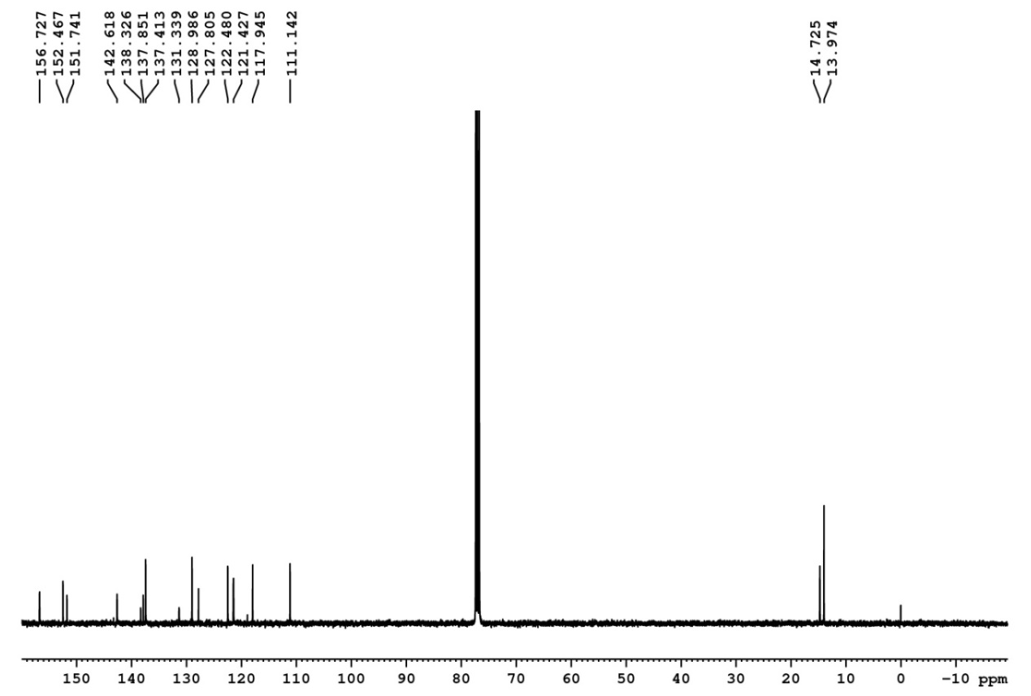

Figure S6. ¹H (300 MHz) and ¹³C (100 MHz) NMR spectra of 3 in CDCl₃.

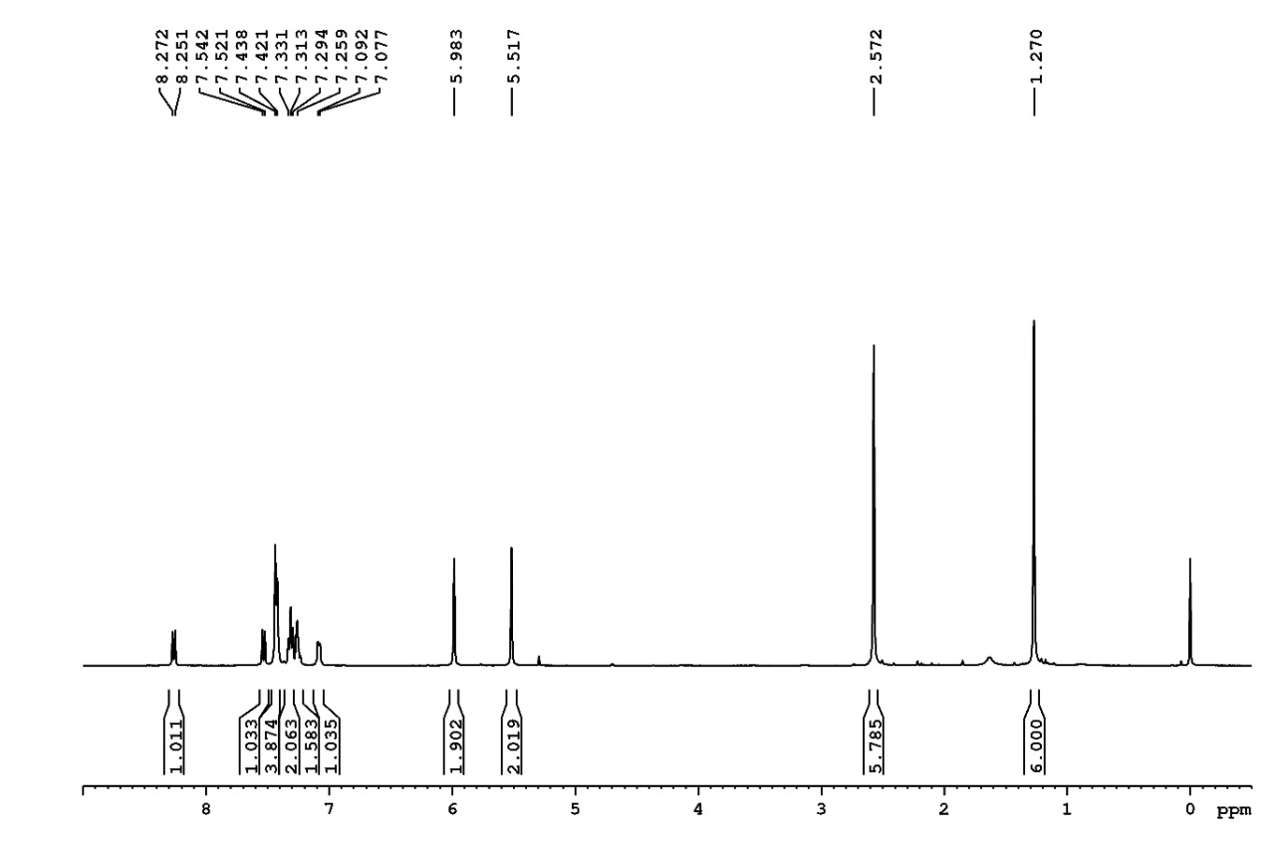

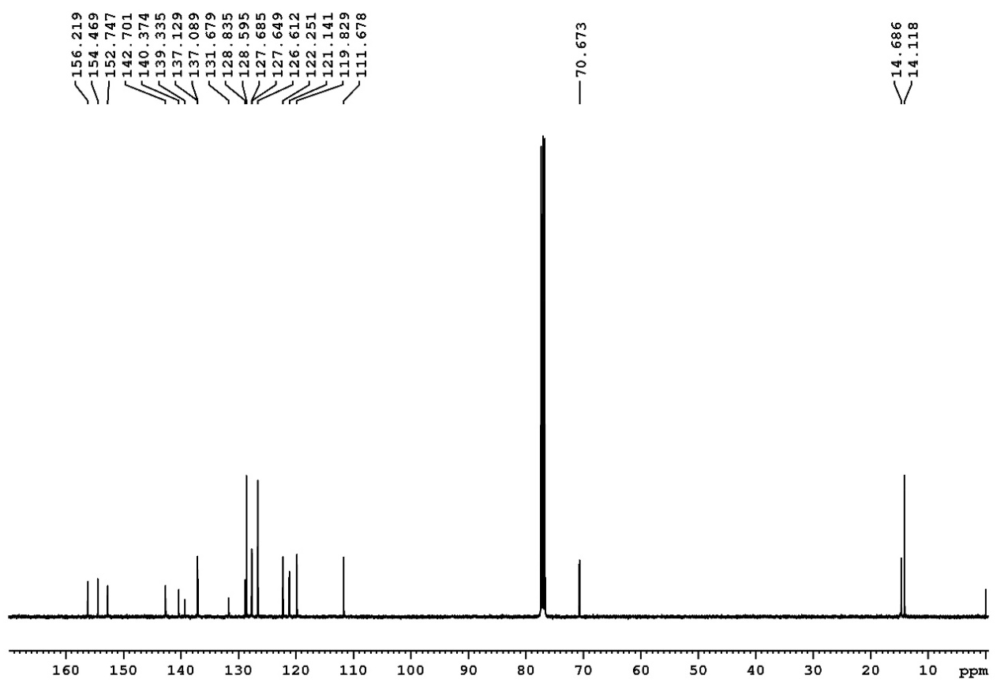

Figure S7. ¹H (400 MHz) and ¹³C (100 MHz) NMR spectra of 10 in CDCl₃.
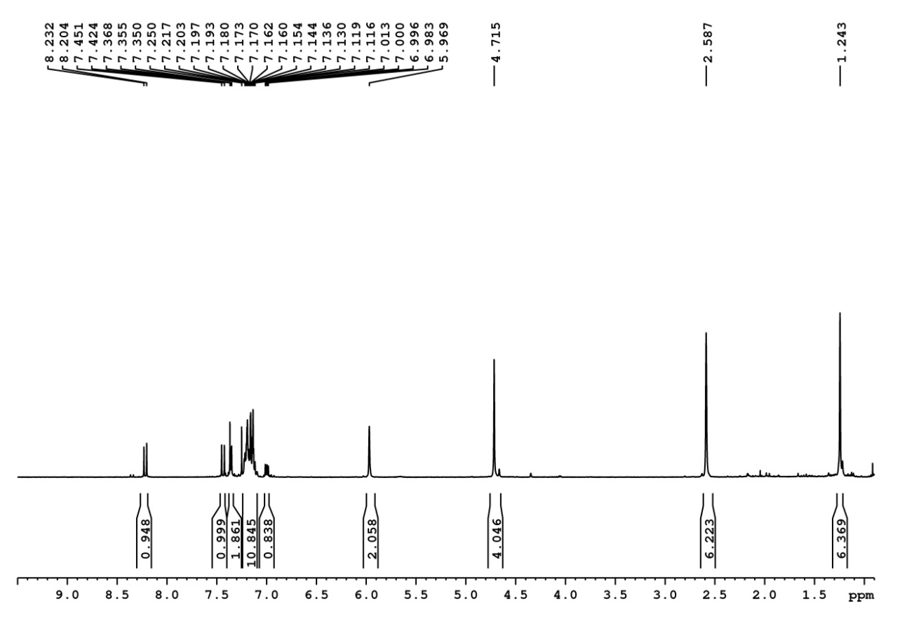

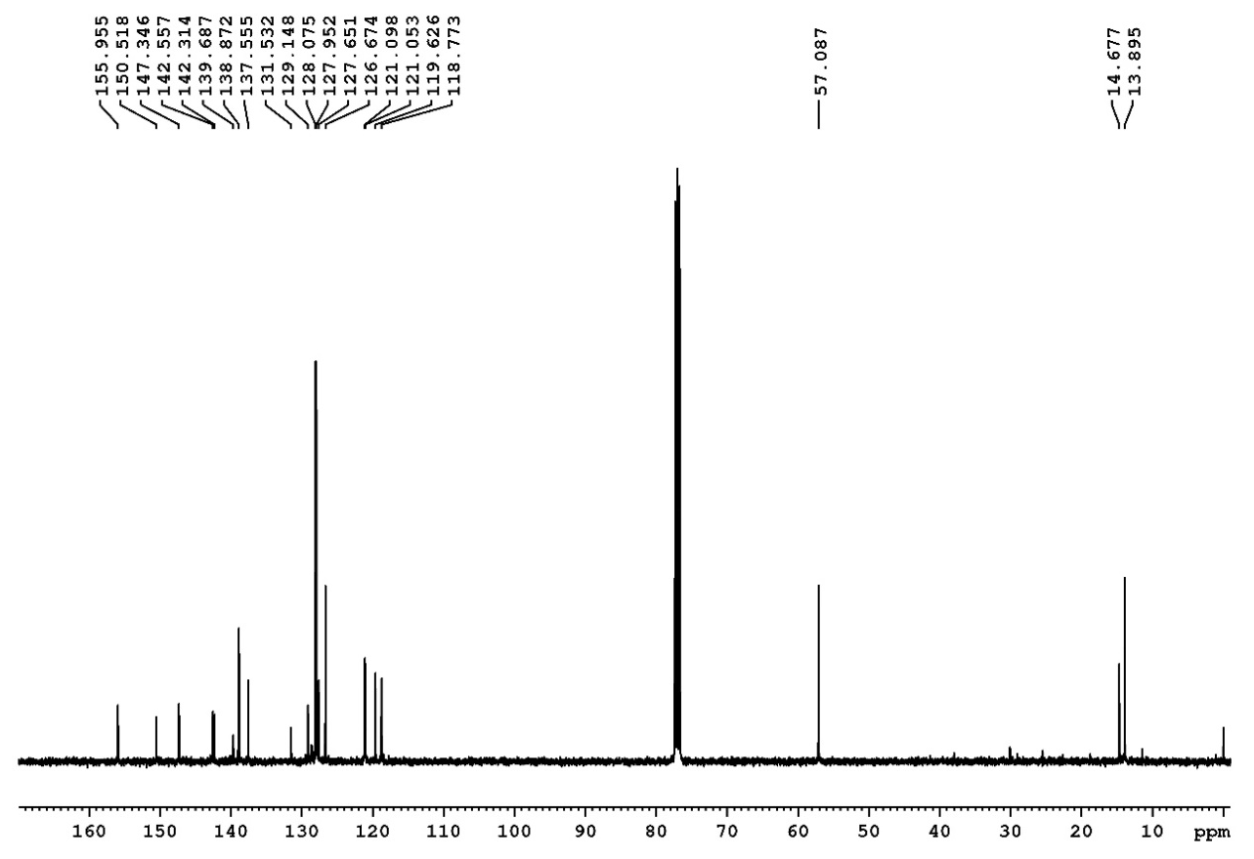

Figure S8. ¹H (400 MHz) and ¹³C (100 MHz) NMR spectra of 11 in CDCl₃.

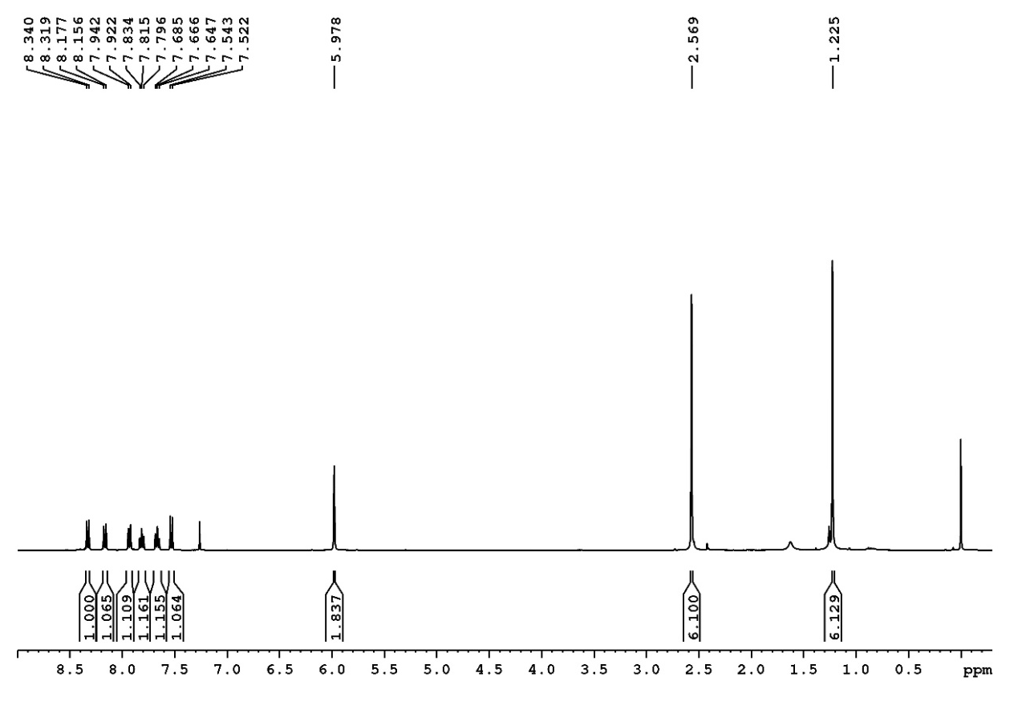

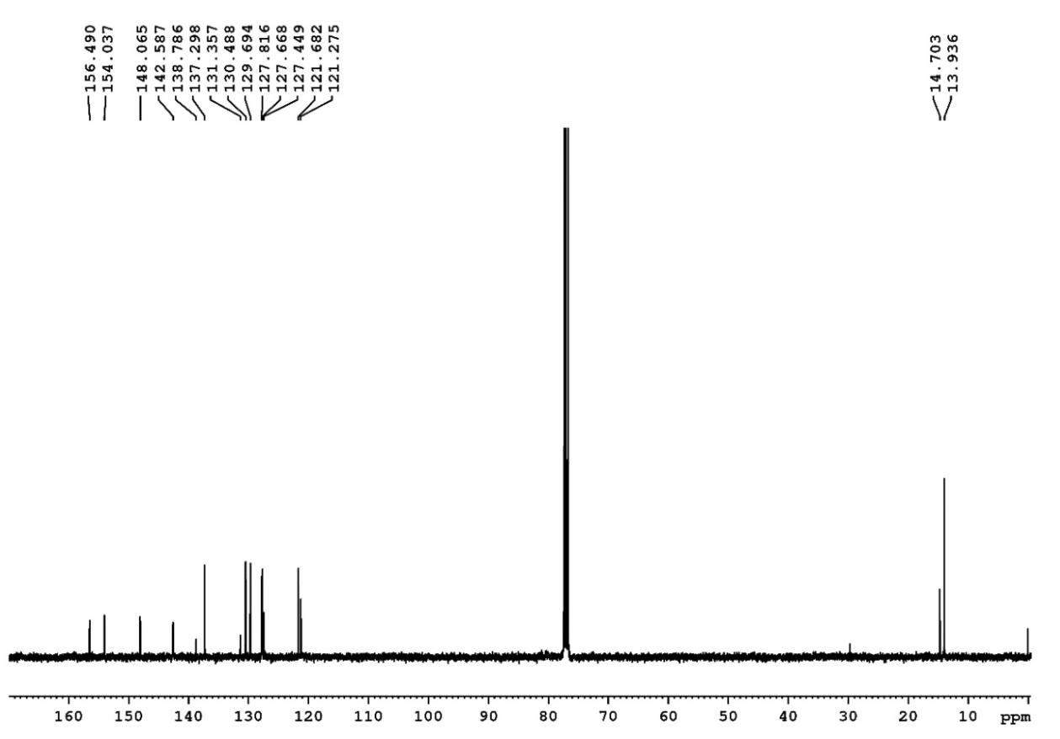

Figure S9. ¹H (400 MHz) and ¹³C (100 MHz) NMR spectra of 12 in CDCl₃.
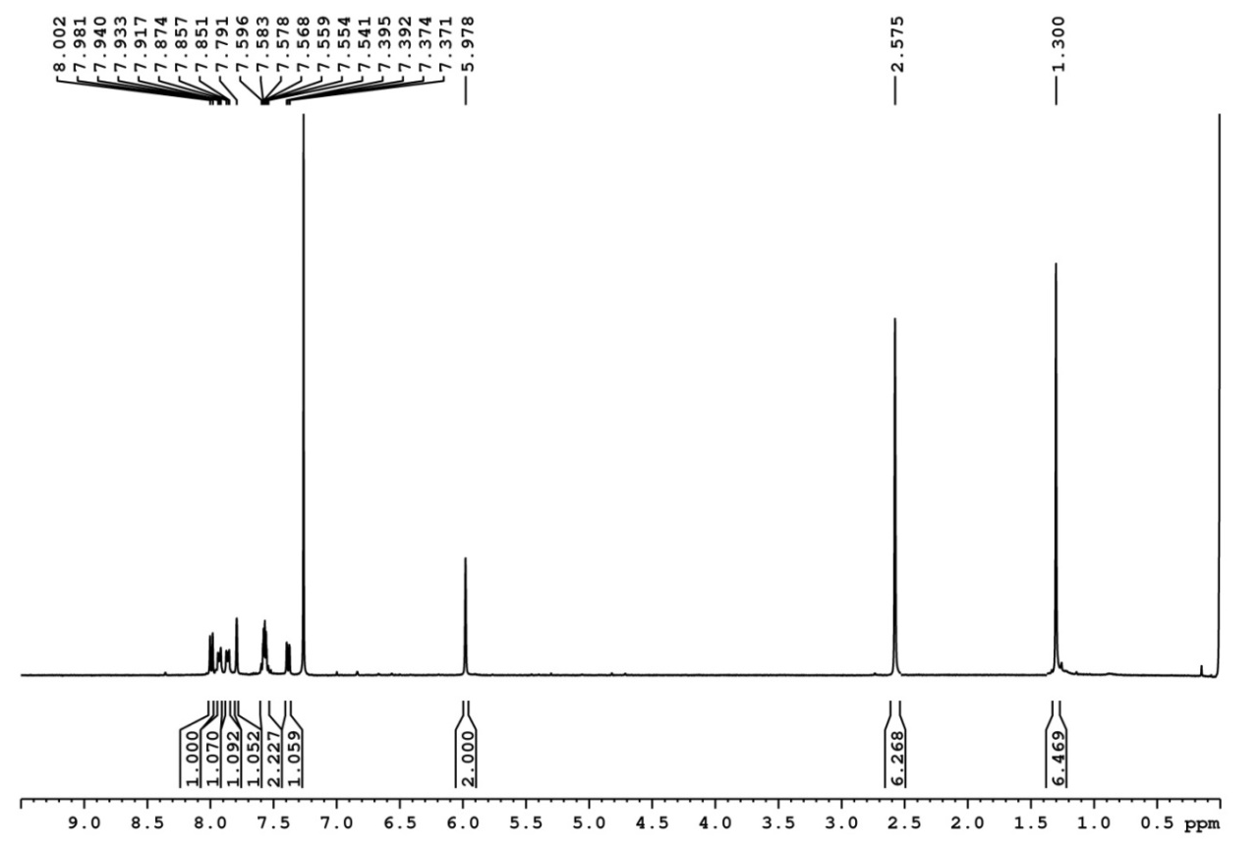

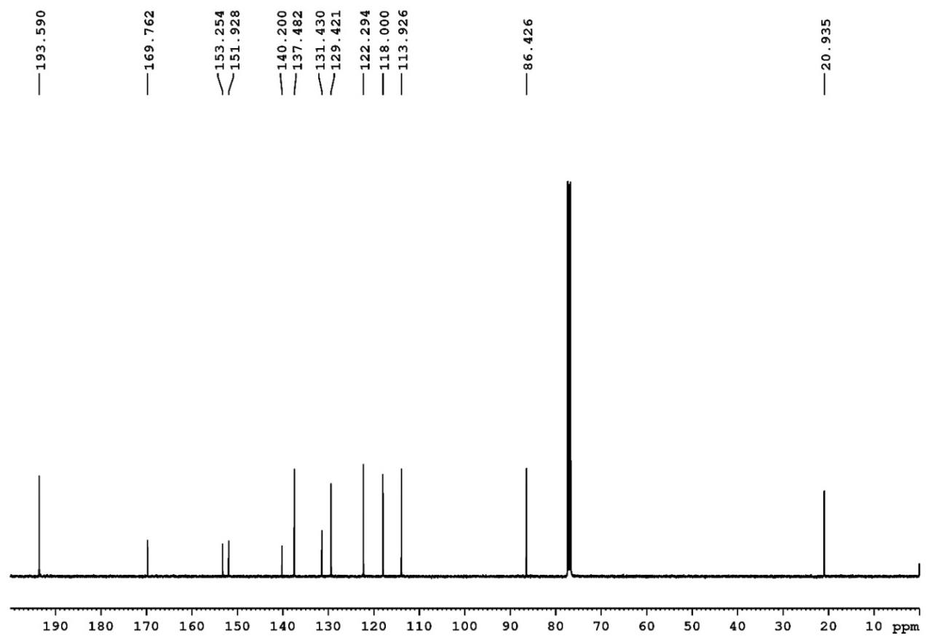

Figure S10. ¹H (400 MHz) and ¹³C (100 MHz) NMR spectra of 13 in CDCl₃.

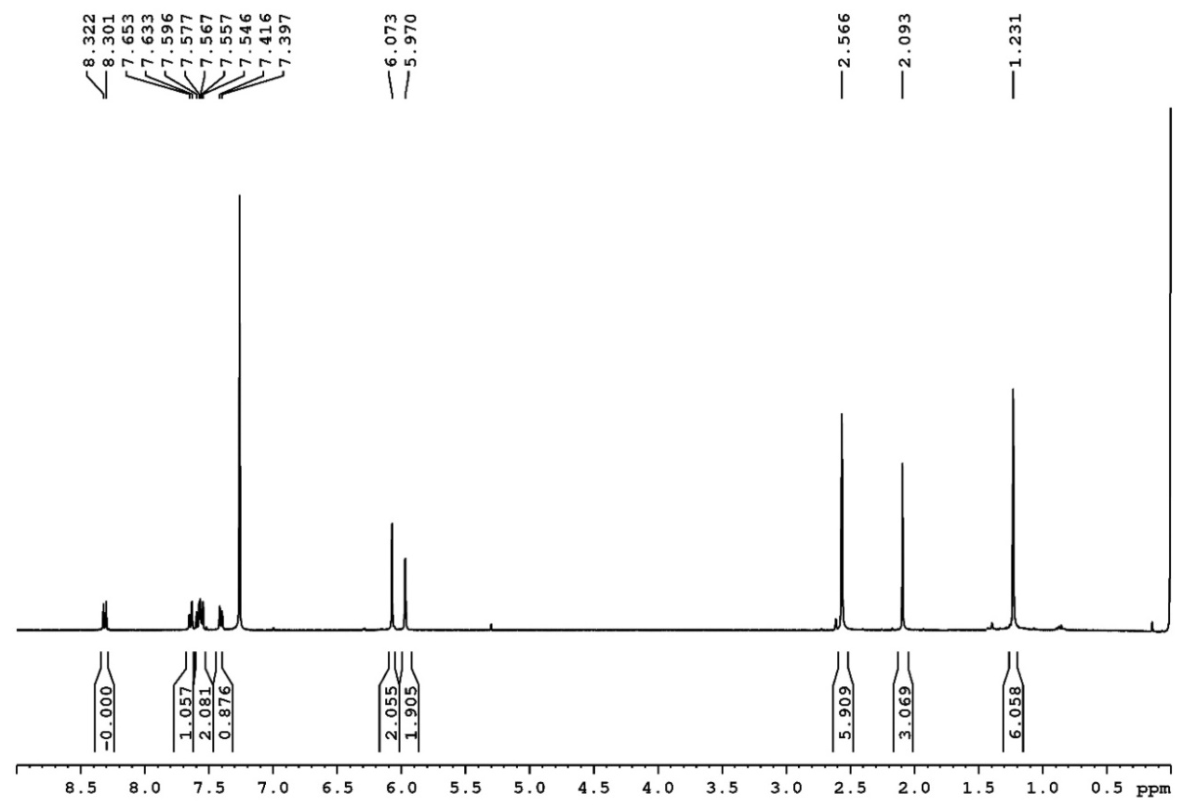

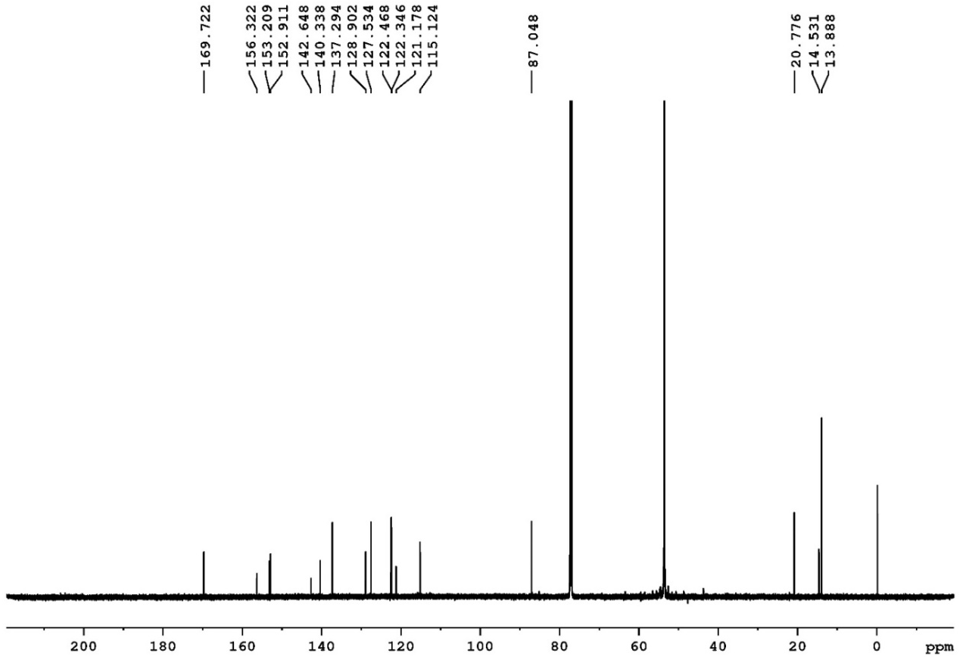

Figure S11. ¹H (400 MHz) and ¹³C (100 MHz) NMR spectra of 14 in CDCl₃.
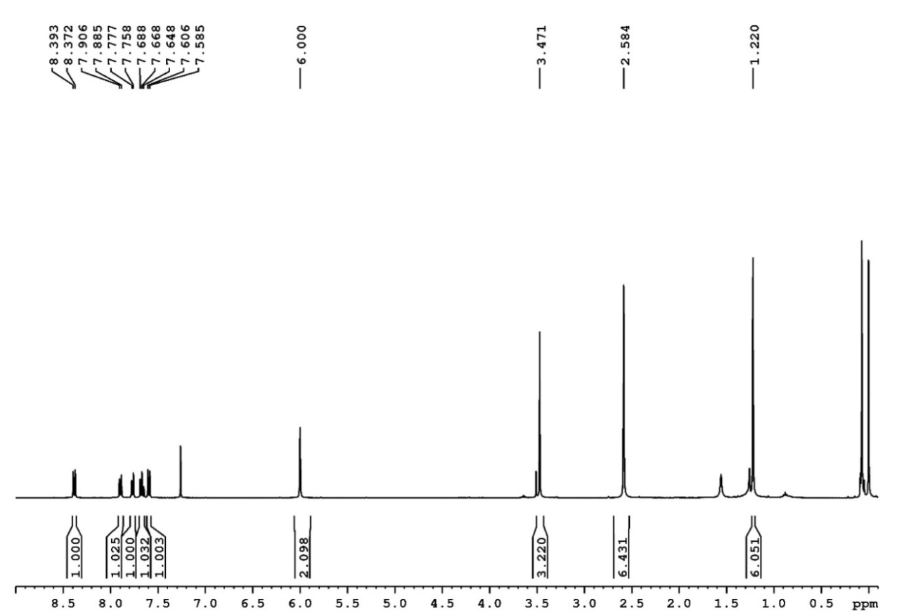

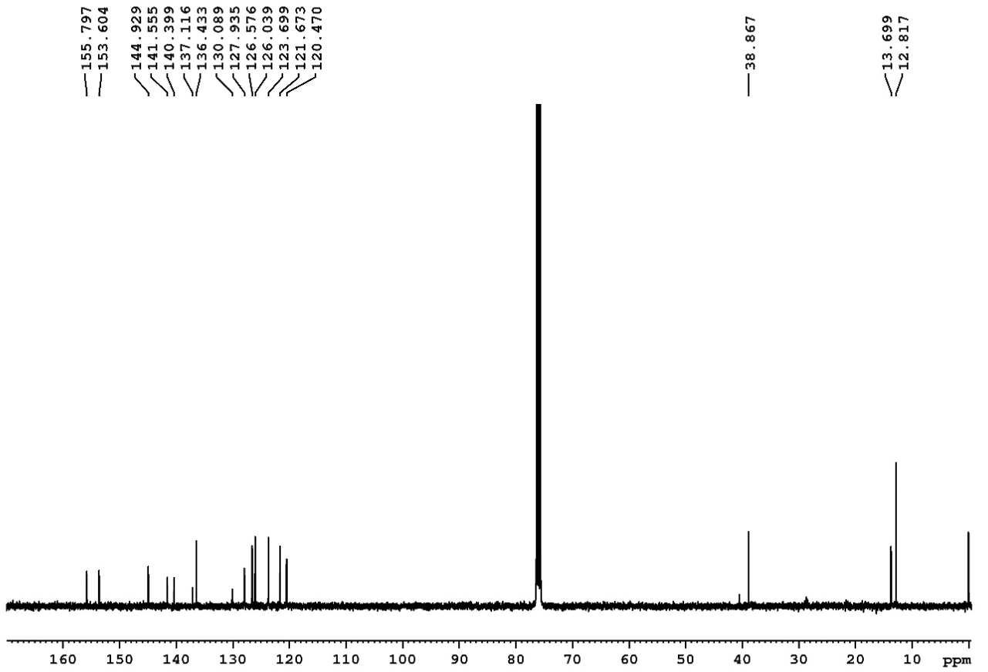

Figure S12. ¹H (400 MHz) and ¹³C (100 MHz) NMR spectra of 15 in CDCl₃.

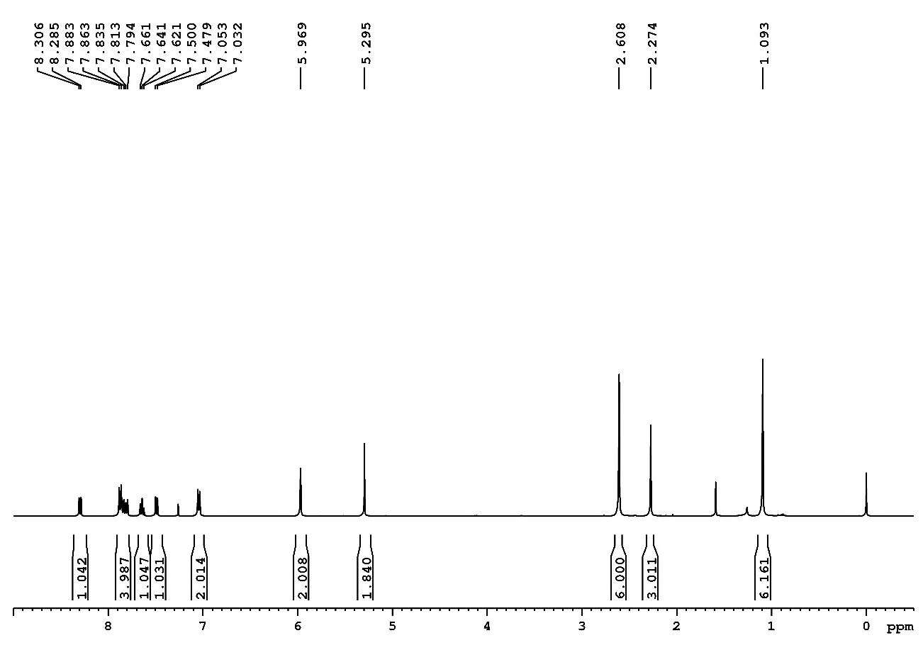

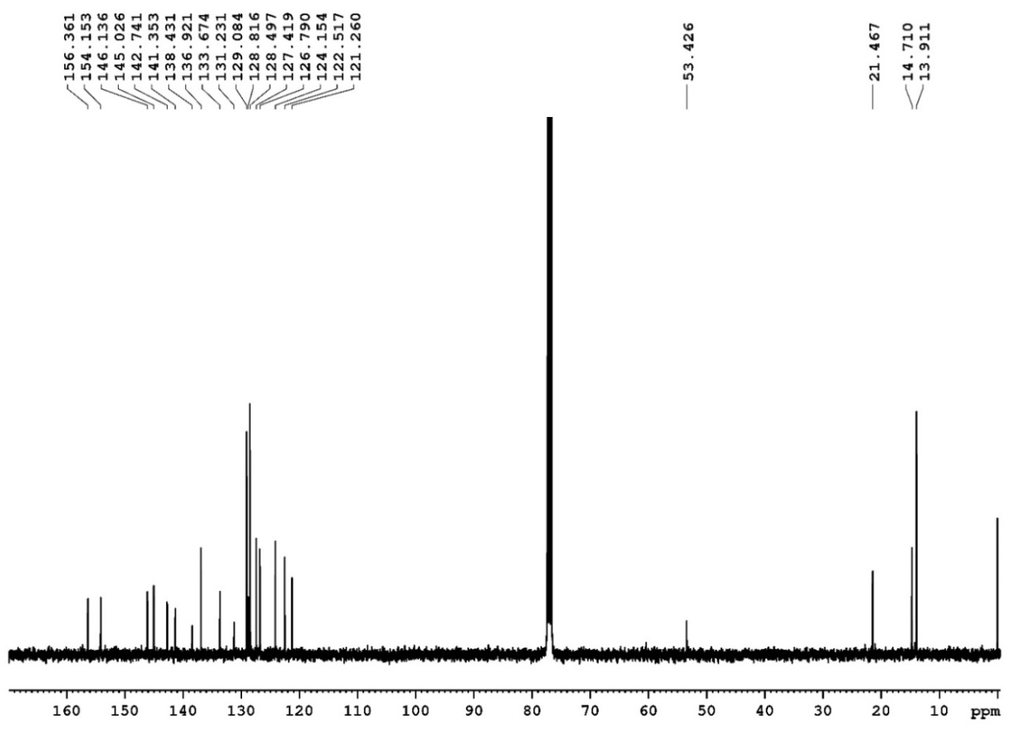

Figure S13. ¹H (400 MHz) and ¹³C (100 MHz) NMR spectra of 16 in CDCl₃.
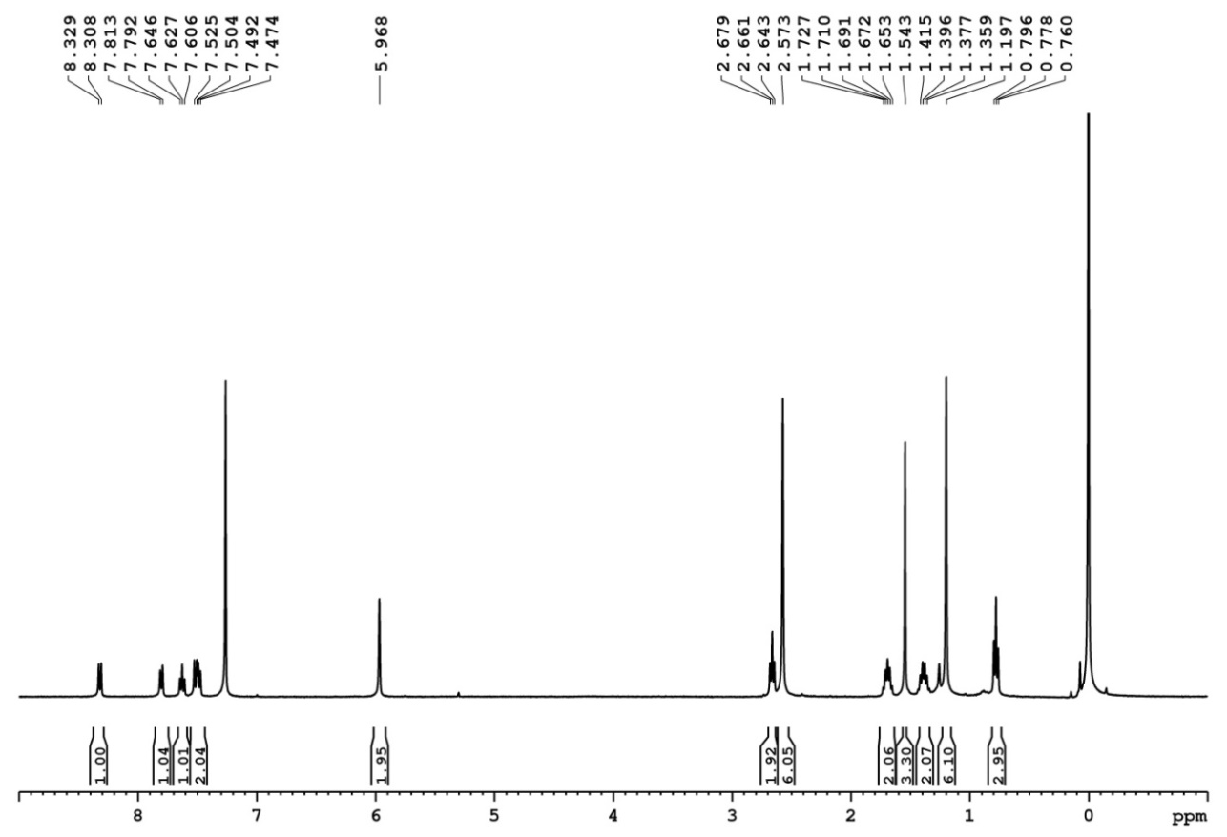

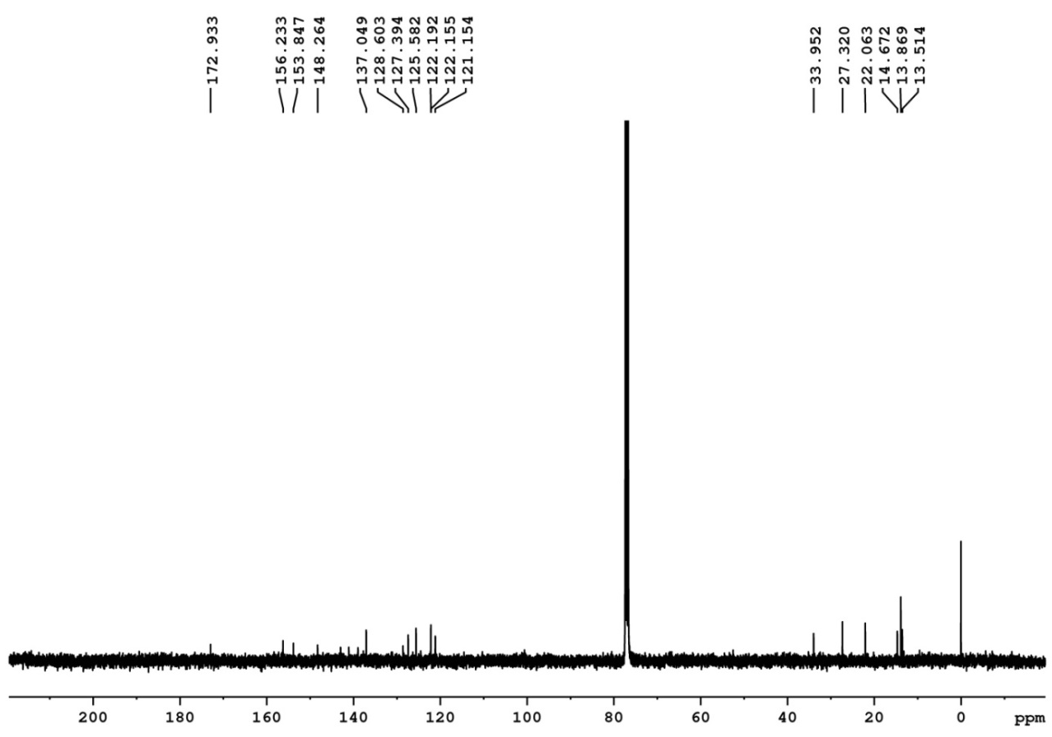

Figure S14. ¹H (400 MHz) and ¹³C (100 MHz) NMR spectra of 17 in CDCl₃.
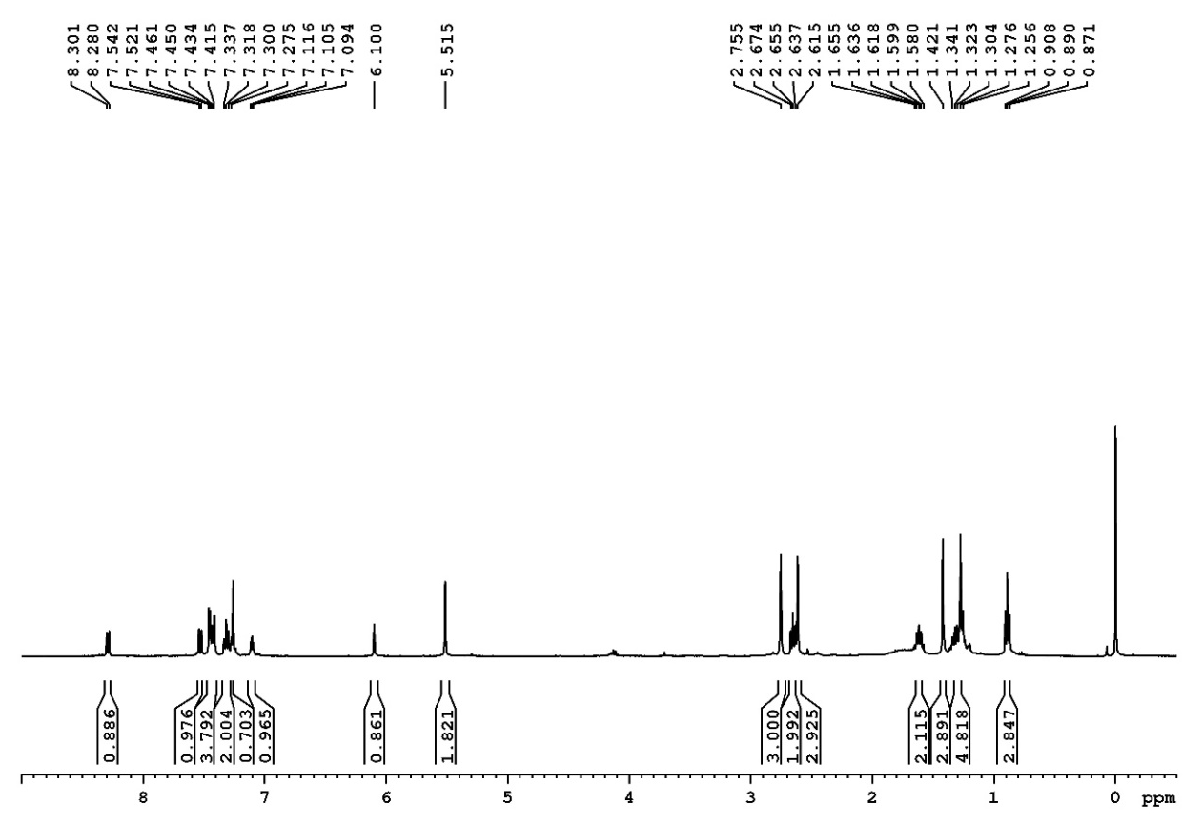

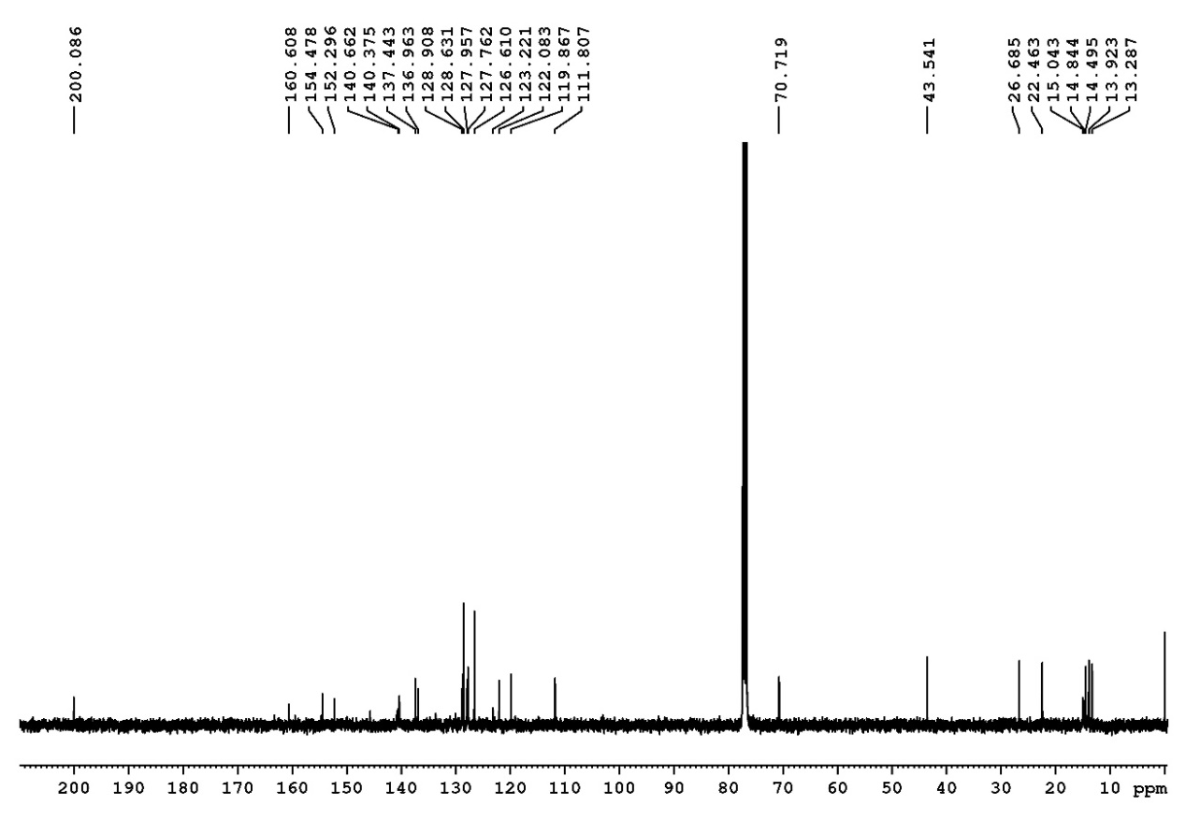

Figure S15. ¹H (400 MHz) and ¹³C (100 MHz) NMR spectra of 18 in CDCl₃.

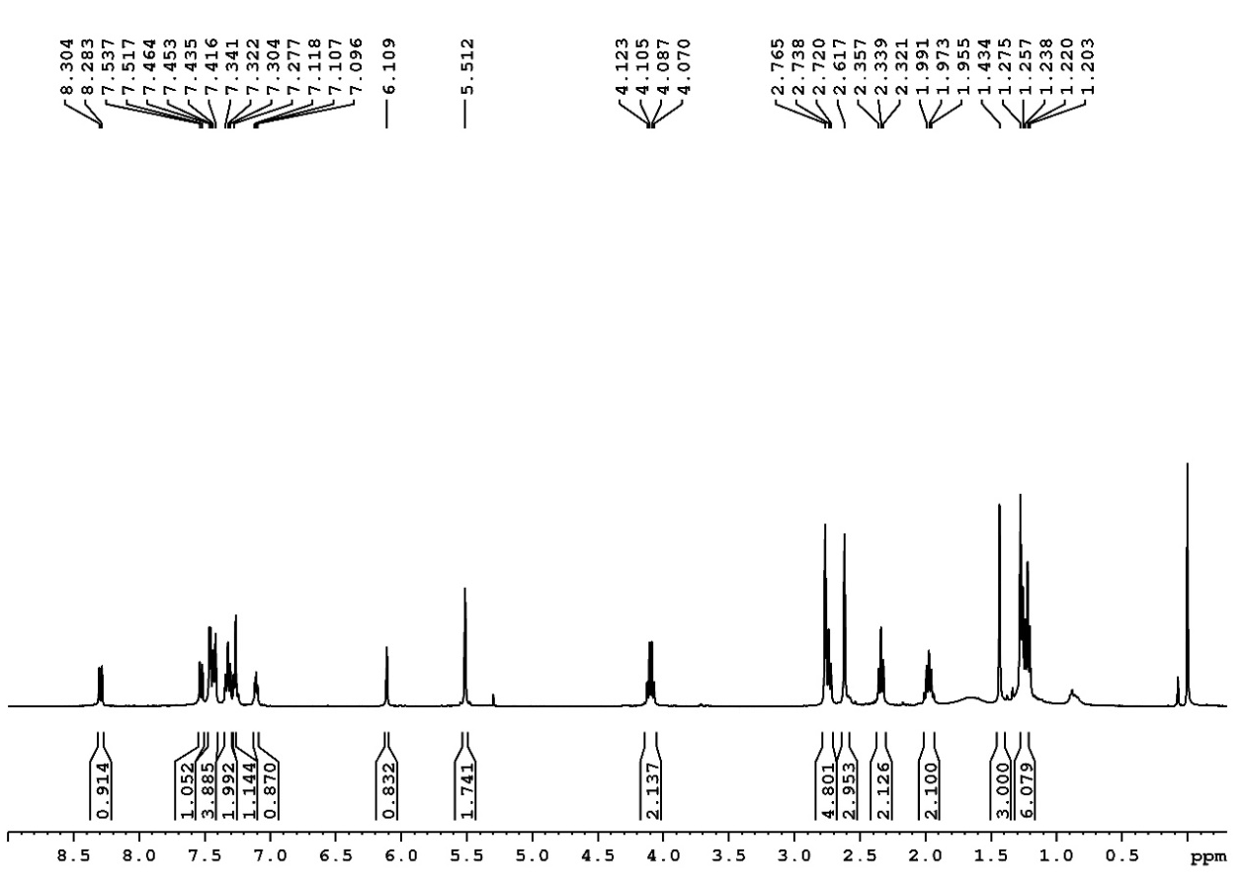

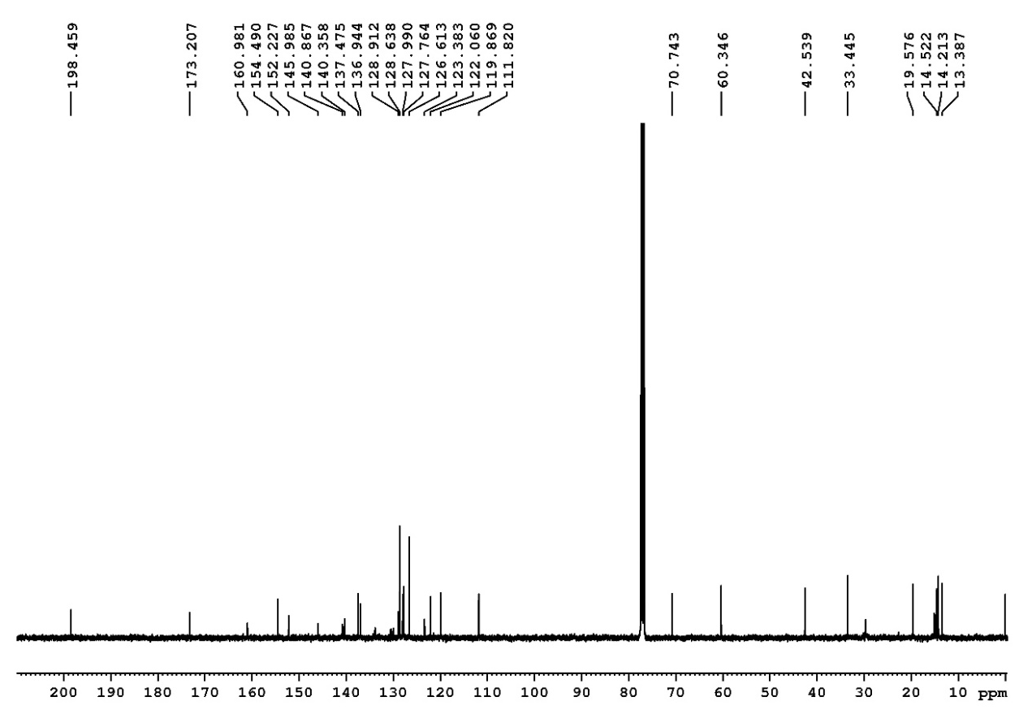

Figure S16. ¹H (400 MHz) and ¹³C (100 MHz) NMR spectra of 19 in CDCl₃.

High-content colocalization images

Figure S17. Fluorescence images of co-localization of compound 3 with organelles markers.

Figure S18. Fluorescence images of co-localization of compound 10 with organelles markers.

Figure S19. Fluorescence images of co-localization of compound 11 with organelles markers.

Figure S20. Fluorescence images of co-localization of compound 13 with organelles markers.

Figure S21. Fluorescence images of co-localization of compound 14 with organelles markers.

Figure S22. Fluorescence images of co-localization of compound 15 with organelles markers.

Figure S23. Fluorescence images of co-localization of compound 16 with organelles markers.

Figure S24. Fluorescence images of co-localization of compound 3 with organelles markers.

Figure S25. Fluorescence images of co-localization of compound 18 with organelles markers.

Figure S26. Fluorescence images of co-localization of compound 19 with organelles markers.

Confocal fluorescence imaging

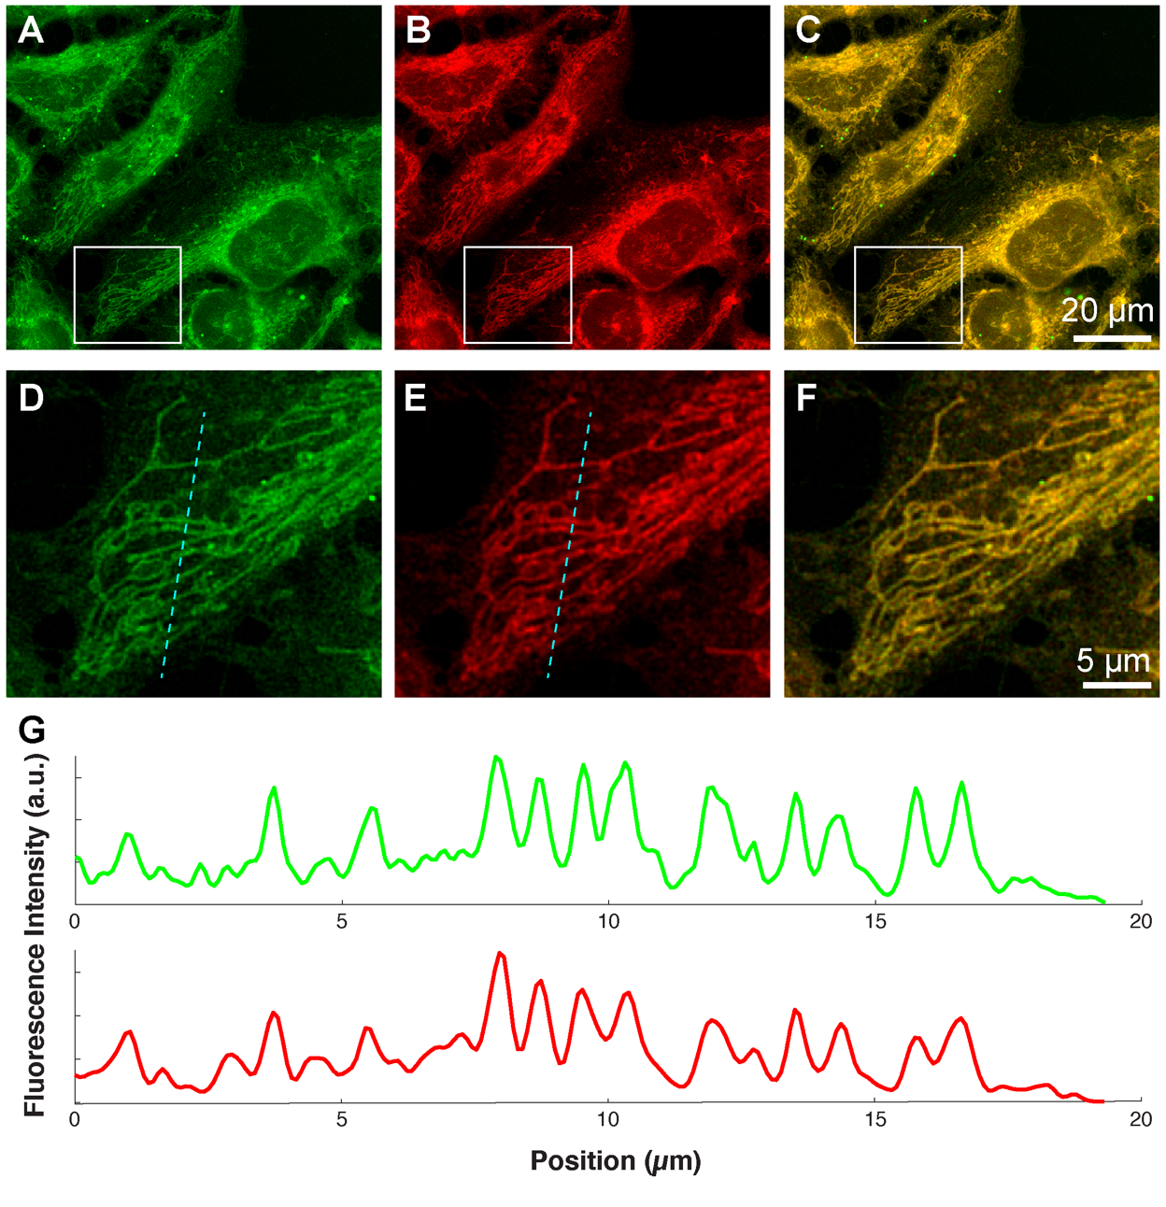
Figure S27. Confocal fluorescence images of HeLa cells. A) Fluorescence image of compound 17 (10 μM, λ_{ex} = 405 nm, collected at 420 - 480). B) Fluorescence image of ER – Tracker red 2 (500 nm, λ_{ex} = 559 nm, collected at 590 – 640 nm). C) Merged image. D-F) Zoom in of intracellular structures marked with white square, displaying the fluorescence signal of compound 17 (D) , ER-tracker (E) and both (F). G) Cross‐section of the image in panels D and E along the cyan dashed line.

Pearson colocalization
Table S1. Co-localization parameters using Mito - Tracker
Compound | Pearson colocalization
3 | 0.56 ± 0.04
10 | 0.42 ± 0.03
11 | 0.27 ± 0.06
13 | 0.54 ± 0.06
14 | 0.39 ± 0.03
15 | 0.48 ± 0.01
16 | 0.31 ± 0.07
17 | 0.52 ± 5E-05
18 | 0.49 ± 0.09
19 | 0.58 ± 0.05

Table S2. Co-localization parameters using ER - Tracker
Compound | Pearson colocalization
3 | 0.89 ± 0.04
10 | 0.82 ± 0.04
11 | 0.81 ± 0.02
13 | 0.72 ± 0.02
14 | 0.78 ± 0.08
15 | 0.82 ± 0.07
16 | 0.88 ± 0.03
17 | 0.85 ± 0.03
18 | 0.83 ± 0.04
19 | 0.91 ± 0.04

Table S3. Co-localization parameters using Lyso - Tracker
Compound | Pearson colocalization
3 | 0.05 ± 0.01
10 | 0.24 ± 0.02
11 | 0.13 ± 0.02
13 | 0.17 ± 0.03
14 | 0.34 ± 0.01
15 | 0.01 ± 3.8 E⁻³
16 | 0.15 ± 0.02
17 | 0.14 ± 0.02
18 | 0.29 ± 0.01
19 | 0.16 ± 0.01

Cytotoxicity assay

Figure S28. Cytotoxicity of 3 at 0, 5, 15, 30, 60, 120, 180, 240 min compared with the cytotoxicity of Triton X-100.
Figure S29. Cytotoxicity of 10 at 0, 5, 15, 30, 60, 120, 180, 240 min compared with the cytotoxicity of Triton X-100.
Figure S30. Cytotoxicity of 11 at 0, 5, 15, 30, 60, 120, 180, 240 min compared with the cytotoxicity of Triton X-100.

Figure S31. Cytotoxicity of 12 at 0, 5, 15, 30, 60, 120, 180, 240 min compared with the cytotoxicity of Triton X-100.

Figure S32. Cytotoxicity of 13 at 0, 5, 15, 30, 60, 120, 180, 240 min compared with the cytotoxicity of Triton X-100.

Figure S33. Cytotoxicity of 14 at 0, 5, 15, 30, 60, 120, 180, 240 min compared with the cytotoxicity of Triton X-100.

Figure S34. Cytotoxicity of 15 at 0, 5, 15, 30, 60, 120, 180, 240 min compared with the cytotoxicity of Triton X-100.

Figure S35. Cytotoxicity of 16 at 0, 5, 15, 30, 60, 120, 180, 240 min compared with the cytotoxicity of Triton X-100.

Figure S36. Cytotoxicity of 17 at 0, 5, 15, 30, 60, 120, 180, 240 min compared with the cytotoxicity of Triton X-100.

Figure S37. Cytotoxicity of 18 at 0, 5, 15, 30, 60, 120, 180, 240 min compared with the cytotoxicity of Triton X-100.

Figure S38. Cytotoxicity of 19 at 0, 5, 15, 30, 60, 120, 180, 240 min compared with the cytotoxicity of Triton X-100.

Absorption and Emission measurements

Figure S39. Normalized absorption and emission spectra of 3 and 10 in solution of toluene
(---, 10⁻⁶ M), acetonitrile (---, 10⁻⁶ M), methanol (---, 10⁻⁶ M) and MilliQ water containing 0.5% Triton X-100 (---, 5×10⁻⁶ M). For the fluorescence spectra, excitation occurred at 480 nm.

Figure S40. Normalized absorption and emission spectra of 11 and 12 in solution of toluene
(---, 10⁻⁶ M), acetonitrile (---, 10⁻⁶ M), methanol (---, 10⁻⁶ M) and MilliQ water containing 0.5% Triton X-100 (---, 5×10⁻⁶ M). For the fluorescence spectra, excitation occurred at 480 nm.

Figure S41. Normalized absorption and emission spectra of 13 and 14 in solution of toluene
(---, 10⁻⁶ M), acetonitrile (---, 10⁻⁶ M), methanol (---, 10⁻⁶ M) and MilliQ water containing 0.5% Triton X-100 (---, 5×10⁻⁶ M). For the fluorescence spectra, excitation occurred at 480 nm.

Figure S42. Normalized absorption and emission spectra of 15 and 16 in solution of toluene (---, 10⁻⁶ M), acetonitrile (---, 10⁻⁶ M), methanol (---, 10⁻⁶ M) and MilliQ water containing 0.5% Triton X-100 (---, 5×10⁻⁶ M). For the fluorescence spectra, excitation occurred at 480 nm.

Figure S43. Normalized absorption and emission spectra of 17 and 18 in solution of toluene (---, 10⁻⁶ M), acetonitrile (---, 10⁻⁶ M), methanol (---, 10⁻⁶ M) and MilliQ water containing 0.5% Triton X-100 (---, 5×10⁻⁶ M). For the fluorescence spectra, excitation occurred at 480 nm.

Figure S44. Normalized absorption and emission spectra of 19 in solution of toluene (---, 10⁻⁶ M), acetonitrile (---, 10⁻⁶ M), methanol (---, 10⁻⁶ M) and MilliQ water containing 0.5% Triton X-100 (---, 5×10⁻⁶ M). For the fluorescence spectra, excitation occurred at 480 nm.
Table S4. Spectroscopic Data and quantum yields
Solvent | Compound | $λ_{abs }$/nm | $λ_{em}$ /nm | (${\overline{ν}}_{abs}-{\overline{ν}}_{em}$) cm⁻¹ | FWHM_{em}/cm⁻¹ | $φ$ (%)
Toluene | 3 | 509 | 527 | 670 ± 50 | 1480 ± 50 | 5 ± 1
 | 10 | 508 | 526 | 670 ± 50 | 1620 ± 50 | 1 ± 0.5
 | 11 | 508 | 523 | 570 ± 50 | 1360 ± 50 | 3 ± 0.5
 | 12 | 508 | 524 | 600 ± 50 | 1420 ± 50 | 2 ± 0.5
 | 13 | 504 | 518 | 540 ± 50 | 990 ± 50 | 53 ± 5
 | 14 | 508 | 525 | 640 ± 50 | 1620 ± 50 | 3 ± 0.5
 | 15 | 508 | 524 | 600 ± 50 | 1620 ± 50 | 6 ± 1
 | 16 | 508 | 528 | 750 ± 50 | 1870 ± 50 | 12 ± 1
 | 17 | 507 | 523 | 600 ± 50 | 1390 ± 50 | 11 ± 1
 | 18 | 510 | 530 | 740 ± 50 | 1600 ± 50 | 2 ± 0.5
 | 19 | 509 | 528 | 710 ± 50 | 1540 ± 50 | 3 ± 0.5
Acetonitrile | 3 | 502 | 518 | 620 ± 50 | 1350 ± 50 | 8 ± 1
 | 10 | 501 | 518 | 660 ± 50 | 1350 ± 50 | 3 ± 0.5
 | 11 | 501 | 515 | 540 ± 50 | 1190 ± 50 | 1 ± 0.5
 | 12 | 501 | 516 | 580 ± 50 | 1290 ± 50 | 3 ± 0.5
 | 13 | 498 | 512 | 550 ± 50 | 940 ± 50 | 40 ± 4
 | 14 | 502 | 517 | 580 ± 50 | 1320 ± 50 | 4 ± 0.5
 | 15 | 502 | 517 | 580 ± 50 | 1450 ± 50 | 7 ± 1
 | 16 | 503 | 520 | 650 ± 50 | 1840 ± 50 | 8 ± 1
 | 17 | 502 | 516 | 540 ± 50 | 1280 ± 50 | 9 ± 1
 | 18 | 503 | 523 | 760 ± 50 | 1960 ± 50 | 4 ± 0.5
 | 19 | 502 | 519 | 650 ± 50 | 1450 ± 50 | 5 ± 1
Methanol | 3 | 503 | 518 | 580 ± 50 | 1350 ± 50 | 9 ± 1
 | 10 | 504 | 521 | 650 ± 50 | 1510 ± 50 | 9 ± 1
 | 11 | 502 | 523 | 800 ± 50 | 1160 ± 50 | 1 ± 0.5
 | 12 | 504 | 519 | 570 ± 50 | 1310 ± 50 | 10 ± 1
 | 13 | 498 | 513 | 590 ± 50 | 1010 ± 50 | 34 ± 3
 | 14 | 503 | 519 | 610 ± 50 | 1480 ± 50 | 10 ± 1
 | 15 | 503 | 518 | 580 ± 50 | 1480 ± 50 | 8 ± 1
 | 16 | 504 | 524 | 760 ± 50 | 1890 ± 50 | 2 ± 0.5
 | 17 | 503 | 518 | 580 ± 50 | 1390 ± 50 | 13 ± 1
 | 18 | 503 | 524 | 800 ± 50 | 1560 ± 50 | 12 ± 1
 | 19 | 503 | 520 | 650 ± 50 | 1500 ± 50 | 12 ± 1
MilliQ + 0.5% Triton X-100 | 3 | 507 | 525 | 680 ± 50 | 1280 ± 50 | 33 ± 3
 | 10 | 507 | 525 | 680 ± 50 | 1420 ± 50 | 41 ± 4
 | 11 | 506 | 524 | 680 ± 50 | 1280 ± 50 | 7 ± 1
 | 12 | 509 | 521 | 450 ± 50 | 1370 ± 50 | 23 ± 2
 | 13 | 503 | 515 | 460 ± 50 | 930 ± 50 | 79 ± 8
 | 14 | 507 | 526 | 710 ± 50 | 1410 ± 50 | 40 ± 4
 | 15 | 507 | 523 | 600 ± 50 | 1420 ± 50 | 51 ± 5
 | 16 | 507 | 526 | 710 ± 50 | 1830 ± 50 | 44 ± 4
 | 17 | 506 | 524 | 680 ± 50 | 1320 ± 50 | 55 ± 6
 | 18 | 506 | 528 | 820 ± 50 | 1540 ± 50 | 33 ± 3
 | 19 | 506 | 527 | 790 ± 50 | 1510 ± 50 | 30 ± 3

