Supporting Information
Total synthesis of 2'-O-methyl-β-L-arabinosyluridine and reassignment the nucleoside from Penicillium sp. as 2'-O-methyl-β-L-uridine
Chunyang Shen¹, Haixin Ding¹, Xueping Tao¹, Jiang Bai¹, Ban-Peng Cao*¹, Yi-Yuan Peng² and Qiang Xiao*¹

¹Jiangxi Key Laboratory of Organic Chemistry, Jiangxi Science & Technology Normal University, 605 Fenglin Road, Nanchang, Jiangxi province, PR China 330013 and ²Key Laboratory of Small Functional Organic Molecule, Ministry of Education, Jiangxi's Key Laboratory of Green Chemistry and College of Chemistry & Chemical Engineering, Jiangxi Normal University Nanchang, Jiangxi 330022

S1. Synthesis and characterization of intermediate products.
S2. NMR spectra.
S3. Table S1 Crystal data and structure refinement for 6.
S4. Table S2. Optimization of reaction conditions
S5. Table S2 Crystal data and structure refinement for 12.
S6. References
S1. Synthesis and characterization of intermediate products.
S1.1. Synthesis of 1,3,5-tri-O-benzoyl-α-L-ribofuranose (4)
1,3,5-Tri-O-benzoyl-α-L-ribofuranose was synthesized according to the procedure reported (Jung et al., 1999; Ma et al., 1996).
Yield: 52%, R_{f} =0.3 (PE:EA=3:1), m.p. 130-131 °C, [α]= -72.0 (c = 0.050, CH₃OH).
¹H NMR (400 MHz, CDCl₃) δ: 8.12-8.09 (m, 4H), 8.04 (d, J = 7.6 Hz, 2H), 7.66-7.57 (m, 3H), 7.46 (t, J = 7.7 Hz, 4H), 7.39 (t, J = 7.7 Hz, 2H), 6.68 (d, J = 4.4 Hz, 1H), 5.59 (d, J = 6.5 Hz, 1H), 4.76-4.71 (m, 2H), 4.65-4.63 (m, 2H), 2.83 (d, J = 10.5 Hz, 1H) .
¹³C NMR (101 MHz, CDCl₃) δ: 166.2, 166.0, 165.5, 133.9, 133.7, 133.5, 130.0 (Cx4), 129.8, 129.7, 129.6, 129.3, 128.7 (Cx4), 128.6 (Cx2), 96.0, 83.2, 72.3, 72.0, 64.2.
HRMS (ESI): M/Z calculated for C₂₆H₂₂O₈, [M+H]⁺: 463.1393, found: 463.1378.
S1.2. Synthesis of 2-O-trifluoromethylsulfonyl-1,3,5-tri-O-benzoyl-α-L-ribofuranose (5)
A mixture of 1,3,5-tri-O-benzoyl-α-L-ribofuranose 4 (4.62 g, 10 mmol, 1 eq.) and anhydrous pyridine (11.7 mL, 14.6 mmol, 14.6 eq.) in anhydrous DCM (150 mL) was stirred under ice bath for 10 min. Trifluoromethanesulfonic anhydride (12 mmol, 2 mL) was then added dropwise with vigorous stirring. The obtained reaction mixture was stirred for another 1 hr at 0 °C and then stirred at room temperature for 3 hrs. Then, the reaction was quenched by the addition of 200 mL of ice water. The aqueous solution was extracted with DCM (3×200 mL) and the combined extract was washed with a saturated solution of sodium carbonate (3×200 mL) and brine (3×200 mL), respectively. The organic phase was dried with anhydrous MgSO_{4.} After filtered and evaporated under reduced pressure, the obtained syrup was purified by column chromatography on silica gel to give 5 as a white solid (5.34 g, 90%).
Yield: 90%, R_{f} = 0.4 (PE:EA = 5:1), m.p. 53-54 °C, [α]= -60.0 (c = 0.050, CH₃OH).
¹H NMR (400 MHz, CDCl₃) δ: 8.14 (t, J = 8.9 Hz, 4H), 8.04 (d, J = 7.9 Hz, 2H), 7.67-7.57 (m, 3H), 7.52-7.36 (m, 6H), 6.92 (d, J = 4.3 Hz, 1H), 5.84 (dd, J = 6.2, 3.3 Hz, 1H), 5.65-5.57 (m, 1H), 4.94-4.85 (m, 1H), 4.77 (dd, J = 12.3, 2.8 Hz, 1H), 4.65 (dd, J = 12.3, 3.3 Hz, 1H).
¹³C NMR (101 MHz, CDCl₃) δ: 165.9, 165.6, 164.8, 134.1, 134.0, 133.6, 130.2 (Cx2), 130.1 (Cx2), 129.6 (Cx2), 129.3, 128.9, 128.7 (Cx4), 128.6 (Cx3), 118.5 (q, J = 319.8 Hz), 93.3, 82.1, 79.6, 70.1, 63.6.
HRMS (ESI): M/Z calculated for C₂₇H₂₁F₃O₁₀S, [M+H]⁺: 595.0886, found: 595.0876.
S1.3. Synthesis of 1,3,5-tri-O-benzoyl-α-L-arabinofuranose (6)
The triflate 5 (5.34 g, 9 mmol, 1 eq.) was dissolved in DMF (90 mL) and KNO₂ (3.83 g, 45 mmol) was added. The reaction mixture was stirred at 40 °C for 24 h. Water (100 mL) was added and the resulting mixture was extracted with DCM (3×100 mL). The organic layer was combined, dried (Na₂SO₄) and concentrated under reduced pressure. The crude product was purified by column chromatography on silica gel to give a white solid 6 (2.16 g, 52%).
Yield: 52%, R_{f} =0.3 (PE:EA=3:1), m.p. 81-82 °C, [α]= -64.8 (c = 0.054, CH₃OH).
¹H NMR (400 MHz, CDCl₃) δ: 8.09-8.03 (m, 6H), 7.62-7.51 (m, 3H), 7.43-7.35 (m, 6H), 6.56 (s, 1H), 5.35 (d, J = 3.4 Hz, 1H), 4.83 (dd, J = 9.1, 4.1 Hz, 1H), 4.76(dd, J = 11.9, 4.0 Hz, 1H),4.72-4.62 (m, 2H), 3.65 (s, 1H).
¹³C NMR (101 MHz, CDCl₃) δ: 166.5 (Cx2), 165.4, 133.8, 133.6, 133.3, 130.0 (Cx4), 129.9 (Cx2), 129.7, 129.6, 129.0, 128.6 (Cx2), 128.5 (Cx4), 102.7, 83.0, 80.5, 79.9, 64.2.
HRMS (ESI): M/Z calculated for C₂₆H₂₂O₈, [M+H]⁺:463.1393, found: 463.1395.
S1.4. Synthesis of 1,3,5-tri-O-benzoyl-2-O-methyl-α-L-arabinofuranose (7)
A mixture of arabinofuranose 6 (1.85 g, 4 mmol, 1 eq.) and HBF₄ (42% aqueous, 4 mmol) in DCM (16 mL) was vigorously stirred at ice bath for 10 min. Trimethylsilyl diazomethane (1.8M hexane solution, 4.48 mL, 8 mmol) was dropwise added during 10 min. The mixture was stirred at 0°C for further 1 h, then poured into water (100 mL), and extracted with DCM (3×100 mL). The organic layer was washed with water (3×100 mL), dried over magnesium sulfate, and concentrated. The residue was purified by column chromatography on silica gel to give a white solid 7 (1.07 g) and arabinofuranose 6 (0.37 g, 70%).
Yield: 70%, R_{f} = 0.5 (PE:EA=4:1), m.p. 123-124 °C, [α]= -70.7 (c = 0.058, CH₃OH).
¹H NMR (400 MHz, CDCl₃) δ: 8.11 (d, J = 7.6 Hz, 2H), 8.07-8.04 (m, 4H), 7.62-7.54 (m, 3H), 7.45-7.37 (m, 6H), 6.62 (s, 1H), 5.45 (d, J = 2.0 Hz, 1H), 4.81-4.80 (m, 1H), 4.70-4.62 (m, 2H), 4.21 (s, 1H), 3.59(s, 3H).
¹³C NMR (101 MHz, CDCl3) δ: 166.4, 165.8, 165.2, 133.8, 133.6, 133.2, 130.0 (Cx4), 129.9 (Cx2), 129.7, 129.3, 128.6 (Cx2), 128.5 (Cx2), 128.4 (Cx2), 100.6, 88.0, 84.0, 77.2, 64.2, 58.2.
HRMS (ESI): M/Z calculated for C₂₇H₂₄O₈, [M+H]⁺: 477.1549, found: 477.1541.
S1.5. Synthesis of 2'-O-methyl- 3',5'-di-O-benzoyl-β-L-arabinosyluridine (8)
To a solution of uracil (0.27 g, 2.4 mmol) in dry MeCN (10 mL) was added BSA (1.95 g, 2.4 mL, 9.6 mmol) and stirred under nitrogen for 1 h at room temperature. After addition of 7 (0.95 g, 2 mmol), TMSOTf (1.78 g, 1.5 mL, 8 mmol) was added to the mixture at ice bath. The mixture was stirred for 15 min before heating to 80 °C for 12 hrs. After cooling, the reaction mixture was poured into water (30 mL) and extracted with EtOAc (3 × 30 mL). The combined extract was washed third with a saturated solution of sodium carbonate (3 × 30 mL) and brine (3 × 30 mL), respectively. The organic phase was dried with anhydrous MgSO_{4,} filtered and evaporated under reduced pressure. The residue was purified by column chromatography on silica gel to give crude products. The crude products were recrystallized from a mixture of EA and PE to give a white solid 8 (0.51 g, 55%). The filtrated stock solution containing isomers of nucleoside 9 was evaporated under reduced pressure and used directly without further purification.
S1.5. 2'-O-methyl- 3',5'-di-O-benzoyl-β-L-arabinosyluridine 8
Yield: 55%, R_{f} = 0.3 (PE:EA=1:1), m.p. 223-224 °C, [α]= -40.0 (c = 0.050, CH₃OH).
¹H NMR (400 MHz, CDCl₃) δ: 9.02 (s, 1H), 8.10-8.05 (m, 4H), 7.64-7.57 (m, 3H), 7.51-7.44 (m, 4H), 6.31 (d, J = 3.7 Hz, 1H), 5.68 (d, J = 8.1 Hz, 1H), 5.48 (s, 1H), 4.84-4.64 (m, 2H), 4.52 (s, 1H), 4.10 (d, J = 3.6 Hz, 1H), 3.41 (s, 3H).
¹³C NMR (101 MHz, CDCl₃) δ: 166.4, 165.7, 163.2, 150.4, 142.0, 134.1, 133.5, 130.0 (Cx2), 129.9 (Cx2), 129.7, 128.8 (Cx3), 128.6 (Cx2), 101.4, 85.8, 82.7, 81.3, 76.5, 63.7, 58.8.
HRMS (ESI): M/Z calculated for C₂₄H₂₂N₂O₈, [M+H]⁺: 467.1454, found: 467.1454.
S1.6. Synthesis of 2',3',5'-tri-O-acetyl-β-L-uridine (10)
2',3',5'-Tri-O-acetyl-β-L-uridine was synthesized as described for 2'-O-methyl-3',5'-di-O-benzoyl-arabinosyluridine to give a white solid 10 (60%).
Yield: 60%, R_{f} = 0.6 (PE:EA = 1:3), m.p. 55-56 °C, [α]= -21.2 (c = 0.052, CH₃OH).
¹H NMR (400 MHz, CDCl₃) δ: 8.86 (s, 1H), 7.39 (d, J = 8.2 Hz, 1H), 6.04 (d, J = 4.7 Hz, 1H), 5.79 (dd, J = 8.1, 2.0 Hz, 1H), 5.46-5.21 (m, 2H), 4.38-4.32 (m, 3H), 2.32- 2.04 (m, 9H).
¹³C NMR (101 MHz, CDCl₃) δ: 170.2, 169.8 (Cx2), 162.5, 150.2, 139.4, 103.6, 87.7, 80.1, 72.9, 70.3, 63.3, 20.9, 20.6, 20.5.
HRMS (ESI): M/Z calculated for C₁₅H₁₈N₂O₉, [M+H]⁺: 371.1091, found: 371.1092.
S1.7. Synthesis of β-L-uridine (11)
The uridine 11 was synthesized as described for 1 starting from 10 to give a white solid.
Yield: 80%, R_{f} = 0.3 (DCM:MeOH = 6:1), m.p. 168-170 °C, [α]= -8.0 (c = 0.050, CH₃OH).
¹H NMR (400 MHz, DMSO) δ: 11.32 (s, 1H), 7.88 (dd, J = 8.1, 2.0 Hz, 1H), 5.77 (dd, J = 5.1, 1.7 Hz, 1H), 5.64 (dd, J = 8.0, 1.9 Hz, 1H), 5.40 (d, J = 3.6 Hz, 1H), 5.11 (d, J = 4.5 Hz, 2H), 4.02 (d, J = 3.5 Hz, 1H), 3.96 (s, 1H), 3.84 (s, 1H), 3.69-3.51 (m, 2H).
¹³C NMR (101 MHz, DMSO) δ: 163.2, 150.8, 140.8, 101.8, 87.8, 84.9, 73.6, 70.0, 60.9.
HRMS (ESI): M/Z calculated for C₉H₁₂N₂O₆, [M+H]⁺: 245.0774, found: 245.0779.
S1.8. Synthesis of 2,2'-anhydro-β-L-arabinosyluridine (12)
To a solution of uridine 11 (0.98 g, 4.0 mmol) in anhydrous DMF (2 mL) was added diphenyl carbonate (0.94 g, 4.4 mmol) and sodium bicarbonate (0.02 g, 0.24 mmol) under nitrogen. The mixture was heated at 100 °C for 4 hrs under nitrogen. Then, the mixture was cooled to room temperature and diethyl ether (40 mL) was added. After stirring a further period of 30 mins, the mixture was filtered and the residue was recrystallized from CH₃OH to afford 12 (0.63 g, 70%) as a white solid.
Yield: 70%, R_{f} = 0.35 (DCM:MeOH:Ammonium = 40:10:1), m.p. 243-244 °C, [α]= -48.0 (c = 0.050, CH₃OH)
¹H NMR (400 MHz, DMSO) δ: 7.84 (d, J = 7.4 Hz, 1H), 6.31 (d, J = 5.6 Hz, 1H), 5.90 (s, 1H), 5.84 (d, J = 7.4 Hz, 1H), 5.20 (d, J = 5.6 Hz, 1H), 4.99 (s, 1H), 4.38 (s, 1H), 4.07 (s, 1H), 3.29-3.17 (m, 2H).
¹³C NMR (101 MHz, DMSO) δ: 171.2, 159.8, 136.9, 108.6, 90.0, 89.2, 88.8, 74.8, 60.9.
HRMS (ESI): M/Z calculated for C₉H₁₀N₂O₅, [M+H]⁺: 227.0668, found: 227.0669.

S2. NMR spectra.
¹H NMR spectrum of 1,3,5-tri-O-benzoyl-α-L-ribofuranose (4)
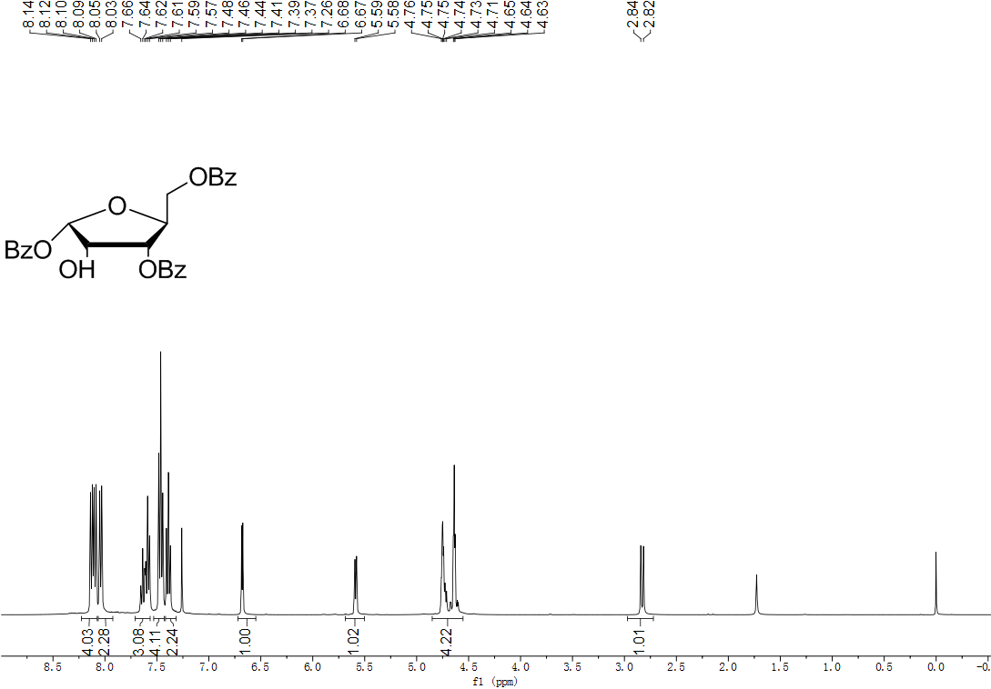
¹³C NMR spectrum of 1,3,5-tri-O-benzoyl-α-L-ribofuranose (4)
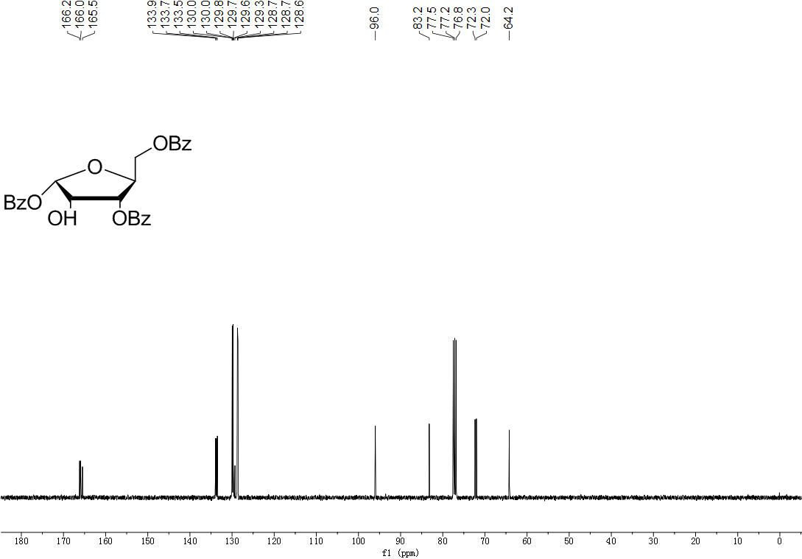

¹H NMR spectrum of 2-O-trifluoromethylsulfonyl-1,3,5-tri-O-benzoyl-α-L-ribofuranose (5) 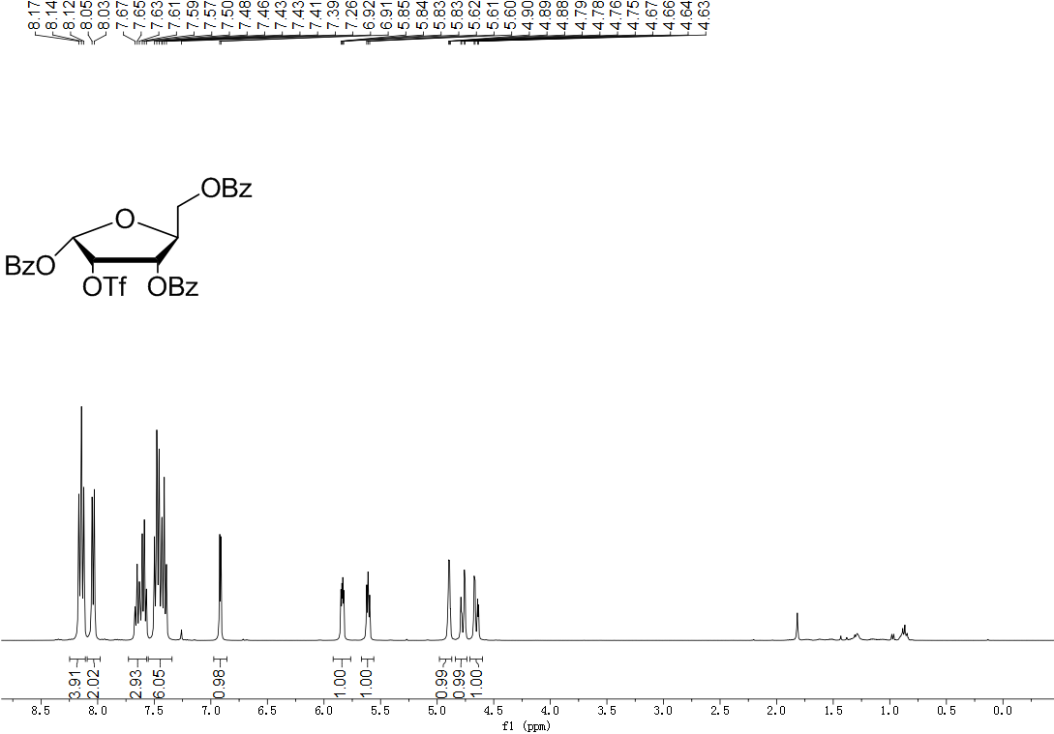
¹³C NMR spectrum of 2-O-trifluoromethylsulfonyl-1,3,5-tri-O-benzoyl-α-L-ribofuranose (5)
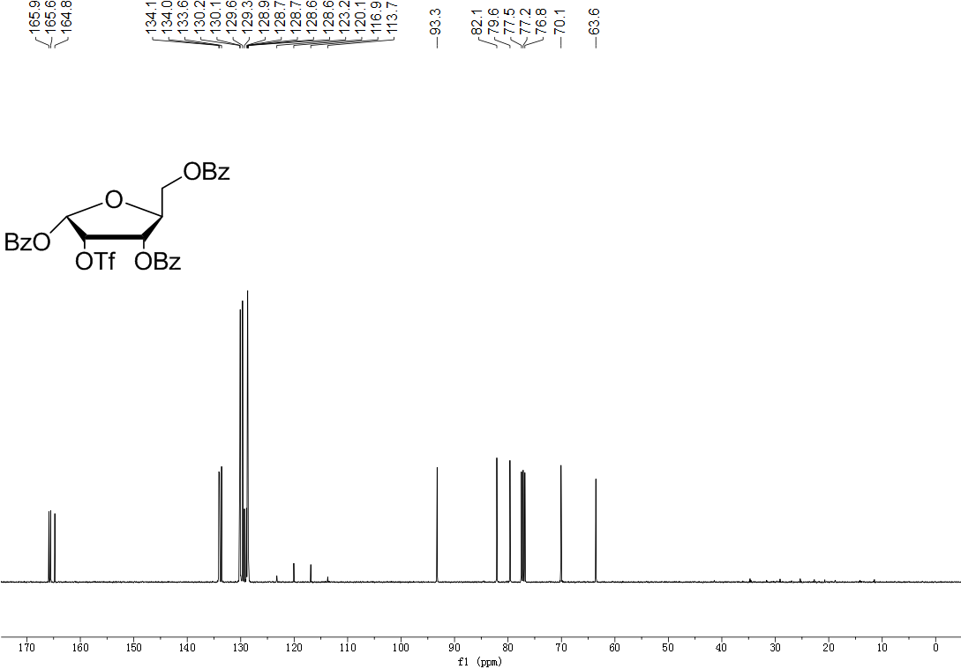
¹H NMR spectrum of 1,3,5-tri-O-benzoyl-α-L-arabinofuranose (6)
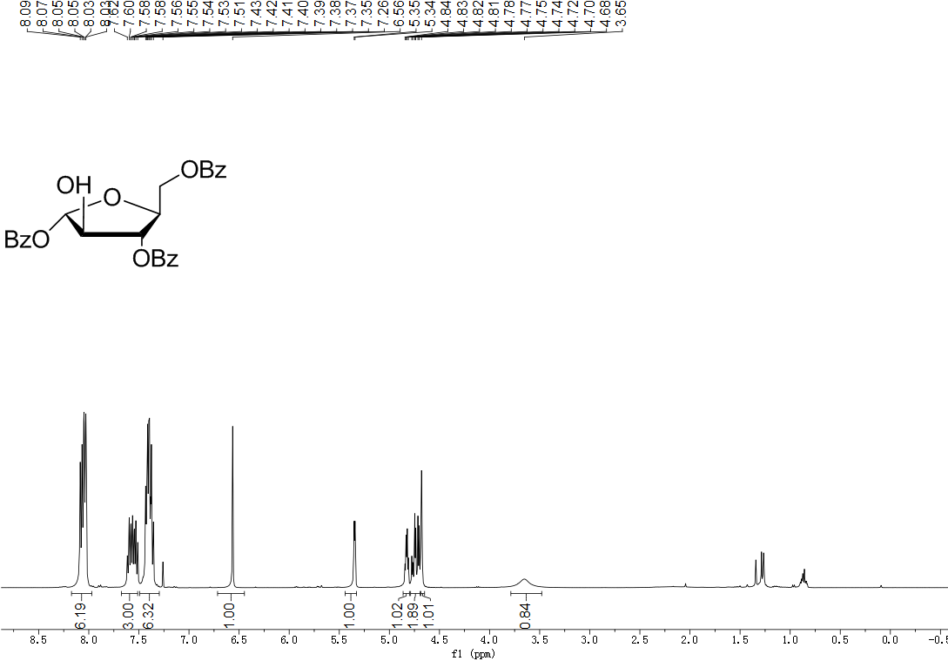

¹³C NMR spectrum of 1,3,5-tri-O-benzoyl-α-L-arabinofuranose (6)
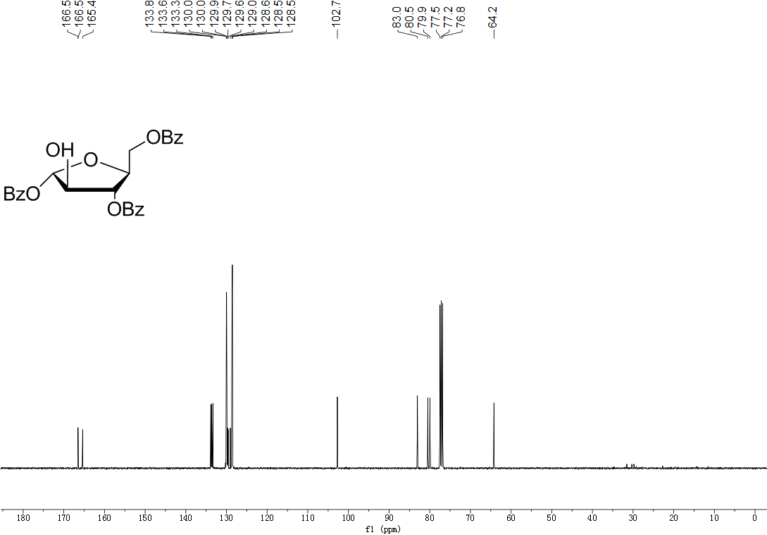

¹H NMR spectrum of 1,3,5-tri-O-benzoyl-2-O-methyl-α-L-arabinofuranose (7)
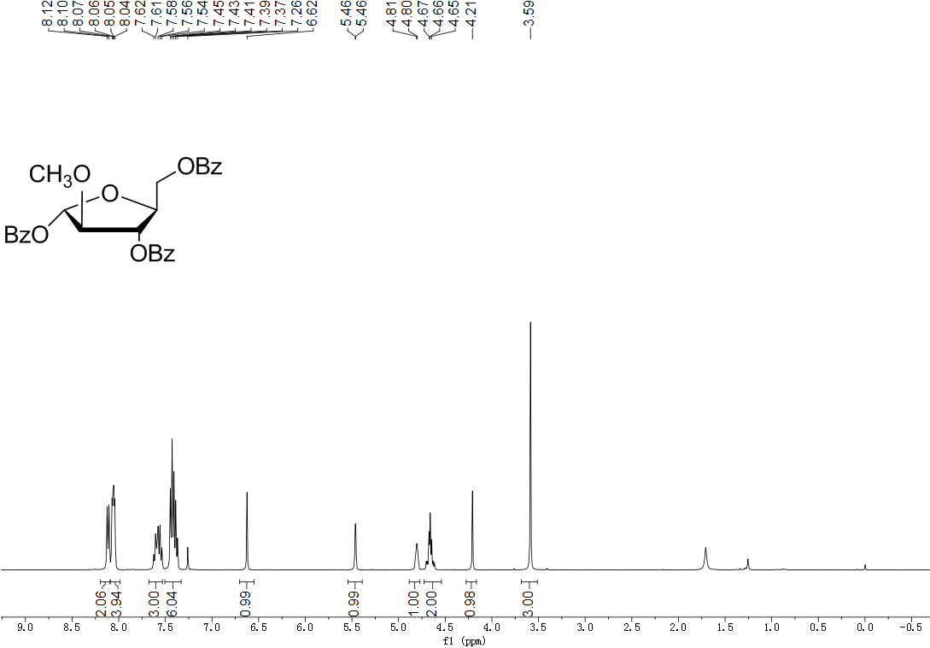
¹³C NMR spectrum of 1,3,5-tri-O-benzoyl-2-O-methyl-α-L-arabinofuranose (7)
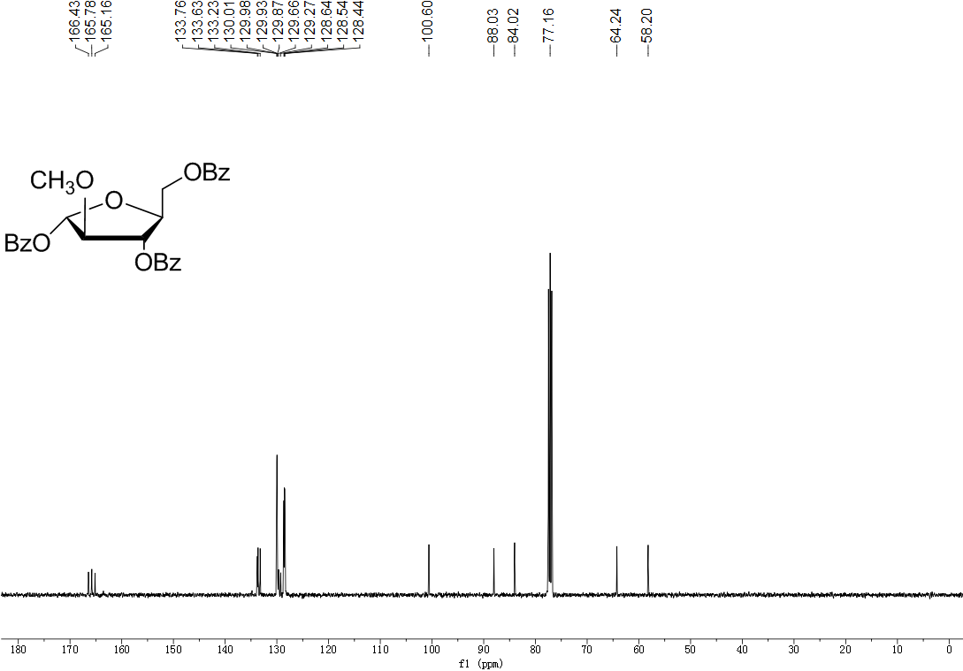

¹H NMR spectrum of 2'-O-methyl- 3',5'-di-O-benzoyl-β-L-arabinosyluridine (8)
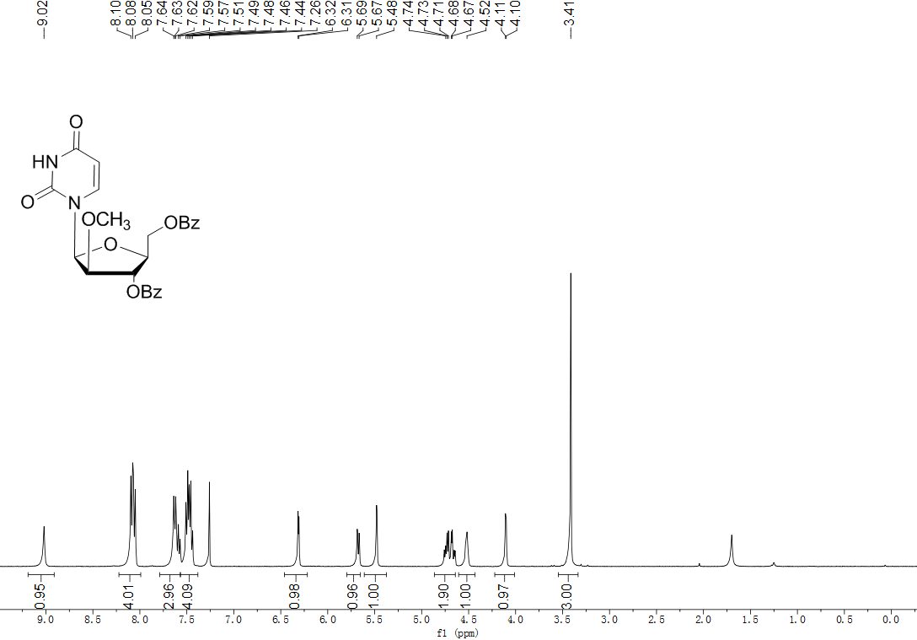

¹³C NMR spectrum of 2'-O-methyl- 3',5'-di-O-benzoyl-β-L-arabinosyluridine (8)
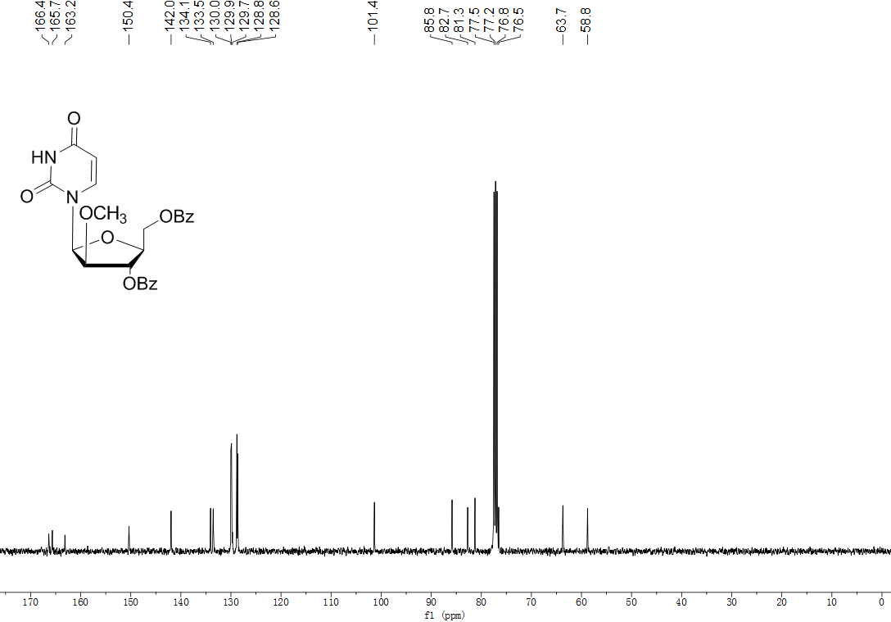

¹H NMR spectrum of 2'-O-methyl-β-L-arabinosyluridine (1)
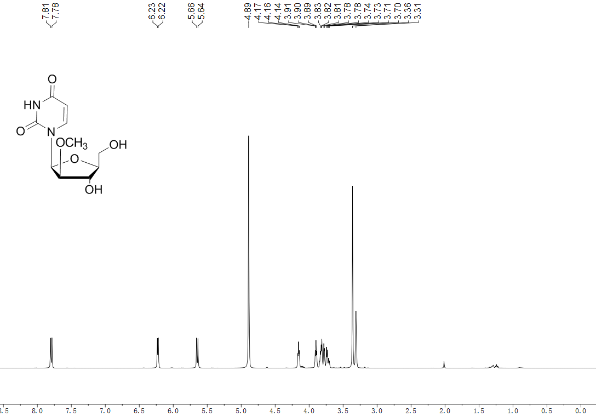

¹³C NMR spectrum of 2'-O-methyl-β-L-arabinosyluridine (1)
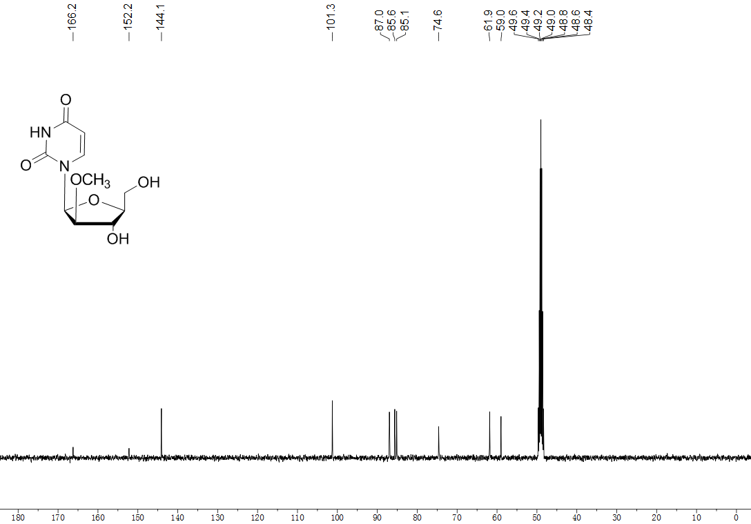

¹H NMR spectrum of 2'-O-methyl-α-L-arabinosyluridine (2)
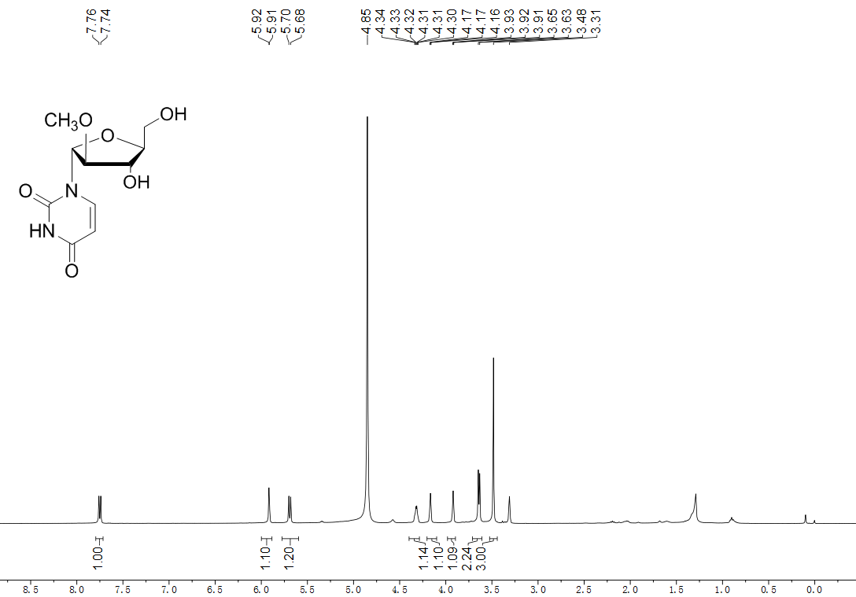

¹³C NMR spectrum of 2'-O-methyl-α-L-arabinosyluridine (2)
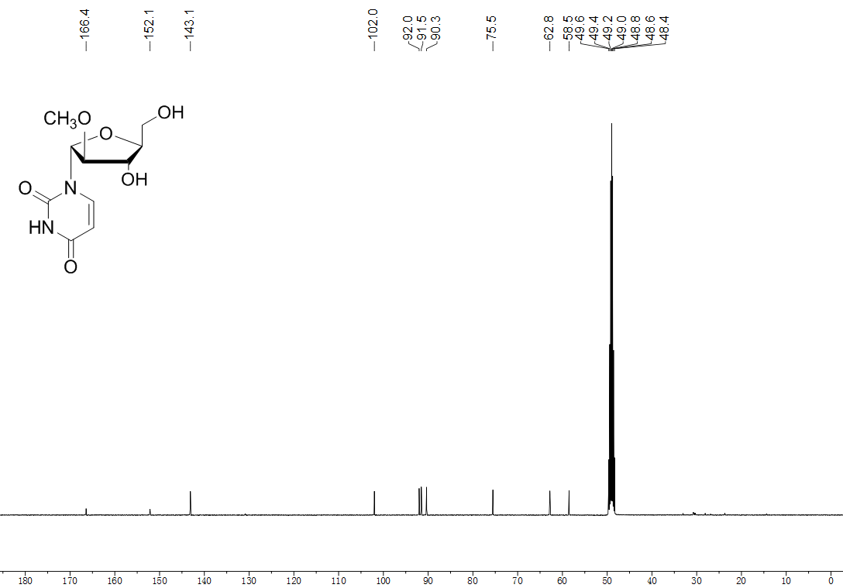

¹H NMR spectrum of 2',3',5'-tri-O-acetyl-β-L-uridine (10)
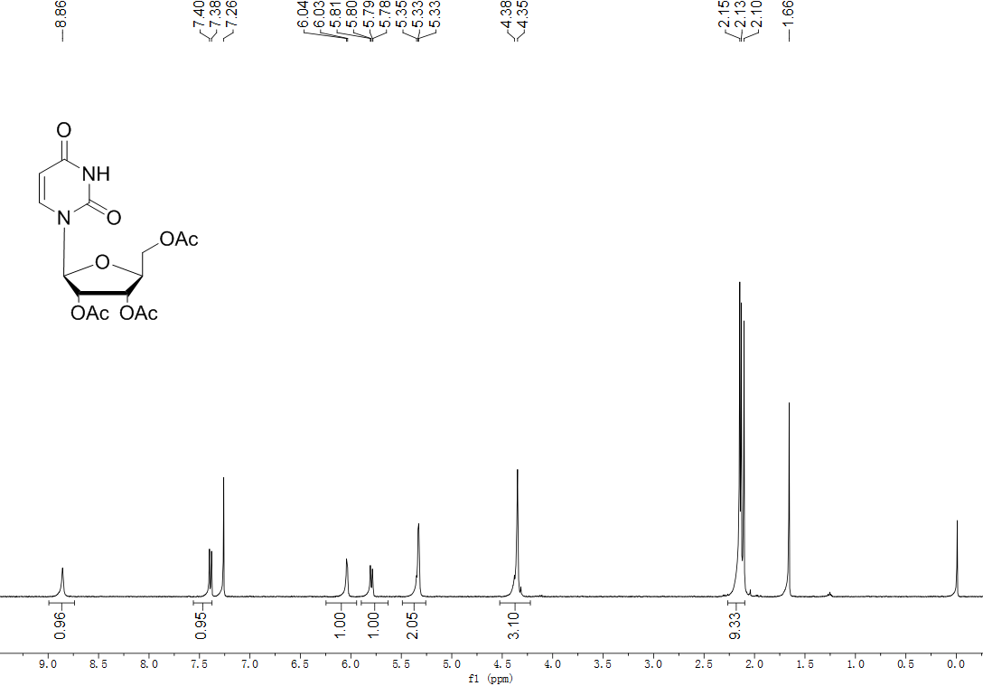

¹³C NMR spectrum of 2',3',5'-tri-O-acetyl-β-L-uridine (10)
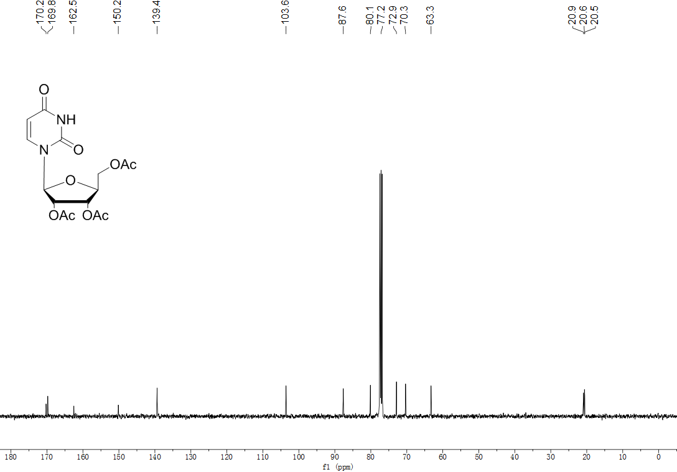

¹H NMR spectrum of β-L-uridine (11)
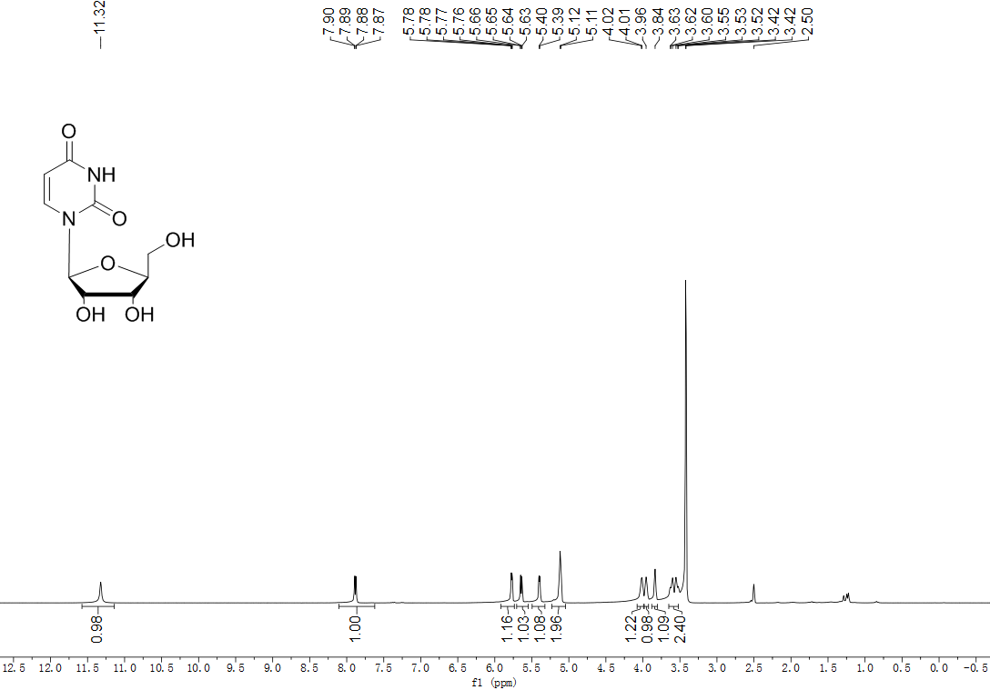
¹³C NMR spectrum of β-L-uridine (11)
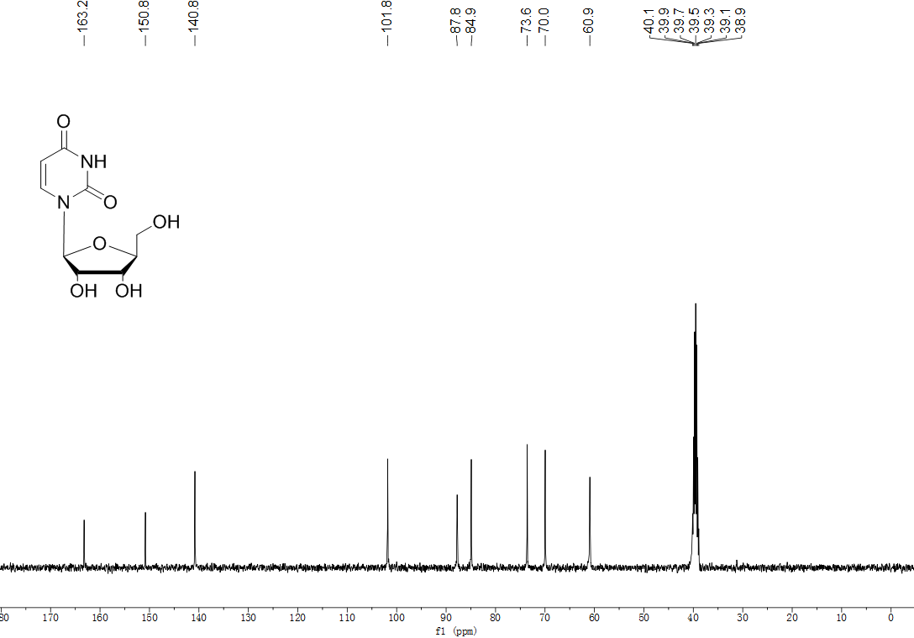

¹H NMR spectrum of 2,2'-anhydro-β-L-arabinosyluridine (12)
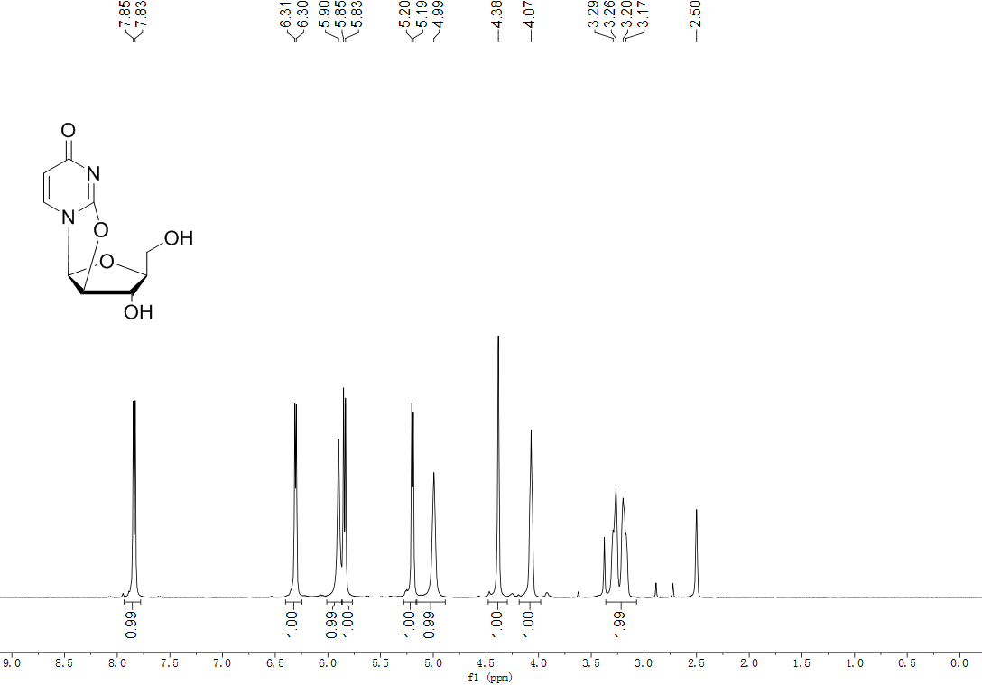
¹³C NMR spectrum of 2,2'-anhydro-β-L-arabinosyluridine (12)
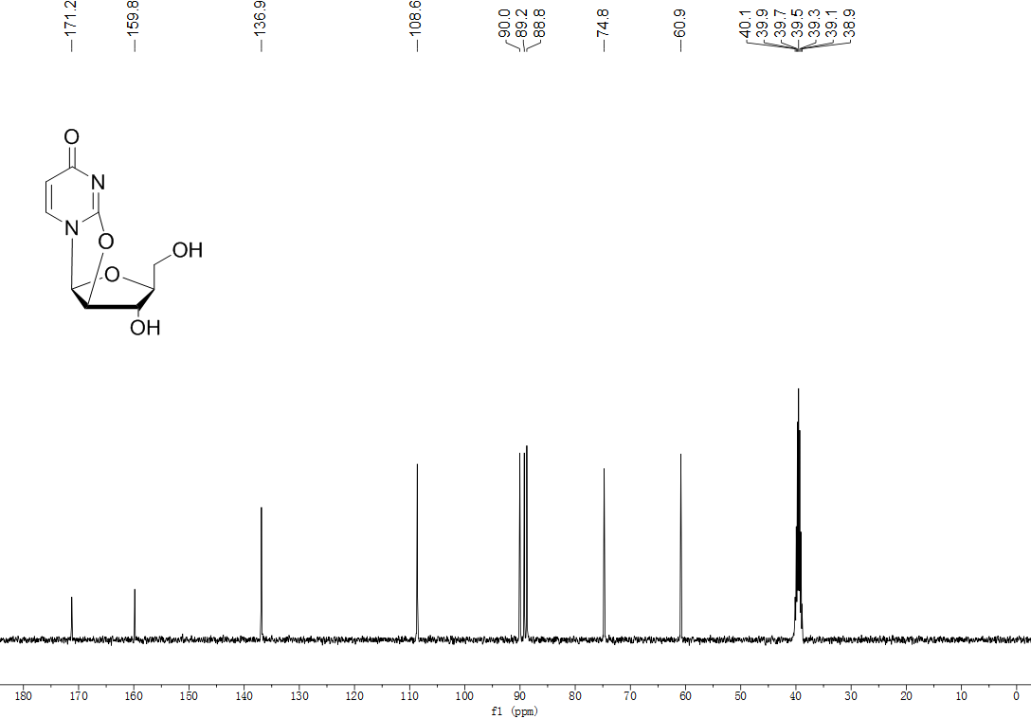

¹H NMR spectrum of 2'-O-methyl-β-L-uridine (3)
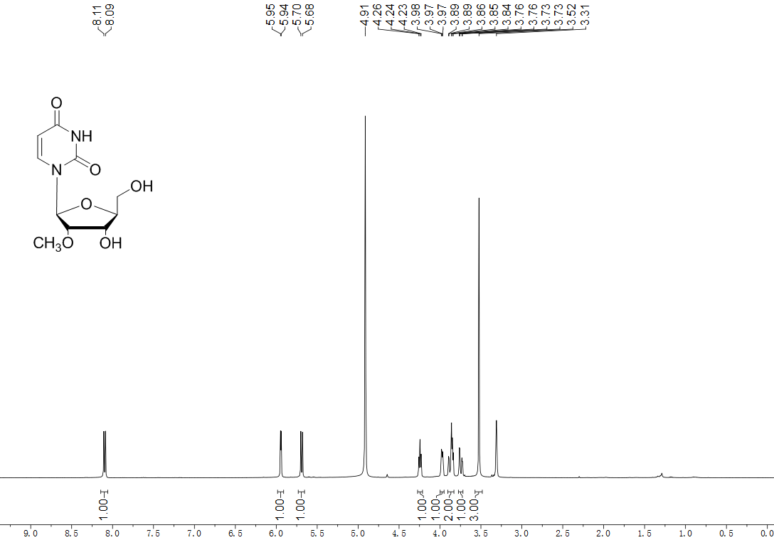
¹³C NMR spectrum of 2'-O-methyl-β-L-uridine (3)
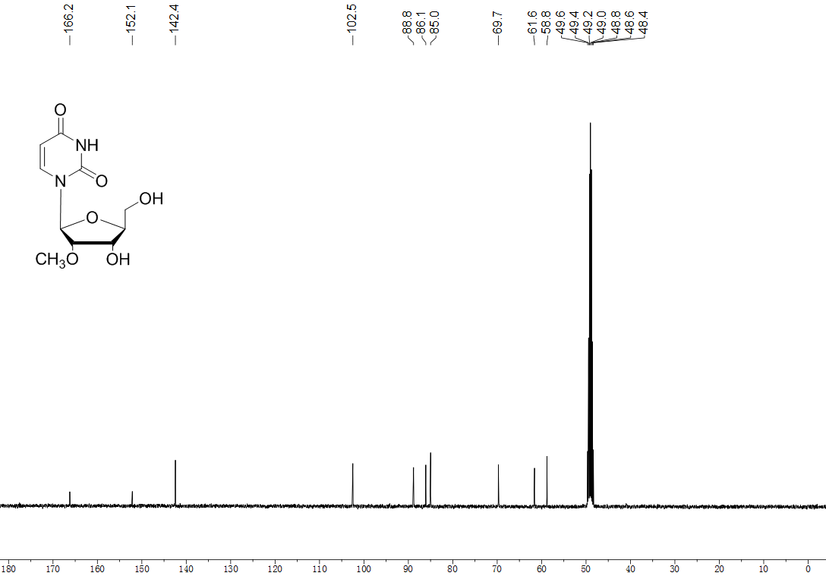
S3. Table S1 Crystal data and structure refinement for 6.
Identification code | 1
Empirical formula | C₂₆H₂₂O₈
Formula weight | 462.43
Temperature/K | 296(2)
Crystal system | orthorhombic
Space group | P2(1)2(1)2(1)
a/Å | 5.8763(16)
b/Å | 17.706(5)
c/Å | 24.914(7)
α/° | 90
β/° | 90
γ/° | 90
Volume/Å³ | 2592.2(12)
Z | 4
ρ_{calc}g/cm³ | 1.185
μ/mm⁻¹ | 0.088
F(000) | 968
Crystal size/mm³ | 0.280 x 0.260 x 0.240
Radiation | MoKα (λ = 0.71073)
2Θ range for data collection/° | 5.418 to 49.99
Index ranges | -6 ≤ h ≤ 6, -11 ≤ k ≤ 21, -29 ≤ l ≤ 26
Reflections collected | 10840
Independent reflections | 4518 [R(int) = 0.0398]
Data/restraints/parameters | 4518/0/307
Goodness-of-fit on F² | 1.024
Final R indexes [I>=2σ (I)] | R₁ = 0.0698, wR₂ = 0.1931
Final R indexes [all data] | R₁ = 0.1116, wR₂ = 0.2253
Largest diff. peak/hole / e Å⁻³ | 0.442/-0.263

S4. Table S2. Optimization of reaction conditions
Entry | Reagent [equiv] | Solvent | Temp.[ᴼC ] | Time [h] | Yield [%]
1 | TMSCHN₂(3eq), HBF₄(42%)(1eq) | DCM | r.t. | 20 | 70
2 | TMSCHN₂(3eq), SiO₂(3eq) | DCM | 0 | 20 | 42
3 | TMSCHN₂(3eq),BF₃OEt₂(40%)(1.1eq),  TBAF·AcOH·THF(48%)(2.2eq) | DCM | r.t. | 20 | 25
4 | TMSCHN₂(2eq), HBF₄(42%)(1eq) | DCM | r.t. | 20 | 70
5 | CH₃I(5eq), Ag₂O(2.5eq) | DMF | 0 | 6 | 53
6 | CH₃I(5eq), Ag₂O(2.5eq) | DMF | r.t. | 5 | 58

S5. Table S3 Crystal data and structure refinement for 12.
Identification code | 1
Empirical formula | C₁₈H₂₀N₄O₁₀
Formula weight | 452.38
Temperature/K | 296(2)
Crystal system | orthorhombic
Space group | P2(1)2(1)2(1)
a/Å | 7.4296(7)
b/Å | 13.6558(12)
c/Å | 18.1898(16)
α/° | 90
β/° | 90
γ/° | 90
Volume/Å³ | 1845.5(3)
Z | 4
ρ_{calc}g/cm³ | 1.628
μ/mm⁻¹ | 0.135
F(000) | 944
Crystal size/mm³ | 0.260 x 0.200 x 0.170
Radiation | MoKα (λ = 0.71073)
2Θ range for data collection/° | 5.382 to 51.99
Index ranges | -8 ≤ h ≤ 9, -16 ≤ k ≤ 15, -22 ≤ l ≤ 19
Reflections collected | 10220
Independent reflections | 3616 [R(int) = 0.0213]
Data/restraints/parameters | 3616/0/298
Goodness-of-fit on F² | 0.930
Final R indexes [I>=2σ (I)] | R₁ = 0.0278, wR₂ = 0.0693
Final R indexes [all data] | R₁ = 0.0311, wR₂ = 0.0719
Largest diff. peak/hole / e Å⁻³ | 0.198/-0.144

S6. References
Ma, T., Pai, S.B., Zhu, Y.L., Lin, J.S., Shanmuganathan, K., Du, J., Wang, C., Kim, H., Newton, M.G., Cheng, Y.C., 1996. Structure− Activity Relationships of 1-(2-Deoxy-2-fluoro-β-l-arabino-furanosyl) pyrimidine Nucleosides as Anti-Hepatitis B Virus Agents. J. Med. Chem. 39, 2835-2843.
Jung, M.E., Nichols, C.J., Kretschik, O., Xu, Y., 1999. Synthesis and Testing of New Modified Nucleosides. Nucleosides, Nucleotides Nucleic Acids 18, 541-546.

