Tables and Figures – solvent paper

Table 1: Partition coefficient (log P) and solubility (log S) calculated with ChemDraw software for all monomers and solvents used in this study.
Monomer or solvent | logP | logS
Water | - | 0.158
Ethanol | 0.07 | 0.3046
Ethyl acetate | 0.29 | -0.5017
BisGMA | 5.09 | -5.571
HEMAM-BDI | 2.37 | -4.312
DMAM | 0.2 | -0.3436

Table 2. Modulus of elasticity (GPa) and yield strength (MPa) tested dry and after 7 days storage in water (wet) for all tested experimental groups. HEMAM-BDI specimens could not tested after water storeage. Values followed by the same superscript within the same column are statistically similar (two-way ANOVA within column). The asterisk symbol * indicates statistical difference between dry and wet results for the same group (t-test). For all tests, α=5%.
Solvent |  | BisGMA |  |  |  |  |  | HEMAM-BDI
Type | Concentration (wt%) | Yield strength (MPa) |  |  | Flexural modulus (GPa) |  |  | Yield strength (MPa) | Flexural modulus (GPa)
 |  | dry | wet | Reduction (%) | dry | wet | Reduction (%) | dry | dry
Control | 0 | 78.1±14.4 b | 48.2±2.1 b* | 38 | 3.55±0.10 b | 2.31±0.20 b* | 35 | 51.5±14.0 b | 5.40±0.59 a
EtOAc | 2 | 85.8±12.9 ab | 42.3±3.3 b* | 51 | 3.42±0.34 b | 2.13±0.23 b* | 38 | 70.1±6.3 a | 4.89±0.31 ab
 | 5 | 71.4±3.8 bc | 45.8±5.0 b* | 36 | 3.17±0.22 bc | 2.19±0.18 b* | 31 | 70.1±14.8 a | 4.94±0.44 a
 | 15 | 76.0±3.0 b | 53.7±7.6 b* | 29 | 3.18±0.07 bc | 2.82±0.43 b | 11 | 86.5±21.0 a | 5.10±0.17 a
 | 20 | 63.0±5.8 c | 53.5±5.7 b | 15 | 2.77±0.41 c | 2.90±0.48 b | -5 | 70.1±8.7 a | 4.57±0.81 bc
EtOH/H₂O | 2 | 101.3±6.6 a | 87.2±13.8 a | 14 | 4.64±0.47 a | 4.23±0.47 a | 9 | 68.1±7.0 ab | 5.01±0.65 a
 | 5 | 89.7±3.7 ab | 88.1±5.4 a | 2 | 4.25±0.44 a | 4.10±0.27 a | 4 | 53.9±17.5 | 5.16±0.36 a
 | 15 | 64.3±9.2 c | 55.2±10.3 b | 14 | 3.31±0.61 b | 2.59±0.36 b | 22 | 62.2±15.3 ab | 3.97±0.34 c
 | 20 | 54.0±5.4 c | 52.6±3.4 b | 3 | 3.00±0.35 bc | 2.89±0.11b | 4 | 47.9±13.4 b | 3.20±0.12 c

Figure 1. Chemical structure of the newly synthesized secondary dimethacrylamide – HEMAM-BDI (MW = 502.61g/mol). BisGMA and DMAM were also used in this study.

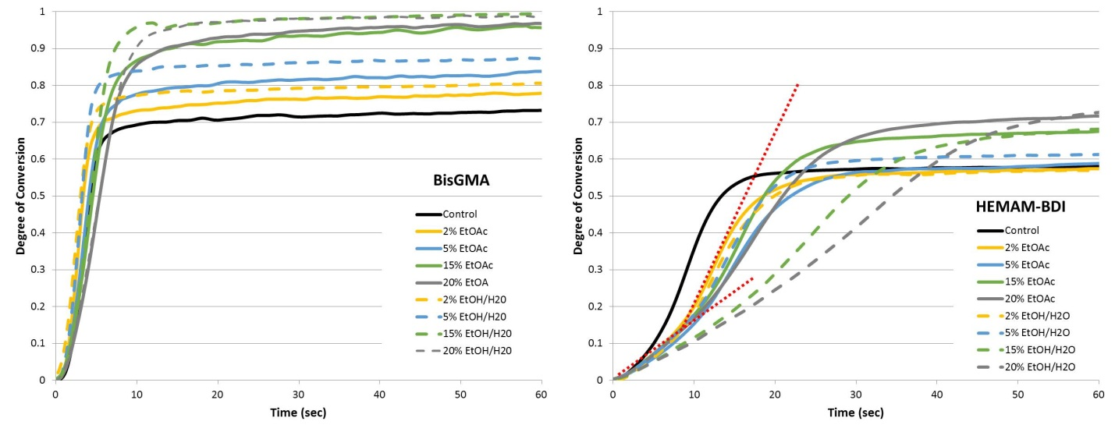
Figure 2. Degree of conversion (%) as a function of time (up to 60 s) for BisGMA- and HEMAM-BDI-based materials, containing different concentrations of ethyl acetate (EtOAc, solid lines) or Ethanol/H₂O (EtOH/H₂O, dashed lines). Dashed red lines on the HEMAM-BDI graph are highlighting the two-stage kinetic profile for the groups with highest solvent concentrations. The lines represent the average of three runs. Vinyl conversion was followed in real time as the materials were photocured with 250 mW/cm² for 300 seconds. Note: due to the very similar kinetic profiles for 0.5, 1 and 2 % solvent concentrations, the 0.5 and 1% concentrations are omitted from the graph for clarity.

Figure 3. Averages of maximum rates of polymerization (Rp_{max}, %.s⁻¹), degree of conversion at Rp_{max} (DC at RP, %) and degree of conversion at 5 min (DC at 50 min, %), for all groups tested. BisGMA-based materials were statistically different from HEMAM-BDI-based materials for every variable, so comparisons were made only within each monomer system, using two-way ANOVA/Tukey’s test (solvent type and concentration as factors, α=5%). Values followed by the same superscript or connected by a horizontal bar are statistically similar. Vinyl conversion was followed in real time as the materials were photocured with 250 mW/cm² for 300 seconds.

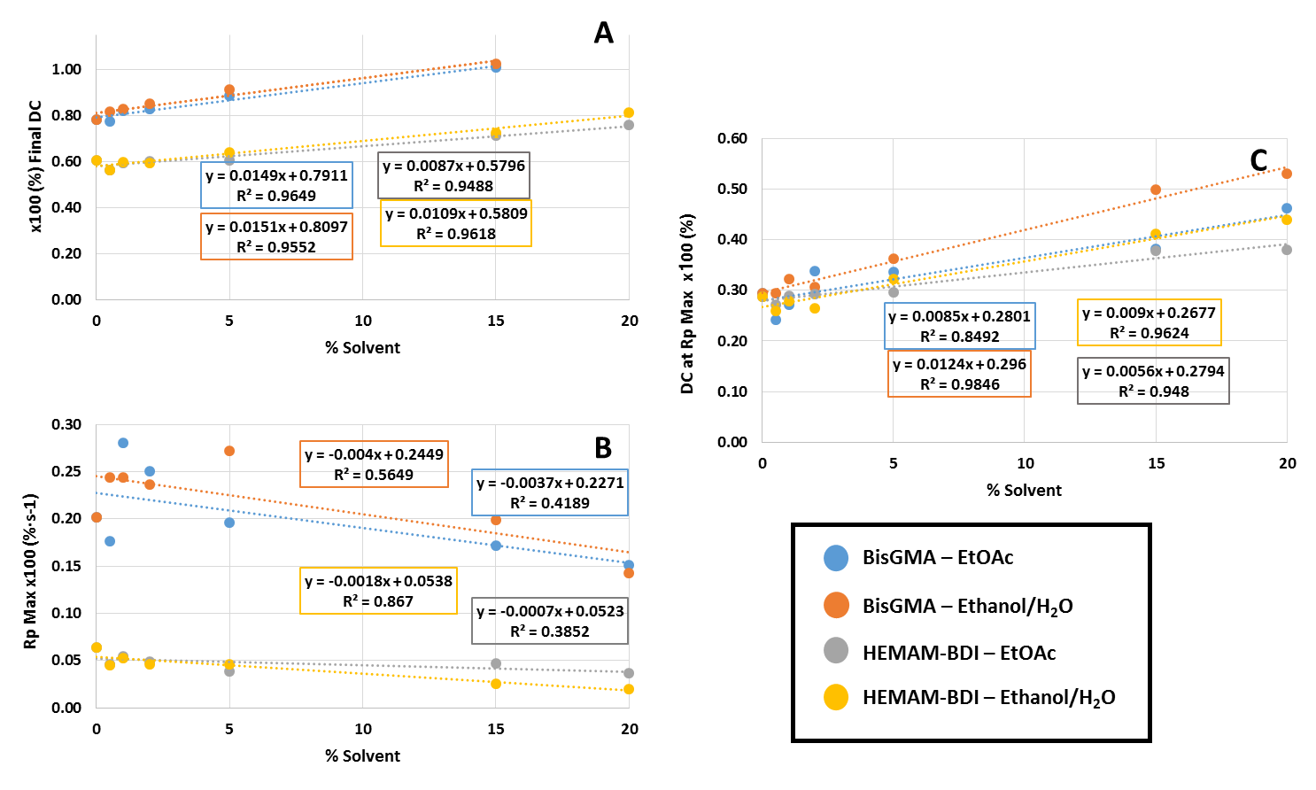
Figure 4. Linear regression curves for: (A) the final degree of conversion (DC) (%), (B) maximum rate of polymerization (Rp_{max}) (%.s⁻¹), and (C) degree of conversion at maximum rate of polymerization (DC at Rp_{max}) (%) as a function of solvent percentage incorporated in the mixtures for BisGMA and HEMAM-BDI resins.

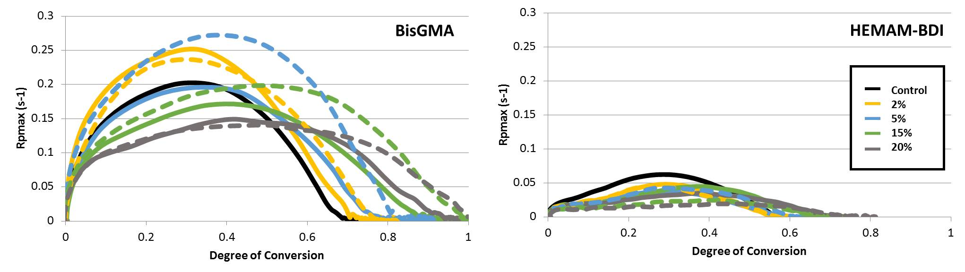
Figure 5. Polymerization rate (%.s⁻¹) as a function of conversion (%) for BisGMA- and HEMAM-BDI-based materials, containing different concentrations of ethyl acetate (EtOAc, solid lines) or Ethanol/H₂O (EtOH/H₂O, dashed lines). The lines represent the average of three runs. Vinyl conversion was followed in real time as the materials were photocured with 250 mW/cm² for 300 seconds. Note: due to the very similar kinetic profiles for 0.5, 1 and 2 % solvent concentrations, the 0.5 and 1% concentrations are omitted from the graph for clarity.

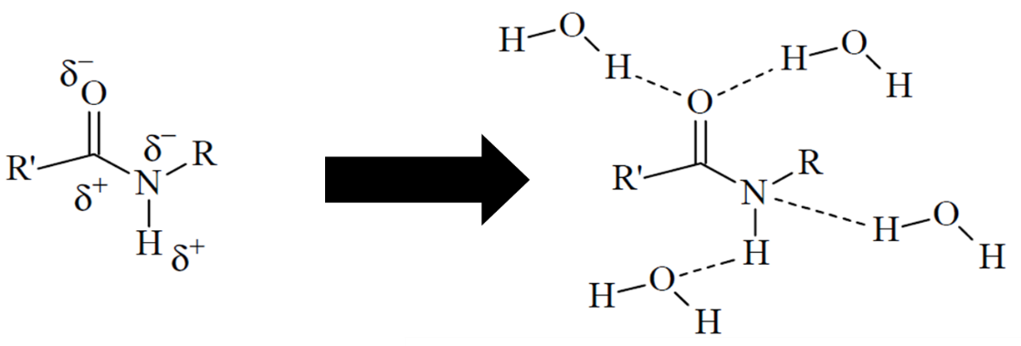
Figure 6. Schematic representation of a secondary methacrylamide with the two dipoles: carbonyl (C=O) and amine (N-H) and the potential hydrogen bonds. (Adapted from De Ruiter2005).

