Supplementary data

**pH-Responsive benzaldehyde-functionalized PEG-based polymeric nanoparticles for drug delivery: effect of preparation method on morphology, dye encapsulation and attachment**

Peter Smyth, Thomas J. Gibson, Gavin Irvine, Gemma Black, Daniel Lavery,Mona Semsarilar, Christopher J. Scottand Efrosyni Themistou⃰

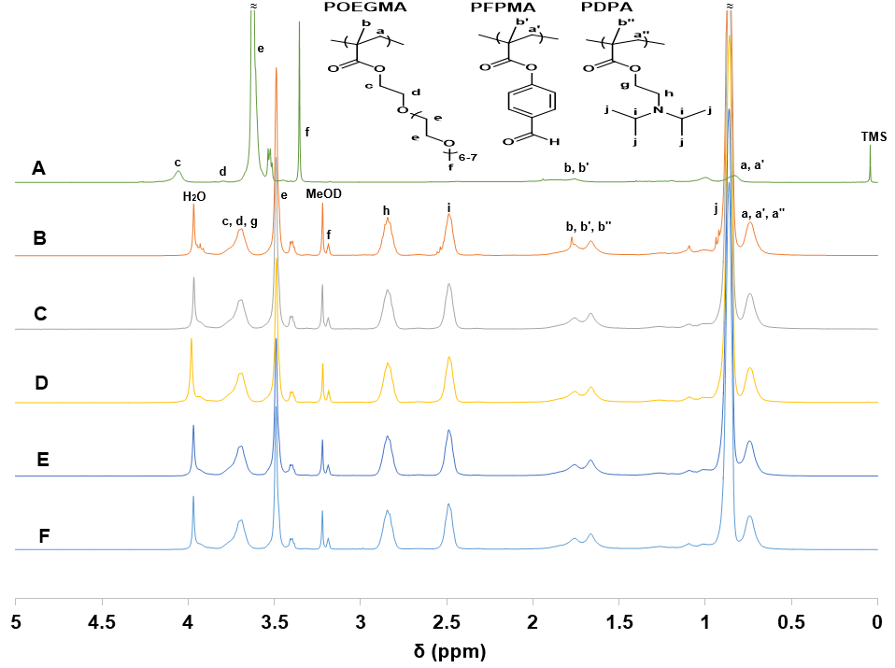

**Figure S1.** 1H NMR spectra obtained in CDCl3 for (A) P(OEGMA23-*st*-pFPMA1) macro-CTA,and in CDCl3/MeOD mixture 3/1 v/v for (B) P(OEGMA23-*st*-pFPMA1)-*b*-PDPA151, (C) P(OEGMA23-*st*-pFPMA1)-*b*-PDPA167, (D) P(OEGMA22-*st*-pFPMA1)-*b*-PDPA186, (E) P(OEGMA22-*st*-pFPMA1)-*b*-PDPA197 and (F) P(OEGMA23-*st*-pFPMA1)-*b*-PDPA235 amphiphilic block copolymers.

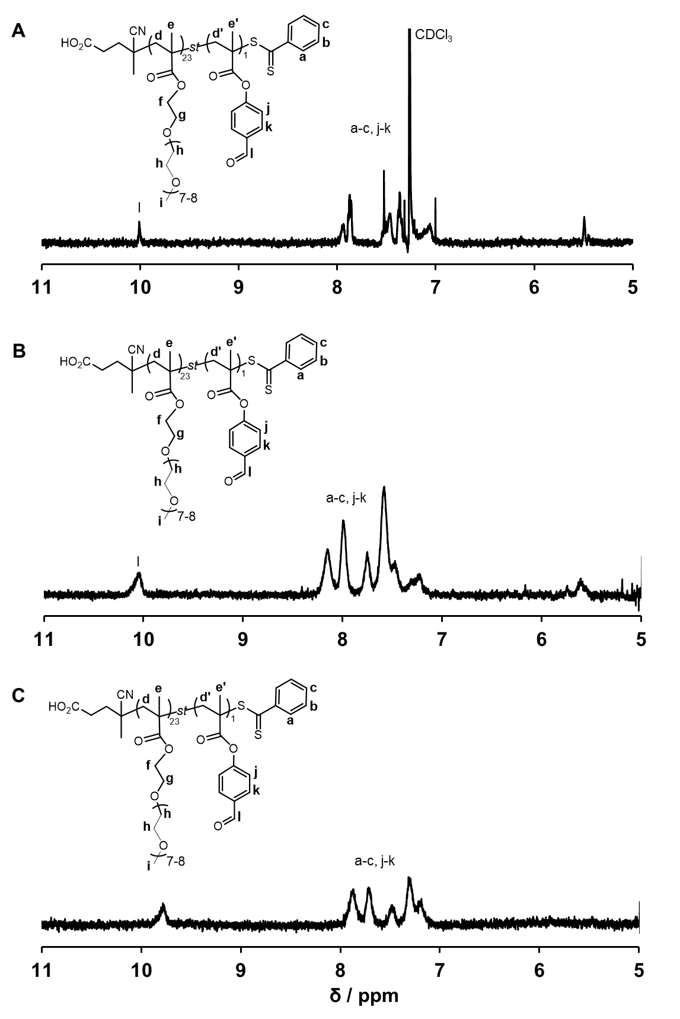

f



a-c, d-f

a-c, d-f

a-c, d-f

f

f

l

F**igure S2.** 1H NMR spectra of P(OEGMA23-*st*-pFPMA1) macro-CTAin (A) CDCl3/MeOD mixture 3/1 v/v, (B) D2O and (C) 2% w/w DCl in D2O.



**Figure S3.** DLS volume weighted diameter distribution of Nile Red encapsulated P(OEGMA22-*st*-pFPMA1)-*b*-PDPA197 polymeric nanoparticles prepared by pH-switch.



**Figure S4.** DLS volume weighted diameter distribution of rhodamine 6G encapsulated P(OEGMA22-*st*-pFPMA1)-*b*-PDPA235 polymeric nanoparticles prepared by single emulsion-solvent evaporation.

**Table S1.** DLS data of P(OEGMA23-*st*-pFPMA1)-*b*-PDPA235 block copolymer nanoparticles prepared by single emulsion-solvent evaporation in PBS buffer (2 mg mL-1) at different solution pH values (7.4, 4.0, 2.0) and PBS buffer used as a control.

|  |  |  |  |  |  |
| --- | --- | --- | --- | --- | --- |
| **Entry** | **Sample** | **Hydrodynamic diameter / nm** | **PDI** |  | **Count rate/**  **kcps** |
| 1 | pH 7.4 | 214.3 | 0.059 |  | 444.6 |
| 2 | pH 4.0 | 121.3 | 0.240 |  | 190.4 |
| 3 | pH 2.0 | 1251.0 | 0.705 |  | 107.4 |
| 4 | PBS buffer | 1113.0 | 0.688 |  | 90.7 |

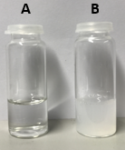

**Figure S5.** P(OEGMA23-*st*-pFPMA1)-*b*-PDPA235 block copolymer nanoparticles prepared by pH-switch in 0.1M PBS buffer (2.2 mg mL-1) at (A) pH 2.0 and (B) pH 7.4.