Supplementary data for

Mathematical modeling of enrichment of estrogens in water samples using reverse osmosis device

Jan Siegel²⁾, Chimi Wangmo¹⁾, Jiří Cuhorka³⁾, Alena Otoupalíková¹⁾, Michal Bittner^{1,2)*}

¹⁾Research Centre for Toxic Compounds in the Environment - RECETOX, Masaryk University, Kamenice 5,
625 00 Brno, Czechia
²⁾Department of Biomedical Engineering, Brno University of Technology, Technická 12, Brno, 616 00, Czechia
³⁾Institute of Environmental and Chemical Engineering, Faculty of Chemical Technology, University of Pardubice, Studentská 573, 532 10 Pardubice, Czechia

*Corresponding author: E-mail: bittner@recetox.muni.cz, Phone: +420 549493807
Supplementary material 1

Derivation of rate of solute concentration in feed tank

The simulation model was developed and verified for the RO system operating in a semi-batch (closed-loop) system, with retentate recycled to the feed tank and permeate collected separately (Figure 1).

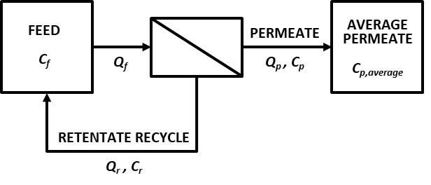
Fig S1. Operational scheme of reverse osmosis batch process. Q – volume flow, C – concentration, f, r, and p refer to feed, retentate, and permeate, respectively.

The permeate concentration based on the material balance around the membrane can be described by:

 | $$Q_{p}C_{p}=Q_{f}C_{f}-Q_{r}C_{r}$$ | (1)
Also, the change in concentration in the feed can be described by:

 | $$-\frac{d(V_{f}C_{f})}{dt}=Q_{f}C_{f}-Q_{r}C_{r}$$ | (2)

Equating eq. (1) and eq. (2), the derivation yields:

 | $$Q_{p}C_{p}=-\left(\frac{{dV}_{f}}{dt}C_{f}+\frac{{dC}_{f}}{dt}V_{f}\right)$$ | (3)
Further, the change (decrease) of volume in feed tank dV_{f} in time dt is equal to permeate flow through membrane Q_{p}:
 | $$-\frac{{dV}_{f}}{dt}=Q_{p}$$ | (4)
Solution volume in feed tank at any time t can be obtained on integrating eq. (4) between 0 to t,

 | $$\frac{V_{f}-V_{f,0}}{t}=-Q_{p}$$ |  | (5)
 | $$V_{f}=V_{f,0}-Q_{p}t$$ | (6)
The final equation, describing the increase in the concentration of solutes in feed tank with time, is obtained by substituting values from eq. (6) into eq. (3) [1]:

 | $$\frac{dC_{f}}{dt}=\frac{Q_{p}(C_{f}-C_{p})}{V_{f,0}-Q_{p}t}$$ | (7)

References

[1] C.S. Slater, C.A. Brooks, Development of a Simulation Model Predicting Performance of Reverse Osmosis Batch Systems, Sep. Sci. Technol. 27 (1992) 37–41. doi:10.1080/01496399208019431.

Supplementary material 2

Combination of solution-diffusion model and material balance in the feed tank [1]

The solvent (water) flux J_{w} and solute flux J_{s} through the membrane are expressed by the following equations:
$$J_{w}=A_{w}\left(∆P-∆π\right)= \frac{Q_{p}}{S}C_{w,p}$$ | (1)
$$J_{S}=B_{S}∆C=B_{S}\left(C_{f}-C_{p}\right)$$ |  | (2)

Solute concentration in the permeate can be described:

 | $${J_{w}C_{p}=J}_{S}C_{w,p}$$ | (3)

where C_{w,p} is a permeate solvent concentration. If the solvent is water, then C_{w,p} = C_{w} [2].
Substituting for J_{w} and J_{s} from eq. (1) and eq. (2) in eq. (3) yields,

 | $${A_{w}\left(∆P-∆π\right)C_{p}=B}_{s}\left(C_{f}-C_{p}\right)C_{w}$$ | (4)
The difference in osmotic pressures ∆π is given by the extended van´t Hoff equation as:

 | $$∆π=φR_{g}T\sum_{i}{{∆C}_{i}}$$ | (5)
where φ is an osmotic pressure coefficient describing the divergence of osmotic pressure between real and theoretical solution. It depends on the type and concentration of the solution, e.g. for NaCl aqueous solution it ranges from 0.928 to 1.281 [3], or for estrogens equals zero. $∆C=C_{f}-C_{p}$is the difference in solutes molar concentrations on feed C_{f} and permeate C_{p} side.

For complex solute, its mass concentration must be used in the model [4]. For low concentrations of solutes, and at a constant temperature, φ is assumed to be constant. Equation (5) after unit conversion can be rewritten as:

 | $$∆π=\frac{1000∙{3600}^{2}∙φR_{g}Ti}{M} \left(C_{f}-C_{p}\right)= ψ\left(C_{f}-C_{p}\right)$$ | (6)
where M is a molar mass of concentrated solutes, and ψ is the solute concentration coefficient [5]. Substituting for Δπ from eq. (6) into rearranged eq. (4), yields an equation for solutes concentration on feed side C_{f}:

 | $$C_{f}=\left(\frac{A_{w}∆PC_{p}}{B_{s}C_{w}}-\frac{A_{w}ψC_{f}C_{p}}{B_{s}C_{w}}+\frac{A_{w}ψC_{p}^{ 2}}{B_{s}C_{w}}+C_{p}\right)$$ | (7)
For high rejection, since $\frac{A_{w}∆P}{B_{S}}≫\frac{A_{w}ψ }{B_{s}}$, and $C_{f}≫C_{p}$, we can ignore higher order terms, eq. (7) then simplifies to

 | $$C_{f}=C_{p}\left(\frac{A_{w}∆P}{B_{s}C_{w}}-\frac{A_{w}ψC_{f}}{B_{s}C_{w}}+1\right)$$ | (8)
or
 | $$C_{p}=C_{f}{\left(\frac{A_{w}∆P}{B_{s}C_{w}}-\frac{A_{w}ψC_{f}}{B_{s}C_{w}}+1\right)}^{-1}$$ | (9)
Substituting the expression for ∆π in eq. (1) from eq. (6) and combining it with eq. (9) for C_{p} yields an expression for permeate flow Q_{p}

 | $$Q_{p}=\frac{SA_{w}}{C_{w}}\left(∆P-ψC_{f}+\frac{ψC_{f}}{1+\frac{A_{w}∆P}{B_{s}C_{w}}-\frac{A_{w}ψC_{f}}{B_{s}C_{w}}}\right)$$ | (10)
Substituting for C_{p} from eq. (9), and for Q_{p} from eq. (10) into the material balance eq. (7) in Supplementary material 1 results in a non-linear master differential equation describing the rate of change of solute concentration in the feed tank C_{f}, eq. (12):

 |  | $$\frac{dC_{f}}{dt}=\frac{Q_{p}(C_{f}-C_{p})}{V_{f,0}-Q_{p}t}$$ |  | (11)
 | $$\frac{{dC}_{f}}{dt}=\frac{Q_{p}(C_{f}-C_{p})}{V_{f,0}-Q_{p}t}=\frac{\left[\frac{SA_{w}∆P}{C_{w}}-\frac{SA_{w}ψ}{C_{w}}C_{f}+\frac{\frac{SA_{w}ψ}{C_{w}}C_{f}}{1+\frac{A_{w}∆P}{B_{s}C_{w} }-\frac{A_{w}ψ}{B_{s}C_{w}}C_{f}}\right]∙\left[C_{f}-\frac{C_{f}}{1+\frac{A_{w}∆P}{B_{s}C_{w}}-\frac{A_{w}ψ}{B_{s}C_{w}}C_{f}}\right]}{V_{f,0}-\frac{SA_{w}∆P}{C_{w}}t+\frac{SA_{w}ψ}{C_{w}}C_{f}t-\frac{\frac{SA_{w}ψ}{C_{w}}C_{f}}{1+\frac{A_{w}∆P}{B_{s}C_{w} }-\frac{A_{w}ψ}{B_{s}C_{w}}C_{f}}t}$$ |  | (12)

Slater et al. [5] proposed simplifying eq. (12) by grouping model constants and initial conditions to:

 | $$\frac{{dC}_{f}}{dt}=\frac{\left[a_{1}-\left(a_{2}C_{f}\right)+\frac{a_{2}C_{f}}{a_{3}-a_{4}C_{f}}\right]∙\left[C_{f}-\frac{C_{f}}{a_{3}-a_{4}C_{f}}\right]}{a_{5}-a_{1}t+a_{2}C_{f}t-\frac{a_{2}C_{f}t}{a_{3}-a_{4}C_{f}}}$$  where C_{f} is the solutes concentration in feed tank and the constants a₁–a₅ are |  |  |  | (13)
 |  | $$a_{1}=\frac{SA_{w}∆P}{C_{w}}$$ | (14)
 |  | $$a_{2}=\frac{SA_{w}ψ}{C_{w}}$$ | (15)
 |  | $$a_{3}=1+\frac{A_{w}∆P}{B_{s}C_{w} }$$ | (16)
 |  | $$a_{4}=\frac{A_{w}ψ}{B_{s}C_{w}}$$ | (17)
 |  | $$a_{5}=V_{f,0}$$ | (18)

References

[1] C.S. Slater, C.A. Brooks, Development of a Simulation Model Predicting Performance of Reverse Osmosis Batch Systems, Sep. Sci. Technol. 27 (1992) 37–41. doi:10.1080/01496399208019431.
[2] K. Jamal, M.A. Khan, M. Kamil, Mathematical modeling of reverse osmosis systems, Desalination. 160 (2004) 29–42. doi:10.1016/S0011-9164(04)90015-X.
[3] W.J. Hamer, Y.-C. Wu, Osmotic Coefficients and Mean Activity Coefficients of Uni-univalent Electrolytes in Water at 25°, J. Phys. Chem. Ref. Data. 1 (1972) 1047–1100. doi:10.1063/1.3253108.
[4] N. Brunswick, Aw Bs c, 52 (1985) 267–284.
[5] C.S. Slater, J.M. Zielinski, R.G. Wendel, C.G. Uchrin, Modeling of small scale reverse osmosis systems, Desalination,. 52 (1985) 267–284. doi:https://doi.org/10.1016/0011-9164(85)80037-0.

Supplementary material 3

Retentate volume time profile without control of simulation termination

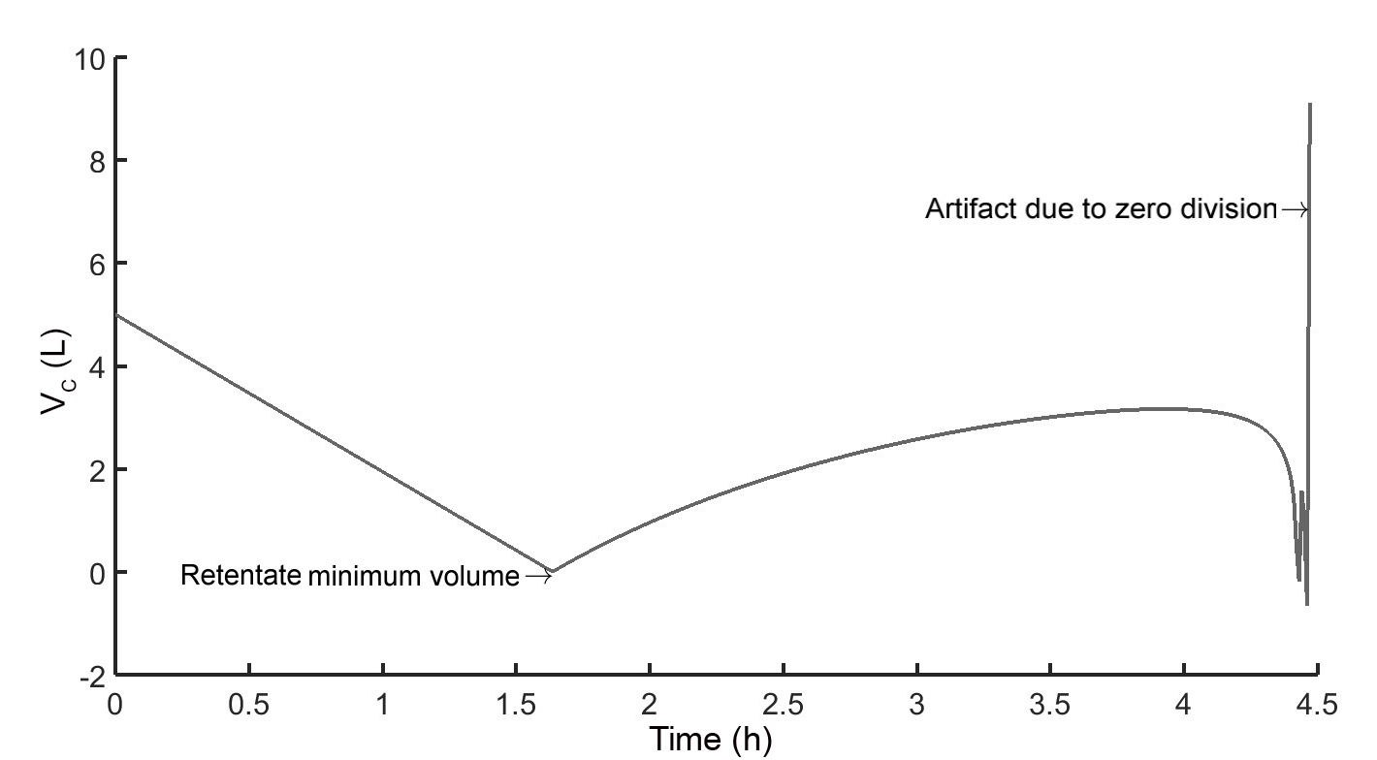

Supplementary material 4

Details of simulation and experimental enrichment of 25 ng_{EE2}/L sample

Mathematical modelling and experimental enrichment were performed in the same way as other EE2 samples as described in the manuscript in chapter 3.1 Experimental enrichment and determination of model constants, and Table 1. Information specific to the enrichment of the sample with 25 ng_{EE2}/L is stated in Table S1.

Table S1. Input parameters and results of RO batch processes. The table only depicts parameters and results specific for the experimental run with 25 ng_{EE2}/L sample.
 | Exp_{EE2} S1
C_{f,EE2},₀ (ng/L) | 25
T (˚C) | 18.5
V_{c} (mL) | 540
dt (h) | 5.17
G_{f,0} (µS/cm) | 516
k_{TDS} | 0.67

Fig S1. Permeate flow rate for the enrichment of 25 ng_{EE2}/L solution sample. Initial permeate flux is 18.1 L/m²h. Specification of initial conditions for this process is described in Table 1 and Table S1.

Fig. S2. Comparison of the simulation and experimental enrichment of 25 ng_{EE2}/L solution. MAPD is 9.14 %.

