Data set
This is the data set for the paper A chronotopic approach to identity performance in a Facebook meme page.
Comments are sorted chronologically, giving each participant a unique number based on his or her time of posting the comment. Facebook allows only 2-tier comment hierarchy: comment (first tier) and comment upon comment (second tier). Second tier comments are indented and indicated by number. Parentheses () contain emoticons and emojis, square brackets [] indicate author’s notes, and braces { } signal hyperlinks and tags.

Excerpt 1.
Post details
Caption: “made of {BrasilBall}”
Date of publication: February 13, 2017
Reactions: over 2,100
Shares: 273
Comments: 96
The number of participants in the comment section: 76

Comments in chronological order:

Participant 1: No hat for UK? 2/10
Date: February 13 at 6:01pm Likes: 51

Participant 1.1: Indoors
Date: February 13 at 6:02pm Likes: 32
Participant 1.2: and monocle
Date: February 13 at 6:02pm Likes: 11
Participant 1.3: Hannover ♡
Date: February 13 at 6:28pm Likes: 0
Participant 1.4: On Sunday his don’t use
Date: February 13 at 6:45pm Likes: 1
Participant 1.5: Brexit is hitting hard (pacman emoticon)
Date: February 13 at 6:56pm Likes: 2

Participant 2: Shouldn't Ukball be Germanyball for this?
Date: February 13 at 6:01pm Likes: 41

Participant 2.1: I still remember Merkel saying "Everyone's welcome" and then letting every other
country close its borders, forcing all these illegals upon the entry countries (squint emoticon)
Date: February 13 at 6:03pm Likes: 15

Participant 3: UNball just pass new resolutions everyday, condemn this, condemn that
Date: February 13 at 6:02pm Likes: 2

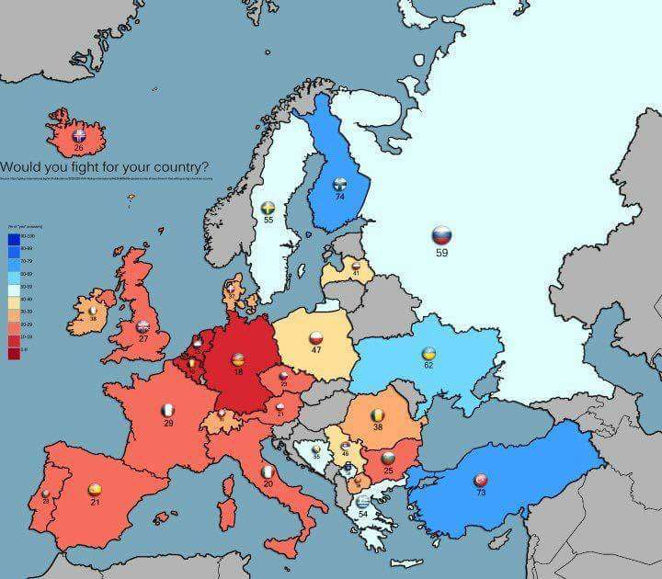
Participant 4: I wonder how middle east would look like in this.
Date: February 13 at 6:03pm Likes: 16

Participant 4.1: Turkey is in a fight since 1980's. Europeans dont know what is fighting for their people. So this doesnt mean anything to me
Date: February 13 at 6:19pm Likes: 0
Participant 4: Participant 4.1 I didn't talk about Turkey alone but whole middle east.
Date: February 13 at 6:20pm Likes: 0
Participant 4.2: Torks gonna hate
Date: February 13 at 6:19pm Likes: 1
Participant 4.3: Why do we gonna hate its proudful to see actually maybe our government is shit maybe our people is shit but not unhonored bastards who shits where he eats
And lets look for europe mostly of them can fight for lgbt not for their country what a lovely people
Date: February 13 at 7:23pm Likes: 7
Participant 4: Participant 4.3True. Got to respect the turks.
Date: February 13 at 7:25pm Likes: 0
Participant 4.4: Participant 4.3 and that why Europe culture conqvered the world?
Date: February 13 at 7:36pm Likes: 0
Participant 4.5: Old Europe did. Modern one is a bunch of triggered rich liberals deluded from reality
Date: February 13 at 7:36pm Likes: 0
Participant 4.3: Participant 4.1 Kurdish Uprisings in the 1980s let me guess?
Date: February 13 at 7:36pm Likes: 0

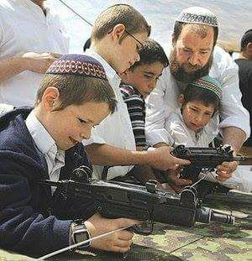
Participant 4(2) [opening second thread]: [no caption]
Date: February 13 at 6:04pm Likes: 24

Participant 4(2).1: [no caption]
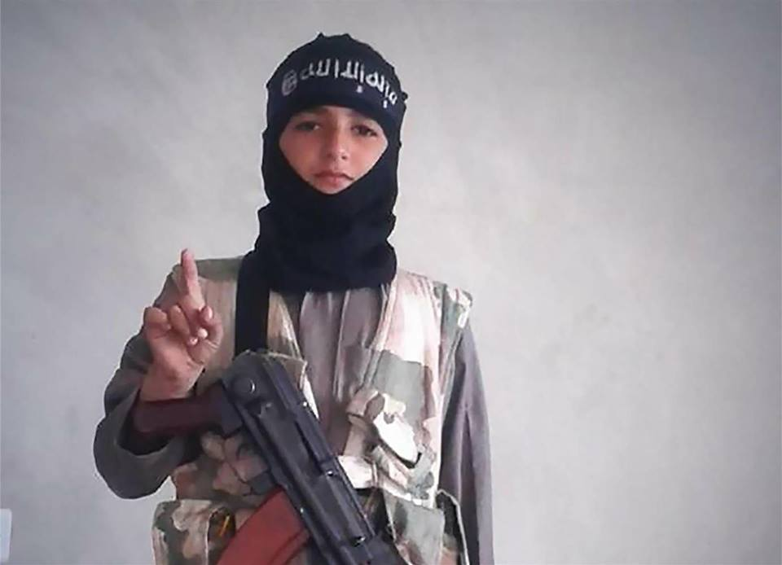
Date: February 13 at 6:25pm Likes: 1

Participant 4(2).2: Cant blame them i mean there surrounded by countries that they have issues with them(Palestinian state, Golan Heights from Syria etc) teaching younger Generations to be "prepared " when the least expect it is a good thing. Mandatory Military Service should be reinstated so the concept of National Preparedness will not be compromised and also as a Sacred Obligation to do your part.
Date: February 14 at 3:20am Likes: 2
Participant 4(2): Participant 4(2).2 I am not so sure about mandatory service. More like mandatory training. Well, at least here mandatory service wasn't such a good idea for the army morale and esteem in the society.
Date: February 14 at 3:31am Likes: 1
Participant 4(2).2: Participant 4(2) Mandatory Military Service for should be implemented(For Women i think it should too so those God Damn Feminazis should shut their trap about bitching equality self entitled bs (But putting them in Training on separate Genders or not depends on the countries policy(For Example Israel has some units that have both men and women that are grouped together and seems to be doing well i guess)
Date: February 14 at 6:18am Likes: 0
Participant 4(2).2 Mandatory Training i agree with that you cannot graduate College unless you finish your mandatory Military training(its like a crash course) plus in High school there is some thing what we call CAT(Civilian Army Training)
Date: February 14 at 6:25am Likes: 0 Edited
Participant 4(2).2: Participant 4(2) regarding Mandatory Military service im saying something like 1 and a half year after that they would give you a option to "Go pro"(Be a Contract Soldier(This is the part where that applicant if he passes qualification test he can pursue a professional career in the Army Just like they are implementing in Russia as part of their reforms in the Army) or No(which means you are out of the hook but you are still a reservist which you will be Mobilized in case of national emergency.
Date: February 14 at 6:25am Likes:0
Participant 4(2).2: Participant 4(2) exempted in the Mandatory Service only if you are: Have history of Mental Issues(which needs to be medically proven by a professional later on you will be given by the Professional a Certificate), Physically(You lost one of your leg, arms or you have some kind of a ailment that hampers your health) and Mentally Disabled(self explanatory lol) and o by the way Fags and Dykes are not exempted(Though the policy should that they keep their orientation to themselves)emergency.
Date: February 14 at 6:25am Likes: 0
Participant 4(2).2: Participant 4(2) regarding Mandatory Military service im saying something like 1 and a half year after that they would give you a option to "Go pro"(Be a Contract Soldier(This is the part where that applicant if he passes qualification test he can pursue a professional career in the Army Just like they are implementing in Russia as part of their reforms in the Army) or No(which means you are out of the hook but you are still a reservist which you will be Mobilized in case of national emergency.
Date: February 14 at 6:31am Likes: 0
Participant 4(2): Participant 4(2).2 I think army is not the place for "making a man and a woman". That's the father and mother job in the early years of kids life. Family should have more autonomy and I think father should be allowed to "teach a lesson" his children. Army is not for dyscyplining a human. If family failed to do so in the early years then army will degenerate him more.
Date: February 14 at 11:50am Likes: 0
Participant 4(2).2: Participant 4(2) Well okay that is your opinion(I mean you know your country better than outsiders(that is your country afterall) is gues; I guess there is no shortage of Patriots there in Poland anyway(I mean afterall Poland was the largest Resisting Army back then in WW2(Both Civilian and Military inside and outside of the Polaco Diaspora)
Date: February 14 at 12:05am Likes: 0
Participant 4(2): Participant 4(2).2 was another glorious mistake my country did. Bloody and glorious.
Date: February 14 at 12:47am Likes: 0
Participant 4(2).2: You're country survived at the end it ain't that totally bad; hell being under the Soviet authorities and occupation for almost half century is a lesser evil compared to what the Nazis would do to Poles if they were the long term occupier instead of the Soviets. I mean like being as a Polaco back then you can get executed for making out(Relationship) with German women lol.
Date: February 16 at 6:36am Likes: 0
Participant 4(2): Participant 4(2).2 No Man. Nothing lesser. Germans wanted to kill your body, bolsheviks wanted to kill your soul.
Date: February 16 at 11:06am Likes: 0
Participant 4(2).2: Participant 4(2) i guess we can say both were unpleasant to Polish people's past.
Date: February 16 at 12:14pm Likes: 1

Participant 5: Huehuhuehuehuehue
Date: February 13 at 6:04pm Likes: 5

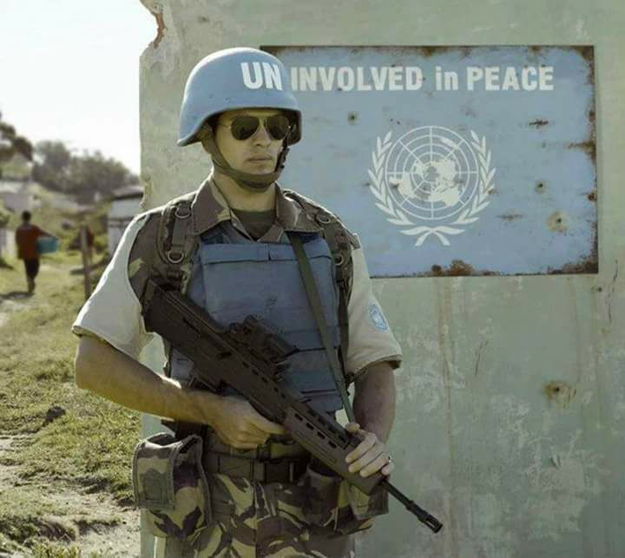
Participant 4(3) [opening a third thread]: [no caption]
Date: February 13 at 6:04pm Likes: 66

Participant 6: {tagging a person}
Date: February 13 at 6:04pm Likes: 0

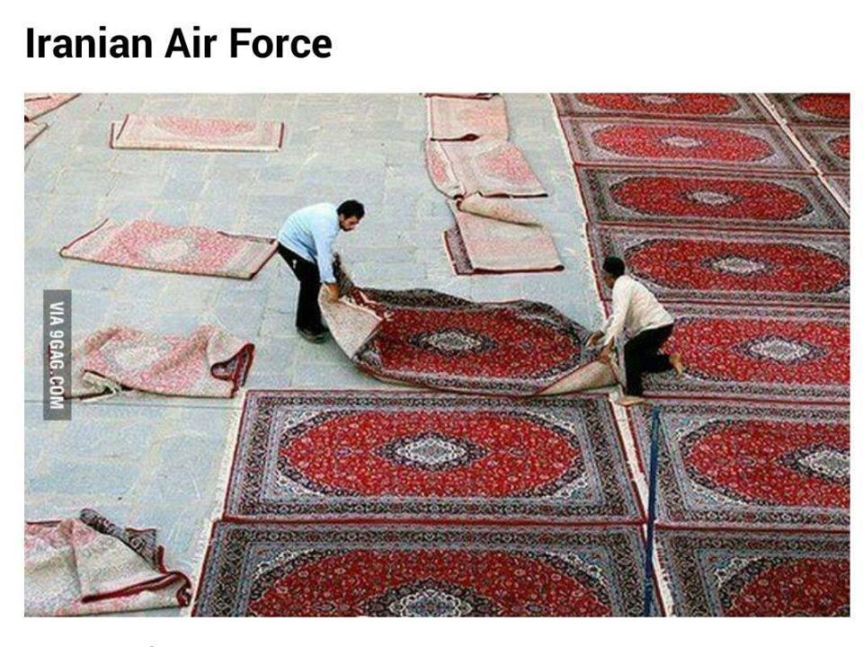
Participant 7: Aviv This is disturbingly accurate.
PS- Iranian Air Force best Air Force!
Date: February 13 at 6:07pm Likes: 66 Edited

Participant 8: {tagging a person}
Date: February 13 at 6:06pm Likes: 0

Participant 9: HUEHUEHUEHUEHUE
Date: February 13 at 6:06pm Likes: 0

Participant 10: Murica, yuo are of genius!
Date: February 13 at 6:06pm Likes: 13

Participant 11: They will kill each other even without it
Date: February 13 at 6:07pm Likes: 10

Participant 11.1: yo boys, sectarian conflict of course (pacman emoticon)
Date: February 13 at 6:33pm Likes: 10

Participant 12: Murica always has the best ideas... believe, they are the best. It's going to be a yuhhge success.
Date: February 13 at 6:09pm Likes: 2

Participant 13: (Thrash dove)
Date: February 13 at 6:13pm Likes: 11

Participant 14: Lol sounds like a plan to me
Date: February 13 at 6:18pm Likes: 2 Edited

Participant 15: Actually agree with Murica on this...
Date: February 13 at 6:26pm Likes: 4

Participant 16: Hauhehaiheiahuehauehsie
Date: February 13 at 6:26pm Likes: 0

Participant 17: Murica can into reel problm solving, {tagging a person}! USA! USA! USA!
Date: February 13 at 6:27pm Likes: 0

Participant 18: {tagging a person} well it's certainly better than Britain's... maybe XD
Date: February 13 at 6:30pm Likes: 0

Participant 19: Participant 19.1wtf is the brazil ball menta be doig xD dont get that one at all lol
Date: February 13 at 6:35pm Likes: 2

Participant 19.1: HAHAHAHA lmao give me a moment to try explain
Date: February 13 at 7:02pm Likes: 0
Participant 19: Teach em football, I guess
Date: February 13 at 7:12pm Likes: 0

Participant 20: Should be Jewcube instead of Britain.
Date: February 13 at 6:36pm Likes: 5

Participant 21: That needs to be Germoney, we're not allowing them in
Date: February 13 at 6:47pm Likes: 4

Participant 22: {tagging a person}
Date: February 13 at 6:56pm Likes: 1

Participant 23: Ily America
Date: February 13 at 7:11pm Likes: 0

Participant 24: We in Brazil want to explode them, Mohaman cannot into HUEHUE
Date: February 13 at 7:11pm Likes: 15

Participant 25: {tagging a person}
Date: February 13 at 7:31pm Likes: 0

Participant 26: {tagging a person} ukoliko nisi video ovo obavezno da vidis
Date: February 13 at 7:36pm Likes: 1

Participant 27: There should be Germany or France instead of UK
Date: February 13 at 7:39pm Likes: 15 Edited
Participant 27.1: afaik, germany has about 30x as many as the UK and 8 times more than anyone else
Date: February 13 at 8:18pm Likes: 15

Participant 28: {tagging a person} XD
Date: February 13 at 7:54pm Likes: 0

Participant 29: Murica: and we become richer same time (wink emoticon)
Date: February 13 at 8:39pm Likes: 1

Participant 30: Participant 29.1 teach them How to huehuehue (3x laughing emoticon, woman with bunny ears emoji, OK hand emoji)
Date: February 13 at 8:39pm Likes: 3

Participant 30.1: Bring them all to LV, great idea. Huehue (face with tears of joy emoji, angel emoticon, laughing emoticon, OK hand emoji)
Date: February 13 at 8:59pm Likes: 2
Participant 30: Huehue, they will run to Germoney (laughing emoticon)
Date: February 14 at 1:03am Likes: 2 Edited

Participant 31: "Bring all their people to Europe"

Who the fuck wrote this believing it was British opinion?
Date: February 13 at 9:00pm Likes: 8

Participant 31.1: mayor of Londonistan city (laughing emoticon)
Date: February 13 at 2:03am Likes: 9 Edited

Participant 32: Shuld replace britain with germany
Date: February 13 at 9:14pm Likes: 8

Participant 33: Needs more germoney
Date: February 13 at 9:19pm Likes: 4

Participant 34: Thanks Obama...
Date: February 13 at 9:55pm Likes: 0

Participant 35: Heueheueheueheueh br
Date: February 13 at 9:58pm Likes: 0

Participant 36: swap britball for eu,uk keeps migrants in calais and rejects even "minors"
Date: February 13 at 10:28pm Likes: 0

Participant 37: (Thrash dove)
Date: February 13 at 11:11pm Likes: 0

Participant 38: (Thrash dove)
Date: February 13 at 11:57pm Likes: 1

Participant 39: (Thrash dove)
Date: February 13 at 12:19pm Likes: 1

Participant 40: (Thrash dove)
Date: February 13 at 12:47pm Likes: 1

Participant 41: [no caption]
Date: February 14 at 1:18am Likes: 6

Participant 41(2): [no caption]
Date: February 14 at 1:18am Likes: 3

Participant 4(2).2: Damn son that is scary as hell lol
Date: February 14 at 6:274m Likes: 3

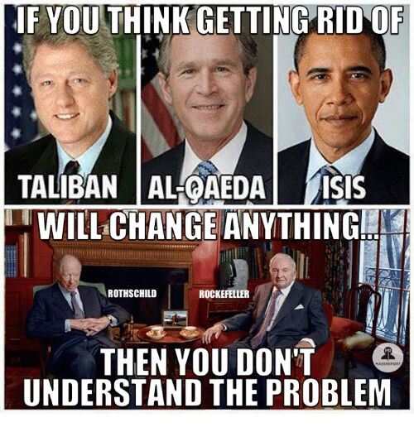
Participant 41(3): [no caption]
Date: February 14 at 1:18am Likes: 4

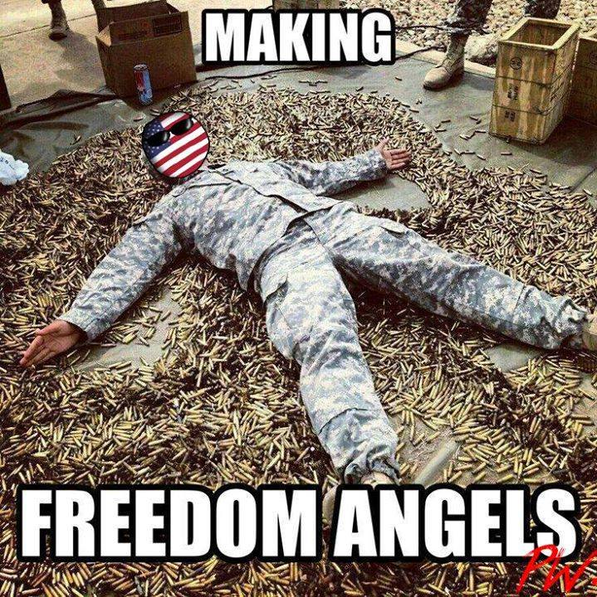
Participant 42: [no caption]
Date: February 14 at 1:35am Likes: 7

Participant 43: {tagging Participant 41.1}
Date: February 14 at 2:02am Likes: 0

Participant 43.1: si, pero ves, la solucion brasilena seria mucha mas pacifica
Date: February 14 at 5:53am Likes: 1

Participant 44: (Thrash dove)
Date: February 13 at 2:11am Likes: 1

Participant 45: {tagging Participant 43.1}
Date: February 14 at 3:30am Likes: 2

Participant 45.1: Akurat
Date: February 14 at 3:31am Likes: 1

Participant 46: Best idea ever! Hahahha
Date: February 14 at 3:36am Likes: 1

Participant 47: HUEHUEHUEHUEHUEHUEHUEHUE BRBRBRBRBRBRBRBBRBR
Date: February 14 at 3:37am Likes: 1

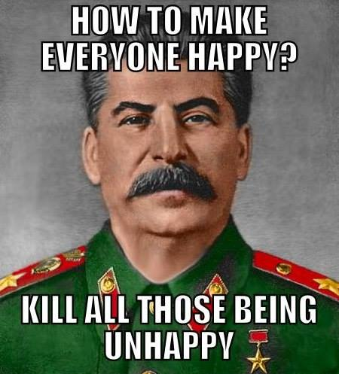
Participant 48: [no caption]
Date: February 14 at 5:00am Likes: 9

Participant 49: (Thrash dove)
Date: February 14 at 6:35am Likes: 0

Participant 50: {tagging a person}
Date: February 14 at 7:52am Likes: 0

Participant 51: {tagging a person}
If they do this in CLMUN XD
Date: February 14 at 11:27am Likes: 0

Participant 52:{tagging a person}
Date: February 14 at 11:53am Likes: 1

Participant 53: {tagging Participant 51.1}
Date: February 15 at 6:14 am Likes: 0

Participant 53.1: [no caption]
Date: February 15 at 6:17am Likes: 0

Excerpt 2
Post details
Caption: made of {Icelandball}
Date of publication: February 6, 2017
Reactions: over 1,800
Shares: 61
Comments: 60
The number of participants in the comment section: 54

Comments in chronological order:

Participant 1: of sad
Date: February 6 at 11:59pm Likes 31

Participant 1.1 [Polandball 2.0]: mani sads, kurwa ;-;
Date: February 6 at 11:59pm Likes 20

Participant 2: BrazilBall is with ya
Date: February 7 at 12:00am Likes 11

Participant 2.1: Does "with ya" mean "white" in Brazilian?
Date: February 7 at 12:55am Likes 0
Participant 2: lol no, white is Branco
Date: February 7 at 1:14am Likes 0
Participant 2.2: Participant 2.1 Especially since there's no such thing as Brazilian language
Date: February 7 at 5:50pm Likes 0
Participant 2: Ye, lol
Date: February 7 at 5:51pm Likes 0

Participant 3: Why? Why do this with little Poland? ;-;
Date: February 7 at 12:02 pm Likes 0

Participant 4: {tagging a person} zuckerban
Date: February 7 at 12:03am Likes 1

Participant 5: S O O N
Date: February 7 at 12:03am Likes 3

Participant 6: Polan can into Facebook?
Date: February 7 at 12:05am Likes 0 Edited

Participant 7: Be careful...
Date: February 7 at 12:05am Likes 0

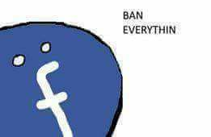
Participant 8: [no caption]
Date: February 7 at 12:05am Likes 43

Participant 9: [no caption]
Date: February 7 at 12:05am Likes 3

Participant 10: Is this the first appearance of a Facebookball? Gives me shivers!
Date: February 7 at 12:06am Likes 5

Participant 10.1 [Icelandball]: Hmm i think we have comics with it - éma
Date: February 7 at 12:14am Likes 2
Participant 10.2: Nah but usually Facebook is represented using the rectangle, like for the German empire- since you know. Banschluss.
Date: February 7 at 12:14am Likes 4
Participant 10.3: On Reddit, the German Empire is just a ball, not to be confused with the Reichtangle.

Here, the German Empire can be both the ball and the rectangle.
As for Facebook, its representation is unofficial, but usually known as Faceblock. When not in banschluss mode, it is in the form of a square or a cube (like Michigan or Israel). In banschluss mode, it is in the form of a rectangle, echoing the Reichtangle.
Date: February 7 at 12:28am Likes 1
Participant 10: Wow (flushed face emoji) gonna take note of this
Date: February 7 at 12:30am Likes 0

Participant 11: Zuckerberg seu desgraçado!
Date: February 7 at 12:08am Likes 7

Participant 11.1: Odeio o Zuckerberg e vou caça-lo!
Date: February 7 at 12:08am Likes 1

Participant 12: Facebook....... why (sad emoticon)
Date: February 7 at 12:12am Likes 5

Participant 13: I give this page 1 week
Date: February 7 at 12:21am Likes 5

Participant 13.1: Kurwa ;-;
Date: February 7 at 3:31am Likes 4
Participant 13.2: Not my fold. You allways find a way to get banned (laughing emoticon)
Date: February 7 at 12:34am Likes 0

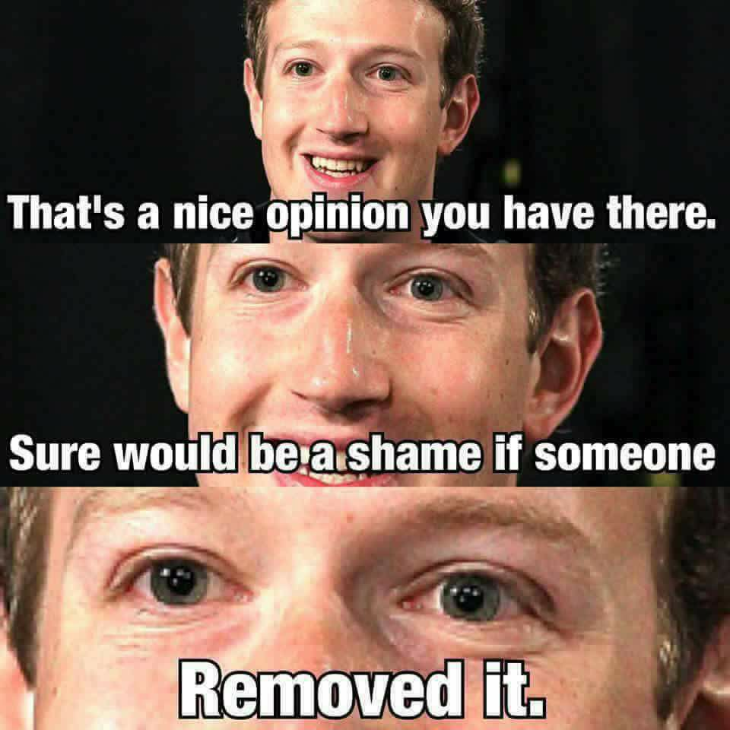
Participant 14: [no caption]
Date: February 7 at 12:21am Likes 50

Participant 14.1: AHHHHHHHHHHHHHHHHH!
Date: February 7 at 12:26am Likes 2

Participant 15: Soon...
Date: February 7 at 12:26am Likes 0

Participant 16: Make {POLANDBALL} great again. But you suffer even on facebook, my God.
Date: February 7 at 12:28am Likes 4 Edited

Participant 17: Run polen! Facebloc is going to blitz a banschluss!!!!
Date: February 7 at 12:35am Likes 1

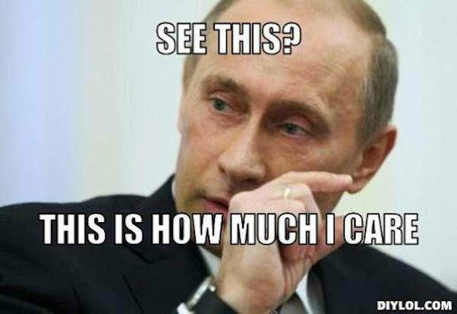
Participant 18: [no caption]
Date: February 7 at 12:44am Likes 5

Participant 19: [no caption]
Date: February 7 at 12:47am Likes 19

Participant 20: {tagging a person}
Date: February 7 at 12:55am Likes 0

Participant 21: YOU GONA HAVE DIS TIME
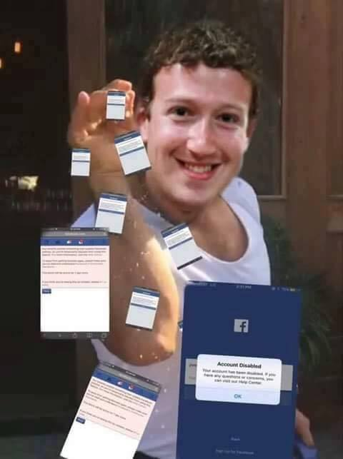
Date: February 7 at 12:57am Likes 16

Participant 22: I'm so sad {tagging a person}
Date: February 7 at 1:13am Likes 0

Participant 23: BrazilBall is with you
Date: February 7 at 2:23am Likes 5

Participant 24: inb4 zucc
Date: February 7 at 2:44am Likes 0

Participant 25: *before PolandBall was banned*
Me: wanna hear a joke?
Friend: what?
Me: Human rights in North Korea
Friend: Haha (laughing emoticon)

*after PolandBall was banned*
Me: wanna hear a joke?
Friend: what?
Me: PolandBall rights on Facebook
Friend: Haha (laughing emoticon)
Date: February 7 at 2:50am Likes 0

Participant 1.1 [Polandball 2.0]: Kurwa ;-;
Date: February 7 at 3:29am Likes 0
Participant 25: {POLANDBALL} , i am very sorry for your lost
Date: February 7 at 3:30am Likes 0

Participant 10.1: We support you guys!
Date: February 7 at 3:33am Likes 0

Participant 26: OFFENSIVE!
Date: February 7 at 3:36am Likes 0

Participant 27: Ban (pistol emoji)
Date: February 7 at 3:44am Likes 0

Participant 28: Zucced
Date: February 7 at 4:30am Likes 1

Participant 29: Omh facebook live poland in peace
Date: February 7 at 4:49am Likes 1 Edited

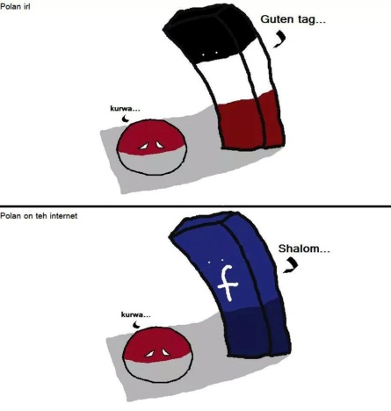
Participant 30: [no caption]
Date: February 7 at 6:56am Likes 26

Participant 31: zucc'd
Date: February 7 at 7:34am Likes 0 Edited

Participant 32: Why were you banned?
Date: February 7 at 8:19am Likes 1 Edited
Participant 32.1: wrongthink
Date: February 7 at 8:53am Likes 1 Edited
Participant 32: ?
Date: February 7 at 8:55am Likes 0
Participant 32.2: ??
Date: February 7 at 11:50am Likes 0
Participant 32.3: ???
Date: February 7 at 2:47pm Likes 0
Participant 32.4: ????
Date: February 7 at 3:27pm Likes 0

Participant 33: {tagging a person}
Date: February 7 at 8:27am Likes 0

Participant 34: {tagging a person}
Date: February 7 at 9:43am Likes 1

Participant 35: Scared.jpg
Date: February 7 at 12:00pm Likes 1

Participant 36: {tagging a person} kurwa
Date: February 7 at 12:32pm Likes 2

Participant 37: of triggers!
Date: February 7 at 5:29pm Likes 0

Participant 38: silly polen thinks can into happiness
Date: February 7 at 8:49pm Likes 0

Participant 39: CUCKBERG
Date: February 7 at 9:33pm Likes 0

