Identifying the mechanisms that shape fungal community and metacommunity patterns in Yunnan, China.
Running title: Metacommunity structure of soil fungi in Yunnan, China
Kingsly C. Beng^{1*}; Richard T. Corlett¹
¹Center for Integrative Conservation, Xishuangbanna Tropical Botanical Garden, Chinese Academy of Sciences, Menglun, Mengla, Yunnan, 666303, China
*Corresponding author
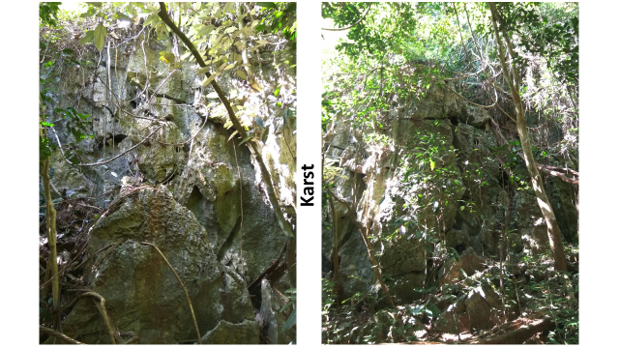

Figure S1 Limestone outcrops in karst forests
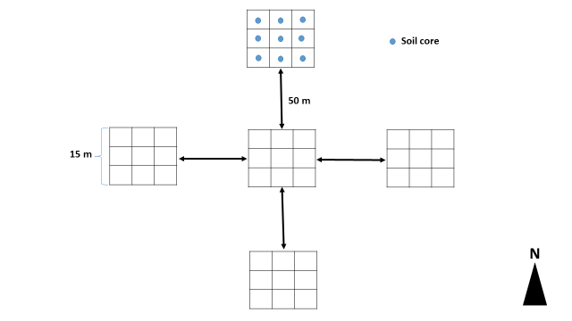
Figure S2 Schematic diagram of sampling design showing the five plots per site, the approximate distance between any two plots and the nine soil cores collected per plot.

Figure S3 Differences in fungal alpha and beta diversity indices between karst and non-karst soils for the Agaricomycetes dataset.

Figure S4 Differences in fungal alpha and beta diversity indices between karst and non-karst soils for the Dothideomycetes dataset.

Figure S5 Differences in fungal alpha and beta diversity indices between karst and non-karst soils for the Eurotiomycetes dataset.

Figure S6 Differences in fungal alpha and beta diversity indices between karst and non-karst soils for the Leotiomycetes dataset.

Figure S7 Differences in fungal alpha and beta diversity indices between karst and non-karst soils for the Sordariomycetes dataset.

Figure S8 Differences in fungal alpha and beta diversity indices between karst and non-karst soils for the Tremellomycetes dataset.

Figure S9 Differences in fungal alpha and beta diversity indices between karst and non-karst soils for the pathotrophs dataset.

Figure S10 Differences in fungal alpha and beta diversity indices between karst and non-karst soils for the saprotrophs dataset.

Figure S11 Differences in fungal alpha and beta diversity indices between karst and non-karst soils for the symbiotrophs dataset.

