ANALYSIS: PD+PA vs. PD-PA vs. Controls

MINUTE VOLUME

Repeated Measures ANOVA
Within Subjects Effects
 |  | Sphericity Correction |  | Sum of Squares |  | df |  | Mean Square |  | F |  | p
Time |  | Greenhouse-Geisser |  | 80.703 | ᵃ | 4.790 | ᵃ | 16.850 | ᵃ | 2.609 | ᵃ | 0.028 | ᵃ
Time ✻ GroupF |  | Greenhouse-Geisser |  | 276.075 | ᵃ | 9.579 | ᵃ | 28.821 | ᵃ | 4.463 | ᵃ | < .001 | ᵃ
Residual |  | Greenhouse-Geisser |  | 1113.431 |  | 172.424 |  | 6.458
Note. Type III Sum of Squares
ᵃ Mauchly's test of sphericity indicates that the assumption of sphericity is violated (p < .05).

Between Subjects Effects
 |  | Sum of Squares |  | df |  | Mean Square |  | F |  | p
GroupF |  | 818.1 |  | 2 |  | 409.06 |  | 5.832 |  | 0.006
Residual |  | 2525.0 |  | 36 |  | 70.14
Note. Type III Sum of Squares

Assumption Checks
Test of Sphericity
 |  | Mauchly's W |  | p |  | Greenhouse-Geisser ε |  | Huynh-Feldt ε
Minute Volume |  | 0.004 |  | < .001 |  | 0.435 |  | 0.510

Post Hoc Tests
Post Hoc Comparisons - GroupF
 |  |  |  | Mean Difference |  | SE |  | t |  | p _{holm}
Control |  | PD-PA |  | -0.713 |  | 0.922 |  | -0.773 |  | 0.445
 |  | PD+PA |  | -3.579 |  | 1.049 |  | -3.411 |  | 0.005
PD-PA |  | PD+PA |  | -2.866 |  | 1.191 |  | -2.406 |  | 0.043

Descriptives Plot (SE)
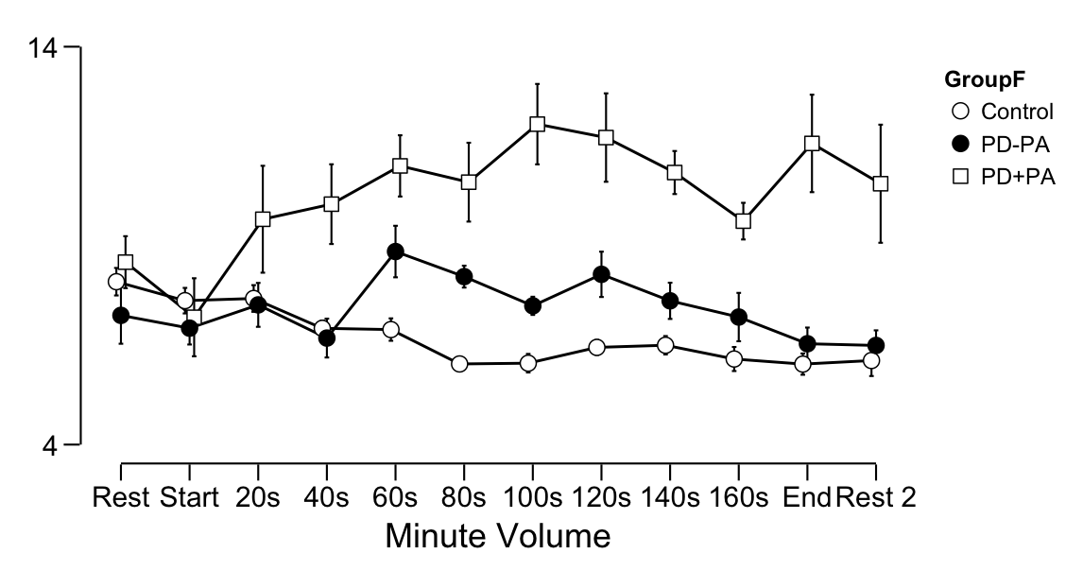
Descriptives Plot (95% CI)

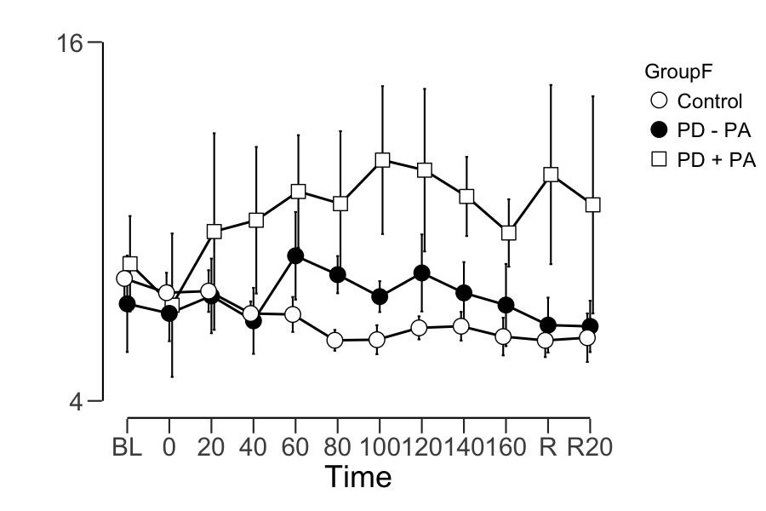

RESPIRATORY RATE

Results

Repeated Measures ANOVA
Within Subjects Effects
 |  | Sphericity Correction |  | Sum of Squares |  | df |  | Mean Square |  | F |  | p
Time |  | Greenhouse-Geisser |  | 493.839 | ᵃ | 5.337 | ᵃ | 92.524 | ᵃ | 3.468 | ᵃ | 0.004 | ᵃ
Time ✻ GroupF |  | Greenhouse-Geisser |  | 673.234 | ᵃ | 10.675 | ᵃ | 63.067 | ᵃ | 2.364 | ᵃ | 0.010 | ᵃ
Residual |  | Greenhouse-Geisser |  | 5126.741 |  | 192.147 |  | 26.681
Note. Type III Sum of Squares
ᵃ Mauchly's test of sphericity indicates that the assumption of sphericity is violated (p < .05).

Between Subjects Effects
 |  | Sum of Squares |  | df |  | Mean Square |  | F |  | p
GroupF |  | 1716 |  | 2 |  | 857.9 |  | 2.716 |  | 0.080
Residual |  | 11371 |  | 36 |  | 315.9
Note. Type III Sum of Squares

Assumption Checks
Test of Sphericity
 |  | Mauchly's W |  | p |  | Greenhouse-Geisser ε |  | Huynh-Feldt ε
Respiratory Rate |  | 0.014 |  | < .001 |  | 0.485 |  | 0.580

Post Hoc Tests
Post Hoc Comparisons - GroupF
 |  |  |  | Mean Difference |  | SE |  | t |  | p _{holm}
Control |  | PD-PA |  | -0.907 |  | 1.957 |  | -0.464 |  | 0.646
 |  | PD+PA |  | -5.173 |  | 2.226 |  | -2.324 |  | 0.078
PD-PA |  | PD+PA |  | -4.266 |  | 2.528 |  | -1.687 |  | 0.200

Descriptives Plot (SE)
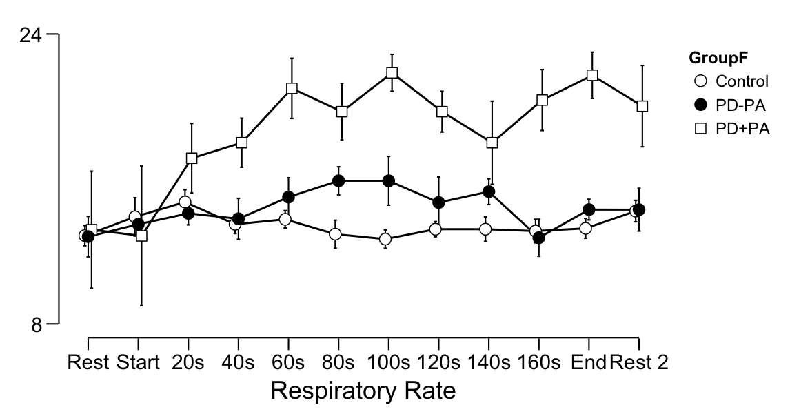

Descriptives Plot (95% CI)

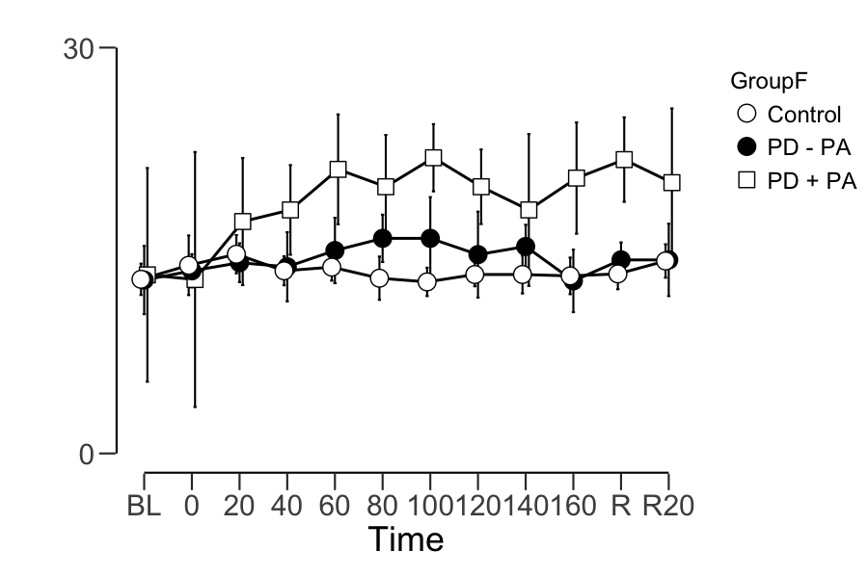

TIDAL VOLUME

Repeated Measures ANOVA
Within Subjects Effects
 |  | Sphericity Correction |  | Sum of Squares |  | df |  | Mean Square |  | F |  | p
Time |  | Greenhouse-Geisser |  | 0.433 | ᵃ | 6.215 | ᵃ | 0.070 | ᵃ | 1.652 | ᵃ | 0.131 | ᵃ
Time ✻ GroupF |  | Greenhouse-Geisser |  | 0.471 | ᵃ | 12.430 | ᵃ | 0.038 | ᵃ | 0.898 | ᵃ | 0.552 | ᵃ
Residual |  | Greenhouse-Geisser |  | 9.442 |  | 223.742 |  | 0.042
Note. Type III Sum of Squares
ᵃ Mauchly's test of sphericity indicates that the assumption of sphericity is violated (p < .05).

Between Subjects Effects
 |  | Sum of Squares |  | df |  | Mean Square |  | F |  | p
GroupF |  | 0.590 |  | 2 |  | 0.295 |  | 0.411 |  | 0.666
Residual |  | 25.853 |  | 36 |  | 0.718
Note. Type III Sum of Squares

Assumption Checks
Test of Sphericity
 |  | Mauchly's W |  | p |  | Greenhouse-Geisser ε |  | Huynh-Feldt ε
Tidal Volume |  | 0.011 |  | < .001 |  | 0.565 |  | 0.696

Post Hoc Tests
Post Hoc Comparisons - GroupF
 |  |  |  | Mean Difference |  | SE |  | t |  | p _{holm}
Control |  | PD-PA |  | -0.031 |  | 0.093 |  | -0.329 |  | 1.000
 |  | PD+PA |  | -0.096 |  | 0.106 |  | -0.902 |  | 1.000
PD-PA |  | PD+PA |  | -0.065 |  | 0.121 |  | -0.540 |  | 1.000

Descriptives Plot (SE)
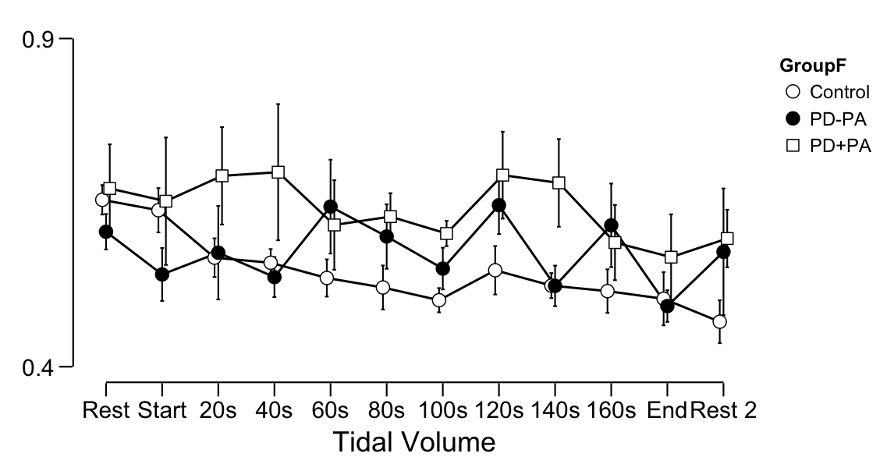

Descriptives Plot (95% CI)

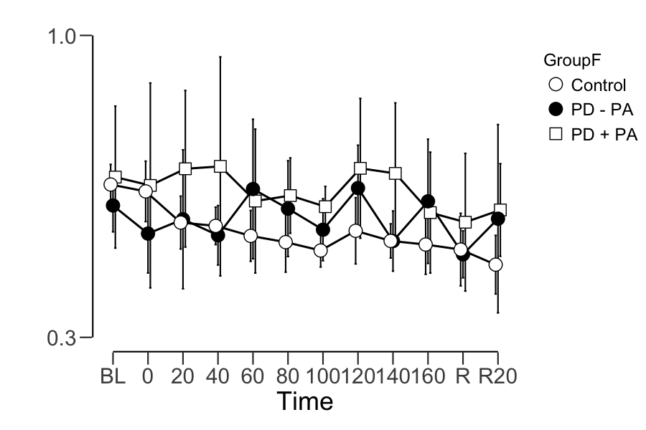

RSSQ RESPIRATORY VOLUME

Rssq Vol resp by group
ANOVA
 |  | Sum of Squares |  | df |  | Mean Square |  | F |  | p
GroupF |  | 0.224 |  | 2 |  | 0.1118 |  | 9.94 |  | < .001
Residuals |  | 0.405 |  | 36 |  | 0.0112

Post Hoc Tests
Post Hoc Comparisons - GroupF
Comparison
GroupF |  |  |  | GroupF |  | Mean Difference |  | SE |  | df |  | t |  | ptukey
Control |  | - |  | PD - PA |  | -0.0677 |  | 0.0404 |  | 36.0 |  | -1.67 |  | 0.229
 |  | - |  | PD + PA |  | -0.2041 |  | 0.0460 |  | 36.0 |  | -4.43 |  | < .001
PD - PA |  | - |  | PD + PA |  | -0.1364 |  | 0.0523 |  | 36.0 |  | -2.61 |  | 0.034

Descriptive Plot (SE)
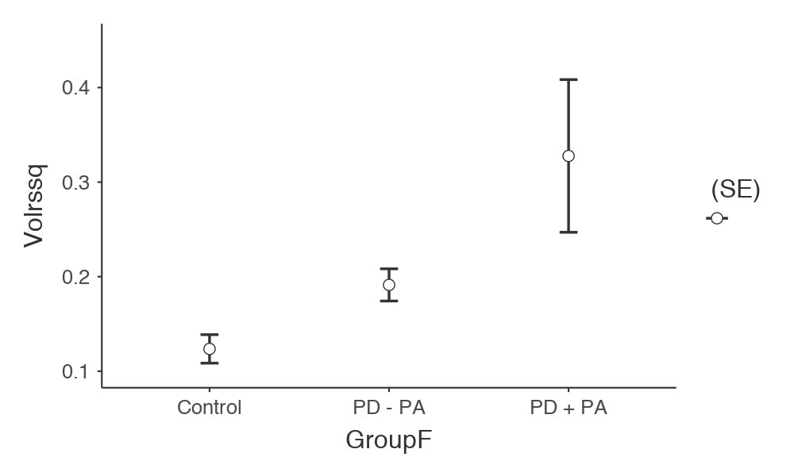
RSSQ RESPIRATORY AMPLITUDE (RA) AND PERIOD (RP)

Kruskal-Wallis
 |  | χ² |  | df |  | p
RArssq |  | 14.91 |  | 2 |  | < .001
RPrssq |  | 7.72 |  | 2 |  | 0.021

Dwass-Steel-Critchlow-Fligner pairwise comparisons
Pairwise comparisons - RArssq
 |  |  |  | W |  | p
Control |  | PD - PA |  | 3.80 |  | 0.007
Control |  | PD + PA |  | 4.54 |  | 0.001
PD - PA |  | PD + PA |  | 2.62 |  | 0.064

PLOT
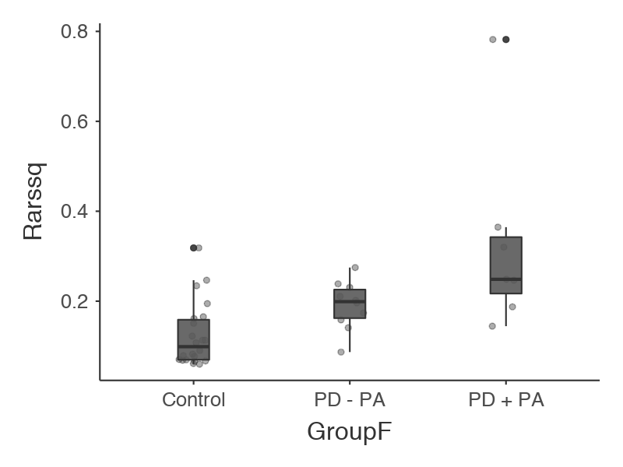

Pairwise comparisons - RPrssq
 |  |  |  | W |  | p
Control |  | PD - PA |  | 3.220 |  | 0.023
Control |  | PD + PA |  | 3.027 |  | 0.032
PD - PA |  | PD + PA |  | 0.138 |  | 0.922

PLOT
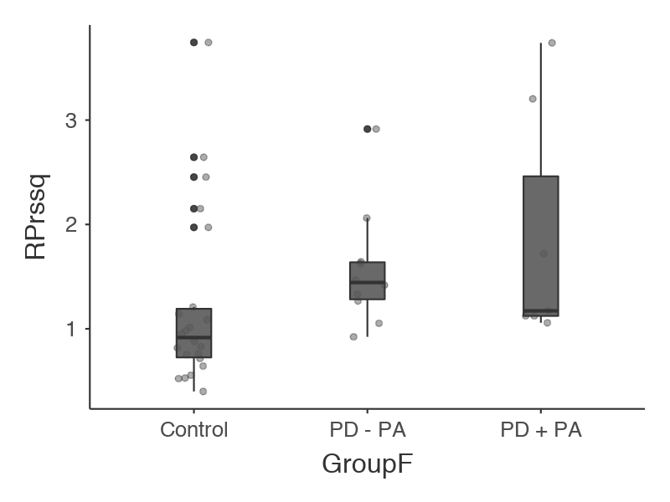

HEART RATE

Results

Repeated Measures ANOVA
Within Subjects Effects
 |  | Sphericity Correction |  | Sum of Squares |  | df |  | Mean Square |  | F |  | p
Time |  | Greenhouse-Geisser |  | 731.601 | ᵃ | 3.229 | ᵃ | 226.567 | ᵃ | 4.429 | ᵃ | 0.004 | ᵃ
Time ✻ GroupF |  | Greenhouse-Geisser |  | 414.607 | ᵃ | 6.458 | ᵃ | 64.199 | ᵃ | 1.255 | ᵃ | 0.281 | ᵃ
Residual |  | Greenhouse-Geisser |  | 5946.079 |  | 116.246 |  | 51.151
Note. Type III Sum of Squares
ᵃ Mauchly's test of sphericity indicates that the assumption of sphericity is violated (p < .05).

Between Subjects Effects
 |  | Sum of Squares |  | df |  | Mean Square |  | F |  | p
GroupF |  | 2103.563 |  | 2 |  | 1051.781 |  | 0.495 |  | 0.614
Residual |  | 76465.579 |  | 36 |  | 2124.044
Note. Type III Sum of Squares

Assumption Checks
Test of Sphericity
 |  | Mauchly's W |  | p |  | Greenhouse-Geisser ε |  | Huynh-Feldt ε
Heart Rate |  | 6.550e -4 |  | < .001 |  | 0.362 |  | 0.413

Post Hoc Tests
Post Hoc Comparisons - GroupF
 |  |  |  | Mean Difference |  | SE |  | t |  | p _{holm}
Control |  | PD-PA |  | -0.014 |  | 0.024 |  | -0.573 |  | 0.685
 |  | PD+PA |  | -0.044 |  | 0.028 |  | -1.596 |  | 0.357
PD-PA |  | PD+PA |  | -0.030 |  | 0.031 |  | -0.962 |  | 0.685

Descriptives Plot (SE)
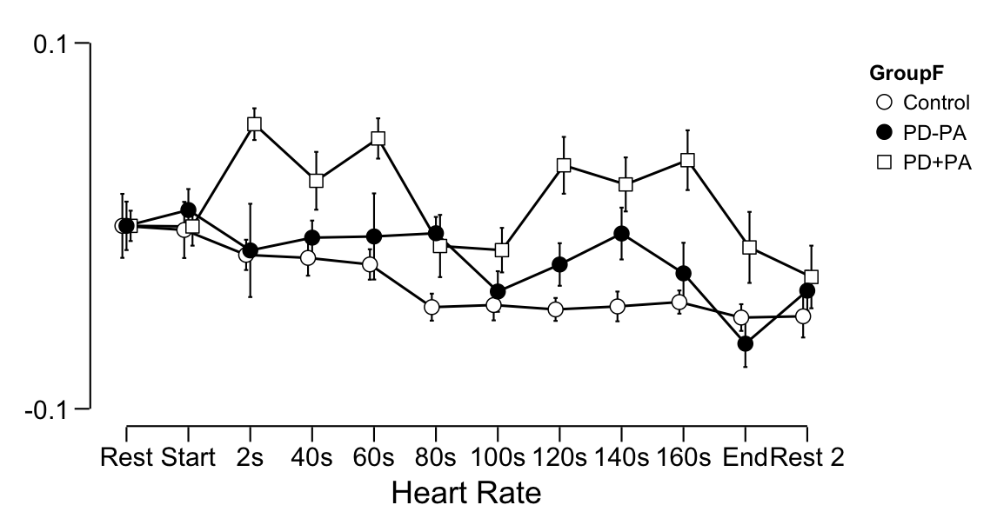

Descriptives Plot (95% IC)
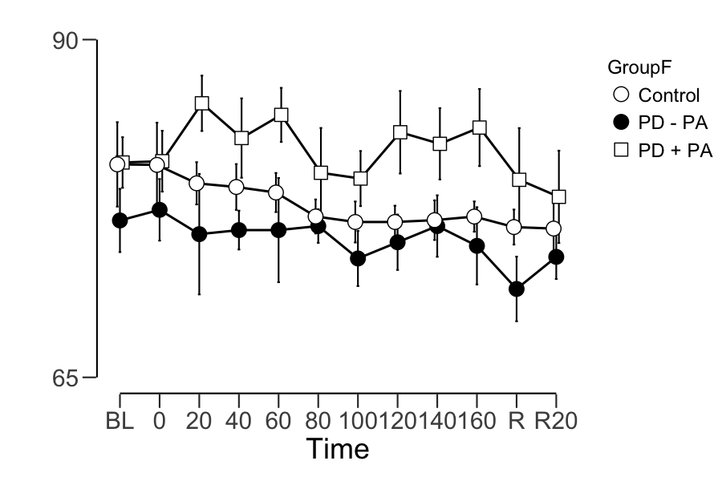

ELECTRODERMAL RESPONSE MAGNITUDE (ERM)

Results

Repeated Measures ANOVA
Within Subjects Effects
 |  | Sphericity Correction |  | Sum of Squares |  | df |  | Mean Square |  | F |  | p
Time |  | Greenhouse-Geisser |  | 21.675 | ᵃ | 4.388 | ᵃ | 4.939 | ᵃ | 6.518 | ᵃ | < .001 | ᵃ
Time ✻ GroupF |  | Greenhouse-Geisser |  | 12.767 | ᵃ | 8.777 | ᵃ | 1.455 | ᵃ | 1.920 | ᵃ | 0.054 | ᵃ
Residual |  | Greenhouse-Geisser |  | 119.719 |  | 157.983 |  | 0.758
Note. Type III Sum of Squares
ᵃ Mauchly's test of sphericity indicates that the assumption of sphericity is violated (p < .05).

Between Subjects Effects
 |  | Sum of Squares |  | df |  | Mean Square |  | F |  | p
GroupF |  | 17.110 |  | 2 |  | 8.555 |  | 3.202 |  | 0.053
Residual |  | 96.200 |  | 36 |  | 2.672
Note. Type III Sum of Squares

Assumption Checks
Test of Sphericity
 |  | Mauchly's W |  | p |  | Greenhouse-Geisser ε |  | Huynh-Feldt ε
Relative SCR |  | 6.355e -4 |  | < .001 |  | 0.399 |  | 0.461

Post Hoc Tests
Post Hoc Comparisons - GroupF
 |  |  |  | Mean Difference |  | SE |  | t |  | p _{holm}
Control |  | PD-PA |  | -0.124 |  | 0.180 |  | -0.687 |  | 0.496
 |  | PD+PA |  | -0.518 |  | 0.205 |  | -2.530 |  | 0.048
PD-PA |  | PD+PA |  | -0.394 |  | 0.233 |  | -1.696 |  | 0.197

Descriptives Plot (SE)
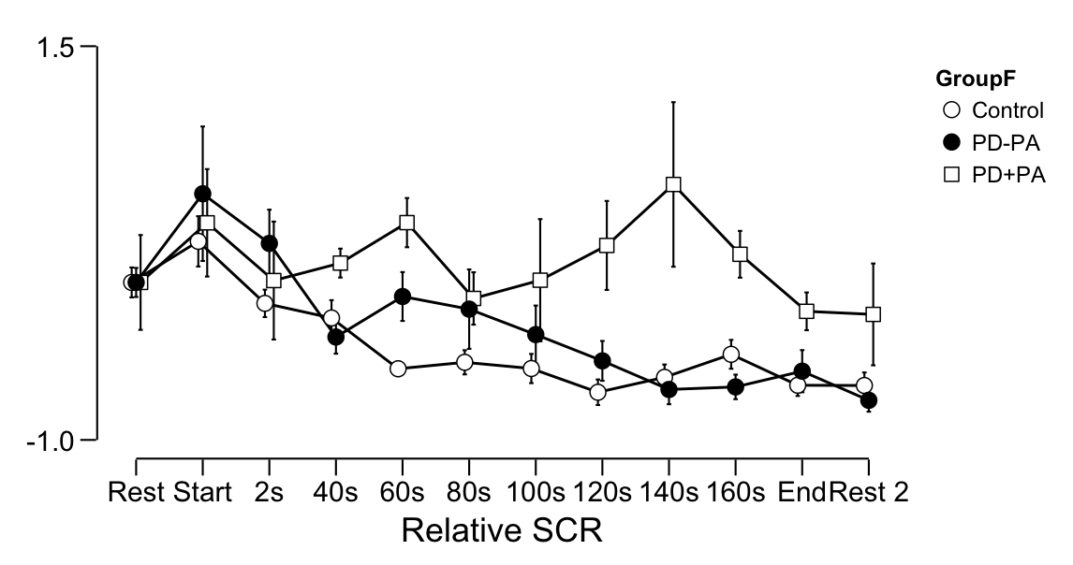

Descriptives Plot (95% CI)

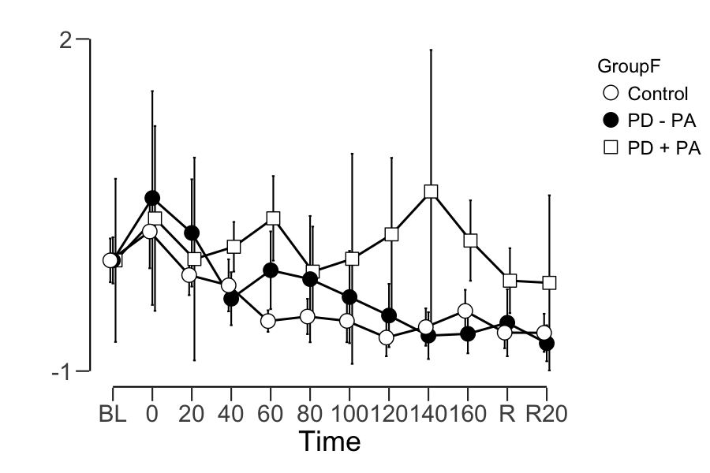

SKIN CONDUCTANCE LEVEL - SCL

Repeated Measures ANOVA
Within Subjects Effects
 |  | Sphericity Correction |  | Sum of Squares |  | df |  | Mean Square |  | F |  | p
Time |  | Greenhouse-Geisser |  | 0.968 | ᵃ | 1.830 | ᵃ | 0.529 | ᵃ | 21.532 | ᵃ | < .001 | ᵃ
Time ✻ GroupF |  | Greenhouse-Geisser |  | 0.336 | ᵃ | 3.660 | ᵃ | 0.092 | ᵃ | 3.737 | ᵃ | 0.010 | ᵃ
Residual |  | Greenhouse-Geisser |  | 1.618 |  | 65.877 |  | 0.025
Note. Type III Sum of Squares
ᵃ Mauchly's test of sphericity indicates that the assumption of sphericity is violated (p < .05).

Between Subjects Effects
 |  | Sum of Squares |  | df |  | Mean Square |  | F |  | p
GroupF |  | 1.172 |  | 2 |  | 0.586 |  | 5.550 |  | 0.008
Residual |  | 3.801 |  | 36 |  | 0.106
Note. Type III Sum of Squares

Assumption Checks
Test of Sphericity
 |  | Mauchly's W |  | p |  | Greenhouse-Geisser ε |  | Huynh-Feldt ε
Time |  | 3.780e -12 |  | < .001 |  | 0.166 |  | 0.175

Descriptives Plot (95% CI)
