ANALYSIS: PD vs. Controls

MINUTE VOLUME
Within Subjects Effects
 |  | Sphericity Correction |  | Sum of Squares |  | df |  | Mean Square |  | F |  | p
Time |  | Greenhouse-Geisser |  | 63.456 | ᵃ | 4.923 | ᵃ | 12.889 | ᵃ | 1.970 | ᵃ | 0.086 | ᵃ
Time ✻ Grupo |  | Greenhouse-Geisser |  | 188.754 | ᵃ | 4.923 | ᵃ | 38.339 | ᵃ | 5.860 | ᵃ | < .001 | ᵃ
Residual |  | Greenhouse-Geisser |  | 1223.951 |  | 187.085 |  | 6.542
Note. Type III Sum of Squares
ᵃ Mauchly's test of sphericity indicates that the assumption of sphericity is violated (p < .05).

Between Subjects Effects
 |  | Sum of Squares |  | df |  | Mean Square |  | F |  | p
Grupo |  | 469.249 |  | 1 |  | 469.249 |  | 5.942 |  | 0.020
Residual |  | 3000.876 |  | 38 |  | 78.970
Note. Type III Sum of Squares

Descriptives

Descriptives Plot (95% CI)
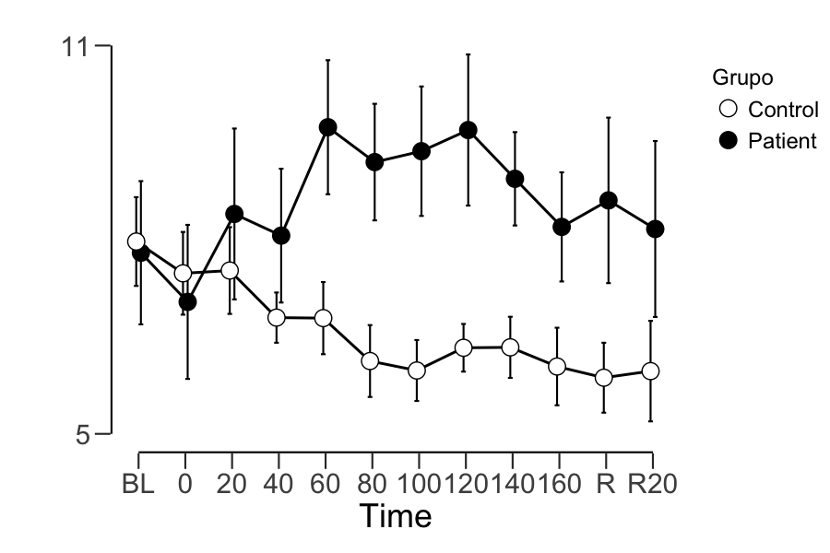

RESPIRATORY RATE

Within Subjects Effects
 |  | Sphericity Correction |  | Sum of Squares |  | df |  | Mean Square |  | F |  | p
Time |  | Greenhouse-Geisser |  | 272.253 | ᵃ | 5.185 | ᵃ | 52.506 | ᵃ | 1.891 | ᵃ | 0.095 | ᵃ
Time ✻ Grupo |  | Greenhouse-Geisser |  | 386.913 | ᵃ | 5.185 | ᵃ | 74.620 | ᵃ | 2.687 | ᵃ | 0.021 | ᵃ
Residual |  | Greenhouse-Geisser |  | 5471.339 |  | 197.035 |  | 27.768
Note. Type III Sum of Squares
ᵃ Mauchly's test of sphericity indicates that the assumption of sphericity is violated (p < .05).

Between Subjects Effects
 |  | Sum of Squares |  | df |  | Mean Square |  | F |  | p
Grupo |  | 894.739 |  | 1 |  | 894.739 |  | 2.758 |  | 0.105
Residual |  | 12328.589 |  | 38 |  | 324.437
Note. Type III Sum of Squares

Descriptives

Descriptives Plot (95% CI)
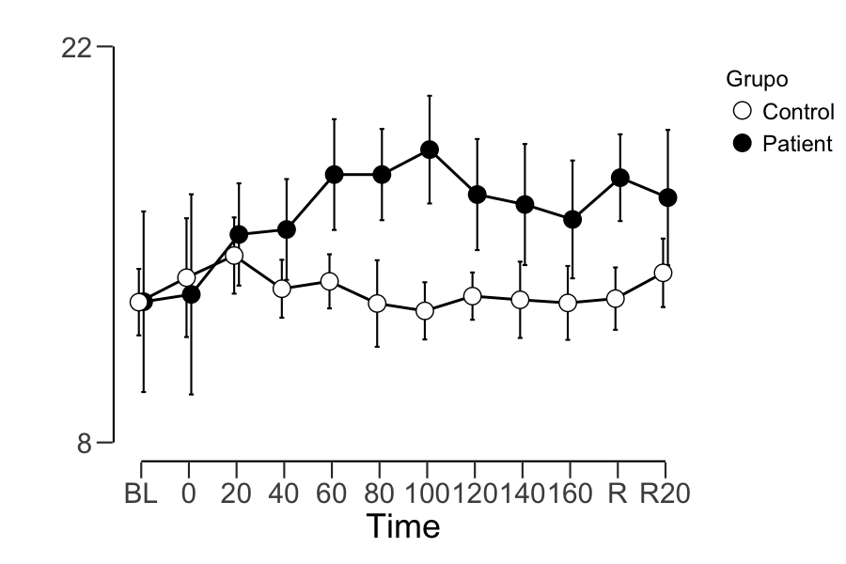

TIDAL VOLUME

Within Subjects Effects
 |  | Sphericity Correction |  | Sum of Squares |  | df |  | Mean Square |  | F |  | p
Time |  | Greenhouse-Geisser |  | 0.594 | ᵃ | 6.345 | ᵃ | 0.094 | ᵃ | 2.310 | ᵃ | 0.032 | ᵃ
Time ✻ Grupo |  | Greenhouse-Geisser |  | 0.272 | ᵃ | 6.345 | ᵃ | 0.043 | ᵃ | 1.059 | ᵃ | 0.389 | ᵃ
Residual |  | Greenhouse-Geisser |  | 9.774 |  | 241.111 |  | 0.041
Note. Type III Sum of Squares
ᵃ Mauchly's test of sphericity indicates that the assumption of sphericity is violated (p < .05).

Between Subjects Effects
 |  | Sum of Squares |  | df |  | Mean Square |  | F |  | p
Grupo |  | 0.494 |  | 1 |  | 0.494 |  | 0.711 |  | 0.404
Residual |  | 26.394 |  | 38 |  | 0.695
Note. Type III Sum of Squares

Descriptives

Descriptives Plot (95% CI)
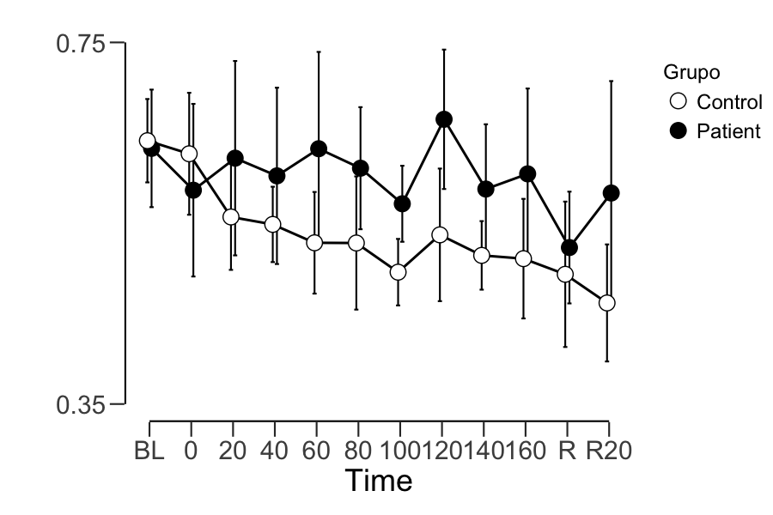

RSSQ RESPIRATORY AMPLITUDE (RA) AND PERIOD (RP)

Independent Samples T-Test
 |  |  |  |  |  |  |  |  |  | 95% Confidence Interval
 |  |  |  | statistic |  | p |  | Cohen's d |  | Lower |  | Upper
Rarssq |  | Mann-Whitney U |  | 59.0 |  | < .001 |  | -1.098 |  | -0.145 |  | -0.0620
RPrssq |  | Mann-Whitney U |  | 98.0 |  | 0.007 |  | -0.568 |  | -0.775 |  | -0.1704

Group Descriptives
 |  | Group |  | N |  | Mean |  | Median |  | SD |  | SE
Rarssq |  | Control |  | 23 |  | 0.124 |  | 0.107 |  | 0.0691 |  | 0.0144
 |  | Patient |  | 17 |  | 0.247 |  | 0.211 |  | 0.153 |  | 0.0372
RPrssq |  | Control |  | 23 |  | 1.227 |  | 0.953 |  | 0.8293 |  | 0.1729
 |  | Patient |  | 17 |  | 1.697 |  | 1.418 |  | 0.824 |  | 0.1999

Respiratory amplitude RSSQ plot (95% CI)

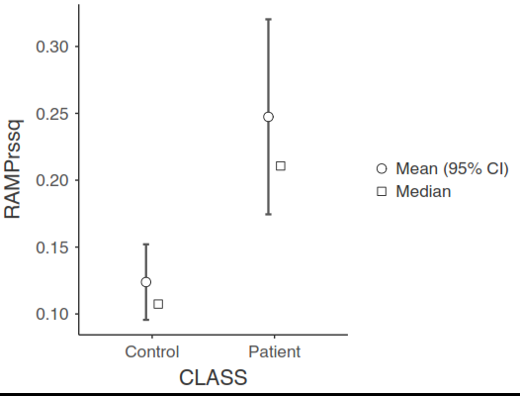

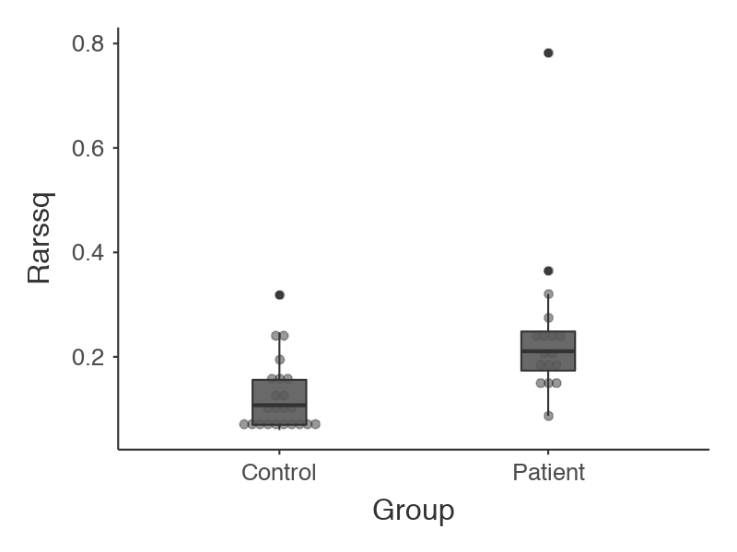

Respiratory period RSSQ plot (95% CI)
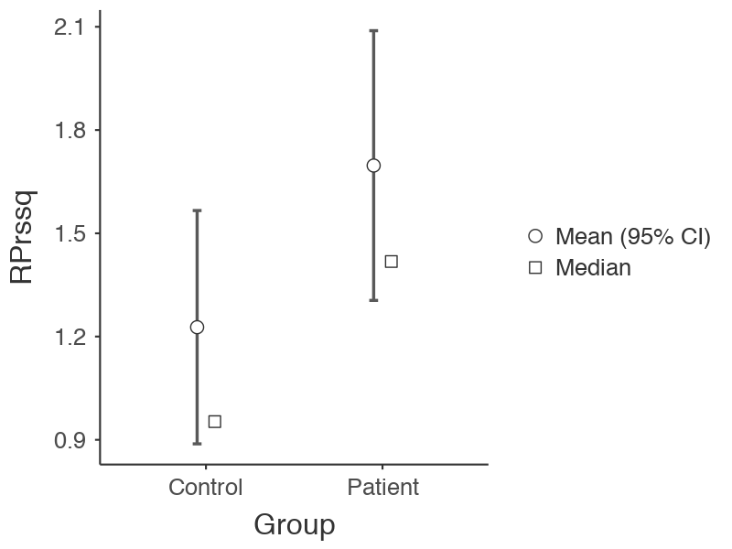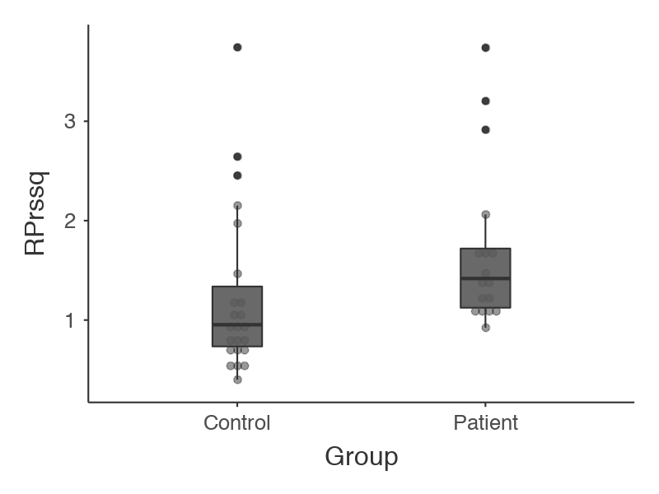

HEART RATE
Within Subjects Effects
 |  | Sphericity Correction |  | Sum of Squares |  | df |  | Mean Square |  | F |  | p
Time |  | Greenhouse-Geisser |  | 892.854 | ᵃ | 3.360 | ᵃ | 265.750 | ᵃ | 5.460 | ᵃ | < .001 | ᵃ
Time ✻ Grupo |  | Greenhouse-Geisser |  | 199.228 | ᵃ | 3.360 | ᵃ | 59.299 | ᵃ | 1.218 | ᵃ | 0.306 | ᵃ
Residual |  | Greenhouse-Geisser |  | 6214.280 |  | 127.670 |  | 48.674
Note. Type III Sum of Squares
ᵃ Mauchly's test of sphericity indicates that the assumption of sphericity is violated (p < .05).

Between Subjects Effects
 |  | Sum of Squares |  | df |  | Mean Square |  | F |  | p
Grupo |  | 46.554 |  | 1 |  | 46.554 |  | 0.022 |  | 0.883
Residual |  | 80477.470 |  | 38 |  | 2117.828
Note. Type III Sum of Squares

Descriptives

Descriptives Plot (95% CI)
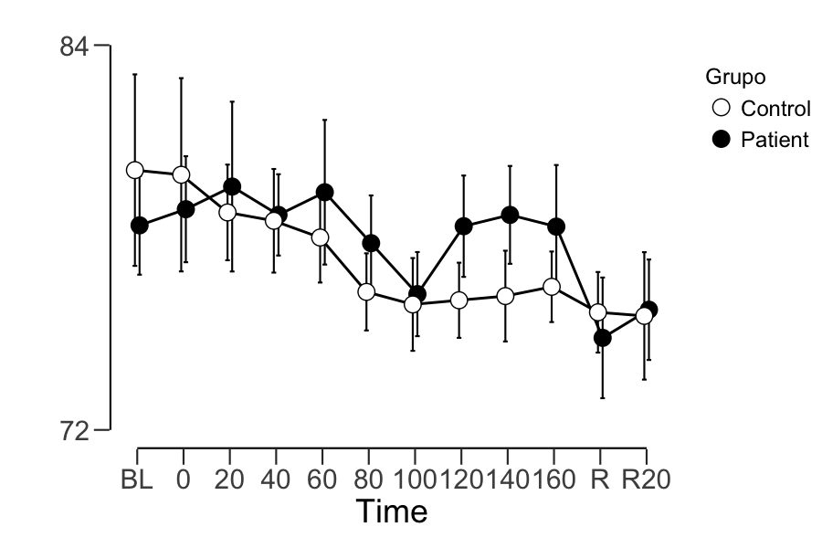

ELECTRODERMAL RESPONSE MAGNITUDE (ERM)

Within Subjects Effects
 |  | Sphericity Correction |  | Sum of Squares |  | df |  | Mean Square |  | F |  | p
Time |  | Greenhouse-Geisser |  | 30.600 | ᵃ | 4.273 | ᵃ | 7.162 | ᵃ | 8.934 | ᵃ | < .001 | ᵃ
Time ✻ Grupo |  | Greenhouse-Geisser |  | 3.817 | ᵃ | 4.273 | ᵃ | 0.893 | ᵃ | 1.115 | ᵃ | 0.353 | ᵃ
Residual |  | Greenhouse-Geisser |  | 130.159 |  | 162.361 |  | 0.802
Note. Type III Sum of Squares
ᵃ Mauchly's test of sphericity indicates that the assumption of sphericity is violated (p < .05).

Between Subjects Effects
 |  | Sum of Squares |  | df |  | Mean Square |  | F |  | p
Grupo |  | 10.464 |  | 1 |  | 10.464 |  | 3.792 |  | 0.059
Residual |  | 104.845 |  | 38 |  | 2.759
Note. Type III Sum of Squares

Descriptives

Descriptives Plot (95% CI)
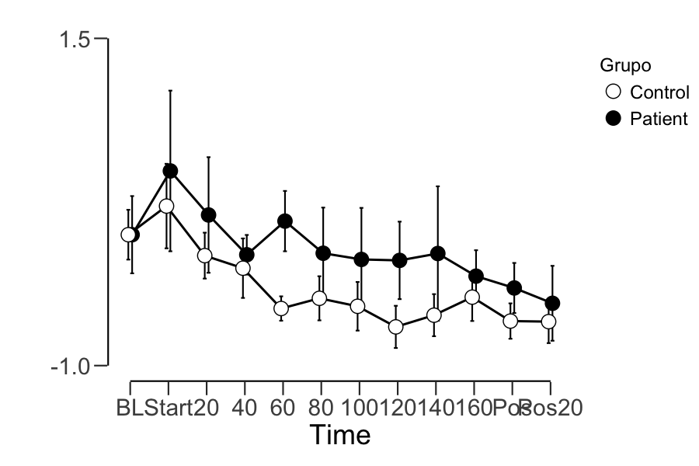

SKIN CONDUCTANCE LEVEL (SCL)

Within Subjects Effects
 |  | Sphericity Correction |  | Sum of Squares |  | df |  | Mean Square |  | F |  | p
Time |  | Greenhouse-Geisser |  | 1.582 | ᵃ | 1.727 | ᵃ | 0.916 | ᵃ | 32.094 | ᵃ | < .001 | ᵃ
Time ✻ Grupo |  | Greenhouse-Geisser |  | 0.094 | ᵃ | 1.727 | ᵃ | 0.054 | ᵃ | 1.907 | ᵃ | 0.162 | ᵃ
Residual |  | Greenhouse-Geisser |  | 1.873 |  | 65.612 |  | 0.029
Note. Type III Sum of Squares
ᵃ Mauchly's test of sphericity indicates that the assumption of sphericity is violated (p < .05).

Between Subjects Effects
 |  | Sum of Squares |  | df |  | Mean Square |  | F |  | p
Grupo |  | 0.293 |  | 1 |  | 0.293 |  | 2.365 |  | 0.132
Residual |  | 4.700 |  | 38 |  | 0.124
Note. Type III Sum of Squares

Assumption Checks
Test of Sphericity
 |  | Mauchly's W |  | p |  | Greenhouse-Geisser ε |  | Huynh-Feldt ε
Time |  | 1.491e -12 |  | < .001 |  | 0.157 |  | 0.164

Descriptives

Descriptives Plot (95% CI)
