Supplementary material 1: Focus group question list and diagrams
1. What is your areas of expertise?
Exercise interventions:
2. What interventions have you used in your research?
a) When delivering and controlling the intervention, what factors determine quality?
3. What determinants of exercise performance do you assess in your research?
a) What tests of exercise performance have you used/observed being used to assess the outcome?
b) When executing the test, what factors determine quality?
Prompt by giving examples e.g. strength training intervention: executed with the principles of frequency, intensity, time and type, supervised verses unsupervised environment, tested with estimated 1RM versus true 1RM, supervised/unsupervised

Diet interventions:
4. What interventions have you used in your research?
b) When delivering and controlling the intervention, what factors determine quality?
5. What determinants of exercise performance do you assess in your research?
c) What tests of exercise performance have you used/observed being used to assess the outcome?
d) When executing the test, what factors determine quality?
Prompt by giving examples e.g. macronutrient ratio intervention for fat loss: food provided to participants versus provided written meal plan. use of DEXA versus surface anthropometry to assess body composition
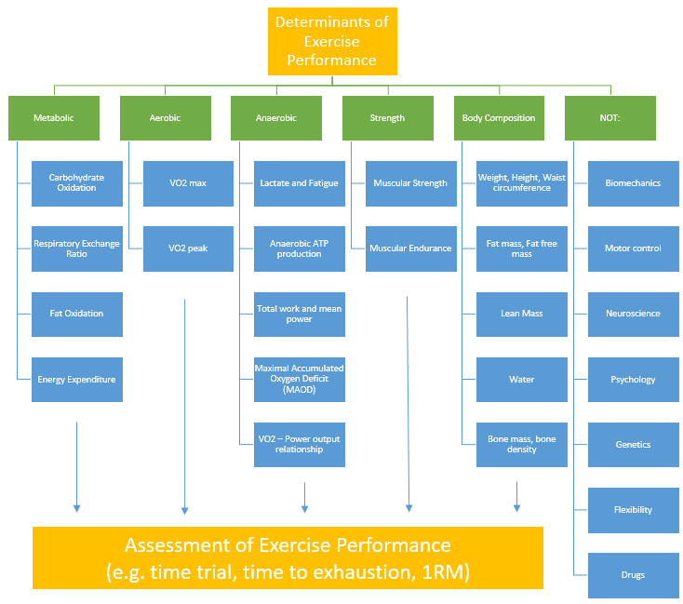
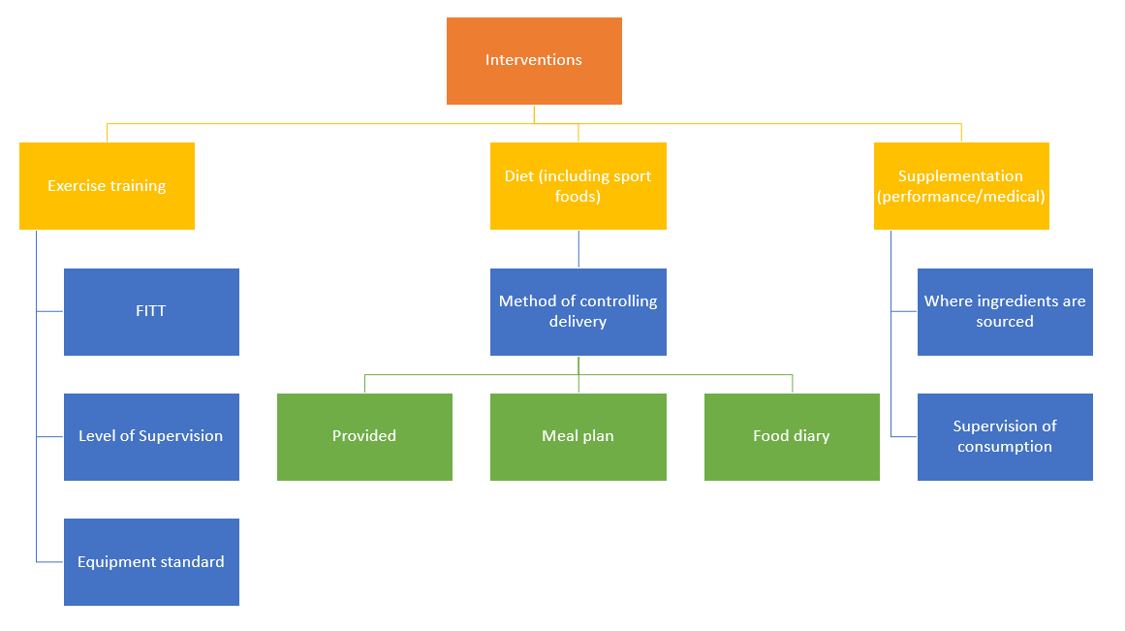
Supplementary material 2: Initial item list from analysis of Phase 1 focus group data
A. Exercise Interventions
Participant compliance
1. Attendance is clearly reported i.e. participants’ completion of each training session is clearly reported
2. Adherence to the dose was adequately monitored i.e. empirical data or records were collected to support adherence to the exercise intervention as prescribed. Warm up and cool down, rest, volume, intensity and progressions are controlled and monitored
3. Criteria for compliance is clearly defined i.e. criteria for participant compliance (hence the inclusion of participants’ data in the results) is clearly defined at design stage
4. Make up sessions were available i.e. make up sessions were available to optimise participant attendance if required
5. The control group adequately monitored i.e. same rigor applied to compliance and monitoring for intervention and control group
Confounding factors
6. Diet factors were controlled OR measured and accounted for (food, fluid, supplements) i.e. diet was either provided or adequately monitored (i.e. records, interviews, questionnaires) and accounted for to allow potential confounding to be assessed
7. Habitual physical activity was measured and accounted for i.e. habitual physical activity was empirically measured or participant-reported to allow potential confounding to be assessed
8. Sleep was measured and accounted for i.e. sleep was either empirically measured or adequately monitored to allow potential confounding to be assessed
9. Psychological/motivational factors were measured and accounted for i.e. relevant psychological factors were appropriately assessed to allow potential confounding to be assessed
10. Body composition was measured and accounted for i.e. changes in body composition were appropriately assessed to allow potential confounding to be assessed

B. Exercise Testing
Participant information
1. Participants characteristics are clearly defined i.e. Relevant medical conditions, baseline habitual physical activity, baseline fitness
2. Incentives provided to participants are clearly reported
Protocol factors
3. A validated protocol was used i.e. validated exercise testing protocol used to evaluate exercise performance or function, appropriate to study population and research questions
4. The test methodology was clearly reported i.e. warm up and cool down, test duration, rest period and test termination or failure criteria clearly described.
5. Familiarisation to exercise test was included and the protocol clearly reported i.e. familiarisation process clearly described and appropriate for study population, duration and intensity of familiarisation clearly reported.
6. The exercise testing conditions are clearly reported i.e. environmental conditions (e.g. temperature, humidity, wind, where appropriate) and location (e.g. lab, field) and time (time of day/week/month/year where appropriate) clearly reported
7. The confounding variables were controlled prior to exercise testing and the protocol clearly reported i.e. physical activity, food and fluid consumption, medications, supplements and ergogenic aids clearly reported

Assessor factors
8. The qualifications of assessor(s) are clearly reported i.e. assessor(s) possessed adequate qualifications to conduct testing
9. The test instructions are standardised i.e. instructions given by assessor(s) was standardised to ensure consistency between participants.
10. The level of participant encouragement is clearly reported i.e. participant encouragement procedure was clearly defined and applied consistently
Equipment
11. The type of equipment/software is clearly reported i.e. brand, make, model, version number is reported where relevant
12. The accuracy and precision of equipment is reported i.e. equipment was appropriately calibrated and a measure of precision was reported

C. Aerobic and anaerobic fitness
Laboratory-based tests
1. The incremental ramping of exercise intensity was appropriate to the participants’ physiological and/or functional status
2. The step magnitude and duration of the incremental protocol are clearly reported
3. Expired gases are collected
4. Gas analysis process is clearly reported i.e. duration and timing of collection
5. Analytical procedure for identifying VO2max or VO2peak is clearly reported
6. The elicited capacity is correctly identified as being either VO2max or VO2peak
7. Exercise workload (e.g. speed, cycle cadence, power output) clearly reported
Field tests
8. Footwear was standardised
9. Location and surface type was standardised
Time trial/time to exhaustion protocols
10. Feedback provided to participant clearly reported e.g. time/distance left, frequency of feedback
11. For time trials, the individual (i.e. participant or researcher) who adjusted the exercise intensity is reported
Metabolic outcomes
12. Where relevant, data is collected in steady state, the criteria defining steady state is clearly described
13. The sampling timepoints of the measured variables are clearly reported e.g. blood, RPE, HR, expired gases
14. The quantity of tissue/blood collected is clearly reported
15. Storage protocol of samples clearly reported e.g. temperature, location, duration
16. Analysis procedures are clearly reported

D. Strength and resistance training
1. The volume (i.e. number of sets/attempts, repetitions, and intensity) is clearly reported
2. If multiple movements are tested in one session, the sequence of the movements is clearly reported
3. The type of resistance is reported e.g. free weights, pneumatic, pin loaded, plate loaded or elastic
4. The rating of perceived exertion is clearly reported for each set/attempt
5. Where relevant, learning effects are addressed e.g. the volume and intensity of the intervention accommodated for participants’ learning, or an appropriate familiarisation period was included
6. The tempo at which repetitions were performed clearly reported

E. Diet and nutrition
1. The aim/role of the diet to manipulate or control bodyweight, physical function or performance is clearly reported (when complimentary to exercise intervention)
Diet prescription
2. The rationale for the diet prescription is justified based on literature or pre-existing guidelines
3. The details of energy and macronutrient prescription are clearly reported
4. Where relevant, the details of micronutrient prescription are clearly reported
5. The details on fluid prescription are clearly reported when relevant to the study question
6. The details on resources (e.g. recipes, menu plans, fact sheets) are clearly reported
Diet assessment
7. The method used to assess diet is valid for the study population, research question, and number of days collected
8. The method(s) of assessing diet are clearly reported (e.g. food record (weighed or estimated), FFQ (short or long form), 24hr pass recall (single or multiple) or diet history (retrospective duration), diet quality index (type and calculation process))
9. The timeframe of the dietary assessment used is relevant to the population and study question (e.g. retrospective vs. current dietary intake)
10. The food group serving quantities are clearly defined (i.e. when data is reported as food groups rather than nutrients)
11. The number of days for food records or 24hr pass recalls are clearly reported
12. The days of the week (e.g. weekdays or weekend) for food records or 24hr pass recalls are clearly reported
13. Whether the days where data is collected were consecutive or non-consecutive is reported (e.g. for 24hr pass recall)
14. The season of collection is clearly outlined
15. The validity of the FFQ used towards the study population and the nutrient in question is clearly reported
16. The weighed food record methodology is clearly reported (e.g. plate tare, plate waste, non-edible portions)
17. The food record estimation methodology is clearly reported (e.g. use of plates, cups, spoons)
18. The respondent (e.g. the participant, a parent for child’s intake or other proxy) is clearly reported
19. The method of data collection is clearly reported (e.g. written, computer entered, survey, application, food photography, interview in person or phone)
20. The training participants receive (e.g. with respect to record keeping, survey completion, nutritional knowledge) is clearly reported
21. The tools used to assist participants to report intake are clearly reported e.g. food models, food atlas, fiduciary marker for food photographs
22. In dietary observation studies, the participant is aware of whether the observation is overt or covert
23. The contribution of dietary supplements/sports foods to nutrient intake is clearly reported
24. The use ergogenic aids (dose, type, brand, duration of use) is clearly reported

Dietary data analysis
25. The database used to calculate nutrient intake is appropriate for the food consumed (e.g. food fortification practices, nutrient composition of foods consumed)
26. The absolute or relative intake is reported when relevant to the population, nutrient or study question
27. The recommended intakes used to evaluate appropriateness of intake are relevant to the study population (e.g. age, sex)
28. The computer analysis software name and version is clearly reported
Behavioural monitoring and support
29. The behavioural therapy is clearly reported (e.g. cognitive behavioural therapy)
30. The therapy parameters are clearly reported (e.g. group or individual, phone or internet support)
31. The resources are clearly outlined (e.g. fact sheets)
32. The questionnaires/scales (e.g. VAS or Likert) used are validated/standardised to assess eating behaviour/appetite in the study population
33. The timing of eating behaviour/appetite assessment in relation to food intake or exercise is clearly reported
Assessor factors
34. The qualifications of the researcher designing, collecting and analysing the dietary data is clearly reported
35. In dietary observation studies, the methodology of observation and observer qualifications are clearly reported (e.g. video, F2F observation)
Biomarkers
36. The timing of collection is clearly reported
37. The laboratory accreditation status is clearly reported
38. The storage conditions of samples and time to analysis is clearly reported
39. The details on assay kit/methodology/ equipment is clearly reported
40. The coefficient of variation of assays is clearly reported

F. Body composition
1. The qualification(s) of the assessor are clearly reported
2. A standardised protocol is used and referenced
3. Where relevant, modifications to standardised protocols (e.g. to account for disability) are clearly reported
4. The technical error of measurement or coefficient of variation of the measures are clearly reported
5. The timing of measurement e.g. time of day and relation to exercise or food/beverage is clearly reported
6. The branding, make and model of equipment is clearly reported
7. Where relevant, the standards used to compare results are clearly reported e.g. growth charts, BMI classifications
8. Where relevant, the hydration status of the participant is measured e.g. for DXA
9. Where relevant, the posture e.g. standing versus supine is clearly reported e.g. for BIA
10. The clothing and footwear that participants are measured in is clearly reported
11. The relevance of the analysis software or regression equations used to calculate body composition is clearly reported

Supplementary material 3: First round results for generic items
Item | % of responses as “important” or “highly important”
A: Exercise Interventions
A1. Attendance is clearly reported i.e. participants’ completion of each training session is clearly reported | 94
A2. Adherence to the dose was adequately monitored i.e. empirical data or records were collected to support adherence to the exercise intervention as prescribed. Warm up and cool down, rest, volume, intensity and progressions are controlled and monitored | 100
A3. Criteria for compliance is clearly defined i.e. criteria for participant compliance (hence the inclusion of participants’ data in the results) is clearly defined at design stage | 94
A4. Make up sessions were available i.e. make up sessions were available to optimise participant attendance if required | 63
A5. The control group adequately monitored i.e. same rigor applied to compliance and monitoring for intervention and control group | 94
A6. Diet factors were controlled OR measured and accounted for (food, fluid, supplements) i.e. diet was either provided or adequately monitored (i.e. records, interviews, questionnaires) and accounted for to allow potential confounding to be assessed | 87
A7. Habitual physical activity was measured and accounted for i.e. habitual physical activity was empirically measured or participant-reported to allow potential confounding to be assessed | 87
A8. Sleep was measured and accounted for i.e. sleep was either empirically measured or adequately monitored to allow potential confounding to be assessed | 47
A9. Psychological/motivational factors were measured and accounted for i.e. relevant psychological factors were appropriately assessed to allow potential confounding to be assessed | 73
A10. Body composition was measured and accounted for i.e. changes in body composition were appropriately assessed to allow potential confounding to be assessed | 93
B: Exercise Testing
B1. Participants characteristics are clearly defined i.e. Relevant medical conditions, baseline habitual physical activity, baseline fitness | 100
B2. Incentives provided to participants are clearly reported | 67
B3. A validated protocol was used i.e. validated exercise testing protocol used to evaluate exercise performance or function, appropriate to study population and research questions | 100
B4. The test methodology was clearly reported i.e. warm up and cool down, test duration, rest period and test termination or failure criteria clearly described. | 100
B5. Familiarisation to exercise test was included and the protocol clearly reported i.e. familiarisation process clearly described and appropriate for study population, duration and intensity of familiarisation clearly reported. | 100
B6. The exercise testing conditions are clearly reported i.e. environmental conditions (e.g. temperature, humidity, wind, where appropriate) and location (e.g. lab, field) and time (time of day/week/month/year where appropriate) clearly reported | 86
B7. The confounding variables were controlled prior to exercise testing and the protocol clearly reported i.e. physical activity, food and fluid consumption, medications, supplements and ergogenic aids clearly reported | 93
B8. The qualifications of assessor(s) are clearly reported i.e. assessor(s) possessed adequate qualifications to conduct testing | 64
B9. The test instructions are standardised i.e. instructions given by assessor(s) was standardised to ensure consistency between participants. | 93
B10. The level of participant encouragement is clearly reported i.e. participant encouragement procedure was clearly defined and applied consistently | 85
B11. The type of equipment/software is clearly reported i.e. brand, make, model, version number is reported where relevant | 93
B12. The accuracy and precision of equipment is reported i.e. equipment was appropriately calibrated and a measure of precision was reported | 100

Supplementary material 4: First round results for specific items
Item | % of responses as “important” or “highly important”
C. Aerobic and anaerobic training items
1. The incremental ramping of exercise intensity was appropriate to the participants’ physiological and/or functional status | 100
2. The step magnitude and duration of the incremental protocol are clearly reported | 100
3. Expired gases are collected | 67
4. Gas analysis process is clearly reported i.e. duration and timing of collection | 100
5. Analytical procedure for identifying VO2max or VO2peak is clearly reported | 100
6. The elicited capacity is correctly identified as being either VO2max or VO2peak | 67
7. Exercise workload (e.g. speed, cycle cadence, power output) clearly reported | 100
8. Footwear was standardised | 20
9. Location and surface type was standardised | 60
10. Feedback provided to participant clearly reported e.g. time/distance left, frequency of feedback | 100
11. For time trials, the individual (i.e. participant or researcher) who adjusted the exercise intensity is reported | 80
12. Where relevant, data is collected in steady state, the criteria defining steady state is clearly described | 60
13. The sampling timepoints of the measured variables are clearly reported e.g. blood, RPE, HR, expired gases | 100
14. The quantity of tissue/blood collected is clearly reported | 100
15. Storage protocol of samples clearly reported e.g. temperature, location, duration | 100
16. Analysis procedures are clearly reported | 100
D. Strength and resistance training items
1. The volume (i.e. number of sets/attempts, repetitions, and intensity) is clearly reported | 100
2. If multiple movements are tested in one session, the sequence of the movements is clearly reported | 75
3. The type of resistance is reported e.g. free weights, pneumatic, pin loaded, plate loaded or elastic | 100
4. The rating of perceived exertion is clearly reported for each set/attempt | 25
5. Where relevant, learning effects are addressed e.g. the volume and intensity of the intervention accommodated for participants’ learning, or an appropriate familiarisation period was included | 100
6. The tempo at which repetitions were performed clearly reported | 75
E. Diet and nutrition items
1. The aim/role of the diet to manipulate or control bodyweight, physical function or performance is clearly reported (when complimentary to exercise intervention) | 100
2. The rationale for the diet prescription is justified based on literature or pre-existing guidelines | 100
3. The details of energy and macronutrient prescription are clearly reported | 100
4. Where relevant, the details of micronutrient prescription are clearly reported | 100
5. The details on fluid prescription are clearly reported when relevant to the study question | 80
6. The details on resources (e.g. recipes, menu plans, fact sheets) are clearly reported | 40
7. The method used to assess diet is valid for the study population, research question, and number of days collected | 100
8. The method(s) of assessing diet are clearly reported (e.g. food record (weighed or estimated), FFQ (short or long form), 24hr pass recall (single or multiple) or diet history (retrospective duration), diet quality index (type and calculation process)) | 100
9. The timeframe of the dietary assessment used is relevant to the population and study question (e.g. retrospective vs. current dietary intake) | 100
10. The food group serving quantities are clearly defined (i.e. when data is reported as food groups rather than nutrients) | 80
11. The number of days for food records or 24hr pass recalls are clearly reported | 100
12. The days of the week (e.g. weekdays or weekend) for food records or 24hr pass recalls are clearly reported | 100
13. Whether the days where data is collected were consecutive or non-consecutive is reported (e.g. for 24hr pass recall) | 80
14. The season of collection is clearly outlined | 80
15. The validity of the FFQ used towards the study population and the nutrient in question is clearly reported | 100
16. The weighed food record methodology is clearly reported (e.g. plate tare, plate waste, non-edible portions) | 100
17. The food record estimation methodology is clearly reported (e.g. use of plates, cups, spoons) | 100
18. The respondent (e.g. the participant, a parent for child’s intake or other proxy) is clearly reported | 100
19. The method of data collection is clearly reported (e.g. written, computer entered, survey, application, food photography, interview in person or phone) | 100
20. The training participants receive (e.g. with respect to record keeping, survey completion, nutritional knowledge) is clearly reported | 100
21. The tools used to assist participants to report intake are clearly reported e.g. food models, food atlas, fiduciary marker for food photographs | 100
22. In dietary observation studies, the participant is aware of whether the observation is overt or covert | 100
23. The contribution of dietary supplements/sports foods to nutrient intake is clearly reported | 100
24. The use ergogenic aids (dose, type, brand, duration of use) is clearly reported | 100
25. The database used to calculate nutrient intake is appropriate for the food consumed (e.g. food fortification practices, nutrient composition of foods consumed) | 100
26. The absolute or relative intake is reported when relevant to the population, nutrient or study question | 80
27. The recommended intakes used to evaluate appropriateness of intake are relevant to the study population (e.g. age, sex) | 100
28. The computer analysis software name and version is clearly reported | 100
29. The behavioural therapy is clearly reported (e.g. cognitive behavioural therapy) | 100
30. The therapy parameters are clearly reported (e.g. group or individual, phone or internet support) | 100
31. The resources are clearly outlined (e.g. fact sheets) | 100
32. The questionnaires/scales (e.g. VAS or Likert) used are validated/standardised to assess eating behaviour/appetite in the study population | 100
33. The timing of eating behaviour/appetite assessment in relation to food intake or exercise is clearly reported | 100
34. The qualifications of the researcher designing, collecting and analysing the dietary data is clearly reported | 80
35. In dietary observation studies, the methodology of observation and observer qualifications are clearly reported (e.g. video, F2F observation) | 100
36. The timing of collection is clearly reported | 100
37. The laboratory accreditation status is clearly reported | 80
38. The storage conditions of samples and time to analysis is clearly reported | 100
39. The details on assay kit/methodology/ equipment is clearly reported | 100
40. The coefficient of variation of assays is clearly reported | 100
F. Body composition items
1. The qualification(s) of the assessor are clearly reported | 100
2. A standardised protocol is used and referenced | 67
3. Where relevant, modifications to standardised protocols (e.g. to account for disability) are clearly reported | 100
4. The technical error of measurement or coefficient of variation of the measures are clearly reported | 100
5. The timing of measurement e.g. time of day and relation to exercise or food/beverage is clearly reported | 100
6. The branding, make and model of equipment is clearly reported | 100
7. Where relevant, the standards used to compare results are clearly reported e.g. growth charts, BMI classifications | 100
8. Where relevant, the hydration status of the participant is measured e.g. for DXA | 100
9. Where relevant, the posture e.g. standing versus supine is clearly reported e.g. for BIA | 100
10. The clothing and footwear that participants are measured in is clearly reported | 100
11. The relevance of the analysis software or regression equations used to calculate body composition is clearly reported | 100

Supplementary material 5: Second round results for generic items
Item | % of responses as “important” or “highly important”
A4. Make up sessions were available i.e. make up sessions were available to optimise participant attendance if required | 58
A8. Sleep was measured and accounted for i.e. sleep was either empirically measured or adequately monitored to allow potential confounding to be assessed | 11
B2. Incentives provided to participants are clearly reported | 47
B8. The qualifications of assessor(s) are clearly reported i.e. assessor(s) possessed adequate qualifications to conduct testing | 47
New participant-suggested item: Where study interventions involved multiple exercise modes, the sequence in which they were performed is reported i.e. combined training interventions, supplementary flexibility training | 88

Supplementary material 6: Second round results for specific items
Items | % of responses as “important” or “highly important”
C2. Where relevant, footwear was standardised within participants e.g. field tests, treadmill tests | 100
C3. Test location and/or surface type was standardised e.g. field tests | 100
C6. Expired gases and ventilation rate is collected | 60
C9. The elicited capacity is correctly identified as being either VO2max or VO2peak | 40
C12. Where data is collected in steady state or transitions, the defining criteria is clearly described | 100
New participant-suggested item: The method for determining desired range of motion is clearly reported | 25
D7. Progression of intensity throughout the intervention is clearly reported e.g. 1RM retesting when using 1RM percentages | 100
E6. The details on resources (e.g. recipes, menu plans, fact sheets) are clearly reported | 60
F2. A standardised protocol is used and referenced e.g. details such as participant preparation, clothing and bladder voiding are included where relevant | 100

Supplementary material 7: Finalised list of specific items identified as important to study quality in exercise performance studies
C. Aerobic and anaerobic fitness
C1 | Exercise workload (e.g. speed, cycle cadence, power output) clearly reported
C2 | Where relevant, footwear was standardised within participants e.g. field tests, treadmill tests
C3 | Test location and/or surface type was standardised e.g. field tests
Aerobic testing
C4 | The incremental ramping of exercise intensity was appropriate to the participants’ physiological and/or functional status
C5 | The step magnitude and duration of the incremental protocol are clearly reported
C6 | Gas analysis process is clearly reported i.e. duration and timing of collection
C7 | Analytical procedure for identifying VO2max or VO2peak is clearly reported
Time trial/time to exhaustion protocols
C8 | Feedback provided to participant clearly reported e.g. time/distance left, frequency of feedback
C9 | For time trials, the individual (i.e. participant or researcher) who adjusted the exercise intensity is reported
Metabolic outcomes
C10 | Where data is collected in steady state or transitions, the defining criteria is clearly described
C11 | The sampling timepoints of the measured variables are clearly reported e.g. blood, RPE, HR, expired gases
C12 | The quantity of tissue/blood collected is clearly reported
C13 | Storage protocol of samples clearly reported e.g. temperature, location, duration
C14 | Analysis procedures are clearly reported
D. Strength and resistance training
D1 | The volume (i.e. number of sets/attempts, repetitions, and intensity) is clearly reported
D2 | If multiple movements are tested in one session, the sequence of the movements is clearly reported
D3 | The type of resistance is reported e.g. free weights, pneumatic, pin loaded, plate loaded or elastic
D4 | The rating of perceived exertion is clearly reported for each set/attempt
D5 | Rest intervals are clearly reported
D6 | Progression of intensity throughout the intervention is clearly reported e.g. 1RM retesting when using 1RM percentages
D7 | Where relevant, learning effects are addressed e.g. the volume and intensity of the intervention accommodated for participants’ learning, or an appropriate familiarisation period was included
D8 | The tempo at which repetitions were performed clearly reported
E. Diet and nutrition
E1 | The aim/role of the diet to manipulate or control bodyweight, physical function or performance is clearly reported (when complimentary to exercise intervention)
Diet prescription
E2 | The rationale for the diet prescription is justified based on literature or pre-existing guidelines
E3 | The details of energy and macronutrient prescription are clearly reported
E4 | Where relevant, the details of micronutrient prescription are clearly reported
E5 | The details on fluid prescription are clearly reported when relevant to the study question
Diet assessment
E6 | The method used to assess diet is valid for the study population, research question, and number of days collected
E7 | The method(s) of assessing diet are clearly reported (e.g. food record (weighed or estimated), FFQ (short or long form), 24hr pass recall (single or multiple) or diet history (retrospective duration), diet quality index (type and calculation process))
E8 | The timeframe of the dietary assessment used is relevant to the population and study question (e.g. retrospective vs. current dietary intake)
E9 | The food group serving quantities are clearly defined (i.e. when data is reported as food groups rather than nutrients)
E10 | The number of days for food records or 24hr pass recalls are clearly reported
E11 | The days of the week (e.g. weekdays or weekend) for food records or 24hr pass recalls are clearly reported
E12 | Whether the days where data is collected were consecutive or non-consecutive is reported (e.g. for 24hr pass recall)
E13 | The season of collection is clearly outlined
E14 | The validity of the FFQ used towards the study population and the nutrient in question is clearly reported
E15 | The weighed food record methodology is clearly reported (e.g. plate tare, plate waste, non-edible portions)
E16 | The food record estimation methodology is clearly reported (e.g. use of plates, cups, spoons)
E17 | The respondent (e.g. the participant, a parent for child’s intake or other proxy) is clearly reported
E18 | The method of data collection is clearly reported (e.g. written, computer entered, survey, application, food photography, interview in person or phone)
E19 | The training participants receive (e.g. with respect to record keeping, survey completion, nutritional knowledge) is clearly reported
E20 | The tools used to assist participants to report intake are clearly reported e.g. food models, food atlas, fiduciary marker for food photographs
E21 | In dietary observation studies, the participant is aware of whether the observation is overt or covert
E22 | The contribution of dietary supplements/sports foods to nutrient intake is clearly reported
E23 | The use ergogenic aids (dose, type, brand, duration of use) is clearly reported
Dietary data analysis
E24 | The database used to calculate nutrient intake is appropriate for the food consumed (e.g. food fortification practices, nutrient composition of foods consumed)
E25 | The absolute or relative intake is reported when relevant to the population, nutrient or study question
E26 | The recommended intakes used to evaluate appropriateness of intake are relevant to the study population (e.g. age, sex)
E27 | The computer analysis software name and version is clearly reported
Behavioural monitoring and support
E28 | The behavioural therapy is clearly reported (e.g. cognitive behavioural therapy)
E29 | The therapy parameters are clearly reported (e.g. group or individual, phone or internet support)
E30 | The resources are clearly outlined (e.g. fact sheets)
E31 | The questionnaires/scales (e.g. VAS or Likert) used are validated/standardised to assess eating behaviour/appetite in the study population
E32 | The timing of eating behaviour/appetite assessment in relation to food intake or exercise is clearly reported
Assessor factors
E33 | The qualifications of the researcher designing, collecting and analysing the dietary data is clearly reported; if multiple researchers present, details of protocol to maintain fidelity is reported
E34 | In studies using dietary observation, the methodology of observation and observer qualifications are clearly reported (e.g. video, F2F observation)
Biomarkers
E35 | The timing of collection is clearly reported
E36 | The laboratory accreditation status is clearly reported
E37 | The storage conditions of samples and time to analysis is clearly reported
E38 | The details on assay kit/methodology/ equipment is clearly reported
E39 | The coefficient of variation of assays is clearly reported
F. Body composition
F1 | Relevant qualification(s) of the assessor are clearly reported
F2 | A standardised protocol is used and referenced e.g. details such as participant preparation, clothing and bladder voiding are included where relevant
F3 | Where relevant, modifications to standardised protocols (e.g. to account for disability) are clearly reported
F4 | The technical error of measurement or coefficient of variation of the measures are clearly reported and, where relevant, are within recommended reliability limits for the method
F5 | The timing of measurement e.g. time of day and relation to exercise or food/beverage/supplementation, menstrual cycle is clearly reported
F6 | Where relevant, the standards used to compare results are clearly reported e.g. growth charts, BMI classifications
F7 | Where relevant, the hydration status of the participant is measured
F8 | Where relevant, the participant posture is clearly reported e.g. standing, supine, position relevant to equipment
F9 | The relevance of the analysis software or regression equations used to calculate body composition is clearly reported

(Items re-numbered from the initial list in Supplementary material 2 due to excluded and additional items)

