**Identification of New Dual FABP4/5 Inhibitors Based on a Naphthalene-1- sulfonamide FABP4 Inhibitor**

Yulong He a,1, Huixia Dou b,c,1, Dingding Gao a, d, 1, Ting Wang b, Mingming Zhang a, ***, Heyao Wang b,**, Yingxia Li a,*

a *School of Pharmacy, Fudan University, Shanghai 201203, China*

b *State Key Laboratory of Drug Research, Shanghai Institute of Materia Medica, Chinese Academy of Sciences, Shanghai 201203, China*

c *University of Chinese Academy of Sciences, Beijing 100049, China*

d*Innovation Research Institute of Traditional Chinese Medicine (IRI), Shanghai University of Traditional Chinese Medicine, Shanghai 201203, China*

1 These authors contributed equally to this work.

* Corresponding author: For Y. L. E-mail: [liyx417@fudan.edu.cn](mailto:liyx417@fudan.edu.cn)

** Corresponding author: For H. W. E-mail: [hywang@simm.ac.cn](mailto:hywang@simm.ac.cn)

*** Corresponding author: For M. Z. E-mail: [zmmworld@126.com](mailto:zmmworld@126.com)

**Supporting information**

**Table of contents**

1. **Supplementary Figure**
2. **Protein Expression and Purification**
3. **Cell Culture**
4. **Cell Viability Assay**
5. **LC-MS data of representative compounds**
6. **1H NMR and 13C NMR Spectrums of Novel Characterized Compounds**
7. **References**
8. **Supplementary Figure**

**1.1**

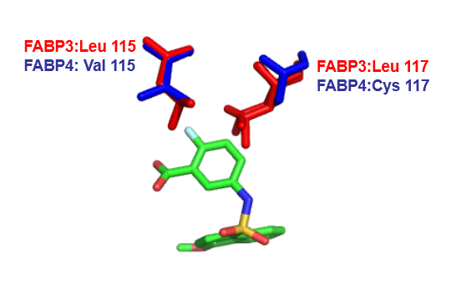

Figure S1 The superimposed structures of the FABP4-**compound 8** complex (PDB: 5Y0F) and FABP3 (PDB:4TKB)

**1.2**

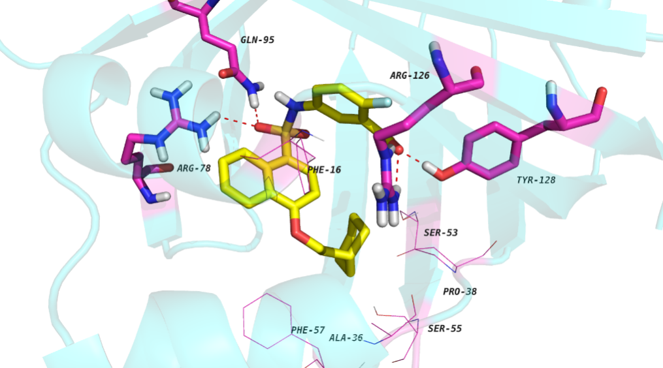

**Figure S2.** Predicted binding mode of **A16** with FABP4.

**2. Protein Expression and Purification**

The purification and crystallization of human FABP4 and FABP5 followed the protocol of Marr, E. et al.1 The cDNA of the full-length FABP4 and FABP5 was cloned into the pET28a vector at the Nde I/Xho I and XbaI/XhoI restriction sites respectively with an N-terminal His tag. BL21 (DE3) bacterial cells were transformed with the PET28a-FABP4 plasmid and Rosetta bacterial cells were transformed with a pET28a-FABP5 plasmid. Cells were grown at 37oC in LB medium supplemented with 80 μg/ml kanamycin, shaking for about 3 hours until the OD600 reached 0.8. IPTG was added to a final concentration of 0.8 mM to induce protein expression and the culture was incubated for additional 4 h. His-tagged FABP4 was isolated by the nickel-affinity chromatography, eluted with elution buffer (50 mM NaH2PO4 pH 8.0, 300 mM NaCl, 80 mM imidazole) and then exchanged into the final buffer (20 mM HEPES pH 7.5, 50 mM NaCl).

**3**. **Cell Culture**

All general reagents for cell culture were obtained from Gibco Life Technology, Shanghai, China. The 3T3-L1 pre-adipocytes (CL-173) were purchased from American Type Culture Collection (ATCC, Manassas, VA, USA) and maintained in DMEM containing 10% FBS in an atmosphere with 5% CO2 at 37 °C. 3T3-L1 pre-adipocytes were differentiated as previously described.2 Briefly, cells were seeded on poly-D-lysine pre-coated plates. Two days after confluence, the cells were stimulated with induction medium (DMEM with 10% FBS plus 0.5mmol/L 3-isobutyl-1-methylxanthine, 1 μmol/L dexamethasone and 2μg/mL insulin) for 48h. Then cells were switched to differentiation medium (2 μg/mL insulin in DMEM with 10% FBS). Thereafter, the differentiation medium was replaced every 2 days and full differentiation is usually achieved by day 8. The murine macrophage cell line RAW264.7 were purchased from American Type Culture Collection (Manassas,USA) and cultured in DMEM containing 10% FBS in a humidified incubator (5% CO2) at 37 °C.

**4. Cell Viability Assay**

The viability of RAW264.7 cells and 3T3-L1 pre-adipocytes was determined using the MTT assay. 3T3-L1 pre-adipocytes and RAW264.7 cells were seeded in 96-well cell plates and cultured overnight in growth medium. The cells were then exposed to concentrations of 30μM and 60μM and further cultured for 24 h at 37 °C. Cell proliferation was determined using the thiazolyl blue tetrazolium bromide assay as previously described.3 In brief, after 24h incubation with compounds, cells were supplemented with 0.5 mg/mL thiazolyl blue tetrazolium bromide (MTT, AMRESCO) at 37 °C for another 4 h. The medium was then removed and 100 μL dimethyl sulfoxide (DMSO) was added to dissolve the resulting formazan. The absorbance of the samples at a wavelength of 492 nm was measured with Flexstation III instrument (Molecular Devices, CA, USA).

1. **LC-MS data of representative compounds**

**10a-LC**

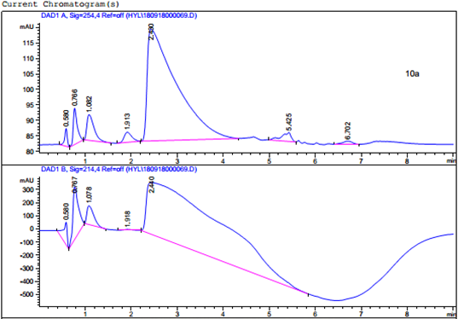

**10a-MS**

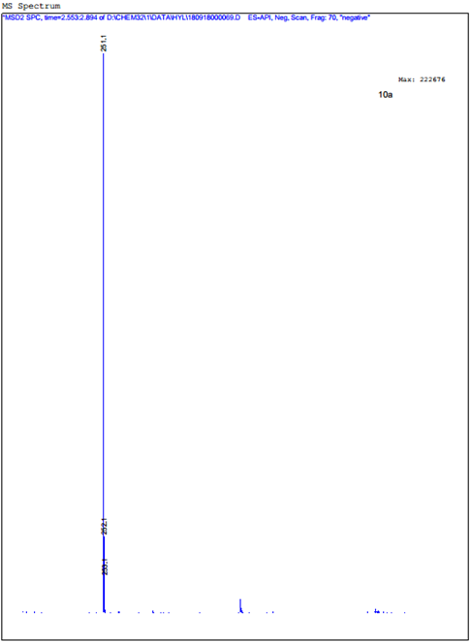

**13a-LC**

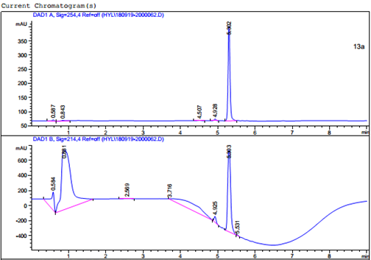

**13a-MS**

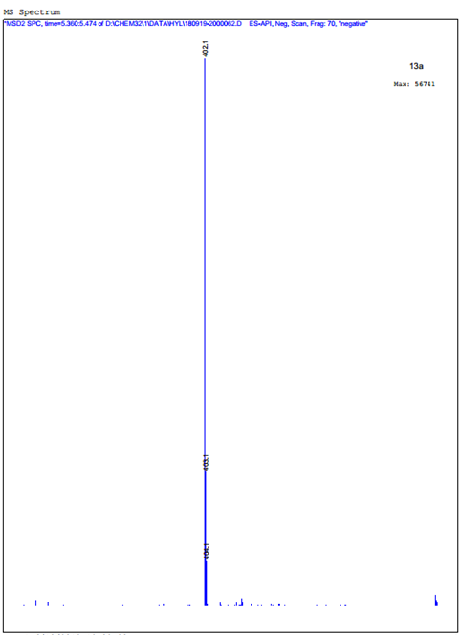

**A1-LC**

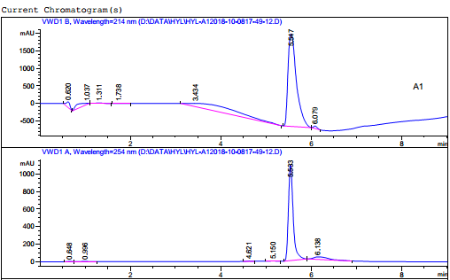

**A1-MS**

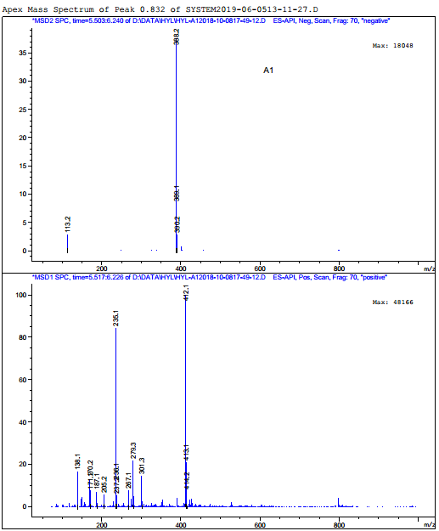

1. **LC**

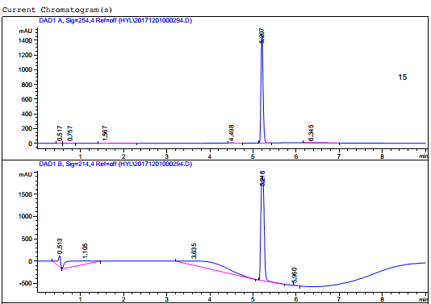

**15-MS**

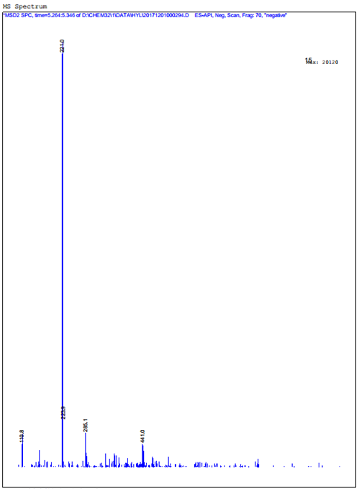

**17-LC**

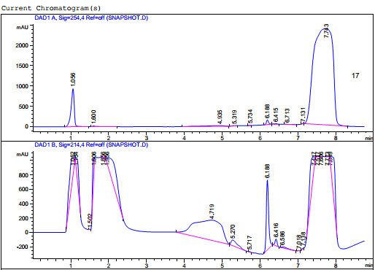

**17-MS**

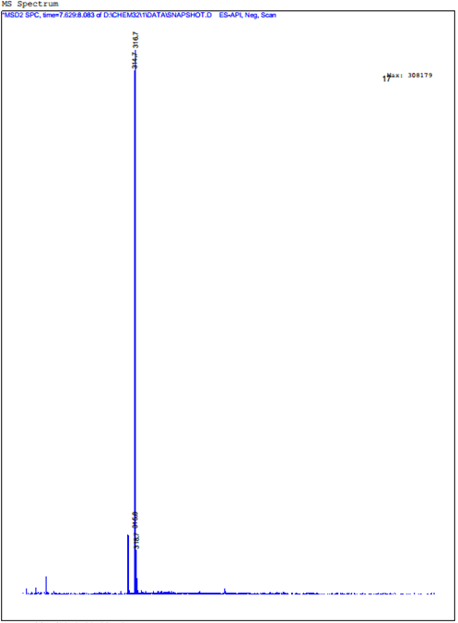

**18-LC**

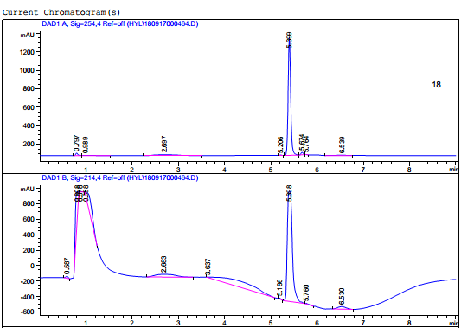

**18-MS**

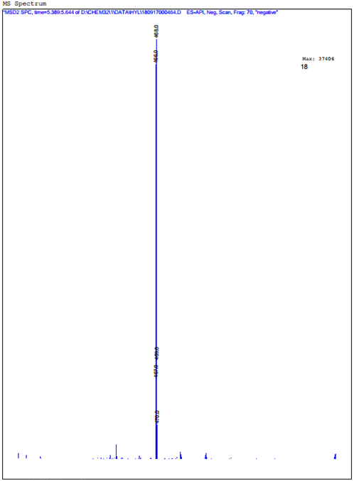

**19a-LC**

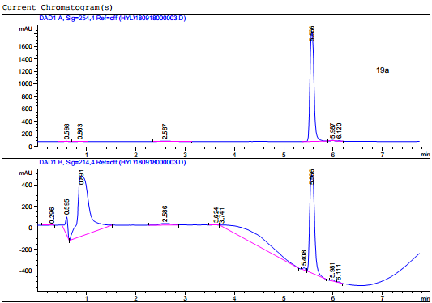

**19a-MS**

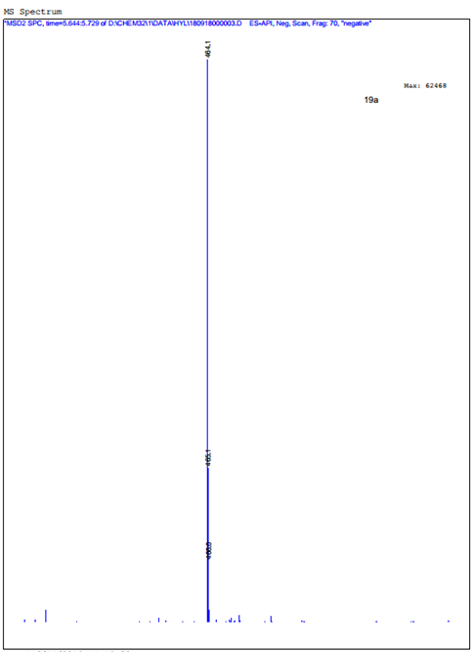

**B1-LC**

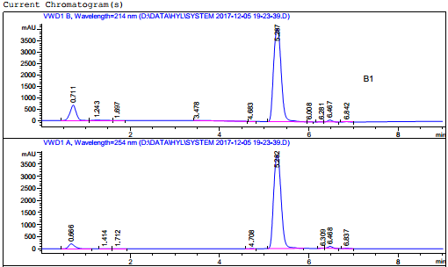

**B1-MS**

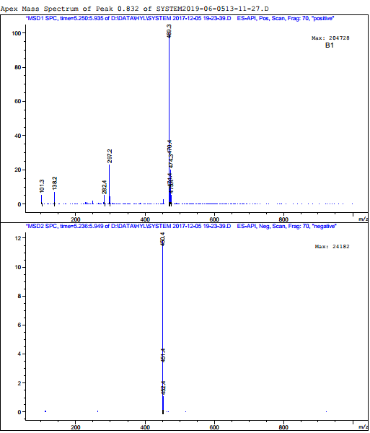

**6. 1H NMR and 13C NMR Spectrums of Novel Characterized Compounds**

**Series A**

1H NMR Spectrum of **13a**

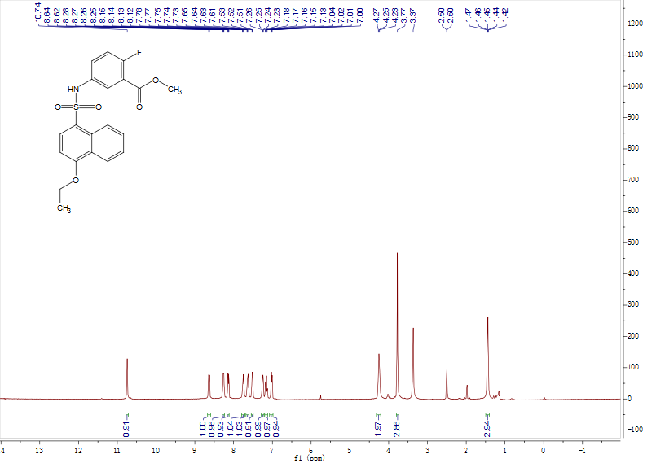

1H NMR and 13C NMR Spectrums of **A1**

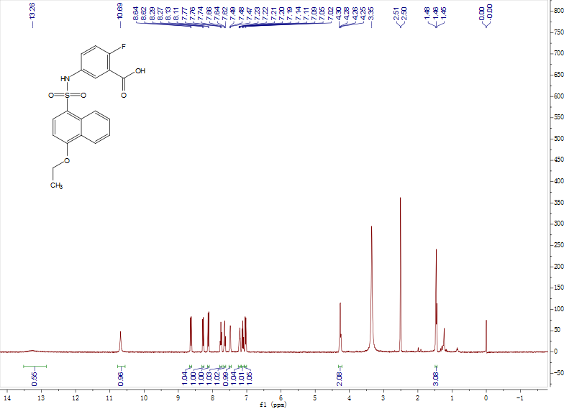

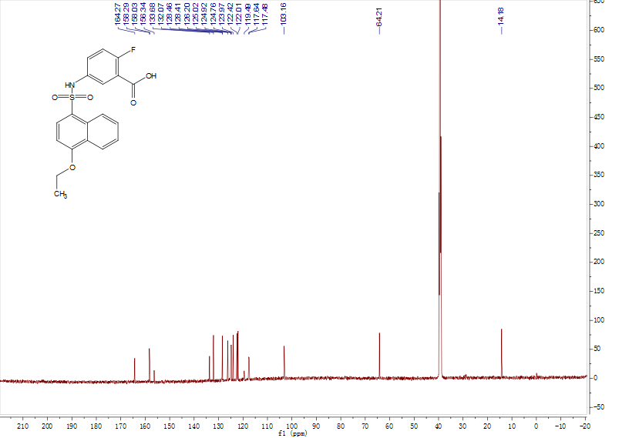

1H NMR and 13C NMR Spectrums of **A2**

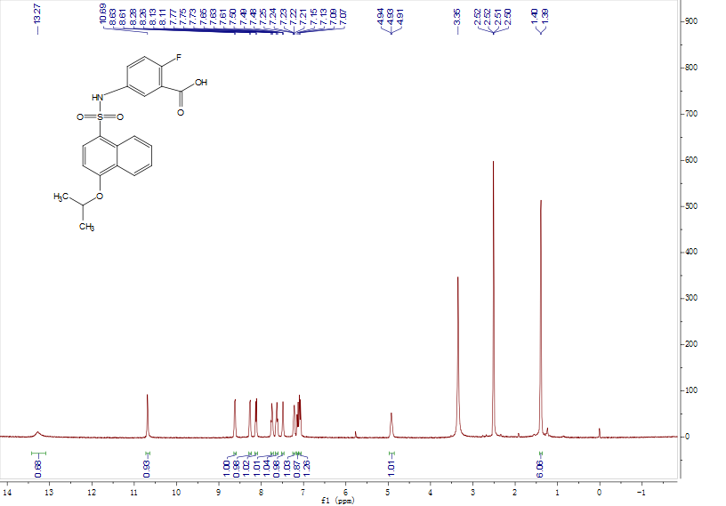

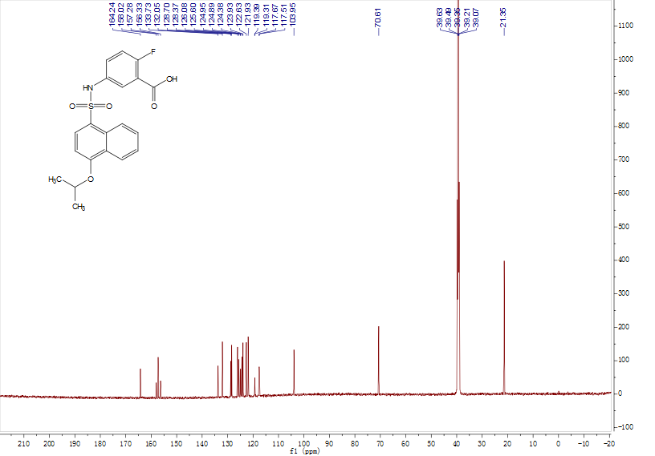

1H NMR and 13C NMR Spectrums of **A3**

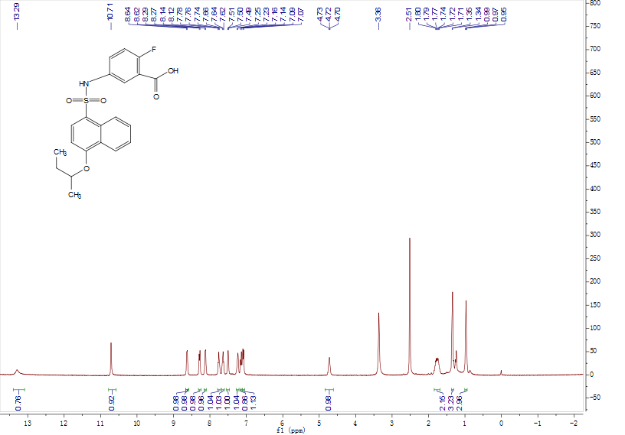

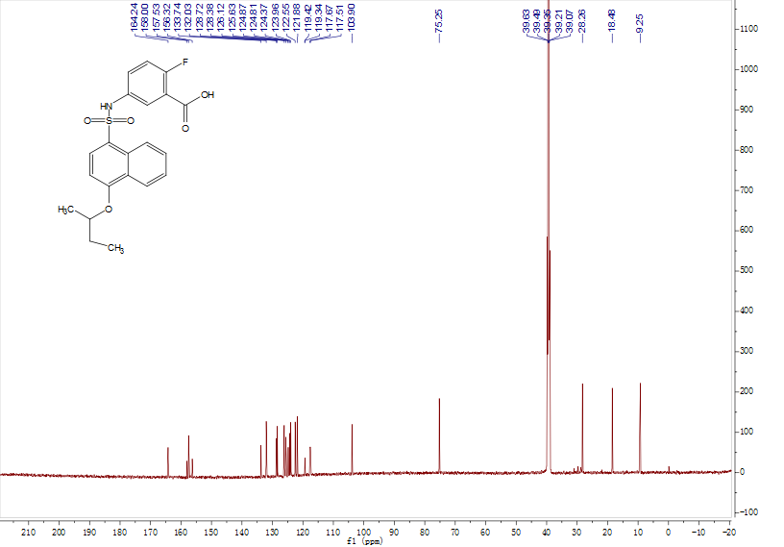

1H NMR and 13C NMR Spectrums of **A4**

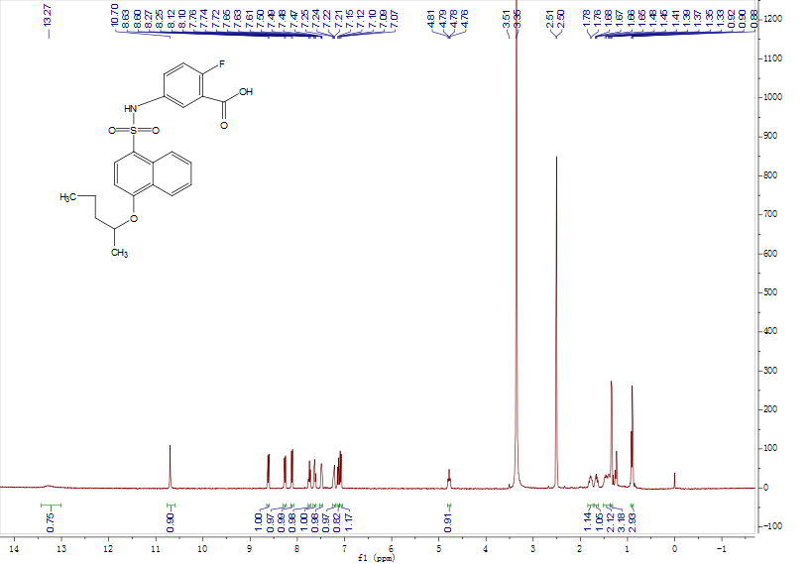

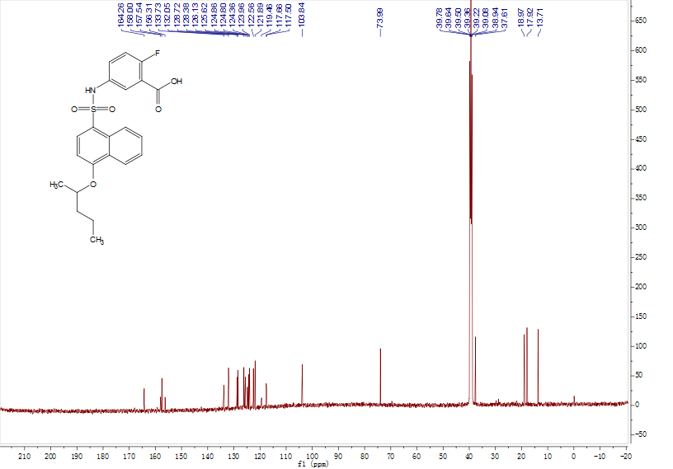

1H NMR and 13C NMR Spectrums of **A5**

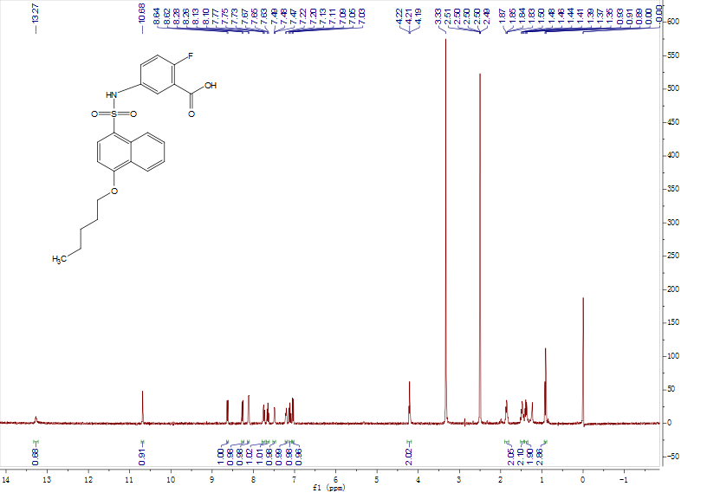

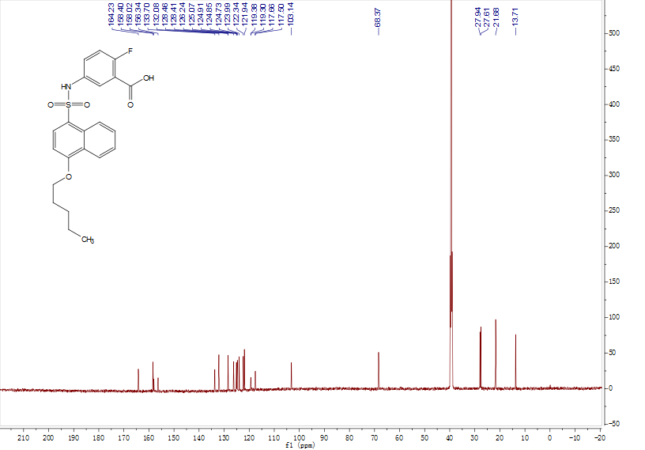

1H NMR and 13C NMR Spectrums of **A6**

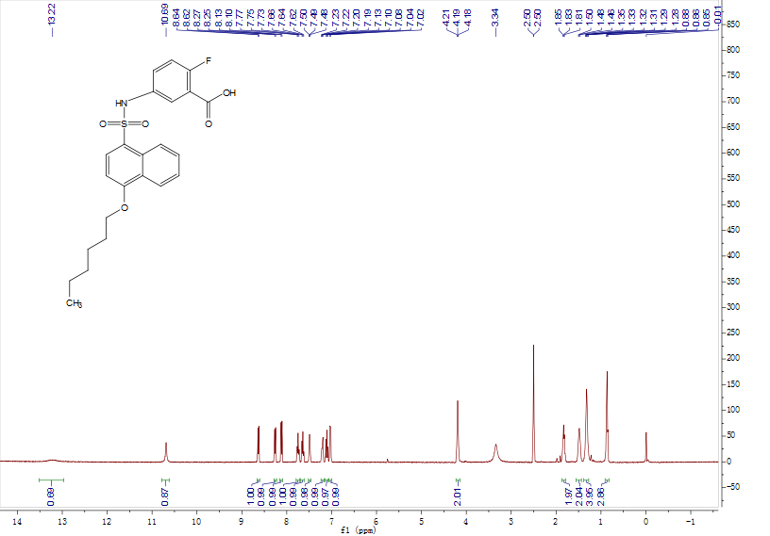

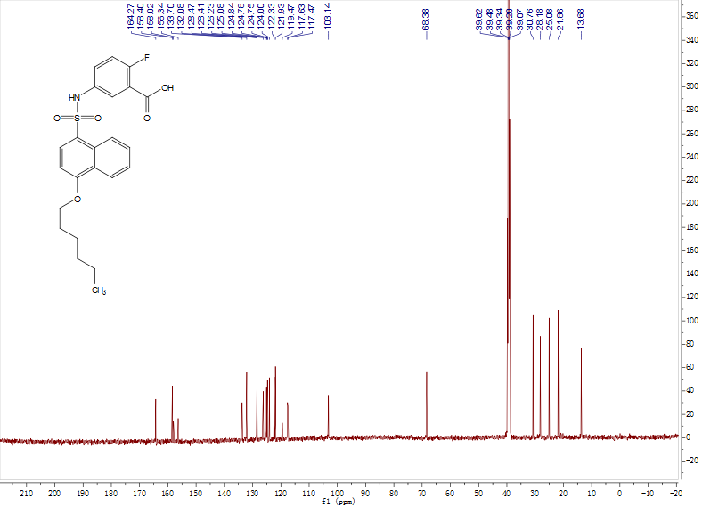

1H NMR and 13C NMR Spectrums of **A7**

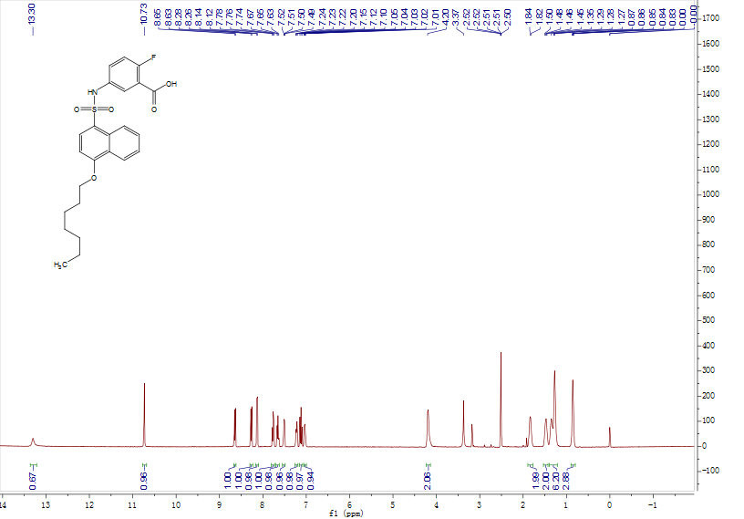

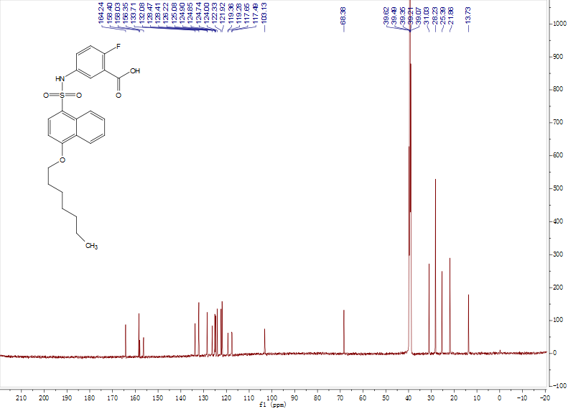

1H NMR and 13C NMR Spectrums of **A8**

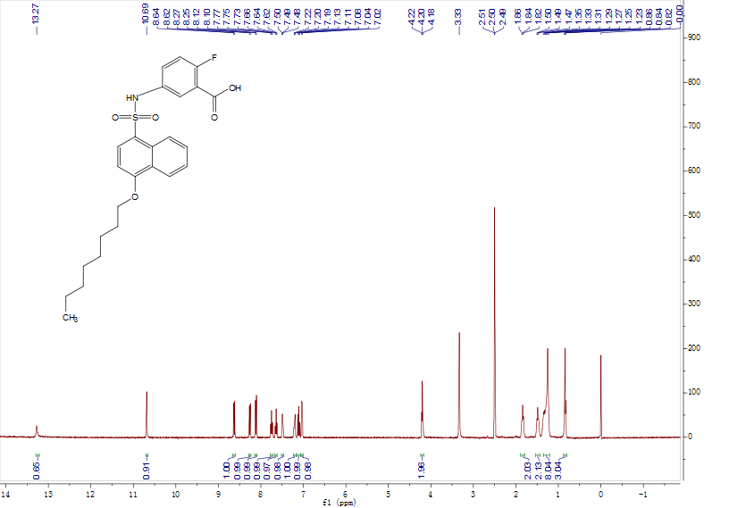

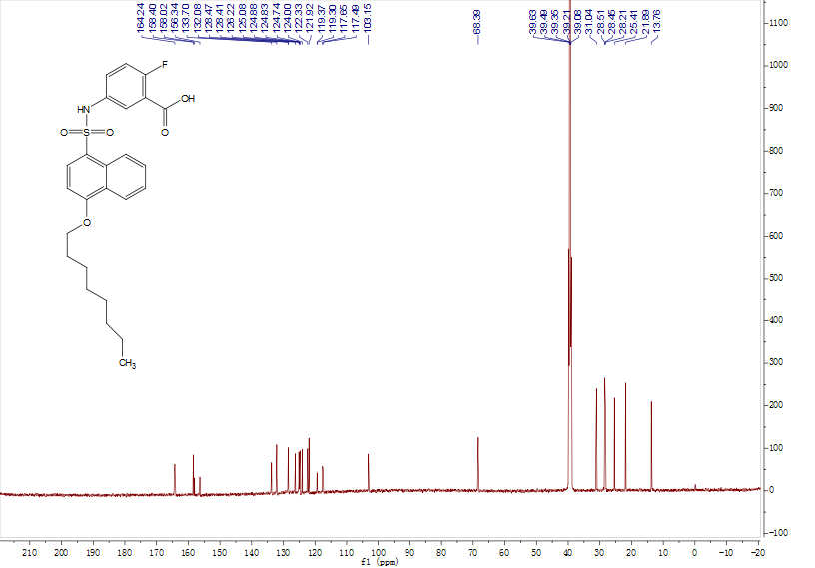

1H NMR and 13C NMR Spectrums of **A9**

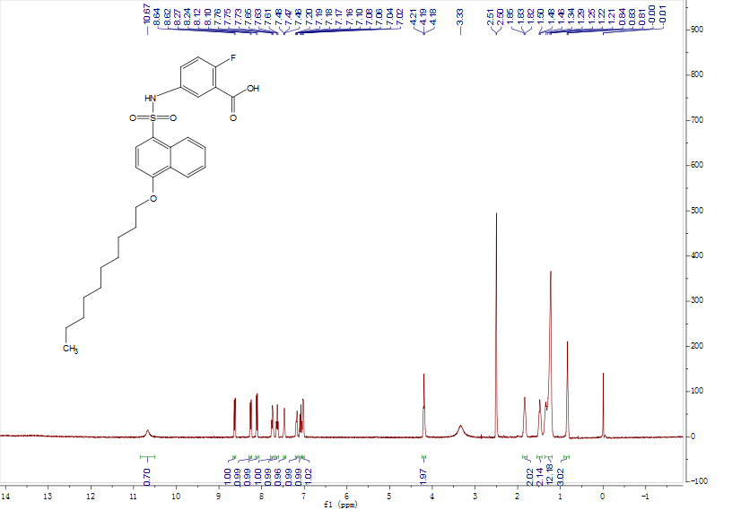

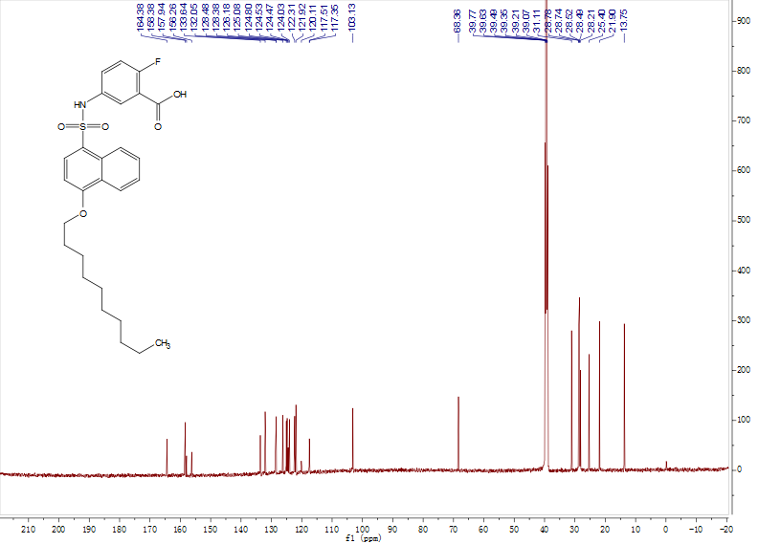

1H NMR and 13C NMR Spectrums of **A10**

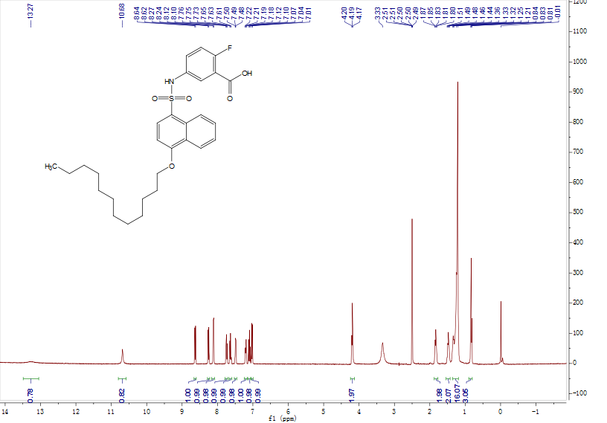

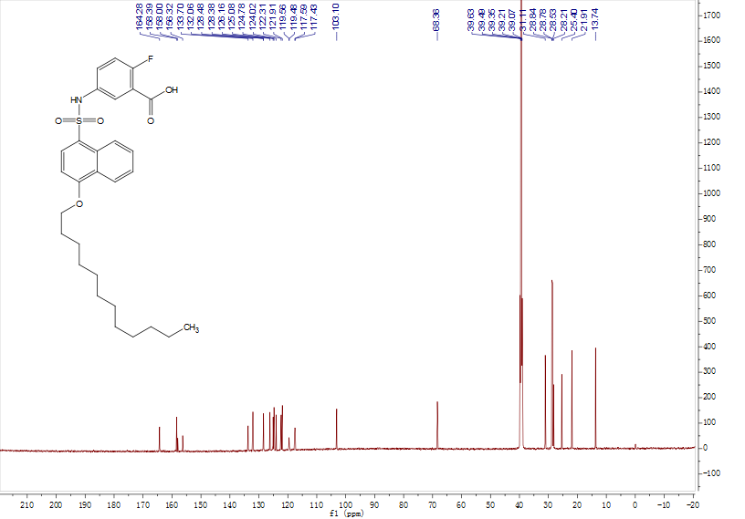

1H NMR and 13C NMR Spectrums of **A11**

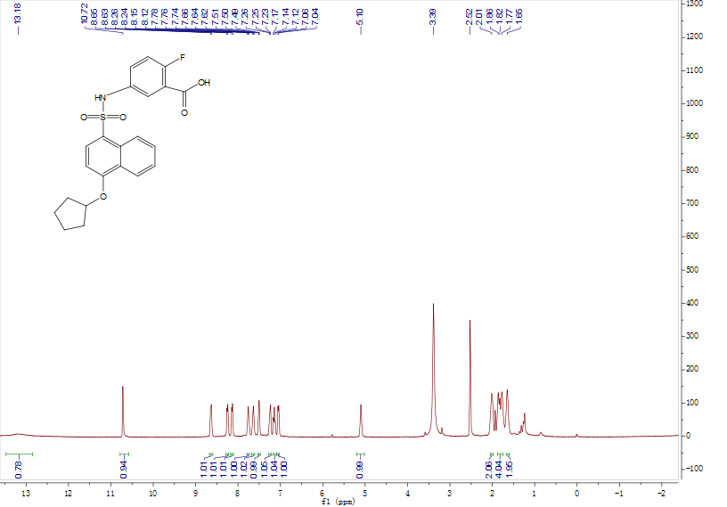

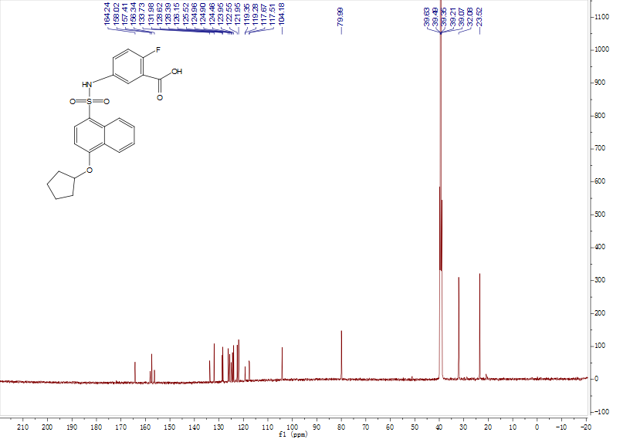

1H NMR and 13C NMR Spectrums of **A12**

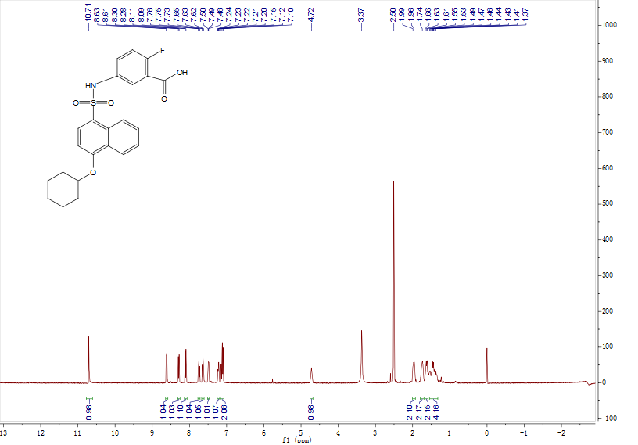

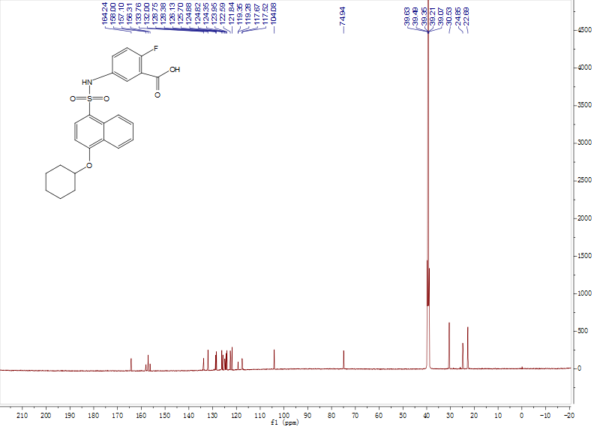

1H NMR and 13C NMR Spectrums of **A13**

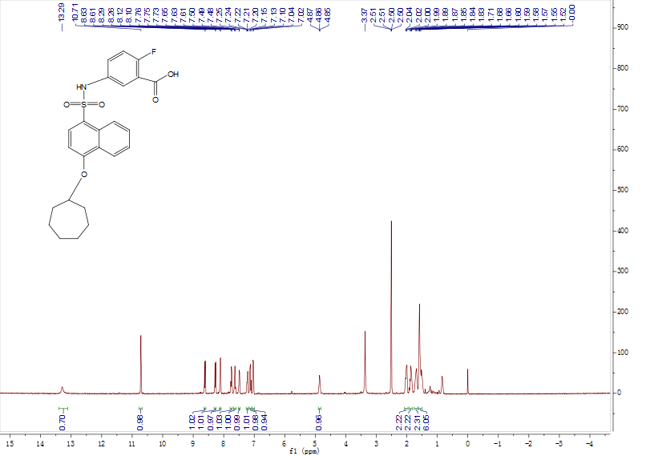

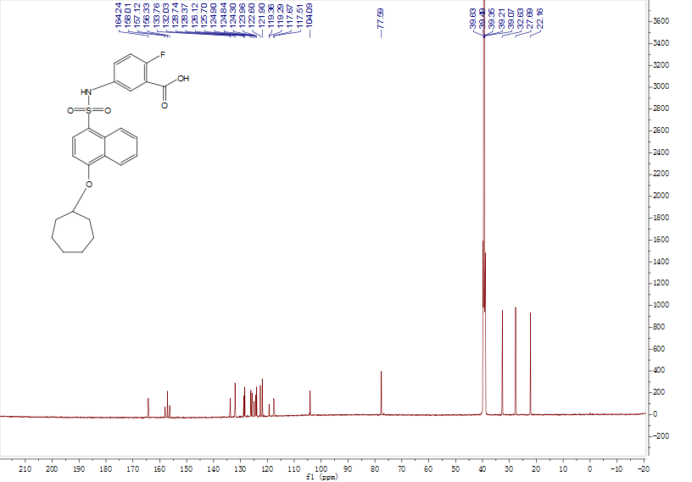

1H NMR and 13C NMR Spectrums of **A14**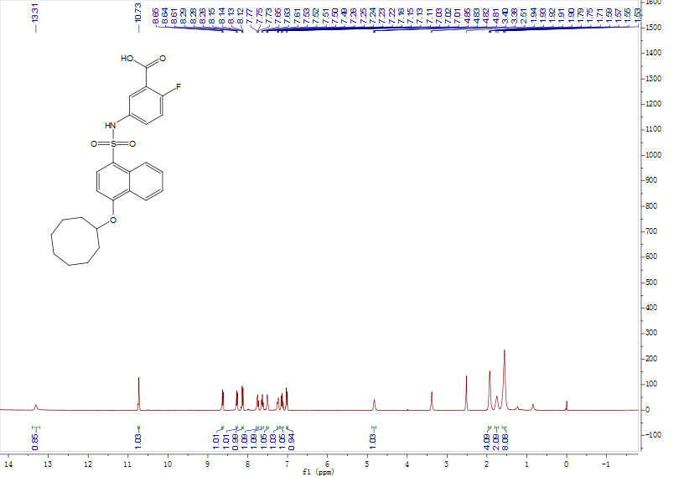

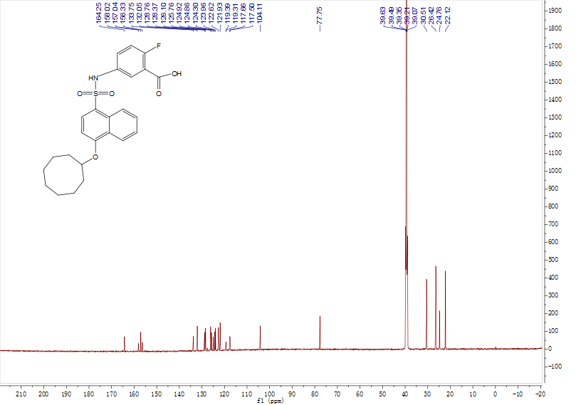

1H NMR and 13C NMR Spectrums of **A15**

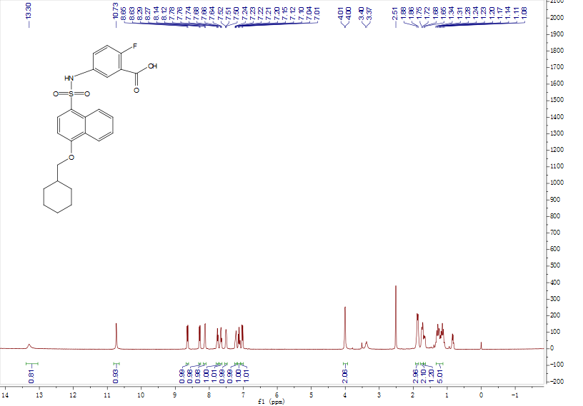

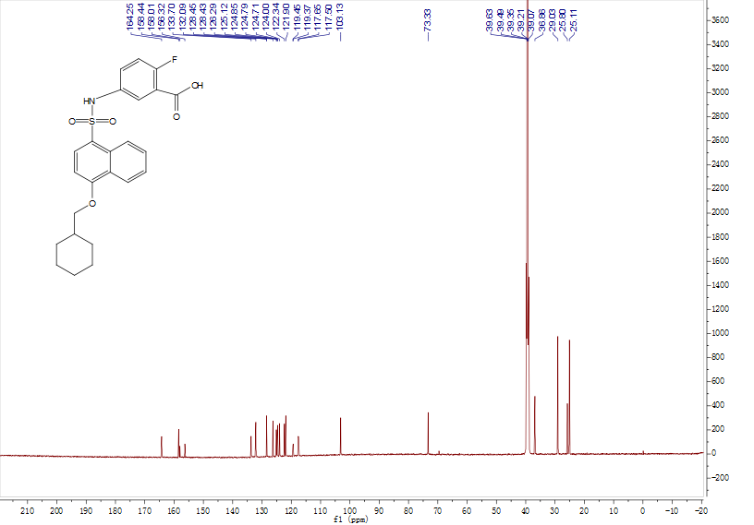

1H NMR and 13C NMR Spectrums of **A16**

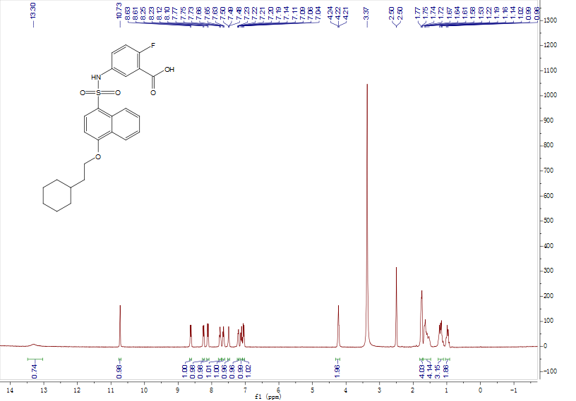

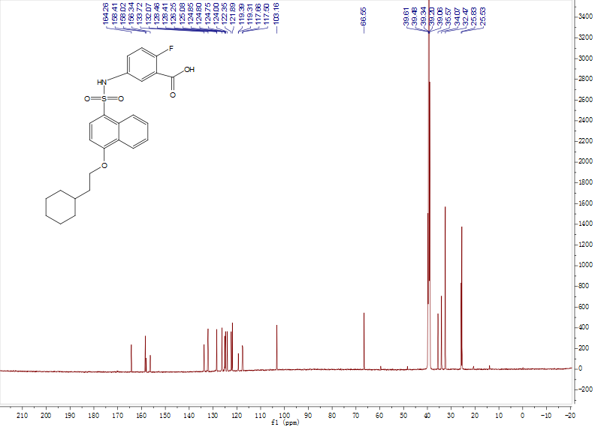

1H NMR and 13C NMR Spectrums of **A17**

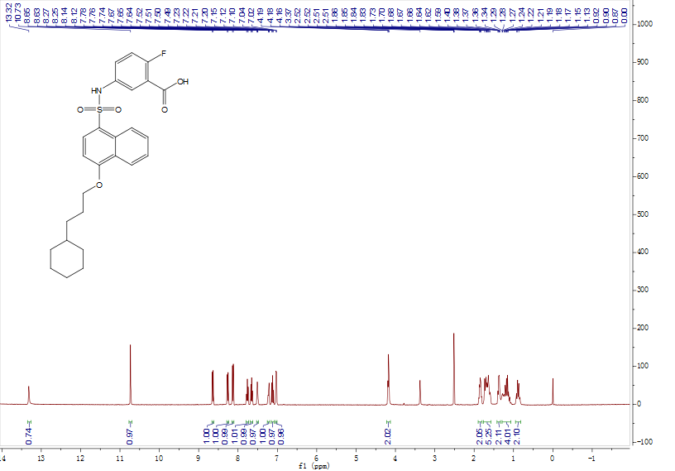

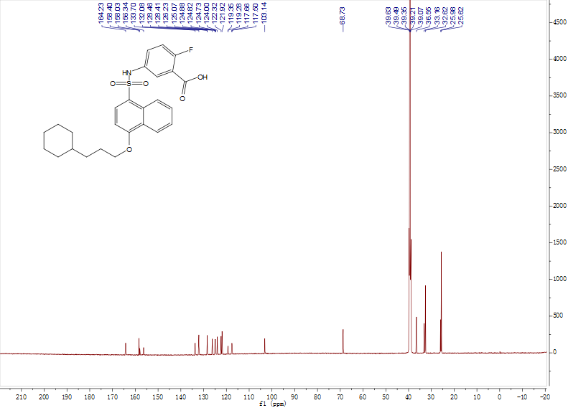

1H NMR and 13C NMR Spectrums of **A18**

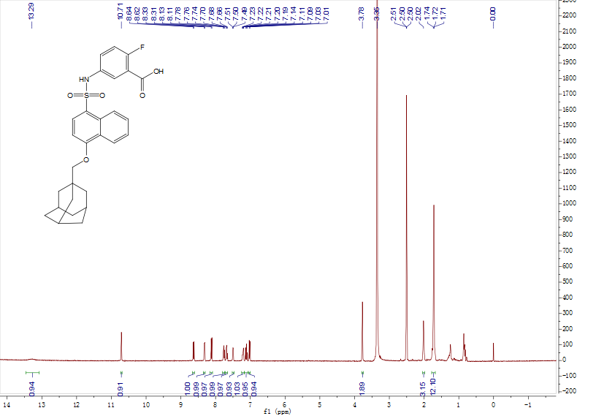

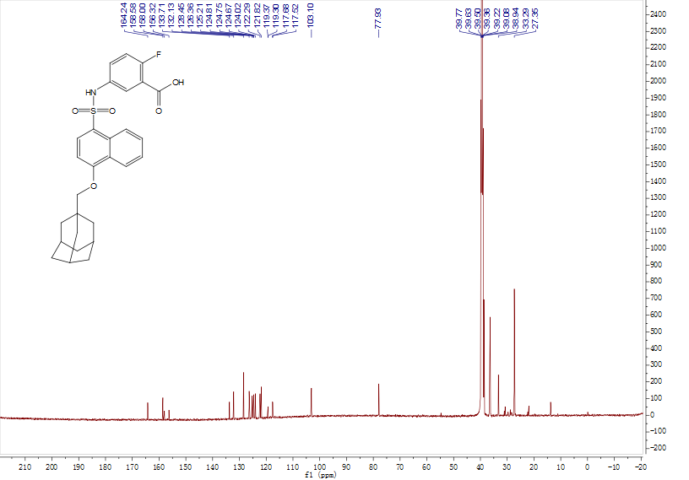

1H NMR and 13C NMR Spectrums of **A19**

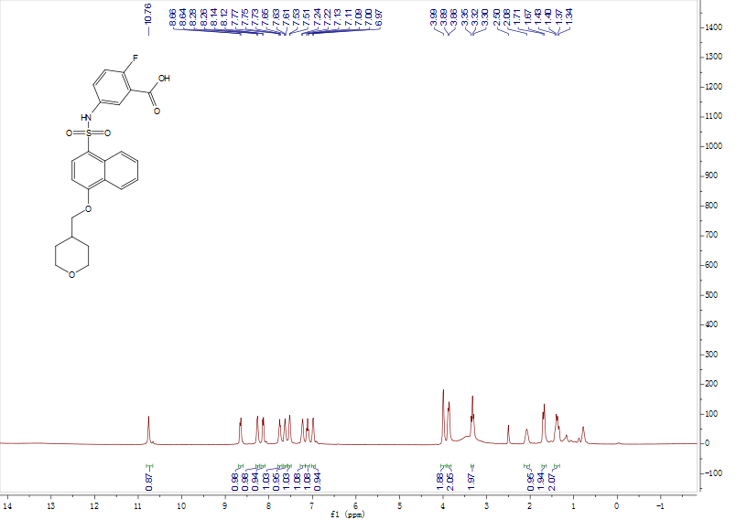

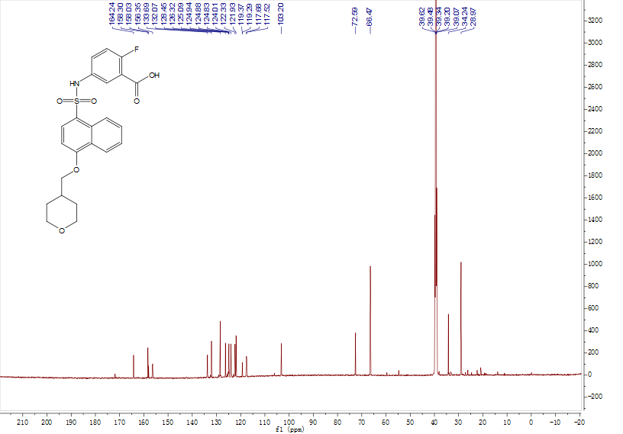

1H NMR and 13C NMR Spectrums of **A20**

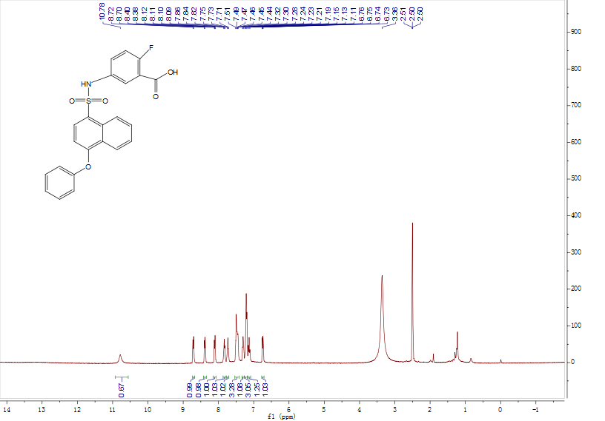

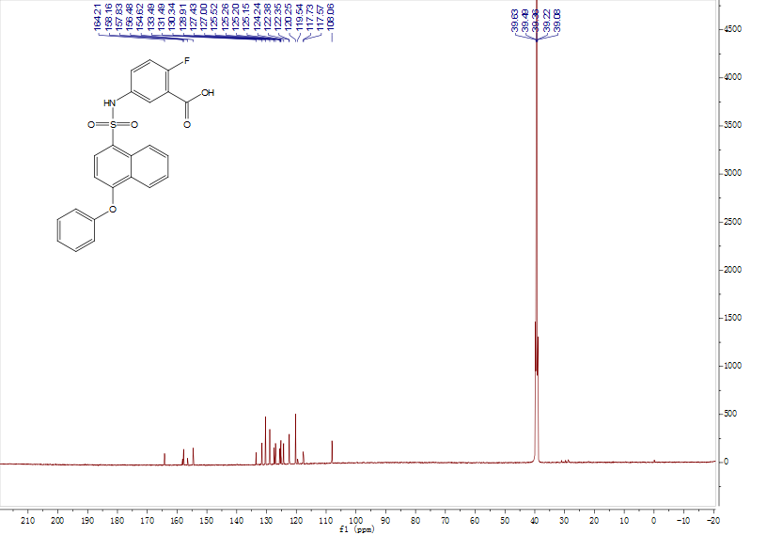

1H NMR and 13C NMR Spectrums of **A21**

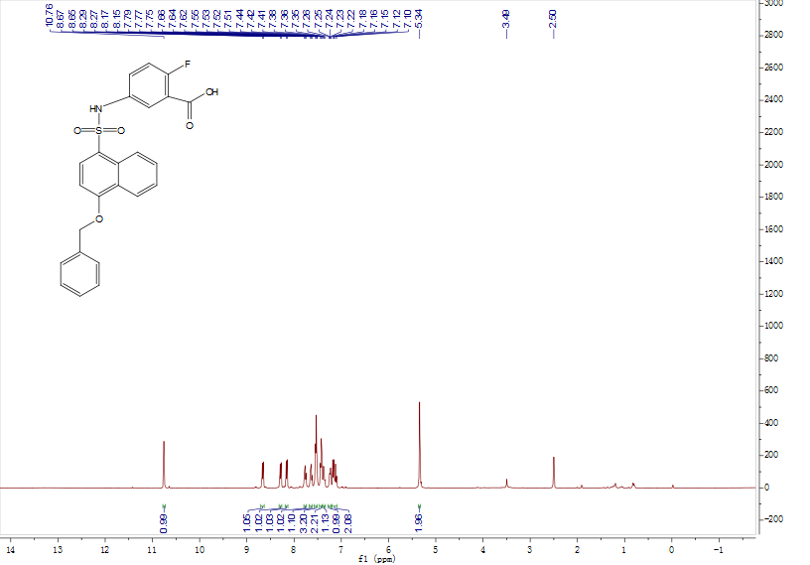

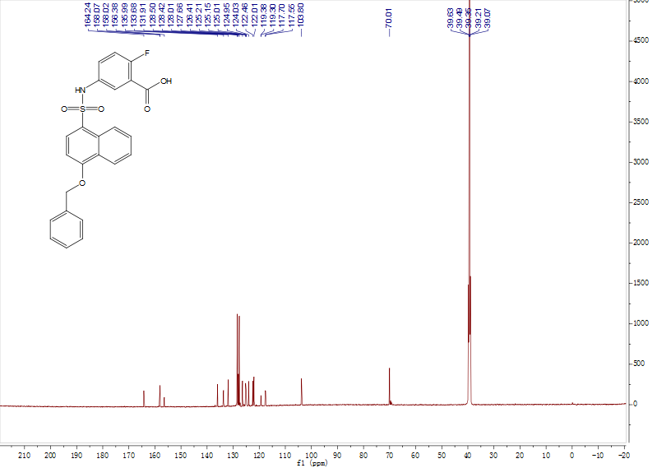

**Series B**

1H NMR Spectrums of **15**

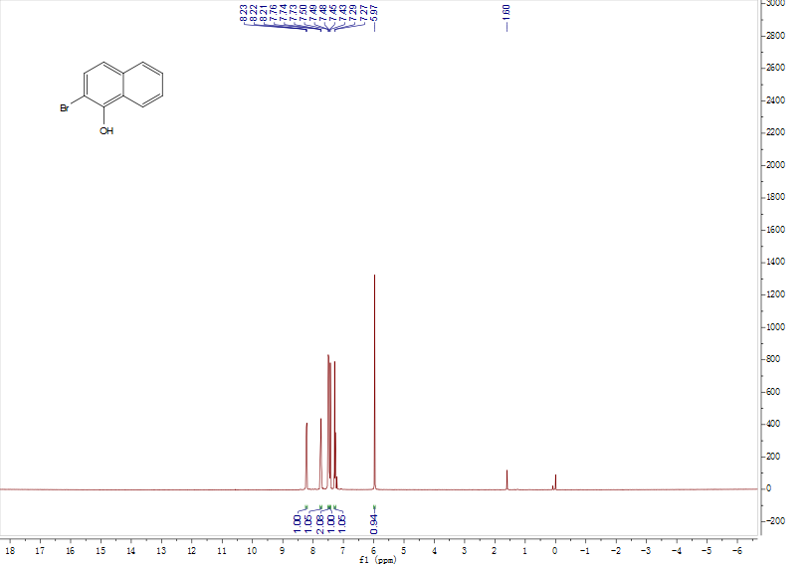

1H NMR Spectrum of **16**

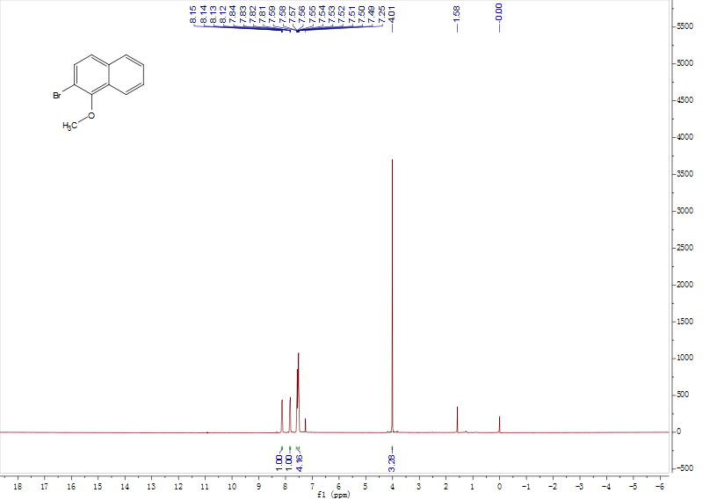

1H NMR Spectrum of **18**

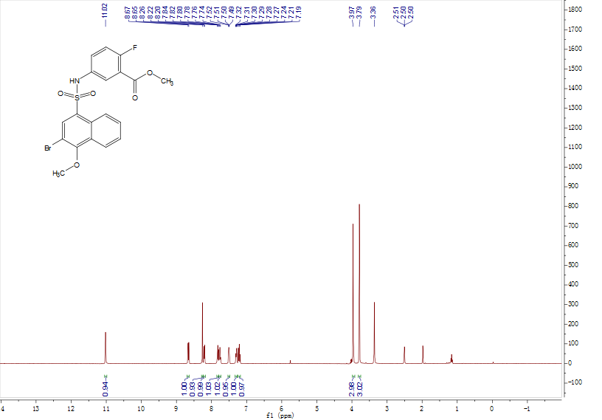

1H NMR Spectrum of **19a**

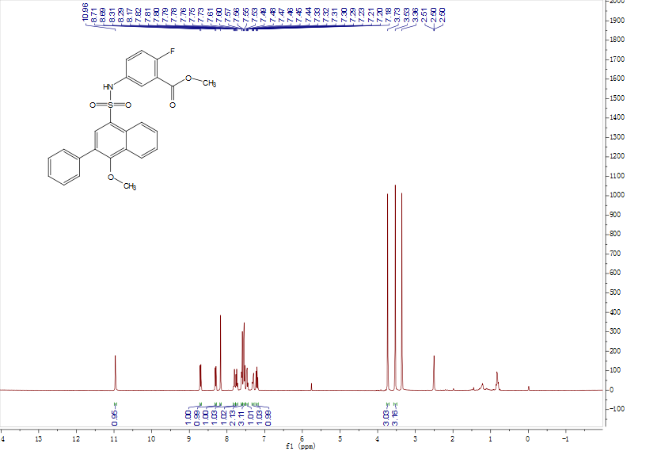

1H NMR and 13C NMR Spectrums of **B1**

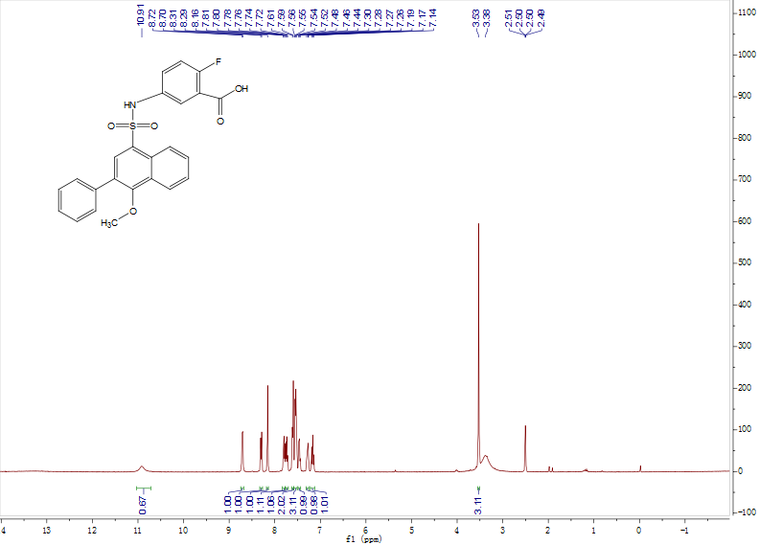

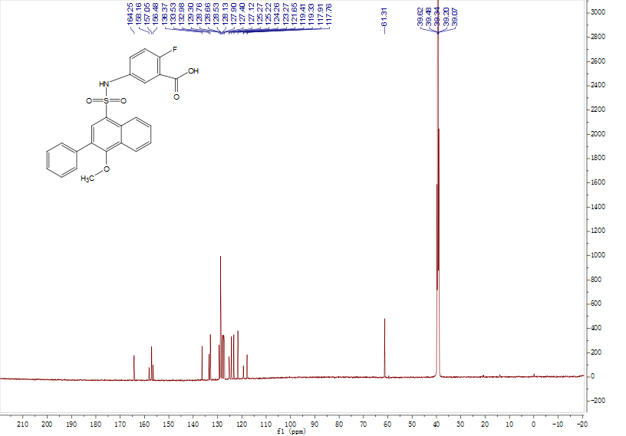

1H NMR and 13C NMR Spectrums of **B2**

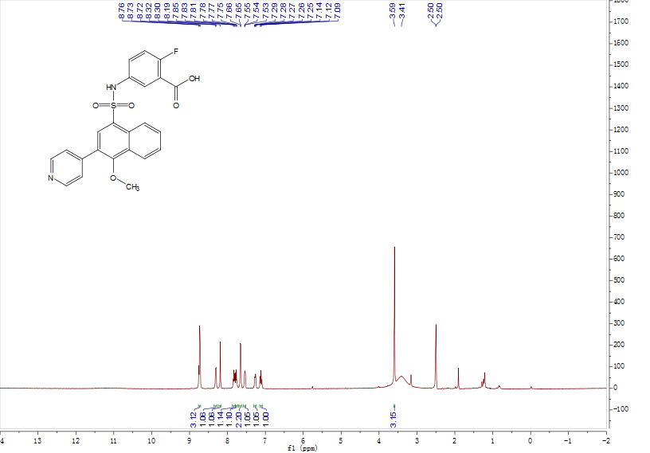

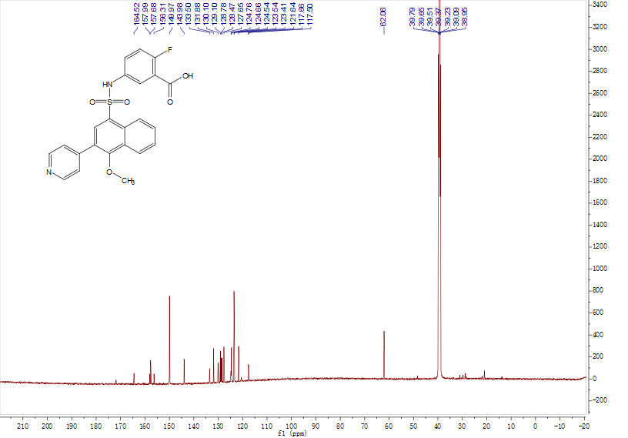

1H NMR and 13C NMR Spectrums of **B3**

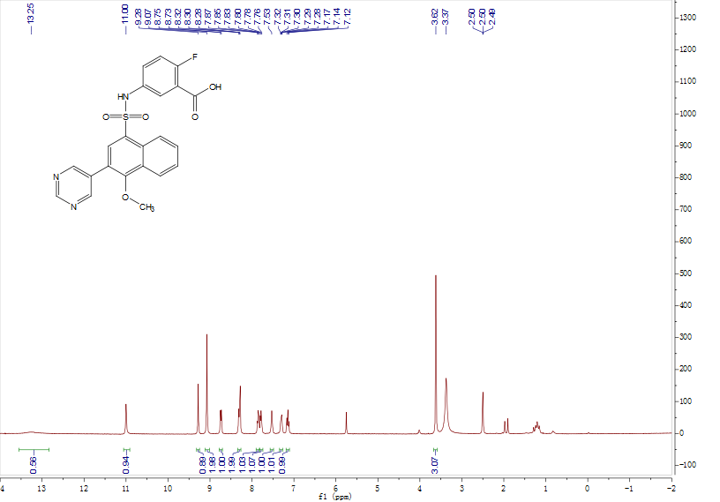

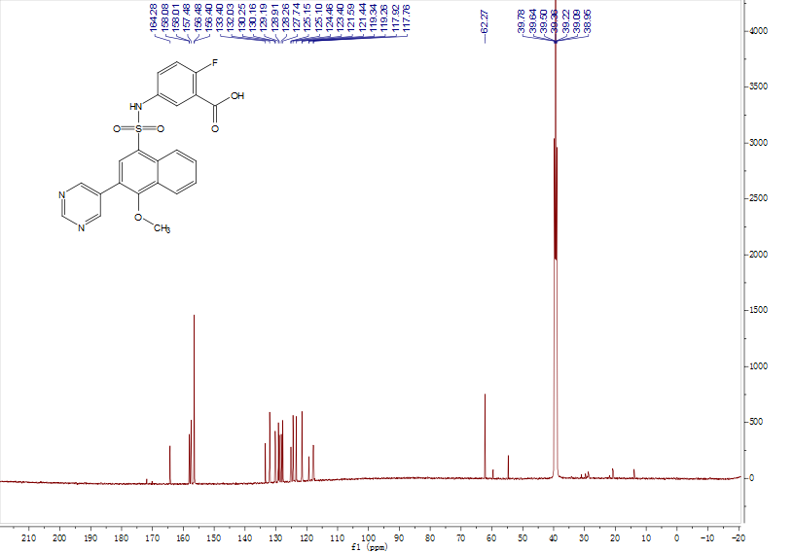

1H NMR and 13C NMR Spectrums of **B4**

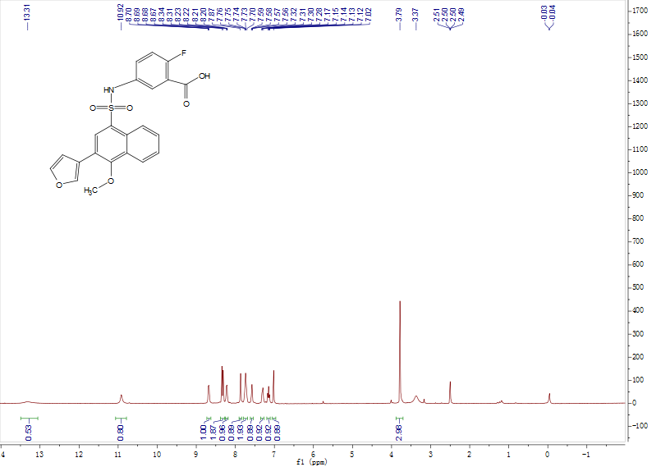

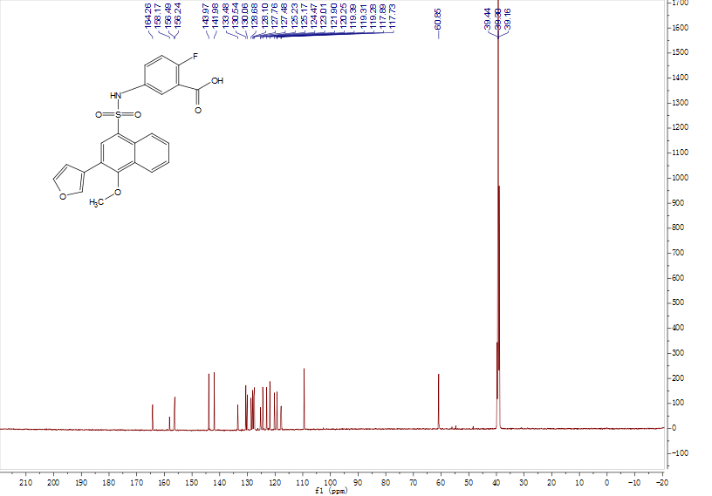

1H NMR and 13C NMR Spectrums of **B5**

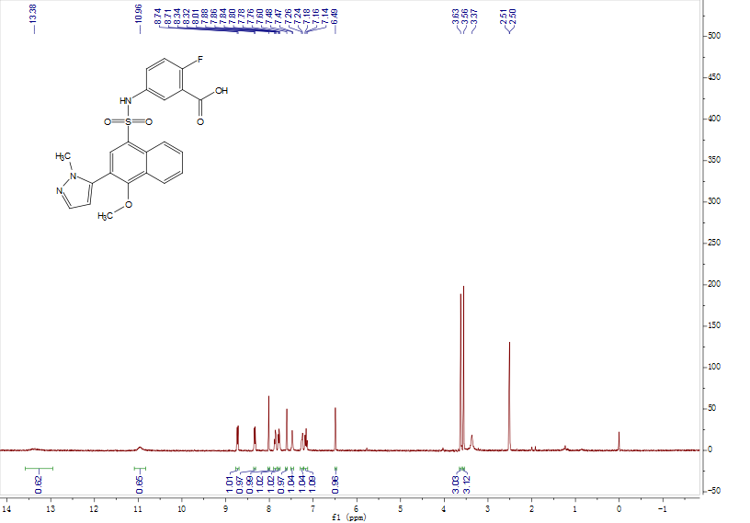

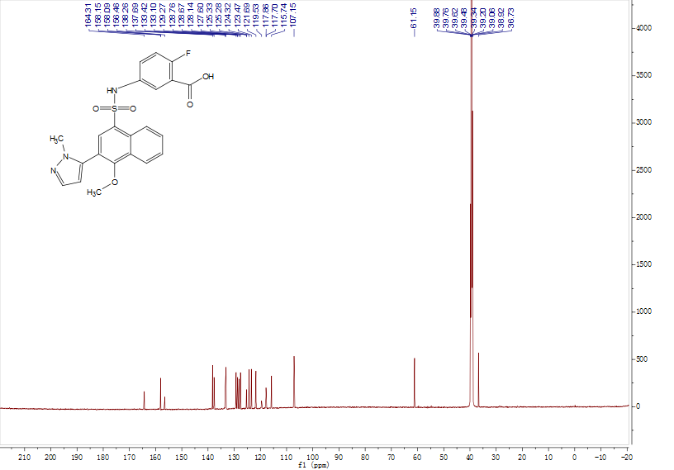

1H NMR and 13C NMR Spectrums of **B6**

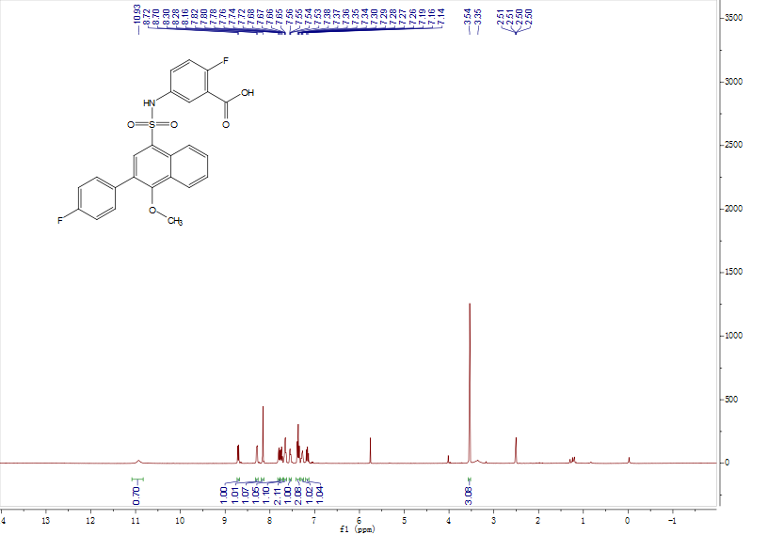

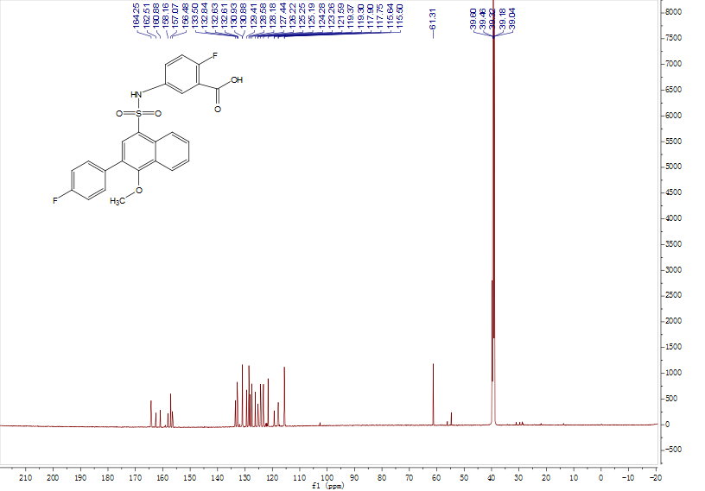

1H NMR and 13C NMR Spectrums of **B7**

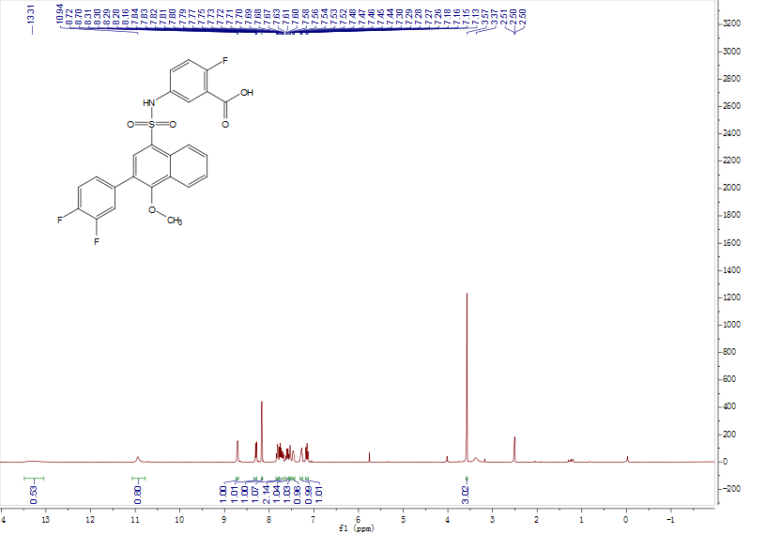

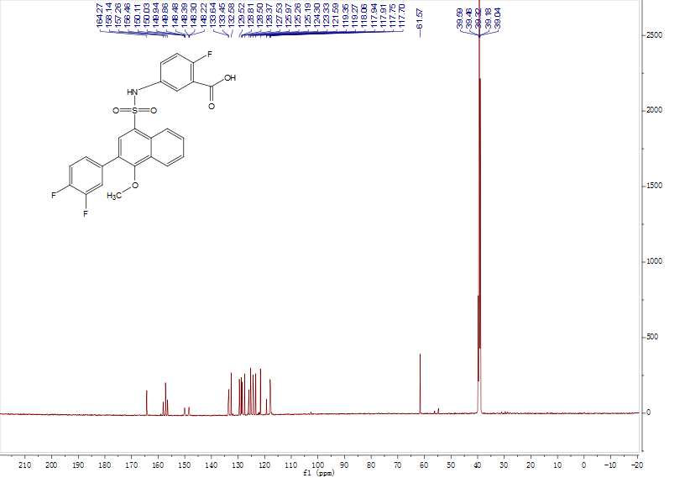

1H NMR and 13C NMR Spectrums of **B8**

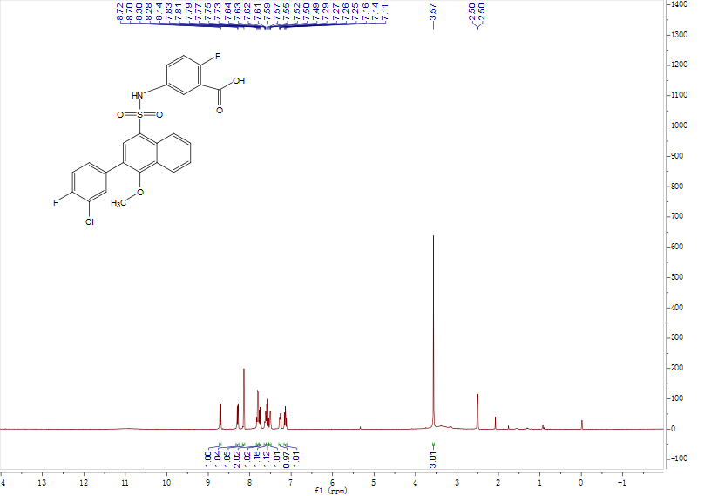

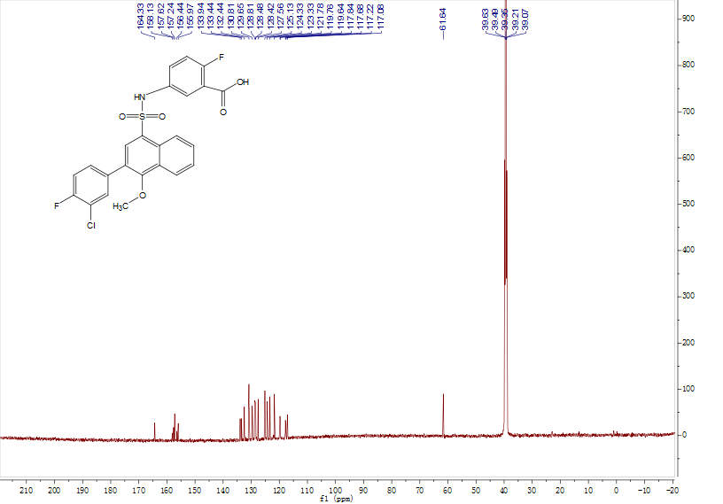

1H NMR and 13C NMR Spectrums of **B9**

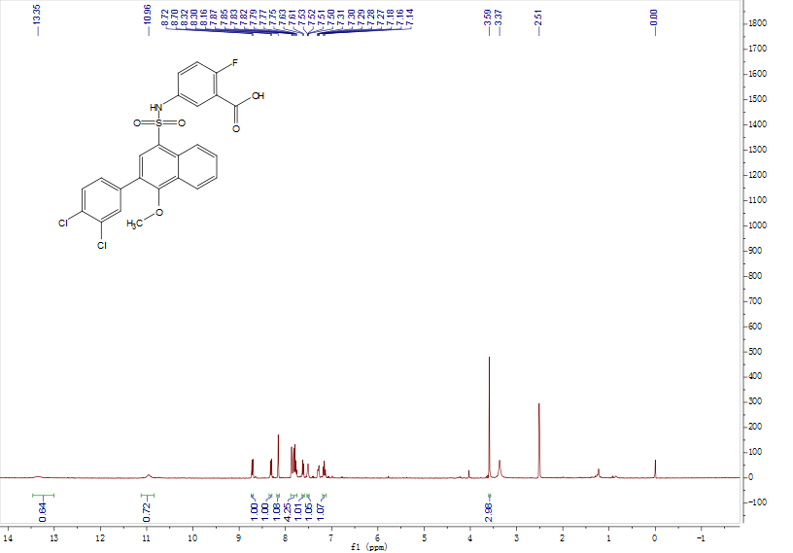

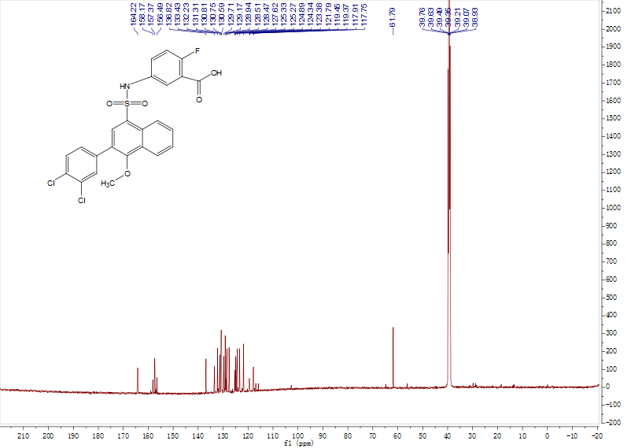

1H NMR and 13C NMR Spectrums of **B10**

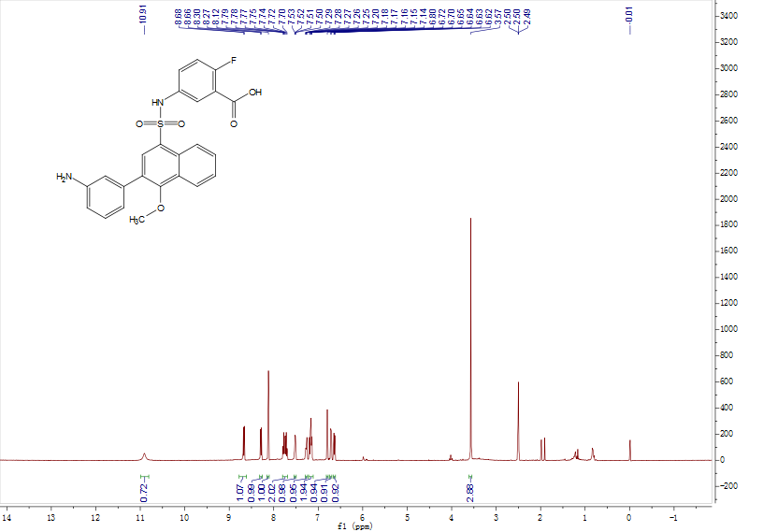

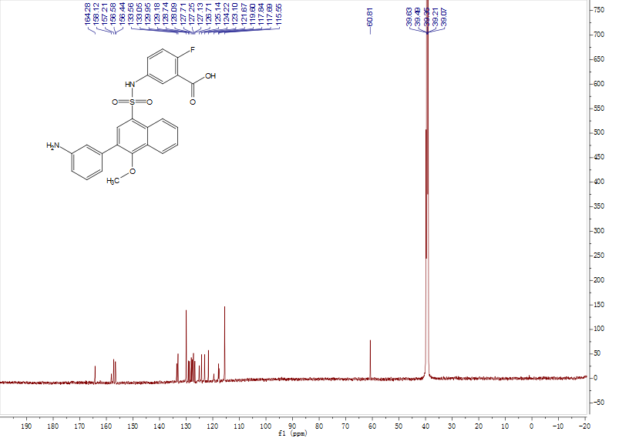

1H NMR and 13C NMR Spectrums of **B11**

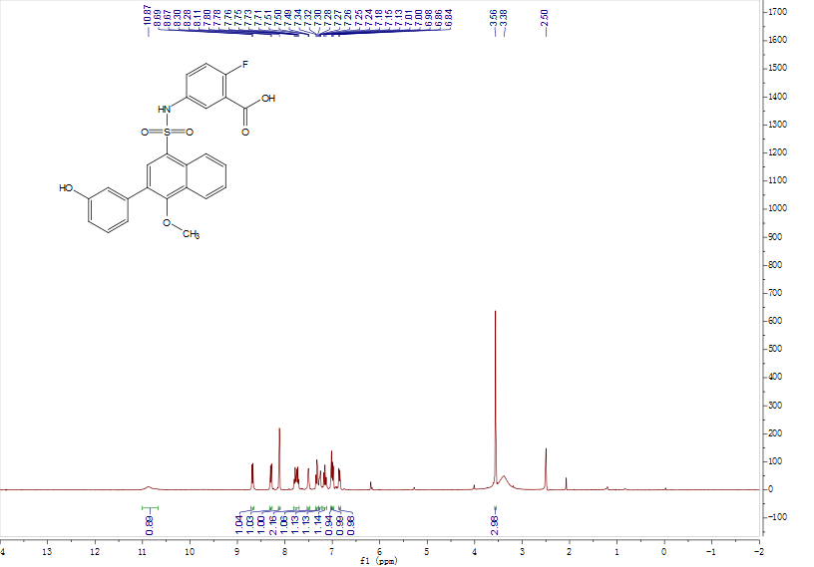

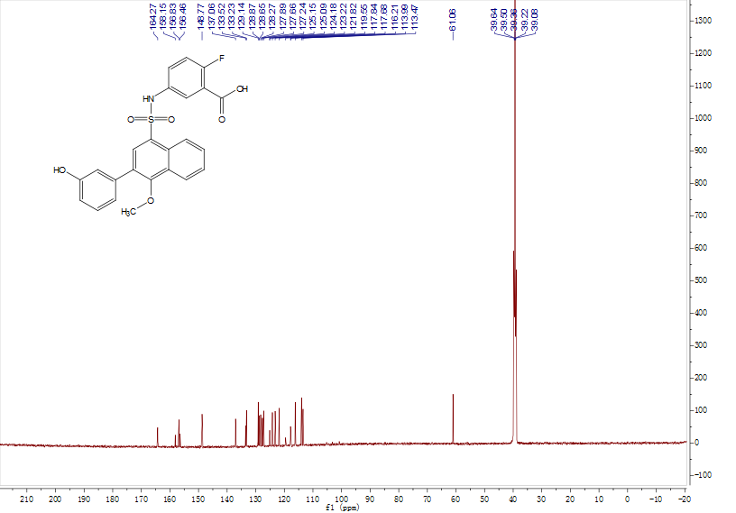

1H NMR and 13C NMR Spectrums of **B12**

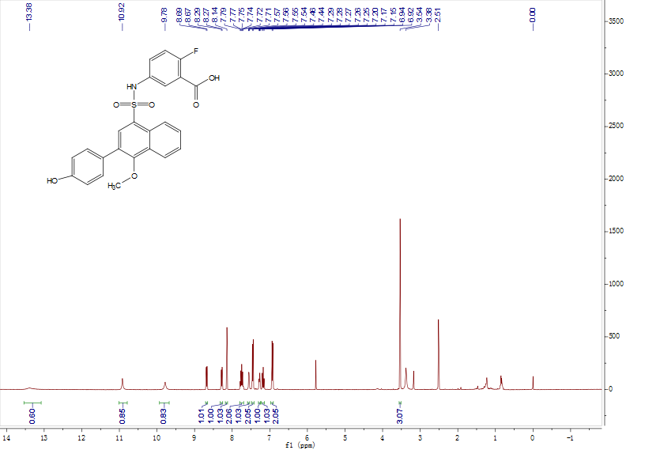

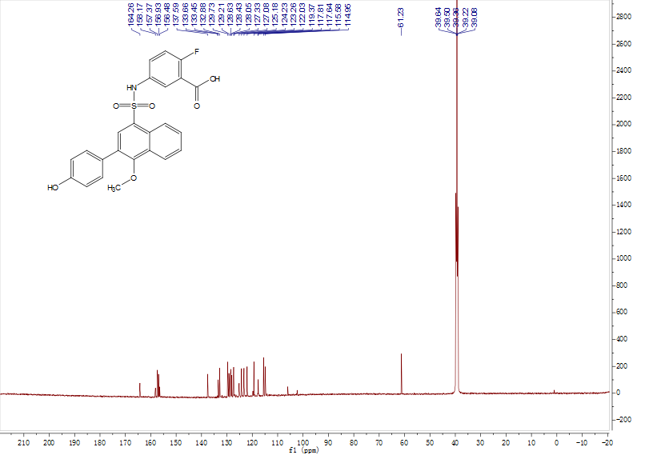

1H NMR and 13C NMR Spectrums of **B13**

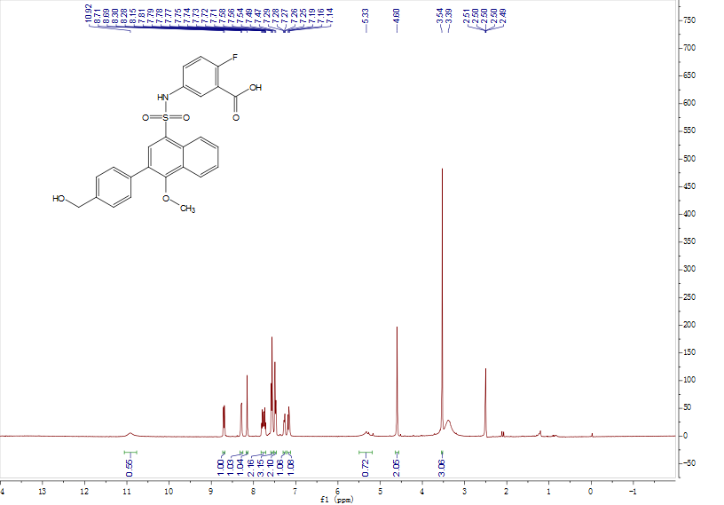

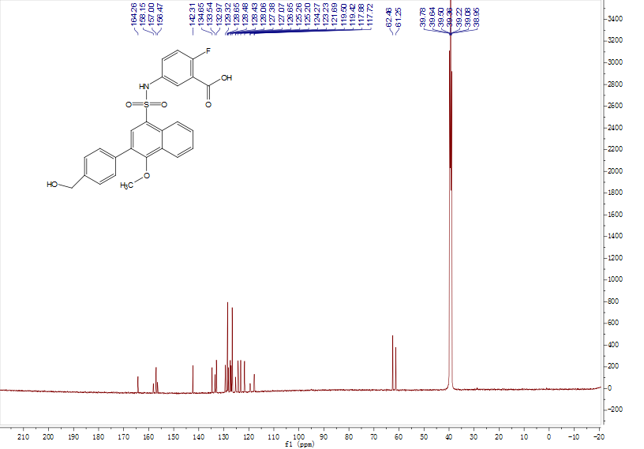

1H NMR and 13C NMR Spectrums of **B14**

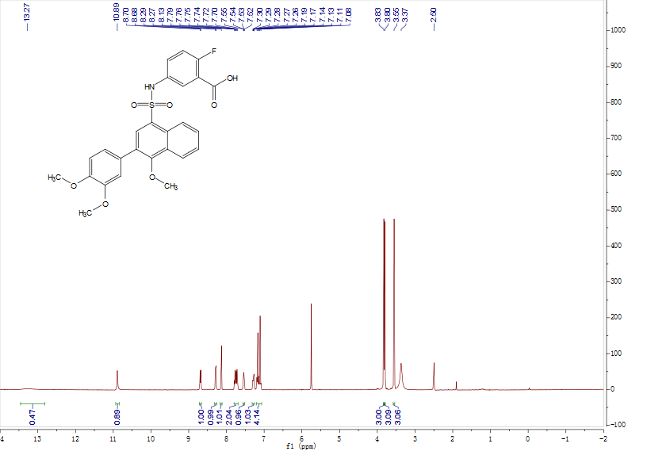

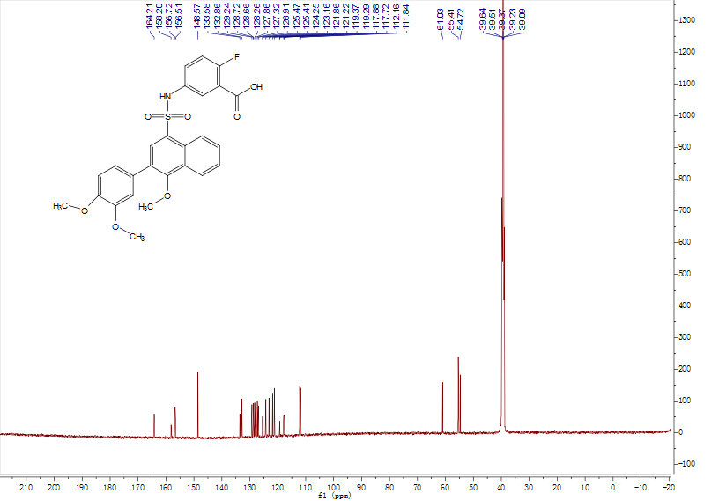

**7. References**

1. Marr E, Tardie M, Carty M, Brown Phillips T, Wang IK, Soeller W, Qiu X, Karam G. *Acta Crystallogr., Sect.* *F* : *Struct. Biol. Cryst. Commun.*2006; 62:1058-1060.
2. Cai H, Wang T, Zhao J, Sun P, Yan G, Ding H, Li Y, Wang H, Zhu W, Chen K. *Acta Pharmacol. Sin.*2013; 34:1397-1402.
3. Wang T, Sun P, Chen L, Huang Q, Chen K, Jia Q, Li Y, Wang H. *J. Agric. Food.Chem.* 2014; 62:5038-5045.