Stone consolidation by biomineralisation. Contribution for a new conceptual and practical approach to consolidate soft decayed limestones

José Delgado Rodrigues

National Laboratory of Civil Engineering, Av. Brasil, 101, 1700-066 Lisbon, Portugal, delgado@lnec.pt

Ana Paula Ferreira Pinto

CERIS, Instituto Superior Técnico – University of Lisbon, Av. Rovisco Pais, 1, 1049-001 Lisbon, Portugal, anapinto@civil.ist.utl.pt
Supplementary data:
S1: Deterioration patterns in elements of Ançã stone, in the Queluz gardens.
S2: Main portal of Loulé church and details of intense scaling.
S3: Limestone elements with scaling and deep cracking network in the main portal of Loulé church.
S4: Santa Cruz church, Coimbra, Portugal, in 1997, before the intervention.
S5 – Aspects of the intense spalling, scaling and deep fractures in limestone blocks of Porta Especiosa (Old Cathedral of Coimbra).

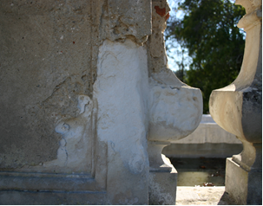 | 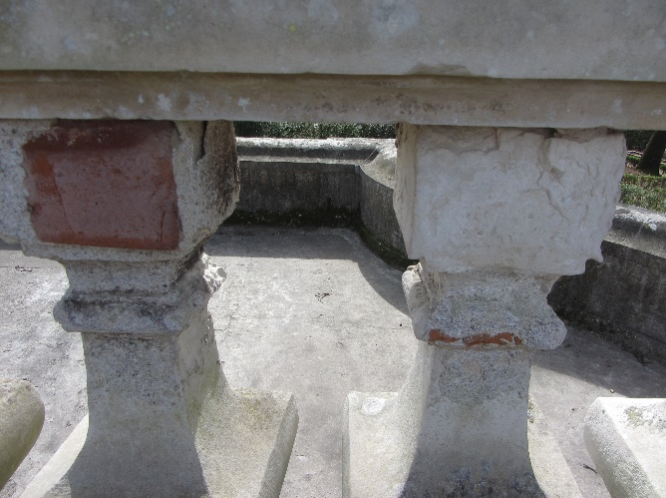
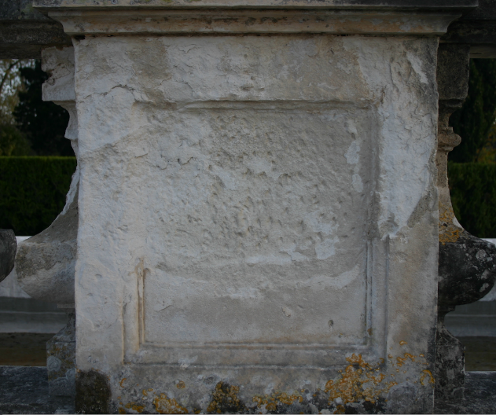 | 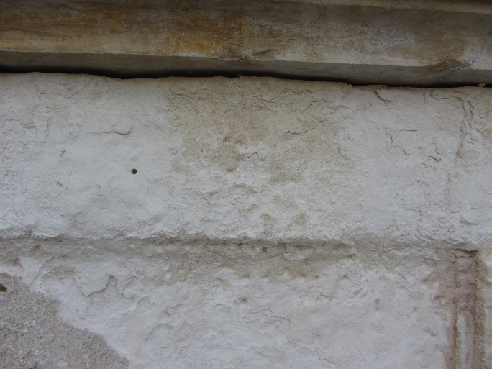
S 1 – Deterioration patterns in elements of Ançã stone, in the Queluz gardens. Heavy mortar reconstructions of eroded areas (top) and detail of the intense scaling and powdering (bottom).

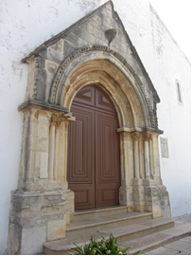 | 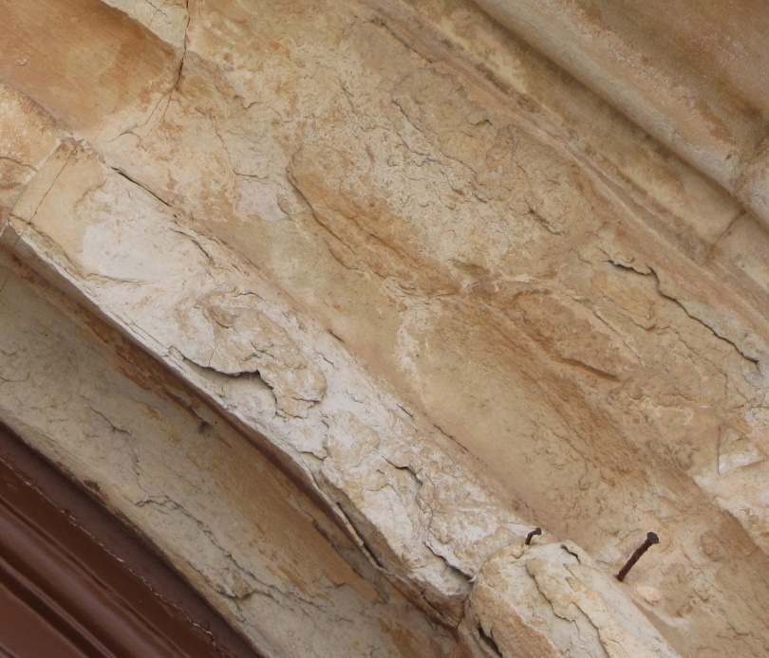
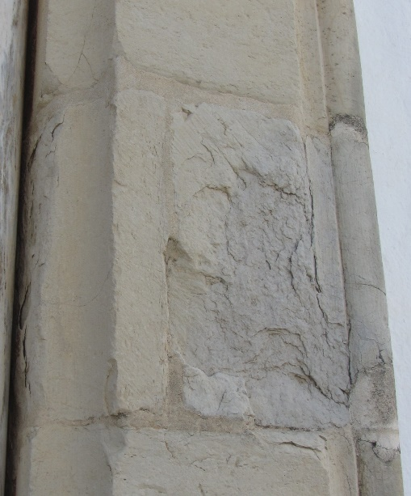 | 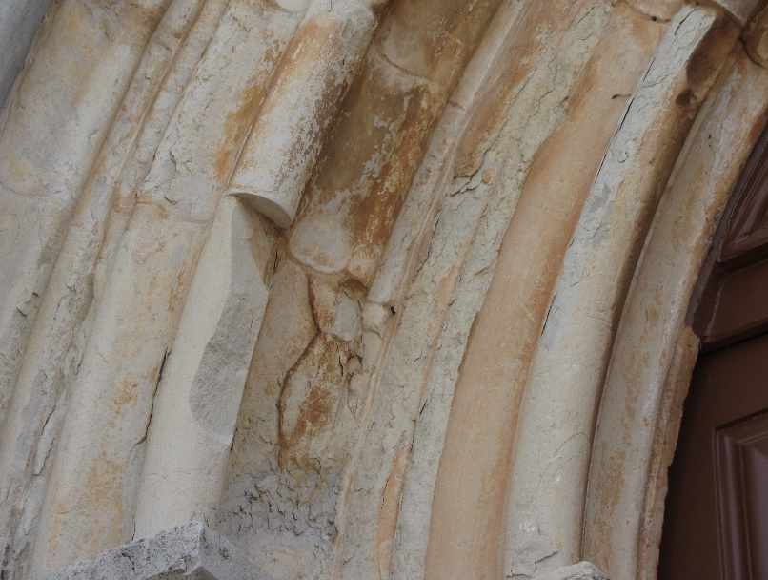
S2 – Main portal of Loulé church and details of intense scaling.

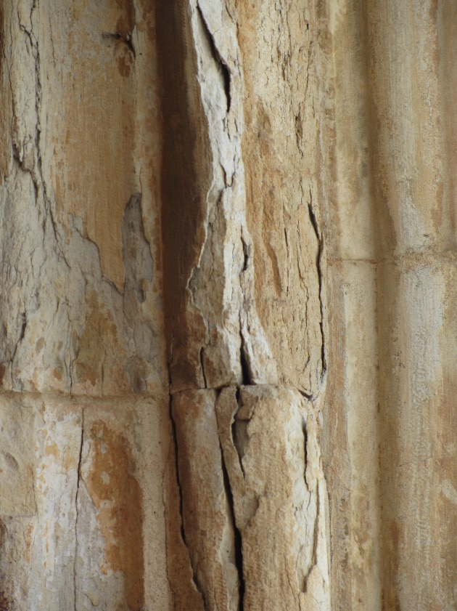 | 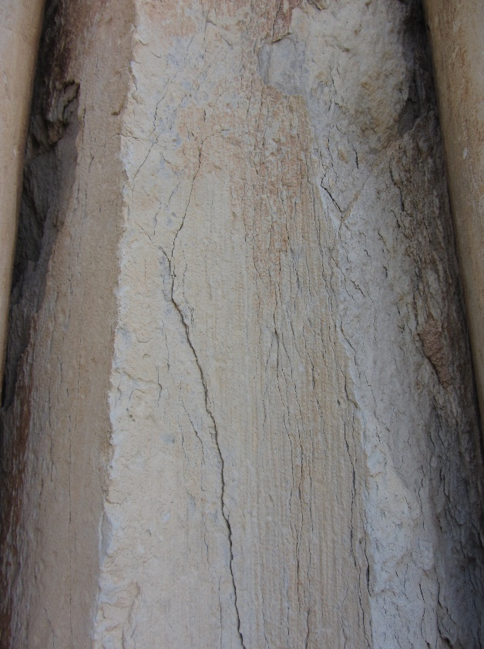
S3 – Limestone elements with scaling and deep cracking network in the main portal of Loulé church. The extreme weakness of the stone surface makes any simple attempt to stabilize pieces into a risky operation. Any slight improvement in the softened zones will be of great benefit when addressing the stabilization of the threatening large cracks.

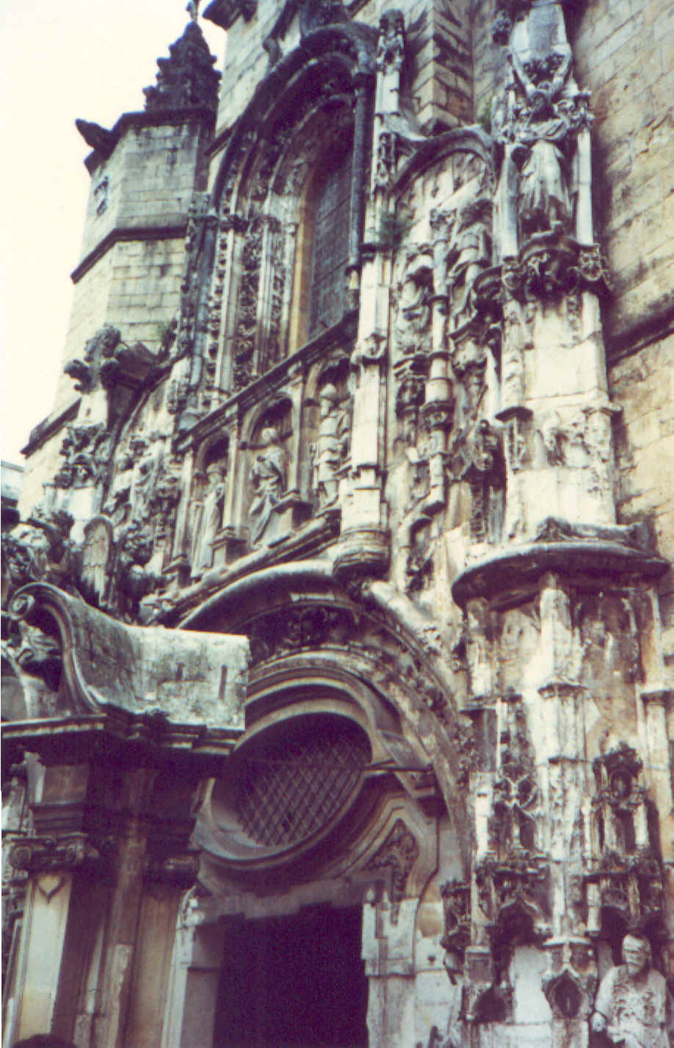 | 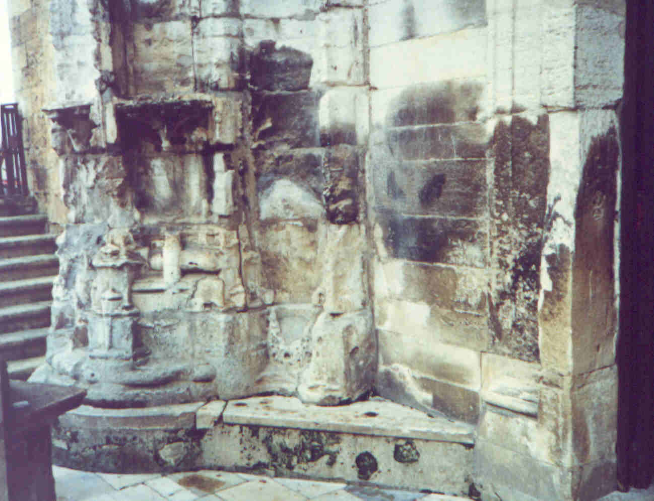
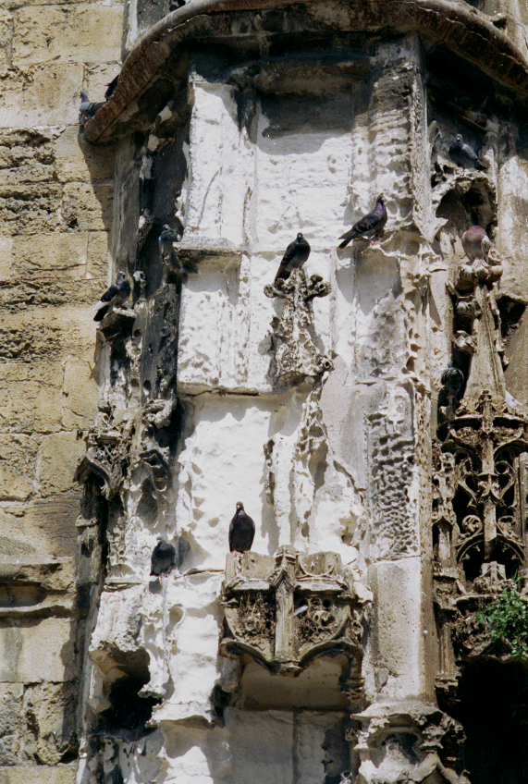 | 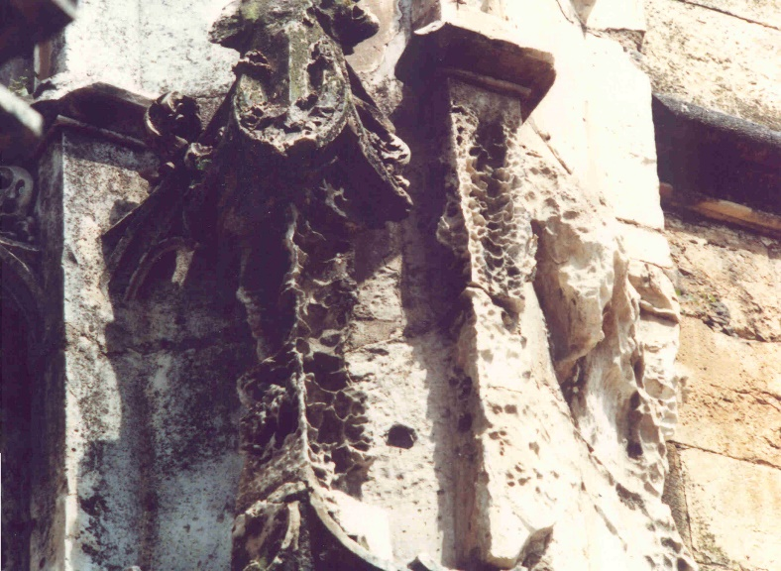
S4 – Santa Cruz church, Coimbra, Portugal, in 1997, before the intervention. The portal is made of Ançã stone, a weak limestone with 27-29% porosity. Powdering and scaling, with severe mass loss were deterioration features spread through the entire portal. The very dark patches in the top right photo are remains of past treatments.

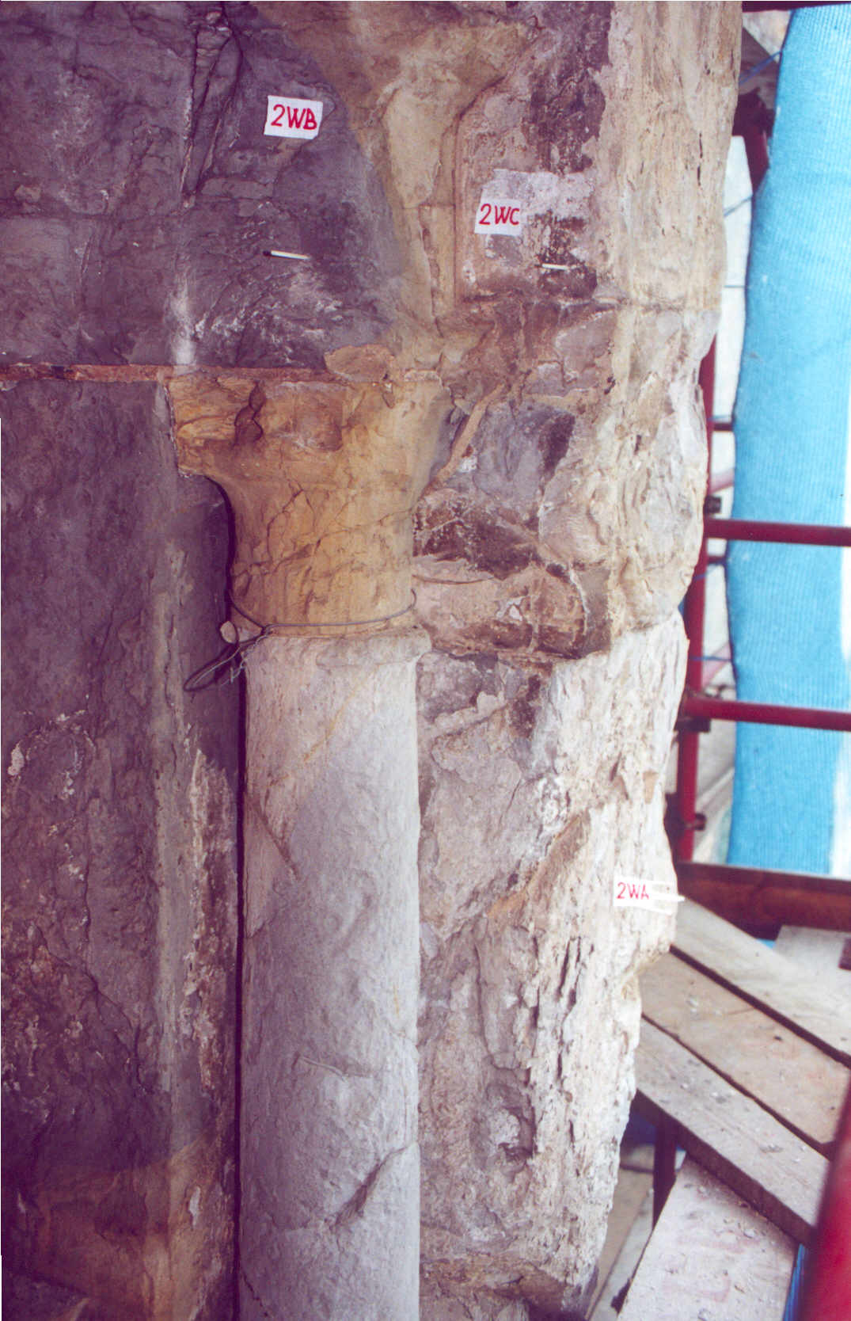 | 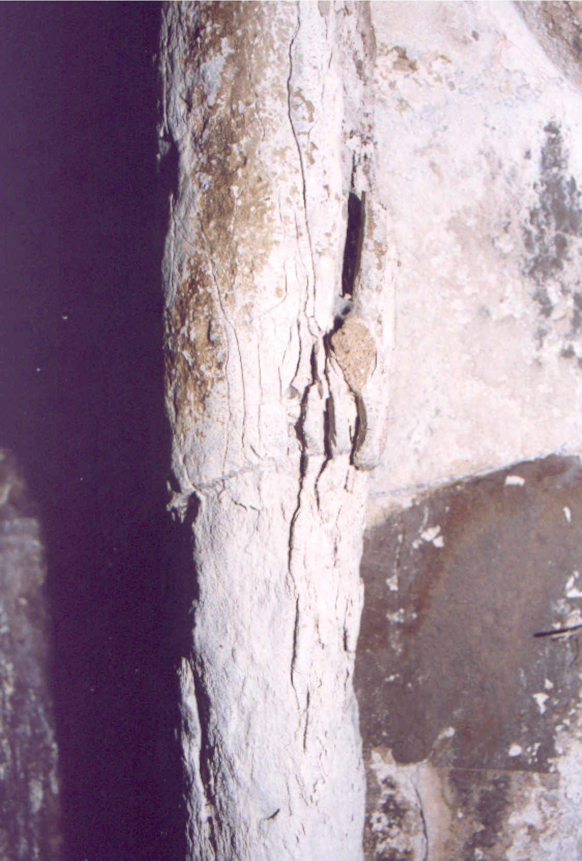
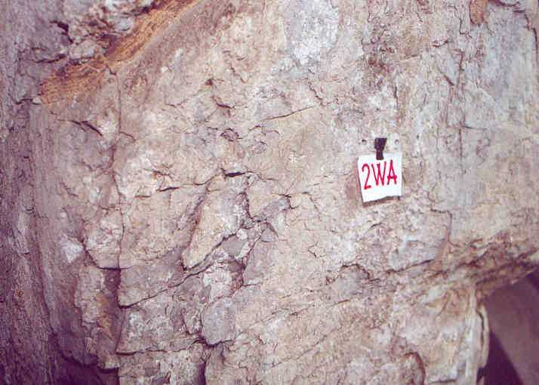
S5 – Aspects of the intense spalling, scaling and deep fractures in limestone blocks of Porta Especiosa (Old Cathedral of Coimbra).

Lisbon, April 2019
José Delgado Rodrigues

