Supporting data 1 (S1)
Raman spectra were obtained using the in Via Ranishaw Raman Microscopy system (Ranishaw, Old Town, Wotton-under-Edge, UK) with a 633 nm He/Ne laser,
Fig. 1 shows typical Raman spectra registered for mullein and Saponaria officinalis L extracts. The samples were investigated "as received" after plant extracts preparations process in the solid form (as presented in Fig. 1A in the main text).
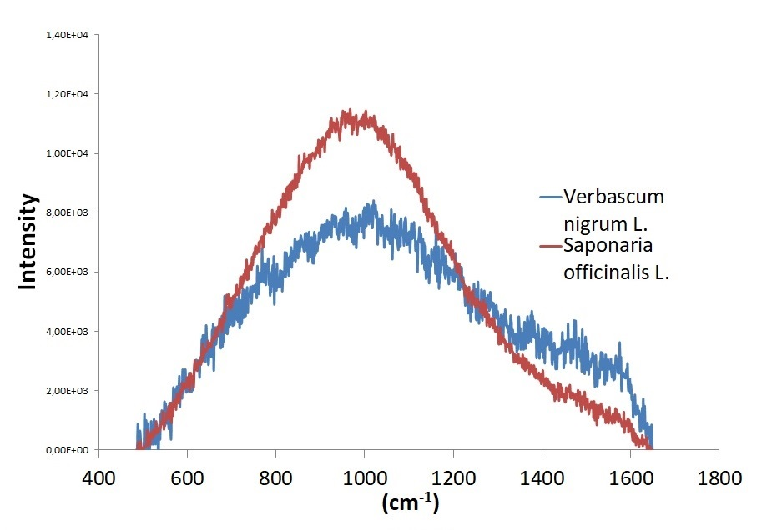
Fig.1

