The expression patterns of vestigial like family member 4 genes in zebrafish embryogenesis
CHANG XUE, HAI HONG WANG, JUN ZHU*, # and JUN ZHOU*, #
CNRS-LIA Hematology and Cancer, Sino-French Research Center for Life Sciences and Genomics, State Key Laboratory of Medical Genomics, Rui-Jin Hospital, Shanghai Jiao Tong University School of Medicine, Shanghai, China

*Address correspondence to: J Zhou or J Zhu. CNRS-LIA, Rui-Jin Hospital, Shanghai Jiao Tong University School of Medicine, Shanghai, China. Tel: 0086-2164453969. E-mail: zj10802@rjh.com.cn or junjun_j@yahoo.com (J Zhou); zhuj1966@yahoo.com or jun.zhu@paris7.jussieu.fr (J Zhu).
#Note: Both authors share senior authorship.

Key words：vgll4 paralogs, expression pattern, zebrafish, embryonic development, WISH analysis
Abbreviations and symbols: dpf, days post fertilization; E, eyes; Ep, epidermis; EpN, epidermis at the border of the neural plate; DFC, dorsal forerunner cells; HB, hindbrain; hpf, hours post fertilization; J, jaw; L, lens; LL, lateral line; LLP, lateral line primordium; MB, midbrain; MDR, midline of diencephalic roof; MHB, midbrain–hindbrain boundary; MTc, midbrain tectum; MTg, midbrain tegmentum; N, neuromasts; OfV, olfactory vesicle; OV, otic vesicle; P, pharynx; PA, pharyngeal arches; PD, pronephric duct; PF, pectoral fin; PP, pharyngeal pouches; Pr, proctodeum; R, retina; r, rhombomeres; r1, rhombomere 1; T, telencephalon; Ve, ventricle; vgll4, vestigiallike family member 4; WISH, whole-mount in situ hybridization.
Corresponding authors at: CNRS-LIA Hematology and Cancer, Sino-French Research Center for Life Sciences and Genomics, Rui-Jin Hospital, Shanghai Jiao Tong University School of Medicine, 197 Rui-Jin Road II, Shanghai, China.
E-mail addresses: zj10802@rjh.com.cn or junjun_j@yahoo.com (J Zhou), zhuj1966@yahoo.com or jun.zhu@paris7.jussieu.fr (J Zhu).
Fax and telephone numbers: 0086-2164453969
E-mail addresses of all the other authors：C Xue:xuechang91@163.com,HH Wang: wanghaihong51@163.com

Abstract
Transcriptional cofactor Vestigial-like 4 (VGLL4) was considered to take part in the early stage of development. Different from human, three paralogs of vgll4 were found in zebrafish, which were vgll4a, vgll4b and vgll4l. However, the expression patterns of the three paralogs during zebrafish development remains unknown. In this study, we used in situ hybridization to elucidate the temporal and spatial expression of zebrafish vgll4 paralogs during normal embryonic and larval development. Similar expression was shown in certain areas at similar stages for the three paralogs. Expression of vgll4a, vgll4b and vgll4l were all found in pectoral fins and otic vesicles during the early developmental stages. On the other hand, a few differences of the three paralogs expression were found in eyes, pharynx, pharyngeal arches and brain tissues. The expression of vgll4a was weak and ubiquitous, while vgll4b was obviously expressed in brain tissues and vgll4l was clearly restricted to each pair of pharyngeal pouches. What’s more, vgll4b and vgll4l had unique expression at mature lateral line neuromasts and forerunner cells respectively. Despite the conservativeness of functional domains, the three paralogs of zebrafish vgll4 shared several similarities and displayed some distinctions in the expression patterns, indicating that they may still have different and exclusive functions, which need to be further explored.
1. Introduction
Transcription cofactor vestigial-like (VGLL) proteins, named after Drosophila transcriptional co-activator Vestigial (Vg) involved in various biological processes, are found expressed both in invertebrates and vertebrates. There are four members of VGLL identified in mammals namely VGLL1, VGLL2, VGLL3 and VGLL4. Acting as transcriptional cofactors, VGLLs do not contain DNA binding domain, their transcriptional regulation functions are mediated through the interaction between TONDU (TDU) domains and other transcription factors (HH Chen et al., 2004). Unlike VGLL1, VGLL2 and VGLL3 which possess a unique TDU domain, there are two TDU domains in series at the carboxyl-terminus of VGLL4. Therefore, VGLL4 is assumed to have different functions from the other three homologs (Faucheux et al., 2010).
Physiologically, VGLL4 was considered to take part in the early stage of development. Similar to VGLL1 and VGLL2, VGLL4 interacts with the transcription factor myocyte enhancer factor (MEF) 2 (Maeda et al., 2002). The tandem TDU domains of VGLL4 might form a bridge between MEF2 and TEAD, both of which are cardiac and skeletal muscle transcription factors implicated in cardiac muscle differentiation (Pobbati and Hong, 2013). In addition, acetylation of VGLL4 could regulate Hippo-YAP Signaling and postnatal cardiac growth by regulating TEAD stability and YAP-TEAD activity (McNamara et al., 2017). In vitro study also suggested that VGLL4/TEF4(TEAD2)/IRF2BP2 complex could regulate the expression of vascular endothelial growth factor (VEGF) in muscle (Pobbati and Hong, 2013).
Pathologically, downregulation of VGLL4 was frequently found in different types of tumors including lung cancer (Zhang et al., 2014) and colorectal carcinoma (Jiao et al., 2017). Therefore, VGLL4 was considered as a tumor suppressor by interfering with several important transcription factors. For example, VGLL4 was shown directly competing with YAP in binding to TEADs through its two TDU domains, thus negatively regulating the YAP-TEAD transcriptional complex and executing its growth-inhibitory function in lung cancer (Zhang et al., 2014) and gastric cancer (Jiao et al., 2014). It was also reported that VGLL4 interfered a TEAD4-TCF4 complex to regulate Wnt and Hippo signaling in colorectal cancer (Jiao et al., 2017).
Although a series of biological functions of vgll4 has been discovered, the endogenous expression of vgll4 gene is not well explored. Northern blot analysis showed that in human tissues vgll4 expression was highest in heart, kidney, and brain (HH Chen et al., 2004). In Xenopus two vgll4 genes, namely vgll4 and vgll4l, were identified and their expression patterns were described mainly in neural tissues during the very early development stage with several distinctions and coincidence (Barrionuevo et al., 2014). Thus a comprehensive spatio-temporal expression pattern study of vgll4 will be useful for its physiological function interpretation.
As a widely used model organism, zebrafish displays much superiority in the research of development. High conservation of vgll4 was observed between human and zebrafish from the point view of sequence, synteny, and interactants, making zebrafish a potential model for investigating the functions of vgll4 during development. Different from human, three vgll4 paralogs including vgll4a, vgll4b and vgll4l were found in zebrafish. Previous analysis has shown that vgll4l is expressed primarily in the endodermally derived pharyngeal pouches (Thisse et al., 2001). However, the expression patterns of the other two members, the possible differences among the three paralogs and potential connection of each paralog to its functions in zebrafish development remain unknown. In this study, temporal and spatial gene expression of vgll4 paralogs in zebrafish was analyzed in normal embryonic and larval development.
2. Results
2.1 Characterization of the zebrafish vgll4 genes
Different from human counterpart, three paralogs of vgll4 were found in zebrafish, naming vgll4a (mapped to chromosomes 23，NCBI Reference Sequence: XM_005161921), vgll4b (mapped to chromosomes 11, NCBI Reference Sequence: NM_213275) and vgll4l (vestigial like 4 like, mapped to chromosomes 8, NCBI Reference Sequence: NM_001079998). Among these three genes, zebrafish vgll4b, locating between atg7 and tamm41, is the potential homolog of human VGLL4 by synteny analysis (Fig.1A). Although the whole amino acid sequences of zebrafish VGLL4a, VGLL4b and VGLL4l are only 39%, 70% and 32% identical to that of human VGLL4 (blastp, www.ncbi.nlm.nih. gov), the functional domains, such as nuclear conservative signal (NCS) and Tondu (TDU1 and TDU2), show great conservativeness with those of human VGLL4 (Fig.1B).
2.2 Vgll4a expression during the development of zebrafish
The expression patterns of three zebrafishvgll4 genes were analyzed by whole-mount in situ hybridization (WISH) using a DIG-labeled anti-sense probe and a sense probe as a negative control for each gene. No positive signals were found in the embryos of various stages incubated with the three sense probes (data not shown).
During the gastrula period and before, hardly could any vgll4a expression be detected (data not shown). Faint and ubiquitous expression of vgll4a was observed in the embryo trunk at about 14 hpf during the preliminary segmentation period (Fig.2A). At 24 hpf, vgll4a was expressed dispersively in pharynx (P), eyes (E), otic vesicles (OV) and brain tissues, especially strong in the telencephalon (T), midline of diencephalic roof (MDR), the midbrain (MB), the hindbrain (HB) and the ventricle (Ve) (Fig.2B-2D). At 36 hpf and 48 hpf, vgll4a showed similar expression patterns as at 24 hpf in the brain, with more prominent expression at the midbrain–hindbrain boundary (MHB) and the rhombomere 1 (r1) at 48 hpf. Enhanced vgll4a expression could be detected in chondrogenic tissues including pharyngeal arches (PA) and pectoral fins (PF) at these stages (Fig.2E-2H, Fig.2J). All these expression signals were sharply weakened at 72 hpf (Fig.2I) and faded at 5 days post fertilization (dpf) (data not shown).
2.3 Vgll4b expression during the development of zebrafish
Vgll4b, which possesses the highest homology with human vgll4 among the three zebrafish vgll4 paralogs, could be detected from a very early stage after fertilization. Ubiquitous expression was displayed in the shield stage at 6 hpf (Fig.3A) and in the whole trunk of the embryo at 12 hpf (Fig.3B). At 24 hpf, vgll4b was highly expressed in head mainly including the areas of eyes, otic vesicles, and pharynx (Fig.3C-3E). As the brain tissues concerned, vgll4b expressions in telencephalon, midbrain tectum (MTc), midbrain tegmentum (MTg) and hindbrain were most prominent. Additionally, obvious expression was also detected in lateral line primordium (LLP) at this stage (Fig.3C-3E).
From 36 hpf to 72 hpf, similar expression pattern was observed with high vgll4b expression in eyes, olfactory vesicles (OfV), otic vesicles, brain tissues and pharyngeal arches and pouches (PA and PP) (Fig.3F-J, L-M). The strong signals of the ubiquitous expression in the brain tissues gradually converted to restricted local expression in midbrain–hindbrain boundary and rhombomeres(r) (Fig.3H, Fig.3J). With the migration and deposition of lateral line primordium cells, vgll4b was expressed in multiple neuromasts (N) of lateral line (LL). Faint expression was also found in proctodeum (Pr) and epidermis (Ep) at these stages (Fig.3F-3L). Among all the time points we checked, only at 48 hpf, a notable expression in heart could be detected，but not for the embryos incubating with the other two parolog probes (Fig.3K). By 5 dpf, signals appeared in swim bladder and signals in brain tissues, eyes, pharyngeal arches and pectoral fins were significantly reduced, while those in otic vesicles and neuromasts were retained (Fig.3N).
2.4 Vgll4l expression during the development of zebrafish
The initial expression of vgll4l, located in epidermis and the dorsal forerunner cells (DFC) at 6 hpf, was quite different from the other two paralogs (Fig.4A). Dorsal forerunner cells appear adjacent to the embryonic shield at midgastrulation and then generates an organizer region called Kupffer’s vesicle (KV) by the 4- to 6-somite stages. However, such particular expression of vgll4l could no longer be detected in KV at 12 hpf, instead, the expression signals appeared on the epidermis at the border of the neural plate (EpN) (Fig.4B). At 24 hpf, deposition of vgll4l could be found in areas of olfactory vesicles, eyes, midbrain, hindbrain, pharyngeal pouches, otic vesicles and proctodeum (Fig.4C-4E). From 36 hpf to 72 hpf, while gradually vanished in eyes, brain and proctodeum, vgll4l expression was highly concentrated in pharyngeal pouches, pectoral fins and otic vesicles (Fig.4F-4J). Expression of vgll4l also appeared in the lateral line at 36 hpf (Fig.4G) but failed to be detected in multiple neuromasts subsequently at 48 hpf and 72 hpf with the migration and deposition of lateral line primordium cells as vgll4b did. Vgll4l was also expressed in the jaw (J) at 72 hpf (Fig.4I). Finally, it did not show any staining at 5 dpf (data not shown). Our WISH result of vgll4l expression is similar to that of Thisse’s (Thisse et al., 2001).
2.5 The quantitative abundance of the three zebrafish vgll4 genes
After WISH analysis of the three zebrafish vgll4 paralogs, real time quantitative polymerase chain reaction (RT-qPCR) was utilized to analyze the expression level of the three vgll4 paralogs at 6 hpf, 12 hpf, 24 hpf, 36 hpf, 48 hpf, 3 dpf and 5 dpf.
Embryos of all the seven stages we detected displayed a comparative expression level of the three genes. From 6 hpf to 5 dpf, the expression level of vgll4a gradually descended to the lowest point at 24 hpf and ascended afterwards. Expression tendency of vgll4l was somehow similar to that of vgll4a. Different from the other two paralogs, low level of vgll4b expression was detected at the early stage but it was continually up-regulated during the embryo development until the highest level at the 5 dpf.
3.Discussion
By comparing the expression patterns of the three vgll4 paralogs detected by WISH, it could be noticed that similar expression was shown in certain areas at similar stages. Significantly, during the early developmental process of zebrafish, in addition to the expression in pectoral fins and otic vesicles, varying degrees of expression of the three paralogs were found in eyes, brain tissues, pharynx and pharyngeal arches and pouches. Nevertheless, a few differences existed among the three expression patterns. For the brain tissues, signals of vgll4b expression were strong and specific while those of vgll4a were weak and ubiquitous. Notable expression was still observed in rhombomeres even by 72 hpf for vgll4b, in contrast, expression of vgll4l in the hindbrain had already faded by 48 hpf. Moreover, for the pharynx, the three paralogs all showed enhanced expression. The subtle difference was that vgll4a and vgll4b were extensively spread in pharynx, pharyngeal arches and pharyngeal pouches, whereas vgll4l was mainly restricted to each pair of pharyngeal pouches.
Despite several similar expression regions and high conservative functional domains, different expression patterns of the three paralogs in these particular tissues or organs suggested that functions of the three paralogs may not be redundant. For example, the pronounced expression of vgll4l in pharyngeal pounches indicated that it may play an important role in craniofacial development. It was reported by Melvin et al’ study that vgll4b morphants displayed only a minor craniofacial phenotype at the highest morpholino (MO) doses, while vgll4l morphants displayed a distinct impairment. Severe vgll4l morphants even displayed complete loss of all viscerocranial cartilages and anterior neurocranial cartilages were further reduced or completely absent (Melvin et al., 2013).
Furthermore, the distinct expression in certain regions of the three vgll4 paralogs demonstrated their unique roles in these tissues. For instance, vgll4b was proved to be high expressed in each mature lateral line neuromast, while the expression of vgll4l in lateral line didn’t retained with the generation of neuromasts. The lateral line is a mechanoreceptive system of zebrafish. The neuromasts were originated from the anterior and posterior lateral line, and the terminal proneuromasts were formed by the migration and deposition of the lateral line primordium by 48 hpf (Tingaud-Sequeira et al., 2004). This progress was accompanied by the strong and specific expression of vgll4b, indicating that it may take part in the course of proliferation, migration and deposition. Similar expression in the neuromasts has been found in a number of other genes like negaly6 (Ji et al., 2015), esr1, esr2a and esr2b (Tingaud-Sequeira et al., 2004). In addition, at 6 hpf, distinct expression of vgll4l was detected in dorsal forerunner cells. These cells are produced from dorsal surface epithelial cells at mid-gastrulation stage, gathering and migrating to the vegetal pole to generate Kupffer’s vesicle (KV) later in the early somitogenesis stage. KV subsequently transfers left–right asymmetry signals such as asymmetric nodal-related genes expressions to the lateral plate mesoderm (LPM) and is very essential for the establishment of zebrafish left-right asymmetric patterning, namely the asymmetry of organs and tissues (Matsui and Bessho, 2012). A number of other genes have been reported to express in this region which all have been confirmed to have significant impact on the zebrafish left-right asymmetry determination, such as atp6ap1b (Gokey et al., 2015), β-catenin 1 and β-catenin 2 (Zhang et al., 2012), cnpy1 (Matsui et al., 2011), chordin (Aamar and Dawid, 2010). Asymmetric development of certain organs, e.g. heart, might be affected by the deficiency of vgll4l.
The low expression levels at late developmental stages shown by WISH might be due to the limit of unequal accessibility to in situ probes, while RT-qPCR analysis displayed the real abundances of vgll4 paralogs at different stages. The different trend of the expression abundance might indicate that the three paralogs of vgll4 may have different functions during the different development stages of zebrafish embryos.
Previous research has provided us with vgll4 expression patterns of another aquatic animal Xenopus laevis with two vgll4 paralogs, vgll4 and vgll4l, which are the orthologs of zebrafish vgll4b and vgll4l respectively (Faucheux et al., 2010). Similar to zebrafish counterparts, both of Xenopus vgll4 and vgll4l are expressed in central nervous system, otic vesicles and branchial arches (Barrionuevo et al., 2014). Furthermore, by searching the Eurexpress database (http://www.eurexpress.org/ee/), we found the expression patterns of murine vgll4 in developing embryos (Embryo Age: 14.5 dpc, Assay ID: euxassay_000238) is quite similar to that of zebrafish and Xenopus. High vgll4 expression could also be seen at central nerve system, lateral ventricles, cerebellum, as well as eyes, skin and alimentary system. Such high consistency indicates that vgll4 orthologs may preserve conservative functions in different species.
Temporal and spatial gene expression of vgll4 paralogs was elucidated and similarities and differences among the three paralogs were discussed in this study, however, further investigations are still needed to explore the mechanism of these phenomena.
4.Experimental Procedures
4.1 Zebrafish maintenance
Zebrafish wild type Tubingen (Tu) strain was maintained and the stages of embryos were defined as previously described by Kimmel et al(Kimmel et al., 1995). Embryos were obtained through natural mating and were treated with 0.0045% 1-phenyl-2-thiourea (Sigma-Aldrich, St. Louis, MO, USA) to inhibit the pigments.
4.2 Synthesis of RNA probes
Coding sequences of vgll4a, vgll4b and vgll4l were amplified from the cDNA library of 36 hpf and 48 hpf zebrafish embryos by PCR with the primers as follows: vgll4a forward primer: 5’-CCGAATTCATGGATATTTTGATCAATGAAATG-3’, vgll4a reverse primer: 5’-TTCTCGAGTTAAGACTGACCAACATGATTG-3’; vgll4b forward primer: 5’-CCGAATTCATGCTTTTTACCAAAATGGACCTGTTGAACTACC -3’, vgll4b reverse primer: 5’- TTCTCGAGTCAAGACACCAGGGACGGGGAGTGATTGTGGTTC -3’; vgll4l forward primer: 5’- CCGAATTCATGGCGGTCACTAATTTCCACTAC-3’, vgll4l reverse primer: 5’-TTCTCGAGTCATTTATCACCAGAAGTTTGGTG-3’. The resulting amplicons were inserted into PCS II vectors using T4 DNA Ligase (promega). Anti-sense and sense DIG-labeled RNA probes were synthesized from the linearized plasmids containing sequences of relevant genes, using the DIG RNA Labeling Kit (SP6/T7) (Roche) under the guidance of the manufacturer’s protocol.
4.3 Whole mount RNA in situ hybridization
Embryos were fixed with 4% paraformaldehyde (PFA) in PBS overnight at 4 °C, washed with PBST, dehydrated in ethanol and stored at −20 °C until use. Whole mount RNA in situ hybridization was performed as described previously by Thisse (Thisse and Thisse, 2008) and the DIG-labeled probes were visualized by BCIP/NBT staining (Vector Laboratories) using alkaline phosphatase-coupled anti-digoxigenin Fab fragment antibody (Roche).
4.4 RT-qPCR analysis
At different developmental stages, total RNA was isolated from the embryos using Trizol reagent (Invitrogen). After determining the concentration of total RNA, retro-transcription was performed using GoScript™ Reverse Transcriptase Mix, Oligo （dT） (Promega) to synthesize the cDNA following the manufacture’s protocol. Real-time quantitative polymerase chain reaction was performed using SYBR green detection method with ABI ViiA7. The SYBR green reagent was provided by Toyobo. The reaction system and amplification program were set according to the recommended protocol of the product. A negative control without cDNA template was run in each assay. Relative mRNA levels were calculated by the comparative CT method (Livak and Schmittgen, 2001).β-actin was utilized as the internal reference. The expression levels of the three paralogs of vgll4 were normalized to the β-actin expression level at each specific stage. Primer pairs used in qPCR were as follows: vgll4a forward primer: 5’-GAATCAACAGTTAGCGTGCTTC-3’, vgll4a reverse primer: 5’-GATGCTTCTGAACCATCTTCGC-3’, vgll4b forward primer: 5’-GCGATTAAAAGTCCATAAATGC-3’, vgll4b reverse primer: 5’-GACGACAGAGACTGCATTCTGG-3’, vgll4l forward primer: 5’-GTGCGTTGAAGATTCAGGAATG-3’, vgll4l reverse primer: 5’-CACTCTGTCGCTGGTCATGTGC-3’, β-actin forward primer: 5’- TGCTGTTTTCCCCTCCATTG-3’, β-actin reverse primer:5’- TTCTGTCCCATGCCAACCA-3’.
Acknowledgements
This study was supported by the National Natural Science Foundation of China numbering 81570280.
References
AAMAR E, DAWID IB (2010). Sox17 and chordin are required for formation of Kupffer’s vesicle and left-right asymmetry determination in zebrafish. Dev Dyn 239: 2980–2988.
BARRIONUEVO MG, AYBAR MJ, TRÍBULO C (2014). Two different vestigial like 4 genes are differentially expressed during Xenopus laevis development. Int J Dev Biol 58: 369–377.
CHEN H-H, MULLETT SJ, STEWART AFR (2004). Vgl-4, a novel member of the vestigial-like family of transcription cofactors, regulates alpha1-adrenergic activation of gene expression in cardiac myocytes. J Biol Chem 279: 30800–30806.
FAUCHEUX C, NAYE F, TRÉGUER K, FÉDOU S, THIÉBAUD P, THÉZÉ N (2010). Vestigial like gene family expression in Xenopus: Common and divergent features with other vertebrates. Int J Dev Biol 54: 1375–1382.
GOKEY JJ, DASGUPTA A, AMACK JD (2015). The V-ATPase accessory protein Atp6ap1b mediates dorsal forerunner cell proliferation and left-right asymmetry in zebrafish. Dev Biol 407: 115–130.
JI D, LI L, ZHANG S, LI H (2015). Identification of a Ly-6 superfamily gene expressed in lateral line neuromasts in zebrafish. Dev Genes Evol 225: 47–53.
JIAO S, LI C, HAO Q, MIAO H, ZHANG L, LI L, ZHOU Z (2017). VGLL4 targets a TCF4–TEAD4 complex to coregulate Wnt and Hippo signalling in colorectal cancer. Nat Commun 8: 14058.
JIAO S, WANG H, SHI Z, DONG A, ZHANG W, SONG X, HE F, WANG Y, ZHANG Z, WANG W, WANG X, GUO T, LI P, ZHAO Y, JI H, ZHANG L, ZHOU Z (2014). A Peptide Mimicking VGLL4 Function Acts as a YAP Antagonist Therapy against Gastric Cancer. Cancer Cell 25: 166–180.
KIMMEL CB, BALLARD WW, KIMMEL SR, ULLMANN B, SCHILLING TF (1995). Stages of embryonic development of the zebrafish. Dev Dyn an Off public 203: 253–310.
LIVAK KJ, SCHMITTGEN TD (2001). Analysis of Relative Gene Expression Data Using Real-Time Quantitative PCR and the 2−ΔΔCT Method. Methods 25: 402–408.
MAEDA T, CHAPMAN DL, STEWART AFR (2002). Mammalian vestigial-like 2, a cofactor of TEF-1 and MEF2 transcription factors that promotes skeletal muscle differentiation. J Biol Chem 277: 48889–48898.
MATSUI T, BESSHO Y (2012). Left-right asymmetry in zebrafish. Cell Mol Life Sci 69: 3069–3077.
MATSUI T, THITAMADEE S, MURATA T, KAKINUMA H, NABETANI T, HIRABAYASHI Y, HIRATE Y, OKAMOTO H, BESSHO Y (2011). Canopy1, a positive feedback regulator of FGF signaling, controls progenitor cell clustering during Kupffer’s vesicle organogenesis. Proc Natl Acad Sci 108: 9881–9886. 1017248108.
MCNAMARA JW, LI A, LAL S, BOS JM, HARRIS SP, VAN DER VELDEN J, ACKERMAN MJ, COOKE R, DOS REMEDIOS CG (2017). MYBPC3 mutations are associated with a reduced super-relaxed state in patients with hypertrophic cardiomyopathy. PLoS One 12.
MELVIN VS, FENG W, HERNANDEZ-LAGUNAS L, ARTINGER KB, WILLIAMS T (2013). A morpholino-based screen to identify novel genes involved in craniofacial morphogenesis. Dev Dyn 242: 817–31.
POBBATI A V., HONG W (2013). Emerging roles of TEAD transcription factors and its coactivators in cancers. Cancer Biol Ther 14: 390–398.
THISSE B, PFLUMIO S, FÜRTHAUER M, LOPPIN B, HEYER V, DEGRAVE A, WOEHL R, LUX A, STEFFAN T, CHARBONNIER XQ, THISSE C (2001). Expression of the zebrafish genome during embryogenesis. ZFIN Direct Data Submiss: https://zfin.org/ZDB-PUB-010810-1.
THISSE C, THISSE B (2008). High-resolution in situ hybridization to whole-mount zebrafish embryos. Nat Protoc 3: 59–69.
TINGAUD-SEQUEIRA A, ANDRÉ M, FORGUE J, BARTHE C, BABIN PJ (2004). Expression patterns of three estrogen receptor genes during zebrafish (Danio rerio) development: evidence for high expression in neuromasts. Gene Expr Patterns 4: 561–8.
ZHANG M, ZHANG J, LIN S-C, MENG A (2012). β-Catenin 1 and β-catenin 2 play similar and distinct roles in left-right asymmetric development of zebrafish embryos. Development 139: 2009–2019.
ZHANG W, GAO Y, LI P, SHI Z, GUO T, LI F, HAN X, FENG Y, ZHENG C, WANG Z, LI F, CHEN H, ZHOU Z, ZHANG L, JI H (2014). VGLL4 functions as a new tumor suppressor in lung cancer by negatively regulating the YAP-TEAD transcriptional complex. Cell Res 24: 331–43.

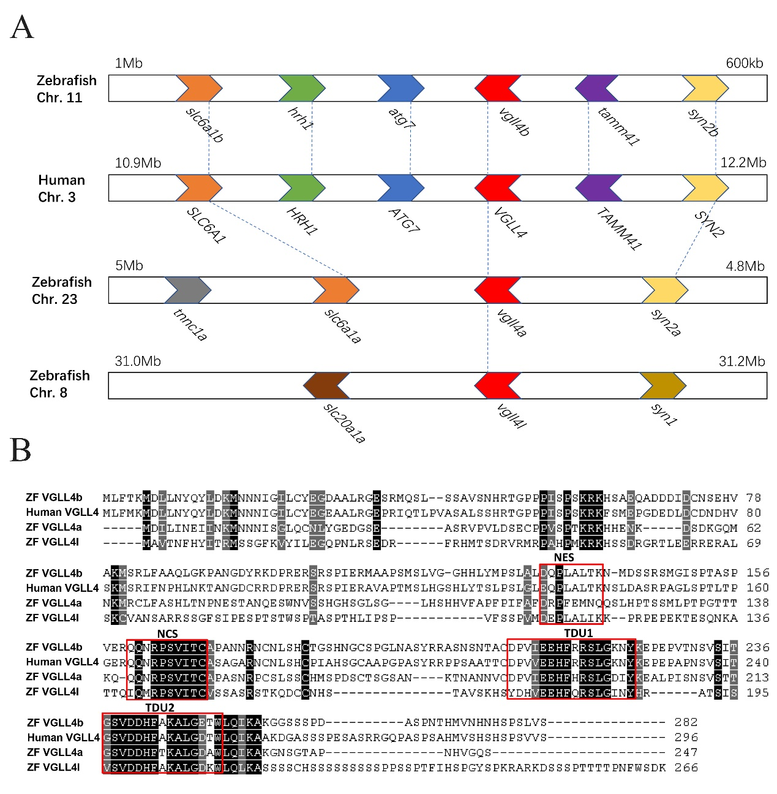

Fig.1. Amino acid sequences and synteny analysis of zebrafish VGLL4a, VGLL4b and VGLL4l and human VGLL4
(A) Synteny analysis of zebrafish vgll4a, vgll4b, vgll4l and human VGLL4. Location information of each gene was obtained from the Ensembl database (http://www.ensembl.org/index.html). Genes of a relationship of paralogs or orthologs shared the same color and were linked by dotted line. The directions of the arrowheads represent for the transcription direction of each gene. (B) The amino acid sequences of VGLL4a, VGLL4b and VGLL4l and human VGLL4. The protein ID are as follows: human-VGLL4 (NP_001121691.1), ZF-VGLL4a (XP_005161978.1), ZF-VGLL4b (NP_998440.1), ZF-VGLL4l (NP_001073467.1). Functional domains as NES, NCS, TDU1 and TDU2 are marked in boxed areas. Identical amino acids were shown in black background and amino acids with high similarities of these four sequences were shown in grey background.

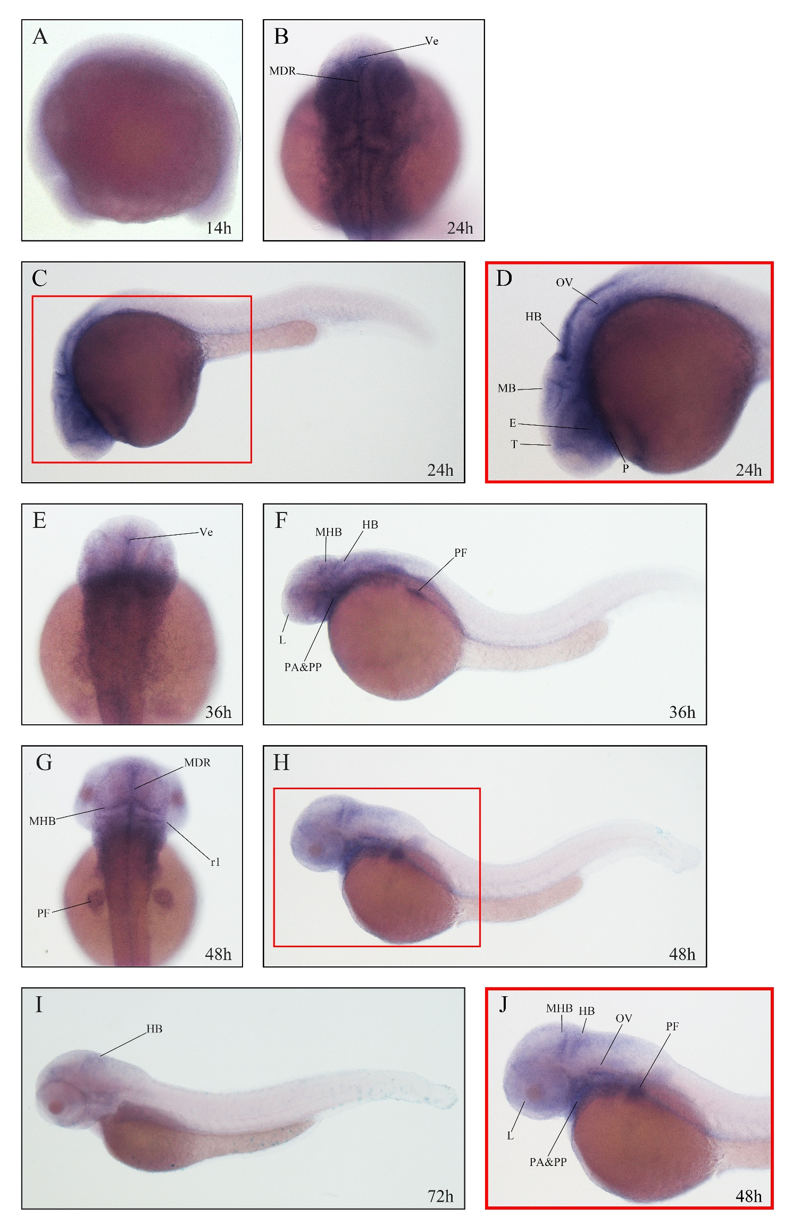

Fig.2. Expression of vgll4a in zebrafish embryos analyzed by WISH
Embryos are shown in lateral view with anterior to the left (A, C, D, F, H, I and J) or dorsal view with anterior to the top (B, E, G). Box area in (C) and (H) was shown enlarged in (D) and (J) respectively. (A) Faint and ubiquitous expression of vgll4a at 14 hpf. (B, C, D) High expression in ventricle (Ve), midline of diencephalic roof (MDR), telencephalon (T), eyes (E), the midbrain (MB), hindbrain (HB), otic vesicles (OV) and pharynx (P) at 24 hpf. (E, F) Expression of vgll4a detected dispersively in ventricle (Ve), midbrain–hindbrain boundary (MHB), hindbrain (HB), lens (L), pharyngeal arches (PA), pharyngeal pouches (PP) and pectoral fin (PF) at 36 hpf. (G, H, J) Similar vgll4a expression to which at 36 hpf in the brain tissues, including MDR, MHB, HB and rhombomeres1 (r1), L, PA, PP, PF and OV at 48 hpf. (I) Sharply decreased expression of vgll4a at 72 hpf.

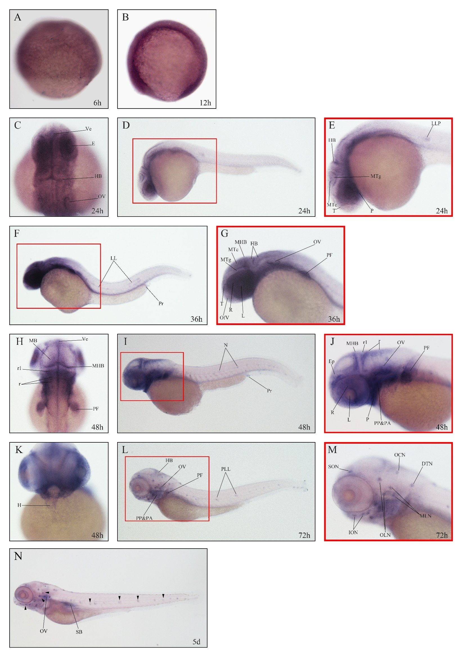

Fig.3. Expression of vgll4b in zebrafish embryos analyzed by WISH
Embryos are shown in lateral view with anterior to the left (B, D, E, F, G, I, J, L and M), dorsal view with anterior to the top (C, H) or ventral view with anterior to the top (K). Box areas in (D), (F), (I) and (L) were shown enlarged in (E), (G), (J) and (M) respectively. (A, B) Ubiquitous expression of vgll4b at 6 hpf and in the whole trunk of the embryo at 12 hpf. (C, D, E) Expression of vgll4b in ventricle (Ve), eyes (E), hindbrain (HB), otic vesicles (OV), pharynx (P), telencephalon (T), midbrain tectum (MTc), midbrain tegmentum (MTg), and lateral line primordium (LLP) at 24 hpf. (F, G) High expression of vgll4b detected in lens (L), retina(R), olfactory vesicles (OfV), OV, pectoral fin (PF), lateral line (LL), proctodeum (Pr), and the brain tissues including T, MTc, MTg, midbrain–hindbrain boundary(MHB) and HB at 36 hpf. (H, I, J, L) Similar expression pattern detected at 48 hpf and 72 hpf. Rhombomeres (r), rhombomeres1 (r1), epidermis (Ep), neuromasts (N), posterior lateral line (PLL). (K) Vgll4b expression in heart (H) at 48 hpf. (M) Specific neuromasts of anterior lateral line system were illustrated: supraorbital neuromast (SON), infraorbital neuromasts (ION), otic lateral neuromasts (OLN), middle line neuromasts (MLN), dorsal trunk neuromast (DTN), occipital neuromasts (OCN). (N) Neuromasts pointed with arrows at 5 dpf. Swim bladder (SB).

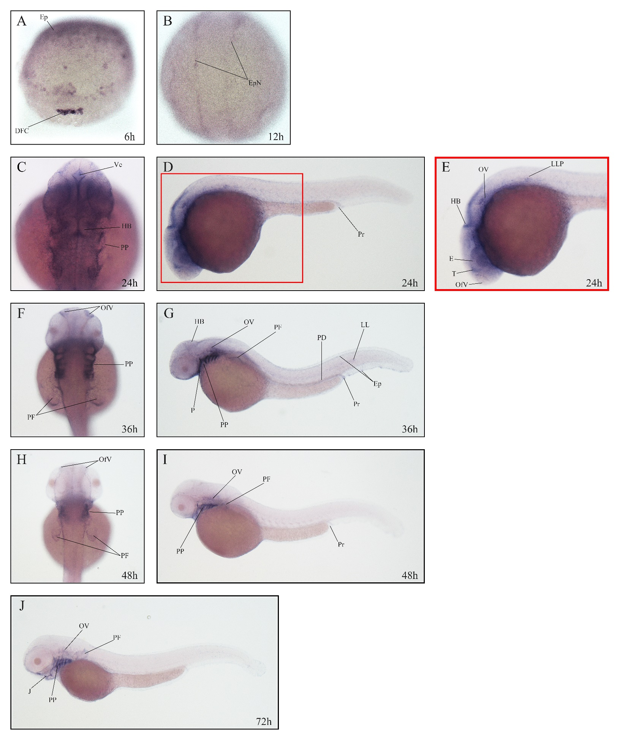

Fig.4. Expression of vgll4l in zebrafish embryos analyzed by WISH
Embryos are shown in lateral view with anterior to the left (D, E, G, I and J) or dorsal view with anterior to the top (C, F, H). Box areas in (D) was shown enlarged in (E). (A) Expression of vgll4l in dorsal forerunner cells (DFC) and epidermis (Ep) at 6 hpf. (B) Distinguishing signal detected on the epidermis at the border of the neural plate (EpN) at 12 hpf. (C, D, E) Deposition of vgll4l in areas of ventricle (Ve), hindbrain (HB), olfactory vesicles (OfV), telencephalon (T), retina (R), pharyngeal pouches (PP), otic vesicles (OV), lateral line primordium (LLP) and proctodeum (Pr) at 24 hpf. (F, G) Vgll4l concentrated in OfV, HB, pharynx (P), PP, OV, pectoral fin (PF), pronephric duct (PD), Pr, Ep and lateral line (LL) at 36 hpf. (G, H) Vanished vgll4l in eyes, Ep, brain and Pr and concentration found in PP, PF and OV at 48 hpf. (I) Remaining expression of vgll4l in PP, OV, jaw (J) and PF at 72 hpf.

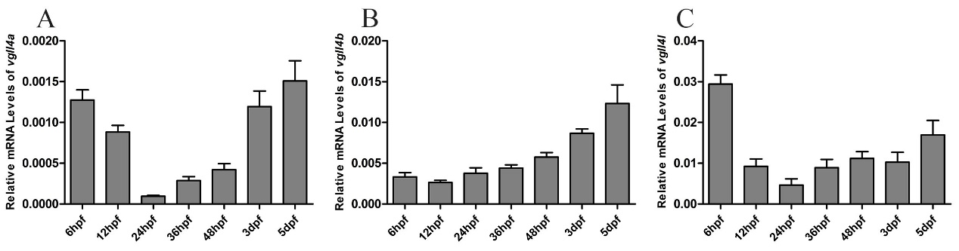
Fig.5. Quantitative gene expression analysed by RT-qPCR.
Quantitative gene expression of vgll4a (A), vgll4b (B) and vgll4l (C) during early embryonic development stages. The expression levels of the three vgll4 paralogs were normalized with actin as the reference. Results were presented as relative expression levels(2^{-ΔCt}) on the y axis versus developmental stages on the x axis. Error bars represented the standard error of means.

