Tables and Figures
Table 1 - Means (SD) of the flexural strength (FS, MPa), flexural modulus (FM, GPa) and toughness (MPa) for all groups tested. Different HDDMA concentrations were added to materials without (0 wt%) or with (10 wt%) thiourethane oligomer. Values followed by the same letters in each column are statistically similar (α=0.05).
TU concentration (wt%) | HDDMA concentration (wt%) | Flexural strength (FS, MPa) | Flexural modulus (FM, GPa) | Toughness (MPa)
0 | 0 | 29.63 (5.46)bc | 1.70 (0.47)ab | 1.38 (0.78)ab
 | 10 | 50.92 (15.21)a | 2.05 (0.32)a | 1.91 (0.69)a
 | 20 | 40.18 (2.86)ab | 2.13 (0.18)a | 1.31 (0.30)ab
 | 30 | 18.38 (4.71)d | 2.10 (0.18)a | 0.48 (0.26)de
10 | 0 | 31.48 (6.83)b | 2.08 (0.17)a | 0.99 (0.24)bc
 | 10 | 19.08 (3.78)d | 1.81 (0.20)ab | 0.55 (0.13)d
 | 20 | 21.11 (3.05)cd | 1.63 (0.20)b | 0.77 (0.21)cd
 | 30 | 13.25 (4.58)d | 1.75 (0.35)ab | 0.36 (0.16)e
*TU (Thio-urethane). **HDDMA (1.6-Hexanediol dimethacrylate).

Table 2 - Means (SD) of the viscosity (η, Pa.s), glass transition temperature (Tg, °C), breadth of tan delta (width at half-height, °C) and crosslinking density (mog/kg). Different HDDMA concentrations were added to materials without (0 wt%) or with (10 wt%) thiourethane oligomer. Values followed by the same letters in each column are statistically similar (α=0.05).
TU wt% | HDDMA wt% | Viscosity (η, Pa.s x10⁻⁴) | Glass transition temperature (Tg, °C) | Width at half-height of tan delta peak (°C) | Crosslinking density at 180°C (mol/kg ×10⁻⁴)
0 | 0 | 10.6 (8.6)a | 138.5 (8.8)ab | 29.94 (0.61)b | 1.89 (0.15)b
 | 10 | 3.4 (0.0)b | 144.5 (1.0)a | 29.94 (1.25)b | 2.02 (0.09)ab
 | 20 | 3.5 (0.0)b | 146.8 (1.4)a | 32.40 (0.26)b | 2.26 (0.11)a
 | 30 | 3.5 (0.0)b | 145.7 (0.5)a | 31.69 (0.51)b | 2.29 (0.17)a
10 | 0 | 9.4 (1.0)a | 121.9 (1.42)c | 45.89 (1.14)a | 1.13 (0.09)d
 | 10 | 3.5 (0.0)b | 128.2 (2.6)bc | 43.49 (0.02)a | 1.74 (0.40)c
 | 20 | 4.8 (2.2)b | 125.5 (0.8)c | 47.32 (0.11)a | 1.88 (0.01)bc
 | 30 | 3.5 (0.0)b | 134.6 (2.2)b | 45.04 (0.67)a | 1.89 (0.07)bc
*TU (Thio-urethane). **HDDMA (1.6-Hexanediol dimethacrylate).

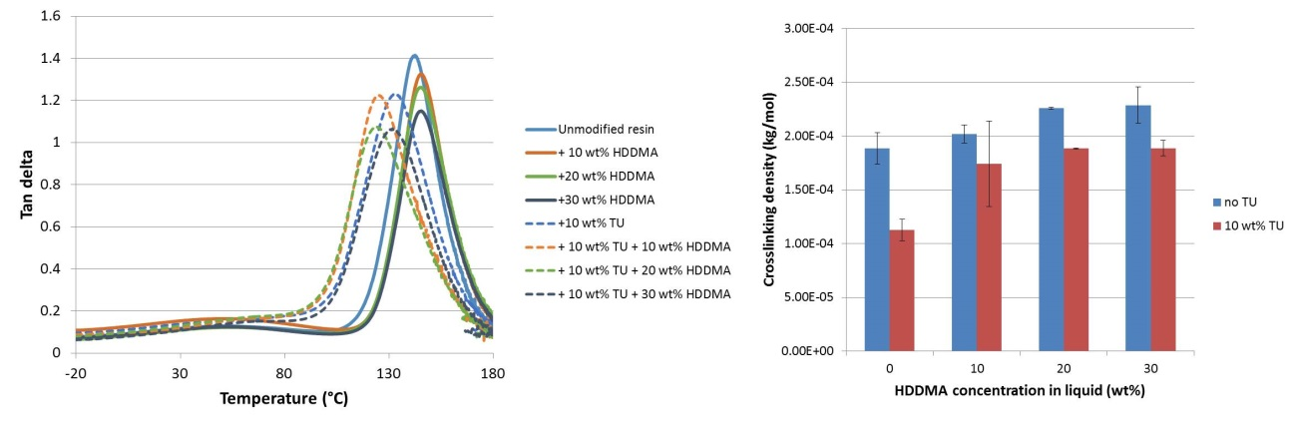
Figure 1- Tan delta curves for acrylic resin modified by the addition of HDDMA (A) or HDDMA + TU (B). The width at half-height was used as an estimate of the polymer homogeneity, with wider ranges of temperature indicating a more heterogeneous polymer. Samples were tested in temperature sweep from -25 to 180°C.

