Supplementary material
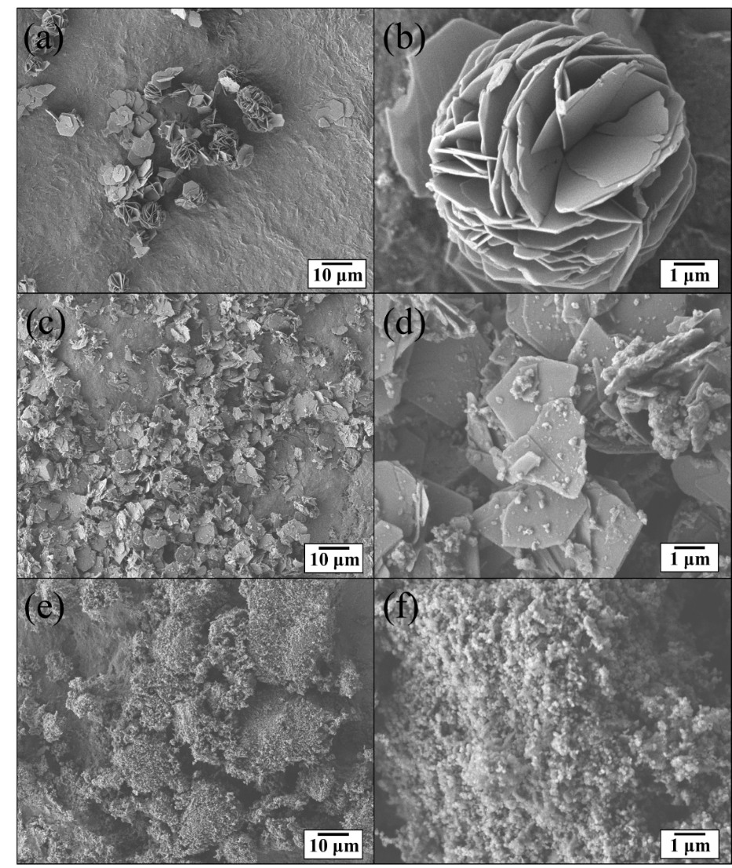
Fig. S1 – SEM micrographs of LDH-CO₃ (a) (b), WLDH-CO₃ (c) (d) and DLDH-CO₃ (e) (f).
As shown in Fig. S1, rosette-shaped LiAl-CO₃ LDH were successfully prepared in this work (Fig. S1a and S1b). As shown in Fig. S1c and S1d, the rosette-shaped LDH-CO₃ were successfully exfoliated by wet ball milling, the plate-like WLDH-CO₃ powder demonstrated a slightly increased specific surface area. The SEM images of the DLDH-CO₃ (Fig. S1e and S1f) indicated that nanoscale particles were obtained by dry ball milling and exhibited a high specific surface area. In this work, three particle sizes with the various specific surface area were successfully prepared by mechanical methods.

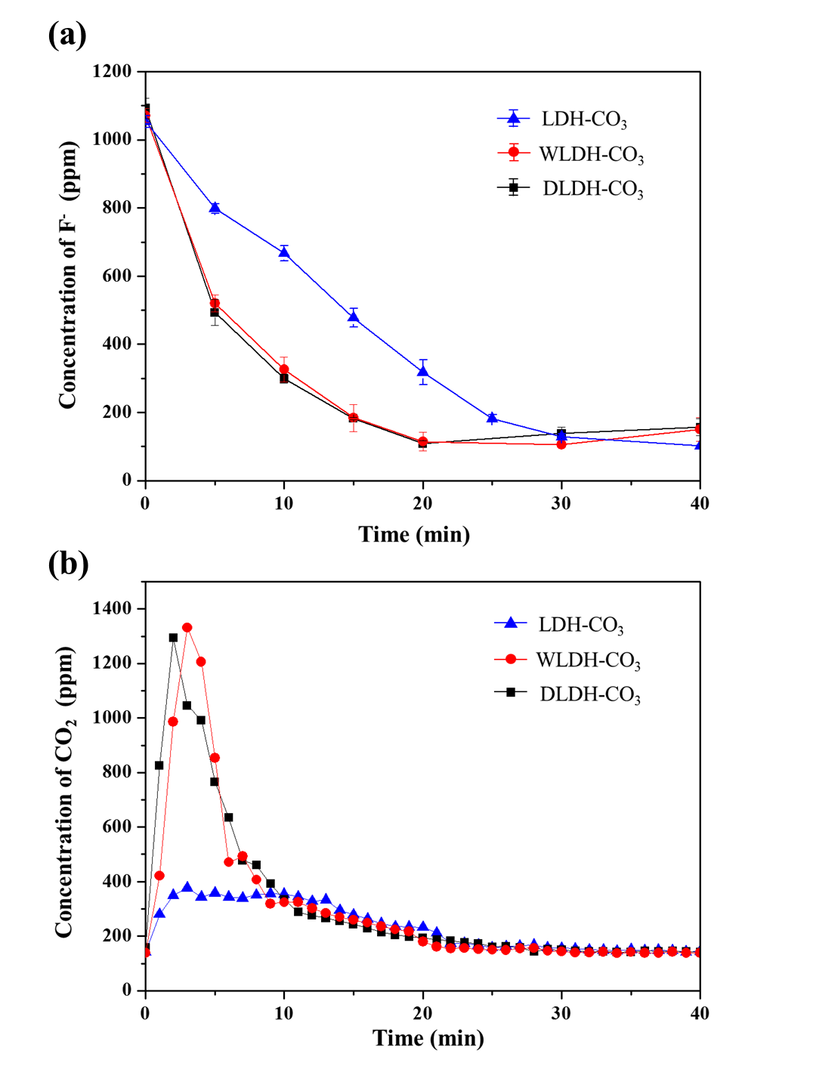
Fig. S2 – Evaluations of the ion-exchanging rate of anions fluoride (F⁻) and carbonate group (CO₃²⁻) in LDH-CO₃, WLDH-CO₃, and DLDH-CO₃. (a) The residual F⁻ ion concentration in the NaF solution changes with reaction time, and (b) the collected CO₂ (g) concentration under argon flow at room temperature.
During the fluoridization, the fluoride concentration of the solution was recorded (in the Fig. S2a). The initial concentration of the fluoride was about 1000 ppm, which decreased with increasing time of immersion and remained almost unchanged around 100 ppm for the LDH powder in each particle size. Among them, DLDH-CO₃ reached equilibrium after 20 min similar to WLDH-CO₃, quicker than LDH-CO₃ reaching equilibrium after 40 min. It could be speculated that the agglomerated rosette-shaped particles led to the insufficient contact area and caused fluoride absorption slower.
On the other hand, the fast fluoride absorption was observed in the WLDH-CO₃ and the DLDH-CO₃ indicating that the fluoride absorption was accelerated after exfoliation of the rosette-shaped LDH. Although they exhibited the similar fluoride absorption rate, the DLDH-CO₃ showed comparatively higher specific surface area than the WLDH-CO₃. The fact could be speculated that most of the fluoride were absorbed through the plane surface of the LDH plates rather than fracture section. However, this hypothesis of absorbed mechanism related to the crystal structure of the LDH is out of the scope of this research, which was not discussed detail here. During the fluoridized treatment, amounts of releasing CO₂ (g) were measured, which have been commonly used to confirm the deintercalation of the CO₃²⁻ in the LDH materials [1]. The data (in the Fig. S2b) reveal that the amounts of the CO₂(g) were increased in initial 5 minutes with peak values around 1300-1350 ppm for the WLDH-CO₃ and the DLDH-CO₃, the concentration was then decreased and tend to steady. The LDH-CO₃ showed a slowly increasing trend of the concentration and remained at around 300-400 ppm for more than 10 minutes, and then decrease to a steady value. These results are in agreement with the results of the F⁻ concentration curve indicating the fact of ion exchange.

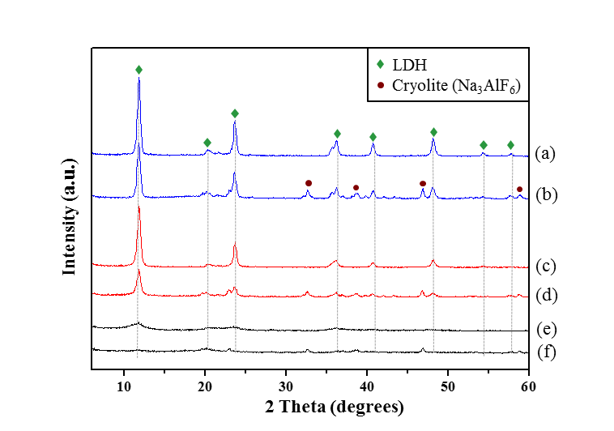
Fig. S3 –XRD patterns of LDH-CO₃ (a), LDH-F (b), WLDH-CO₃ (c), WLDH-F (d), DLDH-CO₃ (e) and DLDH-F (f).
XRD patterns of LDH-CO₃ (a), LDH-F (b), WLDH-CO₃ (c), WLDH-F (d), DLDH-CO₃ (e) and DLDH-F (f). The patterns demonstrated that the LDH has a typical hydrotalcite-like structure before fluoridized treatment. Among them, peak broadening were observed in those treated with wet or dry ball milling due to the refinement of the particles. After fluoride absorption, lower crystallinities were observed in each sample, which was resulted from degradation of the LDH structure. Besides, weak diffraction peaks assigned to fluoride salts (Na₃AlF₆) was found. The fluoride salts (Na₃AlF₆) have been used as a one of composition in glass ionomer (GI) for several decades, and also been used as a filler for some resin composites [2].

References
[1] N. Iyi, H. Yamada, Efficient decarbonation of carbonate-type layered double hydroxide (CO₃²⁻LDH) by ammonium salts in alcohol medium, Applied Clay Science 65-66 (2012) 121-127.
[2] R.L. Bowen, and William A., Marjenhoff. "Dental composites/glass ionomers: the materials, Advances in dental research 6(1) (1992) 44-49.

