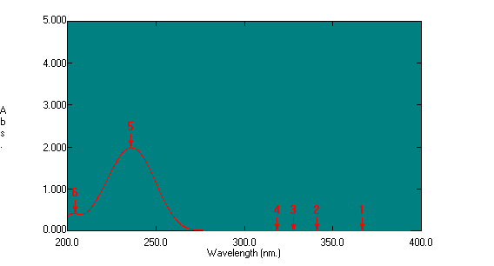
A.

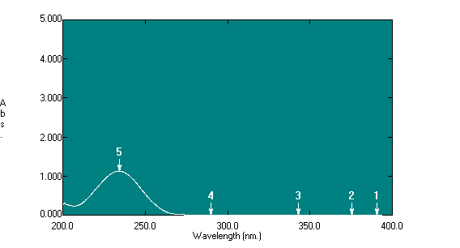

B.

Figure S2: UV/Visible spectra of A. SME and B. ASME (100 µg/ml), isolated and purified from IFBp, in methanol showing ʎmax values at 235.80 and 234.20 nm, respectively.

