Fig. S5A
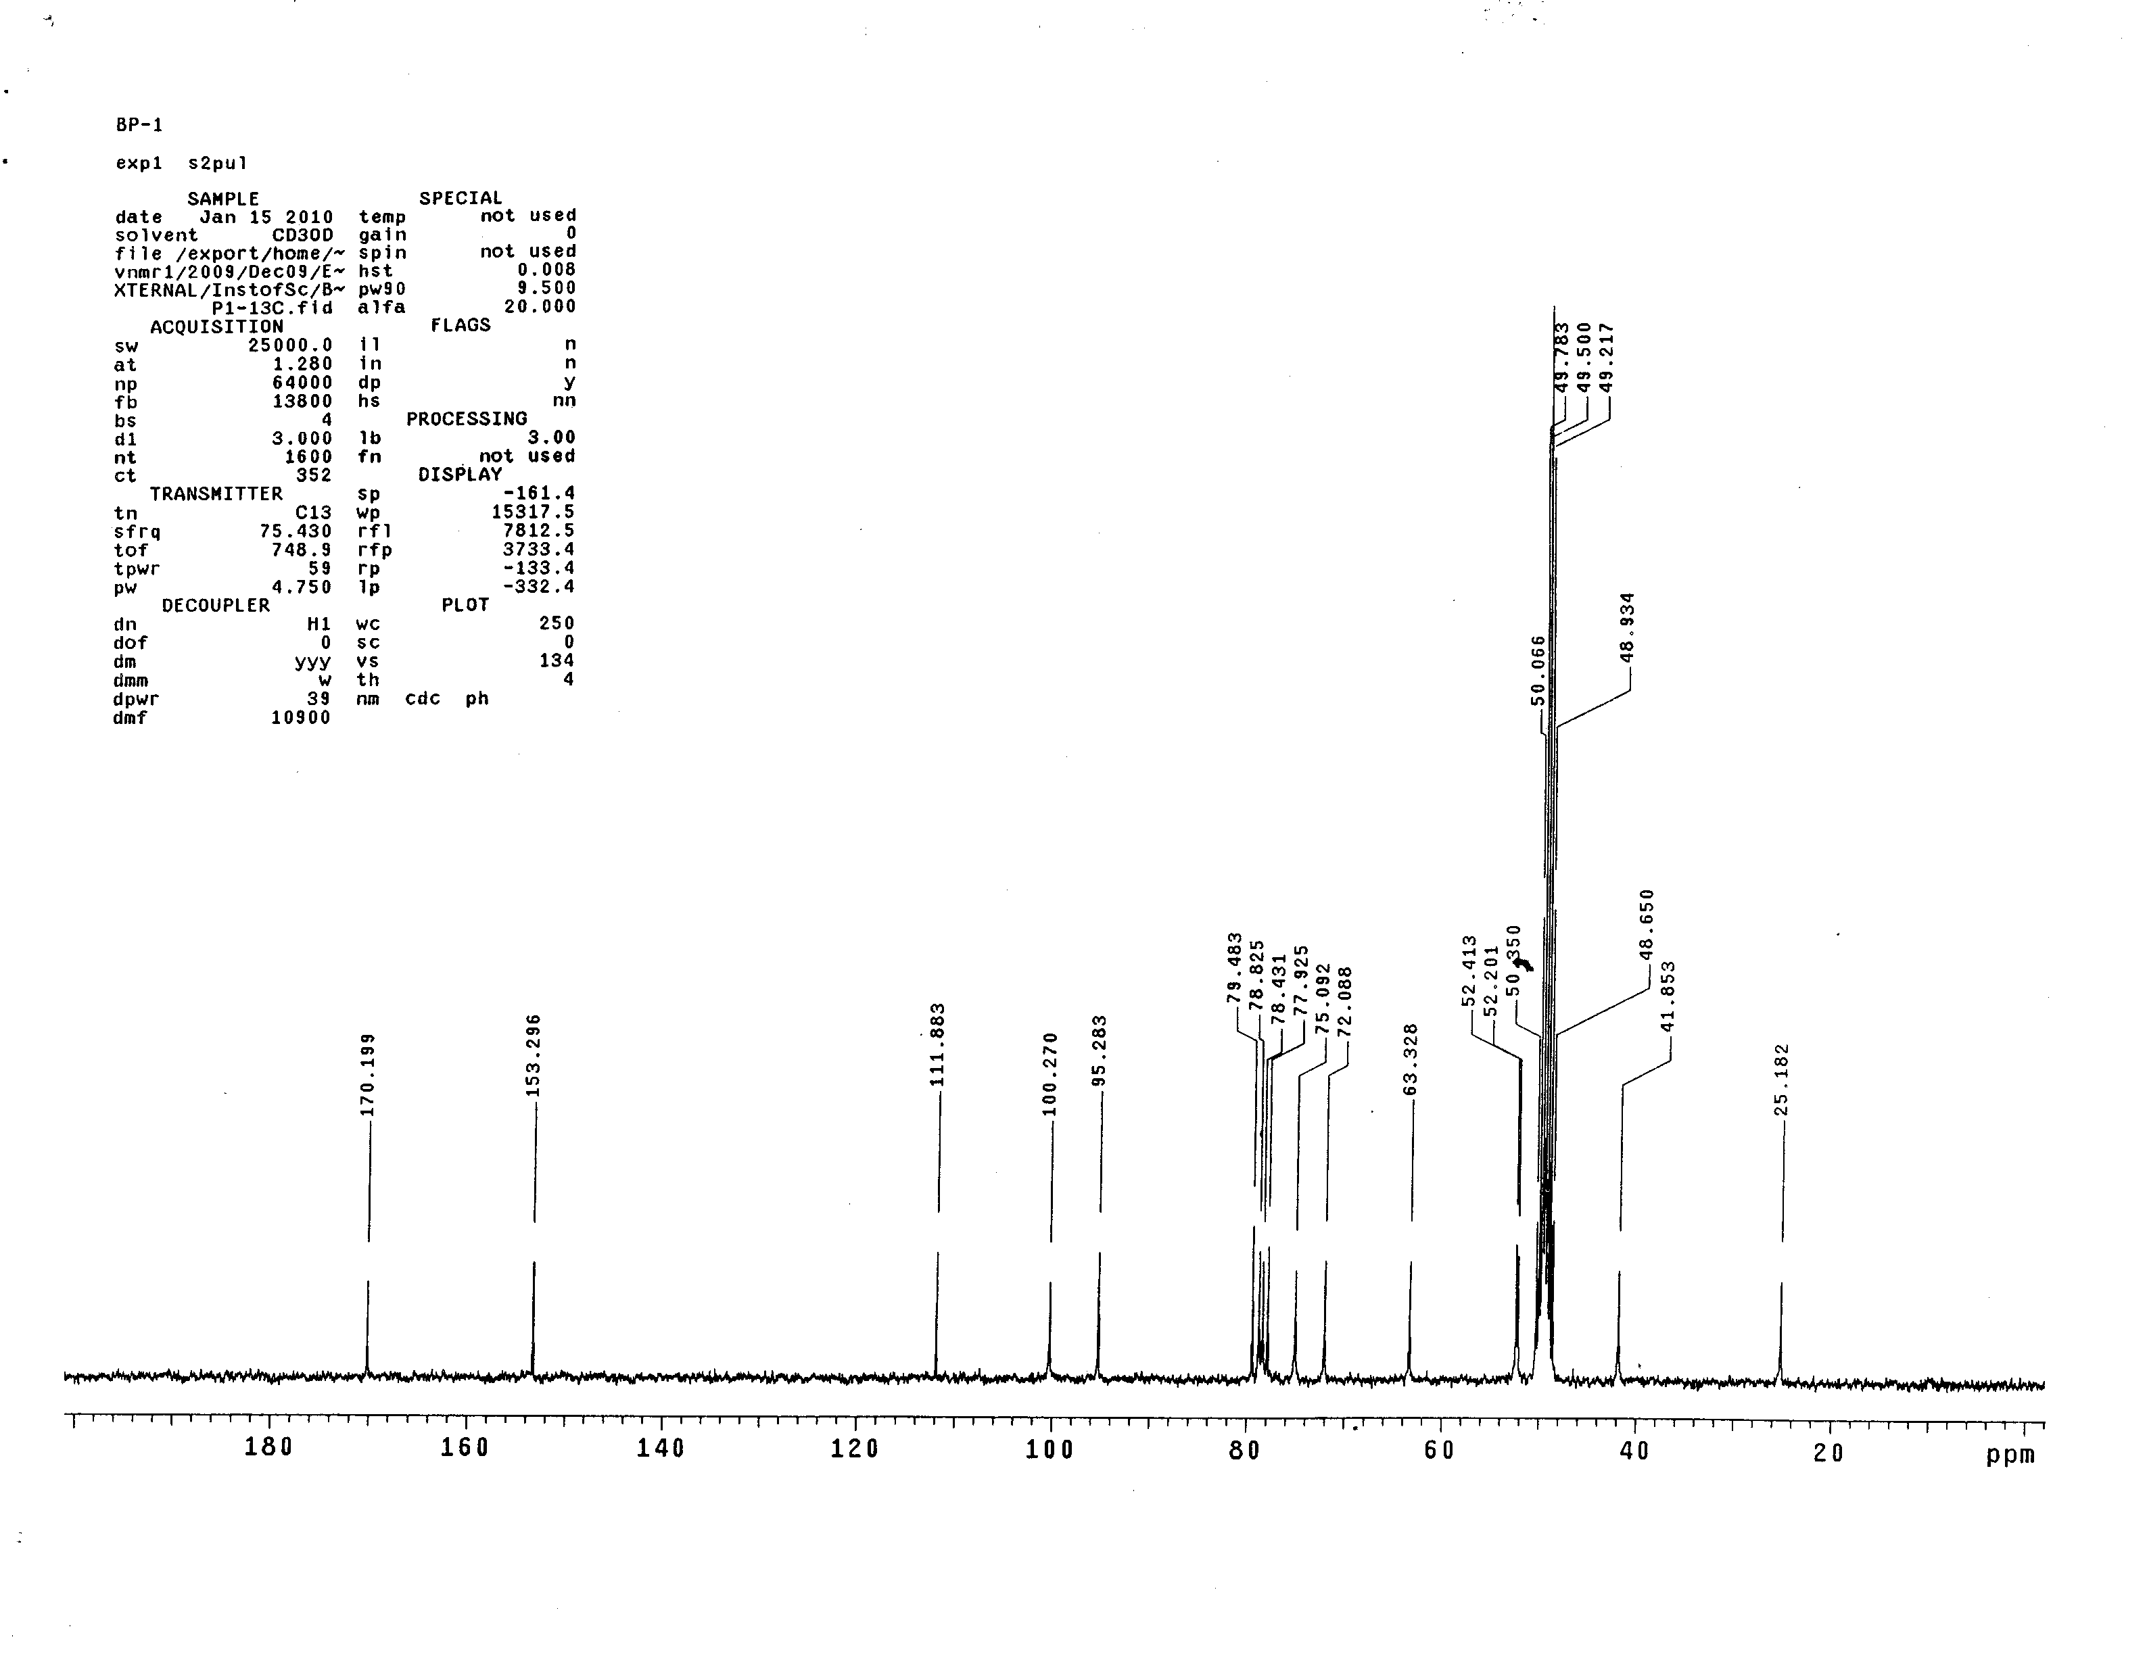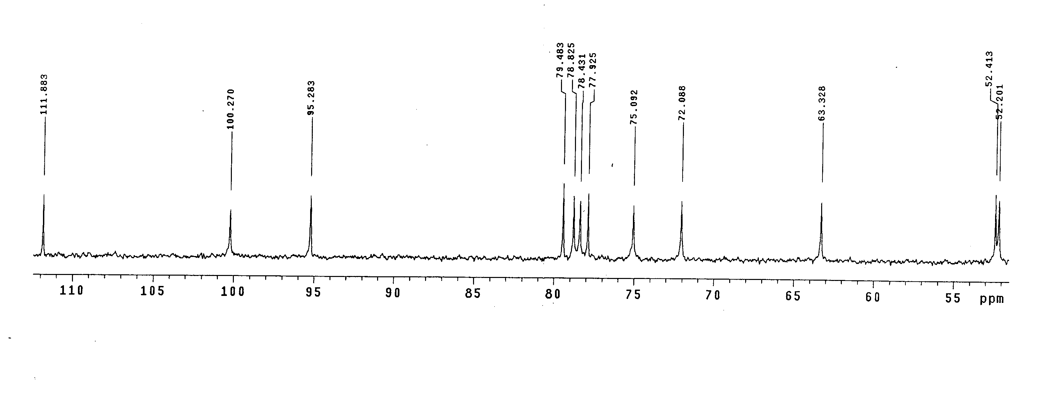

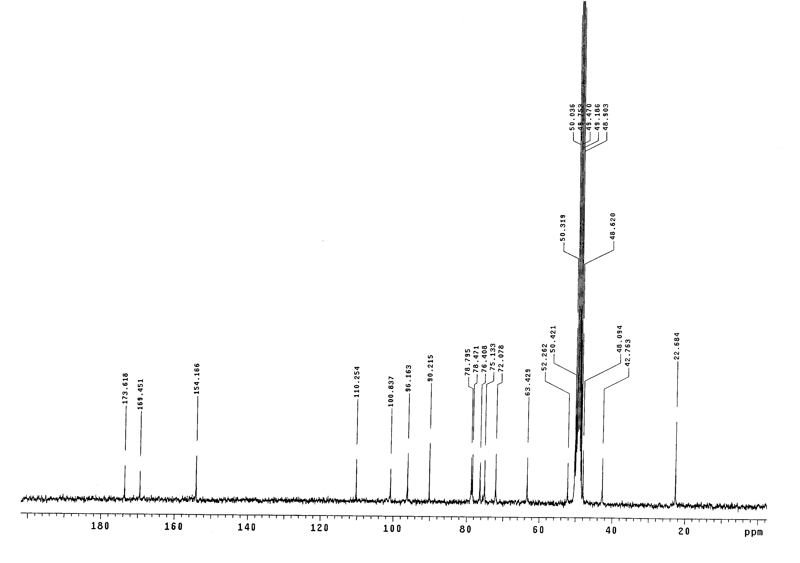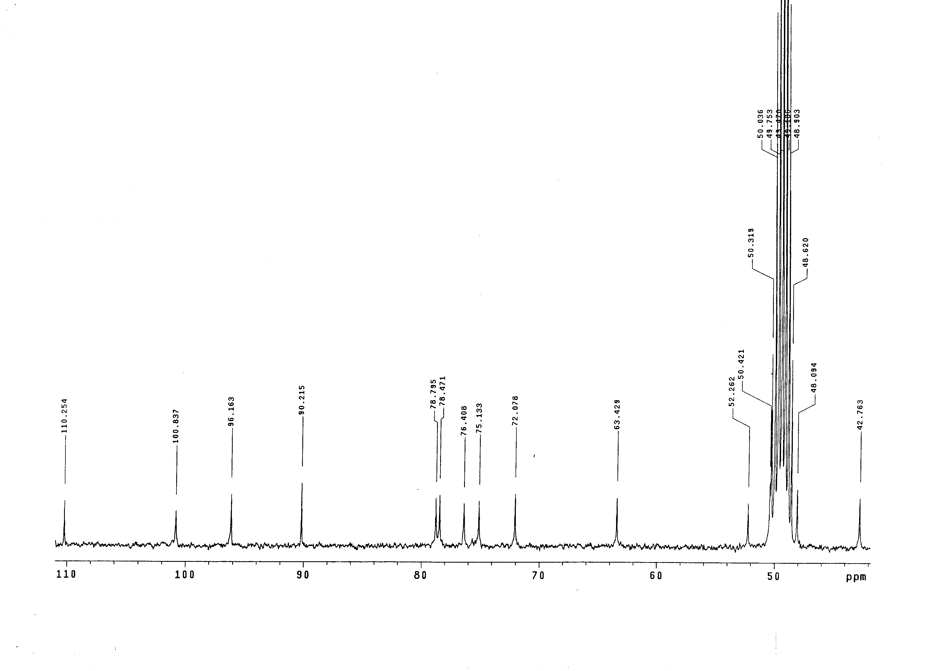Fig. S5B

Fig. S5: ¹³C-NMR (100 MHz) spectra of A. SME and B. ASME, isolated and purified from IFBp, in deuterated methanol using AV-III 400 NMR spectrophotometer.

