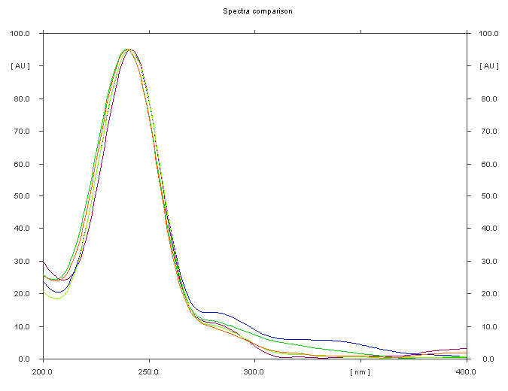
A

B
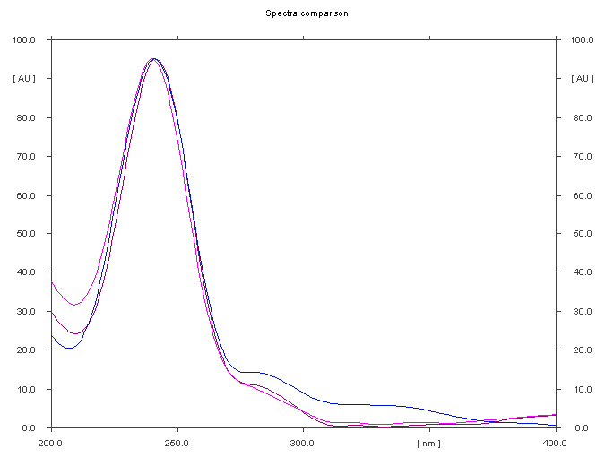

Figure S7: Overlaid absorption spectra of A. SME and B. ASME along with the spectra of analyzed compounds detected in the IFBp of BP at 260 nm.

