Fig. S4A
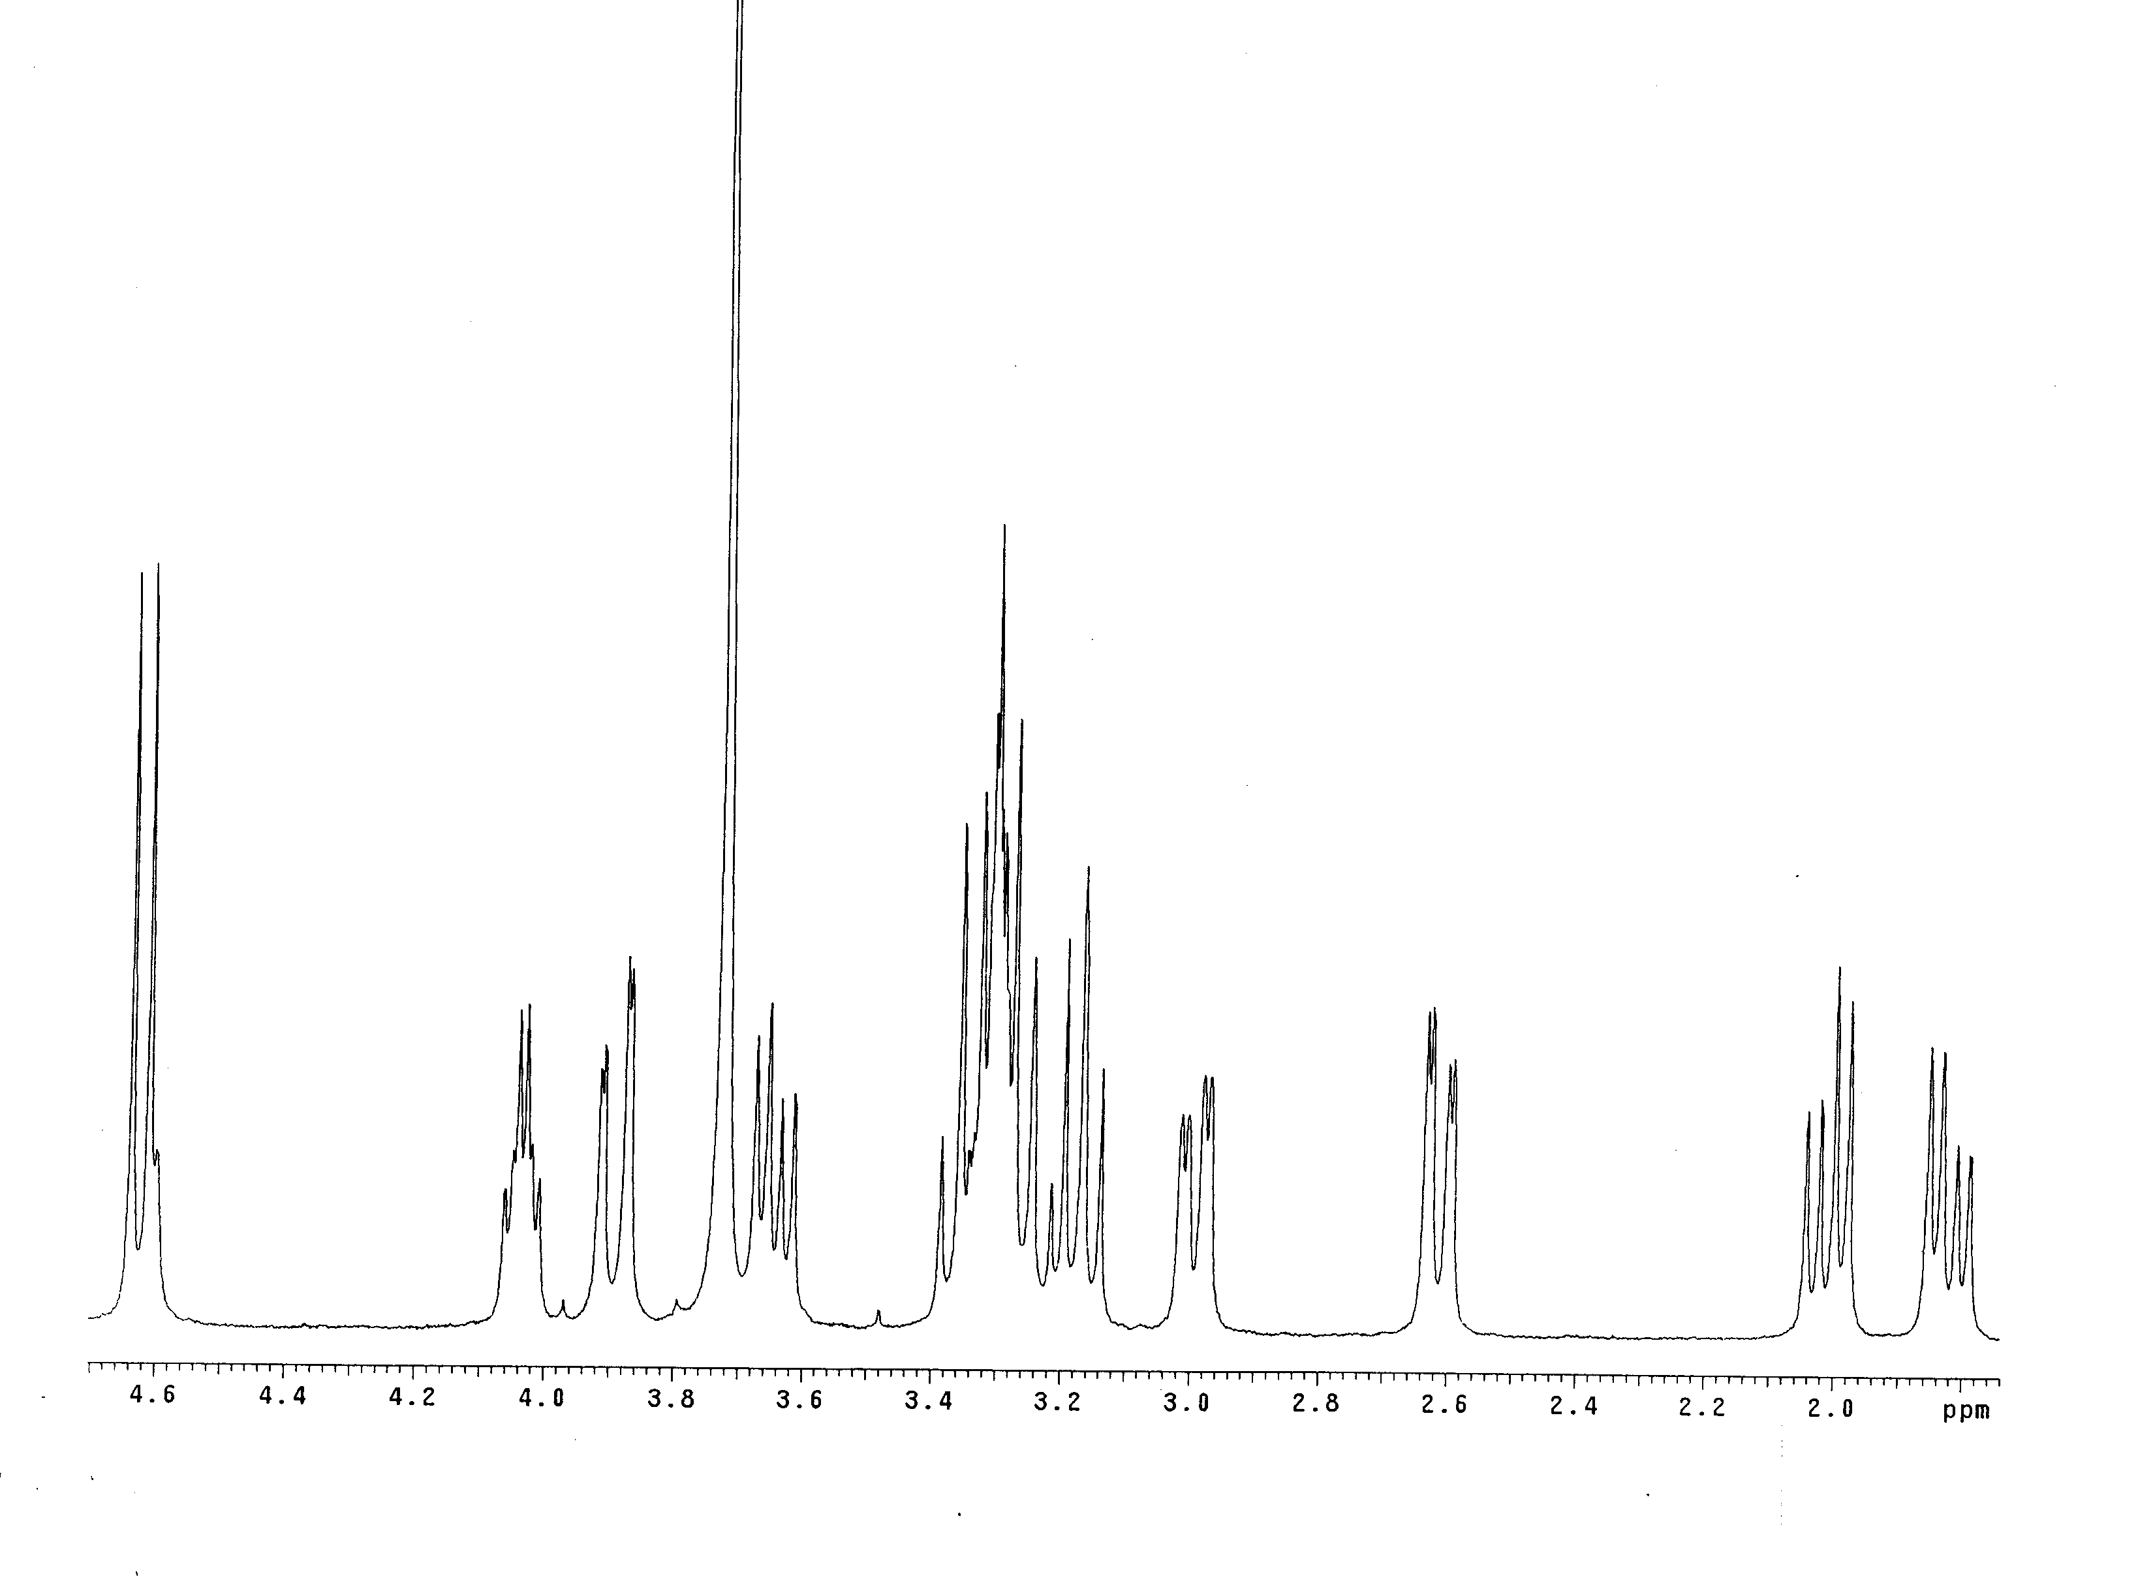
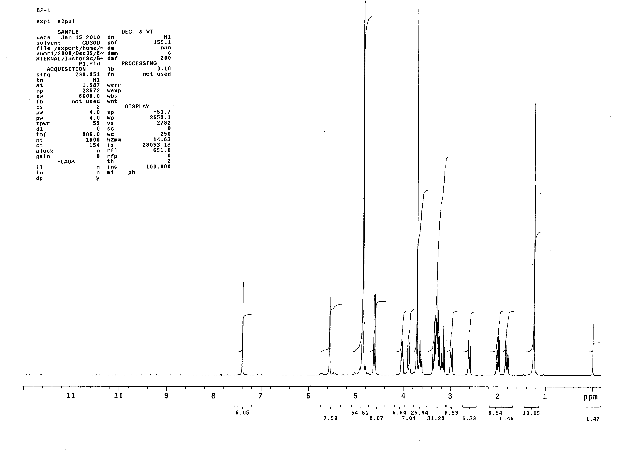

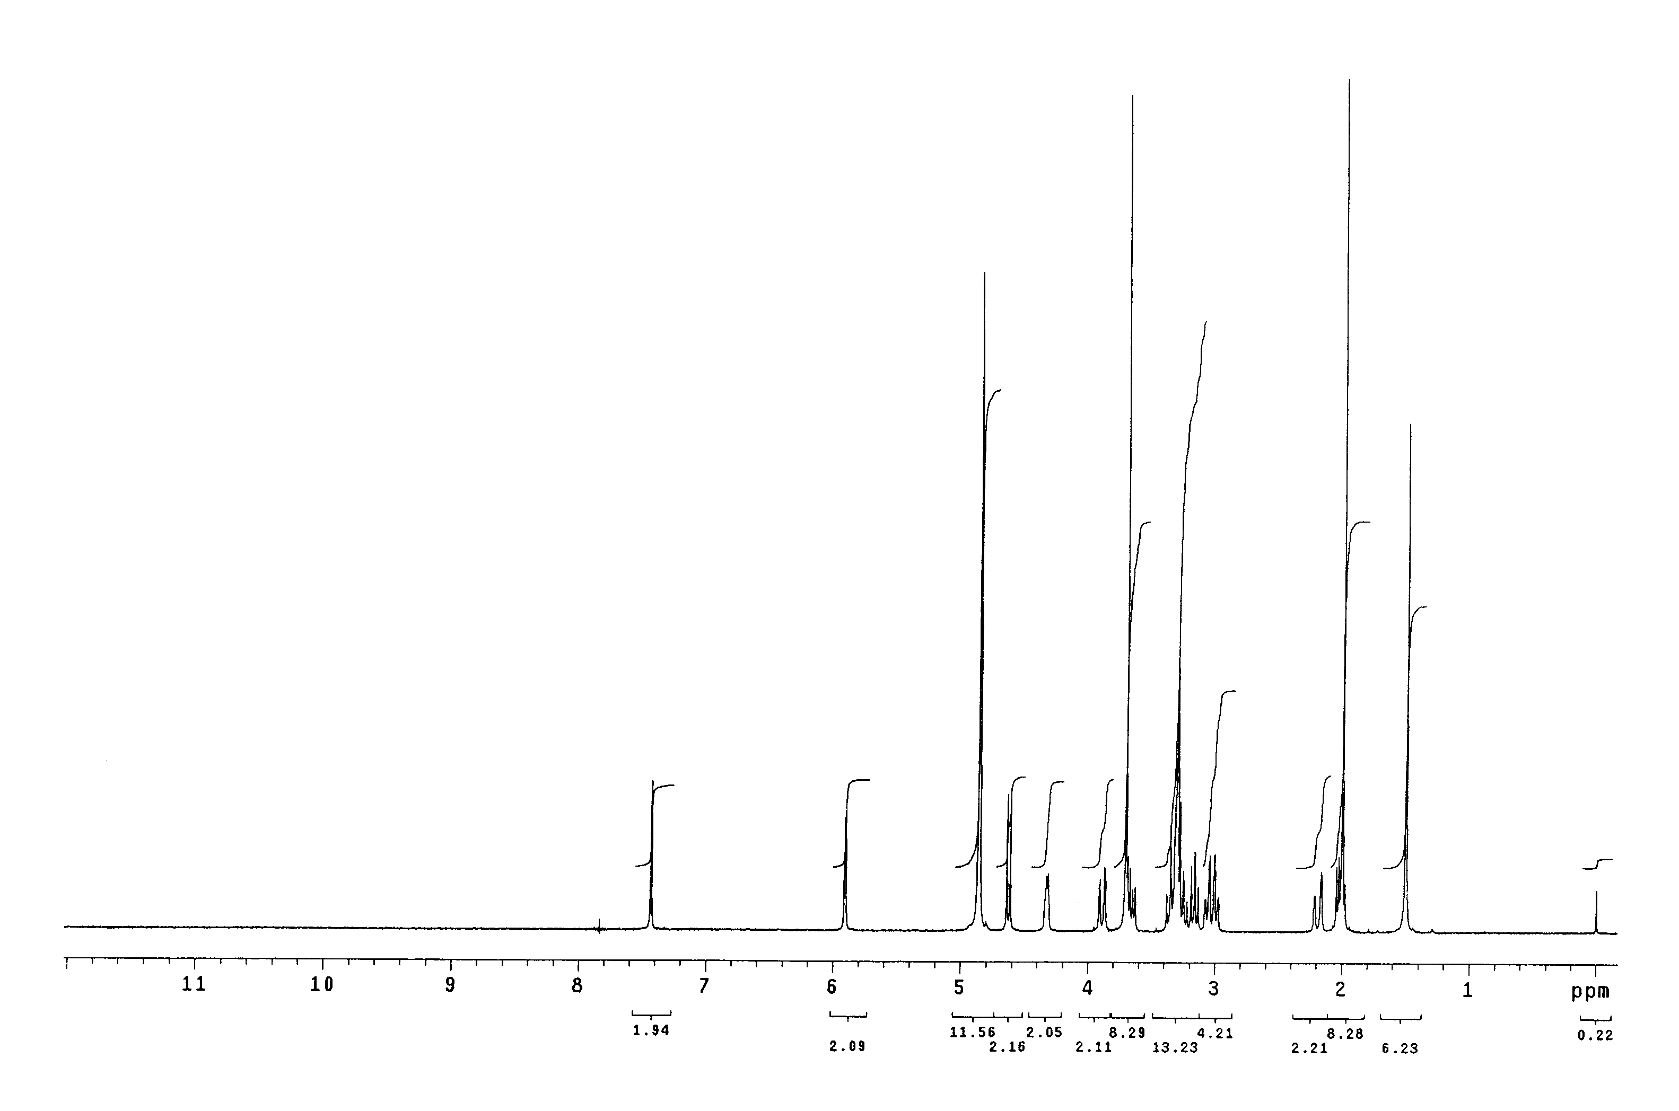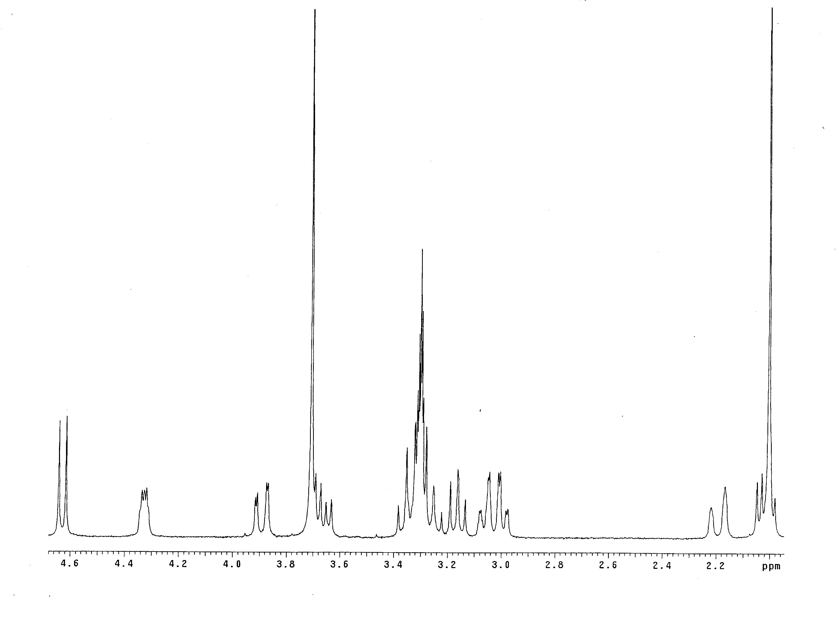Fig. S4B

Fig. S4: ¹H- NMR (400 MHz) spectra of A. SME and B. ASME, isolated and purified from IFBp, in deuterated methanol using AV-III 400 NMR spectrophotometer.

