Supplementary Information
Contextualized genome-scale model unveils high-order metabolic effects of the specific growth rate and oxygenation level in recombinant Pichia pastoris
Paulina Torres¹, Pedro A. Saa¹, Joan Albiol², Pau Ferrer², Eduardo Agosin^{1*}

¹Department of Chemical and Bioprocess Engineering, School of Engineering, Pontificia Universidad Católica de Chile, Vicuña Mackenna 4860, Santiago, Chile
²Department of Chemical, Biological, and Environmental Engineering, Universitat Autònoma de Barcelona, 08193 Bellaterra (Cerdanyola del Vallès), Catalonia, Spain

*Corresponding author
E-mail address: agosin@ing.puc.cl

Table of contents
Table of contents 2
Supplementary Text 3
Text S1. Plasmids construction and Pichia pastoris transformation 3
Plasmid construction 3
Transformation of P. pastoris 3
Text S2. Bioreactor set-up and culture medium 4
Text S3. Contextualization and refinement of the Pichia pastoris GSMM 5
GSMM contextualization for describing aerobic growth on glucose 5
Flux simulations 5
Supplementary Figures 6
Figure S1. Main impacts of the contextualization of the iMT1026 v3.0 GSMM for describing aerobic growth using glucose as sole carbon source. 6
Figure S2. Evaluation of the contextualized P. pastoris GSMM for metabolic flux prediction under glucose-limited conditions correcting by the estimated ashes content. 7
Figure S3. Evaluation of the flux variability of the P. pastoris GSMM for metabolic flux prediction under glucose-limited conditions for the model with and without contextualization. 8
Supplementary Tables 9
Table S1. Summary of reaction modifications based on experimental and literature data 9
Table S2. Constraints used to simulate the different scenarios for the modification of reaction directionalities 13
Table S3. List of reaction constraints for oxygen-sufficient, glucose-limited P. pastoris growth simulation 15
Table S4. Macromolecular composition of P. pastoris GS115 19
Table S5. Raw P. pastoris chemostat data under different μ and DO conditions measured in this study 20
Table S6. Regression analysis and effects estimation for different macroscopic culture parameters 22
References 23

Supplementary Text

Text S1. Plasmids construction and Pichia pastoris transformation

Plasmid construction
We constructed two plasmids using the commercial recombinant vectors pGAPZB (Invitrogen, Carlsbad, CA, USA): one for integrating the thaumatin gene (pGAPZB-TAU) (see Table 1) and the other to revert the auxotrophy of the strain P. pastoris GS115 (PGAPZB-HIS4) (Invitrogen, Carlsbad, CA, USA).
PCR amplification of the his4 fragment was performed using genomic DNA from strain P. pastoris X-33 (Invitrogen, Carlsbad, CA, USA). The genomic DNA was extracted using Wizard Genomic DNA purification kit according to the manufacturer’s instructions (Promega, Madison, WI, USA). PCR amplification of the DNA fragments was performed by Gibson assembly in 35 PCR cycles using Phusion High-Fidelity DNA Polymerase (ThermoFisher, Waltham, MA, USA). All PCR products were treated with DpnI enzyme to eliminate original vector residues and purified by gel extraction using the Qiaquick Gel Extraction kit (Qiagen, Hilden, Germany) following the manufacturer’s instructions. The purified genes fragments and vectors were mixed based on their molar ratios in a final volume of 5 μL containing 100 ng of total DNA. This DNA mix was added to 15 μL of 1.33X master mix (5X isothermal mix buffer, T5 exonuclease 1 U μL⁻¹, Phusion DNA polymerase 2U/μL, Taq DNA ligase 40 U μL⁻¹ and milli-Q purified water) and the reaction mixture was incubated at 50 °C for 1 h. Finally, 10 μL of the reaction mix were used directly to transform chemically competent E. coli TOP 10 cells. The cells were grown at 37 °C in low salt-LB medium containing 25 μg mL⁻¹ zeocin for selection of clones transformed with both vectors.

Transformation of P. pastoris
P. pastoris GS115 wild type strain was used as host. Transformation was performed in two steps. The first transformation was performed using the vector pGAPZB-TAU and the AvrII restriction enzyme to linearize and introduce the latter vector into the cells by electroporation (Gasser et al., 2006). In this case, zeocin (100 μg mL⁻¹) was used for the selection of positively transformed clones. Once positive clones were obtained, the second transformation was carried out using the empty vector PGAPZB-HIS4 (primers in Table below). In this case, the XbaI restriction enzyme was used to linearize the vector. Zeocin-supplemented YNB plates (100 μg mL⁻¹ zeocin) were employed for the selection of positively transformed clones. All transformations were verified by genomic sequencing (Macrogen Inc., Seoul, Korea).
Table. Primers used in this study
Primer | Sequence
HIS-pGAPZB-F | CACACCATAGCTTCAAAATGTTCTTAATGTCTTCCCCAATCACT
HIS- pGAPZB-R | GAGTAAAAAAGGAGTAGAAAGGGGTTAGACCTTATTTATTATGTTCAG
pGAPZB-HIS-F | ATTGGGGAAGACATTAAGAACATTTTGAAGCTATGGTGTGTG
pGAPZB-HIS-R | AATAAATAAGGTCTAACCCCTTTCTACTCCTTTTTTACTCTTCCAGA

Text S2. Bioreactor set-up and culture medium
The strain was cultivated in glucose‐limited chemostat cultures at different dilution rates and dissolved oxygen. Overall, seven different experimental conditions were evaluated following a Doehrlet experimental design. Continuous cultures were performed at a working volume of 1 L in 2-L benchtop bioreactors (Sartorius AG, Göttingen, Germany) using peristaltic pumps (Ismatec, IDEX Health & Science, Germany) to control the feeding and at 1.2 bar total pressure. Once the batch phase was concluded, the continuous phase was initiated at the appropriate specific growth rate and dissolved oxygen (DO) level. DO was maintained using a mixture of three gases; air, pure nitrogen and pure oxygen depending on the DO set point. In all experimental conditions, the stirring rate was set to 700 rpm, aeration to 1 VVM (1 L min⁻¹), and the temperature and pH were respectively kept at 25 °C and 5.0. Off‐gases were cooled in a condenser at 4 °C and desiccated in two silica gel columns. CO₂ and O₂ abundances were analyzed through BCP‐CO₂ and BCP‐O₂ Sensors (BlueSens gas sensor GmbH, Herten, Germany). Each dilution rate was kept for at least five residence times.
Batch medium was composed of (per liter): 39.9 g glycerol, 1.8 g citric acid, 12.6 g (NH₄)₂HPO₄, 0.022 g CaCl₂·H₂O, 0.9 g KCl, 0.5 g MgSO₄·7H₂O, 2 mL biotin (0.2 g L⁻¹), 4 mL PTM1 trace salts stock solution. Chemostat medium composition was composed of (per liter): 50 g glucose, 0.9 g citric acid, 3.45 g (NH₄)₂HPO₄, 0.01 g CaCl₂·H₂O, 1.7 g KCl, 0.65 g MgSO₄·7H₂O, 1 mL biotin (0.2 g L⁻¹), 1.6 mL PTM1 trace salts stock solution, and 0.2 mL of antifoam Glanapon 2000 (Bussetti & Co GmbH, Vienna, Austria). HCl 25% was used to reach pH 5.0.

Text S3. Contextualization and refinement of the Pichia pastoris GSMM

GSMM contextualization for describing aerobic growth on glucose
The iMT1026 v3.0 genome-scale metabolic reconstruction from Tomàs-Gamisans et al. (2018) was employed to describe the metabolism Pichia pastoris. In order to accurately represent the central carbon metabolism behavior of this yeast, we systematically adapted the reconstruction to represent and capture known metabolic features. This process was composed of two main steps: 1) Blocking and modification of reaction directionalities based on published data (e.g., transcriptomics, proteomics, thermodynamics, etc.), and 2) Modification of reaction directionalities based on topological considerations, i.e., removal of thermodynamically infeasible internal loops (Saa and Nielsen, 2016). The details of each step are detailed below.
The first step leveraged the abundant experimental omics data available for this yeast under glucose-limited conditions (Clasquin et al., 2011; Gasser et al., 2007; Krivoruchko et al., 2015; Rußmayer et al., 2015; Zhang et al., 2017). Application of this data greatly constrained the genome-scale metabolic model (see Table S1 for the applied constraints), significantly impacting the flux distribution predictions (see Fig. S1 for main impacts). The second step involved the modification of reaction directionalities based on flux simulations imposing the loopless flux condition. To this task, the Fast-SNP algorithm (Saa and Nielsen, 2016) was used using experimental training data (i.e., fluxomic constraints) under glucose-limited conditions. Briefly, three flux scenarios were simulated: 1) aerobic growth in glucose with q_{S} values between 0.025 to 0.275 mmol g_{DWC}⁻¹ h⁻¹ and conventional exchange directions, 2) 11 aerobic growth conditions on glucose without secondary product formation (i.e., arabitol and ethanol) (Adelantado et al., 2017; Baumann et al., 2010; Carnicer et al., 2012; Garcia-Ortega et al., 2017), and 3) 15 aerobic growth conditions on glucose with formation of secondary products (Adelantado et al., 2017; Baumann et al., 2010; Carnicer et al., 2012; Garcia-Ortega et al., 2017) (Table S2). Reactions that had the same directionality across all the conditions were set to irreversible. The definitive list with the constraints on the GSMM is shown in Table S3.

Flux simulations
Simulations were performed using the Constraint-Based Reconstruction and Analysis (COBRA) toolbox (Schellenberger et al., 2011) in MATLAB 2013 (Mathworks, Natick, MA, USA). Flux predictions were performed using parsimonious Flux Balance Analysis (pFBA). Topological modification of the reaction directionalities was performed using Fast-SNP algorithm (Saa and Nielsen, 2016). Finally, Gurobi 2016 was employed for the optimizations.

Supplementary Figures
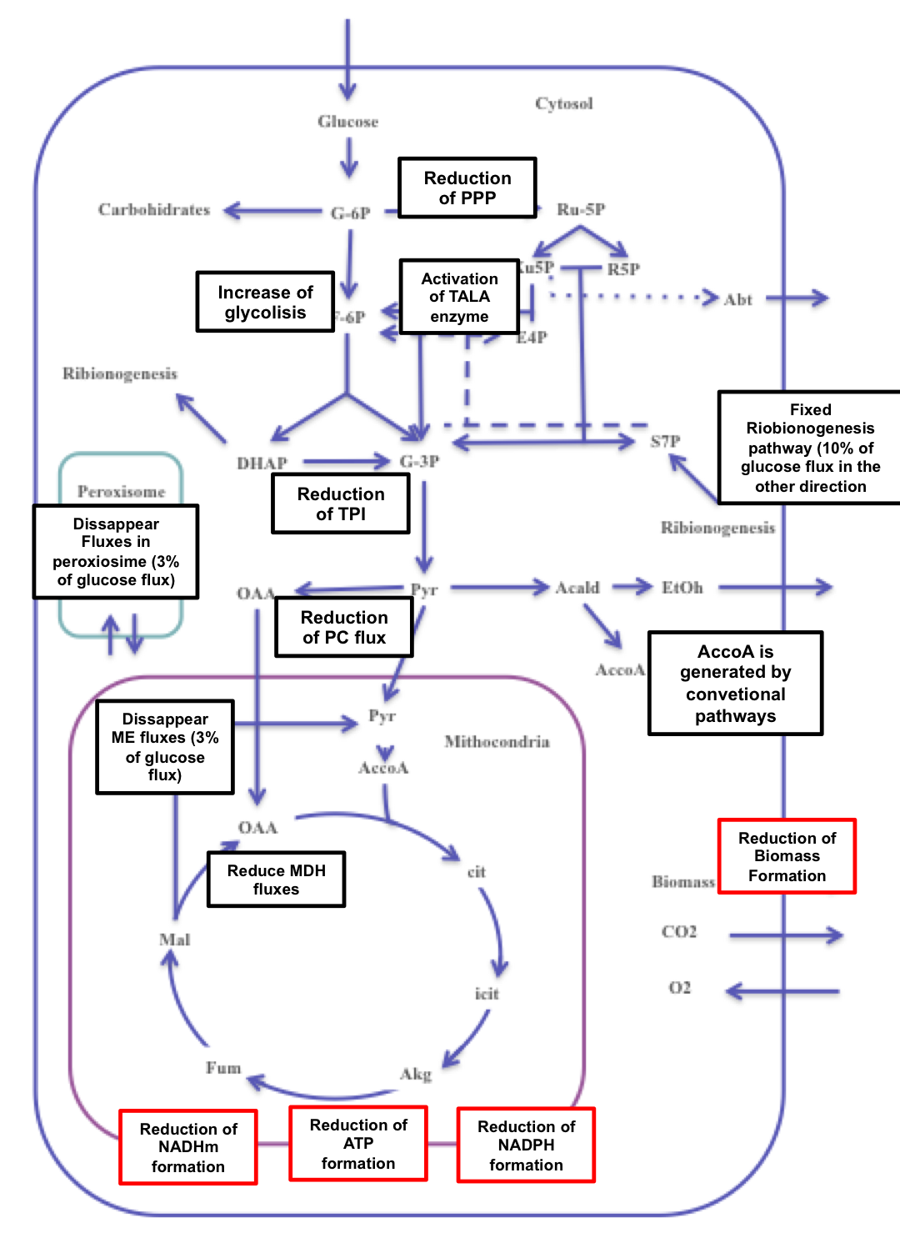

Figure S1. Main impacts of the contextualization of the iMT1026 v3.0 GSMM for describing aerobic growth using glucose as sole carbon source.
Changes due to reactions inactivation and directionalities modifications are shown in black squares. The effects of the loopless flux condition are displayed in red squares.

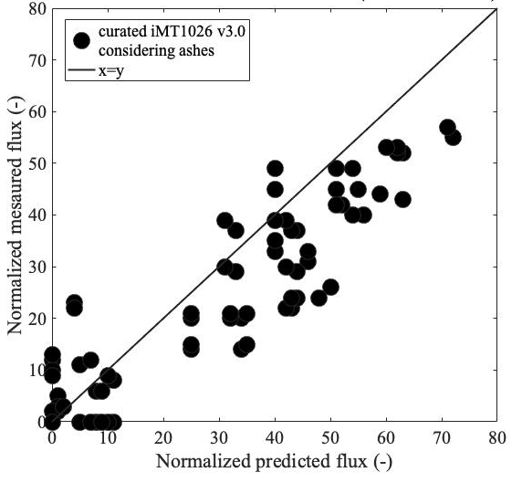
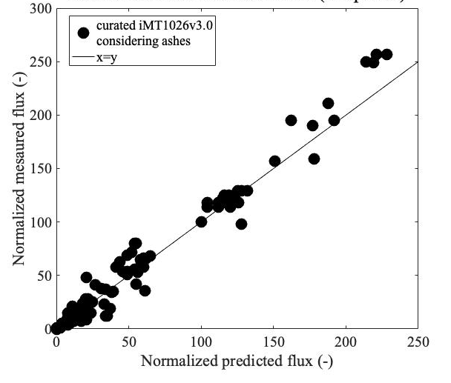
A) Prediction of intracellular fluxes (cytoplasm)
B) Prediction of intracellular fluxes (mitochondria)

Figure S2. Evaluation of the contextualized P. pastoris GSMM for metabolic flux prediction under glucose-limited conditions correcting by the estimated ashes content.
A) Comparison of the predicted intracellular flux through cytoplasmic reactions of the GSMM considering (slope = 1.033, R² = 0.970) against experimental data under appropriate growth conditions. B) Comparison of the predicted intracellular flux through mitochondrial reactions of the GSMM (slope = 0.787, R² = 0.853) against experimental data under the same conditions used in A). For more information about the employed experimental conditions refer to Tables S3 and S4.

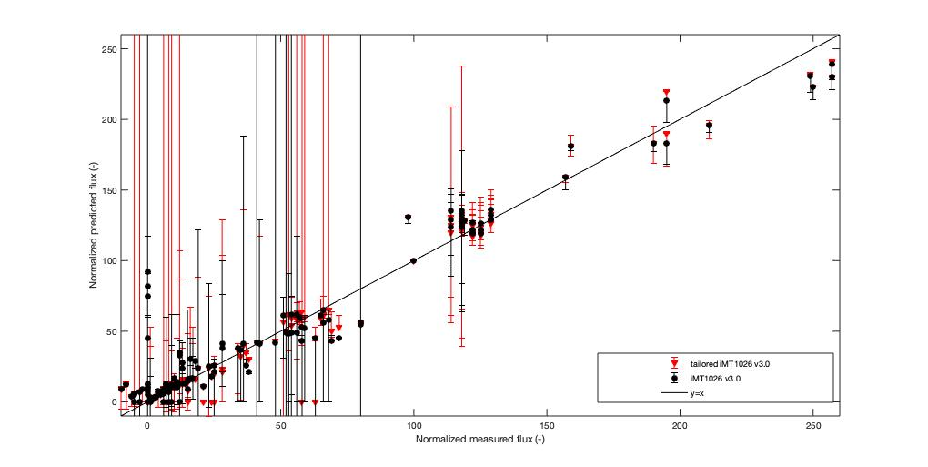
A) Flux variability of intracellular flux predictions (cytoplasm)

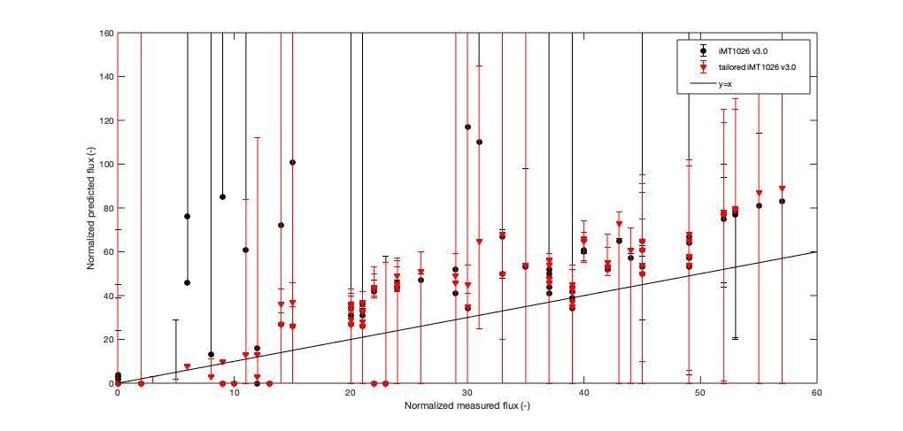
B) Flux variability of intracellular flux predictions (mitochondria)

Figure S3. Evaluation of the flux variability of the P. pastoris GSMM for metabolic flux prediction under glucose-limited conditions for the model with and without contextualization.

Supplementary Tables

Table S1. Summary of reaction modifications based on experimental and literature data
Reaction ID | Stoichiometric equation | Gene | Comment | Action
Exchange reactions
Ex_glyc | gly => |  | Not supplied in the medium | Blocked
Ex_etoh | etoh => |  | Not supplied in the medium | Blocked
Ex_abt | abt => |  | Not detected in the medium | Blocked
Ex_fab | fab => |  | Protein not expressed | Blocked
Ex_pyr | pyr => |  | Present in the medium | Open
Ex_cit | cit => |  | Present in the medium | Open
Cytoplasm
GLUK | glc + atp => h + adp + g6p | PAS_chr4_0624 | Duplicated reaction | Blocked
MDH | mal + nad + h <=> nadh + oaa | PAS_chr4_0815 | Part of the glyoxylate cycle (not needed for glucose growth) (Rußmayer et al., 2015b) | Reversibility constrained
FBA3 | s17bp <=> dhap+e4p | PAS_chr1-1_0072 | Used in the direction S17BP in ribogenesis (Clasquin et al., 2011; Rußmayer et al., 2015b) | Reversibility constrained
SULR | 3 h2o + h2s + 3 nadp <=> 5 h + 3 nadph + so3 | (PAS_chr4_0369 or PAS_chr3_1084) | Thermodynamically favorable in the reverse direction (dG=103 KJ/mol) | Reversibility constrained
MMSAD3 | nad + coa + msa => co2 + nadh + accoa |  | Not considered for lipid synthesis (Krivoruchko et al., 2014) | Blocked
Mitochondrion
MDHm | mal + nad + h <=> nadh + oaa | PAS_chr2-1_0238 | Part of the glyoxylate cycle (not needed for glucose growth) (Rußmayer et al., 2015b) | Reversibility constrained
ME1m | nad + mal => pyr + co2 + nadh | PAS_chr3_0181 | Inactive during glucose growth (Zhang et al., 2017) | Blocked
ME2m | nadp + mal => pyr + co2 + nadph | PAS_chr3_0181 | Inactive during glucose growth (Zhang et al., 2017) | Blocked
Peroxisome
AOD | meoh + o2 => h2o2 + fald | (PAS_chr4_0821 or PAS_chr4_0152) | Absent in peroxisomal fraction during glucose growth (Rußmayer et al., 2015b) | Blocked
DAS | fald + xu5p => g3p + dha | (PAS_chr3_0832 or PAS_chr3_0834) | Absent in peroxisomal fraction during glucose growth (Rußmayer et al., 2015b) | Blocked
DHAKx | atp + dha => h + adp + dhap | PAS_chr3_0841 | Absent in peroxisomal fraction during glucose growth (Rußmayer et al., 2015b) | Blocked
FBAx | fdp => g3p + dhap | (PAS_chr1-1_0072 or PAS_chr1-1_0319) | Absent in peroxisomal fraction during glucose growth (Rußmayer et al., 2015b) | Blocked
FBPx | h2o + fdp => pi + f6p | PAS_chr3_0868 | Absent in peroxisomal fraction during glucose growth (Rußmayer et al., 2015b) | Blocked
SHBPH | h2o + s17bp => pi + s7p | PAS_chr2-2_0177 | Absent in peroxisomal fraction during glucose growth (Rußmayer et al., 2015b) | Blocked
CATp | 2 h2o2 => o2 + h2o | PAS_chr2-2_0131 | Absent in peroxisomal fraction during glucose growth (Rußmayer et al., 2015b) | Blocked
FALDH2 | nad + hmgth => ndh + sfglutth | PAS_chr3_1028 | Absent in peroxisomal fraction during glucose growth (Rußmayer et al., 2015b) | Blocked
SFGTH | h2o + sfglutth => h + gthrd + for | PAS_chr3_0867 | Absent in peroxisomal fraction during glucose growth (Rußmayer et al., 2015b) | Blocked
FDH | nad + h + for => co2 + nadh | PAS_chr3_0932 | Absent in peroxisomal fraction during glucose growth (Rußmayer et al., 2015b) | Blocked
CSp | h2o + accoa + oaa => coa + h + cit | PAS_chr1-1_0475 | Absent in peroxisomal fraction during glucose growth (Rußmayer et al., 2015b) | Blocked
ICLx | icit => glx + succ | PAS_chr1-4_0338 | Absent in peroxisomal fraction during glucose growth (Rußmayer et al., 2015b) | Blocked
MDHp | nad + mal => oaa + h + nad | PAS_chr4_0815 | Absent in peroxisomal fraction during glucose growth (Rußmayer et al., 2015b) | Blocked
ASPTAp | ak + asp <=> oaa + glu | PAS_chr4_0974 | Absent in peroxisomal fraction during glucose growth (Rußmayer et al., 2015b) | Blocked
TKT1x | xu5p + r5p => g3p + s7p | (PAS_chr1-4_0150 or PAS_chr3_0834 or PAS_chr3_0832) | Absent in peroxisomal fraction during glucose growth (Rußmayer et al., 2015b) | Blocked
CATp | 2 h2o2 => o2 + h2o | PAS_chr2-2_0131 | Absent in peroxisomal fraction during glucose growth (Rußmayer et al., 2015b) | Blocked
RPIx | r5p => ru5p | PAS_chr4_0212 | Absent in peroxisomal fraction during glucose growth (Rußmayer et al., 2015b) | Blocked

Table S2. Constraints used to simulate the different scenarios for the modification of reaction directionalities
Conditions |  | Flux bounds | Exchanges |  |  |  |  |  | References
 |  |  | Glucose | Arabitol | Ethanol | CO2 | O2 | Biomass
Scenario 1 | 1 | LB | -0.025 | 0 | 0 | 0 | -1000 | 0
 |  | UB | -0.025 | 0 | 0 | 1000 | 0 | 1000
 | 2 | LB | -0.05 | 0 | 0 | 0 | -1000 | 0
 |  | UB | -0.05 | 0 | 0 | 1000 | 0 | 1000
 | 3 | LB | -0.075 | 0 | 0 | 0 | -1000 | 0
 |  | UB | -0.075 | 0 | 0 | 1000 | 0 | 1000
 | 4 | LB | -0.1 | 0 | 0 | 0 | -1000 | 0
 |  | UB | -0.1 | 0 | 0 | 1000 | 0 | 1000
 | 5 | LB | -0.125 | 0 | 0 | 0 | -1000 | 0
 |  | UB | -0.125 | 0 | 0 | 1000 | 0 | 1000
 | 6 | LB | -0.15 | 0 | 0 | 0 | -1000 | 0
 |  | UB | -0.15 | 0 | 0 | 1000 | 0 | 1000
 | 7 | LB | -0.175 | 0 | 0 | 0 | -1000 | 0
 |  | UB | -0.175 | 0 | 0 | 1000 | 0 | 1000
 | 8 | LB | -0.2 | 0 | 0 | 0 | -1000 | 0
 |  | UB | -0.2 | 0 | 0 | 1000 | 0 | 1000
 | 9 | LB | -0.225 | 0 | 0 | 0 | -1000 | 0
 |  | UB | -0.225 | 0 | 0 | 1000 | 0 | 1000
 | 10 | LB | -0.25 | 0 | 0 | 0 | -1000 | 0
 |  | UB | -0.25 | 0 | 0 | 1000 | 0 | 1000
 | 11 | LB | -0.275 | 0 | 0 | 0 | -1000 | 0
 |  | UB | -0.275 | 0 | 0 | 1000 | 0 | 1000
Scenario 2 | 12 | LB | -0.97 | 0 | 0 | 2.73 | -2.84 | 0.1 | (Carnicer et al., 2012)
 |  | UB | -0.97 | 0 | 0 | 3.01 | -2.57 | 0.1
 | 13 | LB | -1.04 | 0 | 0 | 2.29 | -2.47 | 0.095 | (Tomàs-Gamisans et al., 2016)
 |  | UB | -0.96 | 0 | 0 | 2.55 | -2.23 | 0.105
 | 14 | LB | -1.05 | 0 | 0 | 2.38 | -2.58 | 0.095 | (Tomàs-Gamisans et al., 2016)
 |  | UB | -0.97 | 0 | 0 | 2.66 | -2.3 | 0.105
 | 15 | LB | -1.55 | 0 | 0 | 3.02 | -2.87 | 0.16 | (Sola et al., 2004)
 |  | UB | -1.55 | 0 | 0 | 3.34 | -2.59 | 0.16
 | 16 | LB | -0.94 | 0 | 0 | 2.3 | -2.26 | 0.1 | (Baumann et al., 2010)
 |  | UB | -0.94 | 0 | 0 | 2.38 | -2.2 | 0.1
 | 17 | LB | -1.04 | 0 | 0 | 2.18 | -2.29 | 0.1 | (Carnicer et al., 2009)
 |  | UB | -0.94 | 0 | 0 | 2.56 | -1.95 | 0.1
 | 18 | LB | -0.957 | 0 | 0 | 1.99 | -2.05 | 0.1 | (Adelantado et al., 2017)
 |  | UB | -0.957 | 0 | 0 | 2.01 | -2.03 | 0.1
 | 19 | LB | -1.11 | 0 | 0 | 2.52 | -2.3 | 0.1 | (Adelantado et al., 2017)
 |  | UB | -1.11 | 0 | 0 | 2.62 | -2.2 | 0.1
 | 20 | LB | -1.2 | 0 | 0 | 2.22 | -2.81 | 0.1 | (Garcia-Ortega et al., 2017)
 |  | UB | -1.2 | 0 | 0 | 2.46 | -2.55 | 0.1
 | 21 | LB | -1.2 | 0 | 0 | 2.06 | -2.98 | 0.1 | (Garcia-Ortega et al., 2017)
 |  | UB | -1.2 | 0 | 0 | 2.29 | -2.7 | 0.1
 | 22 | LB | -1.2 | 0 | 0 | 2.04 | -2.97 | 0.1 | (Garcia-Ortega et al., 2017)
 |  | UB | -1.2 | 0 | 0 | 2.26 | -2.69 | 0.1
Scenario 3 | 23 | LB | -1.31 | 0.02 | 0.069 | 2.41 | -2.42 | 0.1 | (Baumann et al., 2010)
 |  | UB | -1.31 | 0.033 | 0.099 | 2.73 | -2.1 | 0.1
 | 24 | LB | -1.34 | 0.11 | 0.27 | 2.43 | -2.67 | 0.095 | (Tomàs-Gamisans et al., 2016)
 |  | UB | -1.22 | 0.15 | 0.35 | 2.67 | -2.43 | 0.105
 | 25 | LB | -1.82 | 0.31 | 0.72 | 2.93 | -2.15 | 0.095 | (Tomàs-Gamisans et al., 2016)
 |  | UB | -1.62 | 0.35 | 0.96 | 3.49 | -1.87 | 0.105
 | 26 | LB | -1.43 | 0.17 | 0.35 | 2.54 | -2.15 | 0.095 | (Tomàs-Gamisans et al., 2016)
 |  | UB | -1.31 | 0.21 | 0.47 | 2.82 | -1.83 | 0.105
 | 27 | LB | -1.64 | 0.18 | 0.71 | 2.7 | -2.07 | 0.095 | (Tomàs-Gamisans et al., 2016)
 |  | UB | -1.48 | 0.26 | 0.95 | 3.18 | -1.55 | 0.105
 | 28 | LB | -1.69 | 0.13 | 1.1 | 5.3 | -4.35 | 0.1 | (Baumann et al., 2010)
 |  | UB | -1.69 | 0.167 | 1.22 | 5.94 | -3.93 | 0.1
 | 29 | LB | -1.4 | 0.2 | 0.31 | 1.93 | -1.65 | 0.1 | (Baumann et al., 2010)
 |  | UB | -1.26 | 0.22 | 0.35 | 2.13 | -1.49 | 0.1
 | 30 | LB | -1.83 | 0.4 | 0.95 | 1.57 | -0.64 | 0.1 | (Baumann et al., 2010)
 |  | UB | -1.65 | 0.44 | 1.05 | 1.73 | -0.44 | 0.1
 | 31 | LB | -1.32 | 0.035 | 0.38 | 2.55 | -1.94 | 0.1 | (Adelantado et al., 2017)
 |  | UB | -1.32 | 0.061 | 0.49 | 2.65 | -1.84 | 0.1
 | 32 | LB | -1.98 | 0.45 | 1.164 | 5.5 | -3.81 | 0.1 | (Adelantado et al., 2017)
 |  | UB | -1.98 | 0.47 | 1.198 | 5.7 | -3.67 | 0.1
 | 33 | LB | -1.28 | 0.0095 | 0.0665 | 2.06 | -3.08 | 0.1 | (Garcia-Ortega et al., 2017)
 |  | UB | -1.28 | 0.0105 | 0.0735 | 2.28 | -2.78 | 0.1
 | 34 | LB | -1.6 | 0.026 | 0.665 | 2.49 | -2.99 | 0.1 | (Garcia-Ortega et al., 2017)
 |  | UB | -1.6 | 0.028 | 0.735 | 2.75 | -2.71 | 0.1
 | 35 | LB | -2 | 0.038 | 1.33 | 3.06 | -2.84 | 0.1 | (Garcia-Ortega et al., 2017)
 |  | UB | -2 | 0.042 | 1.47 | 3.38 | -2.57 | 0.1
 | 36 | LB | -2.4 | 0.05 | 1.995 | 3.53 | -2.89 | 0.1 | (Garcia-Ortega et al., 2017)
 |  | UB | -2.4 | 0.056 | 2.205 | 3.91 | -2.61 | 0.1
 | 37 | LB | -3.5 | 0.252 | 3.325 | 4.42 | -2.81 | 0.1 | (Garcia-Ortega et al., 2017)
 |  | UB | -3.5 | 0.278 | 3.675 | 4.88 | -2.55 | 0.1

Table S3. List of reaction constraints for oxygen-sufficient, glucose-limited P. pastoris growth simulation

Reaction ID | LB | UB
Ex_glyc | 0 | 0
Ex_fab | 0 | 0
Ex_rol | 0 | 0
BIOMASS_glyc | 0 | 0
Ex_pyr | 0 | 1000
Ex_cit | -1000 | 1000
BIOMASS | 0 | 1000
Ex_thau | 0 | 1000
thaut | 0 | 1000
pThau | 0 | 1000
thauAA | 0 | 1000
thauRNA | 0 | 1000
thauDNA | 0 | 1000
GLUK | 0 | 0
MDHm | 0 | 1000
MDH | 0 | 1000
SULR | -1000 | 0
AOD | 0 | 0
DAS | 0 | 0
DHAKx | 0 | 0
FBAx | 0 | 0
FBPx | 0 | 0
SHBPH | 0 | 0
RPIx | 0 | 0
CATp | 0 | 0
FALDH2 | 0 | 0
SFGTH | 0 | 0
FDH | 0 | 0
TKT1x | 0 | 0
CSp | 0 | 0
ICLx | 0 | 0
MDHp | 0 | 0
ASPTAp | 0 | 0
ME1m | 0 | 0
ME2m | 0 | 0
PFK_3 | -1000 | 0
Ex_pyr | 0 | 1000
MMSAD3 | 0 | 0
Ex_h2o | 0 | 1000
H2Ot | -1000 | 0
O2t | 0 | 1000
GLCter | -1000 | 0
M4MPDOLter | 0 | 1000
M7MASNBterg | 0 | 1000
HCO3DH | -1000 | 0
FAcoaRavge | 0 | 1000
HXDCEALR | 0 | 1000
OGLYCOStg | 0 | 1000
CHITINtg | 0 | 1000
MANNANtg | -1000 | 0
FARCOAtm | 0 | 1000
FACOAtm | -1000 | 0
CLPNtm | 0 | 1000
NADHter | 0 | 1000
NADter | -1000 | 0
NADPHter | 0 | 1000
NADPter | -1000 | 0
12DGRter | -1000 | 0
PAter | 0 | 1000
DOLter | -1000 | 0
34HPPt2p | 0 | 1000
3C4MOPtm | 0 | 1000
4ABUTNtm | 0 | 1000
4ABUTtm | -1000 | 0
4H2OGLTtm | -1000 | 0
4H2OGLTtp | -1000 | 0
4HPRO_LTtm | 0 | 1000
ACtp | 0 | 1000
AKGtp | -1000 | 0
CBPtn | -1000 | 0
CITtap | -1000 | 0
CITtcp | 0 | 1000
CYSTtp | 0 | 1000
E4HGLUtm | -1000 | 0
E4HGLUtp | 0 | 1000
E4Ptm | 0 | 1000
GLNt2n | 0 | 1000
GLUt2n | -1000 | 0
GLXtp | 0 | 1000
HCYSt2p | -1000 | 0
MANNANter | -1000 | 0
PAN4Ptm | -1000 | 0
PAPtm | -1000 | 0
PHCHGS | 0 | 1000
PIt2n | -1000 | 0
PNP | -1000 | 0
PTD1INOtn_SC | 0 | 1000
PYRt2p | -1000 | 0
SHSL4r | -1000 | 0
MPK | -1000 | 0
TYRt2m | -1000 | 0
ASPt5n | -1000 | 0
PI4Ptn | -1000 | 0
2DDA7Ptm | -1000 | 0
4HGLSDm | 0 | 1000
ADK1 | 0 | 1000
ADK3m | 0 | 1000
AKGDam | 0 | 1000
ALATA_Lm | -1000 | 0
ASNt2r | -1000 | 0
ASPt2n | -1000 | 0
ASPt2r | 0 | 1000
CITtbm | -1000 | 0
ERGSTter | 0 | 1000
ERGTETROLter | 0 | 1000
FBA2 | -1000 | 0
FBA3 | -1000 | 0
GCC2am | 0 | 1000
GCC2cm | 0 | 1000
GK2 | 0 | 1000
GLCt1 | 0 | 1000
HCO3E | 0 | 1000
HCO3Em | 0 | 1000
HICITDm | 0 | 1000
HMGCOASm | -1000 | 0
ILETAm | -1000 | 0
NDPK9 | 0 | 1000
O2ter | 0 | 1000
OXAGm | 0 | 1000
PANTtm | -1000 | 0
PAtm_PP | 0 | 1000
PDX5PO | 0 | 1000
PUNP7 | 0 | 1000
SQ23EPXter | 0 | 1000
SQLter | 0 | 1000
DASYNm_PP | 0 | 1000
THIORDXm | 0 | 1000
AACOAT | 0 | 1000
ACONTx | 0 | 1000
ALCD19 | 0 | 1000
COAtp | -1000 | 0
FRDO | -1000 | 0
FTCD | 0 | 1000
GluForTx | -1000 | 0
HACD9m | 0 | 1000
HIBDm | 0 | 1000
MGCHrm | 0 | 1000
MI14PP | 0 | 1000
MI4PP | 0 | 1000
MICITDm | -1000 | 0
MTRK | 0 | 1000
NP1 | -1000 | 0
PPItx | 0 | 1000
PROAKGOX1r | 0 | 1000
SBTPD | 0 | 1000
TRPS3r | 0 | 1000
ASNtm | -1000 | 0
GLCISO | 0 | 1000
DHORDm | 0 | 1000
OLIGOPK | 0 | 1000
FOLR2m | 0 | 1000
GGLUCTC | 0 | 1000
ALLTNISOR | -1000 | 0
OHCUREIMDZLNCAR | 0 | 1000
OGLYCOS | 0 | 1000
G15LACH | 0 | 1000
PIt2er | 0 | 1000
ATPter | 0 | 1000
ADPter | -1000 | 0
ATPter_H | 0 | 1000
H2Stm | -1000 | 0
OROTtm | -1000 | 0
CYStm | -1000 | 0
ACSERtm | 0 | 1000
ACACtm | 0 | 1000
DHORtm | 0 | 1000
CITtp | -1000 | 0
AKGMALtp | 0 | 1000
DHAtv | 0 | 1000
GTPGDPtv | -1000 | 0
CO2tg | -1000 | 0
DHFtm | 0 | 1000
NH4tp | -1000 | 0
PEtg_SC | -1000 | 0
PROtm | 0 | 1000
PStg_SC | 0 | 1000
PStv_PP | 0 | 1000
PEtv_PP | -1000 | 0
CDPDGPm_PP | 0 | 1000
2DHPtm | 0 | 1000
3C3HMPtm | -1000 | 0
3MOBtm | -1000 | 0
5AOPtm | -1000 | 0
AATA | 0 | 1000
ACALDtm | -1000 | 0
ACCOACr | 0 | 1000
ACGAM6PS | 0 | 1000
ACGAMPM | 0 | 1000
ACOATA | 0 | 1000
ACONT | 0 | 1000
ACONTm | 0 | 1000
ADSL1r | 0 | 1000
ADSL2r | 0 | 1000
AHCYStm | -1000 | 0
AICART | 0 | 1000
AIRCr | 0 | 1000
ALCD2x | 0 | 1000
ALLTAHr | 0 | 1000
ALLTNr | 0 | 1000
AMETtm | 0 | 1000
AP4AHr | 0 | 1000
ARGSL | 0 | 1000
ARGSSr | 0 | 1000
CO2t | -1000 | 0
CO2tm | -1000 | 0
CO2tv | -1000 | 0
CSNATm | 0 | 1000
CSNATp | 0 | 1000
DADK | -1000 | 0
DHORTS | -1000 | 0
DTMPK | 0 | 1000
DURIPP | -1000 | 0
ETHAPT_PP | 0 | 1000
ETOHtm | -1000 | 0
G5SADr | 0 | 1000
GALU | 0 | 1000
GCCam | 0 | 1000
GCCcm | 0 | 1000
GLCtv | -1000 | 0
H2Ot | -1000 | 0
H2Otp | 0 | 1000
HACNHm | 0 | 1000
HMGCOAR | -1000 | 0
HMGCOAS | -1000 | 0
HMGCOAtm | -1000 | 0
GLYCLTDy | -1000 | 0
IMPC | -1000 | 0
IPDDI | 0 | 1000
IPPMIa | -1000 | 0
IPPMIb | -1000 | 0
LEUTA | -1000 | 0
MAN6PI | -1000 | 0
MCITDm | 0 | 1000
MCOATA | 0 | 1000
MTRI | 0 | 1000
NDPK1 | 0 | 1000
NDPK2 | 0 | 1000
NDPK4 | 0 | 1000
NH4t | 0 | 1000
NH4tm | -1000 | 0
NNAMr | 0 | 1000
O2t | 0 | 1000
O2tm | 0 | 1000
ORPT | -1000 | 0
PGMT | -1000 | 0
PMANM | -1000 | 0
PRAGSr | 0 | 1000
PRASCS | 0 | 1000
PRPPS | 0 | 1000
PUNP4 | 0 | 1000
PUNP6 | 0 | 1000
SACCD1 | 0 | 1000
SACCD2 | 0 | 1000
TREt2v | 0 | 1000
UDPACGLP | 0 | 1000
UGLYCHr | 0 | 1000
UMPK | 0 | 1000
UREASE | 0 | 1000
DASYN_PP | 0 | 1000
PEtm_PP | -1000 | 0
Ex_h2o | 0 | 1000
Ex_o2 | -1000 | 0
Ex_co2 | 0 | 1000
RBK_D | -1000 | 0
Htr | 0 | 1000
PIt2m | 0 | 1000
H2Otm | -1000 | 0
RPI | -1000 | 0
ETOHt | -1000 | 0
ETOHtm | -1000 | 0
FBA | 0 | 1000
GAPD | 0 | 1000
PFK | 0 | 1000
PGK | -1000 | 0
Ex_etoh | 0 | 1000
D_ABTt | 0 | 1000

Table S4. Macromolecular composition of P. pastoris GS115
Component | Experimental composition (g g_{DCW}⁻¹)ª | Estimated composition without ashes (g/g_{DCW}⁻¹)^{b}
Proteins | 0.3700 | 0.3983
Carbohydrates | 0.3690 | 0.3972
Lipids | 0.0620 | 0.0667
RNA | 0.0660 | 0.0710
DNA | 0.0013 | 0.0014
ª Data taken from Carnicer et al., (2009)
^{b} Assuming 7.1% ashes content based on Carnicer et al., (2012)

Table S5. Raw P. pastoris chemostat data under different μ and DO conditions measured in this study
Condition | μ (h⁻¹) |  | DOsat | Y_{S,X} (g_{DCW} g⁻¹) |  | q_{S} (mmol g_{DCW}⁻¹ h⁻¹) |  | q_{CO2} (mmol g_{DCW}⁻¹ h⁻¹) |  | q_{O2} (mmol g_{DCW}⁻¹ h⁻¹) |  | RQ (-)
 | Meanª | S.E.^{b} | (%) | Meanª | S.E.^{b} | Meanª | S.E.^{b} | Meanª | S.E.^{b} | Meanª | S.E.^{b} | Meanª | S.E.^{b}
1.1 | 6.86 E-02 | - | 4 | 5.09 E-01 | 9.71 E-03 | 7.49 E-01 | 2.25 E-05 | 1.74 E+00 | 5.70 E-05 | 1.74 E+00 | 9.12 E-05 | 9.95 E-01 | 3.31 E-02
1.2 | 7.50 E-02 | - | 4 | 5.05 E-01 | 9.22 E-03 | 8.25 E-01 | 4.09 E-05 | 1.94 E+00 | 4.86 E-05 | 1.94 E+00 | 4.86 E-05 | 1.01 E+00 | 5.88 E-03
1^{c} | 7.18 E-02 | 3.16 E-03 | 4 | 5.07 E-01 | 1.87 E-03 | 7.87 E-01 | 3.76 E-02 | 1.84 E+00 | 1.01 E-01 | 1.84 E+00 | 9.70 E-02 | 1.00 E+00 | 5.50 E-03
2.1 | 1.14 E-01 | - | 4 | 5.19 E-01 | 1.02 E-02 | 1.22 E+00 | 4.20 E-05 | 2.78 E+00 | 9.32 E-05 | 2.80 E+00 | 9.28 E-05 | 9.94 E-01 | 4.10 E-03
2.2 | 1.25 E-01 | - | 4 | 5.42 E-01 | 1.28 E-02 | 1.28 E+00 | 4.04 E-05 | 2.75 E+00 | 5.10 E-05 | 2.78 E+00 | 4.91 E-05 | 9.88 E-01 | 4.56 E-03
2^{c} | 1.19 E-01 | 5.51 E-03 | 4 | 5.31 E-01 | 1.13 E-02 | 1.25 E+00 | 3.10 E-02 | 2.77 E+00 | 1.68 E-02 | 2.79 E+00 | 3.17 E-01 | 9.91 E-01 | 2.97 E-03
3.1 | 4.54 E-02 | - | 30 | 5.59 E-01 | 1.15 E-02 | 4.50 E-01 | 1.63 E-05 | 9.78 E-01 | 7.33 E-05 | 9.84 E-01 | 6.38 E-05 | 9.93 E-01 | 6.00 E-02
3.2 | 4.98 E-02 | - | 30 | 5.43 E-01 | 8.70 E-03 | 5.09 E-01 | 3.45 E-05 | 1.08 E+00 | 2.59 E-05 | 1.12 E+00 | 2.67 E-05 | 9.64 E-01 | 8.28 E-03
3^{c} | 4.76 E-02 | 2.24 E-03 | 30 | 5.51 E-01 | 7.88 E-03 | 4.80 E-01 | 2.94 E-02 | 1.03 E+00 | 5.06 E-02 | 1.05 E+00 | 6.77 E-02 | 9.78 E-01 | 1.48 E-02
4.1 | 9.92 E-02 | - | 30 | 5.65 E-01 | 1.04 E-02 | 9.75 E-01 | 2.77 E-05 | 1.97 E+00 | 4.98 E-05 | 2.03 E+00 | 5.13 E-05 | 9.72 E-01 | 2.29 E-16
4.2 | 1.02 E-01 | - | 30 | 5.64 E-01 | 1.46 E-02 | 1.00 E+00 | 6.00 E-05 | 1.95 E+00 | 9.50 E-05 | 1.84 E+00 | 3.52 E-04 | 1.06 E+00 | 1.39 E-01
4.3 | 9.99 E-02 | - | 30 | 5.69 E-01 | 1.20 E-02 | 9.75 E-01 | 3.43 E-05 | 2.01 E+00 | 6.38 E-05 | 2.10 E+00 | 6.66 E-05 | 9.56 E-01 | 3.97 E-03
4^{c} | 1.01 E-01 | 8.20 E-04 | 30 | 5.66 E-01 | 1.58 E-03 | 9.89 E-01 | 9.43 E-03 | 1.98 E+00 | 1.61 E-02 | 1.97 E+00 | 7.64 E-02 | 1.01 E+00 | 3.22 E-02
5.1 | 1.53 E-01 | - | 30 | 5.57 E-01 | 8.04 E-03 | 1.53 E+00 | 3.22 E-05 | 3.12 E+00 | 6.07 E-05 | 3.13 E+00 | 6.08 E-05 | 9.98 E-01 | 2.29 E-16
5.2 | 1.52 E-01 | - | 30 | 5.61 E-01 | 4.41 E-03 | 1.51 E+00 | 6.44 E-05 | 2.99 E+00 | 3.18 E-05 | 2.96 E+00 | 3.58 E-05 | 1.01 E+00 | 3.89 E-03
5.3 | 1.45 E-01 | - | 30 | 5.55 E-01 | 1.78 E-02 | 1.45 E+00 | 7.00 E-05 | 2.94 E+00 | 2.21 E-04 | 2.78 E+00 | 2.01 E-04 | 1.06 E+00 | 5.76 E-02
5^{c} | 1.50 E-01 | 2.44 E-03 | 30 | 5.58 E-01 | 1.77 E-03 | 1.50 E+00 | 2.10 E-02 | 3.02 E+00 | 5.24 E-02 | 2.96 E+00 | 9.90 E-02 | 1.02 E+00 | 1.85 E-02
6.1 | 7.19 E-02 | - | 56 | 5.89 E-01 | 1.11 E-02 | 6.78 E-01 | 5.58 E-05 | 1.22 E+00 | 3.39 E-05 | 1.29 E+00 | 3.30 E-05 | 9.40 E-01 | 7.52 E-03
6.2 | 7.17 E-02 | - | 56 | 5.90 E-01 | 1.76 E-02 | 6.75 E-01 | 2.58 E-05 | 1.21 E+00 | 3.72 E-05 | 1.30 E+00 | 3.99 E-05 | 9.27 E-01 | 3.54 E-03
6.3 | 7.18 E-02 | - | 56 | 5.79 E-01 | 8.74 E-03 | 6.89 E-01 | 4.42 E-05 | 1.28 E+00 | 3.66 E-05 | 1.29 E+00 | 5.05 E-05 | 9.98 E-01 | 2.43 E-02
6^{c} | 7.18 E-02 | 6.62 E-05 | 56 | 5.89 E-01 | 4.12 E-03 | 6.82 E-01 | 6.79 E-03 | 1.21 E+00 | 4.19 E-03 | 1.30 E+00 | 4.59 E-03 | 9.63 E-01 | 3.53 E-02
7.1 | 1.22 E-01 | - | 56 | 5.79 E-01 | 3.61 E-03 | 1.17 E+00 | 5.60 E-05 | 2.33 E+00 | 2.50 E-05 | 2.44 E+00 | 2.18 E-05 | 9.55 E-01 | 4.64 E-03
7.2 | 1.19 E-01 | - | 56 | 5.87 E-01 | 2.08 E-02 | 1.13 E+00 | 7.55 E-05 | 2.04 E+00 | 9.02 E-05 | 2.18 E+00 | 9.78 E-05 | 9.34 E-01 | 5.00 E-03
7.3 | 1.19 E-01 | - | 56 | 5.69 E-01 | 8.47 E-03 | 1.16 E+00 | 3.02 E-05 | 2.27 E+00 | 6.46 E-05 | 2.40 E+00 | 5.46 E-05 | 9.46 E-01 | 1.16 E-02
7^{c} | 1.20 E-01 | 1.04 E-03 | 56 | 5.83 E-01 | 3.94 E-03 | 1.14 E+00 | 1.41 E-02 | 2.18 E+00 | 1.47 E-01 | 2.31 E+00 | 1.29 E-01 | 9.40 E-01 | 6.31 E-03
^{a,b} Measured mean and standard error calculated for 3 technical replicates.
^{c} Mean and standard error calculated for 2 or 3 biological replicates.
Table S5. Raw P. pastoris chemostat data under different μ and DO conditions measured in this study (continuation)
Condition | Carbon Balance (-) |  | Electronic balance (-) |  | C_{X} (g_{DCW}) |  | Y_{S,P} (mg g⁻¹) |  | q_{P} (mg g_{DCW}⁻¹·h⁻¹)
 | Meanª | S.E.^{b} | Meanª | S.E.^{b} | Meanª | S.E.^{b} | Meanª | S.E.^{b} | Meanª | S.E.^{b}
1.1 | 9.46 E-01 | 1.07 E-02 | 9.59 E-01 | 1.09 E-02 | 2.52 E+01 | 4.82 E-01 | 3.09 E-01 | 1.91 E-02 | 4.16 E-02 | 2.70 E-03
1.2 | 9.48 E-01 | 1.02 E-02 | 9.57 E-01 | 1.04 E-02 | 2.50 E+01 | 4.57 E-01 | 2.25 E-01 | 3.66 E-03 | 5.25 E-02 | 1.35 E-06
1^{c} | 9.47 E-01 | 7.60 E-04 | 9.58 E-01 | 1.42 E-03 | 2.51 E+01 | 9.34 E-02 | 2.67 E-01 | 4.16 E-02 | 4.70 E-02 | 5.41 E-03
2.1 | 9.54 E-01 | 1.13 E-02 | 9.67 E-01 | 1.15 E-02 | 2.58 E+01 | 5.07 E-01 | 1.75 E-01 | 1.36 E-02 | 3.82 E-02 | 3.12 E-03
2.2 | 9.56 E-01 | 1.41 E-02 | 9.72 E-01 | 1.43 E-02 | 2.69 E+01 | 6.33 E-01 | 1.43 E-01 | 4.24 E-03 | 3.29 E-02 | 1.08 E-03
2^{c} | 9.55 E-01 | 1.04 E-03 | 9.70 E-01 | 2.31 E-03 | 2.63 E+01 | 5.62 E-01 | 1.59 E-01 | 1.58 E-02 | 3.56 E-02 | 2.66 E-03
3.1 | 9.78 E-01 | 1.27 E-02 | 9.92 E-01 | 1.29 E-02 | 2.83 E+01 | 5.81 E-01 | 4.18 E-01 | 1.17 E-02 | 3.39 E-02 | 1.18 E-03
3.2 | 9.52 E-01 | 9.58 E-03 | 9.77 E-01 | 9.77 E-03 | 2.70 E+01 | 4.31 E-01 | 3.81 E-01 | 5.56 E-03 | 3.49 E-02 | 7.65 E-04
3^{c} | 9.65 E-01 | 1.30 E-02 | 9.85 E-01 | 7.76 E-03 | 2.76 E+01 | 6.71 E-01 | 3.99 E-01 | 1.87 E-02 | 3.44 E-02 | 5.03 E-04
4.1 | 9.58 E-01 | 1.15 E-02 | 9.81 E-01 | 1.17 E-02 | 2.80 E+01 | 5.18 E-01 | 1.83 E-01 | 7.75 E-03 | 3.22 E-02 | 1.49 E-03
4.2 | 9.46 E-01 | 1.61 E-02 | 9.40 E-01 | 1.64 E-02 | 2.76 E+01 | 7.15 E-01 | 1.87 E-01 | 4.94 E-03 | 3.38 E-02 | 1.09 E-03
4.3 | 9.70 E-01 | 1.32 E-02 | 9.98 E-01 | 1.35 E-02 | 2.85 E+01 | 5.99 E-01 | 1.85 E-01 | 4.60 E-03 | 3.25 E-02 | 1.11 E-03
4^{c} | 9.58 E-01 | 7.00 E-03 | 9.69 E-01 | 1.73 E-02 | 2.81 E+01 | 2.44 E-01 | 1.86 E-01 | 1.19 E-03 | 3.32 E-02 | 5.13 E-04
5.1 | 9.54 E-01 | 8.85 E-03 | 9.68 E-01 | 9.03 E-03 | 2.76 E+01 | 3.99 E-01 | 1.34 E-01 | 3.19 E-03 | 3.67 E-02 | 1.02 E-03
5.2 | 9.48 E-01 | 4.86 E-03 | 9.57 E-01 | 4.96 E-03 | 2.82 E+01 | 2.22 E-01 | 1.25 E-01 | 5.28 E-03 | 3.39 E-02 | 1.46 E-03
5.3 | 9.48 E-01 | 1.96 E-02 | 9.42 E-01 | 2.00 E-02 | 2.78 E+01 | 8.91 E-01 | 1.29 E-01 | 3.68 E-03 | 3.38 E-02 | 1.52 E-03
5^{c} | 9.50 E-01 | 2.07 E-03 | 9.56 E-01 | 7.45 E-03 | 2.79 E+01 | 1.61 E-01 | 1.29 E-01 | 2.47 E-03 | 3.48 E-02 | 9.56 E-04
6.1 | 9.48 E-01 | 1.22 E-02 | 9.80 E-01 | 1.25 E-02 | 2.95 E+01 | 5.56 E-01 | - | - | - | -
6.2 | 9.48 E-01 | 1.94 E-02 | 9.84 E-01 | 1.98 E-02 | 2.93 E+01 | 8.75 E-01 | 2.49 E-01 | 1.75 E-02 | 3.03 E-02 | 2.22 E-03
6.3 | 9.49 E-01 | 9.63 E-03 | 9.62 E-01 | 9.82 E-03 | 2.91 E+01 | 4.40 E-01 | 2.63 E-01 | 6.40 E-03 | 3.26 E-02 | 9.53 E-04
6^{c} | 9.48 E-01 | 3.87 E-04 | 9.73 E-01 | 1.11 E-02 | 2.92 E+01 | 6.01 E-02 | 2.56 E-01 | 6.85 E-03 | 3.14 E-02 | 1.15 E-03
7.1 | 9.69 E-01 | 3.98 E-03 | 9.97 E-01 | 4.06 E-03 | 2.89 E+01 | 1.81 E-01 | 1.85 E-01 | 1.20 E-02 | 3.89 E-02 | 2.53 E-03
7.2 | 9.46 E-01 | 2.30 E-02 | 9.81 E-01 | 2.34 E-02 | 2.95 E+01 | 1.05 E+00 | 1.66 E-01 | 1.12 E-02 | 3.37 E-02 | 2.52 E-03
7.3 | 9.53 E-01 | 9.33 E-03 | 9.84 E-01 | 9.52 E-03 | 2.85 E+01 | 4.24 E-01 | 2.61 E-01 | 4.02 E-03 | 3.10 E-02 | 1.50 E-03
7^{c} | 9.50 E-01 | 3.29 E-03 | 9.82 E-01 | 1.69 E-03 | 2.90 E+01 | 5.01 E-01 | 1.75 E-01 | 9.49 E-03 | 3.23 E-02 | 1.36 E-03
^{a,b} Measured mean and standard error calculated for 3 technical replicates.
^{c} Mean and standard error calculated for 2 or 3 biological replicates.

Table S6. Regression analysis and effects estimation for different macroscopic culture parameters
Response coefficients |  | Y_{S,X} (g_{DCW} g⁻¹) |  | q_{S} (mmol g_{DCW}⁻¹ h⁻¹) |  | q_{CO2} (mmol g_{DCW}⁻¹ h⁻¹) |  | q_{O2} (mmol g_{DCW}⁻¹ h⁻¹) |  | q_{P} (mg g_{DCW}⁻¹ h⁻¹) |  | Y_{S,P} (mg g⁻¹)
 |  | value | p-value | value | p-value | value | p-value | value | p-value | value | p-value | value | p-value
 |  |  |  |  |  |  | Regression Analysis
Response mean | b₀ | 0.565 | - | 0.984 | - | 1.983 | - | 1.993 | - | 0.033 | - | 0.186 | -
μ | b₁ | 0.005 | 0.1311 | 0.492 | 0 | 0.975 | 0 | 0.963 | 0 | -0.001 | 0.5509 | -0.127 | 0
DO | b₂ | 0.036 | 0 | -0.062 | 0 | -0.348 | 0 | -0.292 | 0 | -0.004 | 0.0256 | -0.004 | 0.625
μ² | b₁₁ | -0.01 | 0.0753 | 0.015 | 0.1513 | 0.06 | 0.2717 | 0.022 | 0.7724 | 0.002 | 0.5222 | 0.08 | 0.0004
μ·DO | b₁₂ | -0.02 | 0.0071 | 0.004 | 0.713 | 0.032 | 0.5938 | 0.07 | 0.4176 | 0.008 | 0.0205 | 0.011 | 0.52
DO² | b₂₂ | -0.017 | 0.0153 | 0.032 | 0.0143 | 0.149 | 0.0265 | 0.207 | 0.0298 | 0.005 | 0.125 | 0.006 | 0.7349
R² | - | 0.948 | - | 0.938 | - | 0.944 | - | 0.942 | - | 0.683 | - | 0.959 | -
Effects |  |  |  |  |  |  | Effects estimation
 |  | value | std | value | std | value | std | value | std | value | std | value | std
Average |  | 0.565 | 0.005 | 0.984 | 0.008 | 1.983 | 0.043 | 1.994 | 0.061 | 0.033 | 0.002 | 0.186 | 0.0127
μ |  | 0.009 | 0.006 | 0.985 | 0.011 | 1.95 | 0.056 | 1.926 | 0.081 | -0.002 | 0.003 | -0.254 | 0.0164
DO |  | 0.072 | 0.006 | -0.124 | 0.011 | -0.696 | 0.06 | -0.583 | 0.085 | -0.008 | 0.003 | -0.008 | 0.0164
μ² |  | -0.021 | 0.01 | 0.03 | 0.019 | 0.121 | 0.104 | 0.044 | 0.148 | 0.003 | 0.005 | 0.16 | 0.0324
μ·DO |  | -0.039 | 0.012 | 0.008 | 0.022 | 0.064 | 0.116 | 0.14 | 0.165 | 0.016 | 0.006 | 0.022 | 0.0324
DO² |  | -0.034 | 0.012 | 0.063 | 0.021 | 0.298 | 0.115 | 0.414 | 0.164 | 0.01 | 0.006 | 0.011 | 0.0324

References
Adelantado, N., Tarazona, P., Grillitsch, K., García-Ortega, X., Monforte, S., Valero, F., Feussner, I., Daum, G., Ferrer, P., 2017. The effect of hypoxia on the lipidome of recombinant Pichia pastoris. Microb Cell Fact. 16, 86.
Baumann, K., Carnicer, M., Dragosits, M., Graf, A. B., Stadlmann, J., Jouhten, P., Maaheimo, H., Gasser, B., Albiol, J., Mattanovich, D., Ferrer, P., 2010. A multi-level study of recombinant Pichia pastoris in different oxygen conditions. Bmc Syst Biol. 4, 141.
Carnicer, M., Baumann, K., Töplitz, I., Sánchez-Ferrando, F., Mattanovich, D., Ferrer, P., Albiol, J., 2009. Macromolecular and elemental composition analysis and extracellular metabolite balances of Pichia pastoris growing at different oxygen levels. Microb Cell Fact. 8, 65.
Carnicer, M., ten Pierick, A., van Dam, J., Heijnen, J. J., Albiol, J., van Gulik, W., Ferrer, P., 2012. Quantitative metabolomics analysis of amino acid metabolism in recombinant Pichia pastoris under different oxygen availability conditions. Microb Cell Fact. 11, 83.
Clasquin, M. F., Melamud, E., Singer, A., Gooding, J. R., Xu, X., Dong, A., Cui, H., Campagna, S. R., Savchenko, A., Yakunin, A. F., Rabinowitz, J. D., Caudy, A. A., 2011. Riboneogenesis in yeast. Cell. 145, 969-80.
Garcia-Ortega, X., Valero, F., Montesinos-Seguí, J. L., 2017. Physiological state as transferable operating criterion to improve recombinant protein production in Pichia pastoris through oxygen limitation. Journal of Chemical Technology & Biotechnology. 92, 2573-2582.
Gasser, B., Maurer, M., Gach, J., Kunert, R., Mattanovich, D., 2006. Engineering of Pichia pastoris for improved production of antibody fragments. Biotechnol Bioeng. 94, 353-361.
Gasser, B., Maurer, M., Rautio, J., Sauer, M., Bhattacharyya, A., Saloheimo, M., Penttilä, M., Mattanovich, D., 2007. Monitoring of transcriptional regulation in Pichia pastoris under protein production conditions. Bmc Genomics. 8, 179-179.
Krivoruchko, A., Zhang, Y., Siewers, V., Chen, Y., Nielsen, J., 2015. Microbial acetyl-CoA metabolism and metabolic engineering. Metab Eng. 28, 28-42.
Rußmayer, H., Buchetics, M., Gruber, C., Valli, M., Grillitsch, K., Modarres, G., Guerrasio, R., Klavins, K., Neubauer, S., Drexler, H., Steiger, M., Troyer, C., Al Chalabi, A., Krebiehl, G., Sonntag, D., Zellnig, G., Daum, G., Graf, A. B., Altmann, F., Koellensperger, G., Hann, S., Sauer, M., Mattanovich, D., Gasser, B., 2015. Systems-level organization of yeast methylotrophic lifestyle. Bmc Biol. 13, 80.
Saa, P. A., Nielsen, L. K., 2016. Fast-SNP: a fast matrix pre-processing algorithm for efficient loopless flux optimization of metabolic models. Bioinformatics. 32, 3807-3814.
Sola, A., Maaheimo, H., Ylonen, K., Ferrer, P., Szyperski, T., 2004. Amino acid biosynthesis and metabolic flux profiling of Pichia pastoris. Eur J Biochem. 271, 2462-70.
Tomas-Gamisans, M., Ferrer, P., Albiol, J., 2018. Fine-tuning the P. pastoris iMT1026 genome-scale metabolic model for improved prediction of growth on methanol or glycerol as sole carbon sources. Microbial biotechnology. 11, 224-237.
Tomàs-Gamisans, M., Ferrer, P., Albiol, J., 2016. Integration and Validation of the Genome-Scale Metabolic Models of Pichia pastoris: A Comprehensive Update of Protein Glycosylation Pathways, Lipid and Energy Metabolism. Plos One. 11, e0148031.
Zhang, M., Yu, X. W., Xu, Y., Jouhten, P., Swapna, G. V. T., Glaser, R. W., Hunt, J. F., Montelione, G. T., Maaheimo, H., Szyperski, T., 2017. 13 C metabolic flux profiling of Pichia pastoris grown in aerobic batch cultures on glucose revealed high relative anabolic use of TCA cycle and limited incorporation of provided precursors of branched-chain amino acids. Febs J. 284, 3100-3113.

