Supporting information

**A far-red fluorescent probe for selective G-quadruplex DNA targeting property**

**Donghui Youa, Lijuan Liub, Qi Yanga, Xuedan Wuc, Shuo Lia＃, Ao Lib＃**

a School of Chemical Engineering, Chongqing University of Technology, Chongqing 400054, PR China

b College of Pharmacy and Bioengineering, Chongqing University of Technology, Chongqing 400054, China

c Department of Chemistry, University of Virginia, Charlottesville, Virginia 22904, United States

**Table of Contents**

1. Experiment 4-6

1.1. Materials and equipments 4

* Fig. S1 Fig. S1. Synthetic route for dye I (compound 7). 4

1.2. Synthesis Experiments 4-6

1.3. 1H-NMR, 13C-NMR and HRMS spectra of the compounds 7-11

* Fig. S2 The NMR spectrum of compound 1. 7

2. Measurements and methodology 11

2.1 The annealing of DNA 11

2.2 Fluorimetric titrations 11

2.2.1 Fluorescence titration spectra of TPAQD-ACE with DNAs 12

* + - Fig. S11 Fluorescence titration spectra of TPAQD-ACE (2 µM) with DNAs (0-1.0 µM) in 10 mM Tris-HCl buffer (pH 7.4) and 60 mM KCl... 12

2.2.2 Fluorescence titration spectra of TPAQD-Co-ACE with DNAs 13

* + - Fig. S12 Fluorescence titration spectra of TPAQD-Co-ACE (2 µM) with DNAs (0-1.0 µM) in 10 mM Tris-HCl buffer (pH 7.4) and 60 mM KCl... 13

2.2.3 Fluorescence titration spectra of TPAQD-Ni-ACE with DNAs. 14

* + - Fig. S13 Fluorescence titration spectra of TPAQD-Ni-ACE (2 µM) with DNAs (0-1.0 µM) in 10 mM Tris-HCl buffer (pH 7.4) and 60 mM KCl... 14

2.2.4 Fluorescence titration spectra of TPAQD-Cu-ACE with DNAs. 15

* + - Fig. S14 Fluorescence titration spectra of TPAQD-Cu-ACE (2 µM) with DNAs (0-1.0 µM) in 10 mM Tris-HCl buffer (pH 7.4) and 60 mM KCl... 15

2.2.5 Fluorescence titration spectra of TPAQD-Zn-ACE with DNAs. 16

* + - Fig. S15 Fluorescence titration spectra of TPAQD-Cu-ACE (2 µM) with DNAs (0-1.0 µM) in 10 mM Tris-HCl buffer (pH 7.4) and 60 mM KCl... 16

2.2.6 Fluorescence titration spectra of TPAQD-Fe-ACE with DNAs. 17

* + - Fig. S16 Fluorescence titration spectra of TPAQD-Cu-ACE (2 µM) with DNAs (0-1.0 µM) in 10 mM Tris-HCl buffer (pH 7.4) and 60 mM KCl... 17

2.2.7 Detection limit of TPAQD-Ni-ACG for G-quadruplex DNAs. 18

* + - Fig. S17 Normalized response of the fluorescence signal to changing DNA concentrations... 18

3 Cellular application experiment. 19

3.1 Confocal ﬂuorescence imaging of Hep G2 and L02 cells. 19

* Fig. S18 Fig. S17 Cell fuorescence images of ﬁxed L02 cells stained with 5 mg/mL Hoechst (A) and non-TPAQD-ACG (B) and overlap ﬁled (C).... 19

3.2 Cytotoxicity of TPAQD-ACE、TPAQD-Ni-ACE and TPAQD-Co-ACE with Hep G2 and

L02 cells. 21

* Fig. S25 Fig. S25 L02 cell activity curve in the medium containing dye (C: 2.5, 5, 10, 20, 40 μM) for 24 hours..... 21

4. Sequence alignments of oligonucleotides 22

* Table S1. Sequence alignments and structures of oligonucleotides.. 22

References 23

**1. Experiment**

**1.1. Materials and equipments**

NMR spectra were recorded on Bruker AVANCE Ⅲ 600 MHz spectrometer using DMSO-d6 as solvent, and TMS as internal standard. Massspectra (MS) were recorded on a Shimazu LCMS-2010A instrument with an ESI detector. The fluorescence spectra were obtained through a RF-6000 fluorescence spectrophotometer (Shimadzu, Tokyo, Japan) at room temperature. All the oligonucleotides were purchased from Shang Hai Sangon Biotechnology Co., Ltd. (China) and their sequences were listed in Table S1. All the oligonucleotides were dissolved in Tris-HCl buﬀer (10 mM, containing 60 mM KCl, pH 7.4). Sodiumiodide, 1,2-Bis(2-chloroethoxy)-ethane, Triphenylamine, methyl iodide, phosphorus oxychloride, aniline and Polyphosphoric acid were from purchased from Aldrich. Methyl alcohol, ethanol, N,N-Dimethylformamide (DMF), Acetonitrile, and ethyl acetate were obtained from Chengdu Aike Reagent Co., Ltd. (China). All of these chemical are analytical grade reagents that can be used without further purification. Synthesis of ligands 1,4,10,13-tetraoxy-7,16-diazabicyclooctadecane by the method of reference [1].



Fig. S1. Synthetic route for dye I (compound **7**)

**1.2 Synthesis Experiments**

**4-hydroxy-2-methylquinoline (compound 1)** shown in Fig.S1. The aniline (43.5 g, 465 mmol) and ethyl acetoacetate (60.6 g, 465 mmol) were added PPA (180 g). The reaction mixture was stirred at 130 ℃ for 5 h, and the reaction was monitored by TLC. The reaction mixture was poured into ice-water (500 mL) slowly with vigorous stirring. Then the pH value was adjusted to 7 with aqueous Sodium hydroxide. The precipitated solid was filtered and washed thoroughly with petroleum ether to afford compound **1** as a white solid. Yield: 62.8g (76.1%). 1H NMR (600 MHz, DMSO-d6) δ: 2.34 (s, 3H), 5.90 (s, 2H), 7.26 (t, *J* =12 Hz, 1H), 7.50 (t, *J* =6 Hz, 1H), 7.60 (t, *J* = 6 Hz, 1H), 8.02 (d, *J* = 6 Hz, 1H), 11.60 (s, 1H). MS (ESI) Calcd. for: C10H9NO [M+H]+:160.08, found:160.0.

**4-chloro-2-methylquinoline (compound 2)** shown in Fig.S1.A mixture of 35 mL POCl3 and 5 g 4-hydroxy-2-methylquinoline (compound **1**)was heated to 80 ℃ for 5 h. After it was cooled to room temperature, the reaction mixture was poured into ice-water and neutralized with sodium hydroxide and then extracted with dichloromethane. The combined organic layer was dried with sodium sulfate anhydrous and filtered. With a concentrated organic layer, the light yellow purified compound **2** was obtained by using a column chromatograph of silica gel with petroleum ether/ethyl acetate (100 : 1) as the eluent. Yield: 5.18g (93%). 1H NMR (600 MHz, DMSO-d6) δ: 2.96 (s, 1H), 7.97 (t, J=6 Hz, 1H), 8.15 (t, J =6 Hz, 1H), 8.23 (s, 1H), 8.33 (d, *J* = 12 Hz, 1H), 8.52 (d, *J* = 12 Hz, 1H). MS (ESI) Calcd. for: C10H8ClN [M+H]+: 177.1, found: 178.04.

**4-chloro-1,2-dimethylquinolin-1-ium iodide (compound 3)** shown in Fig.S1.A suspension of compound **2** (5g, 28mmol), methyl iodide (8.15g, 56 mmol) and sulfolane (25 mL) was heated to 50 ℃ for 12 h. The precipitated solid was filtered and washed thoroughly with ether to afford compound **3** as a yellow solid. Yield: 6.87 g (76.8%). 1H NMR (600 MHz, D2O) δ: 2.99 (s, 3H), 4.38 (s, 3H), 7.96 (t, *J* =12 Hz, 1H), 8.07 (s, 1H), 8.18 (t, *J* = 6 Hz, 1H), 8.35 (d, *J* = 12 Hz, 1H), 8.52 (d, *J* = 6 Hz, 1H). MS (ESI) Calcd.for: C11H11ClNI [M+H]+:192.06, found:192.0.

**4-(diphenylamino)benzaldehyde (compound 5)** shown in Fig.S1. 142 mL DMF was added to 500 mL three-necked-flask and cooled to 0 ℃. Under N2 protection, 167.5 mL POCl3 was added dropwise at 0 ℃. The mixture was stirred at 0 ℃ for 0.5 h. Then the temperature was increased to room temperature. Triphenylamine (17.64 g) was added into the mixture. Then the mixture was heated to 95 ℃ for 12 h. After cooling to room temperature, the reaction mixture was poured into ice-bath and neutralized with sodium hydroxide and then extracted with dichloromethane. The combined organic layer was dried with sodium sulfate anhydrous and filtered. With a concentrated organic layer, the yellow purified compound **5** was obtained by using a column chromatograph of silica gel with petroleum ether-ethyl acetate (10 : 1) as the eluent. Yield : 9.25 g (43%). 1H NMR (600 MHz, DMSO-d6) δ: 7.18 (d, *J* = 12 Hz, 4H), 7.22 (d, *J* = 6 Hz, 2H), 7.31 (t, *J* =12 Hz, 1H), 7.47 (t, *J* = 6 Hz, 2H), 7.84 (d, *J* = 6 Hz, 4H), 9.88 (s, 2H). MS (ESI) Calcd. for: C20H15NO2 [M+H]+ :301.0, found:302.12.

**4-(1,4,10,13-tetraoxa-7,16-diazacyclooctadecan-7-yl)-2-(4-(diphenylamino)styryl)-1-methylquinolin-1-ium iodide (compound 7/TPAQD-ACE)** shown in Fig.S1. A mixture of 1,2-dimethyl-4-chloroquinolin-1-ium iodode and 1,2-dimethyl-4- iodo-quinolin-1-ium chloride (0.70 g, 2.2 mmol), 4-formyltriphenylamine(0.55 g, 2.0 mmol), diaza-18-crown-6 (0.58 g, 2.2 mmol) and n-butanol(30 m L) was heated to 120℃ under nitrogen with stirring overnight. After cooling to room temperature, the solvent was evaporated under reduced pressure. The red purified compound was obtained by using a column chromatograph of silica gel with dichloromethane-methanol (15:1) as the eluent. Yield: 0.94g (58.75%). 1H NMR (600 MHz, δ6-DMSO) δ: 2.82 (s, -NC*H*2C*H*2N-, 4H), 3.51-3.54 (m, -NC*H*2C*H*2N-, 8H), 3.57-3.58 (t, -NC*H*2C*H*2N-, 4H), 3.84-3.86 (t, -NC*H*2C*H*2N-, 4H), 4.02-4.04 (t, -OC*H*2C*H*2O-, 4H), 4.13 (s, NC*H*3, 3H), 6.95-6.96 (d, *J* = 6 Hz, -C*H*=C*H*-, 2H), 7.08-7.09 (d, *J* = 6 Hz, ph-*H*, 4H), 7.12-7.14 (t, ph-*H*, 2H), 7.34-7.37(t, ph-*H*, 4H), 7.41 (s, ph-*H*, 1H), 7.46-7.49 (d, *J* = 18 Hz, ph-*H*, 1H), 7.65-7.68 (t, ph-*H*, 1H), 7.70-7.73 (m, ph-*H*, 3H), 7. 96-7.99 (m, ph-*H*, 1H), 8.19-8.21 (d, *J* = 12 Hz, ph-*H*, 1H), 8.28-8.30 (d, *J* = 12 Hz, ph-*H*, 1H). 13C NMR (600 MHz, δ6-DMSO) δ: 159.76, 153.61, 149.77, 146.82, 146.75, 142.40, 141.40, 140.50, 133.96, 130.45, 130.38, 130.26, 128.71, 127.16, 127.05, 125.95, 125.59, 125.49, 124.78, 124.72, 121.66, 121.46, 119.81, 119.31, 118.11, 117.99, 106.64, 104.29, 103.21, 71.04, 71.00, 70.43, 69.94, 68.64, 68.52, 68.28, 66.79, 53.32, 47.08, 38.45, 38.27, 37.21. MS (ESI) Calcd. for: C42H49N4O4 [M]+: 673.3749, found:673.3737.

**1.3** 1H-NMR, 13C-NMR and HRMS spectra of the compounds

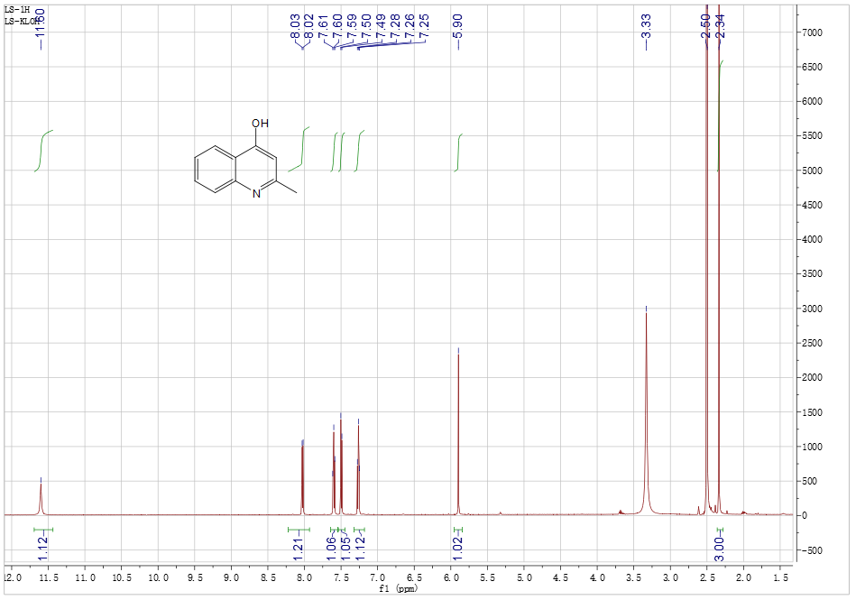

Fig. S2 The NMR spectrum of compound **1.**

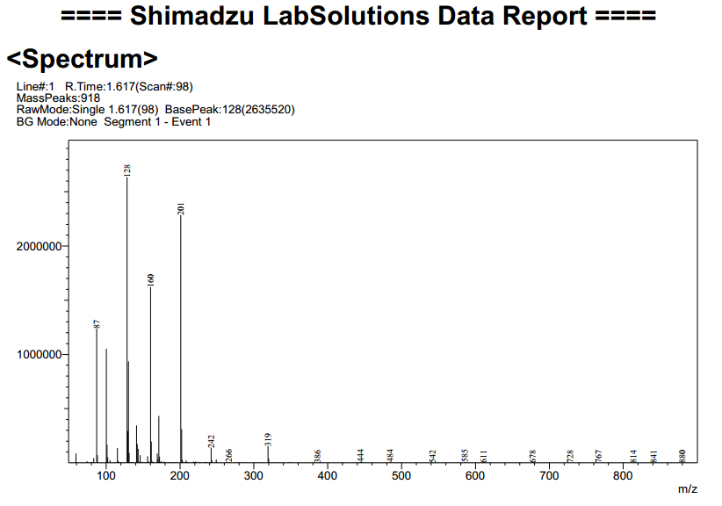

Fig. S3 The Mass spectrometry of compound **1**.

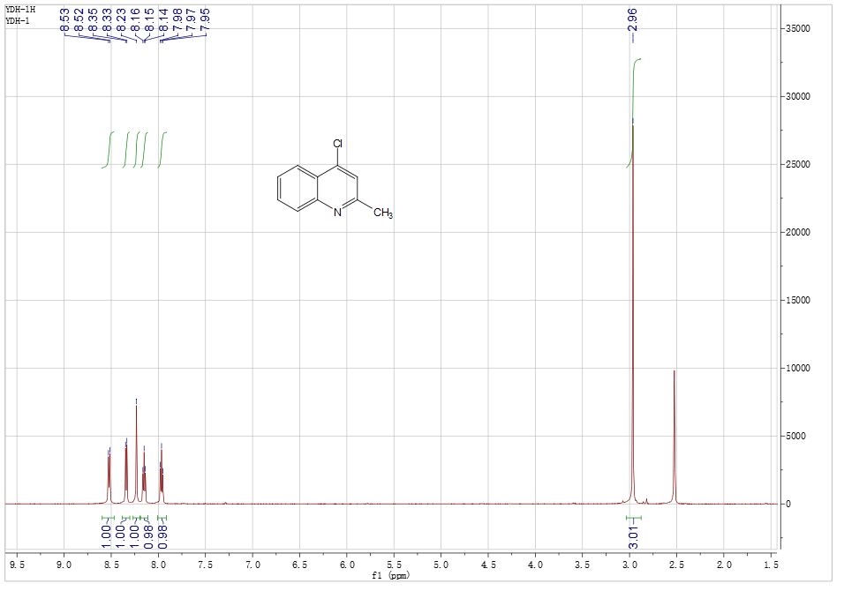

Fig. S4 The NMR spectrum of compound **2**.

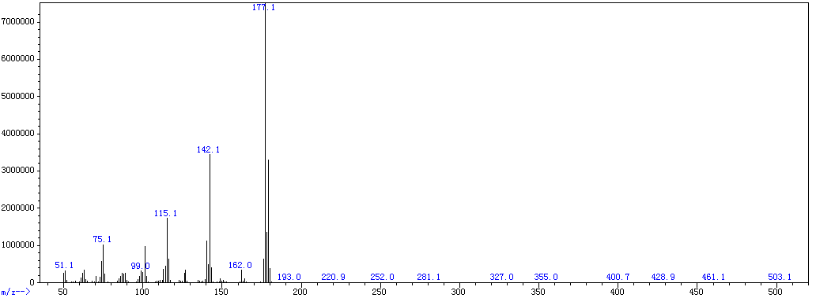

Fig. S5 The Mass spectrometry of compound **2**.

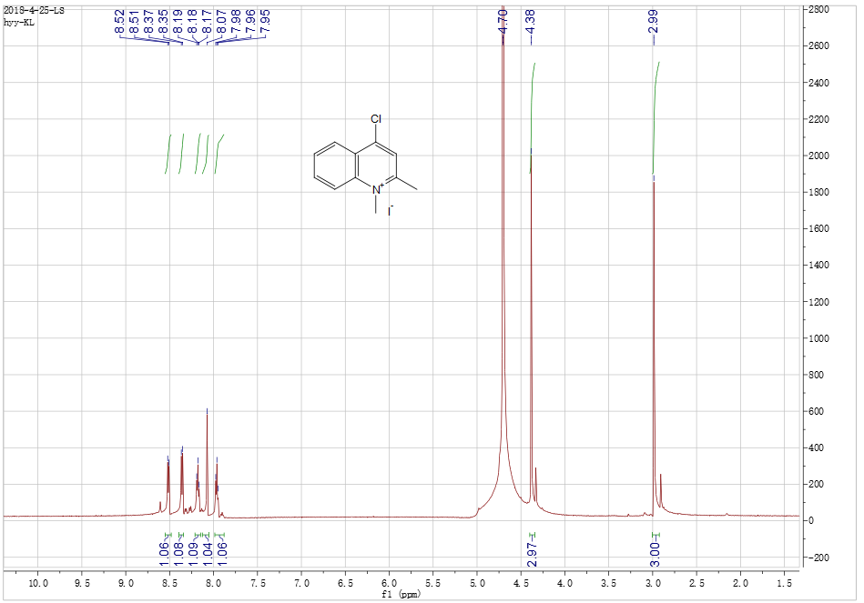

Fig. S6 The NMR spectrum of compound **3-3**.

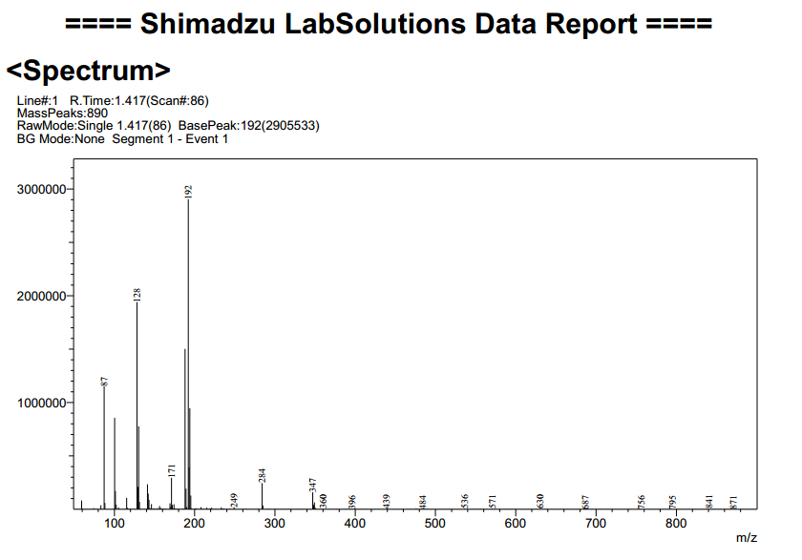

Fig. S7 The Mass spectrometry of compound **3-3**.

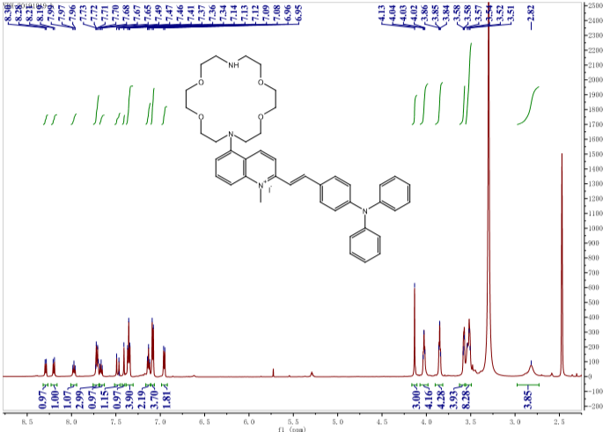

Fig. S8 The HNMR spectrum of compound TPAQD-ACE (compound **7**).

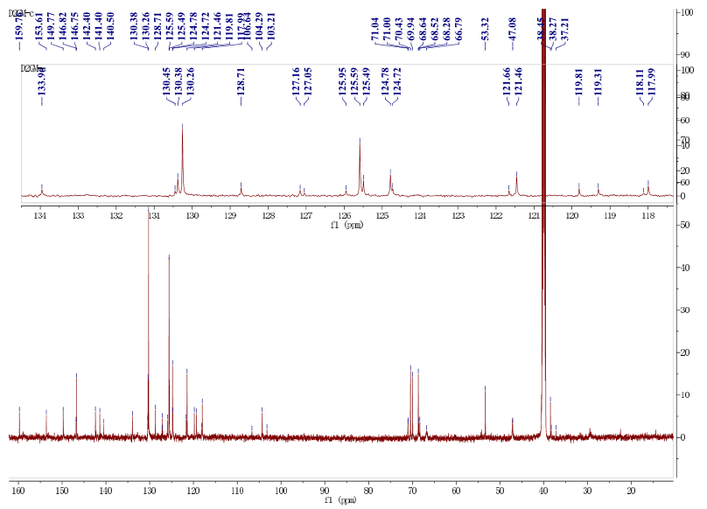

Fig. S9 The CNMR spectrum of compound TPAQD-ACE (compound **7**).

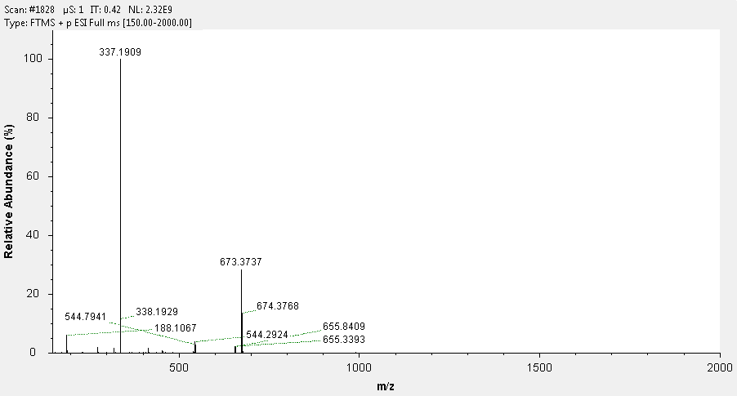

Fig. S10 The Mass spectrometry of compound TPAQD-ACE (compound **7**).

**2. Measurements and methodology**

**2.1 The annealing of DNA**

These DNAs were added into Tris-HCl buﬀer (10 mM, containing 60 mM KCl, pH 7.4**)** to make the DNA samples (100 µM). These DNA samples were placed in Mini Dry Bath and heated to 90 °C for 5 min. After cooling to room temperature, the package was taken out to be 10 μM for use.

**2.2 Fluorimetric titrations**

Fluorescence spectra were measured on a Shimadzu RF-6000 spectrofluorophotometer in a 10 mm quartz cell at room temperature. The concentration of the dye (TPAQD-ACE and TPAQD-M-ACE) was fixed at 1.0 μM. The emission slits were set at 3 nm and excitation slits were set at 5 nm. The ﬂuorescence measurement was obtained at an excitation wavelength of 445 nm, and the emission fluorescence signal was measured about 640 nm. *F0* is the fluorescence intensity of the dye in the absence of G-quadruplex DNA.

**2.2.1 Fluorescence titration spectra of TPAQD-ACE with DNAs.**



Fig. S11 Fluorescence titration spectra of *TPAQD-ACE* (2 µM) with DNAs (0-1.0 µM)

in 10 mM Tris-HCl buffer (pH 7.4) and 60 mM KCl.

**2.2.2 Fluorescence titration spectra of TPAQD-Co-ACE with DNAs.**



Fig. S12 Fluorescence titration spectra of *TPAQD-Co-ACE* (2 µM) with DNAs (0-1.0 µM)

in 10 mM Tris-HCl buffer (pH 7.4) and 60 mM KCl.

**2.2.3 Fluorescence titration spectra of TPAQD-Ni-ACE with DNAs.**



Fig. S13 Fluorescence titration spectra of *TPAQD-Ni-ACE* (2 µM) with DNAs (0-1.0 µM)

in 10 mM Tris-HCl buffer (pH 7.4) and 60 mM KCl.

**2.2.4 Fluorescence titration spectra of TPAQD-Cu-ACE with DNAs.**



Fig. S14 Fluorescence titration spectra of *TPAQD-Cu-ACE* (2 µM) with DNAs (0-1.0 µM)

in 10 mM Tris-HCl buffer (pH 7.4) and 60 mM KCl.

**2.2.5 Fluorescence titration spectra of TPAQD-Zn-ACE with DNAs.**



Fig. S15 Fluorescence titration spectra of *TPAQD-Zn-ACE* (2 µM) with DNAs (0-1.0 µM)

in 10 mM Tris-HCl buffer (pH 7.4) and 60 mM KCl.

**2.2.6 Fluorescence titration spectra of TPAQD-Fe-ACE with DNAs.**



Fig. S16 Fluorescence titration spectra of *TPAQD-Fe-ACE* (2 µM) with DNAs (0-1.0 µM)

in 10 mM Tris-HCl buffer (pH 7.4) and 60 mM KCl.

**2.2.7** **Detection limit of TPAQD-Ni-ACG for G-quadruplex DNAs**



Fig. S17 Normalized response of the fluorescence signal to changing DNA concentrations.

**3 Cellular application experiment**

**3.1** **Fluorescence imaging of Hep G2 and L02 cells**



Fig. S18 Fluorescence imaging of ﬁxed L02 cells stained with 10 μg/mL Hoechst 33342 (A) and

*non-TPAQD-ACG* (B) and overlap ﬁled (C).



Fig. S19 Fluorescence imaging of ﬁxed L02 cells stained with 10 μg/mL Hoechst 33342 (A) and

*TPAQD-ACG* (B) and overlap ﬁled (C).



Fig. 20 Fluorescence imaging of ﬁxed L02 cells stained with 10 μg/mL Hoechst 33342 (A) and

*TPAQD-Co-ACG* (B) and overlap ﬁled (C).****

Fig. S21 Fluorescence imaging of ﬁxed L02 cells stained with 10 μg/mL Hoechst 33342 (A) and

*TPAQD-Ni-ACG* (B) and overlap ﬁled (C).



Fig. S22 Fluorescence imaging of ﬁxed Hep G2 cells stained with 10 μg/mL Hoechst 33342 (A) and

*non-TPAQD-ACG* (B) and overlap ﬁled (C).



Fig. S23 Fluorescence imaging of ﬁxed Hep G2 cells stained with 10 μg/mL Hoechst 33342 (A) and

*TPAQD-ACG* (B) and overlap ﬁled (C).



Fig. S24 Fluorescence imaging of ﬁxed Hep G2 cells stained with 10 μg/mL Hoechst 33342 (A) and

*TPAQD-Co-ACG* (B) and overlap ﬁled (C).

**3.2** **Cytotoxicity of TPAQD-ACE、TPAQD-Ni-ACE and TPAQD-Co-ACE with Hep G2 and L02 cells**



Fig. S25 L02 cells were exposed to various concentrations (2.5, 5, 10, 20, 40 μM) of different dyes for 24 h. Cells viability was measured by MTT assay. Results are expressed as % of control cell viability at the corresponding concentration.



Fig. S26 Hep G2 cells were exposed to various concentrations (2.5, 5, 10, 20, 40 μM) of different dyes for 24 h. Cells viability was measured by MTT assay. Results are expressed as % of control cell viability at the corresponding concentration.

**Table s1 Different sequences of DNAs**

|  |  |  |
| --- | --- | --- |
| **DNA** | **Sequence (from 5′to 3′ )** | **Nucleotide structure** |
| **HRAS** | **TCGGGTTGCGGGVGCACGGGCG** | G-quadruplex |
| **HTG-21** | **GGGTTAGGGTTAGGGTTAGGG** | G-quadruplex |
| **CM22** | **TGAGGGTGGGTAGGGTGGGTAA** | G-quadruplex |
| **22AG** | **AGGGTTAGGGTTAGGGTTAGGG** | G-quadruplex |
| **G3T3** | **GGGTTTGGGTTTGGGTTTGGG** | G-quadruplex |
| **Hum45** | **GGG(TTAGGG)7** | G-quadruplex |
| **C-myc** | **TTGAGGGTGGGTAGGGTGGGTAAA** | G-quadruplex |
| **Src1** | **GGGCGGCGGGCTGGGCGGGG** | G-quadruplex |
| **ckit1** | **AGGGAGGGCGCTGGGAGGAGGG** | G-quadruplex |
| **Ckit3** | **GGCGAGGAGGGGCGTGGCCGGC** | G-quadruplex |
| **ss26** | **ATACGATGCTTCACGGTGCTATCTG** | Duplex |
| **ds26** | **CAATCGGATCGAATTCGATCCGATTG** | Duplex |
| **poly(G-C)9** | **GCGCGCGCGCGCGCGCGC** | Duplex |
| **poly(A-T)9** | **ATATATATATATATATAT** | Duplex |

**References**

# [1] Fangzhen Li, Famei Feng, Jiaoyi Wu, Jiaqing Xie, Shuo Li. DNA binding and cleavage properties of the Ce (III) complex of a diaza-crown ether[J]. Prog. React.Kinet. Mec. 2016, 41(1), 39-47.