ORMOSIL-entrapped copper complex as electrocatalyst for the heterogeneous de-chlorination of alkyl halides
Dror Shamirª*, Inbar Elias^{b}, Yael Albo^{c}, Dan Meyerstein^{d, b}, Ariela Burg^{e}*
ª Nuclear Research Centre Negev, Beer-Sheva, Israel.
^{b} Chemistry Dept., Ben-Gurion University, Beer-Sheva, Israel.
^{c} Chemical Engineering Dept., Ariel University, Ariel, Israel.
^{d} Chemical Sciences Dept., Ariel University, Ariel, Israel.
^{e} Chemical Engineering Dept., Sami Shamoon College of Engineering, Beer-Sheva
Corresponding authors:
Email: arielab@sce.ac.il (A. Burg); drorshamir@gmail.com (D. Shamir)

Abstract
The development of an efficient method for the de-halogenation of alkyl halides is an essential step towards the elimination of these pollutants from the environment. Here we show that entrapment of an electro-catalyst in sol-gel electrodes yields efficient electrodes for this process. In this study Cu(1,4,8,11-tetra-aza-cyclo-tetra-decane)²⁺ was used as the active catalyst in the de-chlorination of CCl₃CO₂⁻. The major electro-catalytic product is oxalate while a minor product, depending on experimental conditions, is either glyoxalate or acetate. The efficiency of the electro-catalytic process depends on the nature of the precursors used to prepare the sol-gel matrix. The observed electro-catalytic current decreases when cyclic voltammetry is performed at high scan rates. This surprising result indicates that the mechanism of the electro-catalytic process is dependent on the scan rate. Plausible mechanisms at low and high scan rates are proposed.

Keywords: Electro-catalytic process; Sol-gel matrix; Cu Complex;

Introduction
Alkyl halides are the undesirable, toxic by-products of many industrial processes[1-5], such as those used to produce bromo-esters and the common flame retardant dialkyl-1-(trimethylsiloxy)alkylphosphonate, which are also used in medical systems. In addition, alkyl halides are also generated by widely used disinfection processes like those used in the treatment of drinking water [6]. Given the ubiquity of alkyl halides and their detrimental effects on the environment and on human health, a variety of methods for their efficient reduction have been investigated and published in the literature[1-4, 7-19]. The main approach to the treatment of these pollutants is their dehalogenation, for which both homogeneous and heterogeneous methods have been suggested[20]. The advantages of heterogeneous methods such as catalyst recycling, and the ease of separating the catalysts from the products, led us to develop a sol-gel-based process for electro-catalytic heterogeneous dehalogenation.
Heterogeneous catalysis, especially when it proceeds via an active species that is entrapped in a sol-gel matrix [7, 21], entails a number of advantages over homogeneous catalysis, including the capacity to recycle the catalyst. In homogeneous systems, in contrast, catalyst recycling is often not possible due to the difficulty entailed in separating the catalyst from the products of the process. In addition, solid-phase catalyst entrapment in a sol-gel often increases the efficiency of the active species relative to its activity in homogenous catalysis [22-25], and because the catalyst is entrapped in the inner pores of the sol-gel matrix, it is both protected and stabilized. The protective and stabilizing features of sol-gel matrices were illustrated by Avnir et al., who showed that the entrapment of the enzyme alkaline-phosphatase in a sol-gel matrix enabled it to remain active at low pH values, that in homogeneous solutions would render them inactive [23]. This result is attributed to the low number of protons in the pores surrounding the enzyme, which protects the protein structures from the deleterious effects of low pH [22-24]. Another important advantage of the sol-gel process is the ability to control the nature of the matrix by varying the precursors used in its synthesis [21]. A recent study that used Ni(C₁₀H₂₄N₄)²⁺ as a catalyst in amine oxidation showed that the diffusion rate of counter anions and/or of H₃O⁺, an important measure of heterogeneous catalysis process efficiency, is affected by the precursors that are used [21].
The advantages of entrapment in sol-gels are applicable to a wide range of species, including inorganic molecules [25, 26], metal nano-particles, metal-oxide nano-particles [7, 27], bacteria [22], yeasts [28] and enzymes [22-24]. Moreover, sol-gel matrices can be exploited in a variety of applications, for example, as catalysts [7, 29-31] and electro-catalysts [32], as ion exchange columns [33, 34], as electron exchange columns [19, 26, 35] and as slow release agents [36, 37].
The importance of developing an efficient treatment method for the alkyl-halide loads present in sewage prompted us to exploit the advantages of the sol-gel process in our investigation of the electro-catalytic de-halogenation of water-soluble alkyl-halides. To that end, we used a heterogeneous process in which tri-chloro-acetate was the representative alkyl-halide and Cu(2,5,8,11-tetramethyl-2,5,8,11-tetraazadodecane) functioned as the active species (Fig. S-1, in the supporting information (SI)). Copper complexes, especially Cu(I) complexes, are used as catalysts in a variety of reactions [38, 39], including the Ullmann reaction [40, 41], the Sandmeyer reaction [42], the Meerwein reaction [43] and the de-halogenation of Cl₃CO₂⁻ [39] in homogenous systems. Due to the importance of copper complexes as catalysts, these reactions have been extensively investigated.[20, 38, 40, 41] However, less is known about the mechanisms of their activity in heterogeneous systems. Mono-valent copper complexes are known as catalysts for the dehalogenation of alkyl halides [20, 39]. Therefore, we decided to focus on the electro-catalytic de-halogenation of water-soluble alkyl-halides in a heterogeneous process that uses tri-chloro-acetate as the representative alkyl-halide and Cu(2,5,8,11-tetramethyl-2,5,8,11-tetraazadodecane)²⁺, Cu^{II}L₁²⁺, as the electro-catalyst (Fig. S-1, in SI). The structures of these compounds were reported earlier [44].
Experimental
Materials – Analytical reagent grade tri-chlor-acetic-acid, TCA, sodium perchlorate, perchloric acid, tetra-methoxy-silane, (MTMS), tri-methoxy-(phenyl)silane (TMPS), methyl-tri-methoxy-silane (MTMS), graphite, CuSO₄ and 2,5,8,11-tetra-methyl-2,5,8,11-tetra-aza-dodecane (L₁), acetonitrile and H₃PO₄ were purchased from Aldrich.
All solutions were prepared in de-ionized water that was further purified by passing it through a Milli Q Millipore setup with a final resistivity >10 MΩ/cm, TDW. Argon was used to de-aerate the solutions for at least 5 min. All reactions were studied at an ionic strength of 0.10 M that was maintained over the course of each reaction by the addition of NaClO₄.
Spectra were measured using a UV-visible diode array spectrophotometer (Agilent 8453). Electrochemical experiments were performed using a multi-channel potentiostat (Metrohm Autolab) using Autolab hardware and GPES/Nova software. Three electrodes were used: Ag/AgCl as a reference electrode, Pt as a counter electrode, and sol-gel or glassy carbon (GC) as the working electrodes. HPLC analyses were performed using a Jasco XLC-3059AS with C18, Hypersil Gold column. The eluent composition was 90% TDW, 10% acetonitrile, and 0.2% H₃PO₄. The flow rate was 1.0 ml/min. ICP analysis was performed using an ICP-OES instrument (SPECTRO ARCOS). The method of CuL₁⁺² entrapment in sol-gel electrodes and matrices is described below.
Electrode preparation – Three kinds of sol-gel electrodes were prepared based on a procedure reported in the literature [28, 45] that we modified to obtain electrodes that were optimized for our experimental requirements. The electrodes differed from each other in terms of their precursors: Cu1 electrodes were made from a mixture of MTMS and TMPS, and Cu2 electrodes were made from TMPS. A third type of electrode made only from MTMS was also prepared, but these electrodes disintegrated shortly after their preparation, and therefore, electrochemical experiments were not performed with them. The effect of the amount of graphite, precursors (MTMS/TMPS), and CuL₁²⁺ in each type of electrode was studied. The optimal conditions were chosen on the basis of the quality of the cyclic voltammetry measurements, the extent of leaching of the active species, CuL₁²⁺, from the electrode, and the electrode drying time. The composition of the precursors affected the electrode drying time, which was significantly longer for the TMPS electrodes than for those prepared with MTMS probably due to the steric hindrance caused by the phenyl and methyl residues in the hydrolysis processes.
The ingredients (graphite, precursor and Cu^{II}L₁²⁺ solution) were mixed on a plate until the mixture exhibited a creamy texture, after which it was inserted into a tube. The composition of each electrode is summarized in Table S-1, and Figure 1 shows an image of a prepared electrode.
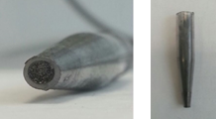
Fig. 1 – ORMOSIL-graphite electrode -entrapped copper complex Cu^{II}L₁²⁺
Results and discussion
Electro-catalysis
The activity of Cu^{II}L₁²⁺ in the electrodes and the de-chlorination mechanism were studied using cyclic voltammetry. Control experiments were done using a glassy carbon (GC) or a sol-gel (B1 and B2) working electrode that did not contain Cu^{II}L₁²⁺. The aqueous solution in the electrochemical cell included NaClO₄ and/or TCA depending on the experiment. No de-chlorination reaction occurred in solutions that contained TCA without Cu^{II}L₁²⁺ or in solutions that did not contain TCA (Fig. 2 for B1 and fig. S-2 for B2).
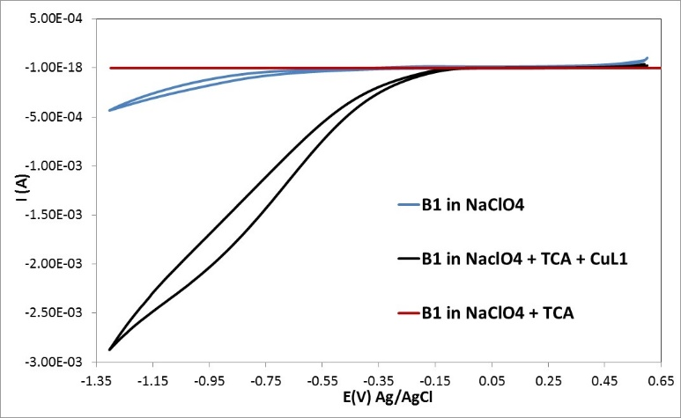
Fig. 2. Cyclic voltammograms for B1 as working electrode. All the experiments were done at pH 7.0 and at a scan rate of 500 mv/s. — in solution containing 0.10 M NaClO₄, — in solution containing 0.10 M NaClO₄ and 0.20 M TCA, — in solution containing 0.10 M NaClO₄, 0.20 M TCA, 1.87×10⁻³ M CuSO₄, 5.60×10⁻³ M L₁.

The voltammograms presented in Fig. 3 were obtained when cyclic voltametric experiments were performed in the absence of the substrate (TCA) with Cu1/Cu2/GC electrode as a working electrode (the GC experiment included Cu^{II}L₁²⁺ solution). The observed waves are attributed to the reduction oxidation reactions of Cu^{II}L₁²⁺ (reactions 1 and 2). The redox potentials were taken from the literature at pH 7.0 [44]
(1) (Cu^{II}L₁) ²⁺ + e⁻ (Cu^{I}L₁)⁺ E = -0.157 V vs. Ag/AgCl, working electrode HDME

(2) (Cu^{I}L₁)⁺ + e ⁻ Cu⁰ + L₁ E = -0.340 V vs. Ag/AgCl, working electrode HDME

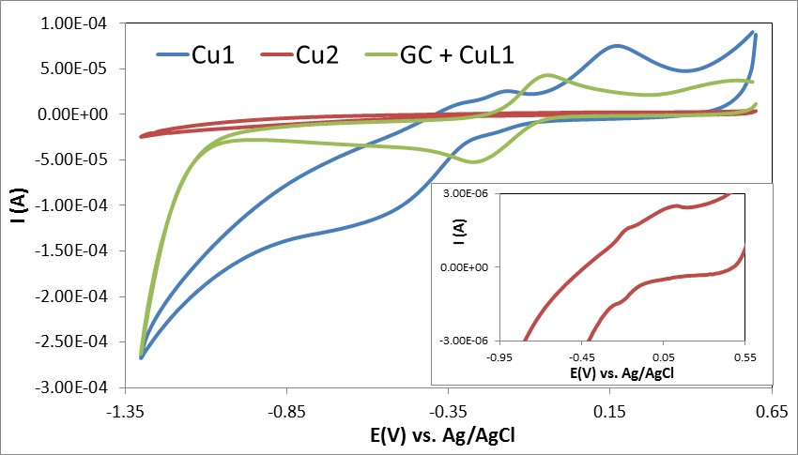
Fig. 3. Cyclic voltammograms of the different working electrodes. All experiments were done in solutions that contained 0.10 M NaClO₄ at pH 7.0 and at a scan rate of 500 mv/s. — Cu1-sol-gel electrode, — Cu2-sol-gel electrode — GC electrode 0.10 M NaClO₄, 1.87×10⁻³ M CuSO₄, 5.60×10⁻³ M L₁.
The inclusion in the sol-gel electrodes of copper and its absence from the solution shifted the redox potentials to somewhat lower values (Fig. 3). The current generated by the Cu1 (MTMS + TMPS) electrode was considerably larger than that generated by the Cu2 (TMPS) electrode. This result indicates that the composition of the precursors used to prepare the sol-gel electrodes significantly affects their electrochemical properties. Clearly, the presence of phenyl groups in TMPS, that are more hydrophobic and sterically demanding than the methyl groups in MTMS, affect the nature of the matrix, which in turn affects diffusion throughout the porous electrodes. Similar effects were reported when sol-gel electrodes were used for other electro-catalytic processes [21, 46]. Fig. 4 and Fig. S-3 present the cyclic voltammograms obtained when the Cu1 and Cu2 electrodes were used as the working electrodes and the solution contained the substrate TCA. The observed increase in the current when TCA is in the solution indicates catalytic de-halogenation is taking place.
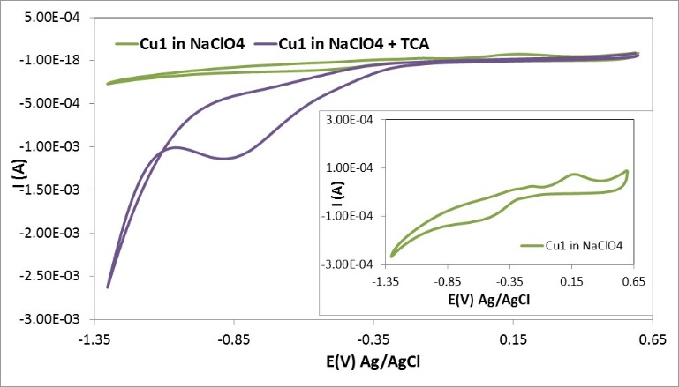
Fig. 4. Cyclic voltammograms for Cu1 as working electrode. All the experiments were done at pH 7.0 and at a scan rate of 500 mv/s. — in solution containing 0.10 M NaClO₄, — in solution containing 0.10 M NaClO₄ and 0.20 M TCA

Current - scan rate dependence
To ascertain whether the de-chlorination reaction is a diffusion-controlled process, the correlation between the current and the scan rate was determined. The fit of the results to the Randles-Sevcik equation [47] is presented in Fig. 5. The linear dependence of the current on the scan rate up to ~500 mv/sec is clear for Cu1 due to the large catalytic current generated, but less so for Cu2, due to the considerably lower current generated, indicating that the process observed is a complex diffusion controlled process [21, 48].
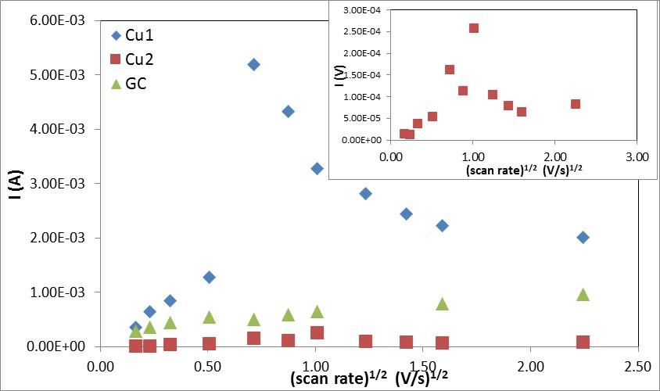
Fig. 5. – Current as a function of root of the scan rate. The currents were measured for Cu1 at -0.90 V) and for Cu2 at -0.80 V in solutions containing 0.10 M NaClO₄, 2.0 M TCA, at pH 7.0 and for GC at -0.71 V) in a solution containing 1.87×10⁻³ M CuSO₄, 5.60×10⁻³ M L₁, 0.10 M NaClO₄, 2.0 M TCA at pH 7.0.

With GC as the working electrode, the current-scan rate dependence reached a plateau at about ~500 mV/s. However, the linear dependence is less definitive because of the lower catalytic currents generated as compared to Cu1 (see Fig S-4). At the plateau, the rate-determining step is the chemical reaction rather than the electrochemical step. For the sol-gel working electrodes, however, a completely different behaviour is observed: the current initially increases with the scan rate, but above ~500 mv/s, the trend reverses and the current decrease as the scan rate continues to increase. To the best of our knowledge, although a decrease in current as a function of an increasing scan rate is reported in the literature [49], the intriguing phenomenon observed here, an increasing and then decreasing current as a function of a continually increasing scan rate, has not yet been reported in the literature. We suggest this finding to be due to a competition between two mechanisms in the catalytic process, and the shift between the two mechanisms may be due to the rapid increase in the less positive potential. The following shift in the mechanism is proposed based on reactions previously reported [[38, 39]]. The first step in the catalytic process is:
(3) Cu^{I}L₁⁺ + Cl₃CCO₂⁻ → Cu^{II}L₁²⁺ + Cl₂CCO₂^{.-} + Cl⁻
which is followed by:
(4) Cu^{II}L₁²⁺ + Cl₂CCO₂^{.-} → L₁Cu^{III}-CCl₂CO₂⁺
Reaction (3) was shown to be the first step in catalytic de-halogenation reactions by this type of Cu^{I}L₁⁺ complex. Reaction (5) is usually slower than reaction (6)[39, 50], but because reaction (3) occurs in pores that are small relative to the solution environment, the radical Cl₂CCO₂^{.-} that forms in proximity to Cu^{II}L₁²⁺ is expected to react with the latter as no Cu^{I}L₁⁺ is present in the immediate vicinity[38, 39].
(5) Cu^{II}L²⁺ + R. → LCu^{III}-R²⁺
(6) Cu^{I}L⁺ + R. → LCu^{II}-R⁺
The final products will be formed via the decomposition of the transient complex L₁Cu^{III}-CCl₂CO₂⁺, see below. However, at sufficiently high scan rates, one of two of the following possibilities could occur:
- The most probable is that the transient L₁Cu^{III}-CCl₂CO₂⁺ complex is electrochemically reduced:
(7) L₁Cu^{III}-CCl₂CO₂⁺ + e⁻ → L₁Cu^{II}-CCl₂CO₂
Or
- Prior to reaction (4), the Cu^{II}L₁²⁺ formed in reaction (3) is electrochemically reduced to Cu^{I}L₁⁺, which reacts with the radical anion Cl₂CCO₂^{.-} to form the transient complex L₁Cu^{II}-CCl₂CO₂.
In both cases, the transient complex formed at the higher scan rate is L₁Cu^{II}-CCl₂CO₂. It is well known that transient LCu^{II}-CCl₂CO complexes have considerably longer lifetimes than do LCu^{III}-CCl₂CO complexes [39], which explains the lower currents observed at the higher scan rates.
It should be noted that considerably different catalytic currents were obtained when the different sol-gel electrodes were used. In the case of the Cu1 electrode (MTMS + TMPS), the observed current was considerably higher than that obtained with the Cu2 (TMPS) electrode. This finding is attributed to the effects of the larger size and more hydrophobic nature of the phenyl relative to the methyl substituents, properties that affect the substrate and counter ion diffusion rates in the meso-pores of the sol-gel matrices. Analogous observations were previously reported when sol-gel electrodes were used in different electrochemical processes [21, 46]. These results clearly indicate that the precursors used to prepare the electrodes significantly affect catalytic process efficiency.
Effect of substrate concentration on current
The effect of substrate concentration on the reduction current was studied. The results presented in Fig. 6 indicate that, as expected, the current increased with an increase in the concentration of TCA.

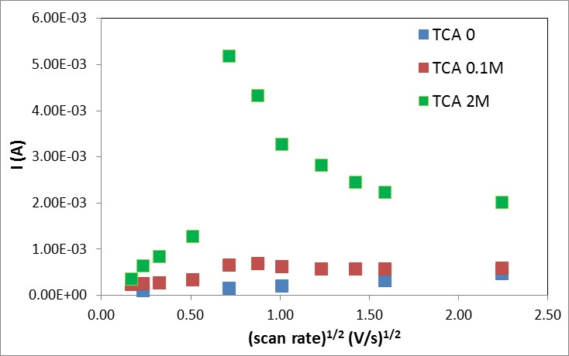
Fig. 6. Current as a function of the root of the scan rate. Experiments were performed with the Cu1-sol-gel electrode as the working electrode at -0.90 V in a solution containing 0.10 M NaClO₄ at pH 7.0 and with different concentrations of TCA.

pH effect on current
Cu^{II}L²⁺ entrapment was performed by mixing its aqueous solution at pH 7.0 with the precursor/precursors. As the structure of Cu^{II}L²⁺ is known to vary with pH [44, 51] (Fig. S-1), and the complex is unstable in acidic solutions, the effect of the pH of the solution was studied. The results are summarized in Fig. 7.
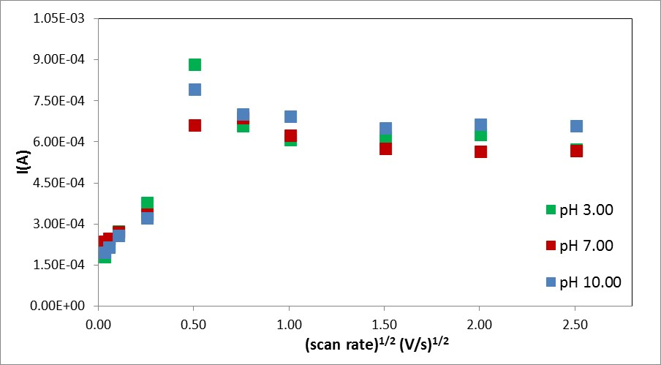
Fig. 7. Current (at E -0.90V) as a function of the root of the scan rate at different pH values. The experiments were performed using the Cu1-sol-gel electrodes as working electrodes in solutions containing 0.10 M NaClO₄ and 0.10 M TCA.
The results indicate that pH had no effect on the reduction current, a finding that is probably due to the stabilizing effect of the sol-gel matrix on catalysts entrapped within [23, 52]. This might be partially due to the small number of protons in the pores near the complex, even in acidic solutions [23], However, as CuL²⁺ decomposes when even one or two amines are protonated, the stability of CuL₁²⁺ in the matrix cannot be solely attributed to this.
Product identification
Though products formed during the electrochemical experiments were present in concentrations too small to measure quantitatively, oxalate was identified and glyoxalate was possibly identified. To validate that we correctly identified our products, the catalytic reduction was performed by another method, the catalytic reduction of TCA by ascorbate in the presence of Cu^{II}L²⁺ (methods described in section S-1 in the SI). Cu^{II}L²⁺ was entrapped in three kinds of sol-gel matrices, the details of which are included in section S-2 in SI (The results indicate that the matrix composition does not affect the results). The products of the catalytic process were identified by HPLC. The results indicate that oxalate and perhaps some glyoxalate were formed. (HPLC chromatograph is included in Fig. S-5 in SI).
The formation of oxalate as the major product is attributed to the following plausible mechanism: The L₁Cu^{III}-CCl₂CO₂⁺ formed in reaction (4) is expected to decompose via:
(8) L₁Cu^{III}-CCl₂CO₂⁺ + H₂O → Cu^{I}L₁⁺ + HOCCl₂CO₂⁻ + H⁺
Reaction (8) is analogous to the mechanisms of decomposition reported for a variety of L₁Cu^{III}-R complexes [[38, 39]]. Reaction (8) will be followed by:
(9) HOCCl₂COO⁻ → HCl + C(O)ClCOO⁻
(10) C(O)ClCOO⁻ + H₂O → ⁻OOCCOO⁻ + HCl + H⁺
The glyoxalate is formed via the decomposition of the L₁Cu^{II}-CCl₂CO formed in reaction (7) via the following mechanism:
(11) L₁Cu^{II}-CCl₂CO₂ + H₂O → Cu^{II}L₁²⁺ + HCCl₂CO₂⁻ + OH⁻
Reaction (11) is analogous to the mechanisms of decomposition of many L₁Cu^{II}-R complexes [38, 39], those that do not decompose via haemolysis [38, 39]. Reaction (11) will be followed by:
(12) Cu^{I}L₁⁺ + HCl₂CCO₂⁻ → Cu^{II}L₁²⁺ + HClCCO₂^{.-} + Cl⁻
(13) Cu^{II}L₁²⁺ + HClCCO₂^{.-} → L₁Cu^{III}-HCClCO₂⁺
(14) L₁Cu^{III}-HCClCO₂⁺ + H₂O → Cu^{I}L₁⁺ + HOCHClCO₂⁻ + H⁺
(15) HOCHClCO₂⁻ → HC(O)CO₂⁻ + HCl
If under the electrochemical conditions, reaction (13) is replaced by:
(16) L₁Cu^{III}-HCClCO₂⁺ + e⁻ → L₁Cu^{II}-HCClCO₂
where reaction (16) is analogous to reaction (7), then the final product would be acetate instead of glyoxalate.

Active species leaching
Leaching of the active species, Cu^{II}L₁⁺², from the electrodes was studied spectrophotometrically and by ICP. The results, which are described in detail in section S-3 in the SI, indicate that if any leaching occurred, it was minimal. This outcome can be explained by the formation of hydrogen bonds between the ligand and the matrix residue, which is supported by similar findings reported in the literature [21, 26, 46].

Conclusions
Our results describe a completely new phenomenon – namely, the observed decrease in electro-catalytic current with increasing cyclic voltammetry scan rates – that to the best of our knowledge, has not yet been published in the literature. A decrease in the current with an increasing scan rate was reported for another mechanisms[49]. However, to the best of our knowledge, this is the first report that in a single system an increase in current was followed by a decrease in current as scan rate continued to raise. Our observation indicates that the mechanism of the electro-catalytic reduction changes with increasing scan rate.
The results presented herein indicate that the Cu^{II}L₁²⁺ complex entrapped in a sol-gel matrix is an efficient electro-catalyst for the de-chlorination of TCA. We suggest two possible mechanisms for this reaction: in one, reactions (4) & (8)-(10), the predicted product is oxalate, while in the other, reactions (7) & (11)-(15), the predicted product is glyoxalate. If the electro-catalytic process in the latter mechanism is performed under a sufficiently negative potential, reaction (16) replaces reaction (14), and the expected product is acetate.
In addition, the results clearly indicate that the use of the electrode consisting of the sol-gel matrix is a good alternative to the homogeneous electro-catalytic process. Furthermore, the sol-gel matrix protects the Cu^{II}L₁²⁺ complex from decomposing at pH values that can render the complex unstable in the homogeneous solution.
The results also show that the nature of the precursors used to prepare the sol-gel electrode has a considerable effect on electrode efficiency. These results have far-reaching implications in terms of catalytic process control and active species recycling.
Acknowledgements
This study was supported by a grant from the Pazy Foundation.

References
1 M. Hammes, K. Stoewe; and W. F. Maier, Applied Catalysis, B: Environmental 117-118, 397-405. (2012).
2 V. P. BoyarskiiT, E. ZheskoS, A. LaninaG and F. Tereshchenko, Russian Journal of Applied Chemistry 80, 1090-1096. (2007).
3 L. Benzhi, H. Xiaobin, D. Yuehua, Y. Shaogui and S. Cheng, Journal of Solid State Electrochemistry 16, 927-930 (2012).
4 Y. J. Kim, S. M. Kim, C. Yu, Y. Yoo, E. J. Cho, J. W. Yangand S. W. Kim, Langmuir 33, 954-958. (2017).
5 A. Kinani, S. Kinani, B. Richard, M. Lorthioy and S. Bouchonnet, TrAC, Trends in Analytical Chemistry 85, 273-280 (2016).
6 D. L. Sedlak and U. V. Gunten, Science 331, 42-43 (2011).
7 J. Adhikary, M. Meistelman, A. Burg, D. Shamir, D. Meyerstein and Y. Albo, European Journal of Inorganic Chemistry 2017, 1510-1515 (2017).
8 E. J. C. Borojovich, R. Bar-Ziv, O. Oster-Golberg, H. Sebbag, M. Zinigrad, D. Meyerstein; and T. Zidki, Applied Catalysis, B: Environmental 210, 255-262 (2017).
9 D. Koushik, S. S. Gupta, S. M. Maliyekkal and T. Pradeep, Rapid dehalogenation of pesticides and organics at the interface of reduced graphene oxide-​silver nanocomposite 308, 192-198. (2016).
10 N. A. Isley, M. S. Hageman and B. H. Lipshutz, Green Chemistry 17, 893-897 (2015).
11 X. Pan, E. Lacote, J. Lalevee and D. P. Curran, Journal of the American Chemical Society 134, 5669-5674 (2012).
12 A. Dewanji, C. Mueck-Lichtenfeld and A. Studer, Angewandte Chemie 55, 6749-6752 (2016).
13 A. Jana, J. Mondal, P. Borah, S. Mondal, A. Bhaumik and Y. Zhao, Chemical Communications 51, 10746-10749 (2015).
14 E. Shandalov, I. Zilbermann, E. Maimon, Y. Nahmani, H. Cohen, E. Adar and D. Meyerstein, European Journal of Inorganic Chemistry 2003, 4105-4109 (2003).
15 E. Shandalov, I. Zilbermann, E. Maimon, Y. Nahmani, H. Cohen, E. Adar and D. Meyerstein, Tetrahedron Letters 45, 989-992 (2004).
16 G. La Sorella, L. Sperni, P. Canton, L. Coletti, F. Fabris, G. Strukul and A. Scarso, The Journal of Organic Chemistry 83, 7438-7446 (2018).
17 J. Jouha, M. Khouili, M.-A. Hiebel, G. Guillaumet and F. Suzenet, Tetrahedron Letters 59, 3108-3111 (2018).
18 M. G. Davie, H. Cheng, G. D. Hopkins, C. A. LeBron and M. Reinhard, Environmental Science & Technology 42, 8908-8915 (2008).
19 J. Adhikary, D. Meyerstein, V. Marks, M. Meistelman, G. Gershinsky, A. Burg, D. Shamir, H. Kornweitz and Y. Albo, Applied Catalysis B: Environmental, accepted for publication (2018).
20 X. Wang, M. Liu, Y. Wang, H. Fan, J. Wu, C. Huang and H. Hou, Inorganic Chemistry 56, 13329-13336 (2017).
21 A. Burg, D. Shamir, L. Apelbaum, Y. Albo, E. Maimon and D. Meyerstein, European Journal of Inorganic Chemistry 2016, 459-463 (2016).
22 D. Avnir, T. Coradin, O. Lev; and J. Livage, Journal of Materials Chemistry 16, 1013-1030. (2006).
23 H. F. Mullerad and D. Avnir, Journal of American Chemical Society 127, 8077-8081 (2005).
24 H. Frenkel-Mullerad, R. Ben-Knaz and D. Avnir, Journal of Sol-Gel Science and Technology 70, 168-171 (2014).
25 J. Blum, A. Rosenfeld, F. Gelman, H. Schumann and D. Avnir, Journal of Molecular Catalysis A: Chemical 146, 117-122 (1999).
26 Y. Lavi, A. Burg, E. Maimon and D. Meyerstein, Chemistry - A European Journal 17, 5188-5192 (2011).
27 E. D. Gaspera, M. Guglielmi, A. Martucci, L. Giancaterini and C. Cantalini, Sensors and Actuators, B: Chemical 164, 54-63 (2012).
28 A. Mellati, H. Attar and M. F. Farahani, Asian Journal of Biotechnology 2, 127-132 (2010).
29 R. Abu-Reziq and H. Alper, Applied Sciences 2, 260-276 (2012).
30 K. Teinz, S. Wuttke, F. Boerno, J. Eicher and E. Kemnitz, Journal of Catalysis 282, 175-182 (2011).
31 F. Frouri, S. Celerier, P. Ayrault and F. Richard, Applied Catalysis, B: Environmental 168-169, 515-523 (2015).
32 O. Lev and S. Sampath, Electroanalytical Chemistry: A Series of Advances p. 212-285, Place PUblished (2010).
33 R. M. Almeida and A. C. Marques, Materials Science & Engineering, B: Advanced Functional Solid-State Materials 149, 118-122 (2008).
34 H. Lu, L. Dan-Dan, W. Bing-Bing and X. Hong-Bo, Research on Chemical Intermediates 41, 3913-3928 (2015).
35 Neelam, Y. Albo, A. Burg, D. Shamir and D. Meyerstein, Chemical Engineering Journal 330, 419-422 (2017).
36 P. Pisitsak and U. Ruktanonchai, Textile Research Journal 85, 949-959 (2015).
37 D. Avnir, J. Blum and Z. Nairoukh, The Sol‐Gel Handbook, p. 963-986 Place PUblished (2015).
38 A. Burg and D. Meyerstein, Advances in Inorganic Chemistry 64, 219-261 (2012).
39 N. Navon, A. Burg, H. Cohen, R. V. Eldik and D. Meyerstein, European Journal of Inorganic Chemistry 423-429 (2002).
40 I. Rusonik, H. Cohen and D. Meyerstein, Dalton Transactions 10, 2024-2028. (2003).
41 M. Saphier, A. Masarwa, H. Cohen and D. Meyerstein, European Journal of Inorganic Chemistry 5, 1226-1234. (2002).
42 C. Ferenc, Mini-Reviews in Organic Chemistry 12, 127-148. (2015).
43 A. Burg, Y. Wolfer, H. Kornweitz, L. Shenar-Jackson, A. Masarwab and D. Meyerstein, Dalton Trans 42, 4985-4993 (2013).
44 G. Golub, H. Cohen, P. Paoletti, A. Bencini, L. Messori, I. Bertini and D. Meyerstein, Journal of American Chemical Society 117, 8353-8361 (1995).
45 L. Rabinovich; and O. Lev, Electroanalysis 13, 265-275 (2001).
46 Y. Wolfer, Ben-Gurion University of the Negev 2018).
47 A. J. Bard, G. Inzelt and F. Scholz, Electrochemical Dictionary, Springer Science & Business Media (2008).
48 S. Attia, A. Shames, I. Zilbermann, G. Goobes, E. Maimon and D. Meyerstein, Dalton Transactions 43, 103-110 (2014).
49 R. S. Nicholson and I. Shain, Analytical Chemistry 36, 706-723 (1964).
50 M. Freiberg, J. Lilie and D. Meyerstein, Inorganic Chemistry 19, 1908-1912 (1980).
51 N. Navon, G. Golub, H. Cohen, P. Paoletti, B. Valtancoli, A. Bencini and D. Meyerstein, Inorganic Chemistry 38, 3484-3488 (1999).
52 O. E. Shapovalova, D. Levy, D. Avnir and V. V. Vinogradov, Colloids and Surfaces B: Biointerfaces 146, 731-736 (2016).

