Megabenthic assemblages at the southern Central Indian Ridge – Spatial segregation of inactive hydrothermal vents from active-, periphery- and non-vent sites

Gerdes KH^{1,2,4}*, Martinez-Arbizu P^{1,4}, Martin Schwentner², Freitag R³, Schwarz-Schampera U³, Brandt A^{5,6}, Kihara TC¹
¹Senckenberg am Meer, German Center for Marine Biodiversity Research, Wilhelmshaven, Germany
²Center of Natural History, Universität Hamburg, Hamburg, Germany
³Federal Institute for Geosciences and Natural Resources, Hannover, Germany
⁴Carl von Ossietzky Universität Oldenburg, Oldenburg, Germany
⁵Senckenberg Research Institute and Natural History Museum Frankfurt, Frankfurt, Germany
⁶Institute for Ecology, Evolution and Diversity, Goethe-University of Frankfurt, FB 15, Max-von-Laue-Str. 13, 60439 Frankfurt am Main, Germany

Supplementary Material
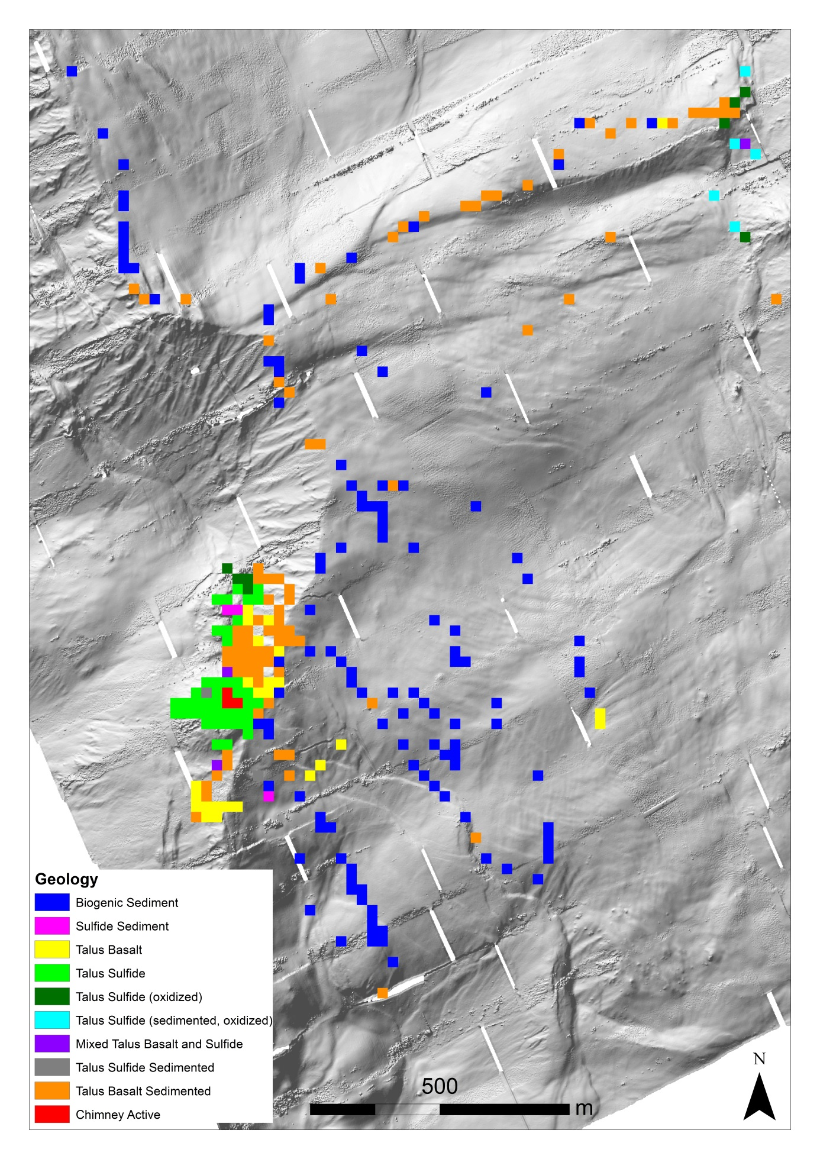
Supplementary Figure 1: Spatial distribution of final substrates types based on hierarchical classification.

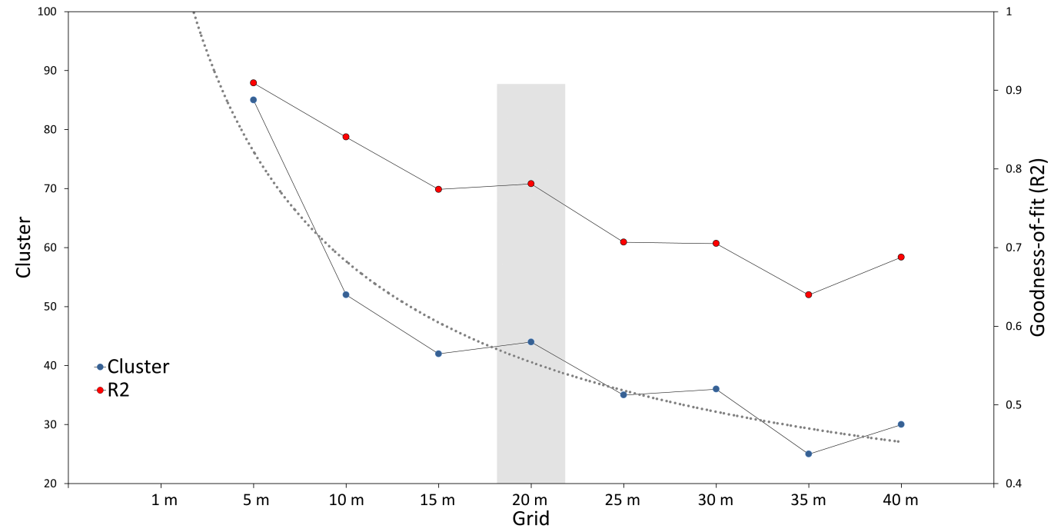
Supplementary Figure 2: Number of faunal clusters and goodness-of-fit (Global R²-value) plotted for each grid size. The 1 m grid size cluster could not be calculated with a computational power of 500 GB Ram. The grey dotted line indicates the smoothed asymptotic trend of the number of clusters. The light grey box shows the selected optimal grid size.

Supplementary Figure 3: Dendrogram of hierarchical clustering of the 20x20 m grids resulting in the separation of 44 faunal clusters. The separation of clusters based on the Simprof post-hoc test and global R of the 'adonis' function (R²= 0.78102). The red dotted lines indicate significant separated cluster based on the Simprof test. The colored line underneath the faunal clusters indicates the relation of each faunal cluster to the corresponding faunal assemblage.

Supplementary Table 2: Taxa identified during video analysis based on the created fauna catalogue. All taxa were identified to lowest taxon possible. Grey highlighted taxa are vent endemic.
Phylum | Taxon (grey indicate HVF taxa) | Faunal Assemblage |  |  |  |  | Total
 |  | I | II | III | IV | V
Arthropoda | Austinograea rodriguezensis Tsuchida & Hashimoto, 2002 | 72 | 2 | 10 |  | 1 | 85
 | Caridea sp. 1 | 1 | 2 | 1 | 28 |  | 32
 | Caridea sp. 2 |  |  |  |  | 1 | 1
 | Caridea sp. 3 |  |  |  |  | 3 | 3
 | Caridea sp. 4 |  |  |  | 12 |  | 12
 | Munidopsis pallida Alcock, 1894 | 4 | 8 | 9 |  |  | 21
 | Nematocarcinus sp. 1 |  |  |  |  | 6 | 6
 | Nematocarcinus sp. 2 |  |  |  |  | 1 | 1
 | Paguroidea sp. |  |  | 1 | 21 |  | 22
 | Rimicaris kairei Watabe & Hashimoto, 2002 | 21,876 | 11 | 8 | 1 |  | 21,896
Bryozoa | Cheilostomatida sp. 1 |  | 1 |  |  |  | 1
Chordata | Megalodicopia hians Oka, 1918 |  | 1 |  |  |  | 1
 | Zoarcidae sp. 1 | 17 |  |  |  |  | 17
Cnidaria | Actiniaria sp. 1 | 1 |  |  |  |  | 1
 | Actiniaria sp. 4 | 2,057 | 15 | 4 |  |  | 2,076
 | Actiniaria sp. 7 | 1 | 1 |  |  | 1 | 3
 | Actinostola sp. 2 |  |  |  |  | 2 | 2
 | Bathypathes cf. patula | 2 | 1 |  |  |  | 3
 | Bathyphellia sp. 1 | 182 | 19 | 15 |  | 1 | 217
 | Bathyphellia sp. 2 | 6 | 23 | 1 | 52 | 1 | 83
 | Candelabrum sp. | 8 | 3 | 4 |  |  | 15
 | Corymorpha sp. |  |  |  |  | 1 | 1
 | Hydrozoa sp. 4 |  | 2 | 1 |  |  | 3
 | Hydrozoa sp. 6 | 1 | 4 | 1 |  |  | 6
 | Hydrozoa sp. 8 | 1 | 6 | 20 |  |  | 27
 | Isididae sp. 1 | 4 |  | 12 |  |  | 16
 | Isididae sp. 2 |  |  |  |  | 1 | 1
 | Isididae sp. 5 | 1 | 10 | 5 |  |  | 16
 | Maractis sp. | 17,063 | 82 | 5 |  |  | 17,150
 | Pennatulacea sp. 1 | 1 |  |  |  | 1 | 2
 | Primnoidae sp. 1 |  |  |  |  | 1 | 1
 | Scleractinia sp. |  | 1 |  |  |  | 1
 | Umbellula sp. |  |  | 1 | 4 |  | 5
 | Zoantharia sp. | 743 | 480 |  |  |  | 1,223
Echinodermata | Brisingidae sp. 1 |  |  | 1 |  |  | 1
 | Chiridota sp. 1 | 10 |  |  |  |  | 10
 | Circeaster marcelli Koehler, 1909 | 2 | 1 | 1 |  | 3 | 7
 | Crinoidea sp. 1 |  |  |  |  | 1 | 1
 | Crinoidea sp. 3 |  |  |  |  | 2 | 2
 | Enypniastes cf. eximia |  |  | 1 |  |  | 1
 | Freyellidae sp. 1 |  |  | 1 | 1 | 2 | 4
 | Oneirophanta sp. |  |  | 1 |  |  | 1
 | Ophiuroidea sp. 3 |  |  |  |  | 2 | 2
 | Sperosoma sp. 1 |  |  |  | 2 |  | 2
 | Sperosoma sp. 2 |  |  |  |  | 1 | 1
 | Styracaster caroli Ludwig, 1907 |  |  |  |  | 2 | 2
 | Synallactes aenigma Ludwig, 1894 |  |  |  |  | 1 | 1
 | Synallactidae sp. 2 |  |  |  | 2 | 1 | 3
Foraminifera | Xenophyophoroidea sp. 4 |  |  |  |  | 1 | 1
Mollusca | Bathymodiolus septemdierum Hashimoto & Okutani, 1994 | 13 |  |  |  |  | 13
Polychaeta | Oasisia sp. 1 | 127 |  |  |  |  | 127
 | Sabellidae sp. 1 |  |  |  |  | 2 | 2
Porifera | Abyssocladia sp. 1 |  |  | 2 |  | 1 | 3
 | Caulophacus sp. |  | 1 |  |  | 4 | 5
 | Chonelasma sp. |  |  |  | 1 | 6 | 7
 | Cladorhizidae sp. 1 | 1 |  | 1 |  |  | 2
 | Euchelipluma sp. 1 |  | 20 | 11 |  |  | 31
 | Geodia sp. |  |  | 5 |  | 1 | 6
 | Hyalonema sp. 1 |  | 4 | 1 | 2 |  | 7
 | Hyalonema sp. 2 | 1 |  | 7 | 1 |  | 9
 | Stalked Porifera | 17 | 49 | 32 |  | 1 | 99
 | Stalked Porifera sp. 1 | 1 |  |  |  |  | 1
 | Tedania sp. | 5 |  |  | 6 |  | 11
 | Total Abundance | 42,218 | 747 | 162 | 133 | 52 | 43,312
 | Total Taxa | 28 | 24 | 28 | 13 | 29 | 63
 | HVF Taxa | 10 | 6 | 5 | 1 | 1 | 10
 | Inactive/ Non-Vent Taxa | 18 | 18 | 23 | 12 | 28 | 53

Supplementary Table 1: Imagery data base (Raw data) of photograph and video annotation of all six transects of both gears (38MFT, 44MFT, 47MFT, 39ROV, 49ROV, 51ROV) including taxa occurrences, observed substrate type and grid affiliation of each grid size (1-40 m), beside technical information. File provided as a separate Excel Table.

Supplementary Data 1: Fauna Catalogue used for identification of megafauna. File provided as a separate Pdf-document.

