ZIF Filled PDMS Mixed Matrix Membranes for Separation of Solvent Vapors from Nitrogen

Fatma Şahin ¹, Berna Topuz², Halil Kalıpçılar^{1*}

¹ Department of Chemical Engineering, Middle East Technical University, 06800, Ankara, Turkey
²Department of Chemical Engineering, Ankara University, 06100, Ankara, Turkey

Corresponding Author:
Halil Kalıpçılar
Tel: +90-312-210 4357
Fax: +90-312-210 2600
e-mail: kalipcil@metu.edu.tr

SUPPORTING INFORMATION

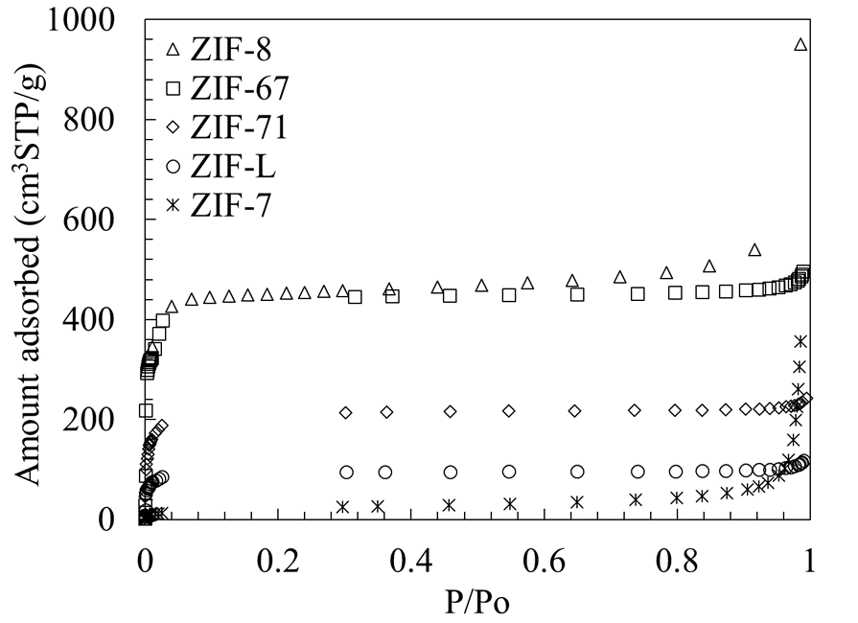

Fig. S1. N₂ adsorption isotherms of ZIFs at 77 K

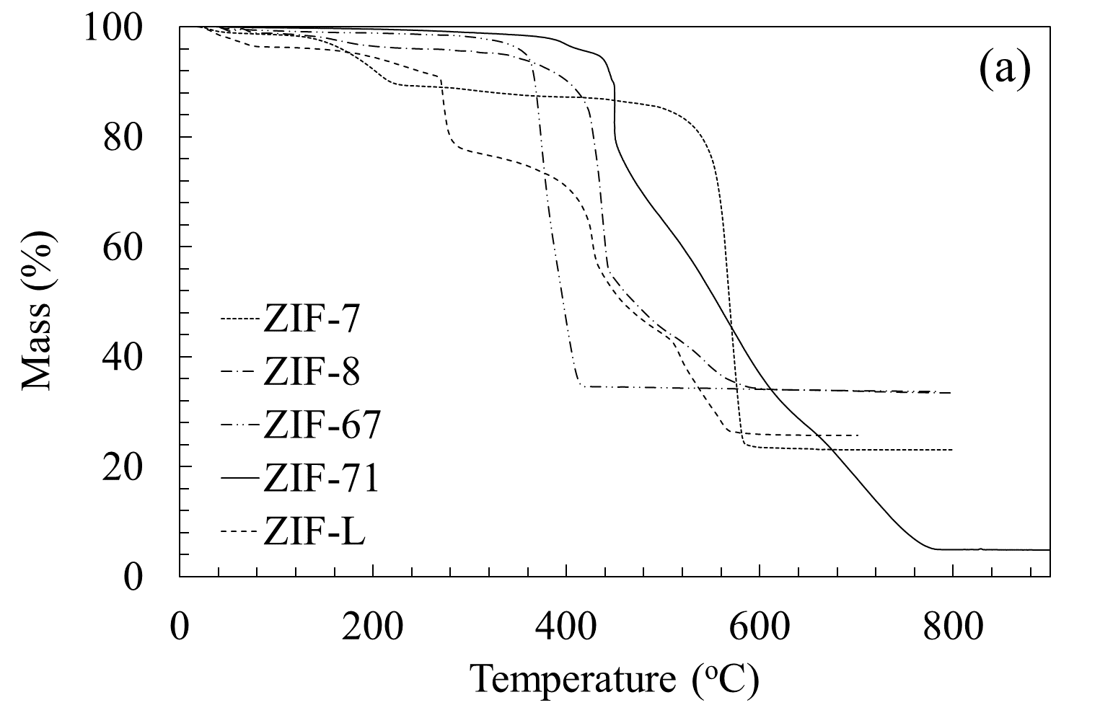

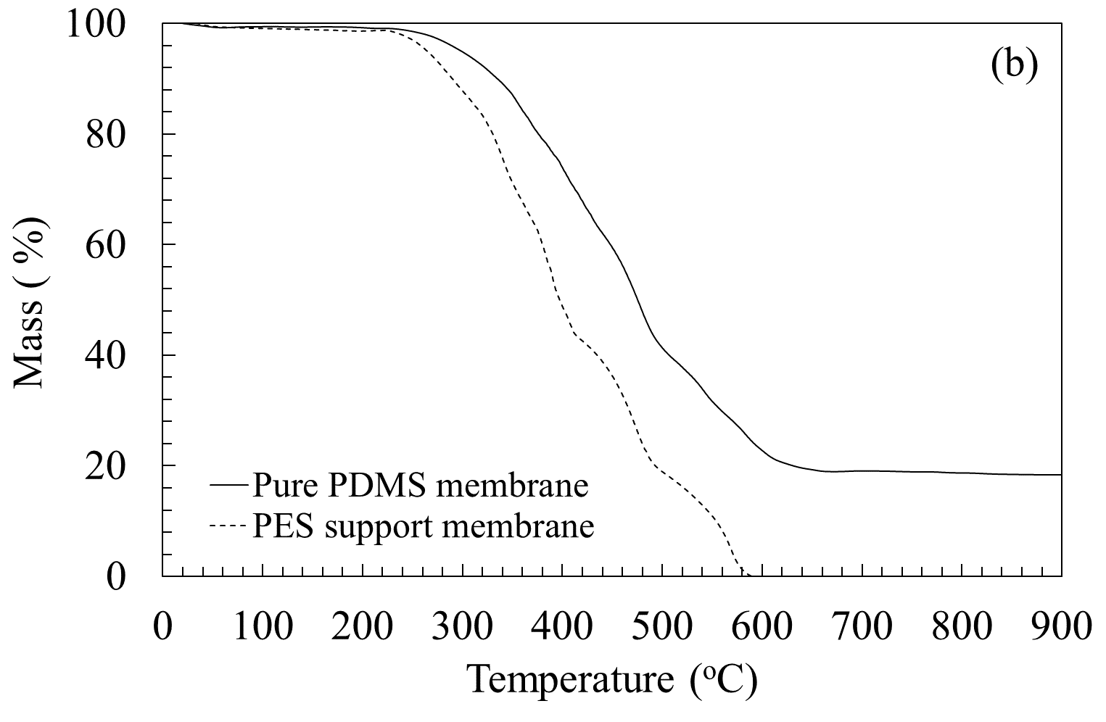

Fig.S2. TGA curves of (a) ZIFs (b) Pure PDMS and PES support membrane

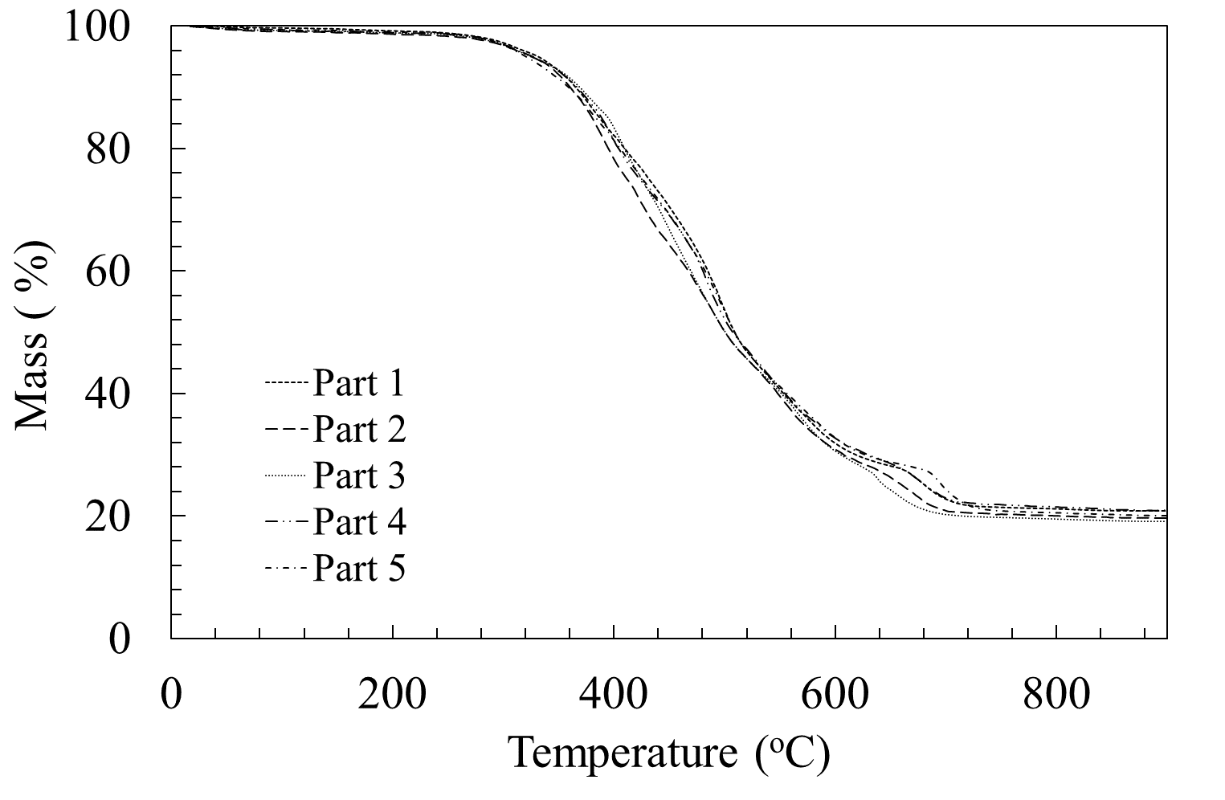
1
4
3
2
5

Fig. S3. TGA curves of pieces of a 20 % ZIF-L/PDMS membrane. The location of membrane pieces analyzed by TGA is schematically shown in the insert.

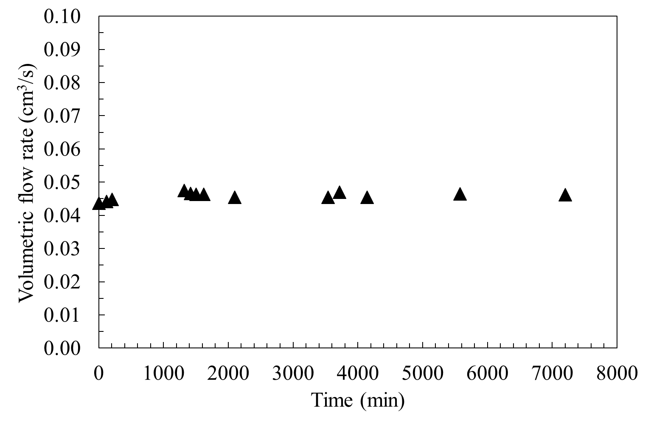

Figure S4. VOCs flux of PES support membrane
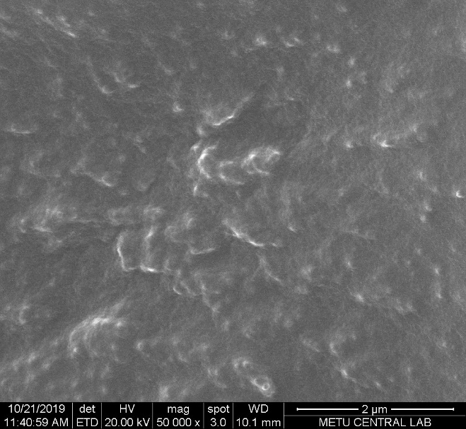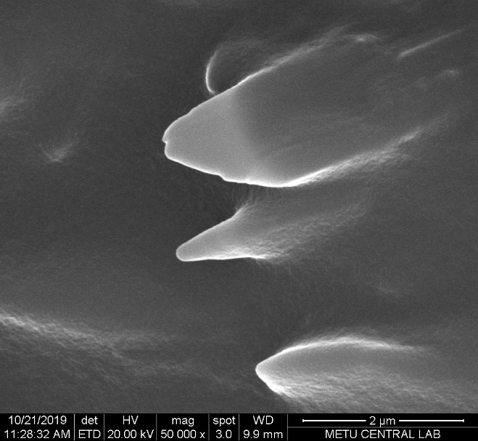
(d)
(c)
(b)
(a)
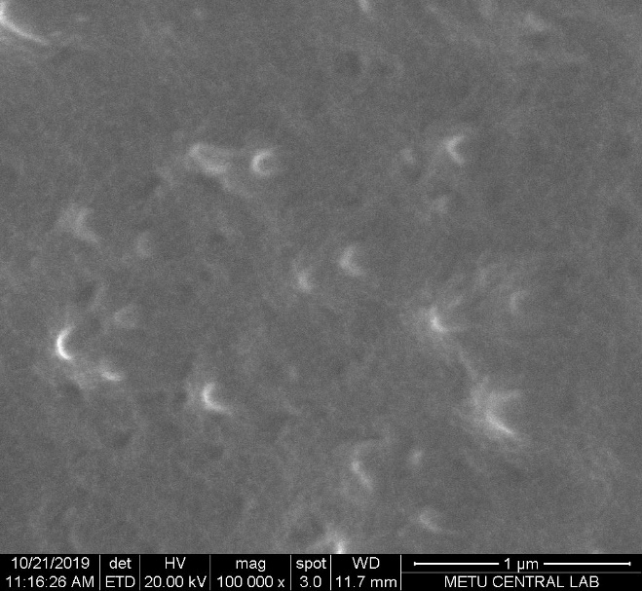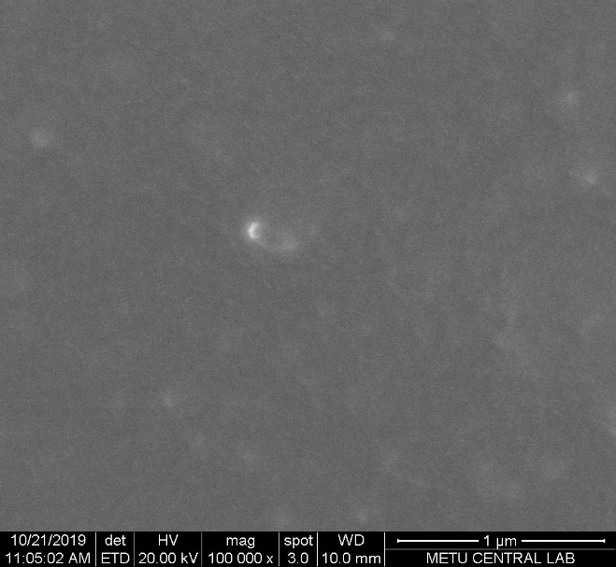
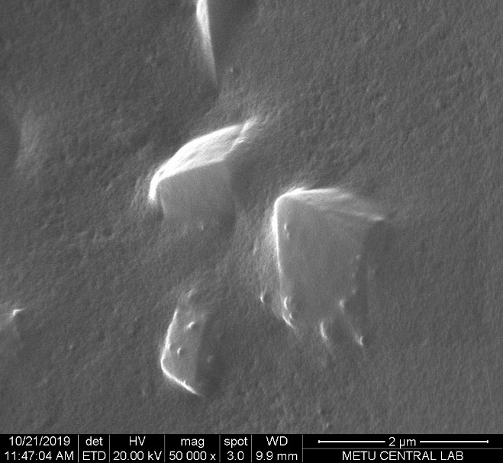
(e)
Figure S5. SEM image of (a) 20 % ZIF-8/PDMS, (b) 20 % ZIF-L/PDMS, (c) 20 % ZIF-
67/PDMS, (d) 20 % ZIF-7/PDMS, (e) 20 % ZIF-71 PDMS MMMs

Table S1. Solubility Parameter (δ) values of solvents
Solvent | δ_{D} (Mpa ^{0.5}) | δ_{P} (Mpa ^{0.5}) | δ_{H} (Mpa ^{0.5}) | δ (Mpa ^{0.5})
MeOH | 14.7 | 12.3 | 22.3 | 29
EtOH | 15.8 | 8.8 | 19.4 | 27
1-propanol | 16 | 6.8 | 17.4 | 25
IPA | 15.8 | 6.1 | 16.4 | 24
EtAc | 15.8 | 5.3 | 7.2 | 18

$δ^{2}= δ_{D}^{2} + δ_{P}^{2} + δ_{H}^{2}$ Eqn S1.
δ_{D} , δ_{P} and δ_{H} values of solvents of taken from literature (M. Charles, Hansen Solubility Parameters: A User’s Handbook, CRC Press LLC, America, 2000).

Table S2. The measured flux of mixed matrix membrane
 |  |  | Molar Composition VOCs : N₂ = 980 : 20
 | Thickness (μm) | Pure N₂ (GPU) | N₂ (GPU) | VOCs (GPU)
Pure PDMS Membrane | 15.2 ± 1.1 | 17 ± 1.8 | 19 ± 2.9 | 406 ± 36.0
20 % ZIF-8 PDMS MMMs | 27.7 ± 0.9 | 10 ± 0.8 | 11 ± 0.7 | 221 ± 14.0
20 % ZIF-L PDMS MMMs | 58.5 ± 1.2 | 2 ± 0.2 | 3 ± 0.1 | 169 ± 20.2
20 % ZIF-67 PDMS MMMs | 59.2 ± 1.2 | 4 ± 0.8 | 5 ± 0.4 | 93 ± 5.1
20 % ZIF-7 PDMS MMMs | 47.0 ± 0.8 | 3 ± 0.5 | 5 ± 0.5 | 149 ± 20.5
20 % ZIF-71 PDMS MMMs | 50.3 ± 0.8 | 7 ± 1.3 | 6 ± 0.2 | 151 ± 20.6

