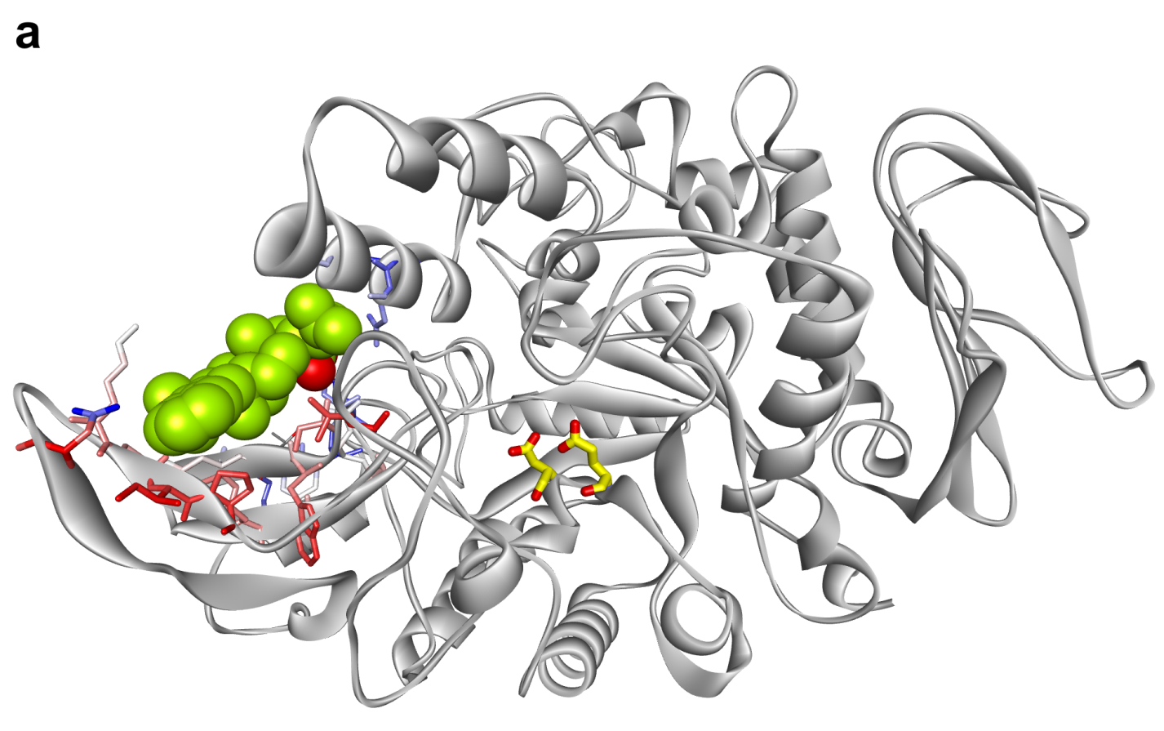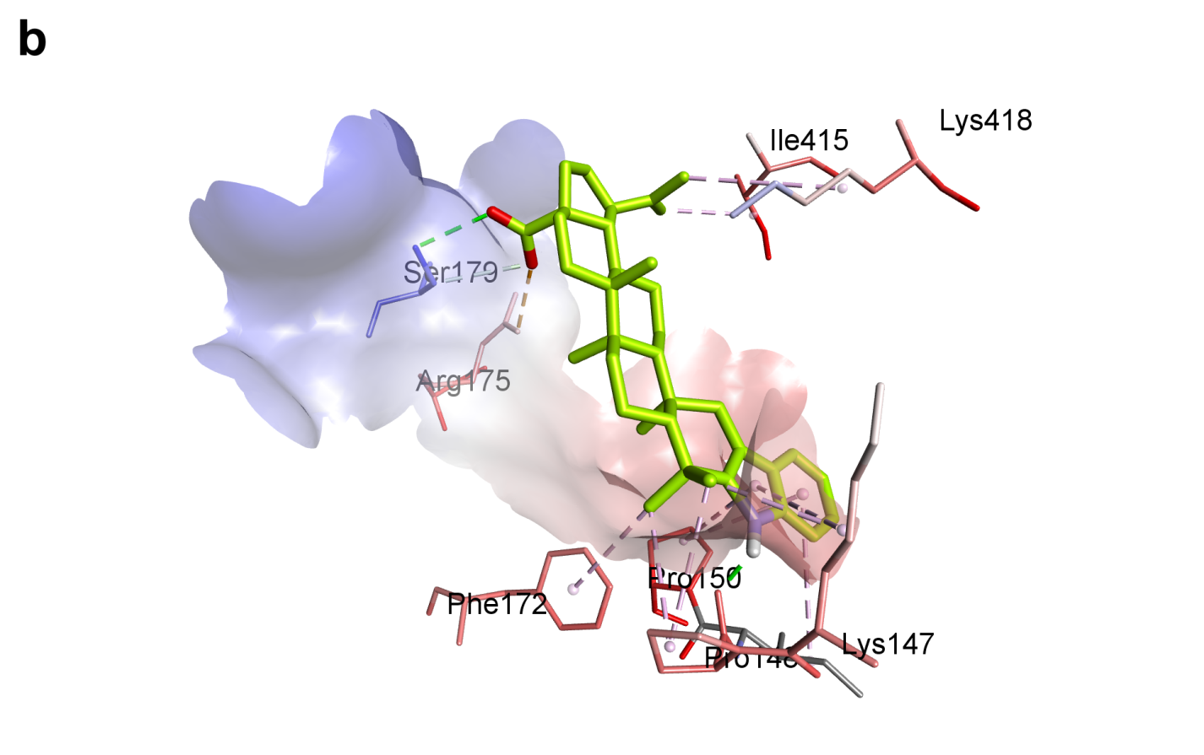
Fig. 1. CPK model of compound 1 docked into the allosteric site of S. cerevisiae α-glucosidase; catalytic Asp214 and Glu276 are shown with yellow carbons (A). Proposed interactions of compound 1 with amino acids of the allosteric site (B).

